

LOCATION: Swansea
LEVEL 4
EXAMINATION PERIOD
MAY 2020

MODULE CODE: M4X01163
MATERIALS AND INTRODUCTION TO MANUFACTURING

TIME: 2 HOURS
answer all questions FROM SECTION A AND SECTION B

Equipment or materials required – Calculator

Constants $N_{A}=6.022×10^{23}$ $g=9.81ms^{-2}$

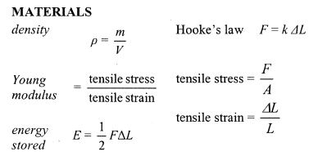
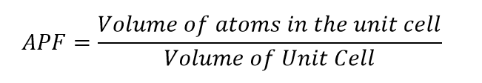
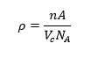
ANSWER ALL QUESTIONS

SECTION A
Multiple choice

1. A material with a low ‘stiffness’ could be said to have:
A High strain
B Low stored elastic potential energy
C A large Young’s modulus
D A small Young’s modulus

2. Hooke’s Law can be determined by:
A Finding the area under a stress strain graph
B Finding the gradient of a stress strain graph
C Finding the area under a force extension
D Finding the gradient of a force extension graph

3. The co-ordination number of a FCC is:
A 2
B 8
C 14
D 12

4. The density of water is $1000kgm^{-3}$. What density would you expect for a gas:
A $8587{kgm}^{-3}$
B $0.0989{kgm}^{-3}$
C $8.73k{gm}^{-3}$
D 1.13$×{10}^{3}{kgcm}^{3}$

5. The total spring constant for two springs in series is:
A $\frac{1}{k_{T}}=\frac{1}{k_{T}}+\frac{1}{k_{T}}$
B $\frac{1}{k_{T}}=\frac{2}{k_{T}}+\frac{3}{k_{T}}$

C $k_{T}=k_{1}+k_{2}$
D $k_{T}==2k_{1}+3k_{2}$

6. A hysteresis curve gives an indication of the:
A Heat lost
B Density of steel
C Composition of rubber
D Structure of diamond

7. The unit Pascal is used to describe:
A Density
B Force per unit volume
C Force per unit area
D Mass per unit volume

8. Which element does not have a FCC structure:
A Rubidium
B Sodium
C Uranium
D Polonium

9. The density of a material can be defined by using ${kgm}^{-3}$ and which other unit:
A ${gmol}^{-1}$
B ${gatom}^{-1}$
C ${gmol}^{-3}$
D ${atom/mol}^{2}$

10. Avagadro’s number is a measure of:
A Number of mole’s
B Number of atoms
C Number of atoms per mole
D Number of atoms per gram

SECTION B
1.
[2]
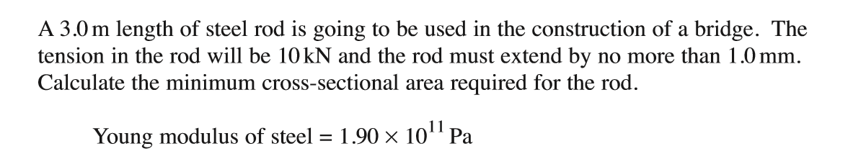

[6]

2.
[5]

a) An aerospace engineer has built two differently designed wings. One wing is made from an aluminium alloy and the other is made from a carbon fibre composite. The engineer tests a sample of each material by applying a varying stress (figure 1).

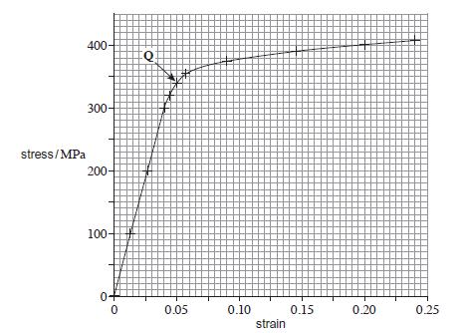
Figure 1
A
B

Curve A shows loading and curve B shows unloading of the cord.

i) State what characteristic of the material is given by Q and what is its effect on the material. [2]
ii) Explaining how you could use figure 1 to calculate the young’s modulus [2]
iii) State what characteristic of the material is given by A and what is its effect on the material. [2]
iv) State what characteristic(s) of the material are given by B and what are their effects on the material [4]

b) To carry out the above test, the engineer made a cylindrical sample of one of the materials. When a force of 150N was applied to a cylinder of length 1500mm and area 0.35$×{10}^{-4}m^{2}$ and extension of 1mm was observed. Given this information, calculate the young’s modulus from these values and compare it to the young’s modulus calculated from figure 1. All workings should be shown. [5]

- Show that the atomic packing factor for SC, BCC and FCC is 0.52, 0.68 and 0.74 respectively
[16]

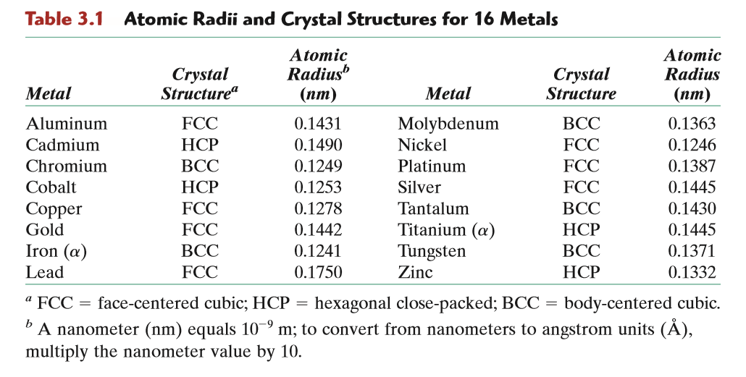

- Aluminum has a FCC crystal structure, an atomic radius of 0.1431nm, and an atomic weight of 26.98 g/mol. Calculate its theoretical density. [6]

- Calculate the radius of a Palladium atom, given that it has an FCC crystal structure, a density of 12$gcm^{-3}$ and an atomic weight of 106.4$gmol^{-1}$. [5]

Diwedd/End

