

Case Study: Tesla’s entry into the U.S. Auto Industries
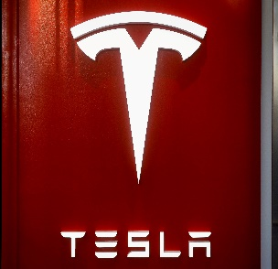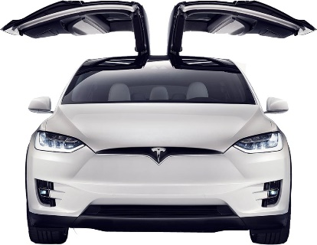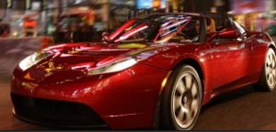

University of Wales, Trinity Saint David, London Campus
Program: MBA (Master of Business Administration)
Assignment Title/Module: Strategic Management
Module Code: LCMB7003
Lecturer: Gladius D. Kulothungan
Prepared by: Kazi Nazrul Islam
Student I.D: 2018937
Word count: 5792 (Excluding Abstract)

CONTENTS PAGE
CONTENTS: Page Numbers:
Abstract: ………………………………………………………………………………………………………………………………. 03
Company Background: …………………………………………………………………………………………………………..03
Mission and Strategic Objectives: …………………………………………………………………………………………..03
Success factors: ………………………………………………………………………………………………………………………04
External Analysis: ……………………………………………………………………………………………………………………06
PESTEL Analysis of Tesla Inc.: ………………………………………………………………………………………………….07
Political factors: ………………………………………………………………………………………………………….07
Economic factors: ……………………………………………………………………………………………………….08
Social factors: …………………………………………………………………………………………………………….10
Technical factors: ……………………………………………………………………………………………………….10
Environmental factors: ……………………………………………………………………………………………….10
Legal factors: ………………………………………………………………………………………………………………11
SWOT Analysis: ……………………………………………………………………………………………………………………….12
Strengths of Tesla: ………………………………………………………………………………………………………12
Weakness of Tesla: …………………………………………………………………………………………………….13
Opportunities available to Tesla: ……………………………………………………………………………….,13
Threats that Tesla to face (if any): ………………………………………………………………………………14
Porters Five Forces Model Analysis for Tesla: ………………………………………………………………………….14
Industry Rivalry in the market: ……………………………………………………………………………………15
The Bargaining power of buyers: ………………………………………………………………………………..15
The Bargaining power of suppliers: …………………………………………………………………………….15
The threat of potential new entries: ……………………………………………………………………………15
The threats of substitutes: ………………………………………………………………………………………….15
Internal Analysis: ………………………………………………………………………………………………………………….. 16
Value chain Analysis: Tesla Inc. ..……………………………………………………………………………………………..16
Primary Activities: ………………………………………………………………………………………………………16
Secondary Activities: ………………………………………………………………………………………………….17
Inbound Logistics: ………………………………………………………………………………………………………17
Operations Logistics: ………………………………………………………………………………………………….17
Outbound Logistics: ……………………………………………………………………………………………………17
Marketing and sales: …………………………………………………………………………………………………18
After sales service: …………………………………………………………………………………………………….18
Strategic Resources and Capabilities of Tesla: ………………………………………………………………………..19
Tesla Infrastructure…………………………………………………………………………………………………….19
Human resource management/Recruitment………………………………………………………………20
Technological development/Skills: ….…………………………………………………………………………20
Procurement………………………………………………………………………………………………………………20
Conclusion: …………………………………………………………………………………………………………………………….21
Recommendations: ………………………………………………………………………………………………………………..21
References/Bibliography: ……………………………………………………………………………………………………….22

Abstract:

This assignment work is mainly based on a very important subject area of Master of Business Administration which is “Strategic Management”. The word ‘Strategy’ (Greek origin) widely used in Army, especially in war time which means planning for something and execution of planning. In business Strategic Management refers to an initiative taken by a manager or a general manager with a clear goal – what is going to be done for the business (Intention) and how it’s going to be done (Emerged action if needed), to enhance the firm’s performance (End result). So, it is very important what strategic decision we take and how we execute it.

The case study I have chosen for this assignment is, “Tesla’s Entry into the U.S. Auto Industries”. We are going to look in depth by completing a strategic analysis of how Tesla faced the central issues and what they have done to overcome those issues, what environment they are in, what culture they have adopted to reach to a place where they are in now and what capabilities and skills, they have acquired to innovate the high-tech auto industries in the USA and around the globe.

Company Background: A brief history of Tesla Inc.:

Tesla Inc. is an American energy and automobile company founded in 2003 in California, USA. Tesla designs, manufactures, develops, and sells vehicles fully run by electric and energy storage systems worldwide. They also produce, install, operate, and maintain solar energy storage systems around the globe. Tesla Inc.’s headquarter is in Palo Alto, California. (Petro, 2019). Tesla also designs, develop, and produces Battery products.

Martin Eberhard and Marc Tarpenning with co-founders JB Straubel, Ian Wright founded Tesla inc.in 2003, with the mission in mind that it is possible to make and drive electric car efficiently which will be better in every way than the car run by Gasoline. Current CEO Elon Musk (joined the company in 2003) and his company’s dream came true as Tesla is producing electric vehicles, clean energy generation and storage products. (Petro, 2019)

But Tesla faced slight financial difficulties during the launch of Model S in 2008 because of the financial crisis worldwide. Roadster was also in declining stage. Elon Musk raised extra $40 billion by convertible debt finance to make things better when the big investor Lehman brothers went bankrupt. Around 4 months later Model S got 1000 order which helped to recover from the financial crisis.

Mission and Strategic objective:

Elon Musk who is now the face of Tesla and CEO joined the company in 2003 and became chairman of the board of director in 2004, after investing $7.5 million of his own money into the company for Tesla series A’s (Tarpenning, 2019), (Tesla a Hell of a ride, 2019), (Black, 2021)

The initial idea of the company was to produce the first all-electric sports car, but they have brought some changes in their original strategic plan, the company’s todays mission is to accelerate the world’s transition to sustainable energy, that involves manufacturing All-electric car in their priority list to create cleaner energy generation. After wide research in 2008, Tesla produced its first car, the Roadster. The Roadster was a first of its kind, electric sports car that could travel up to 245 miles on one charge and do 0 to 60 in less than four seconds. Also, in 2008, following the two founders Eberhard and Tarpenning leaving the company, Elon Musk took over as CEO and still serves in that role today ("Tesla, Inc.").

Success factors: Tesla Inc,

According to ‘Ines Toumi’, in this challenging economic environment, characterized by disruptive technologies and intense competition, it is vital important, to use a more strategic approach in marketing in the automotive and energy industries. Elon Musk is at present one of the most successful entrepreneurs in the world and Tesla is a leader in the market of electric vehicle now a days. (Toumi, 2018)

One of the main success factors of Tesla is the market entry strategy. There are three stages of entry as we see from Tesla’s company profile. As Musk said in a comment, “The strategy of Tesla is to enter at the high end of the market, where customers are prepared to pay a premium, and then drive down market as fast as possible to higher unit volume and lower prices with each successive model”.

In stage one, the Roadster model is introduced which is the most expensive and the first model of Tesla. It was targeted to the niche market for the high-end customers at the top of the electric market. It was the correct market positioning of their first vehicle which appealed the first customer and opened the doors for the subsequence models. It was the topmost quality electric vehicle with the latest technology and hence Musk’s slogan was that “High quality, high price.

In stage two, there are two phases. The first phase was to introduce ‘Model S’ geared with latest technology. it was priced comparatively lower than the Roadster, targeting the Upper middle-class customers which is a large segment of audience. It comprises with the luxury Sedan market, but market was highly competitive. In the second phase of stage two Elon musk introduced Model X which was a combination of a SUV and a Minivan.

As per the strategy Model 3 was introduced in stage 3 targeting the mass market customers. The objective of this study was not to make money but to get popularity. The price was set $35000, fully loaded with latest technology, reaches to 60 MPH within 6 second and a 75-kWh battery had a range to 220 miles extendable to 310 miles with a long-range battery, but it is much cheaper than the other models and the target audience is low to medium wage earner people. It was a huge success as we can see from company history. In the first day of launch Model 3 got 115,000 reservations with pre-order of $1000 deposit per car. No wonder in 2018 Tesla sold 245,240 vehicle which is more than Mercedes vehicles in the US.

The other success factor of Tesla Inc. is to think about environmentally friendly energy. Tesla CEO Elon Musk said in an interview in 2019, “the company’s solar and energy storage business will grow faster than its electric vehicle business”. He said in the third quarter company has restored resources to Tesla Solar and Storage,” (Barhat, 2019) [CNBC Journal]. Other great investment of Tesla spent $2.6 billion and purchased the project Solar city in 2016. So, Elon Musk’s strategy to produce green energy is already started proving fruitful.

Lithium-ion Battery – The Lifeline of Tesla, (Electric vehicle)

Tesla needs a massive quantity of lithium-ion batteries for using in its electric vehicles and Energy’s storage solutions businesses. Tesla also building massive Giga-factories worldwide including its newest Gigafactory 3 in Shanghai, China. On the other hand, General Motors (GM) just announced a multibillion-dollar investment plant to produce lithium-ion battery in Ohio. So, even though GM is going to be a competitor for Tesla’s Battery technology sector but at the same time Tesla can take this advantage and make GM a battery supplier for its automobile factory.

Falling battery prices could be an advantage for leading energy storage companies, including Tesla. Over the past few years’ battery prices have fallen about 87%, from $1,160 / kWh in 2010 to $156/kWh in 2019, the prediction is, average prices will fall to $100/kWh by end of 2023. Electric car production cost will be significantly low if the battery cost less and at the same time running cost will be low. From the following figure (Figure 1) we can see how drastically battery prices fallen in last 10 years.

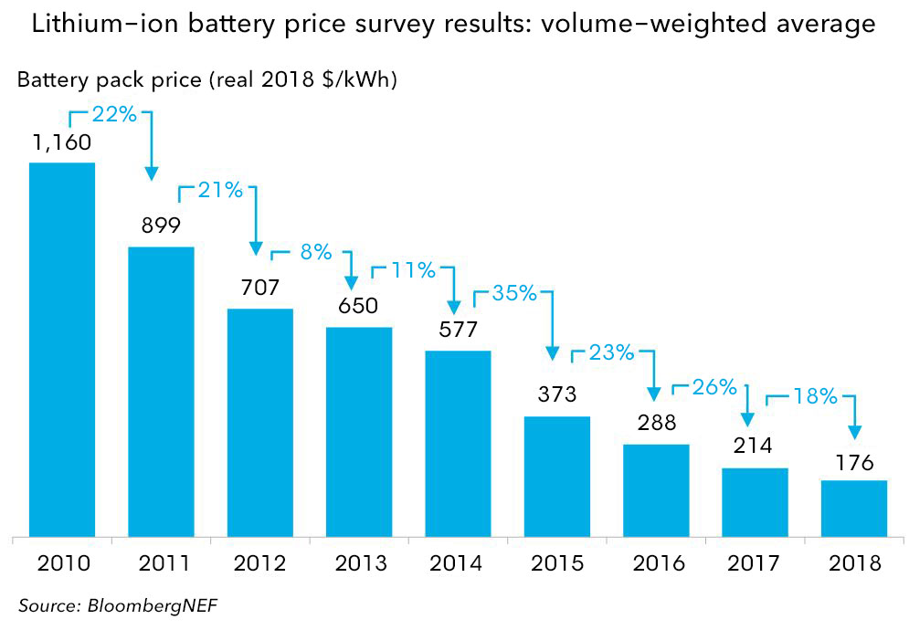
Figure 1: Lithium-ion Battery price Survey (source: Bloomberg.com)
Tesla’s strategic planning for energy could take few more years before it gets implemented completely. The way it looks, may be by 2025 we will be able to say that solar power and energy storage project is another success factor for Tesla.

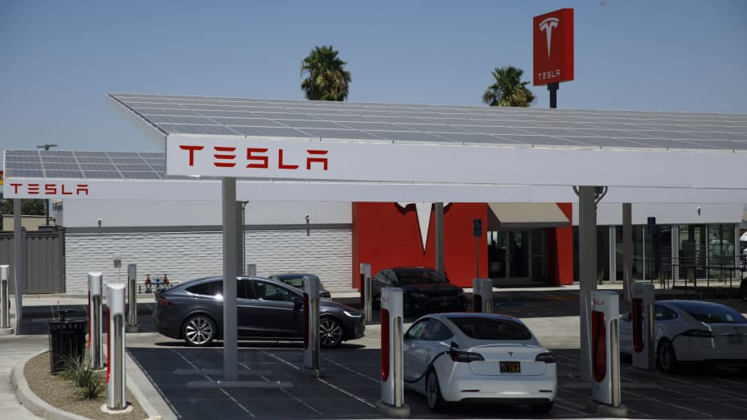
Figure 2: A Tesla Model X electric vehicle drives past car charging at a solar panel canopy at the Tesla supercharger station in Kettleman city in California, USA on Wednesday July 31st, 2019.

External Analysis:

External analysis refers to the external environment that affects the company performance directly or indirectly. Also, external analysis assists us to determine what opportunities available for the growth of the company or threats a company may possibly face. We are going to use a model called PESTEL analysis to see how Tesla is getting affected by the external forces:

PESTEL is a tool analysing the external environment of a company. PESTEL is a tool to analyse the political, economic, sociocultural, technological, environmental, and legal environment of a company and how these factors influence the company on their day-to-day operations in the relevant market. PESTEL analysis helps the company to make better strategic choices for future growth and development. (Petro, 2019)

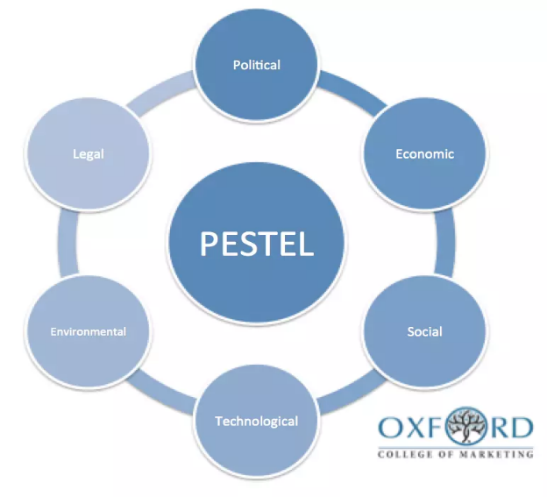
PESTEL Analysis of Tesla Inc
Analysis
TESLA Inc.
.
Figure 3: PASTEL Analysis of Tesla Inc.
Source: Oxford college of Marketing

- Political factor:

Political factors have a great impact on any companies and industries. Since Tesla is strategically working for cleaner and sustainable energy which is not only supported by US government but also supported by the political leaders globally as everyone want to reduce the global warming by using the green and sustainable energy. Tesla is working exactly for the same which is the goal for every citizen of this world to save the planet. Tesla’s $188 million Gigafactory 3 project in shanghai China over 210 acres of land was backed by Chinese government. So political factor is in favour of Tesla’s business strategy.

Brexit in UK caused slight problem to the recruiting process of Tesla HR department as many EU citizen had to leave UK because of post Brexit immigration Law.

- Economic factor:

Economic factors have a huge effect on any company. Here Tesla is not an exception. More opportunities created for Tesla’s electric car when the cost of battery and the renewable energy went down. The lower the battery price, the lower the car manufacturing cost. For example, in last 10 years battery prices have fallen nearly 87% from $1,160 / kWh in 2010 to $156 kWh in 2019. (Figure 1), And the prediction is the price is going to fall to $100 / kWh by 2023. This is a great advantage for Tesla and its EV manufacturing business. As we can see from the following figure (Figure 4), in 2018 around 86.3% revenue came from Tesla’s automotive department.

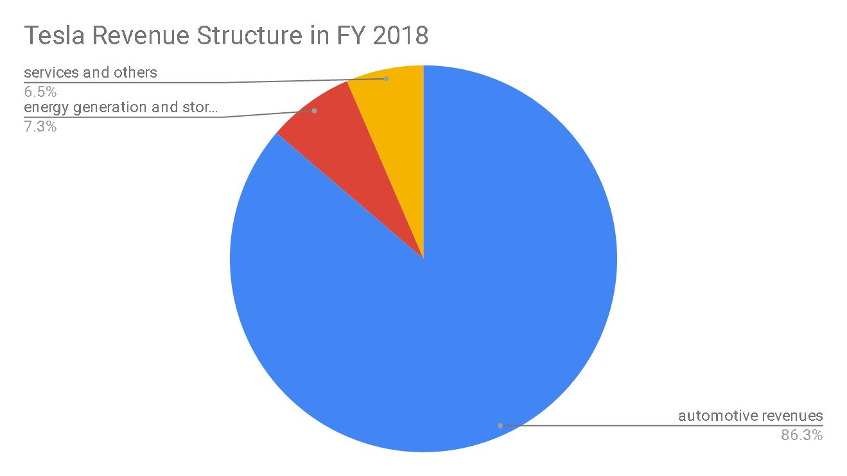

Figure 4: Revenue structure of Tesla Inc. for fiscal year 2018. Source: (Petro, 2019).

Pandemic COVID-19.
According to the researchers the epidemic COVID-19 stamped a huge impact on the economic situation in the world and the amount of the social and economic losses that the world community has suffered from this pandemic COVID-19 is tremendous. For example, the consequences for the world economy can include "the decline in exchange indices; a slowdown in the metal market; reduction of production; less use of transport in the tourism industry and of course a huge reduction of production in the automobile industries. As a result, the economic growth of world economy has already declined from 2.5% to 0.6%. In 2020/2021, global economy it is close to a recession, with a loss of $ 4 trillion. The EU Central Bank said that Europe may experience a similar crisis like the global financial crisis of 2008. (Koshetar, 2021).
Pandemic COVID-19 and Tesla Vehicle Delivery 2019 and 2020
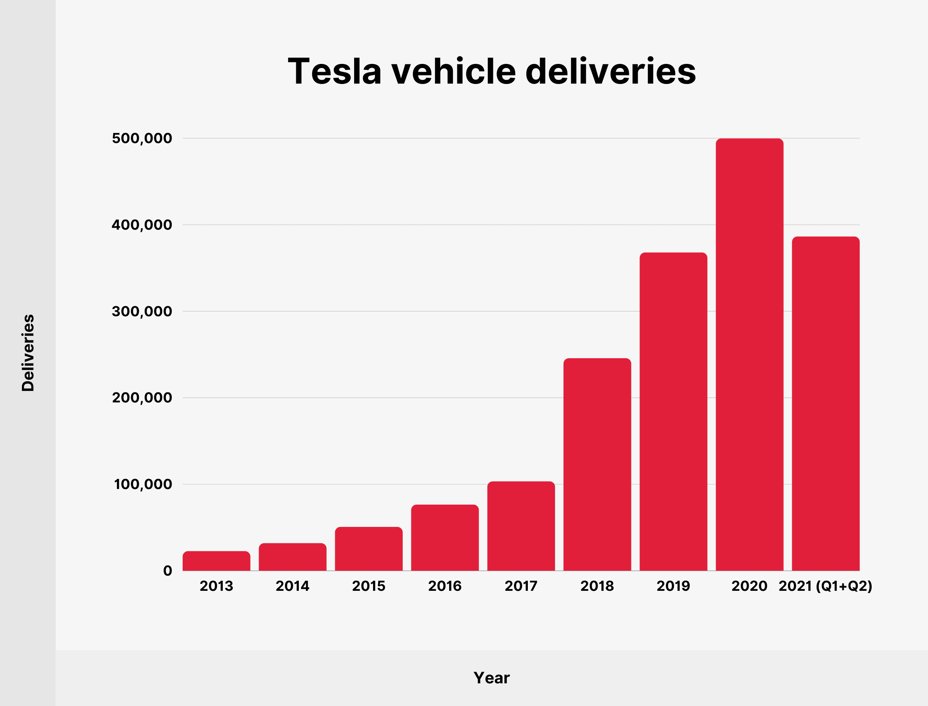
Figure 5: Tesla Inc. vehicle delivery Source: https://backlinko.com/tesla-stats
Despite the global losses in economy for the pandemic COVID-19, Tesla managed to keep up with the vehicle deliveries and revenue growth in 2019/20 and 2021as we see from the above Figure 5 and Figure 6 below. But if the world economy is unstable for longer period of time that would be a possible threat for Tesla.

Pandemic COVID-19 and Tesla Annual Revenue 2019 and 2020
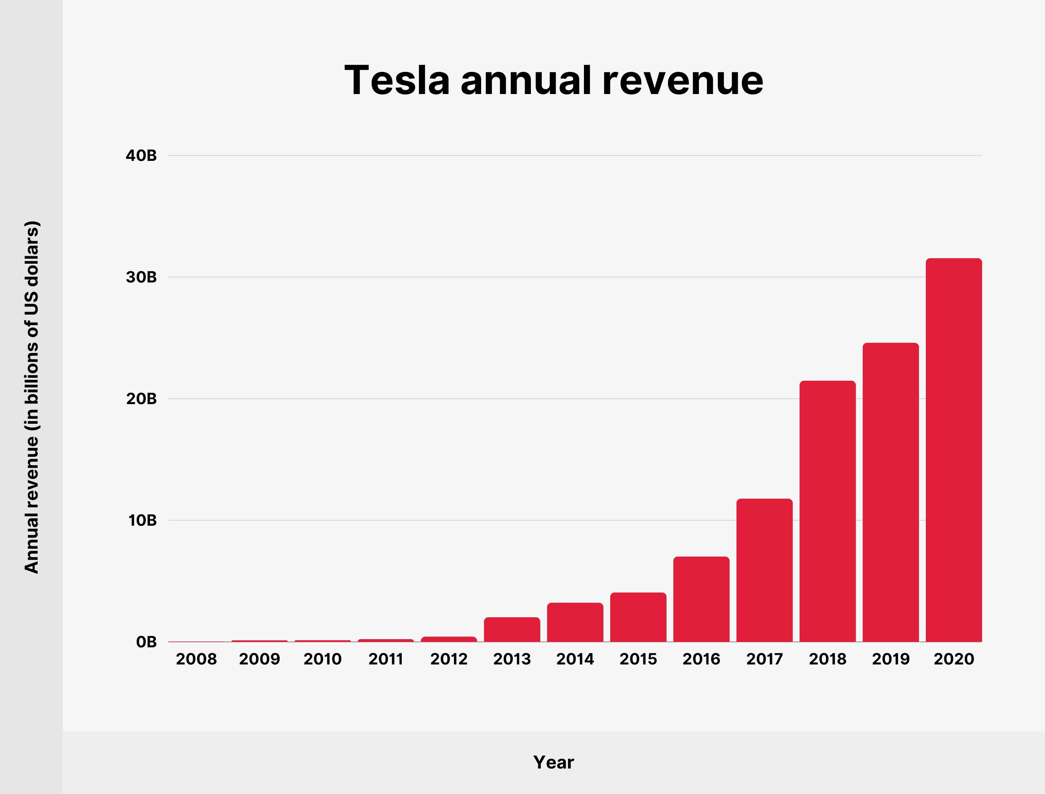
Figure 6: Tesla Inc. Yearly revenue in billion USD Source: https://backlinko.com/tesla-stats
- Social factor

Social factors involve the company employees, customers, and investors which have a huge influence on Tesla’s performance. The main strength of Tesla is the close relationship of its CEO Elon Musk with his employees. As Musk said each of his employee is an owner of Tesla which means each of his employee is a part of Tesla family and they work in the company by taking the ownership and responsibilities for the innovative development of the company. His strategy is every staff got an open access to talk to him anytime they want.

Other sociocultural factors are the customers and investors of Tesla. Elon Musk has succeeded to create a bond with his customers, investors, and other stakeholders of the company. For example, Tesla launched it mass production of model 3 in 2016 saying that he already secured 115,000 pre-ordered cars with $1000 deposit per car (a number that would grow to 500,000 pre-orders by 2018), and deliveries of the car would begin by end of 2017. He was certainly facing difficulties to keep up with the commitment of production and delivery date of late 2017.

By August 2018, Musk’s enthusiasm had turned to misery, as he was in a huge backlog. Working up to 120 hours a week and sleeping on the factory floor, Musk was supervising the production of the Model 3 very closely. He described in his own word; Tesla is in a state of “production hell.” But Musk did not give up, he had trust in him as well as in his staff and his highly automated factory, equipped with over 1,000 robots. In the 2nd quarter Tesla had a loss of $743 million, they needed to produce 5000 car a week to recover the loss. Everybody was thinking Tesla will dry out by the end of the year 2018. But eventually Musk managed his company to produce 5000 cars a week and turned the losses into profit as we can see 2018 and 2019 revenue growth from figure (Figure 6) above and in 2020 and 1st and 2nd quarter of 2021 Tesla was ahead of their target for delivering cars. (Figure 5).

- Technical factor:

The products of Tesla are fully dependent on technological development. These developments determine how cost-efficient and cost-effective their products are. Tesla got opportunities to increase its automation in its products, increasing use of mobile services, and frequently changing technology. Tesla’s first innovation in automobile industry is to make complete electric vehicle using different technology which is different to the conventional gas fuelled car. Tesla’s dream came true when the launched their first model Electric vehicle Roadster packed with high technology.

Tesla also continuously developing its technology and implementing in the subsequent models they are launching. So technical factors are playing a very important role for Tesla’s current and future success. But Elon Musk admitted that excessive implementation of technology in model 3 was a mistake which nearly brought them down to the level of calling bankruptcy. However, if they don’t keep-up with the first moving technology then it could be a threat for them to go obsolete in the high-tech automobile market.

- Environmental factor:
According to Koshetar, et al, “Modern environmental problems is a result of the natural and historical process, which should enter the fairway of the social and natural harmony, between the activities of society and the preservation of the environment.” The methodology for solving the global environmental catastrophe, that aims to determine the vectors and prospects for the development of mankind as a planetary social and natural system and Earth eco-civilization. (Koshetar, 2021)

Since Tesla’s investment is on clean energy and creating Eco-friendly environment, so it is very important that there is ecological consciousness among more and more public. The study of ecological consciousness, which is a part of social consciousness, will create an opportunity to establish the relationship of sociological development with environmental management.

It is important to determine in public consciousness and the causal links between natural and social, which in turn leads to the attention of society to solve ecological problems both internally and externally as well as to the formation of ecological consciousness. This should be a step forward for humanity to realise its social nature on a planetary scale. This is the whole idea of Tesla’s business strategy to create a clean environment by manufacturing fully electric vehicle using sustainable and clean energy and prevent the global warming as much as possible.

- Legal factor:

Legal factors are the set rules that protects the rights of the company, also oversee what a company should or should not do. Such as Tesla’s each patent of vehicle is protected by law. Also, staff welfare within the company, working hours and acceptable working environment are protected by the state law. Increased regulations on energy consumption level, dealership sales regulations are a growth opportunity for Tesla. Emission control rules are in favour of Tesla because it runs by battery so no emission involve but the application of this rule may increase Tesla’s sale because a vast area of London is prohibited for high emission vehicles. So, commuters of London city will either go for electric vehicle like Tesla or for a low emission hybrid car.

SWOT Analysis of Tesla Inc.

Strengths Weaknesses
- Top Employer company  - Most valuable Automotive company  - Best in class electric car  - Highly Innovative company  - Complete Market position  - Energy Efficiency | - Manufacturing complications  - Lack of high-volume production  - Shortages of Batteries  - Premium product range  - Elon Musk – One man show.  - Increase in Liabilities
- Product Liability claim  - Extensive competition  - Product defects  - Long term confidence  - Customer adaptation  - Self-driving cars still a concern  - Economic uncertainty | - Sales Expansion in untapped market  - Less expensive car  - Battery production technology  - Introduction of Pick-up truck  - Market confidence in Tesla  - Air-Taxi Market
Threats Opportunities
Figure 7: SWOT Analysis of Tesla Inc.

Strengths:

Tesla is a leading pioneer in the field of electric vehicle because of its significant use of renewable and sustainable energy such as solar energy. Tesla entered in the automotive industry introducing the brand sports model Roadster, a highest quality electric vehicle fully equipped with latest technology with the brand image “High quality, high price”. This brand was targeted for the niche market for the high wage earner people. This brand got popularity for its innovative design and brand influence.

Tesla’s other strength is it not only stayed in the high end of the market but also gradually captured the whole market model S, X, Y, and mass production of model 3 for all categories of customers in the society. The prediction is by 2040 electric vehicle sale will be increased by 55% as we ca se from the following figure (Figure 8), which is about 65 million. Since Tesla is the market leader for the electric vehicle now, and if it keeps its growth up as it is now, then there is no doubt Tesla will still be on the top of the leader board in the EV sector in 2040.

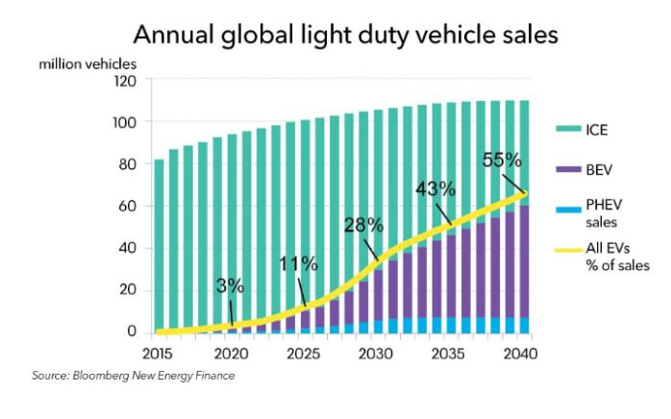
Figure 8: Prediction of Electric vehicle sell in 2040. (Source: Bloomberg.com).

Weaknesses:

Tesla uses highest technology so it is often complicated and heard to learn for its customers, this can have a negative impact and slow down the sale. Very often Tesla struggle to keep up with the supply as it happened in 2018 first and second quarter, even though it managed to recover in the last 2 quarters, but if it happens again, it might have a negative effect on its brand image.

In last year review, Tesla reported an increase of its liability. Low liquidity ratio indicates that the company might not meet its short-term obligations efficiently. In the year 2020, the company reported its current liabilities of US$14,248 million, compared to US$10,667 million in the previous year, which is an increase of 33.6%. Such significant increase in Tesla, Inc.’s liabilities could affect the company’s credibility in the financial market for raising future capital investment. (Marketline, 2021)

Opportunities:
Since Asia-Pacific market is untapped yet for Electric vehicle and Tesla is already specialist and the market leader in this field so, Tesla got a greater opportunity to enter and establish their EV Automotive business in this area.

The other areas Tesla got huge opportunities is the Battery manufacturing technologies and the clean energy storage system. This sector is growing very fast. If Tesla can keep up with the growth as predicted then Tesla could be earning by 2023 an extra US$2.6 billion (20% of expected 22.2 GW, US$13 billion) where US accounts nearly 25% of the global capacity. (Marketline, 2021)

Threats:

Product liability claims, which Tesla fears one of the biggest financial hits. Some auto pilot cars are not performing as it supposed to, and hench facing litigations and claims related to technical failure.

Other threat is the global automotive market, particularly the alternative fuel vehicles are highly competitive. For example, Tesla Model S is competing with internal combustion vehicles in the sedan market with more established car makers like Audi and BMW. Lately many other vehicle makers have entered in the market with alternative fuel system speciality electricity, which counts as a direct competitor of Tesla. These are BMW, Daimler, Fiat, Nissan, Ford and Mitsubishi among others make electric vehicles. Moreover, other established company like Audi, Volkswagen, Porsche, Volvo, and other few Automobile manufacturers also started to develop electric vehicles. Some other manufacturers like Toyota, GM, Ford, and Honda, they sell Hybrid vehicles which is a combination of electricity and gasoline. So, Tesla got a huge competition ahead of them that can eventually reduce the revenue and company’s overall business growth. (Marketline, 2021)

Porter’s Five Forces Model:

How Tesla’s business is affected by the external influence:

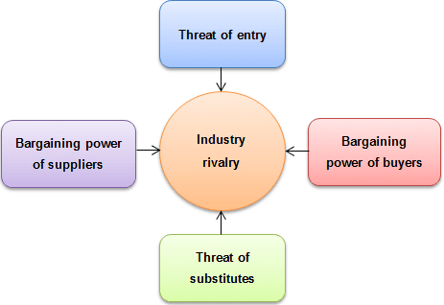

Figure 9: Porter’s Five Forces Model.

Industry rivalry: (High)
When Tesla launched its automotive business in 2003, very few people were thinking that a car will be running only in battery power, on top if it is about a sports car, that is going to be a very optimistic imagination. When Elon Musk made it possible and launched Tesla Model S, a complete electric sports car, Industry rivalry was out of question because it was the first car of this kind. But these days whole world is conscious about the global warming because of the pollution and hence everyone is after the clean and sustainable energy. So, the electric vehicle market has become highly competitive. For example, Tesla model S is competing with BMW and Audi internal combustion vehicle. Some manufacturer is making alternative fuel system vehicle which is electricity, and some established manufacturer like Audi, Porsche, Ford, Volkswagen, Volvo already have started to develop Electric vehicle. Some manufacturers like Toyota, GM, Honda, Ford produces hybrid vehicles. So, there is intense competition in this industry. As a result, Tesla must be very aggressive in its innovation with the new technology and produce electric cars equipped with latest engineering to maintain the sustainability in the market.

Bargaining power of buyers: (Low)
Tesla produced its Model S sports electric vehicle for the niche market targeting the top end of the market with high wage earner people. Model S is equipped with top quality and latest technology. So, Tesla set it in the market as “High quality, high price”. So, buyers did not mind paying higher price for the higher quality car. In this case buyers bargain power was low and they did not mind paying around US$125,000 for Roadster depending on the upgrade and the base price was set by Tesla is UD$98,000. Even the model 3 which is set to US$35,000 still buyer’s bargain power is low because of the innovative technology.

Threat of Substitute: (High to Moderate)
Model S Audi and BMW internal combustion vehicles
Model 3 Audi, Porsche, Volvo electric car

Many automobiles manufacturer started to make Electric vehicle like Tesla, so, the threat of substitute is high. But because Tesla uses unique innovative technology in all its models, that will not be easy to clone by all other manufacturer, this makes the threats of substitute moderate because as a market leader Tesla will always be ahead of other manufacturer because of the strategy of innovating technology.

Bargain power of supplier: (Low to moderate).
Tesla got a very diversified supplier numbers because of their unique capabilities of making electric vehicle. Still, they are the market leader in this industry suppliers don’t have much choice of bargain other than supplying to them. Also, Tesla is producing the main power supply of the car by themselves which is the blood vessel of the car. That’s why the bargain power of suppliers is low to moderate.

Threats of new entry: (High)
Threat of new entry in the automotive industry is very high. This is not because of Tesla is doing excellent business in this sector but lots of manufacturer entering the EV industry to save the planet by reducing global warming. by using renewable energy. The US news issued a list of top 8 fully EV car in the world. 1. Chevrolet Volt EV, 2. Tesla Model S, 3. Hyundai Ioniq EV, 4. Tesla Model 3, 5. Volkswagen e-Golf, 6. Nissan Leaf, 7. BMW i3, 8. Kia Soul EV. Tesla stands second and fourth position in this list. So the threat of new entry absolutely high and Tesla got to take this prototype of other company very seriously.
Internal analysis:
Internal analysis refers to the company Infrastructure, planning and designing, Finance, Human Resource Management, appropriate employee recruitment, Research and technological development, Procurement, Operations by maintaining communications with Inbound and Outbound Logistics, Marketing and sales and post-sales service etc.

What is Value chain Analysis?
The value chain is a business model that explain the actions required to establish the business either the products or services. Michael porter introduced this business model which includes developing a product from design to distribution and all processing in between. The reason of value chain analysis is to improve the business productivity and efficiency in-order to drive maximum value and being cost effective at the same time. This process is analysed in two parts- Primary Activities and Secondary activities.

The value chain analysis: Tesla Inc.
Porters Value chain Analysis

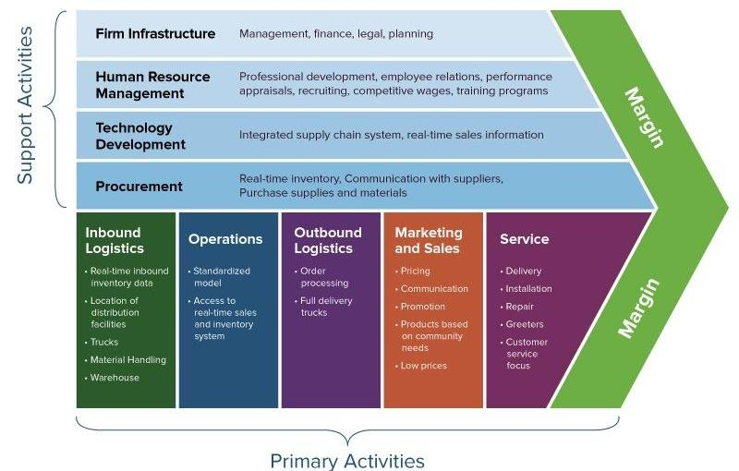 Figure 10: Value chain analysis Source: Smartsheet.com

Primary Activities:

Tesla’s primary activities consists of three tiers. Operations, Marketing and sales, Service. Operations include converting raw materials into a finished product or services. It involves dealings with Inbound Logistics, manufacturing, Outbound Logistics etc.

Secondary (Support) Activities

Secondary or support activities involves Firm infrastructure like Management, Financing, planning legal etc, Human resource management i.e., Recruiting, training and development, Research activities, Technological development, and procurement i.e., real time inventory, communicate with suppliers, purchase etc.

Inbound Logistics:

Tesla faced challenge to find the Lithium batteries they needed to power their car. However, they managed to overcome this challenge by partnering with Panasonic to build a Gigafactory which reduced the battery cost significantly. Tesla also made a partnership with Daimler and Toyota to exchange standard car parts and fundings for their batteries.

Tesla also acquired Solar city in 2016, a solar energy system producer with US$2.6 billion. There are installation facilities for electric car charger. It is a step forward for the world to use sustainable energy.

Tesla’s inbound logistics consists of importing aluminium, lithium, nickel, steel, copper, and cobalt including lithium-ion batteries from suppliers.

Operations:

All the raw materials through inbound logistics are gathered in a warehouse. These are then processed in the manufacturing department and the outcome is the finished car or in the energy storage system is the finished battery. Now a days Tesla is producing Battery cell and energy management system within their own facilities. They also internally do the body designing, assembly and recharging system which would cost a lot if they had to out-source this. Most of the time Elon Musk supervises the production department himself directly. After second quarter of 2018 tesla was in backlog and could not fulfilled delivery schedule. Elon Musk was working 120 hours a week and slept on the factory floor until he hit the target of producing 5000 car a week and end of 2018, he managed to fulfil the delivery target. We can see it from Figure 5 above.

Outbound Logistics

Outbound logistics involve physically collecting, storing, and distributing the finished products, such as, order processing, packaging, distributing, scheduling product collection etc. But like the direct ordering system of Tesla car online, Tesla also introduced a direct delivery system. It helps to reduce the cost when it cuts the investment on a huge building for large inventory.

Marketing and sales:

These are the activities required to ensure that customers are aware of the products, and they have the means to purchase it. This includes advertising, inbound and outbound and outbound sales, channel selection, promotion, pricing etc. Tesla got online store for vehicle and, they have some retail stores like Apple Inc. In marketing their policy is “Zero-dollar marketing”. Thanks to Elon Musk’s Twitter account they attract lots of media coverage free of charge which works as advertisement and helps the company a big chunk of amount from their revenue.

After sales service:

Tesla’s 25,000 super charger network located on the major routes, are the largest global fast-charging network in the world. They are also completely free to use for Tesla owner.
There are about 30 service centres throughout the UK for Tesla’s after sales service. In last 3 years alone, Tesla added 1652 new supercharger stations as we can see from the following figure. (Figure 11). Source: https://backlinko.com/tesla-stats

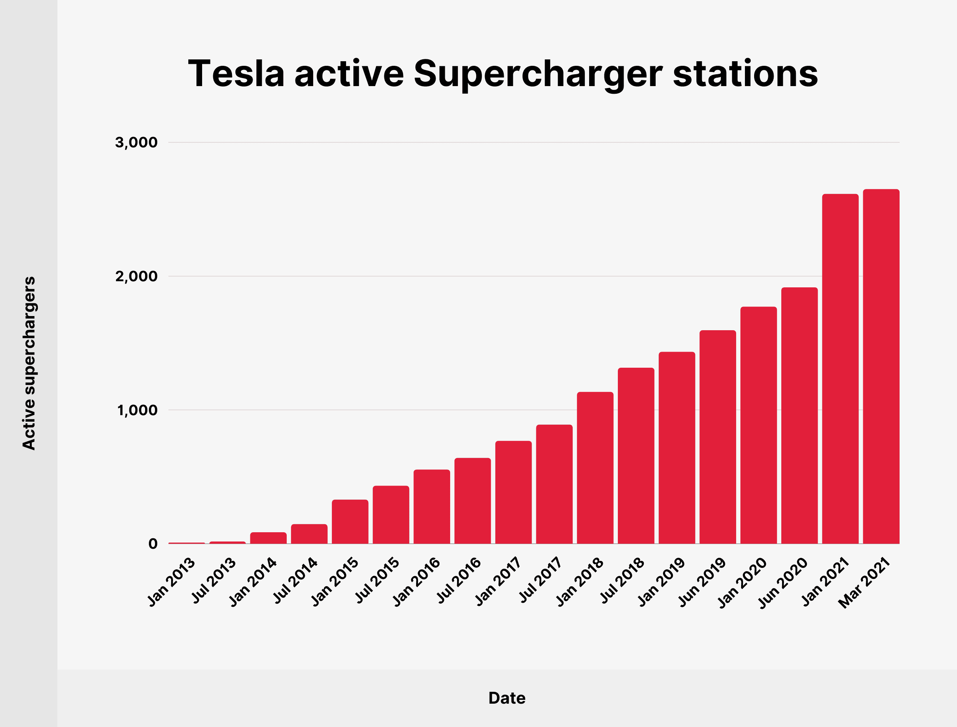

Figure 11: Number of Tesla Supercharger around the Globe

Tesla Infrastructure:

Tesla’s Infrastructure is broken down in two operating systems:

- Automotive
- Energy generation system

Around 86.3% revenue comes from Automotive, and 7.3% revenue earned from Energy system, the rest 6.5% comes from service and others. We can see total Revenue and its breakdown for different sectors from the following figure (Figure 12 and Figure 13).

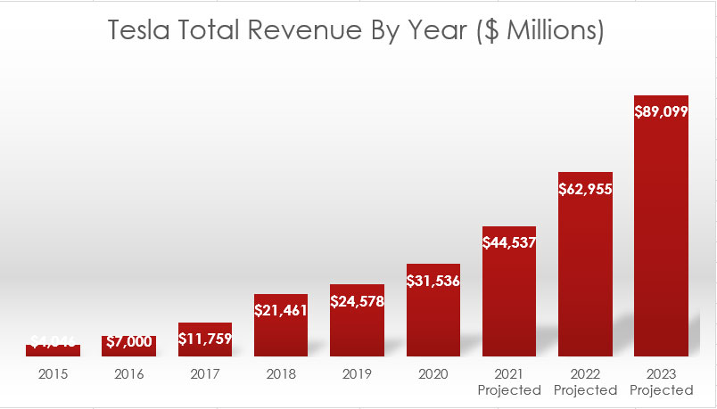
Figure 12: Tesla’s Total Revenue FY up to 2020 and prediction up to 2023. https://stockdividendscreener.com

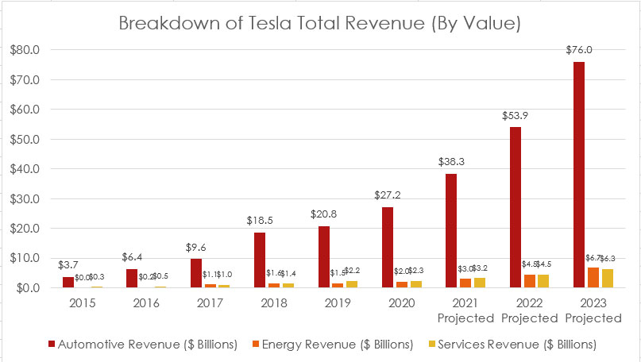
Figure 13: Breakdown of Tesla’s total Revenue. Source: https://stockdividendscreener.com

Human Resource Management/Recruitment:
Human resource management is a clear priority for Tesla. Also, CEO Elon Musk is like the Steve Jobs of Apple, so company’s success depends in a great deal on his retainment. Tesla looks after its employee as we know that staff turnover is very low in Tesla. From the following figure (Figure 14) we can see last 10 years’ recruitment & employee situation.

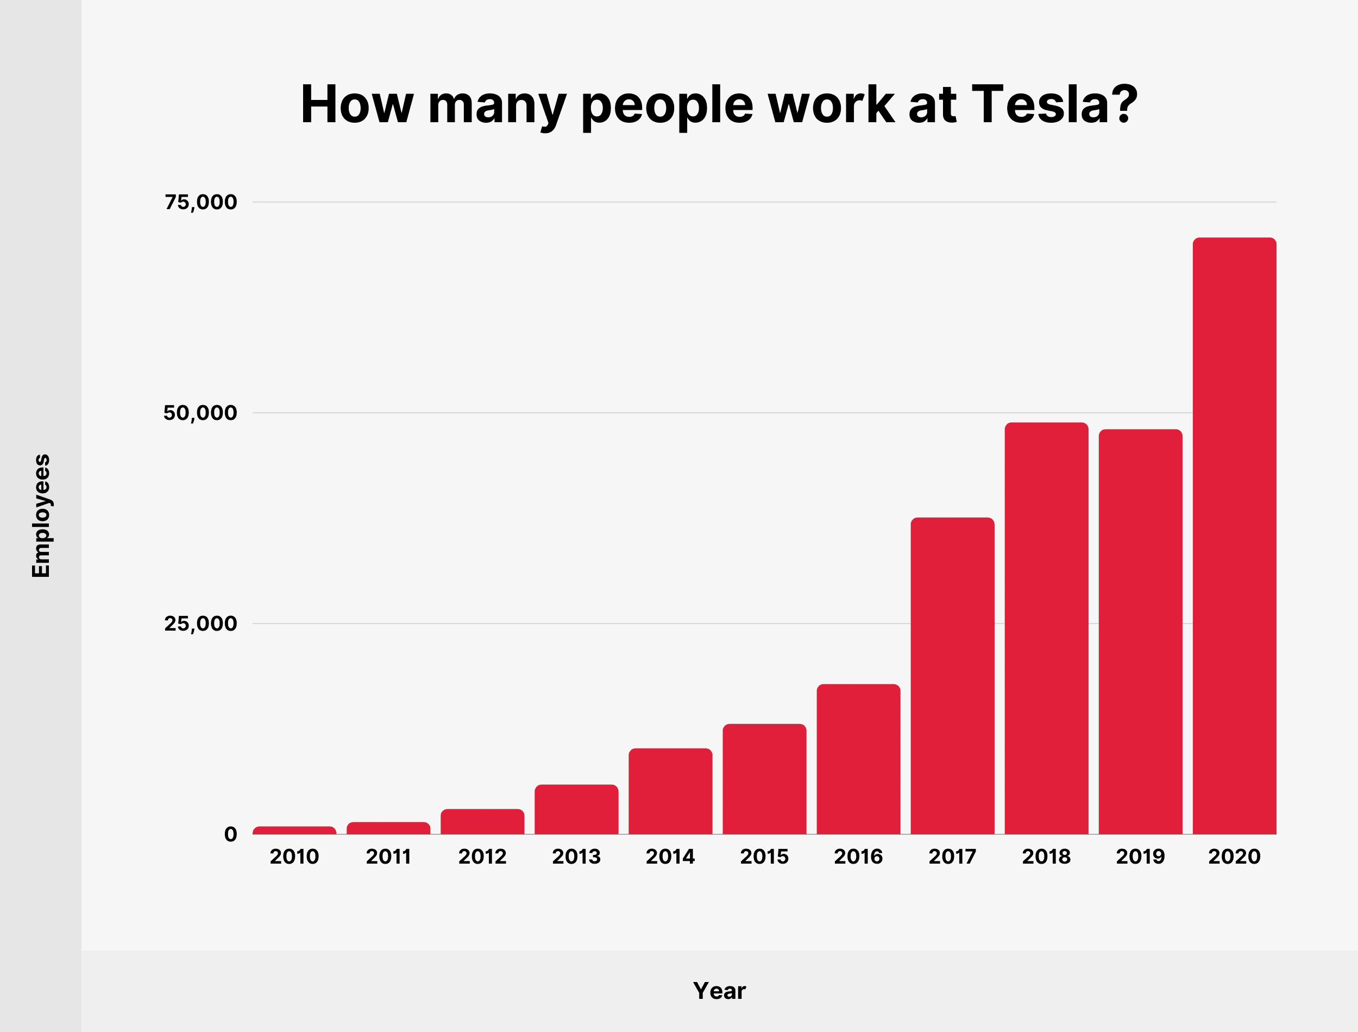
Figure 14: Tesla Number of employees at work from 2010 to 2020.
Source: https://backlinko.com/tesla-stats

Technological development/Skills

Tesla invests heavily in R&D on Technological innovation and development. There is a 11% increase to US$148 million instead of initial plan to increase US$62 million. Additional technological development includes the following:

- Lithium-ion battery cell
- Rader sensors
- FSD Computer system
- Auto pilot control system
- Solar energy products
- Air-Taxi traffic system

Procurement:

Tesla rely on Direct suppliers heavily to source expensive raw materials to produce Lithium-ion battery. Tesla made a partnership with Toyota, Daimler, and Panasonic to establish a cost advantage. Tesla also built a Gigafactory 3 in Shanghai which will certainly reduce the Transportation and manufacturing cost.

Conclusion:

In this assignment we were given the task to do strategic analysis of a company (I have chosen the case study: Tesla Inc.), how they dealt with the central issues they faced, and how the deployed the emergent strategies and achieved competitive advantages.

Tesla’s strategic Management choice worked out well, but some time things did not go as per the plan, so Elon Musk had to choose Emergent strategy (plan B) to reach to the goal. However, as a relatively new company Tesla has been successful up to this point. Elon Musk is steps ahead of the rest of the crowd to choose the company infrastructure which is environment friendly Electric vehicle and the clean energy storage systems. both sectors got bright future. Already this company has created a very strong Brand image with all its models, especially with Roadster, Model S and Model 3. They just need heavy investment to keep up this growth. Their solar power energy and battery Gigafactory is also proving successful. The 2020 Roadster, the next Tesla car to come out soon and we hope this car will be even more innovative and successful in the market.

Recommendation:

From the above analysis we can conclude that Tesla need to revise its business strategy slightly and take the following steps to be on the top of the leader board in the EV and clean energy market:
- Tesla should not repeat the incident of first half of 2018 where they failed to produce and deliver the required quantity of Model 3 car.
- Tesla needs to reduce and balance the liabilities they increased by 33.6% in 2020 within next 2 years to increase the Brand image.
- Since their premium Car Model S is in declining stage, they should pay less attention there and concentrate on producing more vehicles like model 3 and research on innovation of future models with latest technology.
- Tesla is still the leader of the EV automotive market, so they should be investing more capitals to make sure that they can deliver the ordered vehicles on time to sustain the Brand image for a long period of time.
- Tesla got a huge opportunity in their battery technology and energy storage system. They should utilise these opportunities fully and increase their revenue to roughly 20% from this sector by next 2 to 3 years which is currently around 7% of the total revenue. Also, they should be Concentrating on the Gigafactory 3 in shanghai and start production in full capacity as soon as possible.
- Purchasing Solar city spending US$2.6 billion is a brilliant move, within next 10 to 12 years’ time, solar energy is going to be one of the most clean and sustainable energy in the world. So, the future of solar city is bright and hence Elon Musk should start full production in the Solar city as quick as possible.
- Elon Musk should pay attention to their company’s weaknesses as mentioned in Figure 7 (SWOT Analysis) above and turn it to their strengths and at the same time utilise those opportunities mentioned in Figure 7. If the company can keep up with the growth as it is now, then I believe Tesla will be able to stay in the top of the leader board in the world EV Automotive industry and in the sector of clean energy storage system for a long period of time.

BIBLIOGRAPHY

Bibliography
Barhat, V., 2019. Powering the future. CNBC, Issue 14th Dec'2019.
Black, I. K. L., 2021. Tesla founders Martin Eberhard and Marc Tarpenning. CNBC Tech, Issue 6 Feb 2021.
Koshetar, U. e. a., 2021. Social and Economic aspect of the formation of Environmental consciousness.. E3S Web of Conferences, Volume 244, pp. 1 - 9.
Marketline, 2021. Tesla Inc.. Marketline, Issue 14th December 2021, pp. 1 - 3.
Petro, S., 2019. Business and Financial Analysis of Tesla Inc>. International Business Administration, Finance and Accounting. Tallinn University of Technology., Volume Tallinn 2019, p. 1 to 64.
Tarpenning, M. M. E., 2019. Tesla Hell of a ride [Interview] (Late 2019 2019).
Tesla a Hell of a ride. 2019. [Film] Directed by CNBC Broadcasting co.. California, USA: CNBC.
Toumi, I., 2018. Exploring the success of Tesla Inc.. Economics and Management, Kuban State University, Russia, p. 319 328.

Smartsheet.com

https://backlinko.com/tesla-stats

https://stockdividendscreener.com

Bloomberg.com

Oxford college of Marketing

