MBA GENERAL MANAGEMENT FINAL DISSERTATION LCMB7020

NAME- NEHA SHARMA (2130314)

Title - The Role of Human Resources in Managing a Diverse Workforce
Abstract
Human resource management plays one of the most vital roles in managing a diverse workforce and faces numerous challenges in order to do so. It is the responsibility of HRM to develop equal opportunity for each employee and to promote diversity across the organisation. This study has discussed the role of HRM in influencing a diverse workforce and has analysed different steps, strategies, roles, responsibilities of HR and overveiewed the method through which they ensure organisational diversification. Policy development, strategic decision-making, innovation, problem mitigation, recruitment, selection practices, training, development and performance management are the main factors through which HRM develops a diverse workforce. The research study have implemented an explanatory research design which followed a primary research methodology and the data were collected using survey questionnaires. The participants for this data collection process were employees working in different forms of departments in different multinational organisations. The study has further overviewed different theoretical models, to define the role of HR in an multinational organisation and has also overviewed different strategies, through which they ensure a diversified workplace. A profound summary for each of the chapters and overall research study has been discussed along with the major findings of the study and recommendation, regarding ways to improve current approaches towards increasing workforce diversity was also recommended.

Table of Contents
Chapter 1 - Introduction 7
1.1. Research Background 7
1.2. Research Rationale 8
1.3. Research Problem 9
1.4. Research Questions 11
1.5. Research Objectives and Aims 11
Chapter 2 Literature Review 13
2.1 Workforce diversity 13
2.2 The role and Contribution of effective HR Policies right approaches and applying proper techniques to create a diverse work culture. 15
2.3 The ways the HR department promotes innovation and creativity for building diversified work culture. 17
2.4 The essential strategies the HR department should have to work on. 18
2.6 Recruitment and Selection Practices for a Diverse Workforce. 23
2.9 Human niche theory association with Diverse and inclusive approaches in the Workplace 27
2.10 Workplace diversification and firm performance both mediated by HR practices 28
2.12 Theoretical Framework 29
2.13 Literature gap 30
Chapter 3: Research Methodology 31
3.1 Research Methodology 31
3.2 Research design 31
3.3 Data analysis 32
3.4 Research Philosophy 32
3.5 Research strategy 33
3.6 Research approach 33
3.7 Data collection 34
3.8 Sampling methods 35
3.9 Ethical considerations 36
3.10 Reliability and validity criteria of a research 37
3.11 Inclusion and exclusion criteria of Research 37
Chapter 4: Empirical research analysis 38
4.1 Survey findings 39
4.2 Empirical research discussion 60
4.2.1 What is the role and contribution of effective HR policies in giving priority to workforce diversity? 60
4.2.2 What is the significance of taking the right approaches and applying proper techniques in order to create a diverse work culture? 60
4.2.3 How should the HR department promote innovation and creativity for building a diversified work culture? 61
4.2.4 What are the important strategies the HR department should have to work on for making the workforce more diversified than ever? 62
Chapter 5: Conclusion & Recommendation 63
5.1. Conclusion 63
5.2. Recommendation 64
5.2.1 Auditing the recruitment system in the Workplace to promote cultural diversity 64
5.2.2 Implementation of anti-discriminatory policies within the Workplace 65
5.2.3 Introduction of Diversity-based KPIs for tracking and measuring the performance 65
5.2.4 Engaging Employee Resource Groups for fostering diversity and Inclusion within the Workplace 66
5.3. Research Limitation 67
5.4. Significance of future research application 67
Reference 69
Appendix A 76

List of Figures
Figure 1:Workplace Diversity 14
Figure 2: HR's Role in Maintaining Workplace Diversity 16
Figure 3: HR promote workplace diversity 18
Figure 4: HR Challenges in Workplace Diversity Management 20
Figure 5: Diversity and Inclusion Strategies 22
Figure 6: Inclusive Language 23
Figure 7: Recruitment and Selection Practices for a Diverse Workforce 24
Figure 8: Training and Development for a Diverse Workforce goal by 2045 25
Figure 9: Performance Management and Evaluation in a Diverse Workforce 27
Figure 10: Literature review framework 30
Figure 11: The age distribution of the research participants represented in the pie chart 41
Figure 12: The gender classification of the research participants 42
Figure 13: Classification of research participants based on ethnic and racial background. 42
Figure 14: Classification of the research participants based on their educational qualification 43
Figure 15: Classification of the research participant based on their current job positions in organisations 44
Figure 16: Statistical representation of the opinion of research participants in recognising the role of the HR department in retaining and engaging employees from different cultural backgrounds. 45
Figure 17: Statistical representation of the opinions of the research participants on experiencing biases and unfair practices on performance evaluation of employees of different cultures 46
Figure 18: Statistical representation of the opinions of the research participants on the HR departments to address the needs and challenges of diverse employees in Training & Development 46
Figure 19: The statistical representation of the opinions of research participants to be aware of any leadership development program to be undertaken for addressing diversity and inclusion within their workplace. 48
Figure 20: Statistical representation of the research participant's responses on the impact of diverse leadership on employee satisfaction, collaboration, and overall team performance. 48
Figure 21: Statistical representation of the responses of research participants of being familiar with the ethical and legal obligations that HR follows for managing cultural diversity 49
Figure 22: Statistical representation of the research participants based on HR initiative of effective communication practices as a part of its diversity and inclusion policy 50
Figure 23: Statistical representation of the opinions of research participants on the frequency of experiencing any form of discrimination in their workplace. 50
Figure 24: Statistical representation of the opinions of research participants on the effectiveness of handling complaints by HRs related to diversity and inclusion. 51
Figure 25: Statistical representation of the opinions of research participants on giving any feedback to the HR department regarding inclusion and diversity. 52
Figure 26: Statistical representation of the opinions of research participants on the collaboration of the HR department with employee resource groups that focused on diversity and inclusion 52
Figure 27: Statistical representation of the opinions of research participants on the positive impact of HR policies for increasing diversity and inclusion among the workforce. 53
Figure 28: Statistical representation of the opinions of research participants on the transparency in the HR policies while addressing issues related to diversity. 54
Figure 29: Statistical representation of the opinions of research participants on the application of diversity-related metrics to track the effectiveness of diversity in the workplace. 55
Figure 30: Statistical representation of the opinions of research participants on the behaviour of the HR department to address the intersectionality of diversity 55
Figure 31: Elaborations if Human Resource Department provides sufficient support and resources for addressing unconscious bias while promoting exclusivity 56
Figure 32: Effectiveness of the recruitment and selection process in attracting candidates from diverse backgrounds 57
Figure 33: Impact of any diversity-related initiatives or programs by HR departments to develop work environment and workforce 58
Figure 34: Rating of the overall commitment of organisational HRD in fostering a diverse and inclusive workplace 59
Figure 35: Satisfaction rate with the current HR policies to sustain a diverse workforce 60

Chapter 1 - Introduction

1.1. Research Background
The focal point of the research paper is to look into the significance of understanding the roles and responsibilities of human resources in the management of diverse workforces. In the context of today's globalised and multicultural business environment, organisations are seen to continue to expand and operate in diverse markets. Organisations are seen to acknowledge talent more than anything. As businesses are encountering increasingly diverse workforces consisting of individuals from different ethnic, cultural and social backgrounds, this diversity brings organisations both opportunities and challenges (Kharroubi, 2021). This brings the business organising management to the point of requiring effective management strategies to harness the potential a diverse workforce could provide to an organisation.
Globalisation leads to facilitating the movement of people across borders to join a single organisation which results in a workforce that represents a wide range of nationalities and cultures (Kaur et al., 2020). Many organisations also have recognised the value diversity could bring to the team by fostering creativity, innovation, and problem-solving, which leads to many intentional efforts from organisations globally to attract and retain employees from diverse backgrounds (Janes and Harvey, 2022). The purpose of the research paper is also to understand the motivating factors that influence organisations to approach human resources in operating and supporting their diverse workforces.
The goal of the paper is to identify the role of human resources in managing a diverse workforce stems from the need to better comprehend how organisations can effectively navigate the complexities associated with diversity. By investigating the role of HR in managing a diverse workforce, this research aims to uncover how a broader talent pool through a diverse workforce can offer numerous benefits like improved decision-making, open communication and better employee engagement. The paper would concentrate on proposing best practices, strategies and interventions that can enable organisations to fully leverage the potential of their diverse talent pool.
Understanding the specific HR practices better promote diversity and inclusion in the team, therefore, the research paper would contribute to the existing works of literature and pieces of work in empirical evidence to furnish insights into the underlying mechanisms and processes that drive successful diversity management. The increasing demand for diversity in the workforce is becoming a necessity with more days passing by, hence, the following research paper would seek to address this need through justifiable points and examining HR practices supporting organisations to embrace and harness the potential of a diverse workforce.

1.2. Research Rationale
The motive for conducting research on the role of human resources in managing a diverse workforce can be seen as deeply rooted in the need for addressing the challenges and leveraging the opportunities linked with diversified workforces. The strive for global organisations in creating an inclusive environment is to gain a competitive advantage in the global marketplace (Roumpi, Magrizos and Nicolopoulou, 2020). Naturally, understanding the effective practices and strategies employed by HR departments becomes imperative for the paper.
The research paper would first examine the contribution HR makes in managing a diverse workforce. This would guide the paper in developing and implementing the right strategies to attract, retain and develop diverse talent. In addition to that, the research has the potential to showcase how fostering an inclusive workplace culture through the effective use of HR can contribute to the creation of fair and equitable employment opportunities for individuals from various backgrounds. This would help organisations to enhance their performance and productivity. The paper would also highlight the importance of a diverse workforce in bringing different perspectives, experiences, expertise and knowledge, leading to better decisions. Finally, the research paper can have significant societal implications as well. Considering today's multicultural societies, better promotion of diversity and inclusion in the workplace is not only an ethical responsibility but is also seen as a legal requirement in many jurisdictions. As the research paper would uncover best HR practices for managing a diverse workforce this can help organisations comply with legal frameworks into thinking of fostering an environment which could have generated respect and values for individual differences.
There is a growing body of research on diversity and inclusion, however, there is a need for more specific insights into the role of HR in this context. This is the most important goal for the paper to accomplish such heights so that this research paper can contribute to the academic literature in the field of human resource management (HRM). This paper aspires to bridge the gap by examining the unique challenges and opportunities faced by HR departments in managing a diverse workforce. In this order, by doing so, the paper can provide new perceptions, theoretical frameworks, empirical evidence and practical recommendations coming from a new point of view, enriching the existing research findings and empirical evidence.

1.3. Research Problem
The research problem for this particular study is to probe the specific challenges faced by Human Resource (HR) departments in managing a diverse workforce with efficiency and to identify strategies and practices which can enhance their role to promote diversity and inclusion within organisations. This research problem recognises although diversity can offer numerous benefits, it still comes with unique challenges related to communication, teamwork, employee engagement and equal opportunity. In this scenario, HR plays a pivotal role in addressing these challenges, however, without proper knowledge of how to manage well-rounded HR practices or following the specific objectives of HR, things can become a little more complicated for organisations (Segervall, 2023). As a result, having experience in gaining a deeper understanding of the specific obstacles HR can face and making strategies fitting into the situation can better employ to successfully manage diversity.
The research problems would seek to explore relatable areas in the chosen research topic to better understand the core value HR could give in promoting diversity in the workplace. These areas of exploration would include the key challenges HR departments can face in managing a diverse workforce; how HR currently address these challenges and what could be the gaps found in their approach; what effective HR practices and strategies can promote diversity and inclusion; how HR departments can enhance their role to make the most out of individual differences. Addressing these sensitive areas and gathering information would help the study stand out in its potential. The study aims to fill the gap in the existing literature by providing new, different but full of worthwhile insights into the research topic. The research paper would follow the primary research technique in order to have a better overview of where organisations stand currently in approaching human resources to manage and control diversity in their workforces and have an idea of where it would go if things continue like it is now. The new perspectives the following study would try to provide would assist in the development of evidence-based recommendations and guidelines for HR professionals, managers and organisational leaders in creating inclusive workplaces and leveraging the benefits of a diverse workforce. To put these all into a sentence, through exploring the challenges and opportunities related to diversity management in the work environment within HR departments, the paper would identify strategies to enhance their roles and responsibilities in effectively managing a diverse workforce.

1.4. Research Questions
Preparing research questions provides the research paper with clear direction in guiding purpose-driven action for the following study. Exploring and investigating specific areas of research questions would ensure that the researcher gets focused and does meaningful research on the chosen research topic to make the research process forward, authentic and unbiased. The research questions for the research paper follow -
a. What is the significance of taking the right approaches and applying proper techniques in creating a diverse work culture?
b. How should the HR department promote innovation and creativity to build a diversified work culture?
c. What is the role and contribution of effective HR policies in prioritising workforce diversity?
d. What are the important strategies the HR department should need to look out for to make the workforce more diversified than ever?

1.5. Research Objectives and Aims
The primary objective of the research paper is to illustrate the role of HR management in defining diversified work culture. The secondary objective of the research paper is to demonstrate the right approach HR policies should work on to identify talent and promote workforce diversity. This research focuses on executing how HR departments can address benefits by talent acquisition and retention of talent over not emphasising cultural background or ethnicity to promote creativity and innovation. The paper would showcase the significance of giving freedom to diversified work culture in letting everyone express freely to better approach innovation. The research aims would be followed in the paper through these points underneath -
- The primary aim of the study would look for contributions to the development of practical recommendations and guidelines in creating inclusive workplaces which can value talent over individual differences.
- The secondary aim of the study would be to quest for objectives of HR involving identifying challenges, assessing practices and providing recommendations for better handling a diverse workforce.

Chapter 2 Literature Review

2.1 Workforce diversity
The Diversity term often generates controversy. Despite the cultural differences in the organisation we work for, it continues to flourish. According to a study by Mercer, by 2050, 70% of people estimate 2.5 billion people will move to urban areas in the next 20 years in search of healthier workplaces. The covid-19 brings social inequality, climate change issues, supply chain disruption, high inflation, and the probability of recession posing a significant obstacle to advancing a healthy society. Workplace diversity is beyond race and gender.
Diversity differs in quality, educational background, geographic location, religious beliefs and work experiences (Chu et al., 2023). Diversity in business includes talents, enhanced interpersonal skills, risk avoidance and appeal to a global customer base. Diversity can bring substantial benefits in better decision-making, and improving problem-solving. Encouraging greater creativity and innovation that leads to product development and more successful marketing strategies.
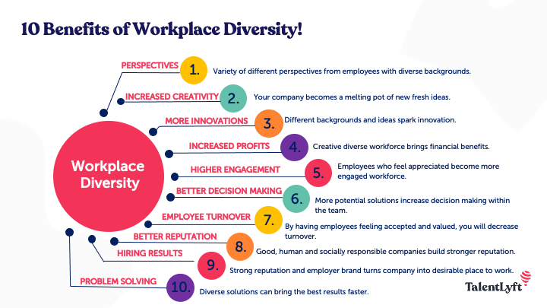
Figure 1:Workplace Diversity
Source: talentlyft.com

Innovation- Companies face unprecedented challenges and an economy that dominates globalisation, the company needs to adopt technological advancement and demographic changes that adopt fast-shifting customer needs. Innovation leads to creative thinking and the same as group thinking which diminishes creativity. According to the European commission's Hi-Res Study, EU countries have more than 100 public and private sector enterprises, across all sizes and sectors that aim to discover workplace practises with high performances and enhance innovation capacity through workplace diversification.
Localisation- Locational diversity emerging as a popular application in extensive computing such as Locationalised diversity helps to resolve personalised services. The global marketplace employs a diverse workforce and it helps to understand the various demographics in the consumer market it serves. Emerging markets around the world are showing significant GDP growth (Karwal and Tandon., 2022). The organisation hires local talent to communicate effectively in the market orientation. The particular individual has deep knowledge about a certain region.
Adaptability- In the modern economy, an organisation should be technologically and culturally adaptable. Reacting to the competitive dynamic the company should stay ahead of the industry trend. Adaptability comes through fostering diversity in creative thinking. The company needs to diversify in pooling a larger talent to hire individuals with diverse skills. At the managerial level, it has been required majorly for the overall success of the company. Practising adaptability helps in responding quickly to changes in a diverse workplace situation.

2.2 The role and Contribution of effective HR Policies right approaches and applying proper techniques to create a diverse work culture.
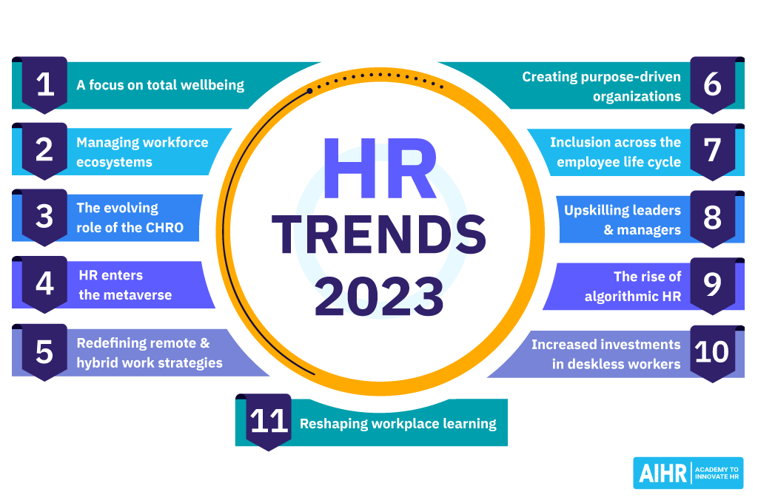
Figure 2: HR's Role in Maintaining Workplace Diversity
Source: aihr.com
Leaders in a Human Resource Position in an Industry build effective Diversity, Equity and Inclusion in the workplace. According to Forbes Human Resource Council, HR follows strategies that manage to achieve diversity in the workplace. During the period of the pandemic, the digitally standardised interview includes authentic diverse teams by asking the same question in the same way to all the candidates while hiring with an unbiased and fair interview (Anwar and Abdullah., 2021). The strategy helps in hiring employees that objectively represent society as a whole. “Cultural add” Vs “Cultural Fit” strategy, where Cultural fit refers to the bias and homogeneous culture. Cultural Add refers to the philosophy that embraces community background and demographics that rear inclusiveness. The difference between the two leads to the development of a more innovative and creative team. Technology can enhance workplace diversity. End-to-end usage of technology in the HRM value chain reduces the scope of biases and prejudices in the workplace. Organisational diversity is the key asset, technology can gather data about workplace behaviour and the effectiveness of the diversity policies can enhance. Diversity and inclusion are necessary to ensure the right voice of the team. According to Glassdoor, 68% of the employees give importance to workplace diversity and 60% of the employees in current organisations want to boost diversity in their workplace.
Managers in an organisation understand the value of workplace diversity and they create and nurture a diverse work team to promote culture. The high potential diverse candidates in an organisation need mentoring, coaching and encouragement by the HR for the growth of diversity in the workplace. From recruitment to pay scale career mobility and financial wellness benefit by addressing the core system that impacts long-term equality and helps to create a more diverse and inclusive workplace (Stahl et al., 2020). As part of HR policy and to maintain diversity, employees need to believe that their voices can be heard and the organisation will never treat them differently. Ensuring the leadership commitment to bring the rewarded but slower and lasting and meaningful change. By avoiding tokenism, the senior leadership team could foster mid-career and high-potential talent and the robust internal pipeline will help in diversifying the future senior leaders. HR should audit their recruitment system. Employees should be treated fairly and not eliminate minority groups. HR should organise Diverse Workplace Programs in the company, so that they may not rely on a small group of people to represent the workplace.

2.3 The ways the HR department promotes innovation and creativity for building diversified work culture.
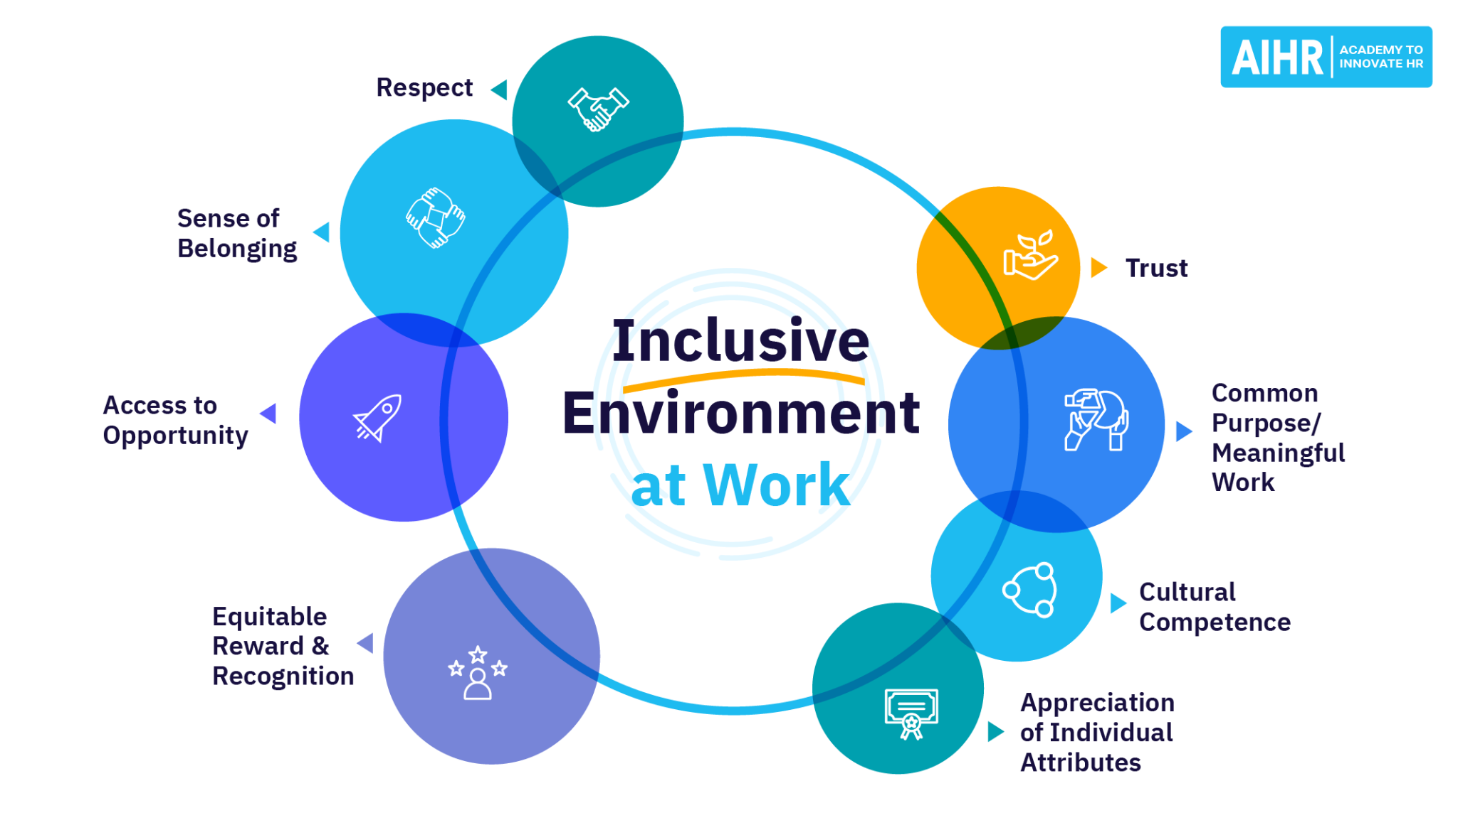
Figure 3: HR promote workplace diversity
Source: aihr.com
HR in the workplace can use technology to enhance creativity and innovation in the discursive workplace. With the help of forums, webinars and social media sites the company gathers ideas for establishing a diverse group that includes company outsiders also. As per IBM research through online communication, the diverse group in an organisation represents more productivity, creating avenues for communication and embracing company policies through social media sites in gathering diverse viewpoints of the employees (Kutieshat and Farmanesh., 2022). Innovation is important in building a robust environment where employees feel safe in taking necessary risks for building a successful organisation. The Boston Consulting Group surveyed 1700 American Firms and gathered results that above and average diversity produces a greater proportion of revenue 45% and the firm with a low-diversity level produces 26% revenue. Another report generated by the Centre of Talent Innovation, Innovative team members share ethnicity with the client and they are 150% more likely to understand the Client’s needs. Cognitive Diversity brings different thinking styles and different people and their thinking abilities. Cognitive thinking is the mix of inherent and acquired diversity. As part of the HR development plan innovation includes major competencies in leadership development. Innovation and leadership are linked directly as Innovation is part of a leader’s responsibility to promote creativity. In the article published by Scientific American in 2014, In “How Diversity Makes Us Smarter”, Katherine W. Philips stated that one cannot buy creativity, Innovation is the key component for the organisation to reward innovative minds and 15% of the companies surveyed with the help of i4cp financial reward are more prone to encourage creativity. As part of HR management, two bi-yearly awards specially for innovation where one idea can be applied for the best innovation idea and another can help in cost reduction in the organisation. Many groundbreaking ideas can be generated from external sources such as partners, software companies, and customers or can be generated from tech trend programs (Do et al., 2022). Innovation is the largest differentiator between high and low-performing organisations. HR always searches for the brightest minds that can create new ideas that give tough competition in the market. Qualcomm Coverage is the internal program that encourages the best performers, especially fresh graduates from different universities around the world with technical talent.

2.4 The essential strategies the HR department should have to work on.
Every organisation encounters challenges in managing the workforce. Nowadays, businesses are more focused on employee experience and company culture, volume and nature of the challenges faced by the HR professionals that are continuously increasing. 2020 is the year that has signed with an enormous challenge to manage efficiently remote and business workforce to keep running it successfully.
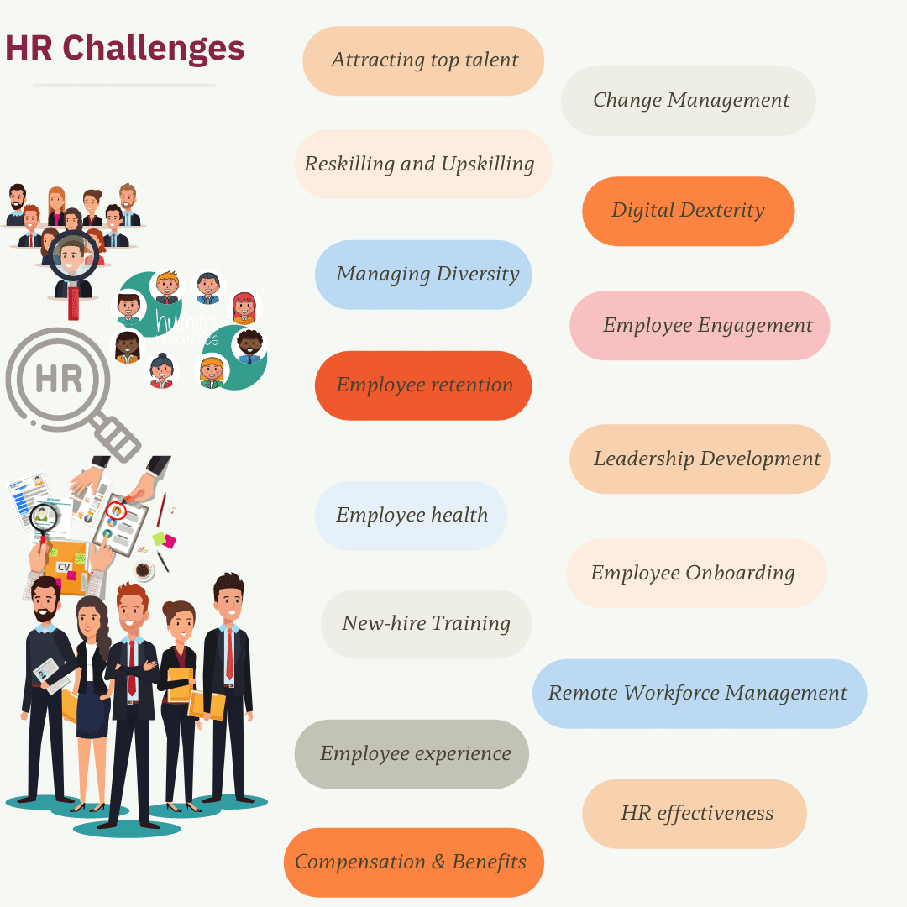
Figure 4: HR Challenges in Workplace Diversity Management
Source: whatfix.com
- Talent Acquisition- To attract the top talent HR should follow companies top priorities as per the competitive nature of the current market. Demographic changes and growing demand for talent required companies to pay higher salaries to attract candidates with compatible skills (Mukhuty, Upadhyay and Rothwell., 2022). Hence, it is the most significant challenge for HR professionals in Workforce management.
Solution- The HR professionals should dig deeper and offer a meaningful experience to their employees with a great sense of purpose. HR should include the employee benefits package to attract talent and to define the employer branding company should include the mission, vision and goals based on the company culture.
- Change Management- Organisational change with long-term plans accounted for the most significant human resource challenge. Organisational change can be structural, economical, geographical, managerial and technological. Sometimes the organisational culture reduces employee morale and job satisfaction. The high attrition rate, especially in the time of Corona, highlights the abilities of the company as well as the HR professionals in handling the challenges.
Solution- Employees should be prior informed about the upcoming changes in the organisation so it helps in employees' decision-making and proves the rationale behind it to the company. HR should consider various scenarios of the business that could affect the business as well as the employees and develop all alternative plans that can minimise the impact (Sharma., 2022). HR should promote adaptability in the workplace which includes communication, relationship building, and problem-solving. Strategic thinking, organisational productivity and teamwork.
Digital Dexterity- Organisations can now upgrade their legacy with the help of digitalisation. Software applications can now easily replace the manual process. The new Cloud technologies drive innovation that increases employee efficiency and productivity. Sometimes digital transformation is handled by specific departments. It can be a burden for the HR department in reskilling, application onboarding, and upscaling training content and courses.
Solution- Overcomminicating and gathering feedback from the employees to understand their diverse needs. The Digital Adoption Program through app guidance is best suited for the employees in managing workflow. Not only employees but also the leaders that bring cultural diversity to the workplace.

2.5 Diversity and Inclusion Strategies.
Workplace Diversity and Inclusion of all ethnicities, backgrounds, and religions and without any gender biases employees feel safe in the modern workplace. Diversity and Inclusion help in retaining the best talent. HR and the talent mongers in various companies believe that the true workplace must embed in the DNA of the company’s core values. Workplace diversity strictly indicates that every employee is unique (Tallman and Bird., 2022). Their skills, characteristics and viewpoints are different and the company should praise them and use them in generating revenue.
- Challenge the Unconscious Bias- Eric Kandel, a famous Nobel award in Neuroscience, stated that the majority of society holds crude assumptions that are not true. Unconscious Bias can be socially seen in female workers. For example, Contrast Bias, Ageism, Gender Bias, Authority Bias and Conformity Bias. This can be seen in the stereotype of people that results in discriminatory practices when people are not treated equally and thus reflects on their behaviour. HR professionals can use the Blendoor app to remove unconscious bias altogether and encourage an excellent workplace inclusion strategy.
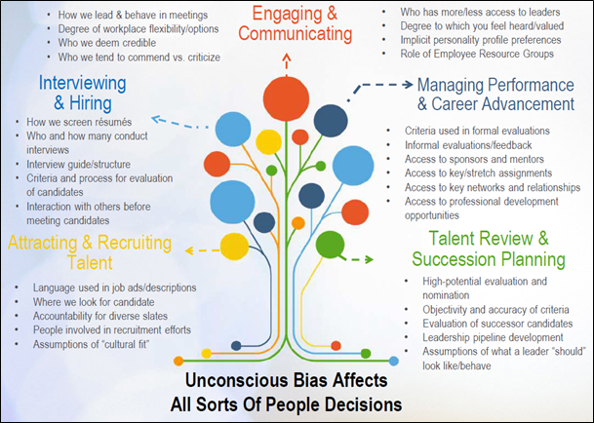
Figure 5: Diversity and Inclusion Strategies

Source: valvemagazine.com
- Inclusive Languages- Tech organisations use word hackers for computer-programmed job descriptions. In the tech industries, 2% of the applicants are female. The more inclusive the language the more female candidates would apply. For example, “Hey Guys” can refer to a male-centric greeting and the company should avoid these acronyms and give more effort to “they” instead of he/she. HR must understand the inclusiveness of using languages so that their word does not marginalise people.
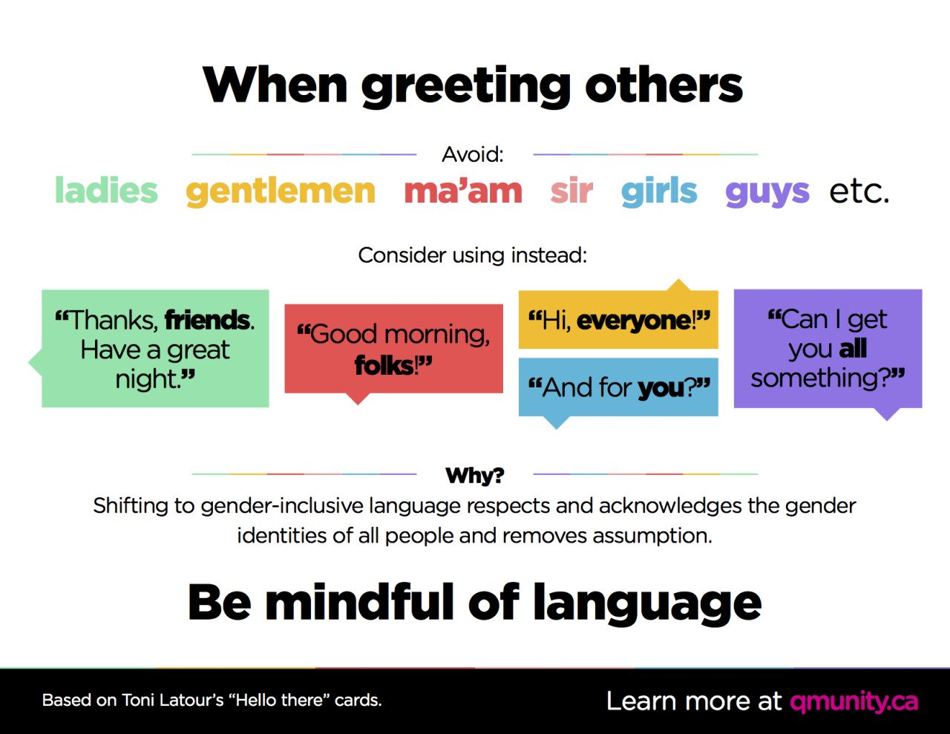
Figure 6: Inclusive Language
Source: buffer.com
- Educating Workplace Diversity to Leadership- Diversity can be limited by the “once-in-a-while” initiatives. The C-level leadership and management should join the workshops to understand the least diverse areas to work that are dominated by males and their role in shaping company value. Diverse responsibilities should be implemented from top to bottom so no conflicts are remaining in decision-making.
- Monitoring Social-Media activities- The company should scan the demographic followers of their company on social media platforms and company websites. According to the renowned Media Specialist, Anil Dash CEO of Glitch, 77% are male and 23% are female and responses have come from followers who can bring novel solutions by readdressing their comments (Kelsey et al., 2022). Companies should be mindful of whose vices they are sharing, amplifying, validating and promoting. Microsoft and GoDaddy are large and renowned companies that believe in activities with the Employee Resource Group that provide opportunities for employees who are in the minority groups and bring chances to share, connect, learn and support one another.

2.6 Recruitment and Selection Practices for a Diverse Workforce.
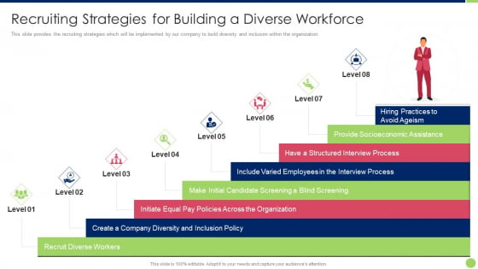
Figure 7: Recruitment and Selection Practices for a Diverse Workforce
Source:slideteam.net
Most companies believe that a Diverse team helps the companies to be more innovative, creative and helps to achieve company goals with a high-profit margin. Diversity recruitment is now becoming the biggest trend and key challenge for Talent Acquisition Professionals or for the Hrs. They should follow the two rules i) Creating a sense of belonging should be the top priority for the organisation and ii) Improving diversity recruitment can start with better company culture. As per the Forbes Survey, Data-Driven recruitment becomes the competitive advantage. Continuous commitment to diversity hiring that focuses on employer branding and candidate expenditures (Abbasi et al., 2022). The talent acquisition professionals nearly 80% believed in diversity hiring and hence it will become a key trend in Industry 4.0 in 2022. According to the biggest recruitment platform GEM integrates with Linkedin, Gmail, Outlook and other ATS platforms surveyed on unconscious bias training, candidate tracking, and reviewing. The company ensures that the HR professionals and the talent acquisition professionals are fair in their recruitment and set the biggest trend for 2022. The survey responded with 65% in talent sourcing, embracing remote and hybrid work 62%, data drive recruitment result in 60%, Soft skill and rethinking role 47% and pay transparency 36%.
Remote work is advantageous for Small Scale organisations. Remote hiring helps to improve the diversity hiring in the organisation which helps to expand the talent pool from different parts of the world. Large organisations follow the formal goals through funnel data and they are more likely to depend on the smaller organisations for recruiting talent. According to the McKinsey and Company report released in 2020, “Diversity Wins: How Inclusion Matters” fostering a diverse team in the company helps to achieve, Better customer representation to understand the customer's ever-changing demands, Radical Innovation through recovery, resilience and reimagination and stronger competitive edge for making such bold decisions (Periera et al., 2023). Companies can craft and audit the job ads by highlighting the employee-inclusive benefits, beware of the specific gender-coded word. Avoid pressuring the candidate about their degree from specific “Ivy”/” Elite” universities and avoid insisting on becoming a native English speaker. HR of the organisations should welcome more and more face faces, perspectives and backgrounds to the company and celebrate diversity as part of employer branding.
2.7 Training and Development for a Diverse Workforce.

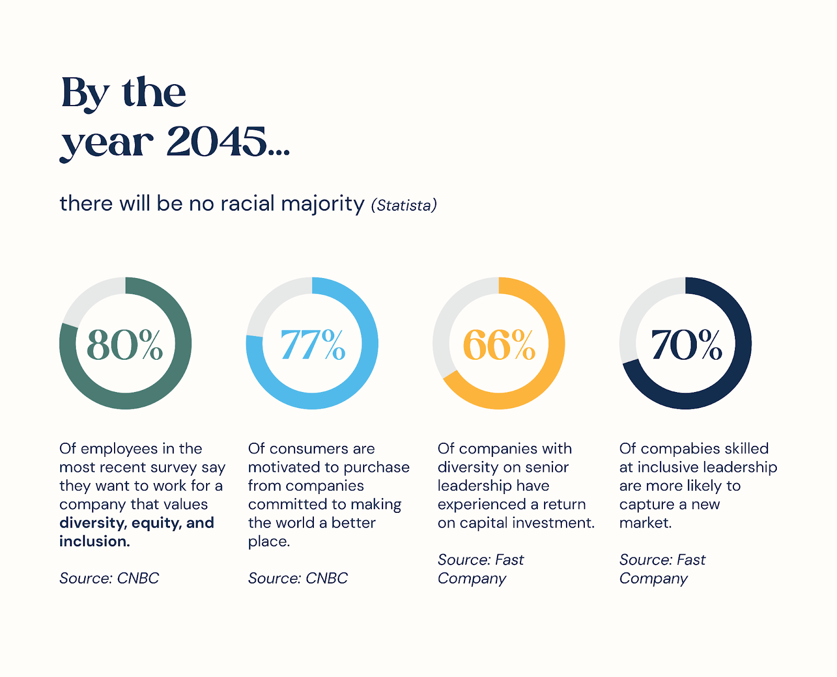
Figure 8: Training and Development for a Diverse Workforce goal by 2045
Source: livinghr.com
Conducting diversity training in the workplace retains employees with the tools and resources that help them to respect one another while accepting different cultures. Training gives employees a better perspective on workplace culture. According to a study conducted by the World Economic Forum in 2022, 76% of Business firms include diverse and decision-making teams to excel in their financial target and the study also reveals that 45% of the business firms on average scored higher rank in diversity and generate revenue through innovation. For Instance, L'oreal is a giant cosmetic company leading the market with impressive success with a multicultural product development team. A diverse team with multiple perspectives, and personalities can help in upgrading the overall company performance.
In another survey conducted by Deloitte, 82% of millennials appreciate higher engagement levels and distinct perspectives and characteristics among the workforce. Diversity in the workplace encourages employees to feel more productive and valued and leads to greater job satisfaction and higher employee retention (Doghan, Bhatti and Juhari., 2019). White paper (CIPD Website) found a direct link between decision-making and workplace diversity so that every employee can participate to outperform individual decision-makers. Each member of the organisation has unique ideas and a knowledge base that helps the company in generating ROI. Not only human training but also the implementation of the Connecteam, Insperity, BuddyPunch and JustWork are the employee scheduling software that can replace Human Resource Management to ensure the duties and responsibilities of the employees. The Bottom Line strategies of this software are Reduce Turnover and Higher Employee Engagement by managing employee attendance, improving communication and productivity, meeting clients' deadlines and ensuring compliance requirements in managing employee performance (Bennett et al., 2022). Fostering a culture of Open and Honest dialogue can foster an environment that is heard and welcomed by all companies. So that people can bring their work experiences to the table helps in brainstorming new ideas and the company can also include outsiders or the online review of the customer to increase productivity to solve problems.
2.8 Performance Management and Evaluation in a Diverse Workforce.
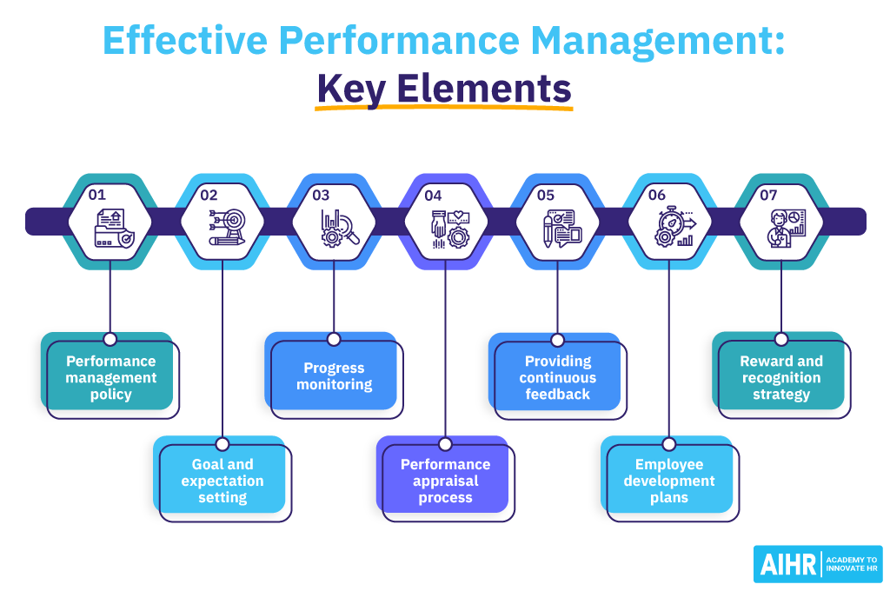
Figure 9: Performance Management and Evaluation in a Diverse Workforce
Source: aihr.com
Decision-makers and HR must understand that the diverse pool of people is established with cross-functional and global teams that learn to grasp these enriching skills in the best possible way in a business (Claus., 2019).
- Understanding Diversity- The company should analyse and optimise individual strength and establish a neutral environment without any class, gender or race. The employees should feel valued and supported by the upper management to outperform without being judged and fear rejection.
- Establish trust in Leadership- In the ongoing Paternalistic Leadership style, the company should set rules to conduct non-discriminatory actions and manage employee behavioural protocols (Ely and Thomas., 2020). The company should build a culture to trust so the employees can trust the leaders and become a successful part of the firm in generating profits.
- Customise Performance Review- Companies should monthly release the employee weakness and strengths by assigning the key responsibility areas of the employees. The customised and empathetic work reviews from the management feel motivated and supported enough in providing their best performance in a diverse set of people.
- Equal Opportunity- In the Federal Government employment refers to non-discrimination based regardless of their abilities and background or lifestyle. Workplace Diversity can be maintained only by nurturing, training and helping employees to develop their skills and talents to avoid legal issues such as bullying, harassment and discrimination.

2.9 Human niche theory association with Diverse and inclusive approaches in the Workplace
According to the human niche hypothesis, human gene-culture coevolution is expected to take place after a genetically selected context achieves sufficient stability through a number of generations for the process of natural selection to operate on the diversity of human genes. According to the research study done by the authors Blom, Kazeroony and Du Plessis, (2019), the human niche theory and the economic theory, are considered to be some of the most efficient frameworks for evaluating how the leaders and managers within an organisation interact with one another and can further provide a scientific understanding of the psychology, that works behind it. According to this theory, the way human resources and leaders generate overall social space and provide access to necessary resources, as well as determine the overall characteristics of different forms of organisational relationships, improves the organisation's approach to diversity and creates an overall strength to abide by organisational changes (Blom, Kazeroony and Du Plessis, 2019). One of the most significant responsibilities that a human resource must ensure is to increase the level of interaction across the organisation, as this according to the Niche theory can increase employees' capability of becoming highly resistant to challenges and can also fuel diverse cultures across the organisation.
Thus, based on the perspectives and findings offered by various authors surrounding this theory, a more humane strategy has been suggested to broadly enhance the comprehension of this framework within the organisation, to increase overall commitment while management faces challenges centred on managing social variation and when the transformation is initiated (Singh et al., 2021). It can be assumed that such a strategy would be multifaceted, making it critical for organisational managers to easily know and grasp the various attitudes of its personnel, that vary from one individual to the next. These strategies are expected to provide a platform for inclusiveness as well as improved meaning and significance surrounding the overall organisation.

2.10 Workplace diversification and firm performance both mediated by HR practices
According to an overview of the above structure and analysis, it is now clear that human resource management plays one of the most significant roles in meditating diversification of an organisation and is also responsible to ensure improvement across different organisational performances. Each of these responsibilities is found to come up with different forms of challenges, based on the situation. According to the observations of the author Lee and Kim, (2020), the current composition of an organisation is becoming increasingly diverse as a result of the workforce coming from different cultures or due to wide ranges of changes among employees' working styles and perspectives. Hence in such circumstances, the requirement of evaluating how the organisation would perform using workforce diversity becomes essential. The authors viewed multisource feedback and structural empowerment as the two critical forms of HRM practices that can influence the effectiveness of a firm's performance as well as increase relational coordination (Lee and Kim, 2020). Multi-source feedback is an HRM approach, which can be practised across the organisation to regularise the method of giving feedback to employees, on their progress, performance or development requirements.
The multi-source feedback system is also called the 360-degree feedback process, which aims to provide a 360-degree view of the current progress of employees and provide feedback on its feedback to encourage further improvement (Ashworth, De Champlain and Kain, 2021). Furthermore, this form of feedback may improve workplace interaction and encourage employees to comprehend the dynamics associated with working with distinct colleagues and alter their behaviours to minimise inconsistencies among perceptions of oneself and their assessment of others. Structured empowerment, on the other hand, refers to the capacity to mobilise resources and achieve goals via access to knowledge, support, assets, and opportunity. It is important in developing particular social workplace circumstances and regulations at places of employment that allow employees to gain similar chances, regardless of their cultural differences (Oonk, 2022). Structural empowerment provides access to opportunities, information, support, and resources and creates chances for learning and development of the workforce including possession of difficult work, new skills and information and professional advancement among members, all of which encourage organisational diversity.

2.12 Theoretical Framework
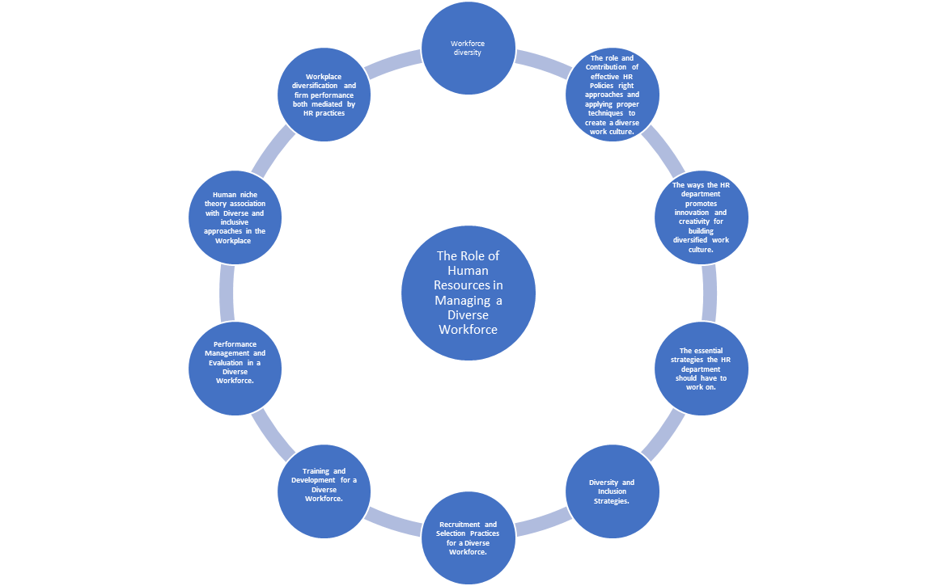
Figure 10: Literature review framework
Source: Self-made
HR plays the most vital roles in the organisation, which include recruitment, policy development, prompting of innovation and creativity, training and development, talent acquisition, strategic implementation, problem-solving, performance management and many more. From the overall analysis, it can be said that when it comes to policy making, the HRM plays a significant role, in developing policies concerning diversity, in order to ensure providing of equal opportunities and value to each member of the organisation to successfully create a sense of equality and to avoid complications (Oubrich et al., 2021). HRM also plays a significant role in introducing innovation across organisations, because the more innovative the organisation will be, the more flexible and interactive, the workforce will become, which as a result will increase overall understanding and bonding. Also during the recruitment process, HR implements different strategies to hire those specific individuals who have the ability to work with people coming from diverse cultures and can collaborate with each other to meet organisational goals, which again aligns HRM strategies towards increasing organisational diversity. On the other hand, training and development help HRM to prepare, each member individually to perform through different challenges and to address issues relating to cultural diversity all by themself and helps in increasing overall team working skills and spirits among diverse groups. HRM also plays a significant role in managing performance and complications, through which it is ensured that every concern relating to cultural diversity is met and individual strengths and performances are managed upon establishing a neural environment overcoming every form of cultural differences with increased trust and dependencies among members to enhance overall diverse performance.

2.13 Literature gap
The chapter on literature review has been completed with significant effort, although specific gaps have been viewed in this study. One of the major gaps that were found in this chapter was the lack of evidential-based data (Jia et al., 2020). It has been viewed that strategies of HR, for managing organisational diversity, are not always the same as HR across different areas implements numerous strategies to encourage organisational diversity. Such factors and evidence were not highlighted in this study, which resulted in a gap in evaluating different forms of approaches, additionally, because the number of reliable articles was low and lacked transparency, only a few articles and studies have been analysed in this chapter. Hence, this study will be discussing all those areas that have been left out by the earlier researchers or lacked relevance due to lack of transparency or biases.

Chapter 3: Research Methodology

3.1 Research Methodology
Research methodology refers to the structured process researchers follow to conduct the study. Research methodology guides researchers in the entire research lifecycle from formulation of research aims and questions to data interpretation. An effective research methodology assists researchers in choosing the right data collection channel, and sampling method. It helps researchers in optimising their resources and efforts.

3.2 Research design
Research design is one of the most vital elements of research methodology. A research design is attributed to the comprehensive plan of research. It includes all assumptions and decisions regarding research methods, sample selection, data interpretation techniques, and so on. It greatly helps researchers to define the research scope and detect variables of interest. It assists researchers in identifying all research variables (Bae, Park, and Jeon, 2022). The most common research designs are exploratory, explanatory, and descriptive research designs. A descriptive research design is used to describe or summarise a phenomenon. In descriptive design, researchers do not manipulate any variables and study only existing variables. This design herpes assesses the frequency along with the distribution of variables to get a better understanding of the topic. On the other hand, exploratory design explores new insights into the research topic. It is mostly used when little knowledge of the topic is available. The sample selection in this type of research design is convenience-based and not representative of the whole population.
The researcher has integrated an explanatory research design. The researcher has selected this design because it is far more flexible than exploratory and descriptive designs.
It allows researchers to modify their method and explore unexpected events while the research is ongoing. The researcher has intentionally included an independent variable to measure its impact on other dependent variables (Brittain, et al., 2020). Using an explanatory design has given the researcher full control over all the extraneous variables and minimises their impact. Explanatory design can be of two types, it is either non-experimental design or experimental design. Here, the researcher has used randomised control trials which is an experimental design. The explanatory research design has enabled the researcher to establish cause-and-effect relationships between them and make the right predictions on the topic. Using an explanatory research design has helped the researcher to include social and economic factors influencing the topic. By setting a temporal order, and describing a correlation this design has helped in inferring causality.

3.3 Data analysis
Data analysis is one of the most critical parts of research methodology. Without proper data analysis, researchers cannot make meaningful conclusions or refute hypotheses. There are various types of data analysis techniques like thematic analysis, inferential statistics, descriptive analysis and many more. Here, the researcher has implemented an empirical analysis. This is a scientific approach that depends on observations and experiments to gather information (Rupra, 2020). This is very helpful in analysing primary data. The rigorous analysis techniques in the empirical analysis have resulted in robust results. By using empirical analysis, the researchers have been significantly helped in identifying anomalies as well as outliers in the data. These outliers often represent extreme values that prevent researchers from getting the expected results. Using empirical analysis, the researcher has tested the assumption of theoretical models with collected empirical data. This has helped the researcher to evaluate the precision and applicability of models. To critically analyse the data and identify correlations, the researcher has used different data visualisation tools also.

3.4 Research Philosophy
Research philosophy is attributed to a set of values and beliefs that structure the approach of researchers to conducting research. The worldview of the researcher and the view of researchers on the topic are reflected in the philosophy. The research findings' interpretation is also greatly influenced by the research philosophy. Different philosophical approaches result in different data interpretations and phenomena. Here, researchers need to be conscious of their assumptions as well as biases to make a rigorous analysis of the research findings (Sobočan, Bertotti, and Strom-Gottfried, 2019). There are generally three types of research philosophies used in academic studies such as ontology, axiology, and epistemology. In this, the ontology philosophical branch mainly deals with the nature of existence and categories that constitute the understanding of the whole world. The ontological approaches are further divided into two branches: Objectivism and constructivism. Ontology philosophy is best applied for research on cutting-edge technologies, environmental issues, and so on. On the other hand, the axiological branch of philology is highly concerned with values, research ethics, and aesthetics. This philosophy recommends researchers to lower their personal beliefs in research to guarantee impartiality in data analysis.
The researcher has employed an epistemology research philosophy. Epistemology is concerned with knowledge and how it is obtained. There are three branches in epistemology: positivism, interpretivism, and realism. The researcher has implemented a positivist approach. Because this is aligned with qualitative research. Positivism has encouraged the researcher to use scientific methods. Positivism philosophy has helped the researcher in identifying potential bias along with limitations in his research approaches. This has facilitated the research’s replicability and allowed the researcher to test the existing theories and results effectively (Shahzad, et al., 2021). The standardised data collection methods in positivism have helped the researcher to analyse datasets with optimal efficiency. Positivism has helped the researcher too. Besides this, the use of empirical evidence in a positivist approach has assisted the researcher to provide deep practical insights on the topic and do informed decision-making during the research. The cumulative knowledge along with cross-validations gained from the positivism philosophy has increased the internal validity of the research.

3.5 Research strategy
Research strategy depicts the comprehensive plan adopted by researchers to obtain research objectives. A suitable strategy guides researchers’ decisions. There are several types of research strategies such as case studies, focus groups, experimental research, mixed methods and so on (Al Harahsheh, and Pius, 2020). Among these, the researcher has used a survey research strategy. the researcher has gathered information on participants' opinions, attitudes, and preferences.

3.6 Research approach
The research approach has greater significance in the research. A research approach refers to the structured method utilised to investigate a specific topic. It provides researchers with a strong framework to gather data, analyse information and draw conclusions. Providing a precise roadmap, it brings great clarity to research and assists researchers to meet all research objectives. Thus, it helps researchers to complete research within limited resources. There are typically three types of research approaches such as inductive, deductive, and abductive (Irfan, Javeda, and Bhatti, 2022). An inductive approach starts with particular observations and then develops border theories on the observations. This is mostly applied when the researchers are tapping into unexplored study areas and have limited resources and aim to develop new theories. Whereas, the abductive approach is a kind of reasoning process lying between inductive and abductive approaches. The abductive approach goes perfectly with exploratory research where the main aim is to develop new insights.
In this research, a deductive approach is implemented by the researcher. The researcher has chosen this approach particularly as it goes most perfectly with primary research. In this, the researcher has used top-down methods to test hypotheses based on empirical evidence. The creative reasoning in the top-down approach also helped the researcher to solve complex phenomena that arise during the research. The steps that the researcher has followed in this approach are theory development, hypothesis formulation, research design, data collection, data analysis, and theory evaluation (Abu-Alhaija, 2019). The deductive approach has inspired the researcher to use statistical analysis along with rigorous methods to enhance the generalizability of the findings. In data collection, there was some incomplete information too. In this, the deductive approach has enabled the researcher not only to propose explanations on incomplete information but also to refine them, via further investigations. But, due to using a deductive approach, the researchers were not able to capture some contextual nuances. This is a limitation of the approach.

3.7 Data collection
As per academic experts, data collection is probably the most important part of research methodology. If the sources are not accurate or relevant, then the research results would be of no use. There are mainly two types of data collection methods. One is primary and the other one is secondary data collection methods. In the secondary method, data is collected through articles, journals, and websites. But there were not sufficient sources which were providing up-to-date on how Human resource professionals maintain diversity at the workplace (Zaman, and Toksoy, 2019). Moreover, often in secondary data collection, the researcher does not have control over the quality of data, as researchers have no idea the primary research from which data is taken has sampling bias, systematic errors or not. Thus, to go deep and evaluate the real section of the topic, the researcher has chosen primary data collection.
The researcher has chosen online survey questionnaires to collect primary data. The researcher has chosen a survey questionnaire over other methods like face-to-face interviews. The main reason is in interviews, often people in fear of repercussions do not give answers honestly, but in surveys offer a stronger sense of privacy and thus participants mostly give honest answers. Another reason is unlike interviews, online surveys can be conducted with a large population with much less time and effort. Moreover, in surveys, all participants answered the same set of questions (Cascio, Weiss, and Racine, 2021). This has made it easier for the researcher to compare the responses and do In a survey, the data comes in a much more structured format helping the researcher in doing statistical interpretation of the data more effectively like identifying trends, and patterns.The researcher has prepared a set of 25 questions. These questions are designed in a way that will reflect the best practices, and techniques today's HR professionals use to create and maintain a diverse workplace. The researcher sent the questions to the participants' official email IDs. The percentage of male participants was slightly higher than female participants. This was completely unintentional (Park, Konge, and Artino, 2020). All participants were aged between 28 to above 55 years old and worked in different levels of organisations. The researcher found the questionnaire by using explanatory research design. To make comprehensive research, the researcher has included participants from different minority and ethnic communities.

3.8 Sampling methods
Sampling methods is another crucial element in research methodology. Research sampling refers to the process in which a subset of participants from a larger dataset is selected. An appropriate sampling method ensures the research results represent the entire population. Without a representative sample, researchers cannot make precise inferences which leads to inaccurate conclusions. There are generally two types of sampling methods: probability and nonprobability sampling. In no-random sampling, participants are selected based on non-random criteria and every participant does not have an equal chance of being selected as a sample. This sometimes causes sampling bias also. Hence, the researcher has used a probability-sampling technique (Brown, Spiro, and Quinton, 2020). There are four types of probability sampling: simple random, systematic, stratified, and cluster sampling. Among these, the researcher has integrated a simple random sampling. Because it is easier to understand and implement than other probability sampling methods. Moreover, without any need for extensive sampling frames, it is also far more time-efficient also It does not need any complex calculations and knowledge about the sample. The researcher has clearly defined the population in this case all participants are from the HR department or working in any department in multinational companies. Then the researcher determined the size. In this, he made sure the sample is large enough to represent the population (Pearse, 2019). Then, the researcher allocated a unique number to each member and selected a set of numbers randomly. The main benefit of using simple random sampling is that by minimising selection bias it always leads to unbiased results. In this the characteristics of the sample can be easily extrapolated. This has helped the researcher to make accurate statistical inferences. The transparency in random sampling has increased the reliability of the research to a great extent.

3.9 Ethical considerations
Research ethics refers to ideology and guidelines that control the ethical conduct of the research. This includes the application of principles along with values to guarantee the protection of human rights and sensitive information. Compliment with research ethics makes research credible enough for future use. Being primary research the importance of research ethics in this research is much higher. The researcher has followed the UWTSD research ethics & integrity code of practices. The researcher has not taken my personal information from participants without their consent (Hesse, et al., 2019). By taking informed consent, the research has ensured all participants were fully aware of the research topic, its possible benefits, and risks. To avoid anonymity issues, the researcher has not taken any personal sensitive information of participants such as personal addresses, email addresses, or postcode. The researcher has not forced anyone to take part in the research. There were some questions that participants tried to avoid. The researcher has not pressurised them to give all answers. To get authentic data, the researcher has incorporated only credible participants who have not been involved in any illegal activities. The researcher has not included any vulnerable population like children or people with cognitive impairment in this research (Pearse, 2019). The researcher has also made sure that he has no dependent relationship with any participant.

The research has made sure of complete fairness and while selecting participants ensures no discrimination based on caste, colour or creed. The researcher has not used any animals in this research and deception procedures. The researcher has emphasised promoting social good through this research. The researcher has reported all data, results, and procedures honestly. All the methods, analyses, and materials used in this research are disclosed with transparency. The researcher has not violated any intellectual property like copyright or patents. The researcher has acknowledged the contribution of his peers in this research (Tiidenberg, 2020). The researcher has focussed on avoiding bias in data analysis, peer review, and expert testimony. The researcher has not fabricated or falsified any data. The researcher has ensured his own perception and opinions have not influenced research findings. The researcher has not made any misleading questions that can result in biassed answers. The researcher has made all steps forward and open-ended questions.

It is ensured that the study results will not cause any physical, psychological or financial harm to any participants. The researcher has given the maximum emphasis on keeping the collected data safe and secure and has not transferred data to any organisation. Finally all the ethical approval from relevant institutions, i.e. the University, were taken before initiating data collection in this study. The researcher has disclosed conflicts of interest such as financial conflicts or conflicts with the publisher that may impact the integrity of the research. On top of that, the researcher has ensured the research findings are not influenced by any external organisation.

3.10 Reliability and validity criteria of a research
Test-reliability
The instruments used by the researcher in this study have provided consistent results over time (Proudfoot, 2022). When the instruments are on the same participants for several occasions, it has resulted in similar results each time.
Inter consistent
It depicts to which extent questions within the study are consistent with each other. There is very much consistency in research questions and there are some follow-up questions too.
Validity
Content validity
It evaluates whether the instruments used in the study cover the entire range of the topic or not. Here, the researcher has put his best efforts to include as many aspects of the topic as possible within time and coital restrictions.
Face validity
It examines whether the researcher has achieved what it was intended to. The researcher here has met all researchers, has answered all research questions, and met research objectives successfully.

3.11 Inclusion and exclusion criteria of Research
The inclusion criteria
Relevances of the topic
The research has directly addressed the role of HR management in maintaining diversity at the workplace. It has explored all HR strategies and policies associated with diversity and inclusion. For instance, It has examined the diversity training programs implemented by organisations.
Research design
Rigorous research methods have been employed to make sure the research findings are valid enough for future use (Asenahabi, 2019). With qualitative studies like surveys, the researcher has examined the relationships between the diversity practices of the HR department with employee engagement with the help of empirical analysis.
Concentration on diversity
The research has examined workplace diversity considering several dimensions like race, gender, age, disability, sexual orientation and many more. It has investigated the incorporation of inclusive HR policies supporting gender equality in top leadership positions.
Organisational context
The scenario of diversity in an organisation may vary significantly depending on the type of organisation. Thus, the researcher has taken participants working in private organisations, public institutions, and NGOs and that also access several industries (Koskey, et al.,2023). This has enabled the evaluation of the broader picture of the HR role in managing diversity.
Exclusion criterias
Irrelevant topics
The researcher has not made the study vague by incorporating aspects that have absolutely no with managing diversity by the HR department.
Non-empirical sources
The researchers have not used any sources that are based on personal opinions like editorials, commentaries or other materials.
Sample size
The researcher has not taken a very small sample size which can restrict the generalizability of the research findings.
Duplication of research
The researcher has excluded students that have not been published but, in the research, to avoid duplications of data.

Chapter 4: Empirical research analysis

In this chapter, the results of the survey will be interpreted in the form of a pie chart symbolising the opinions of the research participants on experiencing any incidents of inclusion and diversity at their workplace and also their opinion on HR initiatives in maintaining diversity and inclusion in the workplace. The demographic distribution of the research participants will also be highlighted through a pie chart. This chapter will help in interpreting the overall experience of inclusion and diversity followed by a empirical research discussions

4.1 Survey findings
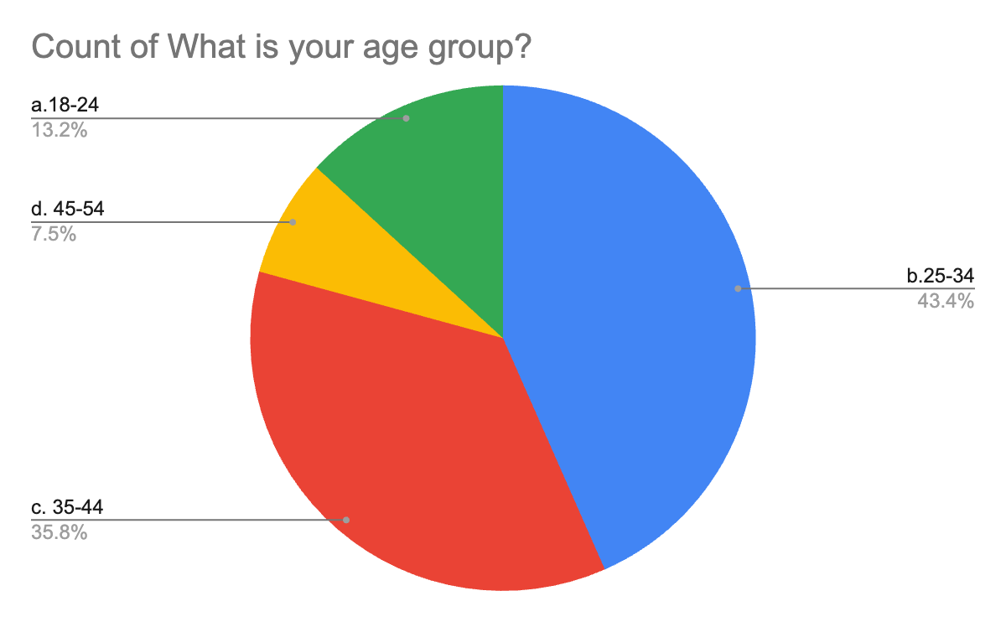
Figure 11: The age distribution of the research participants represented in the pie chart

The above-mentioned pie chart highlighted the age group of the research participants. The age groups of the participants were further classified into 18-24 years, 25-34 years, 35-44 years, 45-54 years, and above 55 years. As the pie chart shows, it is evident to notice that the majority of the respondents (43.4%) are between the 25-34 age group, while 35.8% come under the 35-44 age group. The third majority of participants are in the 18-24 age group which possess around 13.2% of the participants. The age group of 45-54 come with the lowest number of participants at 7.5%.

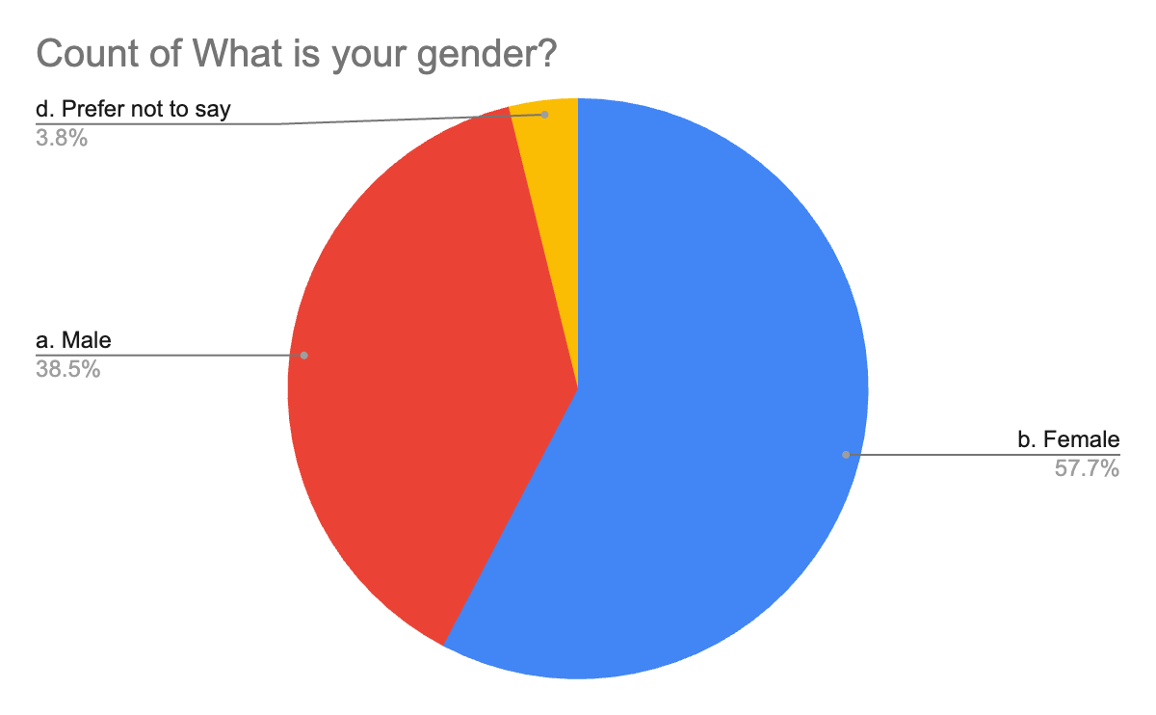
Figure 12: The gender classification of the research participants

The above-mentioned pie chart highlighted the gender classification of the research participants whose responses were considered as the source of primary data. From the pie chart, it can be seen that the majority of participants (57.7%) were females while 38.5% of the participants have been identified as males in the survey. However, there were no research participants that fall under the category of Non-binary. Most of the research participants have been seen to be open in expressing their genders, however, a few of them preferred not to mention their genders.

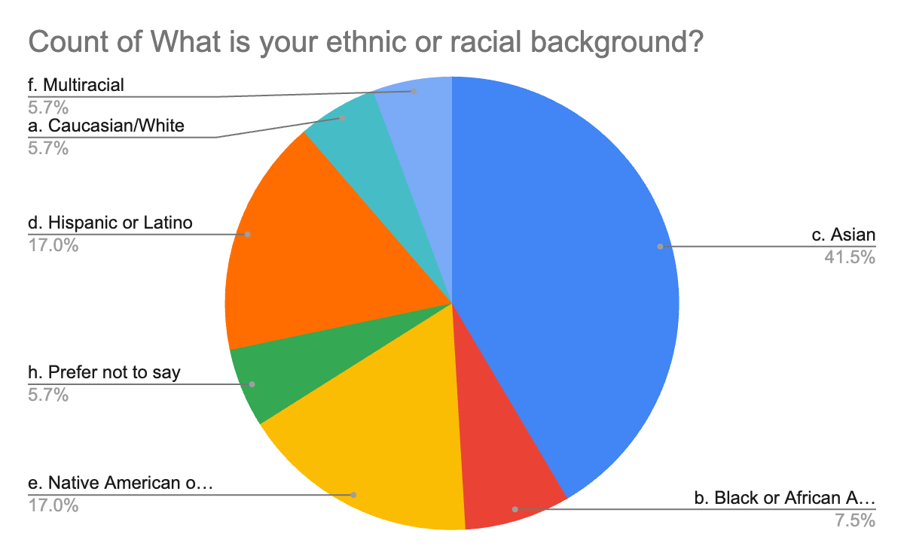
Figure 13: Classification of research participants based on ethnic and racial background.

The above-mentioned pie chart highlighted the ethical or racial-based classification of the research participants included in the survey. The major classification of the ethnic or racial background as highlighted in the pie chart is Asian, Caucasian or White, Black or African, Latino, Native American or Indigenous, and Multiracial. Asians dominated among the participants who joined in the survey with the numbers showing around 41.5% of the participants came from Asian backgrounds. The second to Asians in the participants are Native American or indigenous people who stand at 17%. While surprisingly, 17% of the participants were Hispanic or Latino, being at 17% also makes them place second in terms of the ethical background of the participants for this survey. All of the research participants have their individual experiences of facing any cultural differences within the work culture of their organisations.

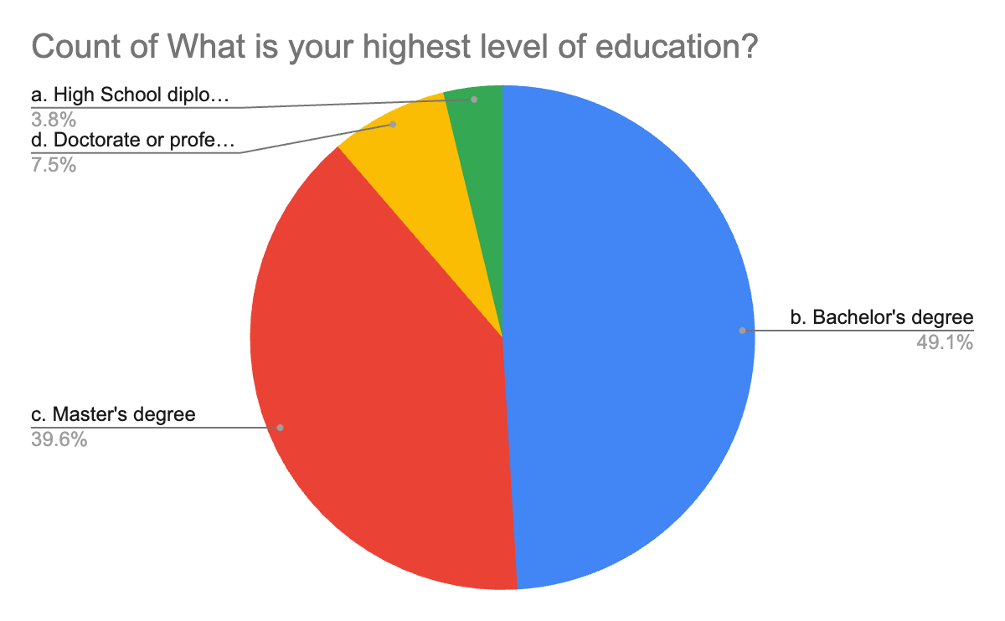
Figure 14: Classification of the research participants based on their educational qualifications

The above-mentioned pie chart highlighted the classification of the research participants based on the segmentation of their educational qualifications. The educational qualifications were distributed into High school or diploma, Bachelor's degree, Master's degree, and Doctorate degree. The majority of the research participants are seen to be qualified with Bachelor's degrees which sum up to approximately 49.1%. About 39.6% of the participants said that they have done their Master's degree. The remaining 7.5% of the participants have acquired any sort of doctorate degree or professional degree. In the UK, there were severe gender differences in pursuing higher education (Office for National Statistics, 2021). According to England & Wales, England possesses more percentage (33.9%) of people pursuing doctorate degrees than that of Wales(18.1%).

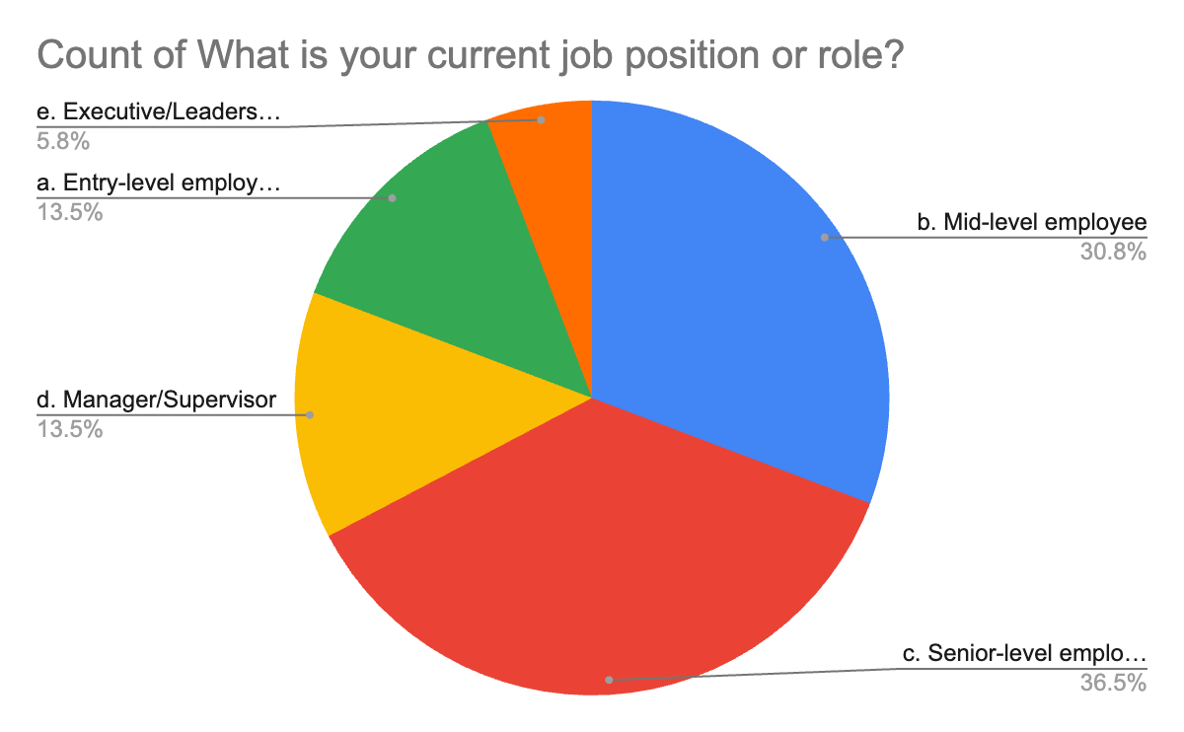
Figure 15: Classification of the research participant based on their current job positions in organisations

The classification of the research respondents based on their current job roles has been highlighted in the pie chart. The job postings mentioned in the pie chart has been segmented further into Entry-level position, Mid-level position, Senior-level position, Manager or Supervisor, and Executive or Leadership position. As the pie chart shows, 36.5% of the research participants have been identified as working in a senior-level position and some of them even have a say in the decision-making process of their respective organisations. Around 30.8% of the research participants fall under the active job role of mid-level employees. Both entry-level employee positions and manager/supervisor positions share 13.5% of the total respondents. Most of the respondents had a lot of say in the business decisions of their organisations. Remaining them actively working in executives or leadership positions.
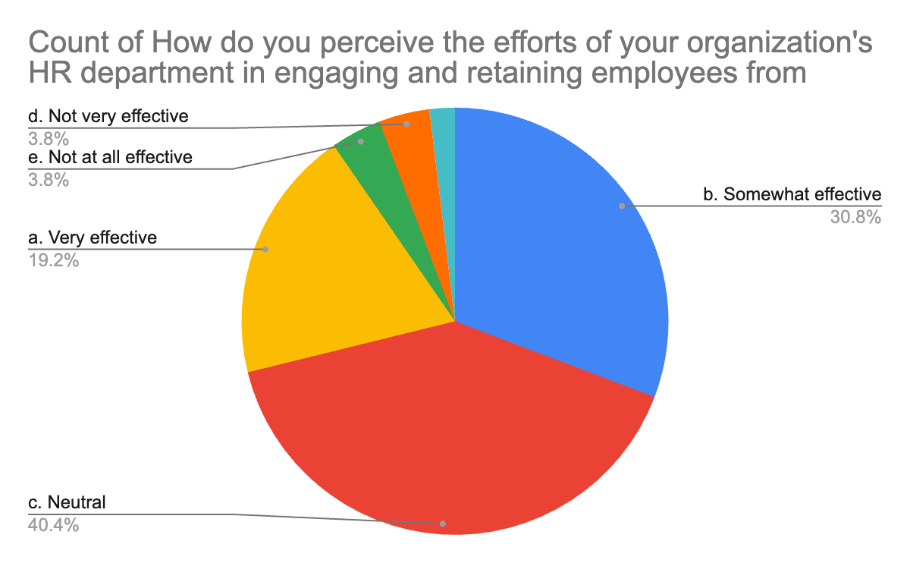
Figure 16: Statistical representation of the opinion of research participants in recognising the role of the HR department in retaining and engaging employees from different cultural backgrounds.

The above-mentioned pie chart highlighted the statistical representation of the participants' opinions and experiences on recognising the efforts of the HR department in their respective organisations to retain and engage with employees from different cultural backgrounds. The reader can check the questionnaires in the appendix. From the pie chart, it is evident that a larger number of participants (40.4%) chose the role of HRs as neutral on the above statement. While only 30.8% of them believe that the engagement of the HR within their workplace has worked somewhat to a certain extent in improving employee retention, particularly in managing employees from different cultural backgrounds. A number of 19.2% of the respondents feel that the efforts of the HR department have been highly effective in engaging and retaining employees from diverse backgrounds. There are only a few numbers of participants who do not see HR as being much effective in their role.
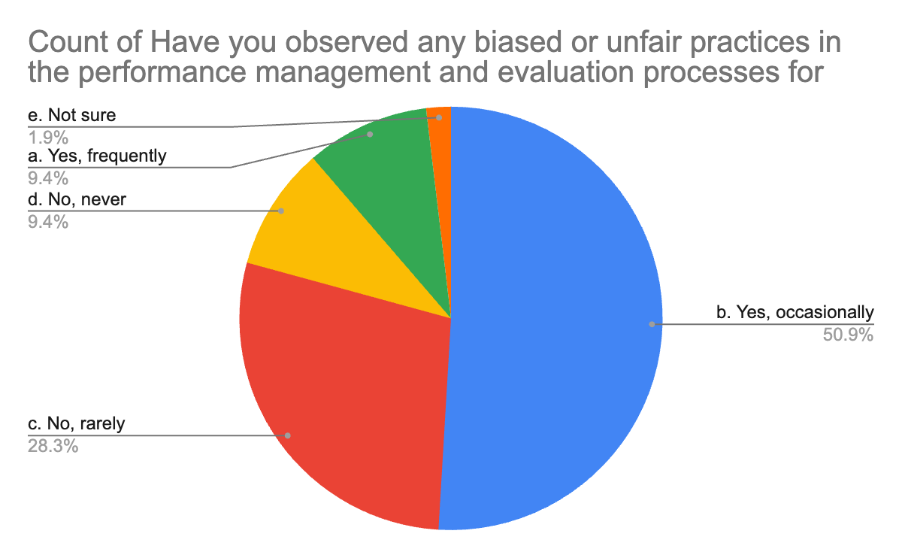
Figure 17: Statistical representation of the opinions of the research participants on experiencing biases and unfair practices on performance evaluation of employees of different cultures

The above-mentioned pie chart highlighted that 50.9% of the research participants have experienced unfair means in their organisations occasionally because of them deriving from different cultural backgrounds. Due to the increased non-acceptance of different cultures at the workplace majority of the research participants have at least faced more than one incident of biases and unfair practices over a year. While around one-third of them have rarely seen any unfair means from HR in performance evaluation. HR has played a significant role in reducing the unfair means or biases in performance analysis of a diverse workforce such that some of the research participants have rarely faced such incidents. 28.3% of them have opined of not experiencing any such means in their workplace. However, 9.4% of the participants have said to frequently observe any bias or unfair practices, surprisingly, similar 9.4% of the participants also stated that they have never experienced anything such as this.

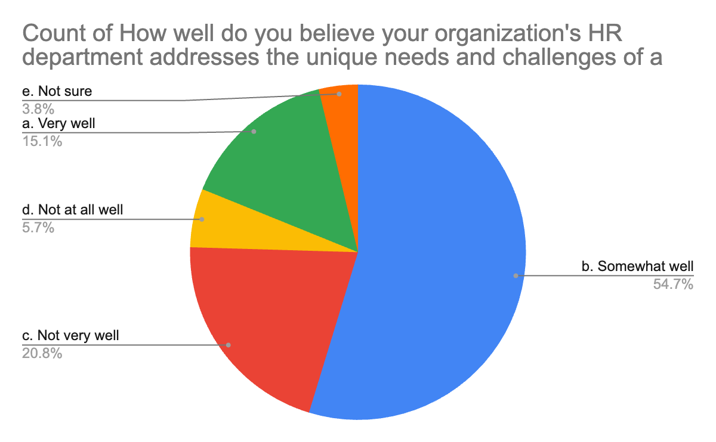
Figure 18: Statistical representation of the opinions of the research participants on the HR departments to address the needs and challenges of diverse employees in Training & Development

In this question, the opinions of the participants have been based on efforts of the HR department to foster the needs and challenges of a diverse workforce while providing Training and Development. In this case, 54.7% of the research participants opined somewhat well on the influence of HR in mitigating the challenges in training and development programs. 20.8% of them responded not very well to the above statement while 15.1% of them believed very well in the contribution of the HR department in fulfilling the unique needs of a diverse workforce.
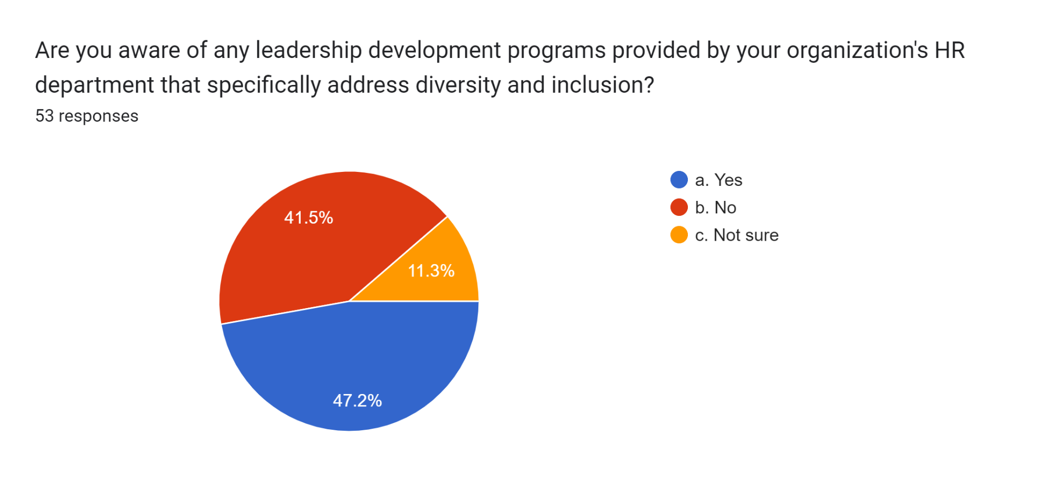
Figure 19: The statistical representation of the opinions of research participants to be aware of any leadership development program to be undertaken for addressing diversity and inclusion within their workplace.

The above-mentioned pie chart highlighted the pictorial representation of the responses based on any implementation of leadership programs for addressing the issue of cultural diversity and inclusion. While responding to that, 47.2% have given a positive response in the implementation of such leadership programs at their workplace. On the other hand, 41.5% of them responded that they were not aware of any such program that has been implemented in their workplace. 11.3% of them responded as not sure while answering the above statement.

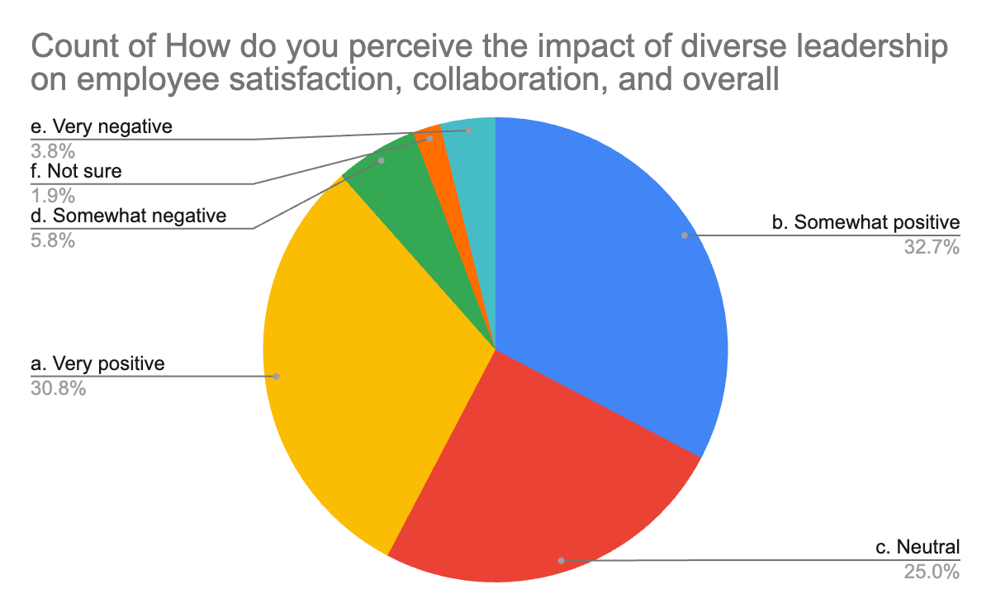
Figure 20: Statistical representation of the research participant's responses on the impact of diverse leadership on employee satisfaction, collaboration, and overall team performance.

In correlation with this survey question, the participants' responses have been statistically portrayed in the pie chart. The pie chart highlighted 32.7% of the participants responding somewhat positively while answering on the impact of diverse leadership on employee satisfaction as well as team collaboration and performance. 30.8% of them firmly believed that diverse leadership positively impacts team performance with increased employee satisfaction and collaboration. While 25% of them have opined neutral on the impact of diverse leadership encouraging employee satisfaction and overall performance. Only a few of the respondents have opined somewhat negatively while responding to the above statement.
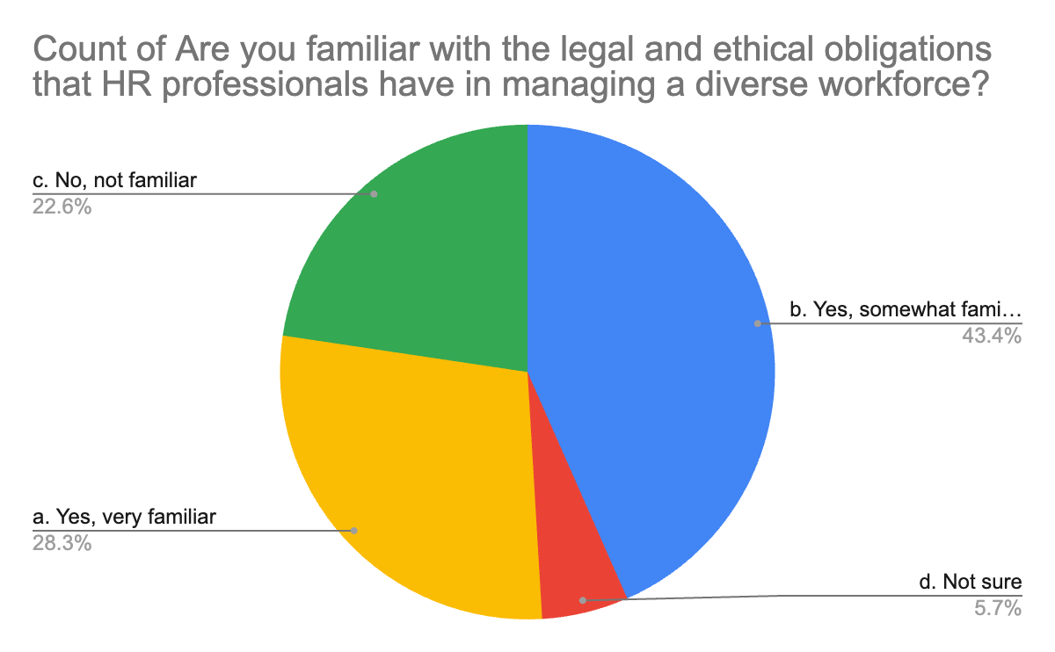
Figure 21: Statistical representation of the responses of research participants of being familiar with the ethical and legal obligations that HR follows for managing cultural diversity

The above-mentioned pie chart highlighted that 43.4% of the research participants have opined to be somewhat familiar with the ethical and legal obligations followed by respective HR departments while managing a diverse workforce. 28.3% of them were very familiar with those obligations set by the HR departments. While 22.6% of them have responded not familiar with those obligations at all in their workplace. Only a few percent of the research participants have opined that they are not sure while responding to the above statement. The adoption of anti-discrimination laws is one of the prime examples of ethical and legal obligations followed in HR policies.
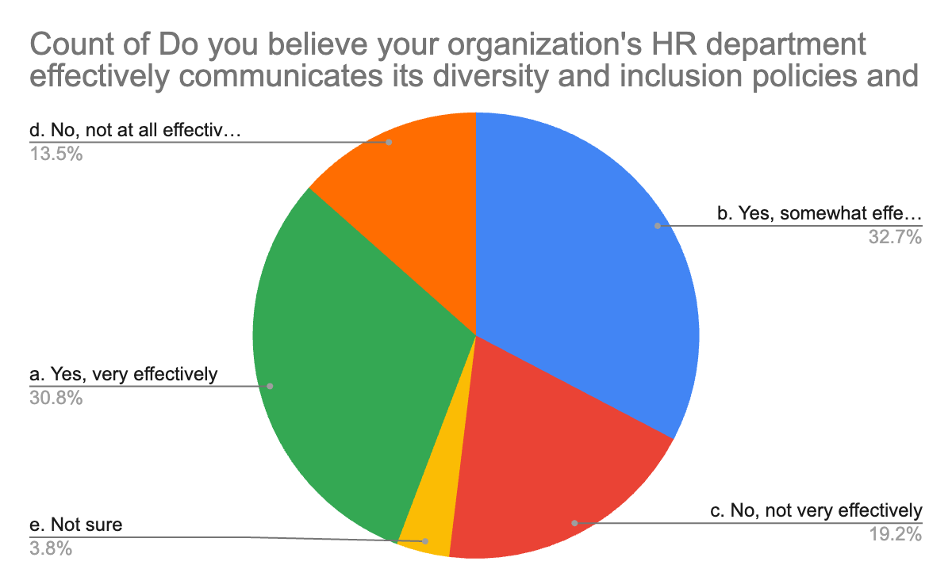
Figure 22: Statistical representation of the research participants based on HR initiative of effective communication practices as a part of its diversity and inclusion policy
From the above pie chart, it is evident that 32.7% of the research participants have found it somewhat effective with the adoption of effective communication as one of the major elements in HR diversity and inclusion policies. 30.8% of them have opined as very effective in the practices of effective communication within their workplace. 19.2% of them responded less effectively while answering the above statement. The remaining 13.5% responded negatively to the statement.

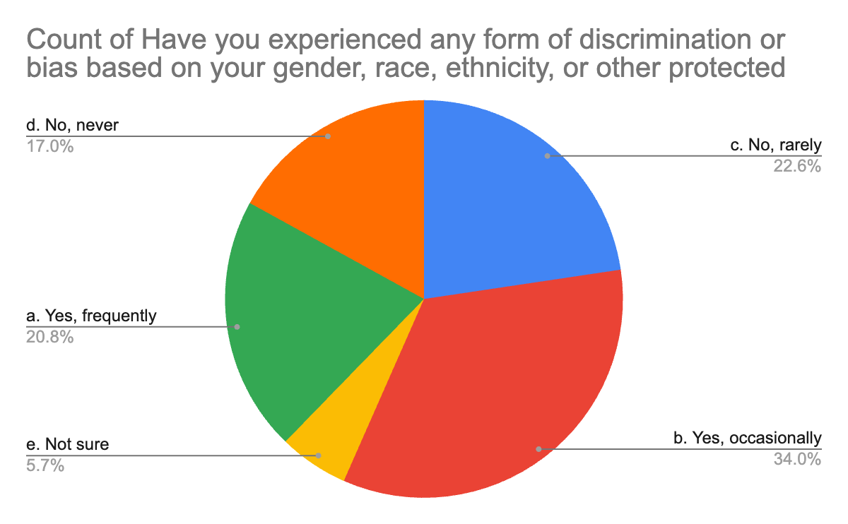
Figure 23: Statistical representation of the opinions of research participants on the frequency of experiencing any form of discrimination in their workplace.
.
The above-mentioned pie chart highlighted 34% of the research participants have occasionally witnessed discrimination based on gender, ethnicity, or race in their workplace. 22.6% of them said to rarely experienced or witnessed any kind of discrimination based on gender, race or ethnicity in their respective workplaces. However, 20.8% of the respondents said that they have frequently witnessed such incidents in their workplace. 17% of them could not recall any such incidents happening ever.

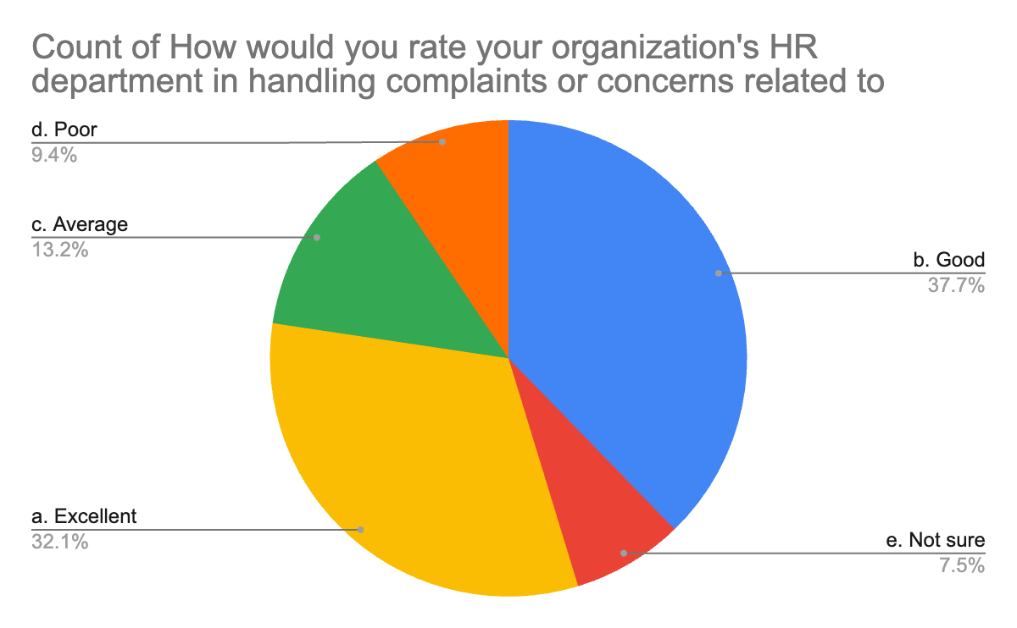
Figure 24: Statistical representation of the opinions of research participants on the effectiveness of handling complaints by HRs related to diversity and inclusion.

In correlation to the specific question, 37.7% of the research participants rated HR's efficiency in handling and solving complaints related to diversity and inclusion as good. A total of 53 responses were collected, of which 32.1% rated it as excellent. While 13.2% of them have rated as average while responding to the above statement. The remaining 9.4% and 7.5% respectively rated HR's efficiency in handling and solving complaints as poor and not sure of HR's role in it.

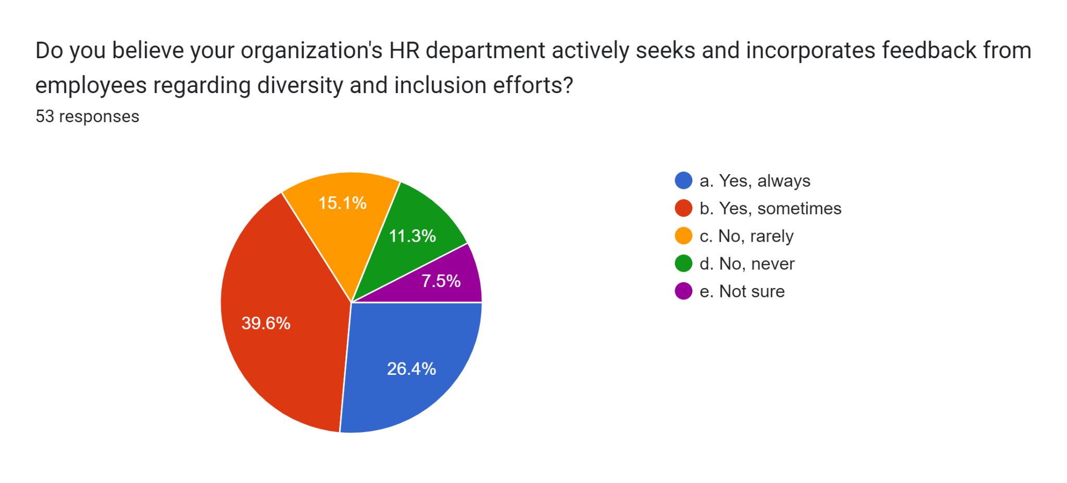
Figure 25: Statistical representation of the opinions of research participants on giving any feedback to the HR department regarding inclusion and diversity.

The above-mentioned pie chart highlighted the HR contribution in taking valuable feedback from the employees to boost cultural diversity and inclusion within the workplace. In total 53 responses have been collected. While responding to the above statement, 39.6% of the research participants believed sometimes the HR department has taken feedback from the employees. 26.4% of them have opined that they frequently get back to HR for the betterment of cultural diversity in the workplace. 15.1% of them have found it very rare to ask for any feedback from the HR department. Only 11.3% said no or never in response to the above statement, whereas, the remaining 7.5% of the participants are not sure of the above statement.

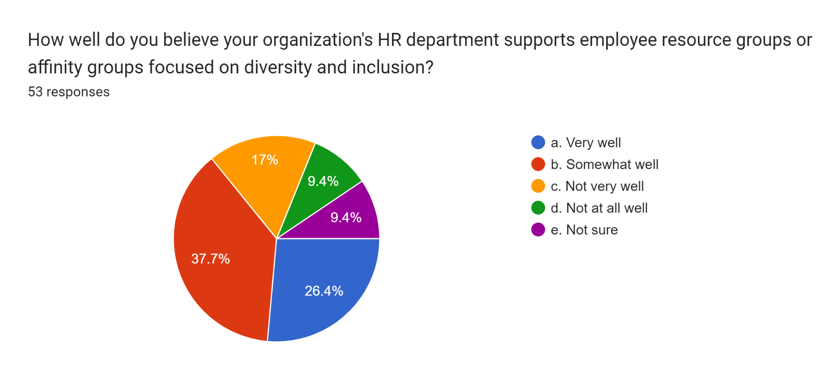
Figure 26: Statistical representation of the opinions of research participants on the collaboration of the HR department with employee resource groups that focused on diversity and inclusion

The above-mentioned pie chart signifies the behaviour of the HR department while responding to employee resource groups that are entirely focused on diversity and inclusion. For that, 53 responses have been collected. Out of which, a majority of 37.7% have opined that in some of the cases, the HR department collectively worked with the employee resource group to improve cultural diversity. 26.4% of them responded very well as they have identified many instances of collaboration in their workplace between the employee resource group and the HR department. Only 17% of them responded to the question as ‘not very well’, as they might have faced negative outcomes of such collaborations. 9.4% is the number in which case, some respondents said 'not at all' to the asked question while the rest of the 9.4% are not quite sure of it.

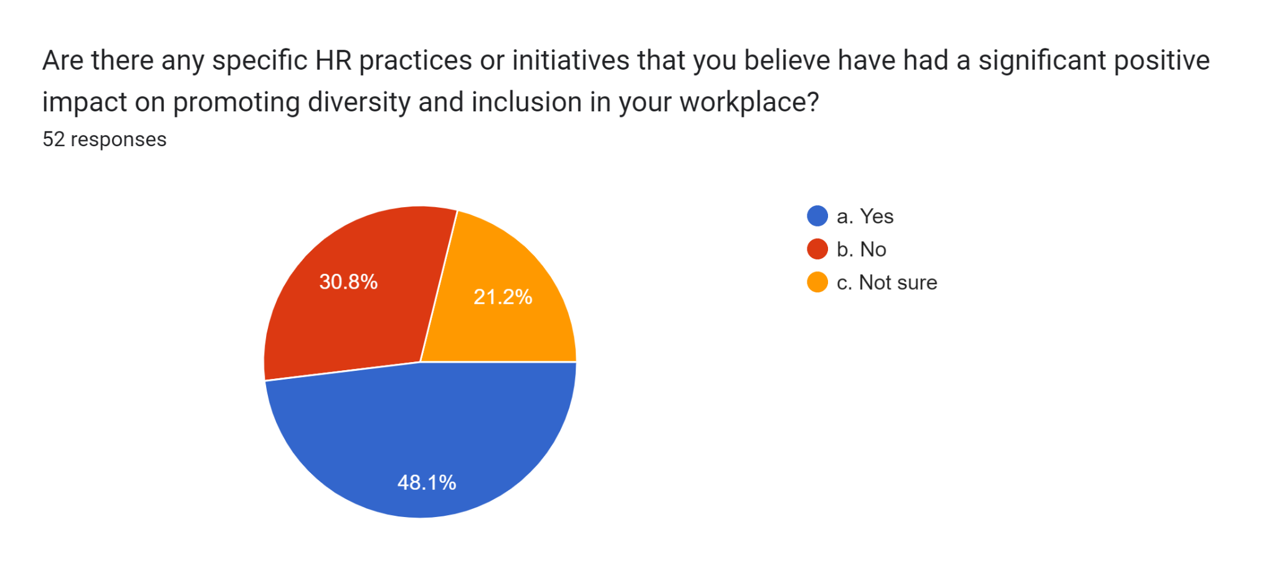

Figure 27: Statistical representation of the opinions of research participants on the positive impact of HR policies for increasing diversity and inclusion among the workforce.
In this particular survey, the participants were asked about the impact of HR policies and regulations to increase cultural diversity and inclusion in the workplace. In total, 52 responses were collected from the participants. Out of which, a majority of 48.1% have opined positively while answering the impact of HR policies. However, 30.8% believed that HR policies negatively impact cultural diversity and inclusion in the workplace. Around 21.2% stayed in a neutral stance while responding to the above statement.

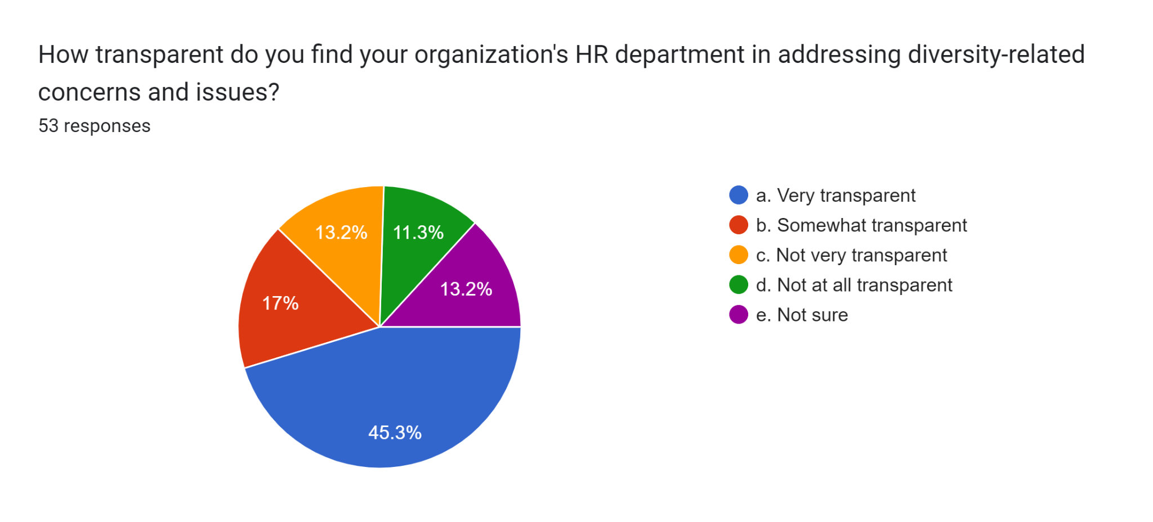
Figure 28: Statistical representation of the opinions of research participants on the transparency in the HR policies while addressing issues related to diversity.

This specific survey question highlights the significance of transparency in HR policies while mitigating any issues or concerns related to cultural diversity. For that 53 responses have been collected from the participants. Out of these, 45.3% have opined that they have experienced a very transparent process in the HR activities while dealing with such issues in their workplace. Around 17% of them have found it somewhat transparent. While another 13.2% have opined that there was nothing transparency in their workplace while dealing with cultural diversity. Around 11.3% of the 53 respondents said 'not at all transparent' with respect to the asked question. Another 13.2% took neutral stances while answering the statement.

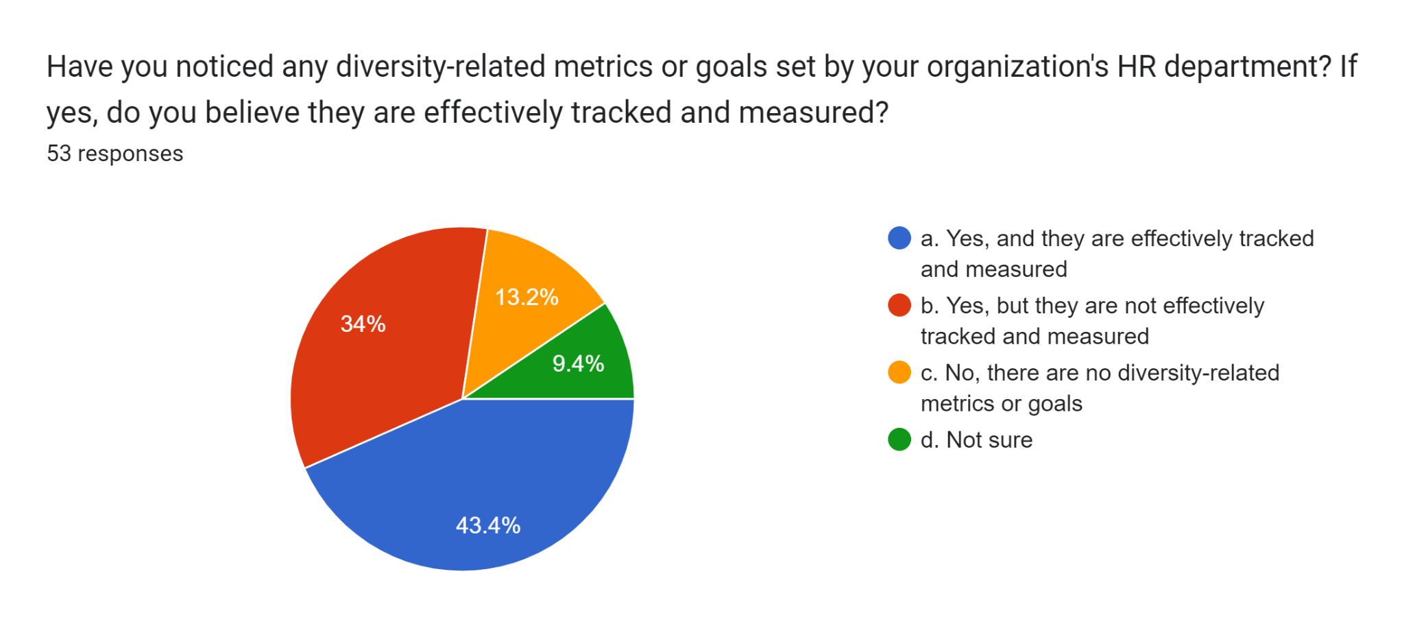

Figure 29: Statistical representation of the opinions of research participants on the application of diversity-related metrics to track the effectiveness of diversity in the workplace.
In this particular survey question, the pie chart highlighted the significance of the usage of Diversity-related metrics to track and measure the progress of cultural diversity within the workplace. In total, 53 responses have been collected, out of which, 43.4% have opined on the effective usage of diversity-related metrics within the workplace to measure progress and effectiveness. While 13.2% of them responded with no application of such practices in their workplace. 34% of them have opined on the usage of such metrics ineffectively without tracking and measuring the performance. Around 9.4% of them have taken a neutral stance while responding to the above statement.
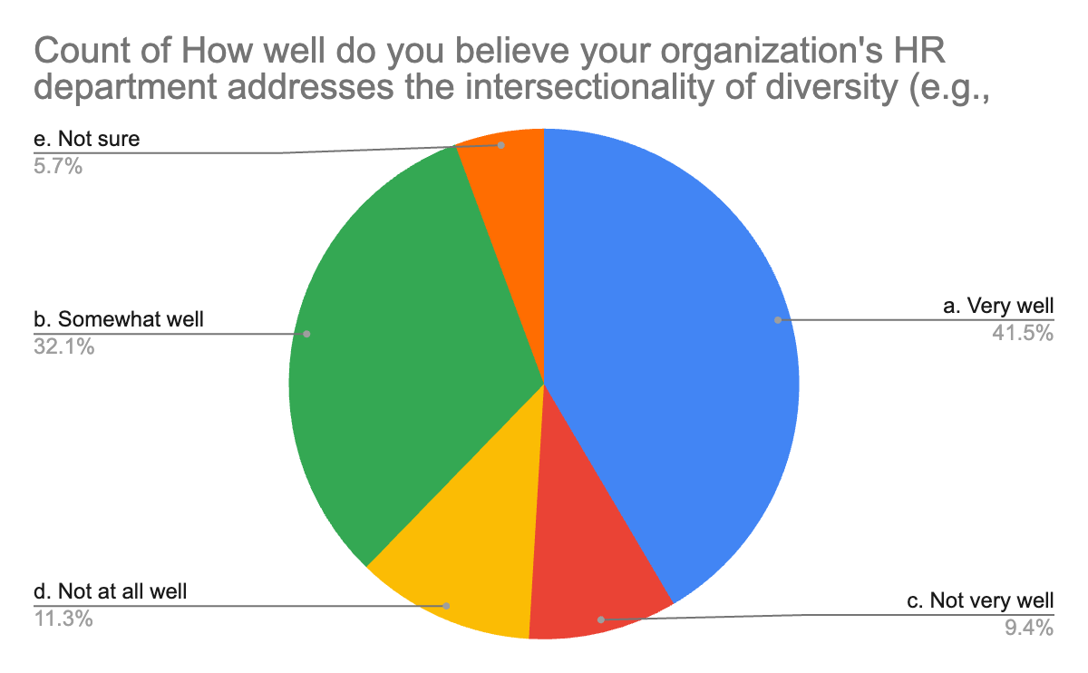
Figure 30: Statistical representation of the opinions of research participants on the behaviour of the HR department to address the intersectionality of diversity
The above-mentioned pie chart highlighted that 41.5% of the research participants have opined very well while answering to the accountability of the HR department to address the intersectionality of diversity, for example, race, gender, and age by treating them simultaneously. Around 32.1% of them opined somewhat well and 9.4% of them responded not very well while responding to the above statement. However, 11.3% of the participants have not witnessed HR addressing the intersectionality of cultural diversity in their workplace. The remaining participants have taken a neutral stance in answering the question.

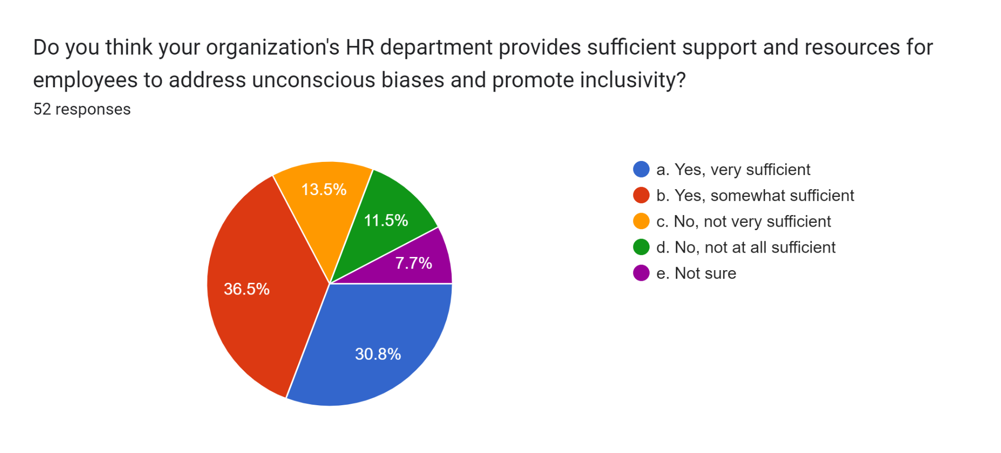
Figure 31: Elaborations if Human Resource Department provides sufficient support and resources for addressing unconscious bias while promoting exclusivity
In correlation to the specific question of whether the participants thought that their organisation's HR department provided sufficient support and resources for employees to address unconscious bias and promote inclusivity; around 52 responses were collected in correlation to the UK and New South Wales. 36.5% of the participants stated that yes they were somewhat sufficient for addressing the unconscious biases and promoting inclusivity. Around 30.8% of the participants, for example, were very satisfied and stated that they were very satisfied. Around 13.5% of the participants who took part in the survey were not satisfied and provided their views in the point of view towards being not at all sufficient. Around 11.5% of the people who took part in the service stated that the organisations' HR departments are not very effective in providing proper resources in coordination with the employees. Only a mere number of 7.7% out of the total respondents stated that they are not sure if the HR department can provide sufficient support and resources for employees in addressing unconscious bias and promoting inclusivity.

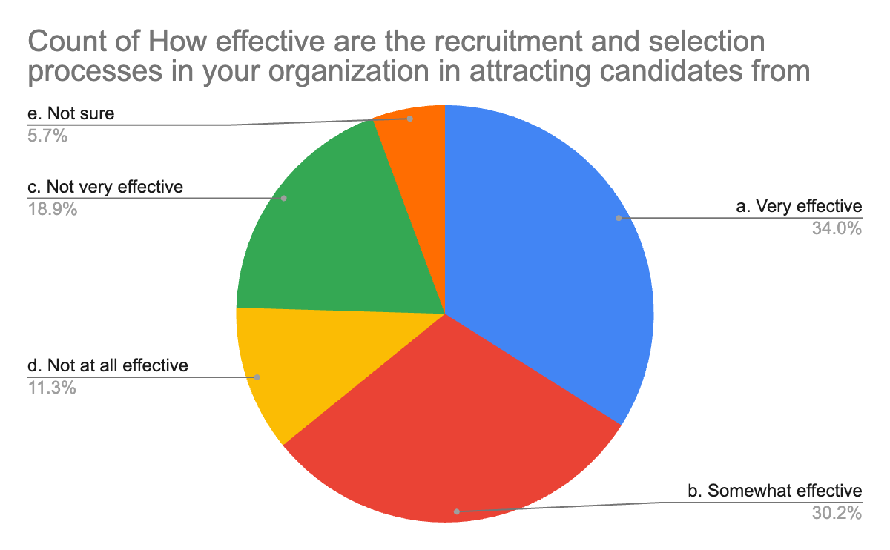
Figure 32: Effectiveness of the recruitment and selection process in attracting candidates from diverse backgrounds
In this particular survey question, the participants were asked about the effectiveness of the recruitment and selection process in their organisation for attracting candidates from diverse backgrounds. In this particular case, a total number of 53 responses were collected. First 18.9% of the respondents stated that the selection process provided by the human resource was not very effective in attracting candidates from diverse backgrounds. 11.3% of the people stated that the process was not at all effective. Around 34% of the participants stated that the process provided by the organisation recruitment was actually very effective. Around 30.2% of the participants stated that the selection process in their organisations was somewhat effective. A small part of the participants were not sure what to answer.

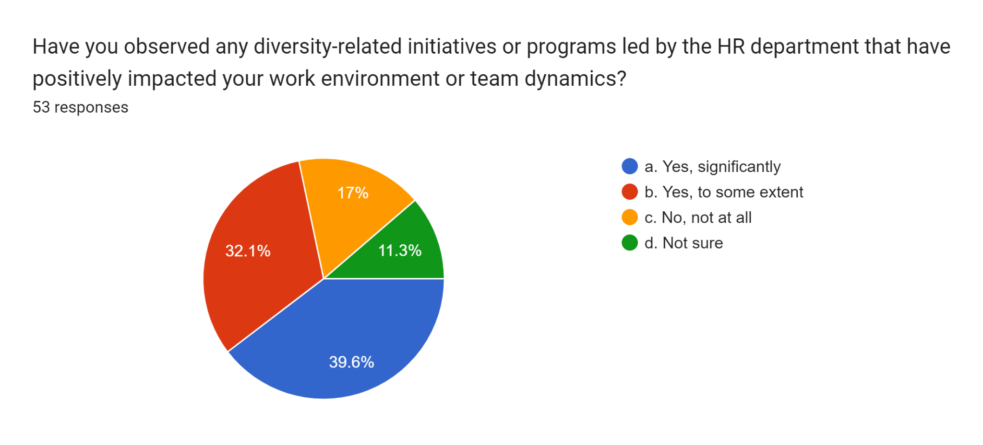
Figure 33: Impact of any diversity-related initiatives or programs by HR departments to develop work environment and workforce
In this specific question, the participants were enquired about the aspect of observing any diversity-related initiative programs led by the human resource that has positively impacted their working environment or team dynamics in companies in the UK. In this case, around 39.6% of the respondents stated that yes significantly very effectively in imparting environments and team dynamics positively. Around 32.1% of the employees highlighted that the initiative or programs were to some extent positively impactful. Around 17% of the people highlighted that they were not at all impacted by the diversity-related initiative or programs the human resource impacted their work environment positively or not. The remaining 11.3% of the people were not sure about the positive or negative impact of the diversity-related initiative by the HR department in their organisations.
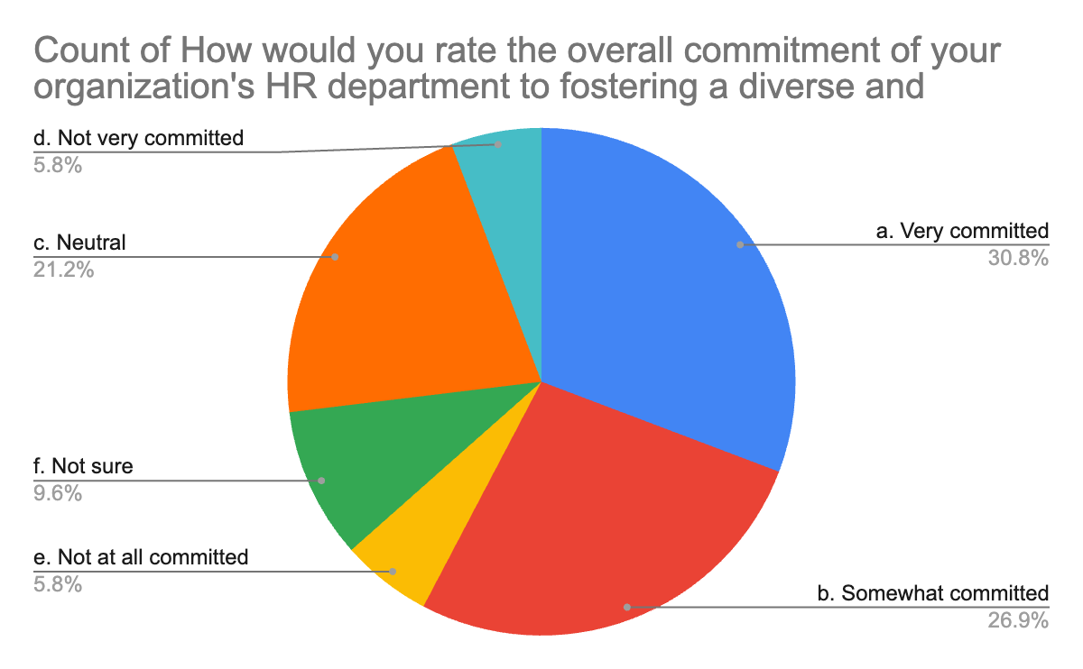
Figure 34: Rating of the overall commitment of organisational HRD in fostering a diverse and inclusive workplace
In this question, the participants were asked about the rating of the overall commitment of their organisations’ HR department to fostering a diverse and inclusive workplace culture in correlation to the UK. In this case, 30.8% of the people rated it to be very committed. 26.9% of the people highlighted that the area department was somewhat committed to fostering diverse and inclusive workplace culture. Around 21.2% of the people chose to be neutral in this response and did not answer this particular question properly. 9.6% of the respondents said that they are not quite sure of giving a rating to the overall commitment of their respective organisations and HR departments to foster diverse and inclusive workplace culture. As shown in the pie chart, there is only a small percentage of the remaining groups among the participants who said that their organisations are not at all very committed and do not agree with the fact of the HR department of their organisations showing any traits of commitment to foster better drivers and inclusive workplace culture.

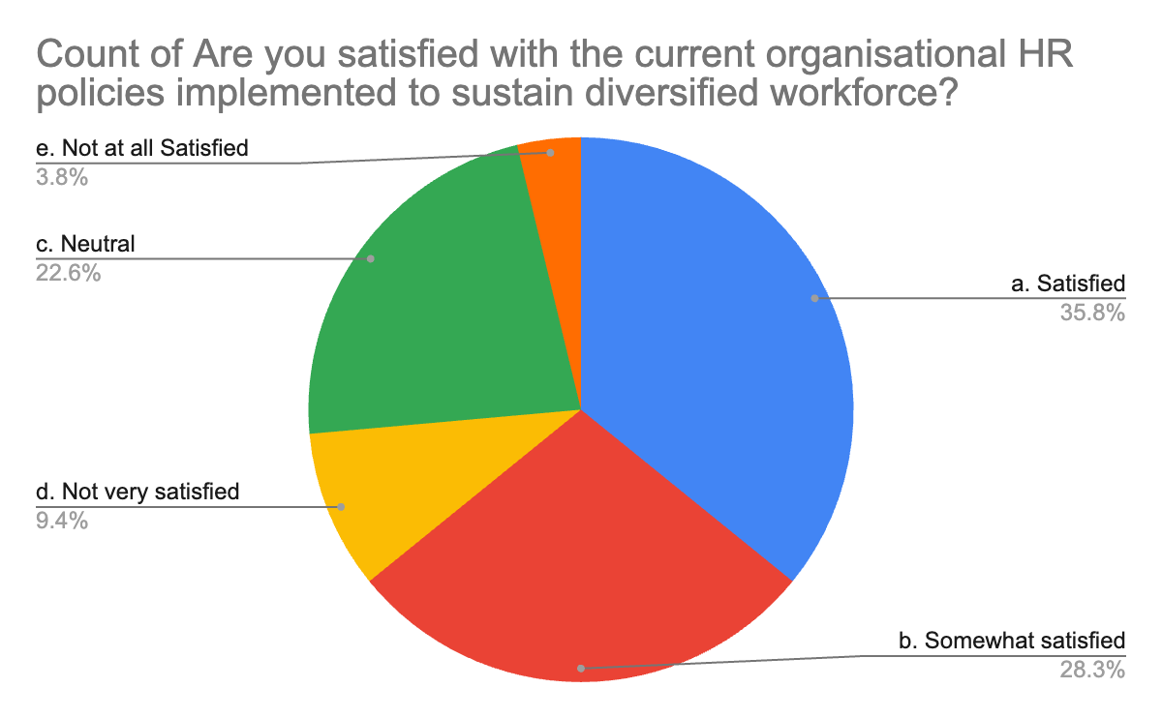
Figure 35: Satisfaction rate with the current HR policies to sustain a diverse workforce
In this particular question, the participants were asked whether they were satisfied with the current organisation's HR policies that were implemented for sustaining a diverse workforce in perspectives related to the UK. About 35.8% of the participants stated that they were satisfied. The majority number of 35.8% showing satisfaction with the current organisation policies shows how most organisations are aware of implementing efficient HR policies that play a key role in maintaining diversification in the workforce. This is a very critical finding from the overall survey that let the researcher better understand how organisations are shaping up in a way that better promotes more diversification, inclusivity and talent acquisition rather than particularly focusing on race or ethnicity. About 28.3% of the participants who took part in this service stated that they were somewhat satisfied with the HR policies. Around 22.6% of the participants were neutral in coordinating the satisfaction with the organisation's policies for a diverse workforce. About 9.4% of the participants were actually not very satisfied with their organisations’ human resource policies for sustaining a diversified workforce. Only a small percentage of participants have been identified in the survey who said that they are not at all satisfied with the current organisation that is being implemented in their respective organisations in sustaining a diversified workforce.

4.2 Empirical research discussion

4.2.1 What is the role and contribution of effective HR policies in giving priority to workforce diversity?
According to Ng, and Sears, (2020), human resources in the present era have the role of fostering workforce diversity to maintain cultural illustrations. These are related to motivating staff and reducing turnover, and absenteeism while increasing productivity (Ng, and Sears, 2020). The key role of HR management in companies is to elaborate proper coordination of culture and leadership that creates and empowers a diverse workplace orientation. However one of the major issues in current-day organisations is managing an increasingly diverse workforce. This is one of the main reasons why employment opportunities with proper laws as per countries and industries are needed for diversity management. This not only brings forward the engagement of diverse behaviour among the employees but also helps in creating strong organisation behaviour for competitive advantage.
In coordination with this justification, it can be highlighted that in question 4.1.6, the participants were asked about the review of organisation and human resources to engage and retain employees from diverse backgrounds and 46.7% of the survey participants were neutral. In addition to that 23.3% of the participants were not sure about the engagement of the human resource. This shows that there is a lack of human resource elaboration to incorporate an increasingly diverse workforce (Khan et al., 2019). This is where the human resource in companies related to the UK has to work forward and correlate equal employment opportunities for more development.

4.2.2 What is the significance of taking the right approaches and applying proper techniques in order to create a diverse work culture?
As per Elia, Petruzzelli, and Piscitello, (2019) one of the techniques that can be highlighted by organisational HR is implementing cross-border alliances in the case of MNC subsidiaries. They are useful in pulling resources like people, technology, and capacities which highlight proper diversity management as different parties across borders share risk and reward and get access to each other's market (Elia, Petruzzelli, and Piscitello, 2019). In addition to that processes like hiring more employees from intercultural illustrations, improving intercultural interaction, incorporating sensitivity training, and zero tolerance policies are effective means to transform organisations while avoiding cultural issues in the workplace which are also advantages that can be highlighted by human resource management.
In coordination with the previous survey questions, it can be elaborated that question 4.1.17 highlights if there are specific practices or interactions that have positive impacts on diversity inclusion in which around 26% of the people stated that they were not sure about that. 16.7% of the population who took part in the survey also provided their view that they were not sure if the impact was positive. Even though a large number of people, which is 56-17% , stated that they had a positive significance, still there were a number of people as mentioned above who were not sure of their positive impact. This also highlights that human resource has to work more hard to create a transparent diversity-related elaboration (Syed, 2020). This can also be useful for promoting diversity and inclusivity in the current generation's workplace.

4.2.3 How should the HR department promote innovation and creativity for building a diversified work culture?
According to the authors Devine, and Ash, (2022) in the present-day orientation, one of the core processes that can be highlighted by human resources to incorporate innovation and creativity for building a diverse workplace is related to cultural diversity training (Devine, and Ash, 2022). In countries like the UK, diversity training is useful irrespective of the industries because being a multicultural country it can help the human resource departments in companies to educate their employees about the appropriate and inappropriate ways to interact with people from different cultures. Moreover, it can also ensure that employees understand the behaviour expectations of the organisation's code of conduct and policies to prevent discrimination and harassment and incorporate proper innovation. Moreover, the human resource department can also give stress incorporating whistle-blower policies for implementing better creativity and innovation by eliminating discrimination.
In correlation to the survey question 4.1.23, it can be stated that around 16.7% of the respondents stated that they are not sure of observing any diversity-related initiatives or programs highlighted by the human resource department for impacting team dynamics. Moreover, 13.3% were actually not sure whether the impact was positive. This shows that human resource elaboration in countries like the UK has to incorporate better ways to implement related initiative programs for underlining team dynamics and an effective cultural environment (Carter, Onyeador, and Lewis Jr, 2020).

4.2.4 What are the important strategies the HR department should have to work on for making the workforce more diversified than ever?
According to Luu, Rowley, and Vo, (2019), One of the main strategies that human resource management in the present era can highlight is addressing employee diversity to enhance the workforce in a better way. In this particular case, it is effective to impress diversity as a part of the hiring process while managing transformational leadership that focuses on managing diversity and considering all diverse groups (Luu, Rowley, and Vo, 2019). Implementing diversity policies that support diverse backgrounds while incorporating feedback from employees regarding diversity efforts can also be included in countries Like the UK. Moreover, human resource management irrespective of the industry can also bring forward policies for handling complaints for improper diversity illustrations while highlighting proper goals like focusing on 100% incorporation of male-female ratio or including 50% of employees from diverse workforce can be used for a success rate.
In correlation to the survey, it can be stated that in question 4.1.14, around 43.3% of the people stated that human resources had effectiveness in handling complaints related to diversity and inclusion. This shows that countries Like the UK have been working forward to develop mitigating strategies for complaints related to workplace diversity. In question, 4.1.15 around 13.3% of the people stated that the feedback process was illustrated by HR departments while 46.7% of the people stated that the procedure was done sometimes. In question 4.1.19, the elaboration of the diversity matrix being noticed was asked to the participants and 36.7% stated that they have noticed but they were not effectively incorporated and measured. This shows that even though the HR department has been working towards proper development in this case , action plans are still needed for incorporating better results.

Chapter 5: Conclusion & Recommendation

5.1. Conclusion
The report has discussed the role of Human Resources in managing a diverse workforce. The primary aim of the research paper was to contribute to the practical application and recommendations for creating an inclusive workplace that would value talents rather than cultural differences. The research paper objectively illustrated the role of Human Resources Management in redefining the diversified Work Culture. The research had huge significance for leveraging the challenges and opportunities linked with cultural diversity and inclusion. The study has uncovered suitable HR practices required for monitoring the diverse workforce including legal framework and regulations. The research had a huge significance as it aims to fulfil the existing gap within the literature and deliver reliable HR practices supported through a literature review. From the discussed literature review, it can be concluded that the practices of diversity and inclusion will help businesses in developing decision-making capabilities and problem-solving abilities resulting in better product development.

It can also be concluded that workplace diversity promotes greater employee engagement and also helps in lowering employee turnover by improving the retention rate of employees. The research has included Localisation as one of the elements of cultural diversity that would help in better understanding the demographics of the local market and communities. Among the recent HR trends, the research highlighted the usage of "Cultural add vs Cultural Fit '' and proper auditing of the HR policies would have helped in increasing diversity and inclusion as supported by the literature. The literature review supported the research study with the identification of “Talent Acquisition, Change Management, and Educating Workplace Diversity to the Leadership” which has helped Global MNCs in successfully monitoring and reducing cultural differences within their workplaces.

In the empirical research findings, it can be concluded that in total 30 participants have given their opinions on 25 questions based on HR initiatives to promote diversity and inclusion in the workplace. The majority of the participants were females and fell in the age group of 35-44 years. Around 56.7% of the research participants have completed Master's degrees and the majority of them have been actively serving as senior-level employees. It was shocking to analyse that around 46.7% of the research participants opined neutral on the efforts of HR in engaging a diverse workforce. From the analysis, it was evident that nearly 46.7% of the participants had witnessed discrimination in their workplace for diverse employees in performance management. From the empirical analysis, the research also highlighted a few recommendations for example providing equal employment opportunities in the workplace with the enforcement of the Equality Act 2010 could help in increasing cultural diversity. The research further highlighted the application of KPIs in recruitment will help in hiring more employees from deprived communities such as BAME.

5.2. Recommendation

5.2.1 Auditing the recruitment system in the Workplace to promote cultural diversity
In today's world, there has been increased awareness of maintaining cultural diversity within the workplace to encourage global talents and creativity that would contribute to the growth of organisations. However, there were plenty of red flags that might occur while promoting cultural diversity in the workplace such as conflicts, complaints, high employee turnover rates, biases, and low morale (Kendrick and Damasco, 2019). The promotion of cultural diversity starts with hiring employees from different cultural backgrounds within the workplace. In the UK, the Office of Federal Contract Compliance Programs(OFCCP) focused on hiring and recruiting a diverse workforce by including minorities, veterans, persons with disabilities, and women. Hiring an auditing agency would help to identify the potential red flags within the different aspects of business that include HR, upper management, and general staff (Cao, Luo and Zhang, 2020). The audit report of the recruiting and hiring practices would have helped in determining whether there are any constraints in hiring a diverse workforce for example biases, nepotism, or favouritism.

Proper auditing would help to raise more awareness of the recruitment process followed by the organisation. It would have helped in formulating strategies for mitigating those red flags to improve diversity and inclusion within the workplace. Hiring talents from Black, Asian, and Minority Ethnic(BAME) can be considered as one of the effective initiatives that would help in promoting cultural diversity and inclusion within the workplace. In the UK, only 19.7% of women have been considered to be on the organisation's board. In 2022, Around 62.8% of BAME communities will get employment (Druthers Search, 2022). Hiring more talents from BAME communities will promote cultural diversity in the workplace and at the same time it will also help in increasing the employment rate further. Additionally, evaluation of the job description will ensure no communities would be eliminated from consideration. The blind reviews and more feedback from the employees would help in removing any kind of bias in the Workplace starting from recruitment and hiring.

5.2.2 Implementation of anti-discriminatory policies within the Workplace
Any kind of discrimination in the workplace is responsible for a negative work environment, job dissatisfaction, and low morale. This has negatively impacted the productivity and performance of the companies in the longer run. There have been many instances in the UK where SMEs often struggle in legalities to fight the employee's allegations of experiencing any form of harassment or discrimination in the workplace due to limited resources. Implementation of anti-discriminatory policies in the HR code of conduct would have helped such organisations to prevent mishaps to occur in the workplace (Cane and Tedam, 2022). For example, enforcement of the federal and state laws for providing equal opportunities set up by the U.K. Equal Employment Opportunity Commission. Discrimination in the workplace harms the employee characteristics that include race, colour, gender equality, religion, sexual orientation, and genetic information.

For example, in California, worker's compensation has been provided to the victims of discrimination in the workplace. However, this had no impact on reducing the number of cases or issues related to any form of discrimination. The enforcement of the EQUALITY ACT 2010 would have helped in reducing gender discrimination for equal pay in the same employment (Vyas, 2021). It will help to protect people irrespective of gender from workplace discrimination. The enforcement of the Sex Discrimination Act 1975 would have helped in reducing sexual discrimination within the workplace. The initiative of implementing the Race Relations Act 1976 would have helped in protecting employees from Racial discrimination in the workplace. The Human Right Act 1998 can also be implemented in the workplace for reducing the allegations of discrimination based on colour, basic rights, race, ethnicity, and religion. This will help in preserving the basic rights of the employees which in turn help in increasing employee satisfaction and productivity (Tamunomiebi and Oyibo, 2020). Such initiatives would have helped in promoting cultural diversity and inclusion by reducing any form of discrimination within the workplace.

5.2.3 Introduction of Diversity-based KPIs for tracking and measuring the performance
Diversity and inclusion have been one of the recent trends that most of the MNCs follow to encourage innovation and creativity that would have helped them in getting a competitive advantage in the operating market. Top MNCs such as Google, Unilever, Microsoft, Disney, and Netflix are focusing more on cultural diversity and inclusion as per the report generated by CNBC (Tupamäki, 2019). However, only recruiting a diverse workforce would not add value to the growth of the company. Managing the performance of the diverse workforce has been the need of the hour. Most of the companies that had got splendid results from the diversified workforce due to the introduction of Key Performance Indicators to monitor and track the performance and progress of the company's inclusive environment to achieve specific goals. To measure and track down the impact of diversity in the workplace, Recruitment KPIs can be used to hire global talent from different cultural backgrounds.

In the UK, many companies have been successful in achieving at least a 20% higher innovation rate and 20% higher revenue by implementing diversity-based KPI metrics for tracking down and monitoring the key drivers that would increase cultural diversity in the workplace to a larger extent. According to the report released by McKinsey, companies targeting diverse ethnicities were more profitable due to improved decision-making capabilities (Kaur and Arora, 2020). The usage of KPI metrics would help in identifying the red flags restricting the performance of those employees. With increased awareness of the problems, strategies can be formulated to turn the red flags into green flags. The application of diversity-based KPIs will also help organisations to track down the effectiveness of diversity and inclusion training programs in the workplace (Baker, French and Ali, 2021). The HR department mostly benefited from the application of these KPIs to formulate retention strategies and identify the gaps in the diversity practices within the organisation that might lead to reputational damage or any kind of legalities due to employee allegations of cultural differences within the workplace which have resulted in harassment and discrimination.

5.2.4 Engaging Employee Resource Groups for fostering diversity and Inclusion within the Workplace
Many companies Worldwide are defying their strategies based on diversity, equity, and inclusion (DEI) for meeting the needs and expectations of different stakeholders in a business including workers. In the internal communities of workers, ERGs are steering toward the benefit and wellness of the workers for fulfilling their needs and requirements (Cote, 2019). Engaging the Employee Resource Groups in fostering diversity and inclusion in the workplace would help in identifying the gaps in the company's policies for promoting diversity and inclusion. In today's world, 90% of the companies in the Fortune 500 have ERGs for improving employee retention and commitment. Many companies have been lacking in forming an organised structure for implying Governance in ERGs activities.

ERGs fostering inclusion would help in increasing the ownership capability of the workers and will also increase their accountability to be part of the business family. The involvement of ERGs will help to strengthen the employee acceptance of any changes within the organisation. ERGs can work in tandem with the HR department to improve diversity in recruitment activities. For example, it will help in encouraging of hiring talents from deprived communities in the UK such as BAME. ERGs fostering incentives for creative ideas would have helped to increase cultural diversity within the workplace (Dupreelle et al., 2020). ERGs groups also helped in building future leaders among the employees by providing developing opportunities such as workshops, and mentorship programs on the significance of multiculturalism practices within the workplace. ERGs can also be portrayed as the voice of the workers and will help in responding to any concerns related to cultural diversity, inclusion, discrimination, and harassment.

5.3. Research Limitation
Due to increasing resource constraints such as time and financial budget, 52 people were included in the survey the research study covered only survey-oriented research data along with available peer-reviewed article-based justification to conclude research goals (Busch and Barkema, 2021).

5.4. Significance of future research application
The research study entirely focused on the specific challenges faced by Human Resource(HR) departments of organisations in the UK. The study has bigger significance as it uncovered all of the potential techniques and strategies that would have helped the organisations in managing the diverse workplace effectively. The research study has been successful in identifying the gaps in current practices of the HR departments Worldwide which in turn reduced their efficiency (Hongal and Kinange, 2020). The study will help future scholars in providing ample knowledge and information regarding the potential gaps within the current practices and also on the future evolution of such practices.
The significance of the study increased further for future scholars by including evidence-based recommendations and guidelines to promote inclusion and diversity within the workplace. The study would also help several companies to raise more awareness on the application of diversity-based KPIs and Employee Resource Groups(ERGs) for the wellness of the employees by tracking down the effectiveness of diversity-focused programs within the workplace (Escoda i Canals, 2021). The future scholar will also be enlightened with reliable information on the UK-based policies and regulations that would help businesses to strategize their legal aspects. However, there is a requirement for a more intensive study on determining the scope and opportunities for applying different performance monitoring frameworks to boost the productivity of a diverse workforce.

Reference
Abbasi, S.G., Tahir, M.S., Abbas, M. and Shabbir, M.S., 2022. Examining the relationship between recruitment & selection practices and business growth: An exploratory study. Journal of Public Affairs, 22(2), p.e2438.
Abu-Alhaija, A.S., 2019. From epistemology to Structural Equation Modelling: An essential guide in understanding the principles of research philosophy in Selecting the Appropriate Methodology. Australian Journal of Basic and Applied Sciences, 13(9), pp.122-128.
Al Doghan, M.A., Bhatti, M.A. and Juhari, A.S., 2019. Do psychological diversity, climate, HRM practices, and personality traits (big five) influence multicultural workforce job satisfaction and performance? The current scenario, literature gap, and future research directions. Sage Open, 9(2), p.2158244019851578.
Al Harahsheh, H.H. and Pius, A., 2020. A review of key paradigms: Positivism VS interpretivism. Global Academic Journal of Humanities and Social Sciences, 2(3), pp.39-43.
Anwar, G. and Abdullah, N.N., 2021. The impact of Human resource management practice on Organisational performance. International Journal of Engineering, Business and Management (IJEBM), 5.
Asenahabi, B.M., 2019. Basics of research design: A guide to selecting appropriate research design. International Journal of Contemporary Applied Researches, 6(5), pp.76-89.
Ashworth, N., De Champlain, A.F. and Kain, N., 2021. A review of multi-source feedback focusing on psychometrics, pitfalls and some possible solutions. SN Social Sciences, 1, pp.1-12.
Bae, I., Park, J.H. and Jeon, H.G., 2022. Non-Probability Sampling Network for Stochastic Human Trajectory Prediction. In Proceedings of the IEEE/CVF Conference on Computer Vision and Pattern Recognition (pp. 6477-6487).
Baker, M., French, E. and Ali, M., 2021. Insights into ineffectiveness of gender equality and diversity initiatives in project-based organisations. Journal of management in engineering, 37(3), p.04021013.
Bennett, P., Burns, R., Champion, S. and Gordon, S., 2022. Effectiveness of an aged simulation training suit to support the development of compassion and person‐centred care in the aged‐care workforce. Australasian Journal on Ageing, 41(2), pp.314-324.
Blom, T., Kazeroony, H. and Du Plessis, Y., 2019. The role of electronic human resource management in diverse workforce efficiency. SA Journal of Human Resource Management, 17(1), pp.1-12.
Blom, T., Kazeroony, H. and Du Plessis, Y., 2019. The role of electronic human resource management in diverse workforce efficiency. SA Journal of Human Resource Management, 17(1), pp.1-12.
Brittain, S., Ibbett, H., de Lange, E., Dorward, L., Hoyte, S., Marino, A., Milner‐Gulland, E.J., Newth, J., Rakotonarivo, S., Veríssimo, D. and Lewis, J., 2020. Ethical considerations when conservation research involves people. Conservation Biology, 34(4), pp.925-933.
Brown, C., Spiro, J. and Quinton, S., 2020. The role of research ethics committees: Friend or foe in educational research? An exploratory study. British Educational Research Journal, 46(4), pp.747-769.
Busch, C. and Barkema, H., 2021. From necessity to opportunity: Scaling bricolage across resource‐constrained environments. Strategic Management Journal, 42(4), pp.741-773.
Cane, T.C. and Tedam, P., 2022. ‘We didn’t learn enough about racism and anti-racist practice’: newly qualified social workers’ challenge in wrestling racism. Social Work Education, pp.1-23.
Cao, J., Luo, X. and Zhang, W., 2020. Corporate employment, red flags, and audit effort. Journal of Accounting and Public Policy, 39(1), p.106710.
Carter, E.R., Onyeador, I.N. and Lewis Jr, N.A., 2020. Developing & delivering effective anti-bias training: Challenges & recommendations. Behavioral Science & Policy, 6(1), pp.57-70.
Cascio, M.A., Weiss, J.A. and Racine, E., 2021. Making autism research inclusive by attending to intersectionality: A review of the research ethics literature. Review Journal of Autism and Developmental Disorders, 8, pp.22-36.
Claus, L., 2019. HR disruption—Time already to reinvent talent management. BRQ Business Research Quarterly, 22(3), pp.207-215.
Cote, R., 2019. Motivating Multigenerational Employees: Is There a Difference?. Journal of Leadership, Accountability and Ethics, 16(2), pp.15-29.
Devine, P.G. and Ash, T.L., 2022. Diversity training goals, limitations, and promise: a review of the multidisciplinary literature. Annual review of psychology, 73, pp.403-429.
Do, H., Budhwar, P., Shipton, H., Nguyen, H.D. and Nguyen, B., 2022. Building organisational resilience, and innovation through resource-based management initiatives, organisational learning and environmental dynamism. Journal of Business Research, 141, pp.808-821.
Druthers Search, 2022. Diversity & Inclusion Workplace Statistics in 2022. Available at: https://www.drutherssearch.com/diversity-inclusion-workplace-statistics-in-2022/#:~:text=In%20the%20UK%2C%20the%20 employment%20rate%20is%20only%2062.8%25%20for,salaries%20that%20are%20%241%2C500%20less.(Accessed on: 18th May 2023)
Dupreelle, P., Novacek, G., Lindquist, J., Micon, N., Pellas, S. and Testone, G., 2020. A new LGBTQ workforce has arrived—inclusive cultures must follow. Boston Consulting Group, June 23.
Elia, S., Petruzzelli, A.M. and Piscitello, L., 2019. The impact of cultural diversity on innovation performance of MNC subsidiaries in strategic alliances. Journal of Business Research, 98, pp.204-213.
Ely, R.J. and Thomas, D.A., 2020. Getting serious about diversity. Harvard Business Review, 98(6), pp.114-122.
Escoda i Canals, J., 2021. Fostering GSRD and stemming discrimination in the organisation: a cultural approach.
Hesse, A., Glenna, L., Hinrichs, C., Chiles, R. and Sachs, C., 2019. Qualitative research ethics in the big data era. American Behavioral Scientist, 63(5), pp.560-583.
Hongal, P. and Kinange, U., 2020. A study on talent management and its impact on organisation performance-an empirical review. International Journal of Engineering and Management Research, 10.
Irfan, M., Javeda, M. and Bhatti, S.H., 2022. Difference-type-exponential estimators based on dual auxiliary information under simple random sampling. Scientia Iranica. Transaction E, Industrial Engineering, 29(1), pp.343-354.
Janes, F. and Harvey, R.H., 2022. The case for diversity, equality and inclusion. Journal of Financial Compliance, 5(3), pp.218-227.
Jia, J., Yan, J., Jahanshahi, A.A., Lin, W. and Bhattacharjee, A., 2020. What makes employees more proactive? Roles of job embeddedness, the perceived strength of the HRM system and empowering leadership. Asia Pacific Journal of Human Resources, 58(1), pp.107-127.
Karwal, R. and Tandon, S., 2022. Impact of workforce diversity on employee performance: A study on its companies. Asian ofnal of Multidisciplinary Research & Review, 3(3), pp.86-102.
Kaur, N. and Arora, P., 2020. Acknowledging gender diversity and inclusion as key to organisational growth: a review and trends. Journal of Critical Reviews, 7(6), pp.125-131.
Kaur, R., Kaur, G., Sahay, U. and Saini, K., 2020. A study of diversity management in different companies and different sectors. International Journal of Advanced Science and Technology, 29(3), pp.284-303.
Kelsey, M.D., Patrick-Lake, B., Abdulai, R., Broedl, U.C., Brown, A., Cohn, E., Curtis, L.H., Komelasky, C., Mbagwu, M., Mensah, G.A. and Mentz, R.J., 2022. Inclusion and diversity in clinical trials: Actionable steps to drive lasting change. Contemporary Clinical Trials, p.106740.
Kendrick, K.D. and Damasco, I.T., 2019. Low morale in ethnic and racial minority academic librarians: An experiential study. Library Trends, 68(2), pp.174-212.
Khan, N., Korac‐Kakabadse, N., Skouloudis, A. and Dimopoulos, A., 2019. Diversity in the workplace: An overview of disability employment disclosures among UK firms. Corporate Social Responsibility and Environmental Management, 26(1), pp.170-185.
Kharroubi, D., 2021. Global workforce diversity management: Challenges across the world. Ekonomicko-manazerske spektrum, 15(1), pp.28-37.
Koskey, K.L., May, T.A., Bright, D., Stone, G., Matney, G. and Bostic, J.D., 2023. Flip it: An exploratory (versus explanatory) sequential mixed methods design using Delphi and differential item functioning to evaluate item bias. Methods in Psychology, 8, p.100117.
Kutieshat, R. and Farmanesh, P., 2022. The impact of new human resource management practices on innovation performance during the COVID-19 crisis: a new perception on enhancing the educational sector. Sustainability, 14(5), p.2872.
Lee, H.W. and Kim, E., 2020. Workforce diversity and firm performance: Relational coordination as a mediator and structural empowerment and multisource feedback as moderators. Human Resource Management, 59(1), pp.5-23.
Luu, T.T., Rowley, C. and Vo, T.T., 2019. Addressing employee diversity to foster their work engagement. Journal of Business Research, 95, pp.303-315.
Mukhuty, S., Upadhyay, A. and Rothwell, H., 2022. Strategic sustainable development of Industry 4.0 through the lens of social responsibility: The role of human resource practices. Business Strategy and the Environment, 31(5), pp.2068-2081.
Ng, E.S. and Sears, G.J., 2020. Walking the talk on diversity: CEO beliefs, moral values, and the implementation of workplace diversity practices. Journal of Business Ethics, 164, pp.437-450.
Office for Natural Statistics, 2021. Education, England and Wales: Census 2021.Available at https://www.ons.gov.uk/peoplepopulationandcommunity/educationandchildcare/bulletins/educationenglandandwales/census2021(Accessed on 17th May 2023)
Oonk, H.B., 2022. Quality of 360-degree performance feedback: a matter of social exchanges (Bachelor's thesis, University of Twente).
Oubrich, M., Hakmaoui, A., Benhayoun, L., Söilen, K.S. and Abdulkader, B., 2021. Impacts of leadership style, organisational design and HRM practices on knowledge hiding: The indirect roles of organisational justice and competitive work environment. Journal of Business Research, 137, pp.488-499.
Park, Y.S., Konge, L. and Artino, A.R., 2020. The positivism paradigm of research. Academic Medicine, 95(5), pp.690-694.
Pearse, N., 2019, June. An illustration of deductive analysis in qualitative research. In 18th European conference on research methodology for business and management studies (p. 264).
Pearse, N., 2019. An illustration of a deductive pattern matching procedure in qualitative leadership research. Electronic Journal of Business Research Methods, 17(3), pp.pp143-154.
Pereira, V., Hadjielias, E., Christofi, M. and Vrontis, D., 2023. A systematic literature review on the impact of artificial intelligence on workplace outcomes: A multi-process perspective. Human Resource Management Review, 33(1), p.100857.
Proudfoot, K., 2022. Inductive/Deductive hybrid thematic analysis in mixed methods research. Journal of Mixed Methods Research, p.15586898221126816.
Roumpi, D., Magrizos, S. and Nicolopoulou, K., 2020. Virtuous circle: Human capital and human resource management in social enterprises. Human resource management, 59(5), pp.401-421.
Rupra, S.S., 2020. A Descriptive Research on the Security Challenges of Cloud Computing Among Selected SMEs in Kenya. International Journal of Innovative Science and Research Technology, 5(9), pp.588-598.
Segervall, M., 2023. Best HR Practices for an International Company: observations from time spent working in HR.
Shahzad, U., Al-Noor, N.H., Hanif, M. and Sajjad, I., 2021. An exponential family of median based estimators for mean estimation with simple random sampling scheme. Communications in Statistics-Theory and Methods, 50(20), pp.4890-4899.
Sharma, N.K. and Kumar, N., 2022. Post-Pandemic Human Resource Management: Challenges and Opportunities. Poonam Shodh Rachna.

Singh, S.K., Mazzucchelli, A., Vessal, S.R. and Solidoro, A., 2021. Knowledge-based HRM practices and innovation performance: Role of social capital and knowledge sharing. Journal of International Management, 27(1), p.100830.
Sobočan, A.M., Bertotti, T. and Strom-Gottfried, K., 2019. Ethical considerations in social work research. European Journal of Social Work, 22(5), pp.805-818.
Stahl, G.K., Brewster, C.J., Collings, D.G. and Hajro, A., 2020. Enhancing the role of human resource management in corporate sustainability and social responsibility: A multi-stakeholder, multidimensional approach to HRM. Human Resource Management Review, 30(3), p.100708.
Syed, J., 2020. Diversity management and missing voices. Handbook of research on employee voice, pp.486-508.
Tallman, S.D. and Bird, C.E., 2022. Diversity and inclusion in forensic anthropology: Where we stand and prospects for the future. Forensic Anthropology, 5(2), p.84.
Tamunomiebi, M.D. and Oyibo, C., 2020. Work-life balance and employee performance: A literature review. European Journal of Business and Management Research, 5(2).
Tiidenberg, K., 2020. Research ethics, vulnerability, and trust on the internet. Second international handbook of internet research, pp.569-583.
Tiidenberg, K., 2020. Research ethics, vulnerability, and trust on the internet. Second international handbook of internet research, pp.569-583.
Tupamäki, K., 2019. Understanding the Value of Online Ad Targeting-Advertiser's Perspective.
Vyas, N., 2021. ‘Gender inequality-now available on digital platform’: an interplay between gender equality and the gig economy in the European Union. European labour law journal, 12(1), pp.37-51.
Zaman, T. and Toksoy, E., 2019. Improvement in estimating the population mean in simple random sampling using information on two auxiliary attributes and numerical application in agricultural engineering. Fresenius Environmental Bulletin, 28(6), pp.4584-4590.

Appendix A
Questionnaire
1.What is your age group?
a. 18-24
b. 25-34
c. 35-44
d. 45-54
e. 55 and above

2.What is your gender?
a. Male
b. Female
c. Non-binary
d. Prefer not to say

3.What is your ethnic or racial background?
a. Caucasian/White
b. Black or African American
c. Asian
d. Hispanic or Latino
e. Native American or Indigenous
f. Multiracial
g. Other (please specify): ______________
h. Prefer not to say

4.What is your highest level of education?
a. High School diploma or equivalent
b. Bachelor's degree
c. Master's degree
d. Doctorate or professional degree

5.What is your current job position or role?
a. Entry-level employee
b. Mid-level employee
c. Senior-level employee
d. Manager/Supervisor
e. Executive/Leadership

6.How do you perceive the efforts of your organization's HR department in engaging and retaining employees from diverse backgrounds?
a. Very effective
b. Somewhat effective
c. Neutral
d. Not very effective
e. Not at all effective
f. Not sure

7.Have you observed any biased or unfair practices in the performance management and evaluation processes for employees from different backgrounds?
a. Yes, frequently
b. Yes, occasionally
c. No, rarely
d. No, never
e. Not sure

8.How well do you believe your organization's HR department addresses the unique needs and challenges of a diverse workforce in terms of training and development opportunities?
a. Very well
b. Somewhat well
c. Not very well
d. Not at all well
e. Not sure

9.Are you aware of any leadership development programs provided by your organization's HR department that specifically address diversity and inclusion?
a. Yes
b. No
c. Not sure

10.How do you perceive the impact of diverse leadership on employee satisfaction, collaboration, and overall performance?
a. Very positive
b. Somewhat positive
c. Neutral
d. Somewhat negative
e. Very negative
f. Not sure

11.Are you familiar with the legal and ethical obligations that HR professionals have in managing a diverse workforce?
a. Yes, very familiar
b. Yes, somewhat familiar
c. No, not familiar
d. Not sure

12. Do you believe your organization's HR department effectively communicates its diversity and inclusion policies and initiatives to employees?
a. Yes, very effectively
b. Yes, somewhat effectively
c. No, not very effectively
d. No, not at all effectively
e. Not sure

13.Have you experienced any form of discrimination or bias based on your gender, race, ethnicity, or other protected characteristics in your workplace?
a. Yes, frequently
b. Yes, occasionally
c. No, rarely
d. No, never
e. Not sure

14.How would you rate your organization's HR department in handling complaints or concerns related to diversity and inclusion?
a. Excellent
b. Good
c. Average
d. Poor
e. Not sure

15.Do you believe your organization's HR department actively seeks and incorporates feedback from employees regarding diversity and inclusion efforts?
a. Yes, always
b. Yes, sometimes
c. No, rarely
d. No, never
e. Not sure

16.How well do you believe your organization's HR department supports employee resource groups or affinity groups focused on diversity and inclusion?
a. Very well
b. Somewhat well
c. Not very well
d. Not at all well
e. Not sure

17.Are there any specific HR practices or initiatives that you believe have had a significant positive impact on promoting diversity and inclusion in your workplace?
a. Yes
b. No
c. Not sure

18.How transparent do you find your organization's HR department in addressing diversity-related concerns and issues?
a. Very transparent
b. Somewhat transparent
c. Not very transparent
d. Not at all transparent
e. Not sure

19.Have you noticed any diversity-related metrics or goals set by your organization's HR department? If yes, do you believe they are effectively tracked and measured?
a. Yes, and they are effectively tracked and measured
b. Yes, but they are not effectively tracked and measured
c. No, there are no diversity-related metrics or goals
d. Not sure

20.How well do you believe your organization's HR department addresses the intersectionality of diversity (e.g., considering factors such as race, gender, age, and disability simultaneously)?
a. Very well
b. Somewhat well
c. Not very well
d. Not at all well
e. Not sure

21.Do you think your organization's HR department provides sufficient support and resources for employees to address unconscious biases and promote inclusivity?
a. Yes, very sufficient
b. Yes, somewhat sufficient
c. No, not very sufficient
d. No, not at all sufficient
e. Not sure

22.How effective are the recruitment and selection processes in your organization in attracting candidates from diverse backgrounds?
a. Very effective
b. Somewhat effective
c. Not very effective
d. Not at all effective
e. Not sure

23.Have you observed any diversity-related initiatives or programs led by the HR department that have positively impacted your work environment or team dynamics?
a. Yes, significantly
b. Yes, to some extent
c. No, not at all
d. Not sure

24.How would you rate the overall commitment of your organization's HR department to fostering a diverse and inclusive workplace culture?
a. Very committed
b. Somewhat committed
c. Neutral
d. Not very committed
e. Not at all committed
f. Not sure
25. Are you satisfied with the current organisational HR policies implemented to sustain diversified workforce?
a. Satisfied
b. Somewhat satisfied
c. Neutral
d. Not very satisfied
e. Not at all satisfied

Ethics form

 |  |  |  | E2 FORM
APPLICATION FOR ETHICAL APPROVAL – MA level

CAIS AM GYMERADWYAETH MOESEGOL – Lefel MA

CEFNOGWYD /  APPROVED |  |  | A GYFEIRIWYD /  REFERRED |  |  | NIS CEFNOGWYD/  NOT SUPPORTED
Mae'r ffurflen hon i'w llenwi gan bob myfyriwr MA cynnal ymchwil, prosiectau neu gynyrchiadau. Dylai'r ffurflen hon gael ei chwblhau gan y myfyriwr mewn ymgynghoriad â thiwtor y modiwl. Rhaid i bob ffurflen gael ei ystyried gan y Pennaeth Ysgol/Cyfadran / Gyfadran. Rhaid i bob ffurflen gael ei gyflwyno i Fwrdd y Gyfadran Moeseg. Bydd y ffurflen yn cael ei adrodd i'r Pwyllgor Moeseg y BrifYsgol/Cyfadran os anarferol a / neu y tu allan arfer arferol. |  |  |  | This form is to be completed by all MA students conducting research, projects or productions. This form should be completed by the student in consultation with the module tutor. All forms must be considered by the Head of School/Faculty. All forms must be presented to the Faculty Ethics Board. The form is only to be reported to the University Ethics Committee if it is unusual and/or falls outside of normal practice.
ADRAN 1 – MANYLION MYFYRIWR SECTION 1 - STUDENT DETAILS

Enw Llawn  Full Name | NEHA SHARMA
Tiwtor y Modiwl/ Cydlynydd Rhaglen  Module Tutor/ Programme Co-ordinator |  | Gladius David Kulothungan |  |  | Enw'r Gradd  Name of Degree |  | MBA GENERAL MANAGEMENT
Teitl dangosol yr Traethawd Hir: |  |  |  |  | Indicative Title of Dissertation:
The Role of Human Resources in Managing a Diverse Workforce

ADRAN 2 – GWEITHGAREDD YMCHWIL |  | SECTION 2 – RESEARCH ACTIVITY
Ydy’r prosiect yn cynnwys: | Does the project include: |  | Ydy / Yes | Nac ydy/No
Defnyddio  neu offeryn ymchwil tebyg (atodwch gopi drafft) | Use of questionnaire or similar research instrument (attach draft copy) |  | Yes
Defnyddio prawf ysgrifenedig neu gyfrifiadurol | Use of written or computerised test |  | Yes
Cyfweliad (cysylltwch gwestiynau posibl) | Interview (attach provisional questions) |  |  | No
Dyddiaduron | Diaries |  |  | No
Arsylwi ar gyfranogwyr a hwythau'n ymwybodol o hynny | Participant observation with their knowledge |  | Yes
Arsylwi ar gyfranogwyr a hwythau ddim yn ymwybodol o hynny | Participant observation without their knowledge |  |  | No
Recordio fideo neu sain | Video or audio-taping |  |  | No
Mynediad i wybodaeth bersonol neu gyfrinachol heb gydsyniad penodol y cyfranogwyr | Access to personal or confidential information without the participants specific consent |  |  | No
Defnyddio unrhyw gwestiynau, ysgogiadau prawf, cyflwyniad y gallai rhai cyfranogwyr eu profi fel rhywbeth sy'n achosi niwed / tramgwydd corfforol, meddyliol neu emosiynol | Administration of any questions, test stimuli, presentation that may be experienced as physically, mentally or emotionally harmful / offensive |  |  | No
Cyflawni unrhyw weithredoedd allai achosi embaras neu effeithio ar hunan-barch | Performance of any acts which may cause embarrassment or affect self-esteem |  |  | No
Ymchwilio i gyfranogwyr sy’n ymwneud â gweithgareddau anghyfreithlon | Investigation of participants involved in illegal activities |  |  | No
Gweithdrefnau lle defnyddir twyll | Procedures that involve deception |  |  | No
Gweini unrhyw sylwedd, cyfrwng neu blasebo | Administration of any substance, agent or placebo |  |  | No
Dull arall o gasglu data neu fformat cyflwyno (esboniwch) | Other method of data collection or presentation format (please explain) |  |  | No

Os 'Na' wedi cael ei dicio ym mhob blwch, dylai'r ffurflen gael ei llofnodi gan Bennaeth yr Ysgol/Cyfadran / Gyfadran a'r canlyniad a adroddwyd i'r Pwyllgor Moeseg ar ddiwedd y semester.  Os 'Ydw' wedi cael ei dicio mewn un neu fwy o'r blychau, rhaid i'r myfyriwr gwblhau'r ffurflen hon a'i chyflwyno i diwtor y modiwl. Rhaid i'r ffurflen wedyn yn cael ei ystyried yn y Bwrdd Moeseg Gyfadran cyn dechrau ar unrhyw waith ymchwil. | If ‘No’ has been ticked in each box, the form should be signed by the Head of School/Faculty/Faculty and the outcome reported to the Ethics Committee at the end of the semester.  If Yes has been ticked in one or more boxes, the student must complete this form and submit it to the module tutor. The form must then be considered at the Faculty Ethics Board prior to the start of any research.
Llofnodau  Os nad oes unrhyw faterion moesegol sylweddol, dylid ffurflen hon gael ei chwblhau a'i llofnodi gan y myfyriwr a'r goruchwyliwr ac yna llofnodi gan Bennaeth yr Ysgol/Cyfadran. | Signatures  If there are no significant ethical issues, this form should be completed and signed by both the student and the supervisor and then signed by the Head of School/Faculty.
Myfyriwr / Student  Neha Sharma |  | Dyddiad: / Date:  16-06-2023
Cydlynydd y prosiect / Tiwtor  Project co-ordinator / Tutor  Arolygwr / Supervisor  Konstantina Mari |  | Dyddiad: / Date:16-06-2023
Pennaeth Ysgol/Cyfadran / Head of School/Faculty  Audsin Dass |  | Dyddiad: / Date16-06-2023

ADRAN 3 – MANYLION Y PROSIECT / YMCHWIL / CYNHYRCHIAD |  |  | SECTION 3 – PROJECT / RESEARCH / PRODUCTION DETAILS
1. |  | Braslun o’r prosiect | Project outline
The aim of this particular study was to discuss the role played by HR management to define and create a diversified culture inside an organisation. This research also looked to identify the role of HR department in identifying proper talent and establishing a diverse workforce.
2. |  | Disgrifiad  Rhowch fraslun cryno o’r prosiect, heb unrhyw jargon, ac yn cynnwys beth bydd angen i’r cyfranogwyr ei wneud. Esboniwch unrhyw dermau technegol neu derminoleg sy'n benodol i'r ddisgyblaeth (Uchafswm 300 o eiriau.) | Description  Provide a brief outline, free from jargon, of the project including what participants will be required to do. Explain any technical terms or discipline specific terminology (Max 300 words.)
The project shed light on the aspect of HR management and their influence over the creation of diversity inside an organisation. This particular research required the participants to provide answers to 25 questions which were included in the research questionnaire prepared for this research.

3. |  | Dulliau Arfaethedig:  Rhowch fraslun o'r dulliau casglu data neu o natur yr amser mewn ymarferiadau (hyd at 500 o eiriau). | Proposed Methods:  Outline how the data will be collected or the nature of rehearsal time (up to 500 words).
Beta will be collected with the help of an online questionnaire which will be provided to the participants in their email. The participants have been identified to be aged between 28 to 55 and the ratio of male participants has been identified to be able to more than female participants which are completely coincidental.

5. |  | Lledaenu Gwybodaeth / Cynulleidfa:  Rhestrwch i bwy y rhoddir neu y dangosir copi o’r canlyniadau neu adroddiad / cyflwyniad terfynol. | Dissemination of Information / Audience:  List to whom a copy of the results or final report / presentation will be given or shown.
A copy of the results of the final report will be provided to the supervisor.

6. |  | Lleoliad y Prosiect:  Nodwch bob lleoliad lle y cesglir data neu y cynhelir ymarferiadau / cynhyrchiad. | Location of Project:  Identify all locations where data will be collected or rehearsals/ production will take place.
Data will be collected through the responses of participants from the online questionnaires. The participants of this online questionnaire come from various places across the globe. The questionnaire includes participants that are black African American natives, Latino, Asian and Caucasian participants mainly.
7. | Cymeradwyaeth Arall: Oes angen cael cymeradwyaeth unrhyw sefydliad arall cyn cychwyn neu gwblhau’r prosiect? Os felly, gan bwy ac a ydy wedi'i sicrhau eisoes? |  | Other Approvals: Is there a requirement for approval from any other organisation / institution prior to starting or completing the project? If so, by whom and has it been obtained?
No, there has been no extra need identified for further approval from any other organisation to complete this research.

ADRAN 4 – MANYLION CYFRANOGWYR / CYNULLEIDFA |  |  | SECTION 4 - PARTICIPANT / AUDIENCE DETAILS
Pwy yw’r cyfranogwyr arfaethedig? |  | Who are the intended participants? |  |  | Ydw / Yes | Na / No
Myfyrwyr / staff Y Drindod Dewi Sant |  | Students / staff of Trinity Saint David |  |  |  | No
Oedolion (dros oed 16 ac yn gymwys i gydsynio) |  | Adults (over the age of 16 and competent to give consent) |  |  | Yes
Plant a phobl ifanc dan oed |  | Children / legal minors |  |  |  | No
Cleifion neu gleientiaid gweithwyr proffesiynol |  | Patients or clients of professionals |  |  |  | No
Rhywun sy’n cael ei gadw yn y ddalfa neu y mae’r llys wedi cymryd cyfrifoldeb amdano |  | Anyone in custodial care or for whom the court has assumed responsibility |  |  |  | No
Aelod o unrhyw sefydliad lle mae’n bosibl bod angen i unigolyn arall hefyd gydsynio. |  | A member of any organisation where another individual may also need to give consent. |  |  |  | No
Eraill: Nodwch: / Others: please identify:

Nifer, Oed a Ffynhonnell y Cyfranogwyr  Rhowch fanylion yr demograffeg y cyfranogwyr / gynulleidfa. |  |  |  | Participant / Audience Number and Age  Provide details of the demographics of the participants / audience.
Nifer o Gyfranogwyr / yn y Gynulleidfa | Participant/ Audience number |  |  | 53 participants
Grŵp oedran y Cyfranogwyr/y Gynulleidfa | Participant/ Audience age group |  |  | 28 to 55 years old

ADRAN 5 – RISGIAU YN PROSIECT | SECTION 5 – RISKS IN PROJECT
Bydd y diffyg ateb cadarnhaol i bob un o'r cwestiynau hyn yn arwain at y gofyniad eglurhad a gallai arwain at oedi yn eich ymchwil. Dim neu Dim NID yn dderbyniol. | A lack of a positive answer to all of these questions may result in the requirement of further explanation and a delay in your research. None or Nil is not acceptable.

Risg Posibl:  (corfforol, seicolegol, cyfreithiol, cymdeithasol neu economaidd) |  |  |  | Potential Risk:  (physical, psychological, legal, social or economic)
A oes unrhyw risg bosibl i: |  |  |  | Is there any potential risk to: |  |  |  | Ydw / Yes |  | Na / No
A | Cyfranogwyr? |  |  | Participants? |  |  |  |  |  | No
B | Ymchwilydd? |  |  | Researcher? |  |  |  |  |  | No
C | BrifYsgol/Cyfadran? |  |  | University? |  |  |  |  |  | No
2 | Rheoli Risg:  Os oes, beth yw'r risg a sut y bydd yn cael ei reoli? |  |  | Management of Risk:  If yes, what is the risk and how will it be managed?
3 | Os ydych yn delio â phlant ac oedolion sy'n agored i niwed a ydych wedi gwneud cais am dystysgrif DRS? | If you are dealing with children and vulnerable adults have you applied for a DRS certificate?

ADRAN 6 – MONITRO, ADBORTH A CHYFRINACHEDD |  |  | SECTION 6 - MONITORING, FEEDBACK AND CONFIDENTIALITY
1. | Monitro:  Os ydych yn sylwi ar unrhyw ymddygiad sy'n groes Cod y BrifYsgol/Cyfadran Ymarfer, unrhyw ganllawiau a gyhoeddir gan y gymdeithas broffesiynol priodol neu weithred anghyfreithlon. Amlinellwch eich strategaeth adrodd. |  |  |  |  | Monitoring:  Should you observe any behaviour that contravenes the University’s Code of Practice, any guidelines published by the appropriate professional association or is illegal outline the strategy of your reporting action.
 |  |  |  |  |  |  | Ydw / Yes |  | Na / No
A wnewch chi roi gwybod am unrhyw ymddygiad sydd yn erbyn Cod Ymarfer y BrifYsgol/Cyfadran neu sy'n anghyfreithlon? |  | Will you report any behaviour that is against the University’s Code of Practice or is illegal? |  |  |  |  | Yes
A ydych yn darparu adborth i'r cyfranogwyr? |  | Will feedback be provided to participants? |  |  |  |  |  |  | No
A fyddwch yn dogfennu'r 'caniatâd i gymryd rhan yn y prosiect' |  | Will you be documenting the ‘consent to participate in the project’ |  |  |  |  | Yes
ADRAN 7 – STORIO, DIOGELWCH A MYNEDIAD I DDATA |  |  |  | SECTION 7 - DATA ACCESS, STORAGE AND SECURITY
 |  |  |  |  |  |  | Ydw / Yes |  | Na / No
1. | Ydych chi'n gyfrifol am storio a diogelwch y data eu casglu? |  | Are you responsible for the storage and security of the data collected? |  |  |  | Yes
2. | Sut y bydd y data yn cael ei storio? |  | How will the data be stored?
The data will be kept secure and protected in a separate database.
3. | Mynediad i Ddata:  Pwy fydd yn cael mynediad at y data? A oes unrhyw amodau i gael mynediad? |  |  |  | Data Access:  Who will have access to the data? Are there are any conditions to access?
Only the researcher will have access to the data.
4. | Cyfrinachedd / Anhysbysrwydd:  Rhestrwch y dulliau a fydd yn cael eu defnyddio i sicrhau cyfrinachedd ac anhysbysrwydd y cyfranogwyr. |  |  |  | Confidentiality / Anonymity:  List the methods that will be used to ensure the confidentiality and anonymity of participants.
Use of strong passwords and 5 walls with help to keep the data secure.

ADRAN 7 – DATGANIAD |  | SECTION 7 - DECLARATION
Rhaid i’r adran hon gael ei chwblhau gan bob parti perthnasol cyn y gellir cyflwyno’ r cais i’r Bwrdd Moeseg Gyfadran. |  | This section must be completed by all concerned parties before it can be submitted to the Faculty Ethics Board.
Datganiad  Mae'r wybodaeth a gynhwysir yma yn gywir, hyd eithaf fy ngwybodaeth a’m cred. Rwyf wedi ceisio dynodi unrhyw risgiau a phroblemau sy’n gysylltiedig â’r prosiect / ymchwil neu gynhyrchiad ac rwyf yn cydnabod f’ymrwymiadau innau a hawliau’r cyfranogwyr. |  | Declaration  The information contained herein is, to the best of my knowledge and belief, accurate. I have attempted to identify any risks and issues related to the project/research or production and acknowledge my obligations and the rights of the participants.
Llofnodau  Dylai'r ffurflen hon gael ei chwblhau a'i llofnodi gan y myfyriwr a'r goruchwyliwr lofnodi ac yna gan Bennaeth yr Ysgol/Cyfadran/ |  | Signatures  This form should be completed and signed by both the student and the supervisor and then signed by the Head of School/Faculty
Myfyriwr / Student  Neha Sharma |  |  | Dyddiad: / Date:  16-06-2023
Cydlynydd y prosiect / Tiwtor  Project co-ordinator / Tutor  Arolygwr / Supervisor  Konstantina Mari |  |  | Dyddiad: / Date:16-06-2023
Pennaeth Ysgol/Cyfadran / Head of School/Faculty  Audsin Dass |  |  | Dyddiad: / Date16-06-2023
Rhaid i bob cais am ymchwil ar sail cyfweliadau gynnwys y dogfennau canlynol: | All interview based research applications must provide the following pro-forma documents:
1. Ffurflen gydsynio ddrafft  2. Sampl o’r cwestiynau a ofynnir  3. Taflen wybodaeth am yr ymchwil sy'n esbonio'n glir ddiben y prosiect, y deilliannau disgwyliedig a'r rheini y dangosir y canlyniadau iddynt. | - A draft consent form  - A sample of the questions that will be asked  - An information sheet on the research that clearly explains what the project is, what the expected outcomes are and who the results will be shown to.

DYCHWELWCH I'R GYFADRAN MOESEG CYDLYNYDD

PLEASE RETURN TO THE FACULTY ETHICS CO-ORDINATOR
.

Cadeirydd y Pwyllgor Moeseg Gyfadran /Chair of the Faculty Ethics Committee Dyddiad: / Date:

University of Wales: Trinity Saint David
E-Thesis Deposit Agreement
Details of the Work
I would like to deposit the following item in the digital repository maintained by the University, and/or in any other repository authorized for use by the University:
Title …The Role of Human Resources in Managing a Diverse Workforce………………………………………………………………………
…………………………………………………………………………………………
This item is a product of my own research endeavours and is covered by the agreement below in which the item is referred to as “the Work”. It is identical in content to that deposited in the Learning Resources Centre, subject to point 4 below.
I agree that the University of Wales: Trinity Saint David may electronically store, copy or translate the Work to any approved medium or format for the purpose of future preservation and accessibility. The University is not under any obligation to reproduce or display the Work in the same formats or resolutions in which it was originally deposited.
UW: TSD Digital Repository
I understand that work deposited in the digital repository will be accessible to a wide variety of people and institutions, including automated agents and search engines via the World Wide Web.
I understand that once the Work is deposited, the item and its metadata may be incorporated into public access catalogues or services, such as national databases of electronic theses.
I agree as follows:
- That I am the author or have the authority of the author/s to make this agreement and do hereby give the University of Wales: Trinity Saint David the right to make available the Work in the way described above.
- That the electronic copy of the Work deposited in the digital repository and covered by this agreement, is identical in content to the paper copy of the Work.
- That I have exercised reasonable care to ensure that the Work is original, and to the best of my knowledge, does not breach any laws including those relating to defamation, libel and copyright.
- That I have, in instances where the intellectual property of other authors or copyright holders is included in the Work, gained explicit permission for the inclusion of that material in the Work, and in the electronic form of the Work as accessed through the open access digital repository, or that I have identified and removed that material for which adequate permission has not been obtained and which will be inaccessible via the digital repository
- That University of Wales: Trinity Saint David does not hold any obligation to take legal action on behalf of the Depositor, or other rights holders, in the event of a breach of intellectual property rights, or any other right, in the material deposited.
- That I undertake to indemnify the University of Wales: Trinity Saint David against all actions, suits, proceedings, claims, demands and costs occasioned by the University in consequence of any breach of this agreement
Signature NEHA SHARMA
Date 16-06-2023

Master’s Degrees by Examination and Dissertation
Declaration Form.
1. This work has not previously been accepted in substance for any degree and is not being concurrently submitted in candidature for any degree.
Signed Neha Sharma
Date 16-06-2023

2. This dissertation is being submitted in partial fulfilment of the requirements for the degree of Master in Business Administration.
Signed Neha Sharma
Date 16-06-2023
3. This dissertation is the result of my own independent work/investigation, except where otherwise stated.
Other sources are acknowledged by footnotes giving explicit references.
A bibliography is appended.
Signed candidate: NEHA SHARM
Date 16-06-2023

4. I hereby give consent for my dissertation, if accepted, to be available for photocopying, inter- library loan, and for deposit in the University’s digital repository
Signed NEHA SHARMA
DATE-16-06-2023
Supervisor’s Declaration.
I am satisfied that this work is the result of the student’s own efforts.
Signed: ……………Konstantina Mari……………………………………………………………..
Date: ………………15/06/2023……………………………………………………………...

