

LEVEL 4 ASSESSMENT SPECIFICATION

Student name: | Gareth Finnegan | Student ID number: | 156038
Programme: | HNC Instrumentation Engineering
Module: | Instrumentation, Automation and Control
Module code: | PCEE4009 | Contribution to Overall Module Assessment (%): | 50%
Lecturer: | Nigel Richards | Internal Verifier: | Jason Pointer
Assignment Title: | Control Systems | Word count (or equivalent): | 2000
Submission deadline: | 12/05/23 | Return date of provisional marks & written feedback: | 24/05/23
Submission method: | All written assessments, where practical and possible, must be submitted via Turnitin unless otherwise instructed by the Lecturer. (Please DO NOT put this assessment specification into Turnitin or it will match many similarities with other students’ submissions.)  Alternative submission method (if applicable):  Late submission of the assessment will result in a late penalty mark. Penalties for late submission: Up to one week late, maximum mark of 40%. Over one week late, 0%. Only the Extenuating Circumstances Panel may approve a change to submission dates.
Academic honesty / referencing: | Academic honesty is required. In the main body of your submission you must give credit to authors on whose research and ideas your work is based. Append to your submission a reference list that indicates the books, articles, etc. that you have used, cited or quoted in order to complete this assessment.

Module Learning Outcomes
(from module syllabus)
3. Describe and select a control strategy to meet an industrial application.
In addition, ensure the control action is programmed/tuned to meet the requirements of the process.

TASK DESCRIPTION

Introduction
You are a Controls Engineer for Pembroke Renewable Solutions. You need to research and select a control strategy to satisfy an industrial application (taken from your workplace). A control system is a system of devices that manages, commands, directs or regulates the behaviour of other devices to achieve a desired result. The definition of a control system can be simplified as a system which controls other systems to achieve a desired state.

Task 1 – Control Types

- Select a typical industrial controls application (from your place of work either provided or agreed by your tutor) and describe:
1) How you would choose a suitable control strategy to fully satisfy requirements.
2) explain how regulators would be used in such systems

An example of an industrial controls application at Valero is the pass flows. The pass flows are the system that controls the rate of flow of product into the heater. Without the use of the pass flows controlling the flow into the heater, equipment may get damaged. If there isn’t enough flow into the heater, the pipes may overheat which may cause cracking and leaks within the pipework. Not enough flow can also cause the product to heat up above the desired temperature which can result in incorrect results. If the flow is too fast the product may not spend enough time in the heater, resulting in the product not getting heated up to the desired temperature. This also causes an incorrect outcome which means the system would have failed. Therefore, in order to achieve the desired output continuously, a pass flow system is put in place. The pass flows consist of an orifice plate with a flow transmitter, and a control valve with two block valves and a bypass. Block and bypass to be used to carry out maintenance work if necessary. It also factors in the temperature on the output of the heater when controlling the position of the valve. The control operator will set the flowrate that he wants on the flow transmitter, and as the transmitter reads the flow in the pipe, it will send an output to the valve where the valve will operate as required.
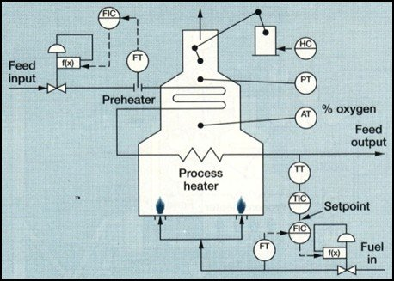
An example would be if the operator wants a flow rate of 50% through the heater, he will set that on the transmitter which will send a signal to the valve to open or close. If the transmitter reads 0% flow rate, then a signal will be sent to the valve telling it to open to allow more flow through the pipes. As the flow rate increases and gets closer to the desired output, the valve will start to open at a slower rate and may overshoot. The flow rate may increase over the set point to 65%, the signal sent to the valve will then tell the valve it needs to close to bring the flow rate back down to the desired value, as the valve closes off it may cause the flow to go below the set point to 40%, from here the process will repeat until the flow rate reaches the desired output. The instrument will need to be tuned in order to reach the desired output in the most efficient time.
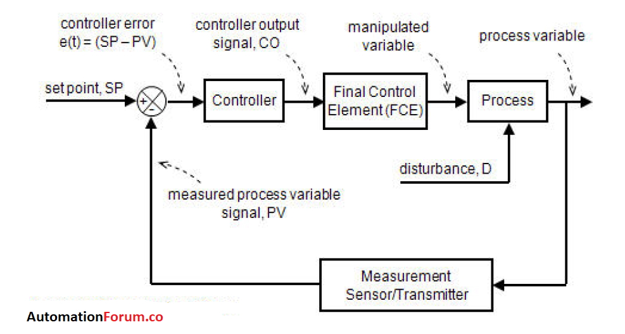
The type of control method used in this application is continuous control. The flow is continuously being monitored by the transmitter and is being controlled by the valve continuously. Continuous control is where a feedback loop is where a control system has a feedback loop between the output and the input. For this example, the flow rate will be the output and feedback from the flowrate will be fed into the input, which is the valve, and this system will adjust when required, in order to achieve the desired output. King (2011) said that continuous control allows for precise adjustment of the input variable in response to changes in the output variable. This ensures that the output stays within the desired range and reduces the risk of process failures.
There are other types of control which could have been used in this example. One of the other types of control is batch control. This is where a set amount of product is processed in a single batch, or a series of batches, in order to achieve the desired output. A batch control system is split into different stages that happen in a batched type of process. A set of variables will be established, for example, the first batch is to put ten litres of liquid into this tank, as well as, putting five litres of a different liquid into the tank. This process will be monitored by an operator to ensure that the sequence is being done as required. The process can be done on a much larger scale than this.
Another type of control is sequential control. This type of control system will determine the order of which the steps of the process are carried out. It is used to ensure the next step in the process will not commence, until the step before it has been completed. Once the set outputs are met by each step, the next step can then begin. This is done by using different sensors and transmitters to indicate when the demands are met.
Regulators are used in control systems to respond to a change in the input value so that they can bring the system back to a steady state, at the desired output. There are two categories that regulators are split into, continuous and discontinuous. Continuous regulators are receiving one or more values from feedback continuously. A continuous regulator will be used in the control system above, and the valve will be that regulator. The valve will receive values from the flow controller and will adjust its position in order to achieve the desired flow rate value.
A discontinuous regulator works differently to a continuous regulator as it operates intermittently. This works in an on/off like manner. An example would be the heating in a house, a temperature will be set by the user, and the heating will turn on until it reaches the set point, it will then turn off once it goes above this set point. If the temperature falls below the threshold, then the heating will turn back on, and the process will repeat. This type of regulator can lead to major overshoot or undershoot as they are not as precise as continuous regulators.

Task 2 – Tuning
- Explain 2 tuning techniques that can be used for control systems.
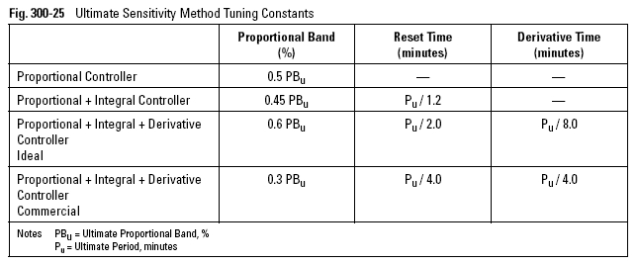
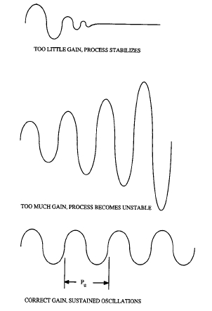
There are 2 tuning techniques that can be used for control systems. One of those methods is the ultimate tuning method. This method is used for tuning PID controllers so that the system responds quickly and accurately to setpoint changes, disturbances and other external factors. The ultimate tuning method measures the systems response to sustained oscillation by introducing a step change and changing the gain on the controller until it oscillates at a constant amplitude. This oscillation can then be measured so that the ultimate gain can be calculated. The image on the right shows an example of if there is too little or too much gain. At the bottom is also an example of the right amount of gain. As you can see, when the lines oscillate consistently at the same height, this is where the correct amount of gain is achieved. The table below shows the calculations used to achieve the correct amount of gain. Jack (2022) states that there is a commercial set of calculations and an ideal set of calculations. He says that the commercial set of calculations should be used in the industry to deal with real life environments and the ideal calculations are mainly used in university’s where the environment conditions are perfect.
One example of where this method can be used in industry is controlling the temperature in a reactor. It is important that the temperature in a reactor is maintained at the required temperature to ensure it cannot overheat, and also so that the product quality from the reactor is accurate. The ultimate tuning method can be applied to this controller to achieve the best control performance. The operator can apply a step change to the temperature and measure the response curve. From here the ultimate gain and period can be measured which then allows the operator to calculate the proportional, integral and derivative gains which can be used to define a more accurate control system. After these have been calculated and implemented into the system, it should operate faster, with less overshoot and a better stability of control.

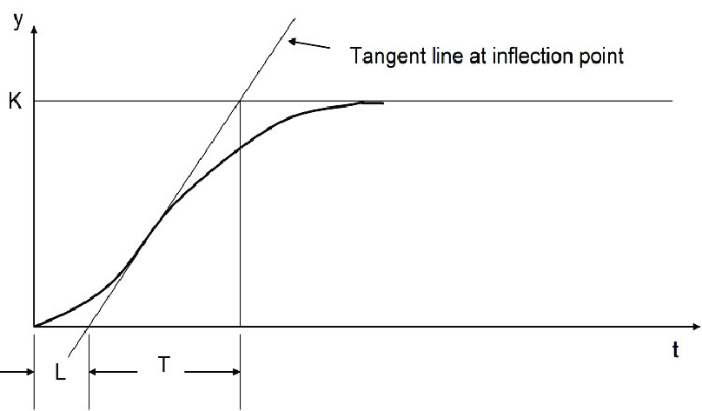
Another tuning method that is used is the reactive tuning method which differs from the ultimate tuning method in the approach it takes to calculate the controller gains. The reaction curve method is calculated by measuring the process response to a step change in the set point and plotting the resulting curve. It identifies the time taken for the system to react from the step change and it then looks at the reaction time and ultimate gain of the system. Then, based on the ultimate gain of the system the controller gains can be calculated to achieve the desired parameters. The reaction curve is simpler than the ultimate curve to calculate, however the results may not be optimal.
Similarly, to the previous method, we can control the temperature in a reactor using this method, however, it will be executed slightly differently. If the control operator identifies that the temperature sensor is oscillating more than desired, they can tune it by introducing slight disturbances to the process and seeing how the controller reacts to it. For example, they could increase the flow rate slightly which may decrease the temperature slightly and observe how the temperature controller reacts. They can then analyse these results and adjust the controllers settings to improve the performance of the system.
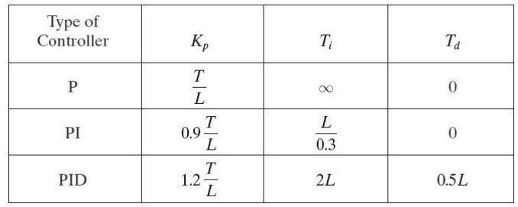
The table on the right shows the calculations needed in order to calculate the reaction curve to achieve the desired results.

- Briefly explain the difference between First and Second Order systems.

A first order system is a type of dynamic system that’s input/output relationship is a first-order differential equation. These systems have a single energy storage element such has a single capacitor or single inductor. The first order system has a time constant which will control how quickly the system reaches its steady state. It also depends on the input signal. The equation for a first order system can be seen below.

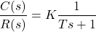

K is the DC Gain of the system ratio between the input signal and the steady state output.
T is the time constant of the system. (How quickly the first order system responds to a unit step input. (Electrical4u, 2021)

According to Ogata (2010), the second order of a control system is a type of dynamic system that can be modelled by a second-order differential equation. This means that they have two energy storage elements compared to just the one. For example, two capacitors or two inductors. The natural frequency determines how quickly the system oscillates and the damping ratio will affect the rate at which the oscillations decay over time. The general equation for second order control systems can be seen below.

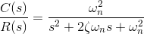

Here, ζ and ω_{n} are the damping ratio and natural frequency of the system, respectively. (Electrical4u, 2021)
The main difference between first and second order systems is that the number of energy storage elements is different. First order systems have one whereas second order systems have two. Another difference is the complexity of the differential equations that are used for them.

- Figure 1 show a heating system with a PID controller. With user-defined simulator settings the system has induced a steady-state error. Using the process reacting tuning method determine (and show the resultant response curve) of the new values for the PID controller and evaluate its performance.

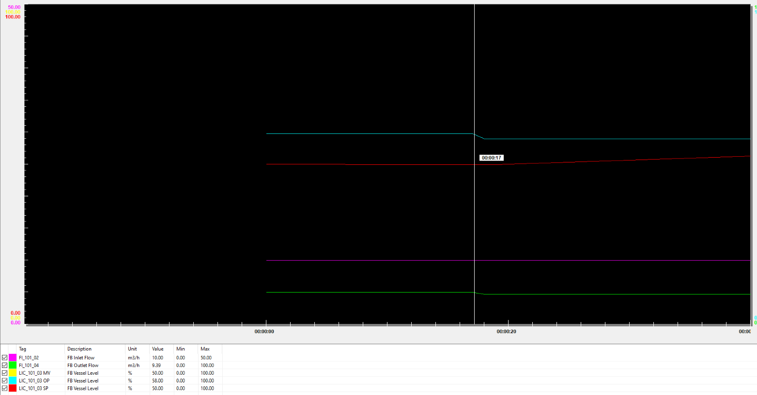
The above image shows the point at which the set point is changed, prior to adjusting any of the tuning. At 17s the valve is set to 59.6%.
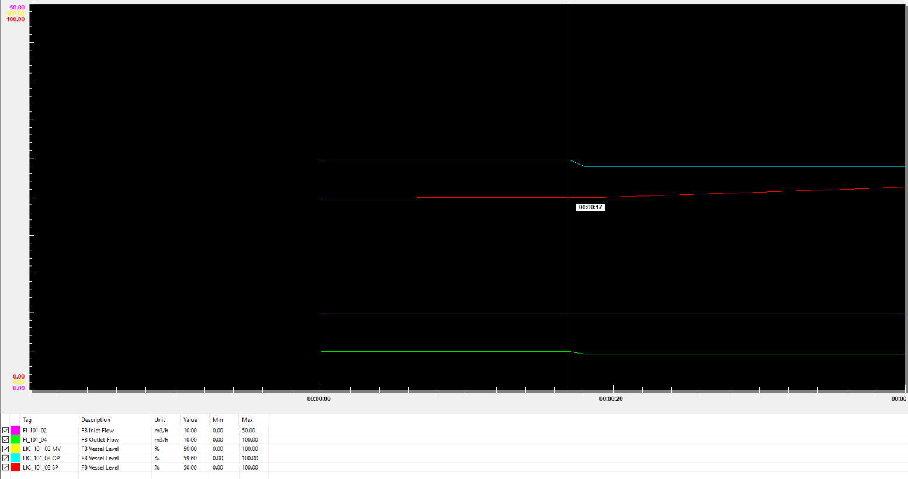
The valve set point is then changed to 58%, also at 17s. as the system is not tuned yet, it takes a few seconds to respond.
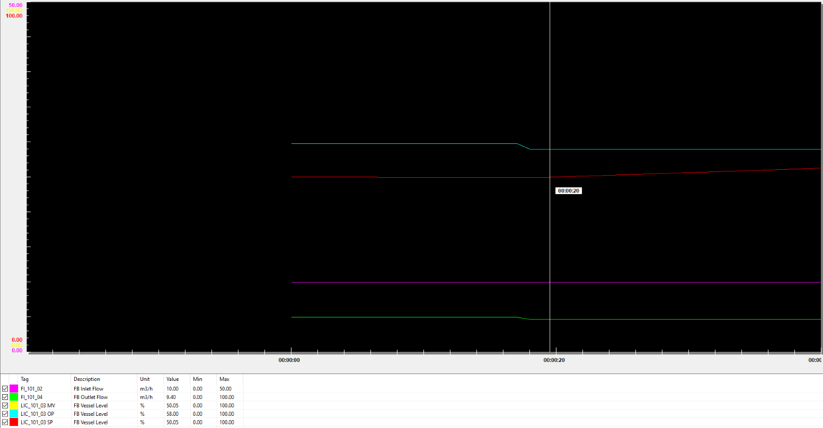
At around 20 seconds, the level in the column begins to change. This took 3 seconds after the change in valve position had occurred.

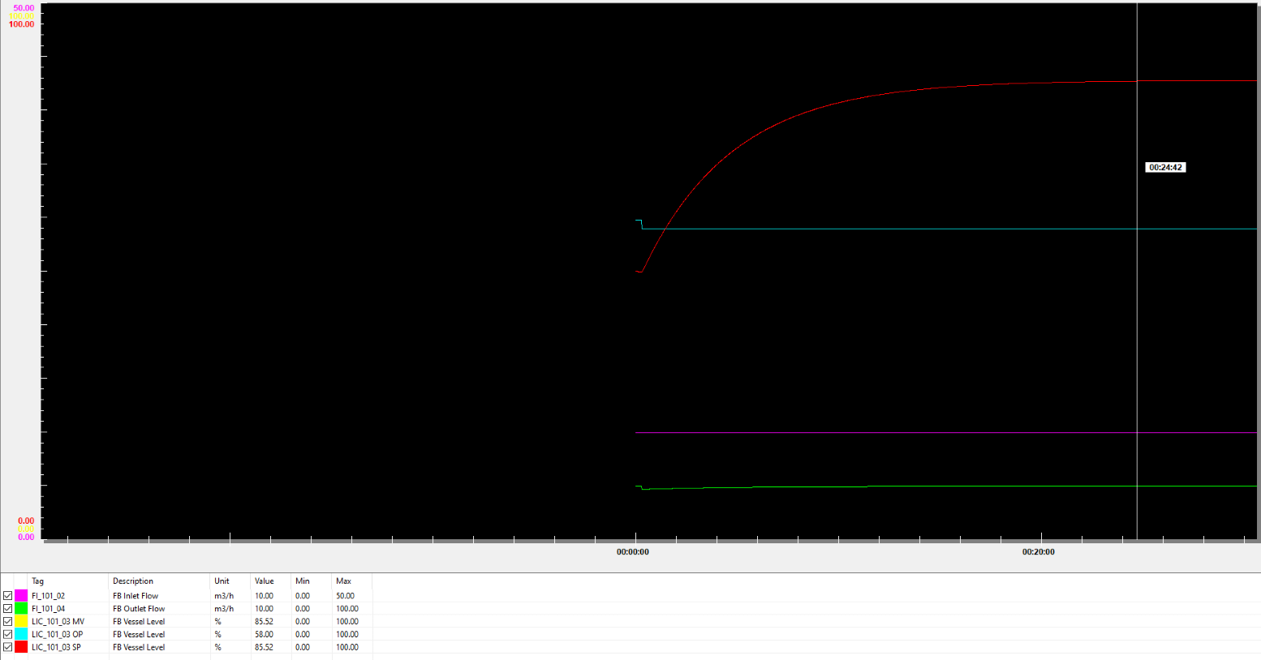
The level in the column reaches its final steady state at 24 minutes and 42 seconds. This means from the point of changing the set point on the valve, to the level reaching a steady state, took 24 minutes and 25 seconds.
To improve the time taken to reach a steady state, calculations were carried out so that the level controller could be tuned to work faster and more accurately.

Controller gain = 1.2(Du ÷ ND)
Controller gain = 1.2 (35.52 ÷ 3)
Controller gain = 14.208

Integral = 0.5 ÷ D
Integral = 0.5 ÷ 3
Integral = 0.166

Derivative = D ÷ 2
Derivative = 3 ÷ 2
Derivative = 1.5

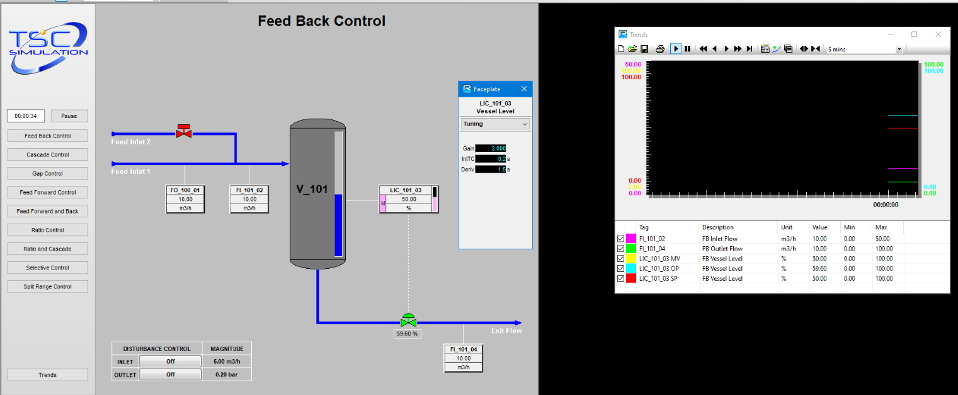
The above image shows the new figures put into the tuning of the level controller. These new figures should ensure the steady state can be achieved faster than before.
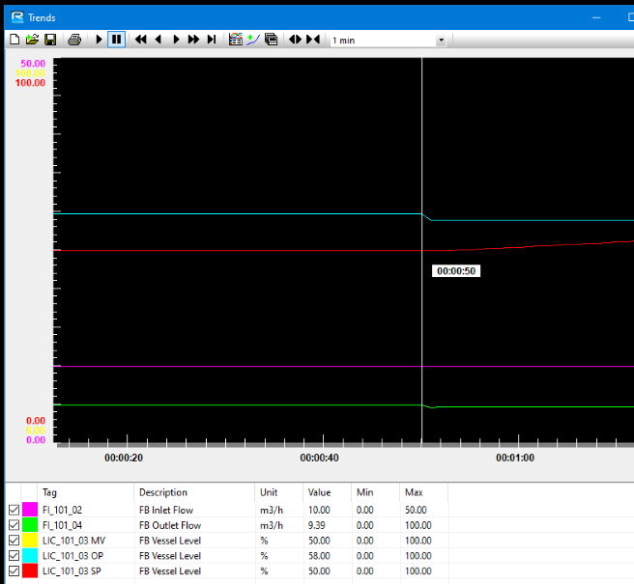
At 50 seconds, the valve set point is changed from 59.6% to 58%, as per previous test.
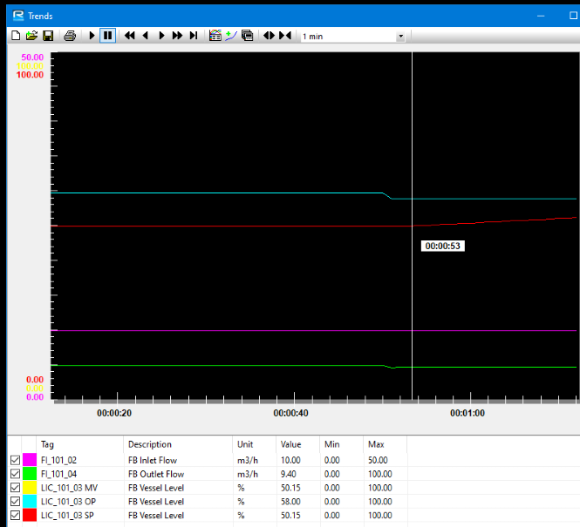
Similarly, to the previous test, it took 3 seconds for the level in the column to change.
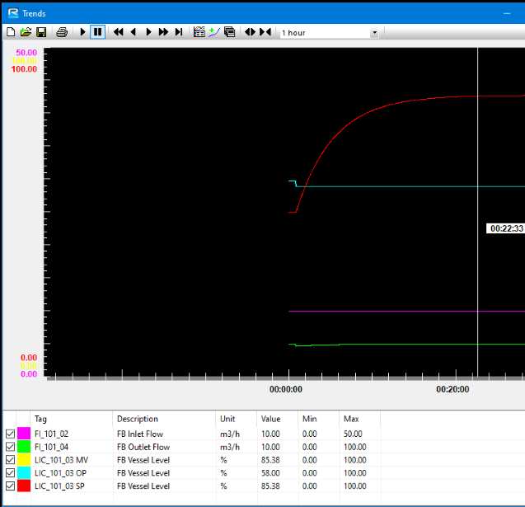
The level in the column reaches its steady state at 22 minutes and 33 seconds. This means that the system took 21 minutes and 43 seconds to reach its steady state. This is 3 minutes and 42 seconds than the previous test before the controller was tuned.

Bibliography
Bolton W. Instrumentation and control systems, 2nd Edition. Newnes. ISBN: 9780081006139 (2015)
First Order Control System: What is it? (Rise & Settling Time Formula) (2021) Electrical4U. Available at: https://www.electrical4u.com/first-order-control-system/?utm_content=cmp-true (Accessed: 09 May 2023).
Hesketh, j. D. (2005). Process control systems: application, design, and adjustment. John Wiley & Sons [Accessed: 30 April 2023]
King, M. (2011). Process control: A Practical Approach. John Wiley & Sons. [Accessed: 28 April 2023]
Jack (2022). ‘Controller Tuning – Ultimate Sensitivity Method’, Oil & Gas Process Engineering [online] Available at: Controller Tuning - Ultimate Sensitivity Method - Oil & Gas Process Engineering (oilngasprocess.com) [Accessed: 2 may 2023]
Ogata, K. (2010) Modern Control Engineering. Pearson Education, Inc. [Accessed: 6 May 2023]
Time response of second order control system (worked example) (2021) Electrical4U. Available at: https://www.electrical4u.com/time-response-of-second-order-control-system/ (Accessed: 11 May 2023).
Images
(1997) Figure 5: Conventional Heater Control Scheme - Researchgate. Available at: https://www.researchgate.net/figure/Conventional-heater-control-scheme_fig7_236543849 (Accessed: 04 May 2023).
(2020) Process reaction curve (ogata,2010) table 1: Tuning rule ... - researchgate. Available at: https://www.researchgate.net/figure/Process-Reaction-Curve-Ogata-2010-Table-1-Tuning-Rule-Table-for-Ziegler-Nichols_fig2_343969081 (Accessed: 08 May 2023).
(No date) Tuning for PID controllers - mercer university. Available at: https://faculty.mercer.edu/jenkins_he/documents/TuningforPIDControllers.pdf (Accessed: 02 May 2023).
Sivaranjith (2018) Continuous control mode- P, PD, PI & PID Control modes, Instrumentation and Control Engineering. Available at: https://automationforum.co/continuous-control-mode-p-pd-pi-pid-control-modes/ (Accessed: 05 May 2023).

GUIDANCE FOR Students
IN THE COMPLETION OF TASKS

NOTE: The guidance offered below is linked to the five generic assessment criteria overleaf.

- Engagement with Literature Skills
Your work must be informed and supported by scholarly material that is relevant to and focused on the task(s) set. You should provide evidence that you have accessed an appropriate range of sources, which may be academic, governmental and industrial; these sources may include academic journal articles, textbooks, current news articles, organisational documents, and websites. You should consider the credibility of your sources; academic journals are normally highly credible sources while websites require careful consideration/selection and should be used sparingly. Any sources you use should be current and up-to-date, mostly published within the last five years or so, though seminal/important works in the field may be older. You must provide evidence of your research/own reading throughout your work, using a suitable referencing system, including in-text citations in the main body of your work and a reference list at the end of your work.

Guidance specific to this assessment: You must provide evidence of individual research with respect to the control system types, tuning methods and computerised control systems. You should use a number of references, from a variety of sources including textbooks, academic journals and academic based websites. Do not use less credible sources, for example internet sites such as Tutor2U and Wikipedia.
The Harvard system of referencing must be employed to evidence research. Give credit to respected authors on whose work your discussion is based; this avoids accusations of plagiarism, and reflects the breadth of your research. Your use of in-text citations and the reference list at the end of the report will be closely examined to ensure that you are conforming to referencing convention. An extensive reference list and good use of in-text citations will earn marks, limited references and errors in citations will result in a loss of marks.

- Knowledge and Understanding Skills
At level 4, you should be able to demonstrate knowledge of the underlying concepts and principles associated with your area(s) of study. Knowledge relates to the facts, information and skills you have acquired through your learning. You demonstrate your understanding by interpreting the meaning of the facts and information (knowledge). This means that you need to select and include in your work the concepts, techniques, models, theories, etc. appropriate to the task(s) set. You should be able to explain the theories, concepts, etc. to show your understanding. Your mark/grade will also depend upon the extent to which you demonstrate your knowledge and understanding.

Guidance specific to this assessment: Your report should show you have gained knowledge and understanding of the second order systems and tuning methods referred to in this assignment. Based on your knowledge of second order systems and tuning methods, determine suitable values to cover the requirement of the tasks specifications.

- Cognitive and Intellectual Skills
You should be able to present, evaluate and interpret qualitative and quantitative data, in order to develop lines of argument and make sound judgements in accordance with basic theories and concepts of your subject(s) of study. You should be able to evaluate the appropriateness of different approaches to solving problems related to your area(s) of study and/or work. Your work must contain evidence of logical, analytical thinking. For example, to examine and break information down into parts, make inferences, compile, compare and contrast information. This means not just describing what! But also justifying: Why? How? When? Who? Where? At what cost? You should provide justification for your arguments and judgements using evidence that you have reflected upon the ideas of others within the subject area and that you are able to make sound judgements and arguments using data and concepts. Where relevant, alternative solutions and recommendations may be proposed.

Guidance specific to this assessment: The report should show evaluation of the responses obtained for the position controller and tank level system. Don’t just LIST the different concepts (avoid bullet points). This may involve you having to synthesise information from different sources, combining their views in a meaningful analysis - don't over-use direct quotes as they are someone else’s words, and do not fully demonstrate your skills of interpretation.

- Practical Skills
At level 4, you should be able to apply the basic underlying concepts and principles to evaluate and interpret these within the context of your area of study. You should be able to demonstrate how the subject-related concepts and ideas relate to real world situations and/or a particular context. How do they work in practice? You will deploy models, methods, techniques, and/or theories, in that context, to assess current situations, perhaps to formulate plans or solutions to solve problems, or to create artefacts. This is likely to involve, for instance, the use of real-world artefacts, examples and cases, the application of a model within an organisation and/or benchmarking one theory or organisation against others based on stated criteria.

Guidance specific to this assessment: Build and test the control systems using Xcos verify correct operation against expected theoretical and specified outcomes.

- Transferable Skills for Life and Professional Practice
Your work must provide evidence of the qualities and transferable skills necessary for employment requiring the exercise of some personal responsibility. This includes demonstrating: that you can communicate the results of your study/work accurately and reliably, and with structured and coherent arguments; that you can initiate and complete tasks and procedures, whether individually and/or collaboratively; fluency of expression; clarity and effectiveness in presentation and organisation. Work should be coherent and well-structured in presentation and organisation.

Guidance specific to this assessment: Your work should be well organised and presented in a professional manner.
Writing style: All writing should be academic in style, formal, focused, concise and subject specific. You should write in the third person. For example, rather than ‘I found…’ you should say something like ‘It was evident…’. Do not use contractions (for example, it’s should be it is), and avoid slang and clichés (such as 'if you pay peanuts, you get monkeys'). Be concise, don't belabour points. You don't have to use 'big' words or long sentences; the aim is to be understood. A writing style that is clear, simple and direct usually works well. Edit your work to ensure your writing style is ‘tight’.

Presentation: The report should be word processed. All graphs, charts and figures in the main body must be clearly labelled and referenced beside or beneath. Where possible they should not be on separate pages but should be incorporated within the text. Ensure there are no spelling errors by spellchecking your work. Also undertake a grammar check in Word, and it may help you to ask somebody to proof-read your work to identify errors.
References: Alphabetical list of authors and their work cited in the report. Use the Harvard system of referencing.
Appendices: where relevant. Avoid ‘padding’

Essential Resources:
• Resources listed on the lecture schedule and on Moodle
• The student handbook

Student FEEDBACK FORM

This section details the extent to which the assessment criteria are demonstrated by you, which in turn determines your mark. The marks available for each category of skill are shown. Lecturers will use the space provided to comment on the achievement of the task(s), including those areas in which you have performed well and areas that would benefit from development/improvement.

Generic Assessment Criteria | Marks available | Marks  awarded
1. Engagement with Literature Skills  . | 20
2. Knowledge and Understanding Skills | 35
3. Cognitive and Intellectual Skills | 10
4. Practical Application Skills | 25
5. Transferable Skills for Life and Professional Practice | 10

Assessment Mark (Assessment marks are subject to ratification at the Exam Board. These comments and marks are to give feedback on module work and are for guidance only until they are confirmed. ) | Late Submission Penalties (tick if appropriate) |  | %
 | Up to 1 week late (40% Max) |  | %
 | Over 1 week late (0%) |  | %

GENERIC ASSESSMENT CRITERIA

Level 4
In accordance with the Framework for Higher Education Qualifications, at the end of Level 4 students will be expected to have demonstrated knowledge of the basic underlying concepts and principles of a subject, and an ability to evaluate and interpret these within the context of that area of study. They should be able to present, evaluate and interpret qualitative and quantitative data in order to develop lines of argument and make sound judgements in accordance with basic theories and concepts of their subject(s) of study. They will have learned how to evaluate different approaches to solving problems, and will be able to communicate the results of their study/work accurately and reliably, and with structured and coherent arguments. They will be able to undertake further training and develop new skills within a structured and managed environment and will have the qualities and transferable skills necessary for employment requiring the exercise of some personal responsibility.

Level 5 | FAIL | MARGINAL FAIL | SATISFACTORY  (3rd / Pass) | GOOD  (2.2 / Pass) | VERY GOOD  (2.1 / Merit) | EXCELLENT  (1st / Distinction) | EXCEPTIONAL  (1st / Distinction)
Category | 0-29% | 30-39% | 40-49% | 50-59% | 60-69% | 70-84% | 85-100%
Engagement with literature (including reading, referencing,  academic conventions and  academic honesty) | Little or no evidence of reading and/or reliance on inappropriate sources.  Views and findings mostly unsupported and non-authoritative.  Referencing conventions used incoherently or largely absent. | Poor engagement with essential reading. No evidence of wider reading. Reliance on inappropriate sources, and/or indiscriminate use of sources. Heavily reliant on information gained through class contact. Inconsistent and weak use of referencing. | Engagement with a limited range of mostly relevant and credible sources but with some reliance on information gained through class contact. Some omissions and minor errors.  Referencing conventions evident though not always applied accurately or consistently. | Engagement with an appropriate range of literature, including sources retrieved independently. Some over-reliance on texts rather than other sources. Referencing may show minor inaccuracies or inconsistencies. | Engagement with a wide range of literature, including sources retrieved independently.  Selection of relevant and credible sources. Generally sound referencing, with no/very few inaccuracies or inconsistencies. | Engagement with an extensive range of relevant and credible literature. Consistently accurate application of referencing. | Engagement with literature (including reading, referencing,  academic conventions and academic honesty)
Knowledge and understanding (Knowledge of the basic underlying concepts and principles of a subject.) | Major gaps in knowledge and understanding of the basic underlying concepts and principles of the subject matter. Inclusion of irrelevant material. Substantial inaccuracies. | Gaps in knowledge of the basic underlying concepts and principles, with flawed or superficial understanding. Some significant inaccuracies and/or irrelevant material. | Limited knowledge and understanding of the basic underlying concepts and principles within the subject area. Some elements may be missing. | Knowledge of the basic underlying concepts and principles is accurate with a good understanding of the field of study but lacks depth and/or breadth. | Competent knowledge of the basic underlying concepts and principles. Exhibits very good understanding. | Excellent knowledge and understanding of the basic underlying concepts and principles of the subject. | Exceptional, detailed knowledge and understanding of the basic underlying concepts and principles
Cognitive and intellectual skills  (Evaluate underlying concepts and principles of a subject and interpret qualitative and quantitative data in order to develop lines of argument and make sound judgements.) | Wholly or almost wholly descriptive work. Little or no evaluation of the underlying concepts and principles.  Failure to develop arguments, leading to illogical or invalid judgements. Minimal or no use of evidence to back up views. | Largely descriptive work, with superficial evaluation of the underlying concepts and principles. Weak interpretation of data, flawed development of arguments and judgements. Information accepted uncritically, uses generalised statements made with scant evidence and unsubstantiated opinions. Ideas sometimes illogical and contradictory. | Limited attempt at evaluation of the underlying concepts and principles, tending towards description.  Can interpret qualitative and quantitative data but with some errors. Some evidence to support emerging arguments and judgements but these may be underdeveloped or with a little inconsistency / mis-interpretation. | Good evaluation of the underlying concepts and principles. Can interpret qualitative and quantitative data, with minor errors.  An emerging ability to use evidence to support the argument.  Mostly valid arguments and logical judgements. | Sound evaluation of the underlying concepts and principles. Can interpret qualitative and quantitative data accurately. Ability to devise arguments using evidence to make mostly appropriate and valid judgements. | Excellent evaluation of the underlying concepts and principles. Can interpret qualitative and quantitative data accurately and with some insight. Excellent ability to devise arguments using evidence and make appropriate and valid judgements. | Exceptional evaluation of the underlying concepts and principles based evidence. Outstanding interpretation of qualitative and quantitative data.  Exceptional ability to devise arguments using evidence and make wholly appropriate and valid judgements.
Practical skills  (Different approaches to solving problems in particular contexts.) | Limited or no use of taught, basic methods, materials, tools and/or techniques.  Little or no appreciation of the context of the application.  Very weak evidence of different approaches to problem-solving in particular contexts. | Rudimentary application of taught, basic methods, materials, tools and/or techniques but without consideration and competence. Flawed appreciation of the context of the application.  Weak evidence of different approaches to problem-solving in particular contexts. | An adequate awareness and mostly appropriate application of basic methods, materials, tools and/or techniques.  Basic appreciation of the context of the application.  Can identify problems in particular contexts and propose basic alternative approaches or solutions though there may be errors. | A good and appropriate application of basic methods, materials, tools and/or techniques.  Clear appreciation of the context of the application.  Good evidence of different approaches to problem-solving in particular contexts and proposes mostly appropriate solutions. | A very good application of a range of basic methods, materials, tools and/or techniques.  Very good consideration of the context of the application. Very good evidence of different approaches to problem-solving in particular contexts and proposes appropriate solutions. | An advanced application of a range of taught, basic methods, materials, tools and/or techniques.  The context of the application is well considered, and insightful.  Excellent evidence of different approaches to problem-solving in particular contexts and proposes appropriate solutions. | Exceptional levels of application and deployment skills in particular practical contexts. Outstanding identification of problems in particular contexts and formulation of wholly appropriate, thoughtful solutions / different approaches.
Transferable skills for life and professional practice  (Communicate the results of their study/work accurately and reliably, and with structured and coherent arguments; the qualities needed for employment requiring the exercise of some personal responsibility within a structured and managed environment.) | Work is poorly structured, disorganised, inaccurate and/or confusingly expressed. Very weak use of language and/or very inappropriate style. Failure to work effectively individual or as part of a group. Little or no evidence of the skills for employment requiring the exercise of some personal responsibility. | Work is poorly presented in a disjointed manner. It is loosely, and at times incoherently, structured, with information and ideas often poorly expressed. Weak use of language and/or inappropriate style. Flawed approach to individual or group work, meeting only partial obligations to others. Limited evidence of the skills for employment requiring the exercise of some personal responsibility. | Mostly ordered presentation and structure in which relevant ideas / concepts are reasonably expressed. Work may lack coherence and/or accuracy in places. Can work as part of a group, meeting most obligations to others but perhaps with limited involvement in group activities.  Demonstrates the basic skills for employment requiring the exercise of some personal responsibility, with some areas of minor weakness. | Mostly coherent, organised and accurate work, in a suitable structure and is for the most part clearly expressed. Can work effectively independently and/or as part of a team, with clear contribution to group activities.  Demonstrates the skills for employment requiring the exercise of some personal responsibility, with some areas of strength and some of minor weakness. | Work is accurate, coherent, fluent, well-structured and organised.  Can work effectively independently and/or as part of a team, with very good contribution to group activities. Demonstrates very good skills for employment requiring the exercise of some personal responsibility, with just occasional minor weakness. | Work is coherent, very fluent and is presented professionally. Can work effectively independently and/or as part of a team, with an excellent contribution to group activities. Demonstrates excellent skills for employment requiring the exercise of some personal responsibility with an appetite for further development. | Work is accurate, exceptionally coherent, very fluent and presented well. Can work effectively independently and/or as part of a team, with an exceptional contribution to group activities. Demonstrates exceptional skills for employment requiring the exercise of some personal responsibility with an appetite for further development.

