Managing Professional Practice in Advocacy: Funding Bid
ECED7004 Assessment 2 Section 1

Veterans and Military Mental Health (VMMH) and Well-being Advocacy Organisation’s mission is to empower our clients. However, an analysis of our service has identified the need for a more holistic approach when supporting our clients because of the barriers which can be caused by mental health, including Post-Traumatic Stress Disorder (PTSD). Furthermore, guidance by Gov.uk (2022) recognises the need for support for armed forces personnel, therefore the development of our services is vital. The UK government state that there are legal powers that are bounded by the Statutory Guidance on the Armed Forces Covenant Duty, under section 343AE(1) the Armed Forces Act 2006, that organisations such as the National Health Service (NHS) Trust must consider so that military personnel are not disadvantaged (Ministry of Defence, 2022). Also, service men and women are seen more urgently under the Armed Forces Covenant for conditions linked to military service, including mental health (Ministry of Defence, 2022). There are also NHS services which are available under Op COURAGE, however, it is argued that these services are stretched because of the number of referrals made to our service.
This paper is a continuation of assignment three; a portfolio which supports the funding for a new initiative. This portfolio will include a funding bid application (Appendix 4) to The Armed Force’s Covenant fund for developing the holistic approach to veterans’ mental health, which intends to develop its services to meet the needs of the community. This assignment uses the Armed Force’s Covenant fund because of its relevant funding and understanding centred around veterans’ well-being (Appendix 1). An explanation of the four complimentary treatments we would like to make available to our clients will be explained and an outline of the importance and effectiveness of each treatment.

Shepherd, et al. (2020) have identified the causes related to difficulties encountered in the transition when veterans leave military service and return to civilian life, which is shown in the diagram below. It outlines different outcomes for veterans compared to the non-veteran workforce in transitioning back into society and lists the reason for this (Shepherd, et al., 2020). This research has influenced the way in which we deliver our services as it helps to improve staff understanding of the causes of mental health and the barriers faced by military personnel.

VMMH and Well-being Advocacy Organisation address barriers that can prevent military personnel from accessing services, such as stigma. Although it has proven hard to find up-to-date research in this area it is demonstrated by Sharp, et al. (2014, pp. 144) that ‘across military studies, one of the most frequently reported barriers to help-seeking is concerns about stigma’. This opinion is reciprocated by Clement, et al. (2015) who argue that mental health stigma has a moderate effect on service personnel when seeking help. Therefore, this is an area that will be considered by the organisation when offering these treatments. As illustrated in the diagram below stigma has become one of the factors in which our clients struggle to seek help for mental health, as within the military community it is a sign of weakness (Williamson, et al., 2019). Research carried out about ‘military stigma’ describes characteristics such as prejudices and consequential barriers to veterans reaching out for medical or psychiatric treatment and having negative mental health effects (Clement, et al., 2015).
Diagram A
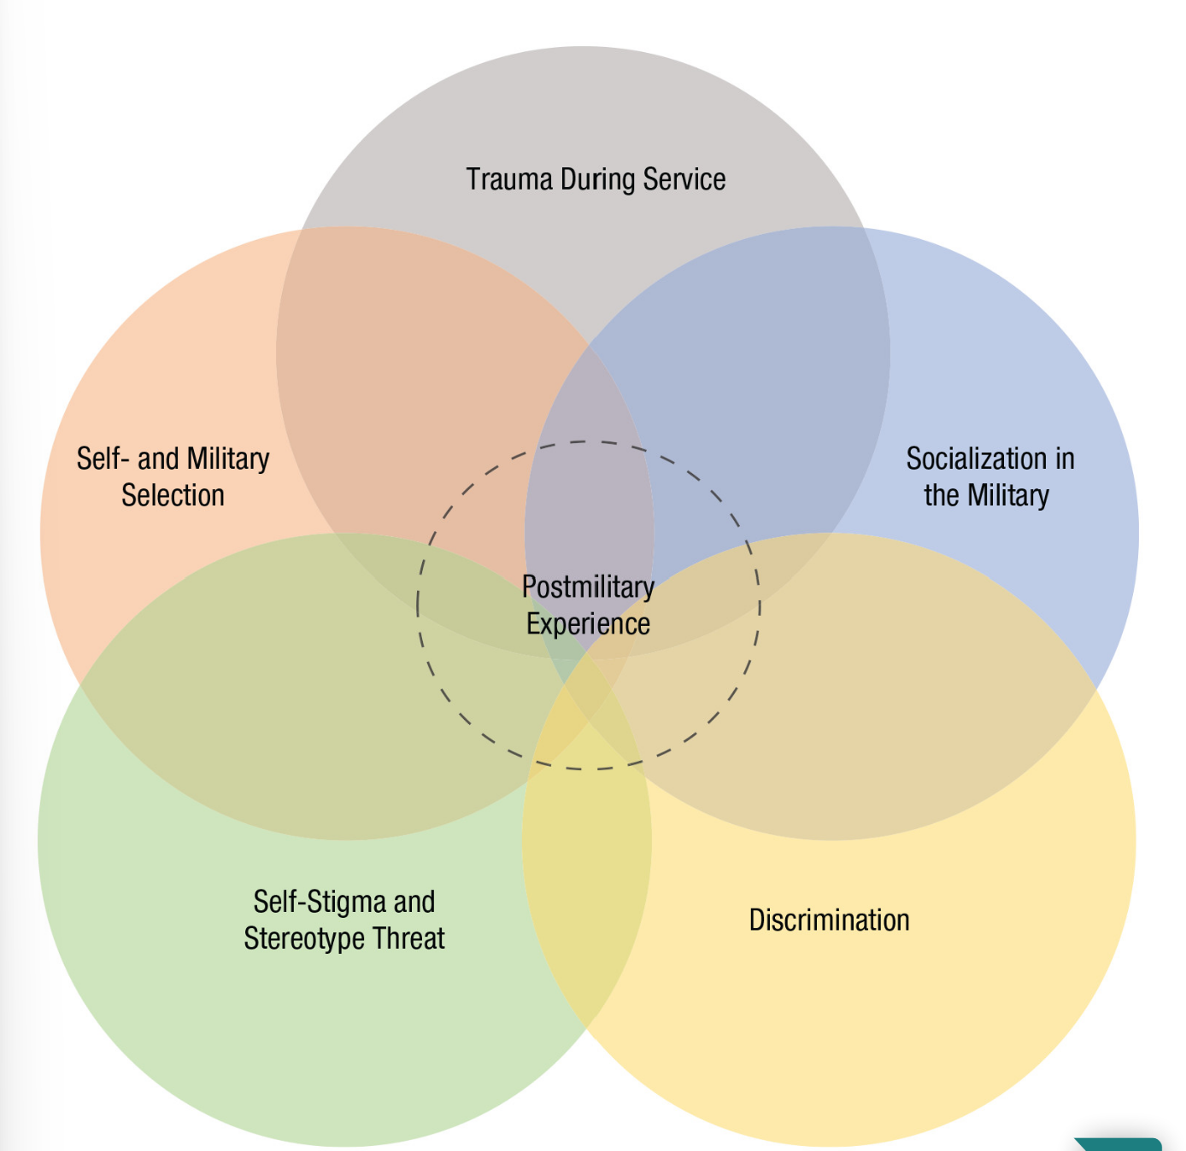

Causes of Differential Outcomes for Veterans and the Unique Contribution of Psychological Theories
(Shepherd, et al., 2020)
Furthermore, Godier-McBard, et al. (2021) explain that military women found barriers to accessing mental health services due to ‘gender stigma’. Primarily, this could be argued, is because of male dominance in the forces as support has been centred around the male gender (Godier-McBard, et al., 2021). This research also found that there is a lack of trust in healthcare personnel and that there are not enough specialists or professionals within the mental health military services (Godier-McBard, et al., 2021).
Our organisation is applying knowledge and understanding of suicide and mental health issues in military personnel and is examining contributing factors that may lead to negative outcomes. One of the studies which was examined is by the University of Manchester which suggests that veterans that are under 25 and have served less than 10 years in the forces have a greater risk of suicide (Gov.UK, 2022). It is also reported by The Royal British Legion (2016) 420,000 ex-service personnel suffer from depression. PTSD in veterans has been recognised in the armed forces since 1980 (Crocq, et al., 2000) and the demand for support in recent times has become much greater (Veterans NHS Wales, no date). Other mental health conditions suffered by service men and women include grief, depression, drug and alcohol misuse, dementia, anxiety and loneliness (Veterans Gateway, 2017).
VMMH and Well-being Advocacy Organisation are empowering our clients to seek specialist help to break through barriers in order to re-integrate back into society and establish better-coping mechanisms related to trauma and mental health-related issues. In order for our work to move forward, important research by our organisation has identified more effective means of support for our clients. It is understood that every individual’s needs vary making some individuals more vulnerable than others because of their levels of resilience. It is recognised by Leppin, et al. (2014) that resilience is defined as an individual’s ability to cope with challenges faced in everyday life and is imitated by psychological resilience and characteristics such as the ability to withstand adversity and persistence.

With this in mind, it is important that military personnel are offered a variety of treatments to suit individual needs. In respect of this, we would like to introduce four different therapies we believe our clients would benefit from:-
- Hypnotherapy
- Cognitive Behaviour
- Trauma Resilience Coaching
- RTM Protocol

American research illustrated by Watts, et al. (2013) and cited by The National Center for PTSD (2015, Table 1) recognises the effectiveness of Cognitive Behaviour Therapy (CBT). The table also shows the results of the improved outcomes for participants with PTSD. This result clearly shows that CBT is a more effective alternative to antidepressant tablets. This is one of the reasons why we have chosen this particular treatment.
Table 1: Cognitive Treatment versus Anti-depressants
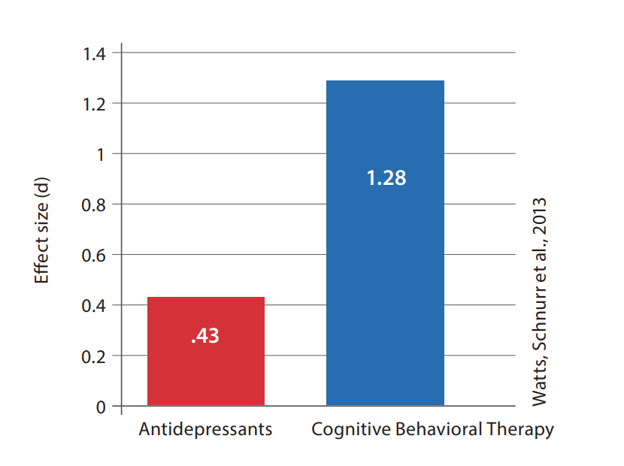
(Watts, et al., 2013, as cited by The National Center for PTSD, 2015).
Further treatments also researched by our organisation include hydrotherapy. Although this is not a cure for PTSD as such, it has been reported that it can help ease the symptoms and make them less severe (PTSD UK, 2023). This is something we would like to make available to our clients alongside any treatments they currently receive that deal with underlying issues (PTSD UK, 2023). Treatments using water have been around for thousands of years and hydrotherapy sometimes used as an alternative to medicine helps with physical and mental health with successful results (Brabble, 2020).
Another treatment we would like to offer is the Reconsolidation of Traumatic Memories (RTM) Protocol, which considers the potential impact this service would have on our clientele. This is recognised as a trauma-focused treatment, which is a process in which the memory is retrieved and altered with no distress caused to the individual and can be seen as more effective than talking (The Evolution Group Inc, 2016). The effectiveness of the treatment was outlined in research by Sturt, et al. (2022), where tests were carried out on 2 groups of soldiers suffering from all severities of post-traumatic stress disorder. RTM Protocol and Trauma-Focused Cognitive Behaviour Treatment (TFCBT) groups were assigned to 60 soldiers and the results stated ‘48% of the RTM group no longer met diagnostic criteria for PTSD compared to 16% in the TFCBT group’ (Sturt, et al., 2022, pp. 3).
As mentioned previously clients will respond differently to different teatments, therefore, we consider it important to be able to offer a range of options. In light of this we are also interested in offering Trauma Resilience coaching ‘ the goal of resilience training is to develop the ability to alleviate or even inoculate against the negative psychological effects of a psychologically painful experience’ (Thompson and Dobbins, 2018, pp. 24). Our organisation would like to introduce this treatment to help clients recognise the signs of stress, learn coping strategies and prepare and empower them for future events or circumstances that they may find difficult (Crown, 2020).
Our organisation has considered realistic and achievable developments which will enhance positive outcomes for our clientele. By extending our services we can reach more people, and although all results and outcomes may vary depending on the individual, it is considered that by offering a range of treatments people will have more choice. A funding bid will follow giving a further explanation of our mission, which seeks to empower and break down barriers for veterans and service personnel so that they can live a more equal and healthier life.

References
Brabble, J. (2020) Healing Waters: Hydrotherapy and Disability after WWI. Available at: http://allofusdha.org/research/healing-waters-hydrotherapy-and-disability-after-wwi/ (Accessed: 8 March 2023).
Clement, S., Schauman, O., Graham, T., Maggioni, F., Evans-Lacko, S., Bezborodovs, N., Morgan, C., Rusch, N., Brown, J.S.L. and Thornicroft, G. (2015). Psychological medicine, What is the impact of mental health-related stigma on help-seeking? A systematic review of quantitative and qualitative studies. 45(1), pp. 11-27. Available at: https://www. proquest.com/docview/1658684309/14DEE463840C4CD1PQ/31?accountid=130472 (Accessed: 7 March 2023).
Combat Stress (2022) Living with PTSD: Craigs Story. Available at: https://www.google.com/search?q=a+case+study+on+uk+solides+ptsd+and+suicide&rlz=1C1CHZN_enGB940GB940&biw=1440&bih=809&tbm=vid&sxsrf=APwXEddO68Z1s4rXNiex3g0zHjPNLEYHpQ%3A1679948203419&ei=q_khZOmmGZOcgQbl77awBA&ved=0ahUKEwipqJ_f9vz9AhUTTsAKHeW3DUYQ4dUDCA0&uact=5&oq=a+case+study+on+uk+solides+ptsd+and+suicide&gs_lcp=Cg1nd3Mtd2l6LXZpZGVvEAMyCgghEKABEMMEEAoyCgghEKABEMMEEAo6BAgjECc6BwgjELACECc6BQgAEKIEOggIIRCgARDDBFCCE1iU_AFg34UCaAFwAHgAgAGzBIgBzxuSAQoxOS45LjIuNS0xmAEAoAEBwAEB&sclient=gws-wiz-video#fpstate=ive&vld=cid:46ab2249,vid:1ryuisnAzwQ
Covenant Fund (2023) Armed Forces Covenant Fund: Reaching and supporting Armed Forces Communities Programme. Available at: https://covenantfund.org.uk/programme/reaching-and-supporting/ (Accessed: 29 March 2023).
Crocq, M. A., and Crocq, L. (2000). ‘From shell shock and war neurosis to posttraumatic stress disorder: a history of psychotraumatology’. Dialogues in clinical neuroscience, 2(1), pp.47–55. Available at: https://doi.org/10.31887/DCNS.2000.2.1/macrocq (Accessed: 25 February).
Crown (2020) People Mental Resilience. Army be the best. Available at: https://www.army.mod .uk/people/health-wellbeing-welfare-support/health-performance-and-wellbeing-in-the-army/mental-resilience/#:~:text=MRT%20is%20designed%20to%20help,deployment% 20and%20general%20military%20life. (Accessed: 20 April 2023).
Godier-McBard, R, L., Cable, G., Wood, D, A., and Fossey, M. (2021) Gender differences in Barriers to Mental Healthcare for UK Veterans: a preliminary investigation. Available at: https://militaryhealth.bmj.com/content/jramc/168/1/70.full.pdf (Accessed: 17 April 2023).
Gov.uk (2022, a) New Figures Provide Latest Data on Veterans Suicide, Available at: https://www.gov.uk/government/news/new-figures-provide-latest-data-on-veterans-suicide (Accessed: 25 February 2023).
Gov.uk (2022, b) New Legal Powers to Support Armed Forces Families and Veterans. Available at:https://www.gov.uk/government/news/new-legal-powers-to-support-armed-forces-families-and-veterans--2 (Accessed: 31 March 2023).
Leppin, L, A., Bora,R, P., Tilburt, C, J., Gionfriddo, R, M. Zeballos-Palacios, C. Dulohery, M, M., Sood, A., Erwin, J, P., Brito, P, J., Boehmer, R, K,. and Montori, M, V. (2014) plos One The Efficacy of Resiliency Training Programs: A systematic Review and Meta- Analysis of Randomized Trials. (10)9, Available at: https://www.ncbi.nlm.nih. ngov/pmc /articles /PMC4210242/ (Accessed : 8 April 2023).
Ministry of Defence (2022) Statutory Guidance on the Armed Forces Covenant Duty: Covering the United Kingdom. Available At: https://assets.publishing.service.gov. uk/government/ uploa/system/uploads/attachment_ data/file/1116148/Armed_Forces_Covenant_Duty_Statutory_Guidance.pdf (Accessed: 31 March 2023).
Ptsd uk (2023) Hydrotherapy and PTSD. Availible at: https://www.ptsduk.org/hydrotherapy /#:~:text=Although%20hydrotherapy%20is%20unlikely%20to,deal%20with%20the%20underlying%20issue. (Accessed: 8 April 2023).
Sharp, M., Fear, T,N., Roberto , J, R., Wessely, S., Greenberg, N., Jones, N., and Goodwin, L., (2015) Epidemiologic Reviews, Stigma as a Barrier to Seeking Health Care Among Military Personnel With Mental Health Problems, Volume 37, Issue 1, pp. 144–162, Available at: https://doi.org/10.1093/epirev/mxu012 (Accessed: 7 April 2023).
Shepherd, S. Sherman, K, D. MacLean, A, and Kay, C, A. (2020) Perspectives on Psychological Science. The Challenges of Military Veterans in their Transition to the Workplace: A Call for Integrating Basic and Applied Psychological Science, (3) 16 , pp. 590-613. Available at: https://journals.sagepub.com/doi/epub/10.1177/1745691620953096 (Accessed: 6 April 2023).
Sturt, J., Rogers, R., Armour, C., Cameron, D., De Rijk, L., Fiorentino, F., Forbes, T., Glen, C., Grealish, A., Kreft, J., de Souza, M, I., Spikol, E., Tzouvara, V., and Greenberg, N. (2022) Reconsolidation of Traumatic Memories Protocol compared to Trauma Focussed Cognitive Behaviour Therapy for posttraumatic stress disorder in UK military veterans: a randomised controlled feasibility trial. Available at: https://assets.researchsquare.com/files/rs-2132714/v1/5119191c-214e-469b-ab4f-6692365d09dc.pdf?c=1666637234 (Accessed: 11 April 2023).
The Armed Forces Covenant Fund ( 2021/22) Armed Forces Covenant Fund Trust: Annual Report & Accounts 2021/22. Available at: https:// covenantfund.org.uk/ wp-content/uploads/ m2022/11 /Final -report-for-online-publication-NS091122.pdf (Accessed: 21 March 2023).
The Evolution Group Inc (2016) Trauma Treatment Specializing in Trauma Informed Care. Available at: https://www.theevolutiongroup.com/rtm-therapy-trauma-treatmen t/#:~ :text=RTM%20Therapy%20uses%20a%20short,than%20two%20or%20three%20sessions. (Accessed: 11 April 2023).
The National Center for PTSD (2015) Effective Treatment for PTSD: Consider Therapy (CBT) as First-Line Treatment, Available at: https://www.pbm.va.gov/PBM/AcademicDetailingService/Documents/Academic_Detailing_Educational_Material_Catalog/66_PTSD_NCPTSD_Provider_Effective_Treatment_for_PTSD.pdf (Accessed: 21 March 2023).
The Royal British Legion (2016) Developing Mental Health Services for Veterans in England: Royal British Legion Consultation Response. Available at: https://www.britishlegion.org.uk/docs/default-source/campaigns-policy-and-research/developing_mental_health_services_for_veterans_in_england_rbl_response.pdf?sfvrsn=57170a26_2 (Accessed: 6 April 2023).
Thompson, R, S., and Dobbins, S. ( 2017) ‘The Applicability of Resilience Training to the Mitigation of Trauma- Related Mental Illness in Military Personnel. Journal of the Psychiatric Nurses Association. Pp.23-34 (24) 1. Available at: https://journals.sagepub.com/doi/epub/10.1177/1078390317739957 (Accessed: 20 April 2023).
Veterans Gateway (2017) Access to Mental Wellbeing Support in Wales, Available at: https://support.veteransgateway.org.uk/app/answers/detail/a_id/407/~/access-to-mental-wellbeing-support-in-wales#:~:text=Common%20issues%20include%20depression%2C%20grief,provide%20expert%20advice%20and%20assistance. (Accessed: 25 February 2023).
Veterans NHS Wales (No Date) About, Available at: https://www.veteranswales.co.uk/about-us.html (Accessed: 25 February 2023).
Watts, B. V., Schnurr, P. P., Mayo, L., Young-Xu, Y., Weeks, W. B., and Friedman, M. J. (2013). Meta-analysis of the efficacy of treatments for posttraumatic stress disorder. The Journal of clinical psychiatry, 74(6), e541–e550. Available at: https://doi.org/10.4088/JCP.12r08225 ( Accessed: 17 April 2023).
Welsh Government (2022) UK Armed Forces Veterans in Wales (Census 2021), Available at: https://www.gov.wales/uk-armed-forces-veterans-wales-census-2021-html#:~:text=In%202021%2C%20around%20115%2C000%20people,3.8%25%2C%201.7%20million). (Accessed: 25 February 2023).
Williamson, V. Greenberg, N. and Stevelink, M, A, S. (2019) BMC Psychology. Perceived Stigma and barriers to care in UK Armed Forces Personnel and Veterans with and with-out Probable Mental Disorder. (7) 75, pp.1-7 Available at: file:///C:/Users/muddy/Down loads/s40359-019-0351-7%20(1).pdf (Accessed: 6 April 2023).

Appendix
Appendix 1
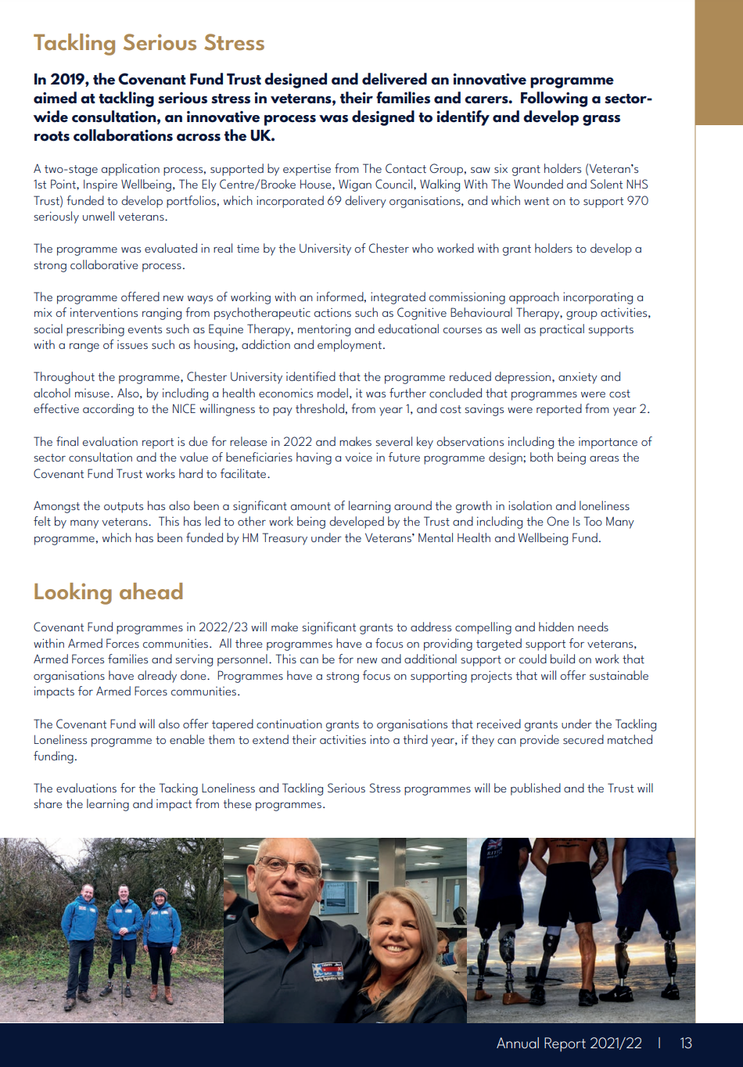
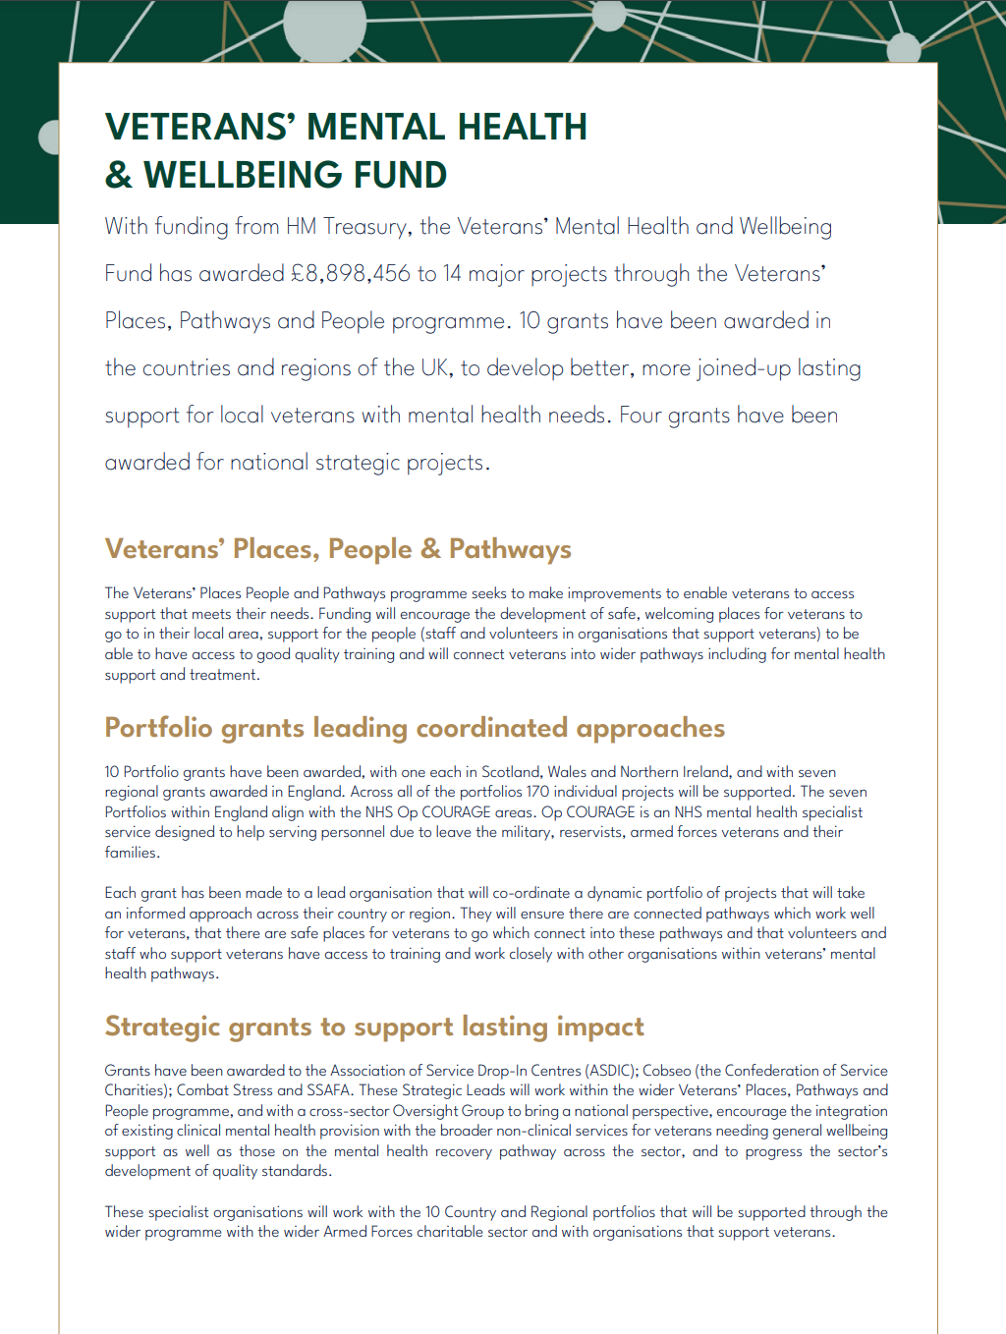

(The Armed Forces Covenant Fund, 2021/22)

Appendix 2
The following case study is called Craigs Story, an account of living with PTSD and recognises the importance of our work:
I joined the army at the age of 16. when coming home from tour I had muscle memory, having to look at my back, at one point I started walking backwards a lot. It wasn’t till I started realising alcohol was taking control that I became alcohol dependent, I had mood swings getting angry at small things, and I realised something was not right. It left me in a bad place. I had to seek help and I was diagnosed with PTSD. I was relieved to think I wasn’t going mad and that there was an answer to my behaviour. I am now seeking help for my well-being which has taught me not to put myself in situations that might trigger stress bringing many challenges like sounds like fireworks, and the smell of oil making me cry or panic. Without these interventions, my life would have spiraled out of control and I wouldn’t be here today (Combet Stress 2022).

Appendix 3

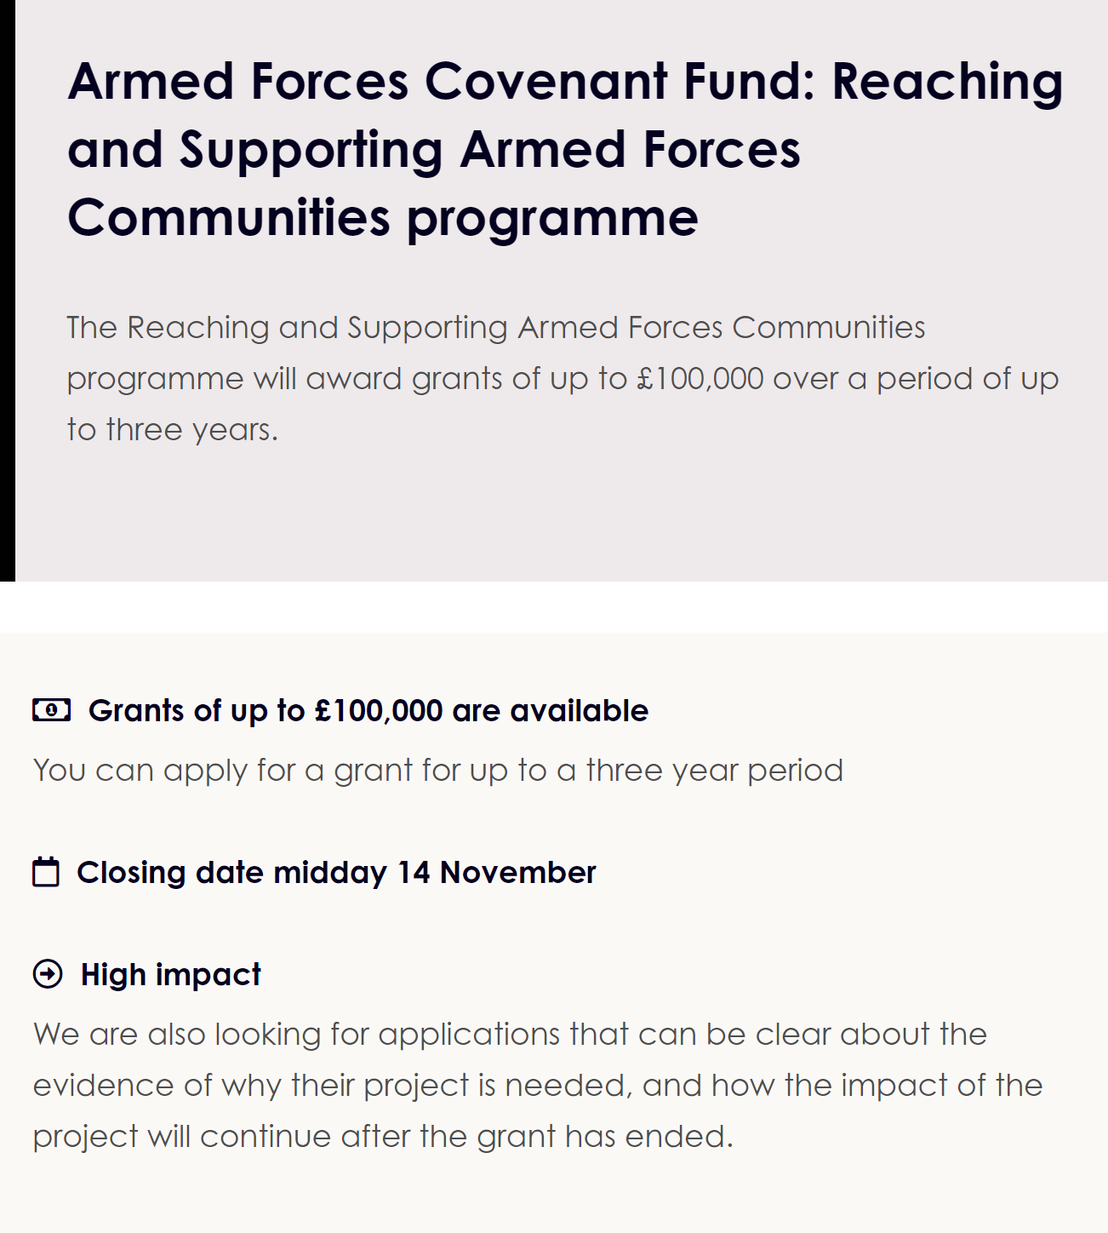
(Covenant Fund 2023)

Appendix 4
It is understood that the funding bid application looks slightly different when applied through the organisation in question but as this is done online and is unable to be applied to this assignment, a replica has been interpreted into this research.

Managing Professional Practice in Advocacy: Funding Bid
Accessment 2
Section 2

DATE SUBMITTED | GRANT NAME
3rd July | The Armed Forces Convent Fund
SUBMITTED TO | ADDRESS OF RECEIVING PARTY
 | 95 Horseferry Road, London, SW1P 2DX
SUBMITTED BY | ADDRESS OF SUBMITTING PARTY

- PROJECT ABSTRACT

Research, media and charities, have been highlighting mental health in the Armed forces and has become a topic that has raised awareness in recent years (House of Commons, 2018). Jones, (2019) recognizes the rise in the past six years in the effects of mental health problems within the British Army by stating discharge for depression has tripled in relation to mental health and has further stated that there is a rise in general mental health issues from a hundred and eighty-eight in 2012/13 to four hundred and twenty-eight in 2017/18. This opinion is replicated in more recent research by the Ministry of Defence (2022) stating ‘1 in 8 (12.5%) UK armed forces personnel were seen by military healthcare services for a mental health-related reason in 2020/21’.
Our organisation must raise awareness of mental health issues among armed forces personnel and ex-veterans, including dampening any stigma that comes within the armed forces that may affect any person asking for help or support (Williamson et al, 2019).
Veteran suicide has been an area to which we would like to draw close attention too. Veteran suicide rates are an issue close to our hearts. It is stated in research that veteran suicides ages Twenty-Five and under are two to four times higher than in the same age group within the general population (Gov. uk, 2022).
A case study talks about a military personals struggles with PTSD, this is Colins story:
I joined the army in 1948 and six years later sent to the Golf war along with thousands of other soldiers. I remember seeing dead bodies everywhere, sounds of guns, and explosions. I left the army in 1992 after years of poor mental health following this. I found I would have mood swings, fits of anger, and smash things up. It’s hard to come down from high alert which is often where drinking alcohol is involved. My relationship ended because of my anger, I couldn’t admit I had a problem as I was meant to be strong. I started self-harming but when it all got to much I contemplated killing myself. Eventually, I was diagnosed Post Traumatic Stress Disorder which was like a huge weight off my shoulders. I hope one day when I start therapies that I can get back to being a normal person (Newton, 2015, Appendix 1).

- STATEMENT OF NEED

Our organisation would like to provide more support to our clients by widening are services to offer therapies to improve the mental health and well-being of our clients. A lot of our support is through linking our clients with other organizations and although this is an important part of our work we would like on-premises support by providing the services as follows in section 111 Program Description.
The urgent need for funding in this area will not only improve mental health but also extend our services to reduce suicide in young veterans suffering from mental health disorders as mentioned in section 1.

Our organization is appealing for funding to the Armed Forces Convent Fund Trust, as there is a related understanding of the work we do and issues raised in the appeal which is highlighted in your Annual Report 2021/2022 and recognizes there is a gap in combating serious stress in veterans (The Armed Forces Covenant Fund, 2021/22). It is understood that the Armed Forces Covenant Fund’s objective is to ‘deliver funding programs that create real change to the Armed Forces communities across the UK’ The Armed Forces Covenant Fund Trust, (2023) and as we share that vision to make real change in mental health for veterans we hope to work with you to make this happen.

- PROGRAM DESCRIPTION

This organization is applying a holistic approach to help support veterans or military personnel. The intention is to initiate therapies such as:
- Hypnotherapy: Techniques and methods to connect to a stronger self and access information stored in the subconscious to explore emotions and behaviour patterns related to traumatic events for positive transformation (The Wellness Institute, 2023, Appendix 2).
- Cognitive Behavior Therapy: Research shows that Cognitive behavioral Therapy (CBT) is an effective treatment for those that are exposed to trauma (American Psychological Association, 2023, Appendix 3).

- Resilience coaching: coach delivers the course on either zoom or teams to help personnel recognize symptoms and signs of traumatic stress and gain knowledge on using resilience methods (Mind in Harrow, 2023, Appendix 4)

- RTM Protocol: an effective treatment for veterans exposed to severe trauma. ‘re-programs the neurological connection between the brain’s feeling center and specific traumatic memories’ (The Research and Recognition Project, 2023, Appendix 5).
The initiative will take place in our Carmarthen head office and will be delivered by specialist staff trained in these therapies. The intention is to implement as soon as the funding is secured.

- GOALS & OBJECTIVES
Reduce suicide rates and offer support and treatment that will contribute to this
Provide more effective treatments for PTSD and other related mental health disorders such as Anxiety and Depression.
Provide better support in the transition from the Military back into society.
Promote the use of more effective non-medicated treatments that sustain a much longer-lasting result

- TIMELINE

ACTIVITY | PROJECTED DATE
Submission of funding bid. The project is unable to start until funding is received. | Aim for August 2023
HR will interview staff and employ staff | TBC
Allocate appropriate rooms and facilities | TBC
Our Public Relations Officer will be responsible for notifying GP and Organization, publicizing on social media and the delivery of events in order to publicize our initiative. | TBC
Our organization will attend community events in order to promote the new initiatives | TBC
Informing organizations, GPs, and NHS services of the referral procedure | TBC

- BUDGET
BUDGET OVERVIEW

The Initiative will consist of funding that will cover three members of staff, part-time specialists in the areas of therapies mentioned previously in section 111. One member of staff is a full-time specialist therapist but also is able to access the needs of the client and the most appropriate treatment.

ITEM DESith other organisations, CRIPTION | PRICE | QUANTITY | TOTAL
Hypnotherapist | £30 per hr. | Part-time 2 days 6hrs | 9,360,00
Resilience Coaching Therapist | 30 per hr. | Part-time, 2 days, 6hrs hrs. | 9,360,000
Cognitive Behavior Therapist  RTM Protocol Therapist | 43,000 yr. | Full-time  Part-time, 2 days 6hrs | 43,000  9,360,000
Room refurbishment | 500 | Paint, appropriate seating | 500
Resources for therapies | 1000 | Books and tools | 100
TOTAL |  |  | 72,580

- APPENDIX

FILE NAME | DESCRIPTION | LOCATION attachment/link
Appendix 1  Newton,S. (2015) | PTSD: The Soldiers’ Stories. | https://www.forces.net/documentary/ptsd-soldiers-stories

Appendix 2  PTSD (2023) | How Solution-Focused Hypnotherapy can Help People with PTSD | https://www.ptsduk.org/how-solution-focused-hypnotherapy-can-help-people-with-ptsd/
Appendix 3  Shubina, I. (2015) | Cognitive-behavioral Therapy of Patients with PTSD: Literature Review. | file:///C:/Users/muddy/Downloads/2014CPSYCCBTforPTSD%20(1).pdf
Appendix 4  Mind in Harrow (2023) | Trauma-informed resilience training (2023) | https://www.mindinharrow.org.uk/training/workplace-training/trauma-informed-resilience-training/

Appendix 5  BrilliantMinds (2020) | The RTM Protocol | https://www.brilliantminds.co.uk/video-the-rtm-protocol/

(Smartsheet,2023)

References list

American Psychological Association (2023) Cognitive Behavioural Therapy (CBT), available at: https://www.apa.org/ptsd-guideline/treatments/cognitive-behavioral-therapy#:~:text=Using%20CBT%20to%20Treat%20PTSD&text=Exposure%20to%20the%20trauma%20narrative,maladaptive%20associations%20with%20the%20trauma. (Accessed: 21 March 2023).
Community Foundation Wales. (2023) Carmarthenshire Fund, Available at: ttps://communityfoundationwales.org.uk/grants/carmarthenshire-fund/ (Accessed: 25 February 2023).
House of Commons (2017-19) Mental Health and the Armed Force, Part One: The Scale of Mental Health Issues: Eleventh Report of session 2017-19, Available at : https://publications.parliament.uk/pa/cm201719/cmselect/cmdfence/813/813.pdf
Grants Online LTD. (2023) Health, Justice and Welfare, Available at: https://www.grantsonline.org.uk/news/health-justice-and-welfare/ (Accessed: 25th February 2023).
Jones, H. (2019) ‘Mental Health Related Discharges Triple in British Army’, UK Defence Journal, Available at: https://ukdefencejournal.org.uk/mental-health-related-discharges-triples-in-british-army/ (Access 20 March 2023).
Mind in Harrow (2023) Trauma Informed Resilience Training. Available at: https://www.mindinharrow.org.uk/training/workplace-training/trauma-informed-resilience-training/ (Accessed: 22 March 2023).
Newton, S. (2015) PTSD: The Soldiers’ Stories. Available at: https://www.forces.net/documentary/ptsd-soldiers-stories (Accessed: 29 March 2023).
Saha, G. (2021) ‘Advocacy in Mental Health, Indian Journal of Psychiatry,63(6), pp. 523-526. Available at: https://www.ncbi.nlm.nih.gov/pmc/articles/PMC8793719/#:~:text=Advocacy%20is%20an%20important%20means,%2C%20legislation%2C%20and%20service%20development. (Accessed: 20 March 2023).
Smartsheet (2023) Free Grant Proposal Templates. Available at: https://www.smartsheet.com/free-grant-proposal-templates (Accessed: 24 March 2023).
The Armed Forces Covenant Fund ( 2021/22) Armed Forces Covenant Fund Trust: Annual Report & Accounts 2021/22. Available at: https://covenantfund.org.uk/wp-content/uploads/2022/11/Final-report-for-online-publication-NS091122.pdf (Accessed: 21 March 2023).
The National Center for PTSD (2015) Effective Treatment for PTSD: Consider Therapy (CBT) as First-Line Treatment, Available at: https://www.pbm.va.gov/PBM/AcademicDetailingService/Documents/Academic_Detailing_Educational_Material_Catalog/66_PTSD_NCPTSD_Provider_Effective_Treatment_for_PTSD.pdf (Accessed: 21 March 2023).
The Research and Recognition Project (2023) The Reconsolidation of Traumatic Memories Protocol TM: An Innovative Treatment for PTSD. Available at: https://thertmprotocol.com/content.aspx?page_id=22&club_id=954411&module_id=383941 (Accessed:
Williamson, V., Greenberg, N., and Stevelink, M, A, S. (2019) ‘Perceived Stigma and Barriers in UK Armed Forces Personnel and Veterans with and without Probable Mental Disorders’, BMC Psychology, pp.2-7. Available at: file:///C:/Users/muddy/Downloads/s40359-019-0351-7.pdf

