Assessment
International Marketing: Principles and Practices

Student Name: Georgian Bularda
Student Number: 2109232
Lecturer Name: Dr Taonga Kaonga Sobere-Snithers
LCMB7026_BIRM

Executive Summary
In this report, a detailed analysis of the external environment of the UK and Australia is being conducted. This can provide better insights to BMW to make better strategic decisions for the development and growth of the company. The targeting is more general, focusing on those who are willing to pay for durability, comfort, and versatility for long-distance travel. The Australian positioning of BMW is based on brand performance, reliability, and the ability to cope with different driving conditions. So, while the UK STP focuses on sophistication and eco-innovation, the Australian STP focuses on lifestyle, power, and practicality. The 7Ps marketing mix has been applied to understand the brand management strategies of BMW in the UK and Australia. Performance evaluation in two countries has depicted that the UK market is more stable for effective business growth of BMW as compared to Australia.

Table of Contents
Introduction 4
Brand Overview 5
Comparison of the socio-cultural context of the UK and Australia 6
Comparison of BMW’s STP strategies in the UK and Australia 11
Comparison of Marketing Mix Strategies in the UK and Australia 15
Evaluation of the performance of marketing strategies 21
Evaluation of marketing ethics practice 24
Recommendations 26
Conclusion 28
References 29

Introduction
As stated by De Ruyter et al. (2022), international marketing principles include the application of marketing strategies and ideas globally. It also includes effective advertising strategies to reach the global customer and expand the business across international borders. This can help an organisation to increase its sales and grow its business to a global extent, along with accessing new markets. However, an organisation needs strategic and systematic planning and procedures to access international industries. In addition to that, it needs specific resources and skills to mitigate and address any problems that can be a barrier to sustainable development. Apart from that, it is also essential to create a roadmap and an action plan to implement the ideas and concept successfully. Thus, in this report, an overview of the marketing concept undertaken by BMW to effectively operate in the UK and Australia will be analysed. Apart from that, the external factors that affect the growth and development of the country will also be discussed. As described by Redjeki, Fauzi and Priadana (2021), marketing plays a primary role in increasing the sales of the company. Thus, the evaluation of ethical marketing practices will also be highlighted in the following report.

Brand Overview
As per the information provided on LinkedIn (2025), BMW Group is one of the world’s leading manufacturers of premium automobiles and motorcycles. It also provides services in finance. The company has four brands: BMW, MINI, Rolls-Royce and BMW Motorrad. Apart from that, BMW Group has about 30 production sites and operates in 140 different countries. In 2024, the company sold over 2.45 million passenger vehicles and around 210,000 motorcycles globally. Apart from that, the net revenue generated by the company in 2024 was € 142.4billion. In addition to that, the company has employee strength of around 159,104 employees. Moreover, BMW believes in maintaining sustainability as one of its corporate strategies in its supply and production chain to maintain its competitiveness and brand value.
As per the data provided on the official website of BMW Group (2025), Oliver Zipse is the chairman, and Walter Mertl is the Finance officer of the company. Some of the members of the leadership board of the company are Dr Milan Nedeljkovic, Dr Joachim Post, Dr Nicolas Peter, Jochen Goller and Ilka Horstmeier. The leadership board of the BMW Group focuses on corporate governance that aims to ensure the well-being of all of its stakeholders. Apart from that, the company helped make the German financial market attractive by providing recommendations and suggestions in the German Corporate Governance Code. Thus, the underlying corporate culture of BMW is based on the concept of transparency. As per the annual report provided by BMW Group (2025), the company experienced a significant decrease in annual revenue in 2024 from the previous year, that is, it generated €10,971 million. Apart from that, the company increased its Group EBT margin by 10% along with an 18% increase in the return on capital employed of the automobile segment.

Comparison of the socio-cultural context of the UK and Australia
PESTLE of the UK
Political factor
The political stability index is a metric used to define the political environment of any country, and in the UK, its score is 0.51 (The Global Economy, 2025). A decline can be observed from the value in 2022, and this means an increased level of uncertainty. Because of that, BMW needs to face certain risks due to changes in regulations, and its strategic initiatives will be impacted as that.
Economic factor
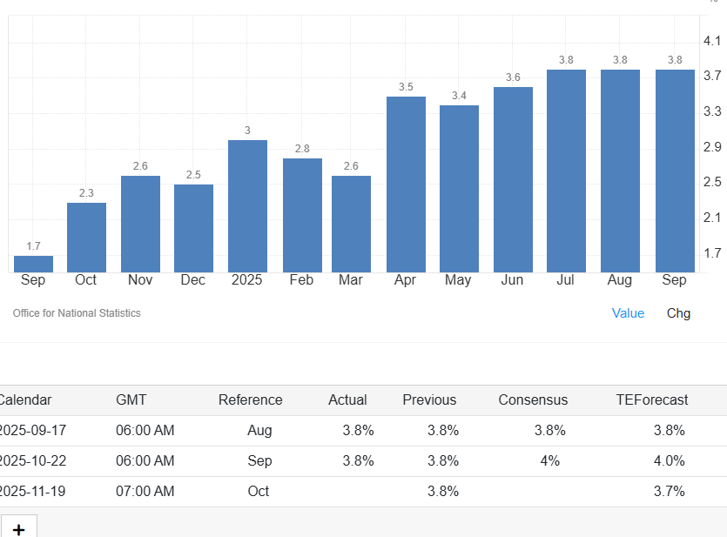
Figure 1: UK inflation rate
(Source: Trading Economics, 2025)
The inflation rate in the UK is currently 3.8 per cent, as per the data found in 2025 (Trading Economics, 2025). A cautious approach has been undertaken by the Bank of England for cutting the interest rates, and it is evident that the UK economy has developed faster in the initial phase of 2025. However, increased tensions regarding trading and fiscal pressures can affect the profitability of BMW.
Social factor
Social trends affect customer choices. A significant shift towards Electromobility has been observed in the UK demographics. The increased awareness towards sustainability and the current environmental condition shifted their preference towards electric vehicles and hybrid models. To remain competitive the BMW needs to continuously improve its offerings, maintaining sustainable standards. Moreover, traditional car ownership is being replaced due to the increased popularity of car-sharing models. Offering digital services and different options for ownership is also needful to implement for the business.
Technological factor
Electrification, advanced driver-assistance systems (ADAS), AI, and robotics are the current new technologies that the UK automobile businesses are focusing on (KGMP, 2025). The automotive industry is advancing with the incorporation of new innovative technologies. Advanced in-car technology and connected services (V2X technology) are the key areas of popularity in the UK, and it made it necessary for BMW to better its offerings (Mintel, 2025).
Legal factor
Several corporate laws in the UK are unavoidable for BMW to run its operations successfully. The Companies Act 2006 is a key legislation whose purpose is to check the formation and operational processes of any company. The Competition Act 1998 / Enterprise Act 2002 are enforced to control the anti-competitive behaviour management. The Competition and Markets Authority (CMA) investigate the actions of BMW regarding this matter to ensure limited chances for conflicts. UK tax laws, such as VAT, corporate Tax, Consumer Rights Act 2015, Zero Emission Vehicle (ZEV) Mandate these are other examples of laws that are maintained by this organisation in the UK (BMW Group, 2025). Employment Rights Act 1996, Data Protection Act are other related legislation. Consequently, the UK has a wide range of laws and regulations to follow and non-compliancewith any of these may cause serious issues (Gov.UK, 2025).
Environmental factor
The trend of sustainability affects the operations of BMW in the UK significantly. Increased pressures on the reduction of carbon emissions and the growing relevance of the circular economy affect the value chain of BMWThe 2008 Climate Change Actin the UK focuses on the achievement of net zero carbon emissionsby 2050, and the current rank of the UK internationally is 3 in terms of managing sustainability (SGI, 2025).
PESTLE of Australia
Political factor
The Political Stability Index of Australia was 0.92 in 2023, which was reduced from the previous year (The Global Economy, 2025). In comparison to the UK, Australia has better political stability. There is low government intervention as perceived from the history within the automobile sector of Australia. However, the Australian government is adopting policies to support Electric vehicles, while the UK has already supported EV development with its existing policies towards EV development.
Economic factor
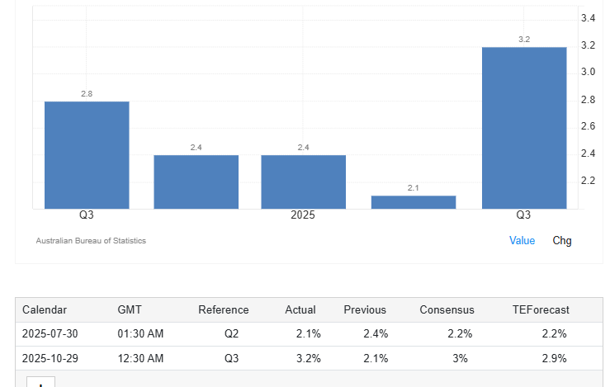
Figure 2: Inflation rate of Australia
(Source: Trading Economics, 2025)
The inflation rate of Australia is 3.2% and the fluctuation of the exchange rate is also affecting the company operations of BMW significantly in the country. The Consumer purchasing power is good in Australia rather than in the UK, which offers more opportunities for improved profitability for the BMW.
Social factor
The people of Australia prefer SUVs and like to purchase things online. People seek luxury car items in this country, which is different from the demographics of the UK. However, awareness towards sustainability can also be observed in this country. In contrast to the UK’s strong customer base towards green products, the Australian people seek luxury products over green items. It is important for BMW to integrate offerings based on the cultural preferences of the two countries.
Technological factor
The ICT infrastructure of Australia is noteworthy, and the country invests much in research and development initiatives. Adopting innovative measures and Advanced Driver Assistance Systems (ADAS), Electric Vehicles are the key technologies that are being focused on by the automobile businesses in Australia (IbisWorld, 2025).
Legal factor
Competition and consumer law, Modern Slavery Act, Data protection, and Tax and trade laws are the key legislations followed by the automobile businesses in Australia (BMW, 2025). In comparison to the UK, Australia has reduced legal obstacles, and there is a greater variety of legal frameworks and BMW needs to follow in the UK.
Environmental factor
The SDG index of Australia is considered to be good, 38th rank out of the 167 countries, and the score in 2025 is 77.88 (SDG Index, 2025). The country is focused on achieving the SDG goals 1 and 3, which are a low poverty rate and the good health and well-being of the people. However, it has been considered the worst country in fulfilling the goal of Responsible Consumption and Production. In comparison to the UK, Australia’s performance towards sustainability is low (SDG Index, 2025).
Compare and contrast the socio-cultural context of the UK and Australia.
Having a social and cultural context similar to that of the UK, Australia, being a Western country with an English-speaking population, has a different attitude towards consuming and influencing lifestyle, which is somehow relevant to BMW (Tomaszewski et al., 2025). The British view car ownership as a status and prestige symbol and it is for this reason that BMW’s luxury and performance are very much appreciated by the professionals. The British market looks for heritage, design sophistication, and brand loyalty. On the contrary, the Australian car culture is influenced by large open spaces and outdoor lifestyles, which put reliability, comfort, and versatility at the top of the list. Consumers prefer SUVs and sports cars that can handle long drives and rough terrains. While quality and innovation are appreciated in both markets, UK buyers are more inclined to think of urban mobility and sustainability (EV adoption), while Australians are the other way around, such as leaning towards practicality and driving experience. Consequently, the BMW marketing strategy in the UK focuses on elegance and technology, while that in Australia concentrates on adventure, performance, and lifestyle adaptability.

Comparison of BMW’s STP strategies in the UK and Australia
The BMW follows a consistent approach for STP (segmentation, targeting and positioning) globally, and the key focus of this company is towards the premium, performance-oriented demographic (Hossain et al., 2024). However, the company adjusts its strategies based on the cultural differences in the countries and follows the different characteristics of people of various countries.
Segmentation
A similar approach for market segmentation is used by the BMW in both the countries such as the UK and Australia. Segmentation means dividing the whole market or demographics into small groups so that targeting the key market becomes easier for any business. It means dividing the demographics into small segments based on some criteria. BMW uses mainly three types of segmentation criteria, such as demographic, psychographic, and behavioural. In both countries, the company focus on age and income as factors. People aged between 30-50, having a good income level, are mainly targeted by this business group in both countries. Affluent professionals are also targeted by this business group as potential customers. Within the psychographic segment, the key factors that are used to differentiate the target market are the personal values of people. Values regarding prioritising performance, innovation and people who prefer luxury and maintain prestige are considered under the targeted psychographic segment of BMW for both countries. Within the behavioural segments, people who have driving enthusiasms are considered as potential future customers for this business group (Micus et al., 2025).
Targeting
A differentiating marketing strategy has been adopted by BMW, and different sub-segments are used by the brand to target the premium market in both the UK and Australia. For addressing the needs of these different sub-segments, the company has been offering various models starting from the 1 Series to the X Series, along with the I Series. The similarity in targeting customers in both markets for BMW is that it focuses on the people seeking luxury products. Individuals who consider luxury as a symbol of success is somewhat different from traditional cars. Prioritisation of the delivery of models is influenced by local preferences and choices. The UK has a great focus on reducing carbon emissions due to increased pressure from regulations and the increased awareness of people towards sustainability. As a large number of people in the UK are environmentally conscious, the company focuses more on models that are environmentally friendly or electric vehicles. In this way, the company targets people who can like the series of this brand. Conversely, the Australian people are highly drawn towards SUVs to maintain their lifestyle. Psychographic segmentation is more followed in this country, along with the demographic segment and income factor (BMW Group, 2025).
Positioning
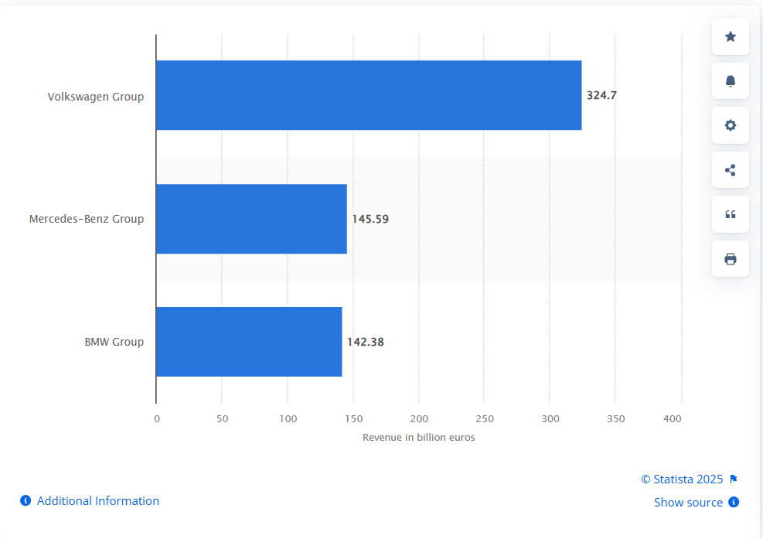
Figure 3: The Competitor revenue of BMW
(Source: Statista, 2025)
In the UK, BMW positions itself as a high-performance brand that is established as a market leader. Moreover, it is sharing its initiatives towards sustainability, and it has made a significant transition towards the development of Electric vehicles, mitigating the current demand of the environmentally conscious market of the UK. The company has created a brand image that explains that it offers convenience for both types of customers, who are driving enthusiasts and those who want luxury car items. Conversely, in Australia, the brand also establishes itself as a premium luxury car brand, and it has demonstrated itself as a leader in offering EVs. The company is prioritising to offer EVs that are more accessible to Australian customers in comparison to its competitors. Mercedes-Benz and Audi are the two main competitors of BMW in the UK and Australian markets (Statista, 2025). These competitors also offer premium car items and include different types of vehicles appealing to their target segment. Volkswagen Group’s performance is often compared with BMW's due to its control over the broader European market.
Feature | United Kingdom | Australia
Market Leadership | BMW is considered to be a market leader within the premium market. The company has good profitability and sales growth, along with better brand recognition within the UK market. | BMW can be said as a strong contender within the operating luxury market in Australia, and in this country, the company is having significant financial growth due to increased preference for luxury items and the maintenance of prestige of the Australian people (BMW Group, 2025).
EV focus | Due to its focus on the development of Electric vehicles, the company is achieving better sales figures, making it appealing to the environmentally conscious customers in the UK. | In Australia, the brand is focusing on the government initiatives to promote the adoption of electric vehicles. For example, the tax breaks and FBT exemptions are supporting the transition towards sustainability measures and the adoption of EVs.
Overall strategy | The company positions itself as a luxury brand that offers better performance, integrating luxury and innovation into its offerings. Premium advertising helps the brand enhance its brand image. | In Australia, the brand positions itself as a premium brand that is trying to emphasise the advantages of EVs.
Table 1: Compare and contrast STP strategies
(Source: Created by the learner)
BMW's STP (Segmentation, Targeting, Positioning) strategy is not the same in the UK and Australia, as there are differences in demographics, geography, and consumer behaviour. The segmentation in the UK is done with the help of urban professionals, executives, and eco-friendly drivers and the metropolitan areas such as London and Manchester. Targeting highlights the people who buy premium cars with a focus on luxury, status, and advanced technology, mainly hybrid and electric models. Positioning emphasises BMW as the top brand for prestige, innovation, and sustainability.On the other hand, in Australia, segmentation is shown through the inclusion of rich families, wanderlust individuals, and sports-car enthusiasts.

Comparison of Marketing Mix Strategies in the UK and Australia
Marketing mix | Country A: UK | Country B: Australia
Product | - Full premium portfolio  - Strong focus on EVs/PHEVs  - High fleet demand, Luxury and advanced technology. | - Similar premium portfolio  - stronger marketing focus on electrification and technology adoption  - EV readiness promoted due to emerging market trends
Price | - Premium pricing influenced by VAT  - Company-car tax  - EV incentives  - Competitive pricing in a mature luxury market | - Premium pricing affected by Luxury Car Tax (LCT)  - Import duties  - Smaller market size  - Vehicles often priced higher than UK equivalents
Place | - Dense dealer network across the UK  - Strong business distribution channels  - Easier logistics due to market size | - Less dense dealer network concentrated in major cities  - Geographic dispersion creates delivery and servicing challenges
Promotion | - Emphasis on brand heritage, performance  - Luxury lifestyle, and sustainability  - Strong use of digital campaigns and experiential marketing | - Stronger emphasis on electrification,  - Innovation and advanced technology  - Promotional efforts highlight future mobility and EV transition
People | - Highly trained premium sales staff  - Strong B2C and B2B (fleet) expertise  - Focus on service quality and after-sales | - Staff trained to explain EV ownership  - charging solutions and technology features  - Strong focus on customer education due to market transition
Process | - Digital buying processes  - Streamlined due to dense market and established infrastructure | - Digital processes accounted for long-distance servicing  - EV infrastructure variations and regional logistics
Physical evidence | - Premium showrooms  - High-quality materials, luxury branding,  - Consistent with BMW’s global identity | - Similar premium showroom experience  - Increased use of tech-driven displays to promote innovation
Table 2: Comparison of the marketing mix for BMW
(Source: Created by the learner)
BMW operates in the global business environment as a leading luxury car manufacturing company, and the 7Ps marketing mix has been effective in understanding the product and service management strategies of the company in the UK and Australia. Marketing mix strategy analysis is the most effective way to understand technology adoption, taxation policies, competitive environment and consumer preferences in a specific country (Rustam et al., 2025). The comparison of the UK and Australia has depicted that BMW successfully maintains a premium brand identity and consistency in product manufacturing, price and promotional strategies.
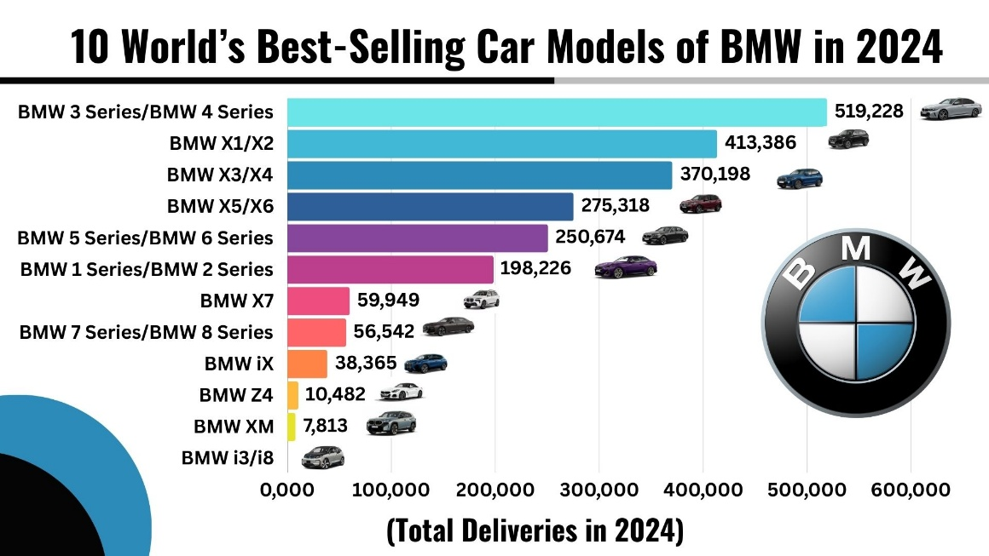
Figure 4: Best-selling car models of BMW
(Source: Scienceagri, 2025)
Product
A consistent product portfolio of luxury cars has been maintained by BMW both in the UK and Australia. Sedans, SUVs, M-Performance models, plug-in hybrids and battery vehicles are the most selling car models of BMW (Bmwgroup, 2025). In the UK, the product management strategy has focused on both the fleet customers and retail buyers. The UK market is more stable and mature for BMW, and the demand for electric vehicles is continuously growing in this market. Therefore, high-end technology sustainable mobility is the main product management strategy for BME in the UK markets with a focus on BEVs and PHEVs. Mercedes-Benz, Audi and Tesla are the most threatening competitors of BMW in the UK market. The Australian market, on the contrary, is still in the transitional phase towards electric vehicles, and technology openness has been the core product development strategy.

Price
Premium pricing strategy has been maintained by BMW in each of its operating countries, and this pricing strategy has maintained the luxury brand identity. Taxation policies, currency exchange rates and market competitive dynamics are the main factors modifying the pricing strategies in different countries (Nagle et al., 2023). Free VAT and Government initiatives support the acceptance of EVs among the UK people. The UK luxury car market is already dominated by German and other premium car brands, hence BMW need to create strategic pricing for attracting both the private and business buyers. In contradiction, the Luxury Car Tax (LCT) imposed by the Australian government has generally increased the price of luxury car models. However, it can be said that the Australian market is more price-sensitive for EVs as compared to the UK market.
Place
Geographic location and population density affect business network management and create price variance in logistics and transportation management (Small et al., 2024). Customers also benefit from a well-structured test-drive system, efficient stock movement and strong fleet-distribution logistics in the automotive industry. In this context, the UK’s compact geography improves customer experience and reduces logistical costs for BMW. In Australia, population density is significantly lower, and markets are concentrated in larger cities such as Sydney, Melbourne, Brisbane and Perth. BMW has faced challenges in providing after-purchase services to customers due to the inconsistency of EV servicing and charging point support. BMW strategically compensates for these challenges by offering remote service solutions and supporting digital purchasing tools.
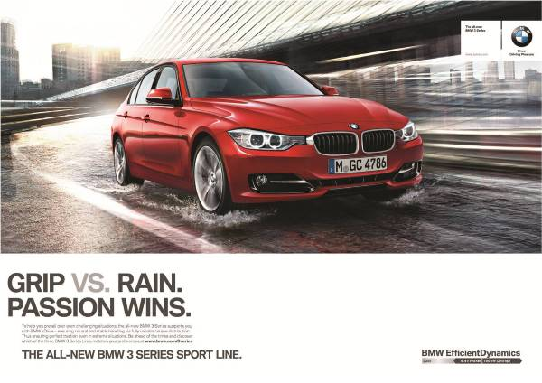
Figure 5: BMW’s emotion-based brand promotional strategy
(Source:Bmwgroup, 2025)
Promotion
In both the UK and Australian markets, BMW has accepted premium promotional strategies driven by emotional promotional themes. Luxury, sustainability engendering excellence is the core factors for driving the promotional campaign of BMW (Bmwgroup, 2025). High-quality storytelling has helped BMW attract customers’ attention in both the offline and online media. Reinforcement, the essence of brand loyalty technological innovation has been leveraged in the promotional strategies of BMW. Electrification has been mainly prioritised in the promotional campaigns in Australia, aligning with sustainable mobility and emerging technologies.
People
In both countries, BMW relies on highly trained staff to provide exceptional customer service. However, in the UK, sales teams require significant fleet expertise and deep knowledge of EV taxation, leasing and benefit-in-kind calculations. On the other hand, Australian staff must devote more attention to customer awareness development, particularly explaining the differences between ICE, hybrid and EV models. BMW must consider the charging requirements and performance expectations on long-distance routes for developing staff training and a productive workforce.
Process
Remote test drives, online configurations, and digital financial applications have been included in the effective service management process in both the UK and Australia. High-density logistic support in the UK market has created opportunities for the automotive industry for uninterrupted services (Wahab et al., 2025). The large geographical distance of Australia has generated a need for remote service facilities. Therefore, flexible and customer-friendly services are required for both countries for efficient operational process management of BMW.
Physical evidence
BMW’s global brand identity ensures showroom standards are kept premium in both markets. However, Australian showrooms often incorporate more technology-driven displays, aligning with promotional focus on innovation and electrification. Whereas, in the UK, physical evidence highlights engineering precision, luxury, and brand heritage has been resonating with a long-established customer base.

Evaluation of the performance of marketing strategies
Performance in the UK
172,240 registrations have been reported by BMW UK in 2024, over a quarter for electric vehicles. This has depicted the high demand for electric vehicles in the UK market, generating spontaneous growth opportunities for BMW. Premium product pricing and usage of advanced technologies in brand promotion have been proven successful in the UK markets (Scienceagri, 2025).
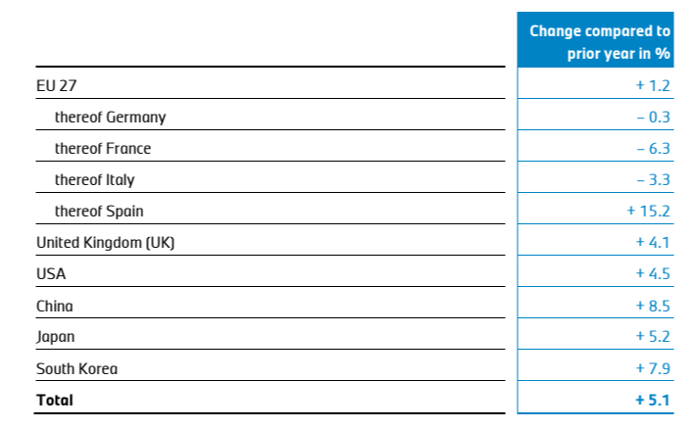
Figure 6: Demand for EVs in the UK
(Source: Scienceagri, 2025)
In the first quarter of 2025, the global EV industry experienced a slight growth of 5% and demand increase has been perceived in the European markets. Approximately 4.1% growth has been experienced in the EV market of the UK (Scienceagri, 2025). Rolls-Royce, Mini and BMW are the flagship models that have experienced high sales and high demand in the first quarter of 2025. The customer numbers in Europe and America have increased by 2.4% between January to September 2025. In short, although the UK market is highly competitive, BMW has successfully maintained its strategic positioning in the luxury car market in the UK.
Performance in Australia
16,555 units of cars are sold in the first quarter of 2025 in Australia, and it has presented 8% higher sales as compared to the previous year. BEVs made up 22% of its volume with a 5.12% growth estimation of the luxury car markets in 2026 (Scienceagri, 2025). Premium brand identity, centralised control and integration of advanced technologies are the core brand management strategies of BMW Australia. On the other hand, the electrification of car models is the prime focus of BMW in the Australian luxury car market.
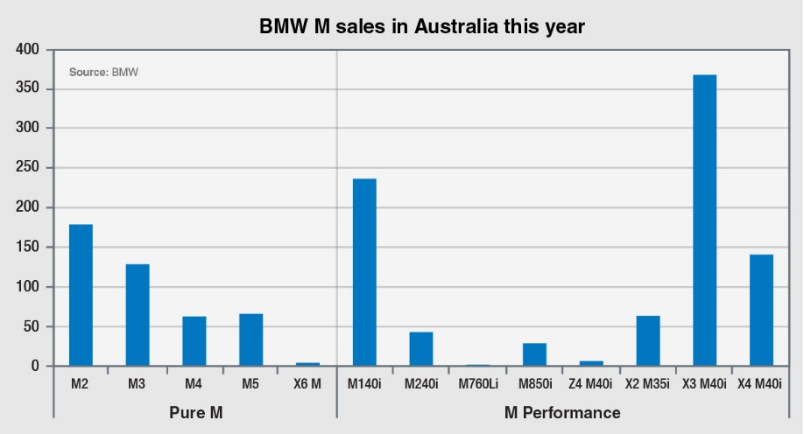
Figure 7: BMW sell performance in Australia
(Source:Goauto, 2025)
The success of BMW's marketing strategy in Australia can be perceived through its increasing sales and stable revenue growth as compared to other luxury car brands. In summary, BMW’s marketing mix strategies appear effective in both the UK and Australia, but are tailored to local market conditions and consumer and regulatory contexts. “Pure M” and “M Performance” are the two flagship models that have contributed to the revenue and sales growth of BMW in the Australian market (Goauto, 2025).
However, the comparison of BMW’s performance in the UK and Australia projects that the UK market is stronger and more mature than in Australia. Higher sales volumes, a larger dealer network and a well-developed market for premium and electric vehicles have been the main opportunities in the UK market. In Australia, BMW also performs well and frequently leads the premium segments. Although sales volumes in the Australian market are smaller, due to the country’s lower population and higher vehicle taxes. While both markets has supported growth, the UK demonstrates greater market stability and Australia reflects more variable premium-car demand.

Evaluation of marketing ethics practice
As demonstrated by Tanveer et al. (2021), the marketing ethical practices refer to maintaining honesty, loyalty and fair practices within the internal and external working environment of an organisation. The core principles of ethical marketing are honesty, maintaining transparency and fairness, being empathetic and fulfilling social responsibility while respecting the privacy of the employees of an organisation. However, an organisation can apply the principle of different business theories to maintain ethical business practices in its internal and external environment. Thus, BMW can take measures to apply the concept of stakeholder theory. According to Mu, Xu and Chen (2024), the stakeholder’s theory states that an organisation must ensure the well-being of its internal and external stakeholders and not just the shareholders. However, the stakeholders include customers, employees, suppliers and all the members who are directly or indirectly associated with the company. Apart from that, BMW must fulfil its responsibility to maintain its brand reputation and be corporate. Thus, an organisation needs to be financially stable and profitable to fulfil and meet its social duties.
Apart from that, it is also essential to follow the legal rules and policies to prevent fines and penalties. Moreover, BMW can maintain ethical practices in its work culture to keep its employees happy and satisfied. As described by Soni (2023), an employee can be a key player in increasing the sales and annual turnover of a company. In addition to that, the company can also provide donations for the development and growth of society and the community. Thus, this can enhance the brand value of an organisation. As per the information provided by BMW Group (2025), the company believes that long-term economic success can only be achieved through environmentally and socially responsible action and activities. Apart from that, the company is committed to the Paris Agreement for achieving carbon emissions of net zero by 2025. Moreover, the company follows the standards of the UN Global Compact to fulfil its responsibilities.
As highlighted on the website of BMW Group (2025), the company upholds its environmental and social standards through its responsible sourcing of raw materials. Apart from that, it ensures the well-being of its suppliers along with respecting and protecting human rights. It also maintains transparency and a dynamic supply chain. Additionally, the company uses solutions such as Catena-X data ecosystem to exchange its data about its entire value chain in a secure and standardised manner, which respects the data privacy and integrity. It also checks its Supplier Code of Conduct to ensure a smooth distribution and processing channels throughout the services it provides.

Recommendations
BMW’s international strategy can focus on various measures and initiatives to implement those actions and activities in its products and services to enhance its development and growth.
- Improve sustainable practices and allocate resources effectively
As stated by Kovilage (2021), sustainable practices can enhance the brand value of an organisation, along with reducing its operational and production costs. Thus, BMW can focus on reducing carbon emissions from its manufacturing and supply chain unit. Apart from that, it can also aim to conserve the non-renewable source of energy and reduce the use of petrol and diesel. Furthermore, it can also innovate its design to reduce pollution from its vehicles and automobiles. In addition to that, it can adopt the promotion of an effective waste management strategy to reduce its waste and adopt the concept of reduce, reuse and recycle. Thus, through these policies, BMW can not only enhance its brand value but can also contribute a positive impact on the environment and the planet.
- Focusing on the digital transformation and adding innovation
BMW can target to add more technology and creativity, along with unique designs, to attract more customers. Thus, this can attract the young generation and the tech-savvy audience. Apart from that, it can also focus on enhancing its customer relationship management (CRM) practices. This can improve customer loyalty and engagement. In addition to that, it can customise its services and allow test drive options to its customers. It can also add the option for customisation of the automobiles according to the customers. This can provide a premium and innovative experience to its customers. Hence, as described by Binsaeed et al. (2023), improvement in customer engagement can be beneficial for a company. Thus, BMW can focus on innovating its existing products, along with adding a range of new products for its customers to expand its business.
- Targeting new global markets
BMW operates in 140 different countries; thus, it can take effective and efficient measures to enter new markets globally. This can help the company to increase its sales and annual revenue. Apart from that, the company can use different social media platforms, such as Instagram and Facebook, to display its newly launched and existing products. Moreover, it can optimise SEO to enhance its visibility to global audiences. As highlighted on Instagram (2025), BMW has 43 million followers on that platform. Thus, this huge follower base can be a competitive advantage for the company to display its products and services.

Conclusion
To conclude, in this report, the external factors such as the political and economic stability of the UK and Australia are being analysed. Thus, it can help BMW take strategic decisions according to the country’s infrastructure and develop in there. Apart from that, the marketing strategies that BMW can adopt are also being considered. This can help the company expand its global reach and access new markets.

References
Binsaeed, R. H., Yousaf, Z., Grigorescu, A., Chitescu, R. I., Nassani, A. A., and Samoila, A. (2023) ‘Customer engagement and customer relationship management capabilities’ effects on innovation performance and customer distrust’s moderating role’, Sustainability, 15(12), pp. 9475.Available at: https://doi.org/10.3390/su15129475
BMW (2025) Website Terms and Conditions - BMW Australia.Available at: https://www.bmw.com/en-au/footer/terms.html(Accessed: 10 November 2025).
BMW Group (2025) BMW GROUP LEGAL COMPLIANCE CODE. Available at: https://www.bmwgroup.com/content/dam/grpw/websites/bmwgroup_com/company/downloads/en/2016/BMW_Group_LEGALCOMPLIANCECODE_EN.pdf(Accessed: 10 November 2025).
BMW Group (2025) BMW Group profile. Available at: https://www.bmwgroup.com/en/company/leadership-and-governance.html(Accessed: 10 November 2025).
BMW Group (2025) BMW GROUP REPORT 2024. Available at: https://www.bmwgroup.com/content/dam/grpw/websites/bmwgroup_com/ir/downloads/en/2025/bericht/BMW-Group-Report-2024-en.pdf (Accessed: 10 November 2025).
BMW Group (2025) Responsibility and Sustainability. Available at: https://www.bmwgroup.com/en/sustainability.html(Accessed: 10 November 2025).
BMW Group (2025) Supplier Network & Raw Material Management. Available at: https://www.bmwgroup.com/en/sustainability/supply-chain.html (Accessed: 10 November 2025).
BMW group (2025)Efficient, sustainable, digital:The new BMW Group Plant Debrecen. Available at:https://www.bmwgroup.com/en.html (Accessed: 10 November 2025).
Bmwgroup(2025) PressClub Global · Article. Available at: https://www.press.bmwgroup.com/global/article/detail/T0122893EN/the-campaign-for-the-new-bmw-3-series-sporting-passion-is-the-central-theme?language=en (Accessed: 10 November 2025)
Bmwgroup. (2025) BMW Group Company Reports. Available at: https://www.bmwgroup.com/en/investor-relations/company-reports.html (Accessed: 10 November 2025)
De Ruyter, K., Keeling, D. I., Plangger, K., Montecchi, M., Scott, M. L., and Dahl, D. W. (2022) ‘Reimagining marketing strategy: Driving the debate on grand challenges’, Journal of the Academy of Marketing Science, 50(1), pp. 13-21. Available at: https://doi.org/10.1007/s11747-021-00806-x
Goauto (2025) Australia second for BMW M share. Available at: https://premium.goauto.com.au/australia-second-for-bmw-m-share/ (Accessed: 10 November 2025)
Gov.UK. (2025) BMW fined for failing to comply with CMA information request. Available at: https://www.gov.uk/government/news/bmw-fined-for-failing-to-comply-with-cma-information-request(Accessed: 10 November 2025).
Hossain, M.I., Akter, N. and Muzareba, A.M. (2024) ‘Segmentation, targeting, and positioning.’ In Marketing in a Transition Economy: New Realities, Challenges, and Prospects (pp. 115-154). Singapore: Springer Nature Singapore.
Ibisworld (2025) Automotive Industry in Australia - Market Research Report (2015-2030). Available at: https://www.ibisworld.com/australia/industry/automotive-industry/1913/(Accessed: 10 November 2025).
Instagram (2025) BMW. Available at: https://www.instagram.com/bmw/?hl=en(Accessed: 10 November 2025).
KGMP (2025) The Digitalisation of the UK Automotive Industry. Available at: https://assets.kpmg.com/content/dam/kpmgsites/uk/pdf/2017/04/The-digitalisation-of-the-UK-automotive-industry.pdf(Accessed: 10 November 2025).
Kovilage, M. P. (2021) ‘Influence of lean–green practices on organizational sustainable performance’, Journal of Asian Business and Economic Studies, 28(2), pp. 121-142.Available at: https://doi.org/10.1108/JABES-11-2019-0115
LinkedIn (2025) BMW Group. Available at: https://www.linkedin.com/company/bmw-group/(Accessed: 10 November 2025).
Micus, C., Homola, D., Prommegger, B., Thaetz, J. and Krcmar, H. (2025) ‘Leveraging Bmw Fleet Data for Customer Integration in Product Development.’ Results in Engineering, p.105498.Available at: https://doi.org/10.1016/j.rineng.2025.105498
Mintel (2025) UK In-Car Technology Market Report 2025. Available at: https://store.mintel.com/report/uk-in-car-technology-market-report(Accessed: 10 November 2025).
Mu, H. L., Xu, J., and Chen, S. (2024) ‘The impact of corporate social responsibility types on happiness management: a stakeholder theory perspective’, Management Decision, 62(2), pp. 591-613.Available at: https://doi.org/10.1108/MD-02-2023-0267
Nagle, T.T., Müller, G. and Gruyaert, E. (2023) The strategy and tactics of pricing: A guide to growing more profitably. Routledge.
Redjeki, F., Fauzi, H., and Priadana, S. (2021) ‘Implementation of appropriate marketing and sales strategies in improving company performance and profits’, International Journal of Science and Society, 3(2), pp. 31-38.
Rustam, S., Darma, R., Jamil, M.H., Tenriawaru, A.N., Fudjaja, L., Akzar, R., Nawi, N.M. and Bakheet Ali, H.N. (2025) ‘Analyzing marketing mix strategies and personal factors influencing BISI hybrid maize seed purchases: Insights from agricultural development in Soppeng District, Indonesia’. Sustainability, 17(7), p.2800. Available at: https://doi.org/10.3390/su17072800
Scienceagri (2025) Premium product pricing and usage of advanced technologies in brand promotionhave been proven successful in the UK markets. Available at: https://www.scienceagri.com/2024/06/the-10-worlds-best-selling-bmw-models.html (Accessed: 10 November 2025)
SDG Index (2025) Rankings. Available at: https://dashboards.sdgindex.org/rankings/(Accessed: 10 November 2025).
SGI (2025) United Kingdom. Available at: https://www.sgi-network.org/2024/United_Kingdom/Environmental_Sustainability(Accessed: 10 November 2025).
Small, K.A., Verhoef, E.T. and Lindsey, R. (2024) The economics of urban transportation. Routledge.
Soni, V. (2023) ‘Impact of generative AI on small and medium enterprises’ revenue growth: the moderating role of human, technological, and market factors’, Reviews of Contemporary Business Analytics, 6(1), pp. 133-153.
Statista (2025) Revenue comparison of the Volkswagen Group, the BMW Group and the Mercedes-Benz Group in FY 2024. Available at: https://www.statista.com/statistics/274013/revenue-comparison-of-volkswagen-bmw-and-daimler/?srsltid=AfmBOoow8F_VHOS7MYKBJsYlUP5Js5CeOm0qnTvrqyvDjncjUocyHPsS (Accessed: 10 November 2025).
Tanveer, M., Ahmad, A. R., Mahmood, H., and Haq, I. U. (2021) ‘Role of ethical marketing in driving consumer brand relationships and brand loyalty: A sustainable marketing approach’, Sustainability, 13(12), pp. 6839.Available at: https://doi.org/10.3390/su13126839
The Global Economy (2025) Australia: Political stability. Available at: https://www.theglobaleconomy.com/Australia/wb_political_stability/(Accessed: 10 November 2025).
The Global Economy (2025) United Kingdom: Political stability. Available at: https://www.theglobaleconomy.com/United-Kingdom/wb_political_stability/ (Accessed: 10 November 2025).
Tomaszewski, W., Dietrich, H., Henseke, G., Xiang, N. and Schoon, I. (2025) ‘Socio‐economic and gender differences in post‐secondary pathways in the UK, Germany, and Australia.’ Social Inclusion, 13.Available at: https://doi.org/10.17645/si.9601
Trading Economics (2025) Australia Inflation Rate. Available at: https://tradingeconomics.com/australia/inflation-cpi(Accessed: 10 November 2025).
Trading Economics (2025) United Kingdom Inflation Rate. Available at: https://tradingeconomics.com/united-kingdom/inflation-cpi(Accessed: 10 November 2025).
Wahab, S., Ahmed, N. and Samsuddin, S. (2025) Parcel Locker as a Solution for Sustainable Operations and a Contactless Self-Service Solution for Last-Mile Delivery. Operations and Supply Chain Management: An International Journal, 18(1), pp.79-88. Available at: http://doi.org/10.31387/oscm0600456

