Task 3: Source Analysis
You have been provided with a source and has asked you (the team) to analyse the source by Identifying one strength, one weakness, and providing an explanation of the strength and weakness identified.
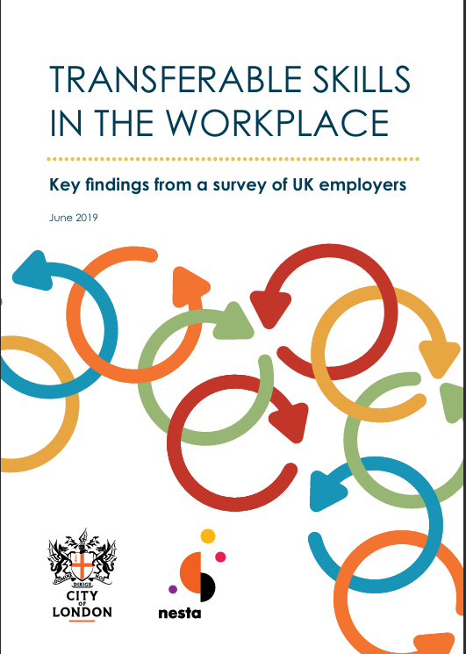

.

Click the link to access the source
https://www.cityoflondon.gov.uk/assets/Services-DCCS/transferable-skills-in-the-workplace.pdf
Strength of the Source:
This report was published in 2019 by the city of London corporation and written by Nesta. A key strength is that its surveys by 101 uk employers which is useful evidence that communication, teamwork and problem solving that employers value when recruiting staff.

Weakness of the Source:
The report states that its bias discussion only and is a weakness because it may not fully explain how personal opinions, limited evidence, or the research method could have influenced the findings for the report . This makes the report seem less balanced and reduces the reliability of its conclusions.

