

LOCATION: BIRMINGHAM
LEVEL 4 | LEFEL 4
EXAMINATION PERIOD | CYFNOD ARHOLIADAU
SEPTEMBER 2021 | mEDI 2021

MODULE CODE: ACCA4017
SOFTWARE DEVELOPMENT
TIME: 2 HOURS
ANSWER ALL Question/s in PArt one
answer aNY TWO questions IN PART TWO

Equipment or materials required – Computers with Python installed or Google Colab

FLORIN-CRISTIAN MATIC

PART ONE: ANSWER ALL QUESTIONS

1. a) What variable type would Python infer for the following values:

1.32 ………Float….........…………………………………..…

124 …………Intiger.........…………………………………..…

Hello …………String.........…………………………………..…

-34.62 …………..Negative float.......…………………………………..…

[-562] ………….List........…………………………………..…

[1 mark each - 5 marks total]

1. b) Spot the errors in the following program to calculate the area of a circle and write the error-free program in the empty box.

Program with errors | Error-free program
print("Enter the radius)  radus = input()  area = 3.14*radius*radius  PRINT(" The area of the circle is : " area) | print("Enter the radius:")  radius= float(input())  area=3.14*radius*radius  print("The area of the circle is:"+str(area))

[1 mark each mistake identified - 5 marks total]

1. c) How many iterations do the following loops have?

- for i in range(50):
print(i) ……50……

- for i in range(1,10,2):
print(i)
……5……

[2 marks each - 4 marks total]

1.d) What is the value of the integer variable total after the following code is executed?

total=0
for x in range(10):
total=total+x
if(x = = 5):
total=0 …30…… [4 marks total]

1.e) Given the following program:

Temp = [23,24,25,29,40,56]

i) Write the code you would use to print the value stored in the third element of the array on the screen

for i in [3]:
print(Temp[i])
...............................................................................................................

ii) Write the code you would use to sum up the first and last elements of the array
the_sum = Temp[0] + Temp[5]
print(the_sum)
.......................................................................................................................................

[1 mark each - 2 marks total]

[20 marks total for Question 1]

Part TWO (Answer any two questions)

1. Calculating the volume of a hemisphere

The volume of a hemisphere (half-sphere) is calculated using the formula:
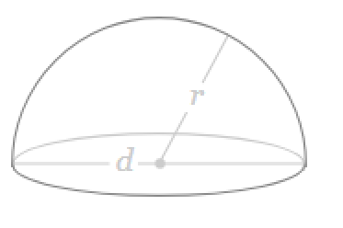

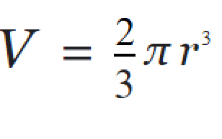

Task:
Write a program to calculate the volume using the above formula.

Allow the user to enter the measurement for r. You may set π as 3.142

pi=3.142
radian = float(input('Radius of hemisphere: '))
volume = (2/3) * (pi * radian ** 3)
print("Volume is: ", volume)

[20 marks total]

2. Using List

Task:
Define a list called height and enter the following values:

height= [122,145,163,122,121,141,170,180].

Use the list functions available to do the following:
- Display the created list.
- Append 190 to the list.
- Display total number of elements in the list.
- Sort the list in ascending order and display the modified list.
- Display the list in reverse order.

height= [122,145,163,122,121,141,170,180]
print("Elements of the List:\n")
for x in height:
print(x)

# append '190' to the list
height.append('190')
print('Updated height list: ', height)

number_of_elements = len(height)
print("Number of elements in the list: ", number_of_elements)

[4 marks each - 20 marks total]

3. Using Turtle

Using Python with Turtle, draw the following shapes:
- A triangle with black background


#Python program to draw color filled triangle in turtle programming
import turtle

t = turtle.Turtle()
t.fillcolor('black')
t.begin_fill()
for i in range(4):
t.forward(150)
t.right(-120)
t.end_fill()
[5 marks total]

- An octagon with yellow background and sides in alternative colours (red and black)

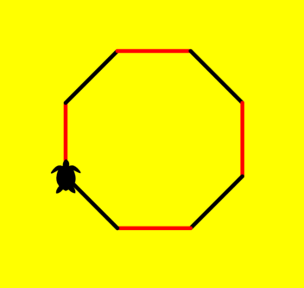

[15 marks total]

[20 marks total for Question 3]

Diwedd/End

