

LOCATION: Swansea | LLEOLIAD: abertawe
LEVEL 7 | LEFEL 7
EXAMINATION PERIOD | CYFNOD ARHOLIADAU
may 2021 | mai 2021

MODULE CODE: ACCA7029
COD Y MODWL: ACCA7029
ENTERPRISE CORE NETWORKING
TIME: 3 HOURS (including uploading all the work on Moodle)

answer ALL quESTIONs

Equipment or materials required – None
Adnoddau neu ddefnyddiau sydd eu hangen – Dim

EZZULDDIN ALAKKAR
2010845

ANSWER ALL QUESTIONS

  - In reference with ISP redundancy, explain
    - Single-homed means that a customer has a single connection to only one ISP. With this set-up, one can use static/default routes provided by the ISP to handle all traffic destined for all outside networks. Additionally, the host can announce its public network and the ISP announces the default route to the host.
    - Dual-homed when a customer is still connected to an ISP via a single connection and a single static or dynamic IP address, but the ISP has two routers on their side. This secondary router provides redundancy at the provider in case the primary router fails.
    - Multihomed Multihoming is the practice of connecting a network and IT infrastructure to two or more providers via the Border Gateway Protocol (BGP). (12 marks)

  - Refer to Figure 1, identify RSTP port roles and explain them.
Root
The root port is the switch port on every nonroot bridge that is the chosen path to the root bridge.
There can be only one root port on every switch.
The root port is considered as part of active topology.
It forwards, sends, and receives BPDUs (data messages).
Designated
Each switch has at least one switch port as the designated port for the segment.
In active topology, the switch with the designated port receives frames on the segment that are destined for the root bridge.
There can be only one designated port per segment.
Alternate
The alternate port is a switch port that offers an alternate path toward the root bridge.
It assumes a discarding state in an active topology.
The alternate port makes a transition to a designated port if the current designated path fails.
Disabled
A disabled port has no role within the operation of spanning tree.
Backup
The backup port is an additional switch port on the designated switch with a redundant link to the shared segment for which the switch is designated.
The backup port has the discarding state in active topology.

(13 marks)
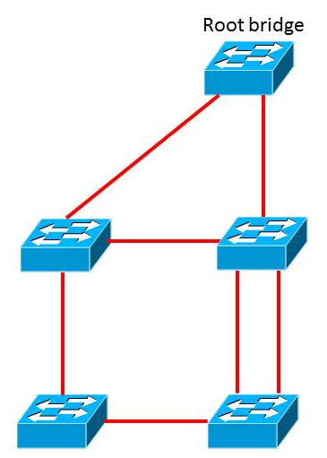

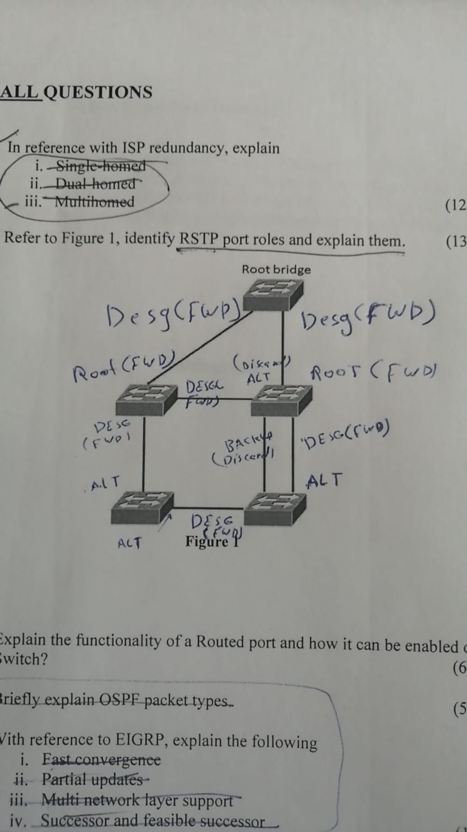

Figure 1

  - Explain the functionality of a Routed port and how it can be enabled on a Switch? Routed access is an alternative configuration in which Layer 3 is extended all the way to the access layer switches. In this design, access layer switches act as full Layer 3 routed nodes (providing both Layer 2 and Layer 3 switching), and the access-to-distribution Layer 2 uplink trunks are replaced with Layer 3 point-to-point routed links. Consequently, the Layer 2/Layer 3 demarcation point is moved from the distribution switch to the access switch. It can be enabled by the “No switchport” command. (6 marks)

  - Briefly explain OSPF packet types.

- Hello, Discover and maintain neighbors. Packets are sent periodically on all OSPF interfaces to discover neighbors and ensure that other adjacent neighbors are still online.
- 2. Dtabase description, Summarize database contents. Packets are exchanged when an OSPF adjacency is formed. They describe the LSDB contents.
- Link-state request, Download databases. If a router thinks that part of its LSDB is stale, it requests part of a neighbor’s DB using this packet type.
- Link-state update, Update databases. This is an explicit LSA for a specific network link and normally is sent in direct response to an LSR.
- Link-state acknowledged, Flood acknowledgments. These are sent in response to LSA flooding, making flooding a reliable transport feature.

(5 marks)

  - With reference to EIGRP, explain the following
    - Fast convergence, EIGRP uses DUAL to achieve rapid convergence. A router running EIGRP stores its neighbors’ routing tables so that it can quickly adapt to changes in the network. If no appropriate route or backup route exists in the local routing table, EIGRP queries its neighbors to discover an alternative route. These queries are propagated until an alternative route is found, or it is determined that no alternative route exists.
    - Partial updates, EIGRP sends partial triggered updates instead of periodic updates. These updates are sent only when the path or the metric for a route changes; they contain information about only that changed link rather than the entire routing table. Propagation of these partial updates is automatically bounded so that only those routers that require the information are updated. As a result, EIGRP consumes significantly less bandwidth than IGRP. This behavior is also different than link-state protocol operation, which sends a change update to all routers within an area
    - Multi network layer support EIGRP supports IP version 4 (IPv4), IP version 6 (IPv6), AppleTalk, and Novell NetWare Internetwork Packet Exchange (IPX) using protocol-dependent modules that are responsible for protocol requirements specific to the network layer. EIGRP’s rapid convergence and sophisticated metric offer superior performance and stability when implemented in IP, IPv6, IPX, and AppleTalk networks.
    - Successor and feasible successor
Successor
A successor is a neighboring router that has a least-cost path to a destination (the lowest FD) that is guaranteed not to be part of a routing loop.Successor routes are offered to the routing table to be used for forwarding packets.
Multiple successors can exist if they have the same FD.
Feasible successor (FS)
A feasible successor is a neighbor that is closer to the destination, but it is not the least-cost path.
A feasible successor ensures a loop-free topology because it must have an AD less than the FD of the current successor route.
Feasible successors are selected at the same time as successors but are kept in the topology table as backups to the successor routes.
The topology table can maintain multiple feasible successors for a destination.
(14 marks)

- The University is planning on merging all its locations and bringing it under one network. You have been hired as an IT Infrastructure consultant by UWTSD. Your task is to lead and work with the IT&S team to successfully complete this migration. The key objectives of this migration are design and implement:
    - Secure scalable network
    - Network management
    - High Availability
    - Support Digital Transformation

Your answer should include not only the technical aspects (LAN/WAN design, topology, architecture, choice of devices, redundancy, technologies, implementation, etc) addressing the key objectives but also the entire scope of the project. This should include planning, designing, project management, risk assessments, etc (50 marks)

- The network would be secured and all routers will be hardening, by implementing Authentications, Authorisations, and Accounting (AAA) on all the routers. Furthermore, ACLs should be used to restrict unwanted access and filtering others and securing access controlling. The two most popular remote access RADIUS to secure the network access and TACACS for devices administration. However, the routers need to be hardening by applying a specific commands on the interfaces that are connected to the public network, such as
- Disable topology discovery tools by using “No cdp enable” , “no lldp transmit”, and” no lldp receive”.
- Disable TCP and UDP small services
- Disable IP redirect services -
- Disable proxy Address Resolution Protocol (ARP)
- Disable service configuration
- Disable the Maintenance Operation Protocol (MOP) service
- Disable the packet assembler/disassembler (PAD) service

The network should also designed as hierarchical LANs, by dividing the network into modular layers to allow each layer to implement specific functions. Modular layers also provides fault containment, furthermore, with this design, all the network devices can be placed or taken for services or any other reasons with no impact on the rest of the network. The design would be devided into Access layer, Distributed layer, and Core layer. However, the three layer design are required in this case because the university has multiple sites.

- The access layer is to give all endpoints devices direct access to the network. It also provides high-bandwidth device connectivity using wired and wireless access techniques.VLANs should be used in this layer to segment, so different devices can be placed into different logical networks for better performance, management, and security. To protect the network from malicious attacks, the end users and endpoints connecting to the network should be prevented from accessing services for which they are not authorised. Quality of Services should be implemented in this layer to provide end-to-end users satisfaction in terms of quality of services.

- The distribution layer is to provide aggregation point for the access layer and acts as a services and control boundary between the access layer and the core layer. It works as a boundary between the layer 2 domain of the access layer and the layer 3 domain of the core layer to provide two important functions, the distribution layer creates a boundary for spanning tree protocol, limiting propagation of layer 2 fault. For layer 3 on the other hand, the distribution layer provides a logical point to summarise IP routing information when it enters the core of the network. The summarization reduces IP routing tables for easier troubleshooting and reduces protocol overhead for faster recovery from failures. Furthermore, in this layer the switches can be allocated within the buildings to reduce the cost of using fiber-optic between buildings. Adding to that, the switches in this layer should be interconnected to each other using either a layer 2 or 3 links.
- The core layer provides connection between the distribution layers for large network. Furthermore, this layer provides scalability, high availability, and fast convergence to the network. It also provides provide interconnectivity between the end-user/endpoint campus access layer and other network blocks, such as the data center, the private cloud, the public cloud, the WAN, the internet edge, and network services. The image illustrates the 3 layer suggested design.

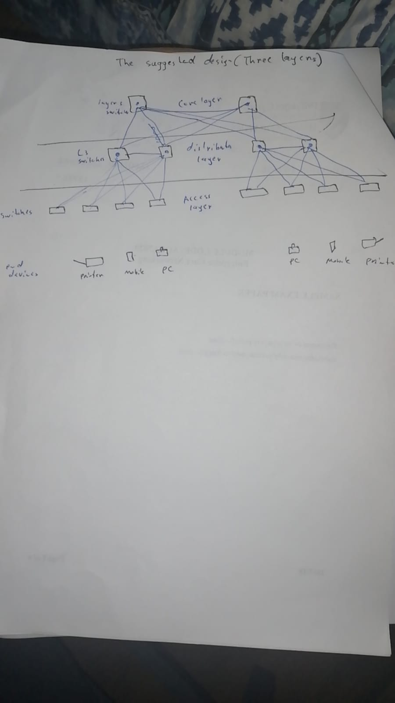

Diwedd/End

