Analysis of Variance Results Write-up
A fully powered MRC Phase III randomised controlled trial took place in May 2016. The study aimed to analyse the impact of a coping intervention on cancer-specific distress (CSD). Specifically, the study focused on whether individuals receiving the intervention would report significantly less CSD over time than those not receiving the intervention. Participants were recruited in the screening waiting area of the Cancer Genetics Service for Wales (CGSQ). Two-hundred and sixty patients participated in this research. They completed a version of the Impact of Event Scale (IES; Horowitz et al., 1979) that was adapted for CSD. Sociodemographic information was also collected at this time. The 260 participants were randomised into the intervention group (N= 129) or the control group (N = 131) upon referral. The control group were given standard information by the CGSQ, the intervention group were given standard information in addition to study information and the coping intervention. The coping intervention was presented in the form of a self-help leaflet, designed in line with psychological coping theory (Lazarus & Folkman, 1984). It intended to reduce CSD for those waiting for genetic risk information, through various coping techniques. To measure the short and long-term impact of the coping leaflet on CSD the IES was completed across three time points. At referral (Time 1), whilst waiting for their genetic risk information (Time 2), and one-month after receiving risk information (Time 3).
Due to the nature of this study it was surprising to find that 16.2% of participants reported a CSD score of 0 at baseline, highlighting a large floor effect for this sample when answering questions on the adapted IES. More than a third of participants (37.7%) reported high CSD (scores of 19 or more) at baseline (Time 1) on the adapted IES. The categories for CSD in this study were determined by Horowitz (1982).
Inspection of the histogram, stem and leaf plot, Q-Q plots, and boxplot prior to the primary analysis, found that five participants had scores that were highlighted as outliers. These scores were much higher than the rest of the participants scores, consequently they were removed from the dataset. This report will now focus on the remaining 255 participants for further analysis, when comparing CSD across time between the intervention group (N = 125) and the control group (N = 130). The sample included 221 females and 31 males, with three participants missing data regarding gender. The sample involved more females than males, therefore this does not support a representative sample. Furthermore, research shows that there are gender differences associated with coping (Ki et al., 2018), so the results in this study should be examined with caution. The participants age ranged from 18-81 (M = 50.70, SD = 12.03) with two participants missing data. Of those who gave sociodemographic information, 29.6% were educated to university degree or higher level. More than half (68.9%) of participants were married or living with a partner and 79.4% had at least one child.
Table 1 illustrates the mean scores and standard deviations for CSD over time, separated by group. No significant differences were found in CSD at baseline between participants randomly assigned to the control group (M = 16.34, SD = 15.11) and the intervention group (M = 17.13, SD = 17.53), t (253) = .39, p = .70. This shows an advantageous independent group design.

Table 1
Means and Standard Deviations for CSD by Group and Over Time.
Group | Time 1 |  | Time 2 |  | Time 3
 | M | SD | M | SD | M | SD
Control  N = 130 | 16.34 | 15.11 | 17.67 | 17.20 | 12.53 | 13.64
Intervention  N= 125 | 17.13 | 17.53 | 19.05 | 18.78 | 11.39 | 13.12
Total  N = 255 | 16.73 | 16.31 | 18.35 | 17.97 | 11.97 | 13.37
Note. CSD = cancer-specific distress
To investigate the effects of the coping leaflet on CSD over time a 2 x 3 mixed design Analysis of Variance (ANOVA) was conducted. The within-subjects factor was time (Time 1, Time 2, and Time 3) and the between-subjects factor was group (control or intervention). Mauchly’s test of sphericity indicated that the assumption of sphericity had been violated (χ² (2) = 40.73, p <0.001). Thus, degrees of freedom were corrected using Greenhouse-Geisser estimates of sphericity (ε = .87) for the within-subjects variable of time. None of the other assumptions of the data were violated. The analysis revealed no significant main effect of group F (1, 253) = .04; p = .84, partial η² = 0.000, indicating no significant difference in CSD between the control group and the intervention group. There was also no significant interaction between time and group F (1.74, 440.30) = 1.00; p = 0.36, partial η² = 0.004, meaning there was no significant difference in CSD reported between the control and intervention group over time. Nevertheless, there was a significant main effect of time F (1.74, 440.30) = 25.45; p <0.001, with a medium effect size - partial η² = 0.09, according to the guidelines proposed by Cohen (1988), revealing a significant difference in CSD over time for both groups.
To explore the main effect of time further a series of post-hoc pairwise comparisons were conducted to investigate the significance in greater depth, since there were three levels of time. With the application of the Bonferroni post-hoc test, it was found that for both groups, CSD was significantly higher upon referral (Time 1) (M = 16.73; SD = 16.31) than one-month after receiving genetic risk information (Time 3) (M = 11.97; SD =13.37) (p = .000). CSD was also significantly higher whilst waiting for genetic risk information (Time 2) (M = 18.35; SD = 17.97) compared to one-month post-risk information (Time 3) (M = 11.97; SD =13.37) (p = .000). No significant difference was found between CSD at baseline (Time 1) (M = 16.73; SD = 16.31) and whilst waiting for genetic risk information (Time 2) (M = 18.35; SD = 17.97) (p = .08).
When considering the potential value of the intervention leaflet on CSD, the results show that the participants CSD was not affected by the coping leaflet as hypothesised. Long-term, CSD significantly decreased when comparing CSD upon referral and whilst waiting for genetic information, with CSD one-month after being given genetic risk information. Short-term, a general pattern of increase in CSD between referral and the waiting period emerged, but this increase was not significant, though it does warrant further investigation. In conclusion, the results show that regardless of access to the intervention, CSD generally improved by the one-month post-risk information time point. There are limitations to this study as it did not consider the cancer risk results given to the participants. It would be interesting for future research to take into consideration the genetic risk results that participants were given to gain a better understanding of the impact of the coping intervention, though ethical approval must be considered. Additionally, the coping leaflet was targeted towards reducing CSD during the waiting period, so another implication for future research would be to ensure CSD is measured before risk information is given.

References
Cohen J. (1988). Statistical Power Analysis for the Behavioral Sciences. New York, NY: Routledge
Horowitz, M., Wilner, N., & Alvarez, W. (1979). Impact of Event Scale: a measure of subjective stress. Psychometric Medicine 1979: 41: 209 – 218.
Horowitz, M. J. (1982). Stress response syndromes and their treatment. In L. Goldberger, & S. Breznitz (Eds.), Handbook of stress: Theoretical and clinical aspects (pp. 711-732). New York, NY: Free Press.
Ki, P., Rohner, R., Britner, P., Halgunseth, L., & Rigazio-DiGilio, S. (2018). Coping With Remembrances of Parental Rejection in Childhood: Gender Differences and Associations With Intimate Partner Relationships. Journal Of Child And Family Studies, 27(8), 2441-2455. doi: 10.1007/s10826-018-1074-8
Lazarus, R., & Folkman, S. (1984). Stress, appraisal, and coping. New York: Springer.

Appendix
SPSS Datasheet

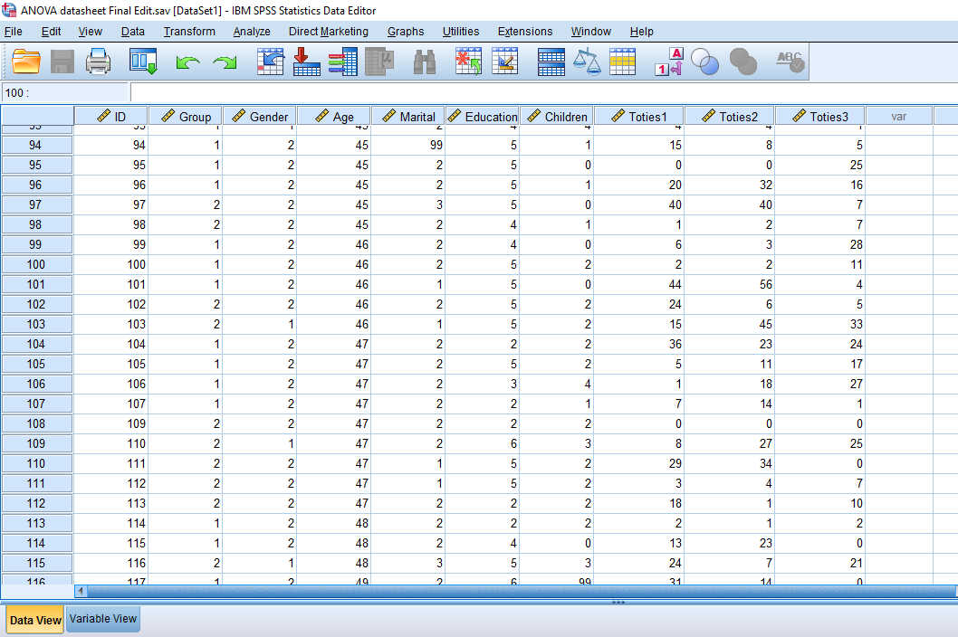

SPSS Output
Frequencies

Statistics
 |  | Group | Gender | Marital status | Education | Number of children
N | Valid | 260 | 257 | 256 | 258 | 258
N | Missing | 0 | 3 | 4 | 2 | 2

Frequency Table
Group
 |  | Frequency | Percent | Valid Percent | Cumulative Percent
Valid | Intervention | 129 | 49.6 | 49.6 | 49.6
Valid | Control | 131 | 50.4 | 50.4 | 100.0
Valid | Total | 260 | 100.0 | 100.0

Gender
 |  | Frequency | Percent | Valid Percent | Cumulative Percent
Valid | Male | 31 | 11.9 | 12.1 | 12.1
Valid | Female | 226 | 86.9 | 87.9 | 100.0
Valid | Total | 257 | 98.8 | 100.0
Missing | 99 | 3 | 1.2
Total |  | 260 | 100.0

Marital status
 |  | Frequency | Percent | Valid Percent | Cumulative Percent
Valid | Single | 36 | 13.8 | 14.1 | 14.1
Valid | Married/Living with partner | 177 | 68.1 | 69.1 | 83.2
Valid | Divorced/separated | 32 | 12.3 | 12.5 | 95.7
Valid | Widowed | 11 | 4.2 | 4.3 | 100.0
Valid | Total | 256 | 98.5 | 100.0
Missing | 99 | 4 | 1.5
Total |  | 260 | 100.0

Education
 |  | Frequency | Percent | Valid Percent | Cumulative Percent
Valid | Left before 16 | 48 | 18.5 | 18.6 | 18.6
Valid | Left at 16 | 52 | 20.0 | 20.2 | 38.8
Valid | Left at 18 | 13 | 5.0 | 5.0 | 43.8
Valid | College/Diploma | 47 | 18.1 | 18.2 | 62.0
Valid | University degree or higher | 76 | 29.2 | 29.5 | 91.5
Valid | Other | 22 | 8.5 | 8.5 | 100.0
Valid | Total | 258 | 99.2 | 100.0
Missing | 99 | 2 | .8
Total |  | 260 | 100.0

Number of children
 |  | Frequency | Percent | Valid Percent | Cumulative Percent
Valid | 0 | 53 | 20.4 | 20.5 | 20.5
Valid | 1 | 57 | 21.9 | 22.1 | 42.6
Valid | 2 | 79 | 30.4 | 30.6 | 73.3
Valid | 3 | 58 | 22.3 | 22.5 | 95.7
Valid | 4 | 9 | 3.5 | 3.5 | 99.2
Valid | 5 | 2 | .8 | .8 | 100.0
Valid | Total | 258 | 99.2 | 100.0
Missing | 99 | 2 | .8
Total |  | 260 | 100.0

Descriptives
Descriptive Statistics
 | N | Minimum | Maximum | Mean | Std. Deviation | Skewness |  | Kurtosis
 | Statistic | Statistic | Statistic | Statistic | Statistic | Statistic | Std. Error | Statistic | Std. Error
Age | 258 | 18 | 81 | 50.70 | 11.951 | -.079 | .152 | -.090 | .302
Toties1 | 260 | 0 | 67 | 17.12 | 16.631 | .822 | .151 | -.356 | .301
Toties2 | 260 | 0 | 70 | 18.87 | 18.266 | .763 | .151 | -.477 | .301
Toties3 | 260 | 0 | 73 | 12.90 | 14.852 | 1.344 | .151 | 1.273 | .301
Valid N (listwise) | 258

Frequencies
Statistics
Toties1
N | Valid | 260
N | Missing | 0

Toties1
 |  | Frequency | Percent | Valid Percent | Cumulative Percent
Valid | 0 | 42 | 16.2 | 16.2 | 16.2
Valid | 1 | 15 | 5.8 | 5.8 | 21.9
Valid | 2 | 12 | 4.6 | 4.6 | 26.5
Valid | 3 | 7 | 2.7 | 2.7 | 29.2
Valid | 4 | 7 | 2.7 | 2.7 | 31.9
Valid | 4 | 1 | .4 | .4 | 32.3
Valid | 5 | 7 | 2.7 | 2.7 | 35.0
Valid | 6 | 6 | 2.3 | 2.3 | 37.3
Valid | 7 | 8 | 3.1 | 3.1 | 40.4
Valid | 8 | 1 | .4 | .4 | 40.8
Valid | 8 | 7 | 2.7 | 2.7 | 43.5
Valid | 9 | 3 | 1.2 | 1.2 | 44.6
Valid | 10 | 6 | 2.3 | 2.3 | 46.9
Valid | 11 | 4 | 1.5 | 1.5 | 48.5
Valid | 12 | 3 | 1.2 | 1.2 | 49.6
Valid | 13 | 5 | 1.9 | 1.9 | 51.5
Valid | 14 | 11 | 4.2 | 4.2 | 55.8
Valid | 15 | 4 | 1.5 | 1.5 | 57.3
Valid | 16 | 2 | .8 | .8 | 58.1
Valid | 17 | 6 | 2.3 | 2.3 | 60.4
Valid | 18 | 1 | .4 | .4 | 60.8
Valid | 18 | 5 | 1.9 | 1.9 | 62.7
Valid | 19 | 2 | .8 | .8 | 63.5
Valid | 20 | 1 | .4 | .4 | 63.8
Valid | 21 | 2 | .8 | .8 | 64.6
Valid | 22 | 1 | .4 | .4 | 65.0
Valid | 23 | 5 | 1.9 | 1.9 | 66.9
Valid | 24 | 3 | 1.2 | 1.2 | 68.1
Valid | 25 | 8 | 3.1 | 3.1 | 71.2
Valid | 26 | 5 | 1.9 | 1.9 | 73.1
Valid | 27 | 4 | 1.5 | 1.5 | 74.6
Valid | 28 | 2 | .8 | .8 | 75.4
Valid | 29 | 3 | 1.2 | 1.2 | 76.5
Valid | 30 | 1 | .4 | .4 | 76.9
Valid | 31 | 5 | 1.9 | 1.9 | 78.8
Valid | 33 | 1 | .4 | .4 | 79.2
Valid | 33 | 1 | .4 | .4 | 79.6
Valid | 34 | 2 | .8 | .8 | 80.4
Valid | 35 | 3 | 1.2 | 1.2 | 81.5
Valid | 36 | 3 | 1.2 | 1.2 | 82.7
Valid | 37 | 4 | 1.5 | 1.5 | 84.2
Valid | 38 | 5 | 1.9 | 1.9 | 86.2
Valid | 40 | 4 | 1.5 | 1.5 | 87.7
Valid | 41 | 1 | .4 | .4 | 88.1
Valid | 42 | 1 | .4 | .4 | 88.5
Valid | 43 | 1 | .4 | .4 | 88.8
Valid | 44 | 9 | 3.5 | 3.5 | 92.3
Valid | 45 | 5 | 1.9 | 1.9 | 94.2
Valid | 49 | 2 | .8 | .8 | 95.0
Valid | 50 | 2 | .8 | .8 | 95.8
Valid | 51 | 4 | 1.5 | 1.5 | 97.3
Valid | 52 | 1 | .4 | .4 | 97.7
Valid | 53 | 1 | .4 | .4 | 98.1
Valid | 54 | 1 | .4 | .4 | 98.5
Valid | 59 | 2 | .8 | .8 | 99.2
Valid | 66 | 1 | .4 | .4 | 99.6
Valid | 67 | 1 | .4 | .4 | 100.0
Valid | Total | 260 | 100.0 | 100.0

Explore
Case Processing Summary
 | Cases
 | Valid |  | Missing |  | Total
 | N | Percent | N | Percent | N | Percent
Toties1 | 260 | 100.0% | 0 | 0.0% | 260 | 100.0%
Toties2 | 260 | 100.0% | 0 | 0.0% | 260 | 100.0%
Toties3 | 260 | 100.0% | 0 | 0.0% | 260 | 100.0%

Descriptives
 |  |  | Statistic | Std. Error
Toties1 | Mean |  | 17.12 | 1.031
Toties1 | 95% Confidence Interval for Mean | Lower Bound | 15.08
Toties1 | 95% Confidence Interval for Mean | Upper Bound | 19.15
Toties1 | 5% Trimmed Mean |  | 15.97
Toties1 | Median |  | 13.00
Toties1 | Variance |  | 276.577
Toties1 | Std. Deviation |  | 16.631
Toties1 | Minimum |  | 0
Toties1 | Maximum |  | 67
Toties1 | Range |  | 67
Toties1 | Interquartile Range |  | 26
Toties1 | Skewness |  | .822 | .151
Toties1 | Kurtosis |  | -.356 | .301
Toties2 | Mean |  | 18.87 | 1.133
Toties2 | 95% Confidence Interval for Mean | Lower Bound | 16.64
Toties2 | 95% Confidence Interval for Mean | Upper Bound | 21.10
Toties2 | 5% Trimmed Mean |  | 17.66
Toties2 | Median |  | 14.00
Toties2 | Variance |  | 333.657
Toties2 | Std. Deviation |  | 18.266
Toties2 | Minimum |  | 0
Toties2 | Maximum |  | 70
Toties2 | Range |  | 70
Toties2 | Interquartile Range |  | 31
Toties2 | Skewness |  | .763 | .151
Toties2 | Kurtosis |  | -.477 | .301
Toties3 | Mean |  | 12.90 | .921
Toties3 | 95% Confidence Interval for Mean | Lower Bound | 11.08
Toties3 | 95% Confidence Interval for Mean | Upper Bound | 14.71
Toties3 | 5% Trimmed Mean |  | 11.46
Toties3 | Median |  | 7.00
Toties3 | Variance |  | 220.592
Toties3 | Std. Deviation |  | 14.852
Toties3 | Minimum |  | 0
Toties3 | Maximum |  | 73
Toties3 | Range |  | 73
Toties3 | Interquartile Range |  | 20
Toties3 | Skewness |  | 1.344 | .151
Toties3 | Kurtosis |  | 1.273 | .301

Extreme Values
 |  |  | Case Number | Patient ID | Value
Toties1 | Highest | 1 | 241 | 241 | 67
Toties1 | Highest | 2 | 129 | 129 | 66
Toties1 | Highest | 3 | 75 | 75 | 59
Toties1 | Highest | 4 | 165 | 165 | 59
Toties1 | Highest | 5 | 10 | 10 | 54
Toties1 | Lowest | 1 | 260 | 260 | 0
Toties1 | Lowest | 2 | 254 | 254 | 0
Toties1 | Lowest | 3 | 247 | 247 | 0
Toties1 | Lowest | 4 | 245 | 245 | 0
Toties1 | Lowest | 5 | 233 | 233 | 0ª
Toties2 | Highest | 1 | 75 | 75 | 70
Toties2 | Highest | 2 | 241 | 241 | 69
Toties2 | Highest | 3 | 10 | 10 | 60
Toties2 | Highest | 4 | 18 | 18 | 60
Toties2 | Highest | 5 | 7 | 7 | 58^{b}
Toties2 | Lowest | 1 | 256 | 256 | 0
Toties2 | Lowest | 2 | 255 | 255 | 0
Toties2 | Lowest | 3 | 247 | 247 | 0
Toties2 | Lowest | 4 | 245 | 245 | 0
Toties2 | Lowest | 5 | 244 | 244 | 0ª
Toties3 | Highest | 1 | 241 | 241 | 73
Toties3 | Highest | 2 | 231 | 231 | 63
Toties3 | Highest | 3 | 180 | 180 | 59
Toties3 | Highest | 4 | 135 | 135 | 54
Toties3 | Highest | 5 | 108 | 108 | 52
Toties3 | Lowest | 1 | 260 | 260 | 0
Toties3 | Lowest | 2 | 255 | 255 | 0
Toties3 | Lowest | 3 | 254 | 254 | 0
Toties3 | Lowest | 4 | 247 | 247 | 0
Toties3 | Lowest | 5 | 245 | 245 | 0ª
a. Only a partial list of cases with the value 0 are shown in the table of lower extremes.
b. Only a partial list of cases with the value 58 are shown in the table of upper extremes.

Tests of Normality
 | Kolmogorov-Smirnovª |  |  | Shapiro-Wilk
 | Statistic | df | Sig. | Statistic | df | Sig.
Toties1 | .152 | 260 | .000 | .885 | 260 | .000
Toties2 | .151 | 260 | .000 | .887 | 260 | .000
Toties3 | .193 | 260 | .000 | .825 | 260 | .000
a. Lilliefors Significance Correction

Toties1

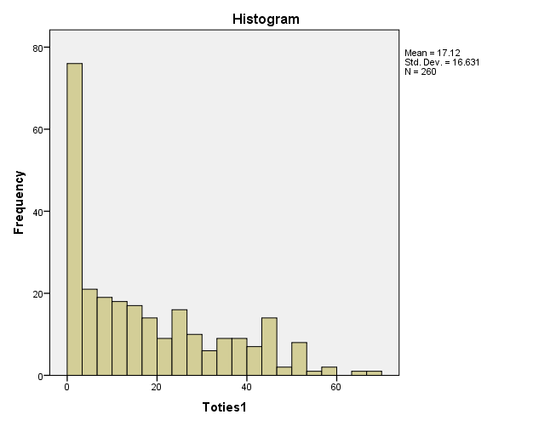
Toties1 Stem-and-Leaf Plot

Frequency Stem & Leaf

84.00 0 . 000000000000000000000000000000000000000000111111111111111222222222222333333344444444
32.00 0 . 55555556666667777777778888888999
29.00 1 . 00000011112223333344444444444
20.00 1 . 55556677777778888899
12.00 2 . 011233333444
23.00 2 . 55555555666667777889999
9.00 3 . 111113344
15.00 3 . 555666777788888
16.00 4 . 0000123444444444
7.00 4 . 5555599
9.00 5 . 001111234
2.00 5 . 99
.00 6 .
2.00 6 . 67

Stem width: 10
Each leaf: 1 case(s)

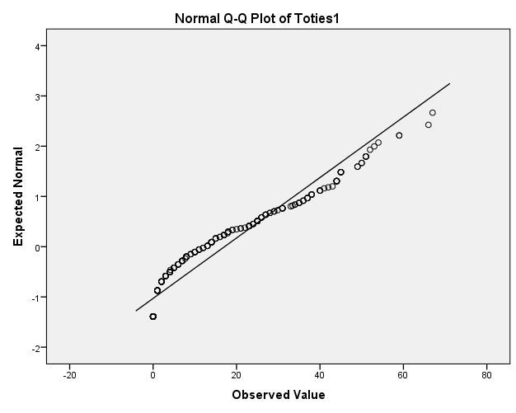

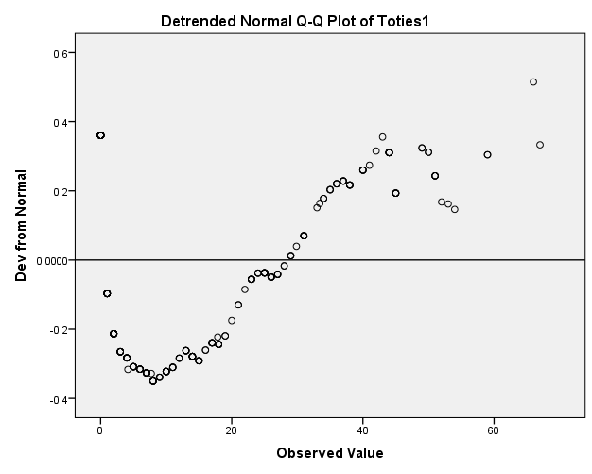

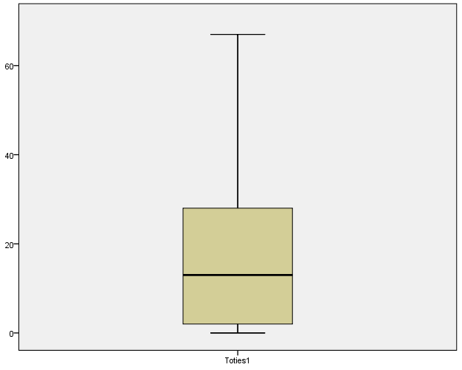

Toties2
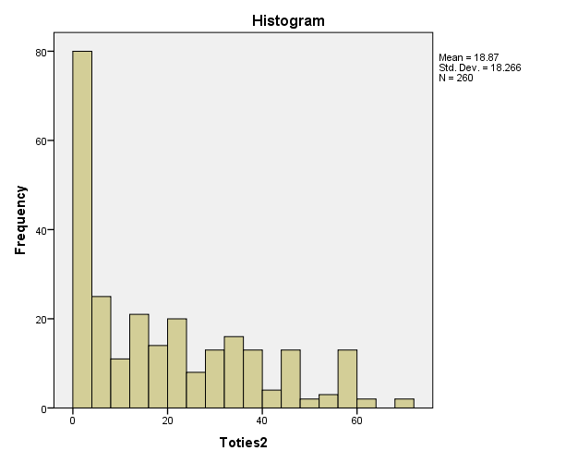

Toties2 Stem-and-Leaf Plot

Frequency Stem & Leaf

86.00 0 . 00000000000000000000000000000000000000000000000111111111111111222222233333333333444444
23.00 0 . 55566666666677777778888
23.00 1 . 00011112222233333444444
19.00 1 . 5555566666777899999
22.00 2 . 0111112222223333333344
13.00 2 . 5566678889999
21.00 3 . 000011222333333444444
14.00 3 . 56677788888999
7.00 4 . 2223444
11.00 4 . 55555567778
2.00 5 . 03
15.00 5 . 556666666778888
2.00 6 . 00
1.00 6 . 9
1.00 7 . 0

Stem width: 10
Each leaf: 1 case(s)

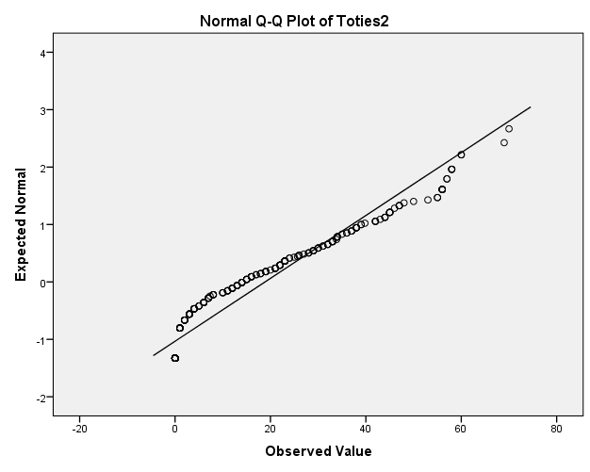

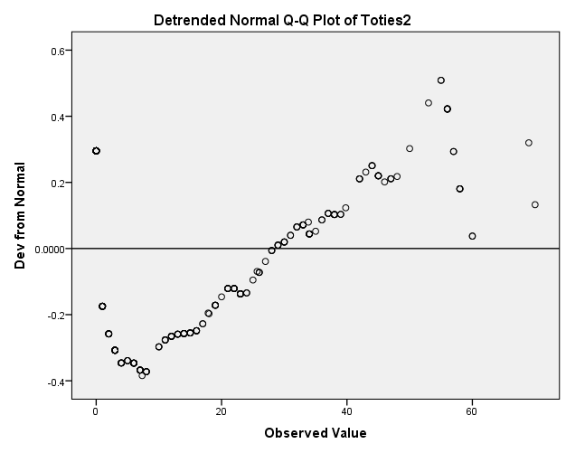

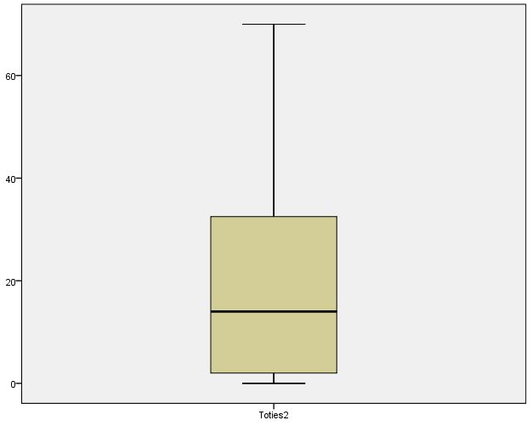

Toties3
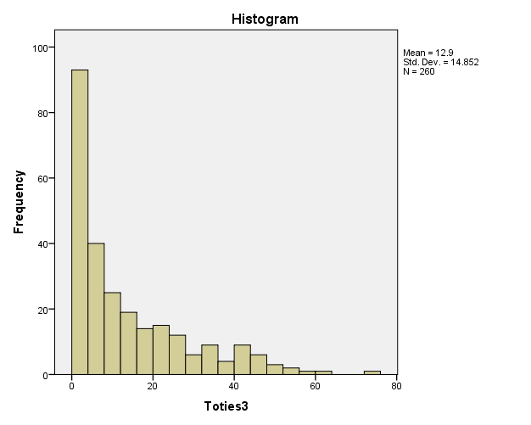

Toties3 Stem-and-Leaf Plot

Frequency Stem & Leaf

114.00 0 . 00000000000000000000000000001111111111222333334444444444
30.00 0 . 55566677788999
27.00 1 . 0001111223344
20.00 1 . 555667789
18.00 2 . 0111234
13.00 2 . 577789&
9.00 3 . 224&
6.00 3 . 58&
12.00 4 . 12334&
6.00 4 . 78&
5.00 Extremes (>=52)

Stem width: 10
Each leaf: 2 case(s)

& denotes fractional leaves.

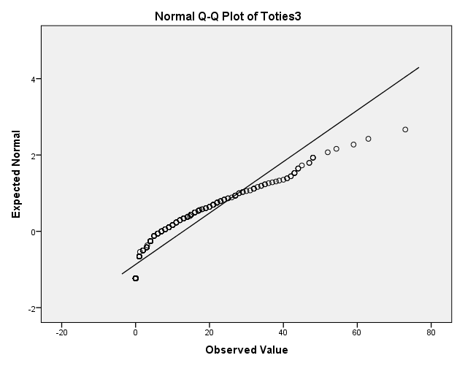

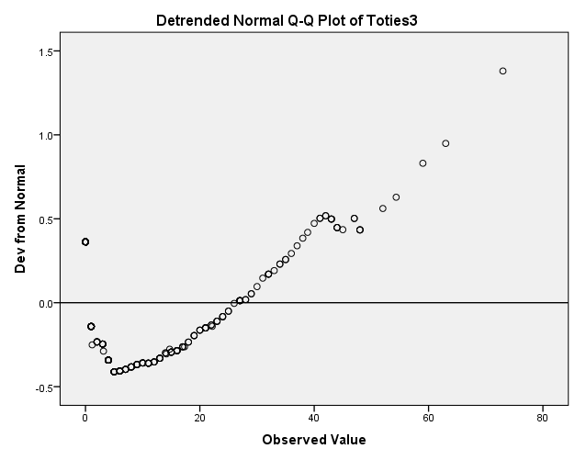

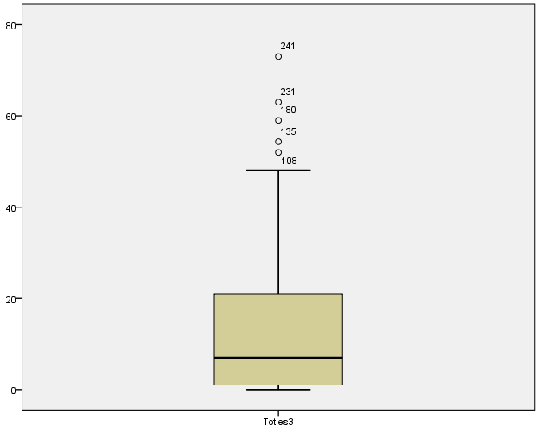

Frequencies
Statistics
 |  | Group | Gender | Marital status | Education | Number of children
N | Valid | 255 | 252 | 251 | 253 | 253
N | Missing | 0 | 3 | 4 | 2 | 2

Frequency Table
Group
 |  | Frequency | Percent | Valid Percent | Cumulative Percent
Valid | Intervention | 125 | 49.0 | 49.0 | 49.0
Valid | Control | 130 | 51.0 | 51.0 | 100.0
Valid | Total | 255 | 100.0 | 100.0

Gender
 |  | Frequency | Percent | Valid Percent | Cumulative Percent
Valid | Male | 31 | 12.2 | 12.3 | 12.3
Valid | Female | 221 | 86.7 | 87.7 | 100.0
Valid | Total | 252 | 98.8 | 100.0
Missing | 99 | 3 | 1.2
Total |  | 255 | 100.0

Marital status
 |  | Frequency | Percent | Valid Percent | Cumulative Percent
Valid | Single | 36 | 14.1 | 14.3 | 14.3
Valid | Married/Living with partner | 173 | 67.8 | 68.9 | 83.3
Valid | Divorced/separated | 31 | 12.2 | 12.4 | 95.6
Valid | Widowed | 11 | 4.3 | 4.4 | 100.0
Valid | Total | 251 | 98.4 | 100.0
Missing | 99 | 4 | 1.6
Total |  | 255 | 100.0

Education
 |  | Frequency | Percent | Valid Percent | Cumulative Percent
Valid | Left before 16 | 47 | 18.4 | 18.6 | 18.6
Valid | Left at 16 | 49 | 19.2 | 19.4 | 37.9
Valid | Left at 18 | 13 | 5.1 | 5.1 | 43.1
Valid | College/Diploma | 47 | 18.4 | 18.6 | 61.7
Valid | University degree or higher | 75 | 29.4 | 29.6 | 91.3
Valid | Other | 22 | 8.6 | 8.7 | 100.0
Valid | Total | 253 | 99.2 | 100.0
Missing | 99 | 2 | .8
Total |  | 255 | 100.0

Number of children
 |  | Frequency | Percent | Valid Percent | Cumulative Percent
Valid | 0 | 52 | 20.4 | 20.6 | 20.6
Valid | 1 | 57 | 22.4 | 22.5 | 43.1
Valid | 2 | 77 | 30.2 | 30.4 | 73.5
Valid | 3 | 57 | 22.4 | 22.5 | 96.0
Valid | 4 | 8 | 3.1 | 3.2 | 99.2
Valid | 5 | 2 | .8 | .8 | 100.0
Valid | Total | 253 | 99.2 | 100.0
Missing | 99 | 2 | .8
Total |  | 255 | 100.0

Descriptives
Descriptive Statistics
 | N | Minimum | Maximum | Mean | Std. Deviation | Skewness |  | Kurtosis
 | Statistic | Statistic | Statistic | Statistic | Statistic | Statistic | Std. Error | Statistic | Std. Error
Age | 253 | 18 | 81 | 50.70 | 12.032 | -.077 | .153 | -.114 | .305
Toties1 | 255 | 0 | 66 | 16.73 | 16.313 | .823 | .153 | -.396 | .304
Toties2 | 255 | 0 | 70 | 18.35 | 17.968 | .791 | .153 | -.442 | .304
Toties3 | 255 | 0 | 48 | 11.97 | 13.372 | 1.140 | .153 | .269 | .304
Valid N (listwise) | 253

T-Test
Group Statistics
 | Group | N | Mean | Std. Deviation | Std. Error Mean
Toties1 | Intervention | 125 | 17.13 | 17.529 | 1.568
Toties1 | Control | 130 | 16.34 | 15.110 | 1.325

Independent Samples Test
 |  | Levene's Test for Equality of Variances |  | t-test for Equality of Means
 |  | F | Sig. | t | df | Sig. (2-tailed) | Mean Difference | Std. Error Difference | 95% Confidence Interval of the Difference
 |  |  |  |  |  |  |  |  | Lower | Upper
Toties1 | Equal variances assumed | 1.625 | .204 | .388 | 253 | .699 | .793 | 2.047 | -3.238 | 4.824
Toties1 | Equal variances not assumed |  |  | .386 | 244.513 | .700 | .793 | 2.053 | -3.250 | 4.837

T-Test
Group Statistics
 | Group | N | Mean | Std. Deviation | Std. Error Mean
Toties2 | Intervention | 125 | 19.05 | 18.776 | 1.679
Toties2 | Control | 130 | 17.67 | 17.202 | 1.509

Independent Samples Test
 |  | Levene's Test for Equality of Variances |  | t-test for Equality of Means
 |  | F | Sig. | t | df | Sig. (2-tailed) | Mean Difference | Std. Error Difference | 95% Confidence Interval of the Difference
 |  |  |  |  |  |  |  |  | Lower | Upper
Toties2 | Equal variances assumed | .354 | .552 | .611 | 253 | .541 | 1.378 | 2.254 | -3.060 | 5.816
Toties2 | Equal variances not assumed |  |  | .610 | 249.012 | .542 | 1.378 | 2.258 | -3.068 | 5.824

T-Test
Group Statistics
 | Group | N | Mean | Std. Deviation | Std. Error Mean
Toties3 | Intervention | 125 | 11.39 | 13.116 | 1.173
Toties3 | Control | 130 | 12.53 | 13.641 | 1.196

Independent Samples Test
 |  | Levene's Test for Equality of Variances |  | t-test for Equality of Means
 |  | F | Sig. | t | df | Sig. (2-tailed) | Mean Difference | Std. Error Difference | 95% Confidence Interval of the Difference
 |  |  |  |  |  |  |  |  | Lower | Upper
Toties3 | Equal variances assumed | 1.166 | .281 | -.680 | 253 | .497 | -1.140 | 1.677 | -4.443 | 2.162
Toties3 | Equal variances not assumed |  |  | -.681 | 253.000 | .497 | -1.140 | 1.676 | -4.440 | 2.159

T-Test
Group Statistics
 | Gender | N | Mean | Std. Deviation | Std. Error Mean
Toties1 | Male | 31 | 16.65 | 15.728 | 2.825
Toties1 | Female | 221 | 16.63 | 16.368 | 1.101

Independent Samples Test
 |  | Levene's Test for Equality of Variances |  | t-test for Equality of Means
 |  | F | Sig. | t | df | Sig. (2-tailed) | Mean Difference | Std. Error Difference | 95% Confidence Interval of the Difference
 |  |  |  |  |  |  |  |  | Lower | Upper
Toties1 | Equal variances assumed | .223 | .637 | .006 | 250 | .995 | .018 | 3.125 | -6.136 | 6.172
Toties1 | Equal variances not assumed |  |  | .006 | 39.683 | .995 | .018 | 3.032 | -6.111 | 6.147

T-Test
Group Statistics
 | Gender | N | Mean | Std. Deviation | Std. Error Mean
Toties2 | Male | 31 | 17.35 | 16.148 | 2.900
Toties2 | Female | 221 | 18.46 | 18.280 | 1.230

Independent Samples Test
 |  | Levene's Test for Equality of Variances |  | t-test for Equality of Means
 |  | F | Sig. | t | df | Sig. (2-tailed) | Mean Difference | Std. Error Difference | 95% Confidence Interval of the Difference
 |  |  |  |  |  |  |  |  | Lower | Upper
Toties2 | Equal variances assumed | 1.568 | .212 | -.321 | 250 | .749 | -1.109 | 3.459 | -7.922 | 5.704
Toties2 | Equal variances not assumed |  |  | -.352 | 41.572 | .727 | -1.109 | 3.150 | -7.468 | 5.250

T-Test
Group Statistics
 | Gender | N | Mean | Std. Deviation | Std. Error Mean
Toties3 | Male | 31 | 13.07 | 14.809 | 2.660
Toties3 | Female | 221 | 11.84 | 13.181 | .887

Independent Samples Test
 |  | Levene's Test for Equality of Variances |  | t-test for Equality of Means
 |  | F | Sig. | t | df | Sig. (2-tailed) | Mean Difference | Std. Error Difference | 95% Confidence Interval of the Difference
 |  |  |  |  |  |  |  |  | Lower | Upper
Toties3 | Equal variances assumed | 2.186 | .140 | .477 | 250 | .633 | 1.226 | 2.567 | -3.831 | 6.282
Toties3 | Equal variances not assumed |  |  | .437 | 36.976 | .665 | 1.226 | 2.804 | -4.455 | 6.907

General Linear Model
Within-Subjects Factors
Measure: MEASURE_1
Time | Dependent Variable
1 | Toties1
2 | Toties2
3 | Toties3

Between-Subjects Factors
 |  | Value Label | N
Group | 1 | Intervention | 125
Group | 2 | Control | 130

Descriptive Statistics
 | Group | Mean | Std. Deviation | N
Toties1 | Intervention | 17.13 | 17.529 | 125
Toties1 | Control | 16.34 | 15.110 | 130
Toties1 | Total | 16.73 | 16.313 | 255
Toties2 | Intervention | 19.05 | 18.776 | 125
Toties2 | Control | 17.67 | 17.202 | 130
Toties2 | Total | 18.35 | 17.968 | 255
Toties3 | Intervention | 11.39 | 13.116 | 125
Toties3 | Control | 12.53 | 13.641 | 130
Toties3 | Total | 11.97 | 13.372 | 255

Box's Test of Equality of Covariance Matricesª
Box's M | 19.725
F | 3.245
df1 | 6
df2 | 461828.969
Sig. | .003
Tests the null hypothesis that the observed covariance matrices of the dependent variables are equal across groups.
a. Design: Intercept + Group
Within Subjects Design: Time

Multivariate Testsª
Effect |  | Value | F | Hypothesis df | Error df | Sig. | Partial Eta Squared
Time | Pillai's Trace | .134 | 19.447^{b} | 2.000 | 252.000 | .000 | .134
Time | Wilks' Lambda | .866 | 19.447^{b} | 2.000 | 252.000 | .000 | .134
Time | Hotelling's Trace | .154 | 19.447^{b} | 2.000 | 252.000 | .000 | .134
Time | Roy's Largest Root | .154 | 19.447^{b} | 2.000 | 252.000 | .000 | .134
Time * Group | Pillai's Trace | .006 | .753^{b} | 2.000 | 252.000 | .472 | .006
Time * Group | Wilks' Lambda | .994 | .753^{b} | 2.000 | 252.000 | .472 | .006
Time * Group | Hotelling's Trace | .006 | .753^{b} | 2.000 | 252.000 | .472 | .006
Time * Group | Roy's Largest Root | .006 | .753^{b} | 2.000 | 252.000 | .472 | .006
a. Design: Intercept + Group
Within Subjects Design: Time
b. Exact statistic

Mauchly's Test of Sphericityª
Measure: MEASURE_1
Within Subjects Effect | Mauchly's W | Approx. Chi-Square | df | Sig. | Epsilon^{b}
 |  |  |  |  | Greenhouse-Geisser | Huynh-Feldt | Lower-bound
Time | .851 | 40.726 | 2 | .000 | .870 | .879 | .500
Tests the null hypothesis that the error covariance matrix of the orthonormalized transformed dependent variables is proportional to an identity matrix.
a. Design: Intercept + Group
Within Subjects Design: Time
b. May be used to adjust the degrees of freedom for the averaged tests of significance. Corrected tests are displayed in the Tests of Within-Subjects Effects table.

Tests of Within-Subjects Effects
Measure: MEASURE_1
Source |  | Type III Sum of Squares | df | Mean Square | F | Sig. | Partial Eta Squared
Time | Sphericity Assumed | 5652.284 | 2 | 2826.142 | 25.447 | .000 | .091
Time | Greenhouse-Geisser | 5652.284 | 1.740 | 3247.882 | 25.447 | .000 | .091
Time | Huynh-Feldt | 5652.284 | 1.758 | 3214.731 | 25.447 | .000 | .091
Time | Lower-bound | 5652.284 | 1.000 | 5652.284 | 25.447 | .000 | .091
Time * Group | Sphericity Assumed | 221.424 | 2 | 110.712 | .997 | .370 | .004
Time * Group | Greenhouse-Geisser | 221.424 | 1.740 | 127.234 | .997 | .361 | .004
Time * Group | Huynh-Feldt | 221.424 | 1.758 | 125.935 | .997 | .361 | .004
Time * Group | Lower-bound | 221.424 | 1.000 | 221.424 | .997 | .319 | .004
Error(Time) | Sphericity Assumed | 56196.082 | 506 | 111.059
Error(Time) | Greenhouse-Geisser | 56196.082 | 440.296 | 127.633
Error(Time) | Huynh-Feldt | 56196.082 | 444.836 | 126.330
Error(Time) | Lower-bound | 56196.082 | 253.000 | 222.119

Tests of Within-Subjects Contrasts
Measure: MEASURE_1
Source | Time | Type III Sum of Squares | df | Mean Square | F | Sig. | Partial Eta Squared
Time | Linear | 2914.127 | 1 | 2914.127 | 22.237 | .000 | .081
Time | Quadratic | 2738.158 | 1 | 2738.158 | 30.066 | .000 | .106
Time * Group | Linear | 119.146 | 1 | 119.146 | .909 | .341 | .004
Time * Group | Quadratic | 102.279 | 1 | 102.279 | 1.123 | .290 | .004
Error(Time) | Linear | 33155.047 | 253 | 131.048
Error(Time) | Quadratic | 23041.035 | 253 | 91.071

Levene's Test of Equality of Error Variancesª
 | F | df1 | df2 | Sig.
Toties1 | 1.625 | 1 | 253 | .204
Toties2 | .354 | 1 | 253 | .552
Toties3 | 1.166 | 1 | 253 | .281
Tests the null hypothesis that the error variance of the dependent variable is equal across groups.
a. Design: Intercept + Group
Within Subjects Design: Time

Tests of Between-Subjects Effects
Measure: MEASURE_1
Transformed Variable: Average
Source | Type III Sum of Squares | df | Mean Square | F | Sig. | Partial Eta Squared
Intercept | 188119.490 | 1 | 188119.490 | 343.448 | .000 | .576
Group | 22.568 | 1 | 22.568 | .041 | .839 | .000
Error | 138577.527 | 253 | 547.737

Profile Plots

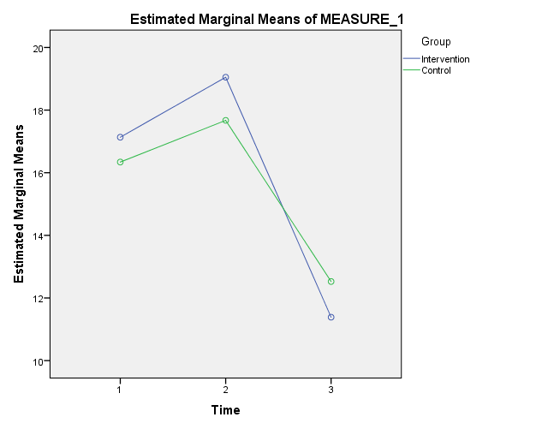

General Linear Model
Within-Subjects Factors
Measure: MEASURE_1
Time | Dependent Variable
1 | Toties1
2 | Toties2
3 | Toties3

Between-Subjects Factors
 |  | Value Label | N
Group | 1 | Intervention | 125
Group | 2 | Control | 130

Descriptive Statistics
 | Group | Mean | Std. Deviation | N
Toties1 | Intervention | 17.13 | 17.529 | 125
Toties1 | Control | 16.34 | 15.110 | 130
Toties1 | Total | 16.73 | 16.313 | 255
Toties2 | Intervention | 19.05 | 18.776 | 125
Toties2 | Control | 17.67 | 17.202 | 130
Toties2 | Total | 18.35 | 17.968 | 255
Toties3 | Intervention | 11.39 | 13.116 | 125
Toties3 | Control | 12.53 | 13.641 | 130
Toties3 | Total | 11.97 | 13.372 | 255

Box's Test of Equality of Covariance Matricesª
Box's M | 19.725
F | 3.245
df1 | 6
df2 | 461828.969
Sig. | .003
Tests the null hypothesis that the observed covariance matrices of the dependent variables are equal across groups.
a. Design: Intercept + Group
Within Subjects Design: Time

Multivariate Testsª
Effect |  | Value | F | Hypothesis df | Error df | Sig. | Partial Eta Squared
Time | Pillai's Trace | .134 | 19.447^{b} | 2.000 | 252.000 | .000 | .134
Time | Wilks' Lambda | .866 | 19.447^{b} | 2.000 | 252.000 | .000 | .134
Time | Hotelling's Trace | .154 | 19.447^{b} | 2.000 | 252.000 | .000 | .134
Time | Roy's Largest Root | .154 | 19.447^{b} | 2.000 | 252.000 | .000 | .134
Time * Group | Pillai's Trace | .006 | .753^{b} | 2.000 | 252.000 | .472 | .006
Time * Group | Wilks' Lambda | .994 | .753^{b} | 2.000 | 252.000 | .472 | .006
Time * Group | Hotelling's Trace | .006 | .753^{b} | 2.000 | 252.000 | .472 | .006
Time * Group | Roy's Largest Root | .006 | .753^{b} | 2.000 | 252.000 | .472 | .006
a. Design: Intercept + Group
Within Subjects Design: Time
b. Exact statistic

Mauchly's Test of Sphericityª
Measure: MEASURE_1
Within Subjects Effect | Mauchly's W | Approx. Chi-Square | df | Sig. | Epsilon^{b}
 |  |  |  |  | Greenhouse-Geisser | Huynh-Feldt | Lower-bound
Time | .851 | 40.726 | 2 | .000 | .870 | .879 | .500
Tests the null hypothesis that the error covariance matrix of the orthonormalized transformed dependent variables is proportional to an identity matrix.
a. Design: Intercept + Group
Within Subjects Design: Time
b. May be used to adjust the degrees of freedom for the averaged tests of significance. Corrected tests are displayed in the Tests of Within-Subjects Effects table.

Tests of Within-Subjects Effects
Measure: MEASURE_1
Source |  | Type III Sum of Squares | df | Mean Square | F | Sig. | Partial Eta Squared
Time | Sphericity Assumed | 5652.284 | 2 | 2826.142 | 25.447 | .000 | .091
Time | Greenhouse-Geisser | 5652.284 | 1.740 | 3247.882 | 25.447 | .000 | .091
Time | Huynh-Feldt | 5652.284 | 1.758 | 3214.731 | 25.447 | .000 | .091
Time | Lower-bound | 5652.284 | 1.000 | 5652.284 | 25.447 | .000 | .091
Time * Group | Sphericity Assumed | 221.424 | 2 | 110.712 | .997 | .370 | .004
Time * Group | Greenhouse-Geisser | 221.424 | 1.740 | 127.234 | .997 | .361 | .004
Time * Group | Huynh-Feldt | 221.424 | 1.758 | 125.935 | .997 | .361 | .004
Time * Group | Lower-bound | 221.424 | 1.000 | 221.424 | .997 | .319 | .004
Error(Time) | Sphericity Assumed | 56196.082 | 506 | 111.059
Error(Time) | Greenhouse-Geisser | 56196.082 | 440.296 | 127.633
Error(Time) | Huynh-Feldt | 56196.082 | 444.836 | 126.330
Error(Time) | Lower-bound | 56196.082 | 253.000 | 222.119

Tests of Within-Subjects Contrasts
Measure: MEASURE_1
Source | Time | Type III Sum of Squares | df | Mean Square | F | Sig. | Partial Eta Squared
Time | Linear | 2914.127 | 1 | 2914.127 | 22.237 | .000 | .081
Time | Quadratic | 2738.158 | 1 | 2738.158 | 30.066 | .000 | .106
Time * Group | Linear | 119.146 | 1 | 119.146 | .909 | .341 | .004
Time * Group | Quadratic | 102.279 | 1 | 102.279 | 1.123 | .290 | .004
Error(Time) | Linear | 33155.047 | 253 | 131.048
Error(Time) | Quadratic | 23041.035 | 253 | 91.071

Levene's Test of Equality of Error Variancesª
 | F | df1 | df2 | Sig.
Toties1 | 1.625 | 1 | 253 | .204
Toties2 | .354 | 1 | 253 | .552
Toties3 | 1.166 | 1 | 253 | .281
Tests the null hypothesis that the error variance of the dependent variable is equal across groups.
a. Design: Intercept + Group
Within Subjects Design: Time

Tests of Between-Subjects Effects
Measure: MEASURE_1
Transformed Variable: Average
Source | Type III Sum of Squares | df | Mean Square | F | Sig. | Partial Eta Squared
Intercept | 188119.490 | 1 | 188119.490 | 343.448 | .000 | .576
Group | 22.568 | 1 | 22.568 | .041 | .839 | .000
Error | 138577.527 | 253 | 547.737

Estimated Marginal Means
Time
Estimates
Measure: MEASURE_1
Time | Mean | Std. Error | 95% Confidence Interval
Time | Mean | Std. Error | Lower Bound | Upper Bound
1 | 16.737 | 1.023 | 14.722 | 18.753
2 | 18.361 | 1.127 | 16.141 | 20.580
3 | 11.956 | .838 | 10.304 | 13.607

Pairwise Comparisons
Measure: MEASURE_1
(I) Time | (J) Time | Mean Difference (I-J) | Std. Error | Sig.^{b} | 95% Confidence Interval for Difference^{b}
 |  |  |  |  | Lower Bound | Upper Bound
1 | 2 | -1.623 | .731 | .082 | -3.386 | .140
1 | 3 | 4.782* | 1.014 | .000 | 2.338 | 7.225
2 | 1 | 1.623 | .731 | .082 | -.140 | 3.386
2 | 3 | 6.405* | 1.025 | .000 | 3.934 | 8.876
3 | 1 | -4.782* | 1.014 | .000 | -7.225 | -2.338
3 | 2 | -6.405* | 1.025 | .000 | -8.876 | -3.934
Based on estimated marginal means
*. The mean difference is significant at the .05 level.
b. Adjustment for multiple comparisons: Bonferroni.

Multivariate Tests
 | Value | F | Hypothesis df | Error df | Sig. | Partial Eta Squared
Pillai's trace | .134 | 19.447ª | 2.000 | 252.000 | .000 | .134
Wilks' lambda | .866 | 19.447ª | 2.000 | 252.000 | .000 | .134
Hotelling's trace | .154 | 19.447ª | 2.000 | 252.000 | .000 | .134
Roy's largest root | .154 | 19.447ª | 2.000 | 252.000 | .000 | .134
Each F tests the multivariate effect of Time. These tests are based on the linearly independent pairwise comparisons among the estimated marginal means.
a. Exact statistic

Profile Plots

SORT CASES BY Gender.
SPLIT FILE SEPARATE BY Gender.
GLM Toties1 Toties2 Toties3 BY Group
/WSFACTOR=Time 3 Polynomial
/METHOD=SSTYPE(3)
/PLOT=PROFILE(Time*Group)
/EMMEANS=TABLES(Time) COMPARE ADJ(BONFERRONI)
/PRINT=DESCRIPTIVE ETASQ HOMOGENEITY
/CRITERIA=ALPHA(.05)
/WSDESIGN=Time
/DESIGN=Group.

General Linear Model
Warnings
Box's Test of Equality of Covariance Matrices is not computed because there are fewer than two nonsingular cell covariance matrices.

Within-Subjects Factors
Measure: MEASURE_1
Time | Dependent Variable
1 | Toties1
2 | Toties2
3 | Toties3

Gender = Male
Between-Subjects Factorsª
 |  | Value Label | N
Group | 1 | Intervention | 15
Group | 2 | Control | 16
a. Gender = Male

Descriptive Statisticsª
 | Group | Mean | Std. Deviation | N
Toties1 | Intervention | 21.68 | 18.388 | 15
Toties1 | Control | 11.94 | 11.410 | 16
Toties1 | Total | 16.65 | 15.728 | 31
Toties2 | Intervention | 20.89 | 17.612 | 15
Toties2 | Control | 14.04 | 14.415 | 16
Toties2 | Total | 17.35 | 16.148 | 31
Toties3 | Intervention | 13.87 | 15.761 | 15
Toties3 | Control | 12.32 | 14.336 | 16
Toties3 | Total | 13.07 | 14.809 | 31
a. Gender = Male

Box's Test of Equality of Covariance Matrices^{a,b}
Box's M | 9.871
F | 1.459
df1 | 6
df2 | 6016.462
Sig. | .188
Tests the null hypothesis that the observed covariance matrices of the dependent variables are equal across groups.
a. Gender = Male
b. Design: Intercept + Group
Within Subjects Design: Time

Multivariate Tests^{a,b}
Effect |  | Value | F | Hypothesis df | Error df | Sig. | Partial Eta Squared
Time | Pillai's Trace | .133 | 2.150^{c} | 2.000 | 28.000 | .135 | .133
Time | Wilks' Lambda | .867 | 2.150^{c} | 2.000 | 28.000 | .135 | .133
Time | Hotelling's Trace | .154 | 2.150^{c} | 2.000 | 28.000 | .135 | .133
Time | Roy's Largest Root | .154 | 2.150^{c} | 2.000 | 28.000 | .135 | .133
Time * Group | Pillai's Trace | .100 | 1.554^{c} | 2.000 | 28.000 | .229 | .100
Time * Group | Wilks' Lambda | .900 | 1.554^{c} | 2.000 | 28.000 | .229 | .100
Time * Group | Hotelling's Trace | .111 | 1.554^{c} | 2.000 | 28.000 | .229 | .100
Time * Group | Roy's Largest Root | .111 | 1.554^{c} | 2.000 | 28.000 | .229 | .100
a. Gender = Male
b. Design: Intercept + Group
Within Subjects Design: Time
c. Exact statistic

Mauchly's Test of Sphericity^{a,b}
Measure: MEASURE_1
Within Subjects Effect | Mauchly's W | Approx. Chi-Square | df | Sig. | Epsilon^{c}
 |  |  |  |  | Greenhouse-Geisser | Huynh-Feldt | Lower-bound
Time | .993 | .183 | 2 | .913 | .994 | 1.000 | .500
Tests the null hypothesis that the error covariance matrix of the orthonormalized transformed dependent variables is proportional to an identity matrix.
a. Gender = Male
b. Design: Intercept + Group
Within Subjects Design: Time
c. May be used to adjust the degrees of freedom for the averaged tests of significance. Corrected tests are displayed in the Tests of Within-Subjects Effects table.

Tests of Within-Subjects Effectsª
Measure: MEASURE_1
Source |  | Type III Sum of Squares | df | Mean Square | F | Sig. | Partial Eta Squared
Time | Sphericity Assumed | 344.061 | 2 | 172.030 | 2.096 | .132 | .067
Time | Greenhouse-Geisser | 344.061 | 1.987 | 173.151 | 2.096 | .133 | .067
Time | Huynh-Feldt | 344.061 | 2.000 | 172.030 | 2.096 | .132 | .067
Time | Lower-bound | 344.061 | 1.000 | 344.061 | 2.096 | .158 | .067
Time * Group | Sphericity Assumed | 267.457 | 2 | 133.728 | 1.629 | .205 | .053
Time * Group | Greenhouse-Geisser | 267.457 | 1.987 | 134.599 | 1.629 | .205 | .053
Time * Group | Huynh-Feldt | 267.457 | 2.000 | 133.728 | 1.629 | .205 | .053
Time * Group | Lower-bound | 267.457 | 1.000 | 267.457 | 1.629 | .212 | .053
Error(Time) | Sphericity Assumed | 4760.420 | 58 | 82.076
Error(Time) | Greenhouse-Geisser | 4760.420 | 57.625 | 82.611
Error(Time) | Huynh-Feldt | 4760.420 | 58.000 | 82.076
Error(Time) | Lower-bound | 4760.420 | 29.000 | 164.152
a. Gender = Male

Tests of Within-Subjects Contrastsª
Measure: MEASURE_1
Source | Time | Type III Sum of Squares | df | Mean Square | F | Sig. | Partial Eta Squared
Time | Linear | 213.534 | 1 | 213.534 | 2.493 | .125 | .079
Time | Quadratic | 130.527 | 1 | 130.527 | 1.663 | .207 | .054
Time * Group | Linear | 259.969 | 1 | 259.969 | 3.035 | .092 | .095
Time * Group | Quadratic | 7.488 | 1 | 7.488 | .095 | .760 | .003
Error(Time) | Linear | 2484.244 | 29 | 85.664
Error(Time) | Quadratic | 2276.176 | 29 | 78.489
a. Gender = Male

Levene's Test of Equality of Error Variances^{a,b}
 | F | df1 | df2 | Sig.
Toties1 | 8.873 | 1 | 29 | .006
Toties2 | .609 | 1 | 29 | .441
Toties3 | .064 | 1 | 29 | .802
Tests the null hypothesis that the error variance of the dependent variable is equal across groups.
a. Gender = Male
b. Design: Intercept + Group
Within Subjects Design: Time

Tests of Between-Subjects Effectsª
Measure: MEASURE_1
Transformed Variable: Average
Source | Type III Sum of Squares | df | Mean Square | F | Sig. | Partial Eta Squared
Intercept | 23160.044 | 1 | 23160.044 | 42.119 | .000 | .592
Group | 848.506 | 1 | 848.506 | 1.543 | .224 | .051
Error | 15946.193 | 29 | 549.869
a. Gender = Male
Estimated Marginal Means
Time
Estimatesª
Measure: MEASURE_1
Time | Mean | Std. Error | 95% Confidence Interval
Time | Mean | Std. Error | Lower Bound | Upper Bound
1 | 16.808 | 2.729 | 11.227 | 22.388
2 | 17.465 | 2.882 | 11.571 | 23.360
3 | 13.094 | 2.703 | 7.566 | 18.622
a. Gender = Male

Pairwise Comparisonsª
Measure: MEASURE_1
(I) Time | (J) Time | Mean Difference (I-J) | Std. Error | Sig.^{b} | 95% Confidence Interval for Difference^{b}
 |  |  |  |  | Lower Bound | Upper Bound
1 | 2 | -.658 | 2.344 | 1.000 | -6.615 | 5.299
1 | 3 | 3.714 | 2.352 | .376 | -2.263 | 9.690
2 | 1 | .658 | 2.344 | 1.000 | -5.299 | 6.615
2 | 3 | 4.371 | 2.208 | .172 | -1.238 | 9.981
3 | 1 | -3.714 | 2.352 | .376 | -9.690 | 2.263
3 | 2 | -4.371 | 2.208 | .172 | -9.981 | 1.238
Based on estimated marginal means
a. Gender = Male
b. Adjustment for multiple comparisons: Bonferroni.

Multivariate Testsª
 | Value | F | Hypothesis df | Error df | Sig. | Partial Eta Squared
Pillai's trace | .133 | 2.150^{b} | 2.000 | 28.000 | .135 | .133
Wilks' lambda | .867 | 2.150^{b} | 2.000 | 28.000 | .135 | .133
Hotelling's trace | .154 | 2.150^{b} | 2.000 | 28.000 | .135 | .133
Roy's largest root | .154 | 2.150^{b} | 2.000 | 28.000 | .135 | .133
Each F tests the multivariate effect of Time. These tests are based on the linearly independent pairwise comparisons among the estimated marginal means.
a. Gender = Male
b. Exact statistic

Profile Plots

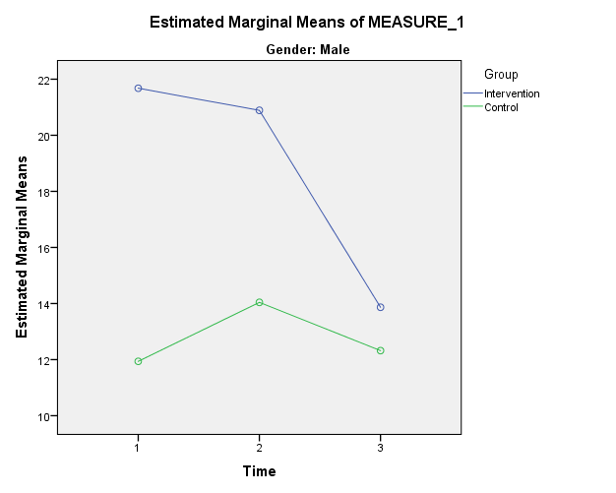

Gender = Female
Between-Subjects Factorsª
 |  | Value Label | N
Group | 1 | Intervention | 109
Group | 2 | Control | 112
a. Gender = Female

Descriptive Statisticsª
 | Group | Mean | Std. Deviation | N
Toties1 | Intervention | 16.67 | 17.411 | 109
Toties1 | Control | 16.60 | 15.364 | 112
Toties1 | Total | 16.63 | 16.368 | 221
Toties2 | Intervention | 18.96 | 19.001 | 109
Toties2 | Control | 17.98 | 17.622 | 112
Toties2 | Total | 18.46 | 18.280 | 221
Toties3 | Intervention | 11.15 | 12.775 | 109
Toties3 | Control | 12.52 | 13.587 | 112
Toties3 | Total | 11.84 | 13.181 | 221
a. Gender = Female

Box's Test of Equality of Covariance Matrices^{a,b}
Box's M | 17.750
F | 2.914
df1 | 6
df2 | 346793.376
Sig. | .008
Tests the null hypothesis that the observed covariance matrices of the dependent variables are equal across groups.
a. Gender = Female
b. Design: Intercept + Group
Within Subjects Design: Time

Multivariate Tests^{a,b}
Effect |  | Value | F | Hypothesis df | Error df | Sig. | Partial Eta Squared
Time | Pillai's Trace | .134 | 16.899^{c} | 2.000 | 218.000 | .000 | .134
Time | Wilks' Lambda | .866 | 16.899^{c} | 2.000 | 218.000 | .000 | .134
Time | Hotelling's Trace | .155 | 16.899^{c} | 2.000 | 218.000 | .000 | .134
Time | Roy's Largest Root | .155 | 16.899^{c} | 2.000 | 218.000 | .000 | .134
Time * Group | Pillai's Trace | .005 | .555^{c} | 2.000 | 218.000 | .575 | .005
Time * Group | Wilks' Lambda | .995 | .555^{c} | 2.000 | 218.000 | .575 | .005
Time * Group | Hotelling's Trace | .005 | .555^{c} | 2.000 | 218.000 | .575 | .005
Time * Group | Roy's Largest Root | .005 | .555^{c} | 2.000 | 218.000 | .575 | .005
a. Gender = Female
b. Design: Intercept + Group
Within Subjects Design: Time
c. Exact statistic

Mauchly's Test of Sphericity^{a,b}
Measure: MEASURE_1
Within Subjects Effect | Mauchly's W | Approx. Chi-Square | df | Sig. | Epsilon^{c}
 |  |  |  |  | Greenhouse-Geisser | Huynh-Feldt | Lower-bound
Time | .816 | 44.198 | 2 | .000 | .845 | .855 | .500
Tests the null hypothesis that the error covariance matrix of the orthonormalized transformed dependent variables is proportional to an identity matrix.
a. Gender = Female
b. Design: Intercept + Group
Within Subjects Design: Time
c. May be used to adjust the degrees of freedom for the averaged tests of significance. Corrected tests are displayed in the Tests of Within-Subjects Effects table.

Tests of Within-Subjects Effectsª
Measure: MEASURE_1
Source |  | Type III Sum of Squares | df | Mean Square | F | Sig. | Partial Eta Squared
Time | Sphericity Assumed | 5188.817 | 2 | 2594.408 | 22.589 | .000 | .094
Time | Greenhouse-Geisser | 5188.817 | 1.690 | 3070.511 | 22.589 | .000 | .094
Time | Huynh-Feldt | 5188.817 | 1.709 | 3035.500 | 22.589 | .000 | .094
Time | Lower-bound | 5188.817 | 1.000 | 5188.817 | 22.589 | .000 | .094
Time * Group | Sphericity Assumed | 155.600 | 2 | 77.800 | .677 | .508 | .003
Time * Group | Greenhouse-Geisser | 155.600 | 1.690 | 92.077 | .677 | .485 | .003
Time * Group | Huynh-Feldt | 155.600 | 1.709 | 91.027 | .677 | .486 | .003
Time * Group | Lower-bound | 155.600 | 1.000 | 155.600 | .677 | .411 | .003
Error(Time) | Sphericity Assumed | 50305.639 | 438 | 114.853
Error(Time) | Greenhouse-Geisser | 50305.639 | 370.085 | 135.930
Error(Time) | Huynh-Feldt | 50305.639 | 374.354 | 134.380
Error(Time) | Lower-bound | 50305.639 | 219.000 | 229.706
a. Gender = Female

Tests of Within-Subjects Contrastsª
Measure: MEASURE_1
Source | Time | Type III Sum of Squares | df | Mean Square | F | Sig. | Partial Eta Squared
Time | Linear | 2544.639 | 1 | 2544.639 | 18.815 | .000 | .079
Time | Quadratic | 2644.177 | 1 | 2644.177 | 27.993 | .000 | .113
Time * Group | Linear | 56.993 | 1 | 56.993 | .421 | .517 | .002
Time * Group | Quadratic | 98.607 | 1 | 98.607 | 1.044 | .308 | .005
Error(Time) | Linear | 29619.074 | 219 | 135.247
Error(Time) | Quadratic | 20686.565 | 219 | 94.459
a. Gender = Female

Levene's Test of Equality of Error Variances^{a,b}
 | F | df1 | df2 | Sig.
Toties1 | .529 | 1 | 219 | .468
Toties2 | .188 | 1 | 219 | .665
Toties3 | 1.263 | 1 | 219 | .262
Tests the null hypothesis that the error variance of the dependent variable is equal across groups.
a. Gender = Female
b. Design: Intercept + Group
Within Subjects Design: Time

Tests of Between-Subjects Effectsª
Measure: MEASURE_1
Transformed Variable: Average
Source | Type III Sum of Squares | df | Mean Square | F | Sig. | Partial Eta Squared
Intercept | 162269.012 | 1 | 162269.012 | 295.612 | .000 | .574
Group | 1.925 | 1 | 1.925 | .004 | .953 | .000
Error | 120214.641 | 219 | 548.925
a. Gender = Female

Estimated Marginal Means
Time
Estimatesª
Measure: MEASURE_1
Time | Mean | Std. Error | 95% Confidence Interval
Time | Mean | Std. Error | Lower Bound | Upper Bound
1 | 16.633 | 1.104 | 14.458 | 18.808
2 | 18.470 | 1.232 | 16.042 | 20.899
3 | 11.834 | .888 | 10.085 | 13.583
a. Gender = Female

Pairwise Comparisonsª
Measure: MEASURE_1
(I) Time | (J) Time | Mean Difference (I-J) | Std. Error | Sig.^{c} | 95% Confidence Interval for Difference^{c}
 |  |  |  |  | Lower Bound | Upper Bound
1 | 2 | -1.837 | .772 | .055 | -3.700 | .026
1 | 3 | 4.799* | 1.106 | .000 | 2.130 | 7.469
2 | 1 | 1.837 | .772 | .055 | -.026 | 3.700
2 | 3 | 6.636* | 1.139 | .000 | 3.888 | 9.385
3 | 1 | -4.799* | 1.106 | .000 | -7.469 | -2.130
3 | 2 | -6.636* | 1.139 | .000 | -9.385 | -3.888
Based on estimated marginal means
*. The mean difference is significant at the .05 level.
a. Gender = Female
c. Adjustment for multiple comparisons: Bonferroni.

Multivariate Testsª
 | Value | F | Hypothesis df | Error df | Sig. | Partial Eta Squared
Pillai's trace | .134 | 16.899^{b} | 2.000 | 218.000 | .000 | .134
Wilks' lambda | .866 | 16.899^{b} | 2.000 | 218.000 | .000 | .134
Hotelling's trace | .155 | 16.899^{b} | 2.000 | 218.000 | .000 | .134
Roy's largest root | .155 | 16.899^{b} | 2.000 | 218.000 | .000 | .134
Each F tests the multivariate effect of Time. These tests are based on the linearly independent pairwise comparisons among the estimated marginal means.
a. Gender = Female
b. Exact statistic

Profile Plots



