 |  | TOTAL BUSINESS CONSULTING  Excellence on demand

Project Initiation Document and Brand Standard Audit:

Sheraton Skyline Hotel – Annual Internal Audit

London Heathrow

Date: 27 July 2020

Mihaela Costea

Table of Contents

- Project Initiation Document......................................................................3
  - Purpose....................................................................................4
  - Project Scope..........................................................................4
  - Deliverables............................................................................5
  - Constraints..............................................................................5
  - Assumptions...........................................................................6
- Confidence in the audit team.................................................................6
3. The audit team and the Project Plan.......................................................8
3.1. Project Manager:......................................................................8
3.2. Project Team: ...........................................................................8
  - Project Control ......................................................................9
  - Quality Control.......................................................................9
  - Start Date for Audit commencement..............................10
  - Completion Date for Audit ...............................................10

  - Project Definition
  - Purpose

We present a project through which we will analyze any problems or shortcomings in the current audit process and the ways in which our organization, from Total Business Consulting, can remedy these shortcomings and problems. The Audit value has already been performed by the Sheraton Skyline hotel.

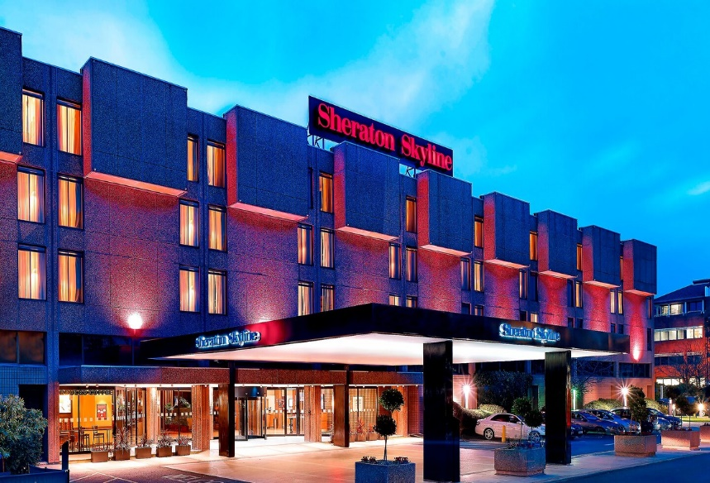

Being part of the Marriott hotel chain, the expectations of customers at the Sheraton Skyline hotel are very high. The Marriott hotel chain includes 30 brands and we want to make sure that the hotel falls within the required parameters.
The hotel has 350 rooms, Club Rooms with free breakfast, 17 meeting rooms and high-tech Doha room. The hotel also has a pool.
Room prices range from £80 to £140 and the apartments are up to 305 per night.
We aim to analyze, in detail, whether the Sheraton Skyline hotel meets all quality conditions and standards.
The objective of Total Business Consulting is to be successful through expertise, seriousness, professionalism, impeccable quality and promptness of services provided
At the end of this project, we will be able to show all the discovered problems as well as practical solutions for their remedy. We guarantee success in meeting the hotel's objectives if our recommendations are followed.

  - Purpose Objectives

We will analyze the state of cleanliness, the condition of the hotel, the way the operations are performed, the services offered, the financial performance, the performance and commitment of the employees, the management of the facilities and the leadership. We will determine if they are in the parameters.

  - Project Scope

The hotel is located on Bath Road, Hayes, close to Heathrow Airport. Being located a few minutes from all airport terminals is a great option for those visiting for tourism or business purposes. The hotel also has easy access to central London and offers easy access to people with disabilities.
The competition in the areas is very high, it is in the immediate vicinity of The London Heathrow Marriott Hotel, a category 5 hotel that is bigger and is a real competition because the price for a room starts from 105.
A new hotel will open in September 2020, Courtyard London. It is a very large, new hotel, with modern furniture and decorations that will definitely put you in difficulty. The hotel will be of category 4, so the room prices will be similar. Other hotels, such as Renaissance and Moxy, being of categories 3 and 4, will not make the hotel difficult because it does not offer many facilities sought by guests.
A noteworthy threat comes from the Airbnb site which offers prices of up to 17 per room with bathroom

  - Deliverables

Our three-member team will complete a 12-week placement and report in detail on all objectives set, which will be presented to the General Manager of the Hotel and Senior Leadership at Marriott International.
The report will include:
Audited departments: Food and Beverage; Kitchen; Front Office; Housekeeping; Leisure; Sales & Marketing; Finance; Human Resources and Maintenance.
Recommendations: Our team has general knowledge of the hospitality industry with proven expertise, research and analysis and will provide recommendations
with commercial impact.
Points: We will assign a number of points to each objective analyzed and we will make recommendations for actions for each problem.
Pass/Fail: The Food & Beverages Department will be marked with Pass and Fail. Areas that have failed will benefit from an action plan to be resolved within 30 days.

  - Constraints

- The global pandemic is a serious problem that will hinder activity because certain rules must be followed
- The UK's exit from the European Union will bring with it labour problems
- The reduced activity of Heathrow Airport will bring a small number of tourists.
- The sustainability trend in the hotel industry will generate high costs for the hotel that is not organized to operate sustainably.
- The expansion of advanced technology in the field of tourism will make the hotel have to align with this trend that is increasingly sought after by guests.

  - Assumptions

Because of Covid-19, we will have to follow the rules imposed by the government, such as respecting the social distance, wearing a protective mask inside the hotel and disinfecting with special solutions. If these rules are followed, both by the team and by the hotel employees, we will not encounter serious problems.
It is known that most workers in the hospitality industry come from European countries. Brexit brings with it new rules that have made workers leave the country. Under these conditions, it is possible that many departments will have less staff which will affect the audit. If we face this problem we will be able to offer the necessary recommendations to fix this problem.
The reduced flights operated at Heathrow Airport will have a result in a few tourists arrivals. This means that during the audit there will be few tourists in the hotel.
From what we have already noticed, the hotel is not equipped with advanced technology and does not offer sustainable services. This needs to be improved along the way, we will provide solutions for this hotel to stay competitive.

- Confidence in the Audit Team

We at Total Business Consultancy, adapt for each client the frameworks and ways of working that are developed by our team with experience working with over 50 brands in more than 10 countries.

We are a team of established leaders in the hospitality industry, each of us has distinct specialities and we offer consultancy to organizations in the field. We are united by our passion for this field, we share our experience and intuition to help companies in the hospitality sector to increase profitability, improve brand loyalty and surpass their competition
Our open-minded experts have the opportunity to give something back to this industry, they will give constructive advice and opinions, either for long-term projects or daily problems facing your hotel.
We work in an organized and structured way, we plan strategically and we find shortcomings in the existing strategy, we develop solutions to known problems, we highlight the growth opportunities.
Our team understands the context in which the Sheraton Skyline falls and we will provide you with recommendations to be competitive in the local market, to improve your financial performance, to deliver services and to be a Marriott Brand Standard Audit Compliant.

Cost/Benefit Analysis
The price of our services is £2000 with an advance of 15%. The rest of the price will be paid only at the end of the audit. We also request accommodation for two of our team members and a complete menu for the entire project period.
We also want to be provided with a small meeting room, twice a week for 2 hours, preferably in the morning.
Re-audits of those contested just £50 plus expenses

We would like to emphasize that these costs are very low compared to the benefits you will get by following our recommendations and solutions.

Due to the improvements, we will bring to the hotel strategy, of the financial performance and to the way of serving the clients, in the future the audit costs will seem to you nothing compared to what you will receive in return from us.

Risks Analysis
We will need a staff member on each shift to monitor and observe the audit results so as not to have unpleasant surprises in handling the results because employees do not behave as they do every day.

- The Audit Team and the Project Plan

  - Project Manager

The project manager will be me, I will be responsible for coordinating my team, for integrating it into the hotel without affecting its smooth running.
I have a vast experience in the hotel field as I worked for 15 years at JW Marriott Bucharest Grand Hotel, in the first years as a supervisor then, for 13 years I was a regional manager.

  - Project Team

Lorrin Brown
Strategy Director

Lorrin has a rich career of 20 years. He is a top chef in the UK, a successful entrepreneur in the food industry and an expert in the hospitality industry. He has experience in several fields, from start-ups, increasing institutional investments, to advising leaders in the catering industry. Lorrin is now a global consultant in the field of strategy and innovation.
He is a member of the board of directors of London City Hall and is a trusted contact person in the UK.

Roxanne Alexandra
Taylor
Consultant

Roxanne has ten years of sales and marketing experience in the hospitality industry, worked for Ramada Hotel in Paris and is now a marketing consultant specializing in local marketing, business development and sales tactics. Current customers of Roxanna Park Plaza Westminster Hotel, EC4 Hotels and more.

The team members will report directly to me, twice a week, in the meetings we will hold at the hotel.

  - Project Control

The information will be stored securely and will be sent to the general manager once a week, by email. Progress will be monitored.

  - Quality Control

To ensure that we provide quality audit information, we will work in rotation, in daily, night and weekend shifts.

  - Start date for Audit commencement: 4 July 2020

  - Completion date for Audit: 25 September 2020

Project Manager

MIHAELA COSTEA
__________________________________

Date:
3 Jul 2020
_________________________________

