DS 1 My digital life
Prepared by Iryna Libych, group 4(flexi)
Student ID 2613531

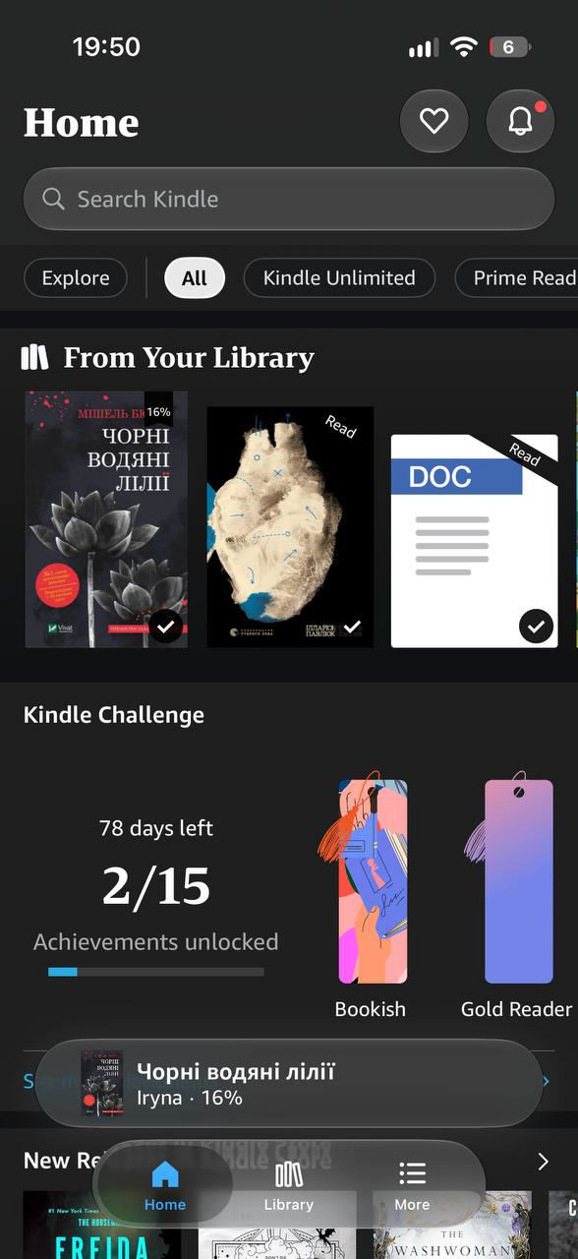
Screenshot 1 My library in a Kindle App
This screenshot shows my Kindle app which I use to read my favourite e-books and keep my digital library in one place. This app is important to me because I can access my books anytime and anywhere.

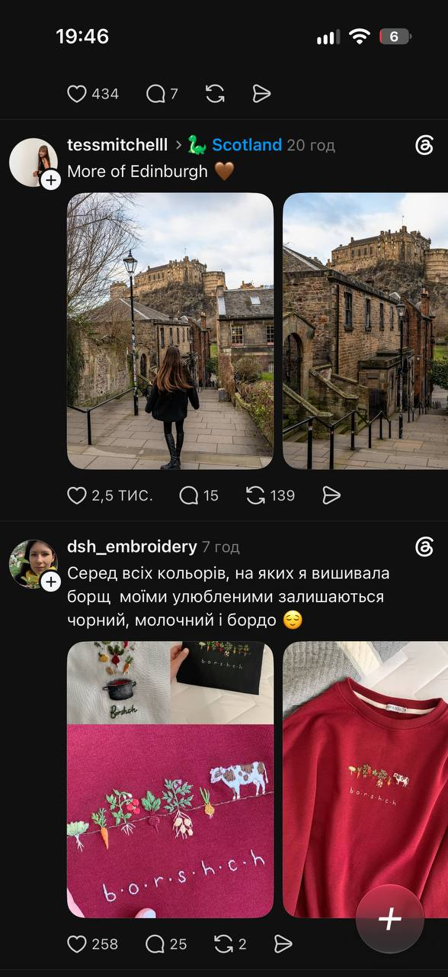
Screenshot 2 The Threads social media platform
This screenshot shows Threads which I use to stay updated on global trends and share my thoughts with a global community. This app is important to me because it helps me discover new ideas and follow topics I’m interested in.

Screenshot 3 Diia App
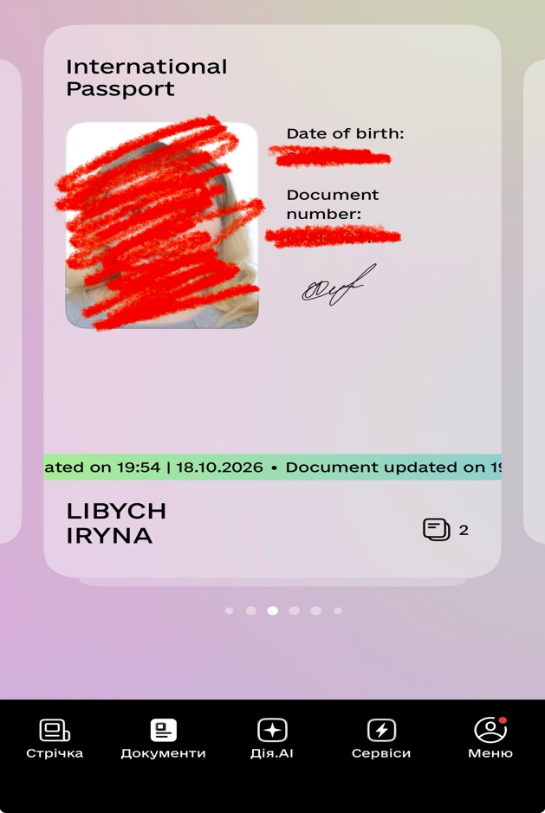
This screenshot shows the Diia app, a Ukrainian digital service which I use to access my digital documents and online services. This app is important to me because I can use important services from my phone.

Screenshot 4 Evri tracking app
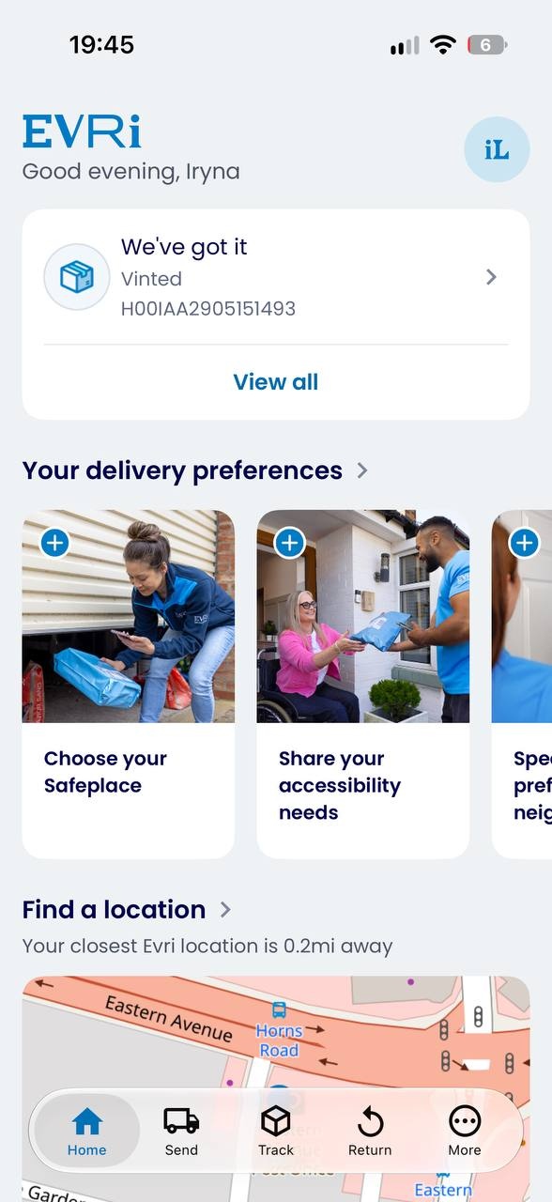
This screenshot shows the Evri tracking app which I use to track my online shopping orders and check their delivery status in real time. This app is important to me because it makes online shopping more convenient.

Screenshot 5 TFL Go App
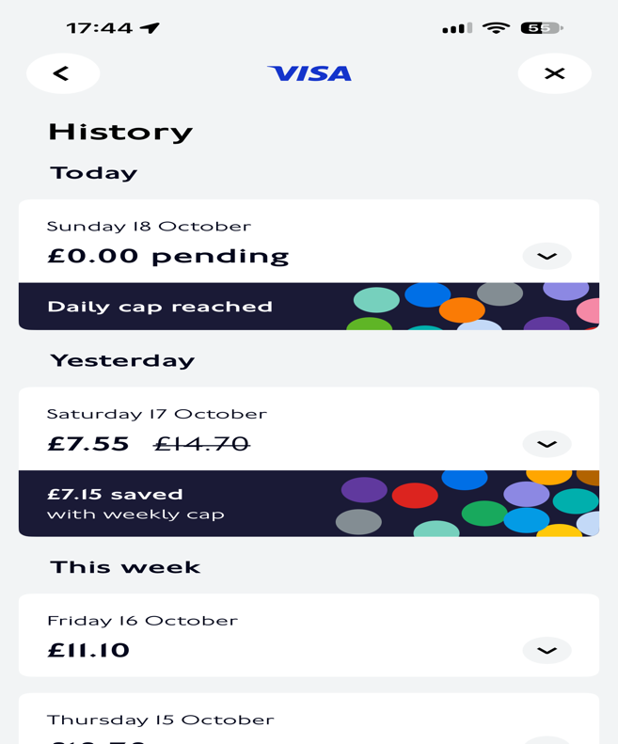
This screenshot shows TFL Go app which I use to plan my journeys and control my travel expenses. This app is important to me because it helps me travel around London more easily.

My Short Reflection
Digital tools play a significant role in my daily routine and I use them for both my studies and personal life. I regularly use social media, online platforms, Microsoft Office, email and e-libraries to find information and complete tasks. Although I’m comfortable with most of these tools, I would like to improve my ability to use digital tools effectively for my university work, especially my skills in Excel and other programmes. Sometimes I find new programmes difficult to use when I try them for the first time. I hope that by completing this module I will become more confident, feel more independent digital tools and learn new digital skills. I believe digital skills are very important because I need them for my personal life, for everyday tasks, at university and in my future work.

Submission Checklist
Before you submit, please check:
​​​ ☒ I added 4–6 screenshots
☒ I wrote short sentences for each screenshot
☒ I wrote my short reflection
☒ My work is my own
☒ My file opens correctly
​​☒ My file opens correctly

