A
Academic report
Individual report
Module name: Digital Skills and Research Methods
Module code: BMSW4003
Lecturer name: Amitave Banik
Assessment 2

Florina Stancu (2030034)

The impact of Virtual Learning Environment- Moodle on the learning experience of the students at UWTSD London campus

Abstract
The virtual learning environment is very helpful for the university to conduct classes regularly and to interact with the students on a regular basis. The VLE is quite significant in the current situation of the COVID-19 pandemic. It is quite flexible and provides the students with relevant resources and backup lectures. It is quite significant in helping the students connect with their teachers and communicate with them during these uncertain times. As a result, their learning process is not hampered.

Table of Contents
Introduction 4
Background 4
Aims 4
Research Objectives 4
Rationale 4
Literature Review 5
Concept of VLE 5
The significance of VLE during the learning process 5
The positive impacts of VLE on the learning experience of the students 5
The negative impacts of VLE on the learning experience of the students 6
The opinions of the students regarding the VLE 6
Research Methodology 7
Research method and the methodology 7
Data Collection 7
Data Type 7
Data collection process 8
Population, Sample and Sample size 8
Ethics in data collection 8
Results/Findings, analysis and discussion 9
Primary Data Analysis 9
Secondary Data Analysis 14
Summary of the findings 14
Conclusion and Recommendation 16
References 17
Appendices 19
Appendix 1 (Questionnaire) 19
Appendix 2 (Excel Result table) 21

Introduction

Background
During the time of the COVID-19 pandemic, the Virtual Learning Environment (VLE) is considered as the only mode of maintaining continuity in education. The virtual learning environment has gained quite significance and it is used by various Universities and Colleges for imparting education. Similarly, the University of Wales Trinity St David London (UWTSD) campus has also been using virtual learning environment so that there is no disruption in the process of learning and teaching. A good example of the VLE of this campus is its Moodle that enhances the students’ learning experience and facilitates them to focus on all aspects of their courses in a much better way (AlMuharraqi and Toworfe, 2021).

Aims
The aim of this research work is to analyse the importance of VLE in enhancing the learning experience of the students, including those of the UWTSD London Campus.

Research Objectives
- To identify the significance of VLE during the learning process.
- To analyse the positive impacts of VLE on the learning experience of the students.
- To analyse the negative impacts of VLE on the learning experience of the students.
- To analyse the opinions of the students regarding the VLE.

Rationale
The VLE is quite significant in the current situation of the COVID-19 pandemic. It is quite significant in helping the students connect with their teachers and communicate with them during these uncertain times. As a result, their learning process is not hampered. Thus, the significance of VLE makes it a quite rational subject matter of discussion (Diab-Bahman, et al., 2021).

Literature Review

Concept of VLE
A virtual learning environment is a platform which is web-based and helps in conducting study through the use of digital media. It comprises of various activities, resources, interactive facilities within the entire course structure. It also comprises of assessment in the form of various stages. Such a platform allows content creation, storage, management and use. Also, the facility of curriculum planning and mapping is available. It facilitates learner engagement and administration. The progress and achievement of students can also be tracked easily. It facilitates easy collaboration and communication between the professors and students by the posts, blogs, emails, notices etc. Also, real-time communication is facilitated by way of live lectures that have both video and audio facility (Hamill, 2020).

The significance of VLE during the learning process
The virtual learning environment is quite significant to maintain the flow of information and facilitates better learning among the students. The Moodle is very helpful for giving relevant information to the students. Also, the class schedules and duration are also displayed on the Moodle. It is an open source for the students to communicate with their professors regularly. All the doubts that they have can be posted on the Moodle and their solutions are provided by the professors. It is accessible from all parts of the world if the students have their login ID and passwords. It promotes flexible learning with complete security and privacy of the users. Also, easy integration is facilitated through this platform (Hamutoglu, et al., 2020).

The positive impacts of VLE on the learning experience of the students
A major impact of the virtual learning environment is that, it improves the learning process of students and they get a better experience as compared to the traditional offline classes. They get the facility of personalised learning by way of well-designed courses, discussions etc. Also, they get complete support and mentoring from their professors from time to time. Any doubt can be posted by them on the Moodle and the professors resolve them immediately. It facilitates easy collaboration and communication between the professors and students by the posts, blogs, emails, notices etc. Also, the various lectures are available anytime and the students can watch them as many times as they want for further reference. Also, various polls, quizzes and presentations are used by the professors to teach, which makes the learning experience of students more interesting and effective (Hantoobi, et al., 2021).

The negative impacts of VLE on the learning experience of the students
In spite of the various positive impacts that the virtual learning environment has on the learning experience of students, there are various negative impacts as well. The availability of recorded lectures on the Moodle creates a feeling among the students that they should not attend online classes and watch the lectures when it is convenient for them. This creates lack of communication between the professors and students and various backlogs of lectures are also created with which the students cannot cope. With respect to this, the offline class is more beneficial for the students as they can interact regularly and face to face conversations can be conducted (Kassim and Hassan, 2021).

The opinions of the students regarding the VLE
Most of the students consider the virtual learning environment to be very helpful for them to receive education, especially, during the time of the COVID-19 pandemic. They consider this platform to be very helpful as the facility of backup lectures are present. As a result of this, they can watch the lectures anytime to clear any confusions or revise their lessons. Also, this facility is helpful when they are facing network issues during the actual lectures or miss any important point. Also, the several interactive tools such as- polls, presentations, quizzes etc., which is present on the Moodle makes the learning experience of students more interesting and detailed (Ko and Wei, 2021).

Research Methodology

Research method and the methodology
- Research philosophy- For undertaking this research work, the positivism philosophy has been selected as it is perfectly suitable with the mixed data collection methods that will be adopted. It provides solution to the research problems by conducting hypothesis testing. It helps in establishing relationships among the variables under observation and gives reliable results (Leino, et al., 2021).
- Research approach- The various approaches that may be adopted for conducting the research are- abductive, deductive and inductive approaches. However, for conducting this research, the deductive approach has been selected as relevant observations can be arrived at from a set of information and data. It helps in conducting research work within the desired time. Also, not much uncertainties are involved in this approach.
- Research strategy- The strategy that will be adopted for conducting the research work is that, all stages of the research will be done sequentially and systematically. Also, focus will be given on reliability and relevance of data collection process (Maaliw, et al., 2020).

Data Collection
The use of both qualitative and quantitative methods will be done for collection of data. For the collection of qualitative data, the use of various books, journal articles, literatures and internet sources have been taken. However, for collecting quantitative data, the survey has been conducted among the students of UWTSD London campus.

Data Type
The use of both primary and secondary data collection techniques has been adopted. For collecting data of primary nature, the survey was conducted with the help of a self-designed questionnaire. The respondents were the students of UWTSD London campus. Also, for collecting data of secondary nature, several literatures, journals and Internet sources were used.

Data collection process
At first, for conducting the survey, the students of UWTSD London campus when approached and their consent was taken. Then they were asked to give their email IDs in which the questionnaire was sent to them. They were asked to respond to all the questions and send the questionnaire back via email. In this way the data was collected from the primary source. Whereas, for collecting data from the secondary source, in-depth analysis of literatures, journals and sources of internet were done.

Population, Sample and Sample size
For conduct of the survey, the sample size of 14 was chosen from the entire population that comprised of students of UWTSD London campus. The method of random sampling was used for choosing the samples (MOLOTSİ, 2020).

Ethics in data collection
All the ethical considerations were completely followed while undertaking research work. Complete confidentiality and privacy of the respondent’s information were maintained (Parrish, et al., 2021). Also, full communication and transparency was also maintained with the respondents.

Results/Findings, analysis and discussion

Primary Data Analysis
Qs 1. What do you prefer between virtual or face-to-face learning?
- Virtual learning environment
- Face to face learning
Options | Responses | Total responses | Percentage of responses
Virtual learning environment | 10 | 14 | 71
Face to face learning | 4 | 14 | 29

Qs 2. Do you think VLE has improved your learning?
- Yes
- No
- Maybe
Options | Total responses | Response | Percentage of responses
Yes | 14 | 9 | 64
No | 14 | 1 | 7
Maybe | 14 | 4 | 29

Qs 3. Were you given a training session on the VLE as part of your course?
- Yes
- No
Options | Total responses | Response | Percentage of responses
Yes | 14 | 8 | 57
No | 14 | 6 | 43

Qs 4. How helpful your University (UWTSD) has been in offering you the resources to learn from home?
- Helpful
- Very unhelpful
- Neither helpful nor unhelpful
Options | Total responses | Response | Percentage of responses
Helpful | 14 | 4 | 28
Very unhelpful | 14 | 5 | 36
Neither helpful nor unhelpful | 14 | 5 | 36

Qs 5. Are you regularly encouraging to use the VLE as part of your learning?
- Yes
- No
- Occasionally
Options | Total responses | Response | Percentage of responses
Yes | 14 | 11 | 78
No | 14 | 2 | 14
Occasionally | 14 | 1 | 8

Qs 6. Does VLEs enhances student learning experience?
- Yes
- No
Options | Total responses | Response | Percentage of responses
Yes | 14 | 14 | 100
No | 14 | 0 | 0

Qs 7. How do you rate VLE (Moodle)?
- 1
- 2
- 3
- 4
- 5
Options | Total responses | Response | Percentage of responses
1 | 14 | 0 | 0
2 | 14 | 0 | 0
3 | 14 | 3 | 21
4 | 14 | 5 | 36
5 | 14 | 6 | 43

Qs 8. Do you enjoy learning remotely?
- Yes
- No
Options | Total responses | Response | Percentage of responses
Yes | 14 | 13 | 93
No | 14 | 1 | 7
Qs 9. What impacts do you think virtual learning environment have?
- Positive
- Negative
- Very satisfied
- Not very satisfied
Options | Total responses | Response | Percentage of responses
Positive | 14 | 13 | 93
Negative | 14 | 0 | 0
Very satisfied | 14 | 1 | 7
Not very satisfied | 14 | 0 | 0

Qs 10. Would you recommend virtual learning environment?
- Yes
- No
Options | Total responses | Response | Percentage of responses
Yes | 14 | 12 | 86
No | 14 | 2 | 14

Secondary Data Analysis
From the various literatures and journal articles, it was observed that, the virtual learning environment is quite significant to maintain the flow of information and facilitates better learning among the students. The Moodle is very helpful for giving relevant information to the students. Also, the class schedules and duration are also displayed on the Moodle. It is an open source for the students to communicate with their professors regularly.

Summary of the findings
- It was observed that 71% of the respondents prefer virtual learning environment. Whereas, 29% of the respondents prefer face to face learning.
- It was observed that 64% of the respondents feel that VLE has improved their learning. 7% of the respondents say that VLE has not improved their learning. Whereas, 29% of the respondents reply as maybe.
- It was observed that 57% of the respondents said that they were given training sessions on the VLE as a part of their course. Whereas, the 43% say that no training session has been provided to them.
- It was observed that 28% of the respondents found the resources offered by the university as helpful, 36% found them very unhelpful. Whereas, 36% of the respondents found them neither helpful nor unhelpful.
- It was observed that 78% of the respondents say that they are encouraged to use the VLE as a part of their learning, 14% say no and 8% to reply as occasionally.
- It was found that all the respondents found that virtual learning environment enhances their learning experience.
- it was observed that 21% of the respondents rate the VLE Moodle as three, 36% of the respondents rate it as four and 43% of the respondents rate it at five.
- It was observed that 93% of the respondents enjoy learning remotely. Whereas former 7% of the respondents do not enjoy learning remotely.
- It was observed that 93% of the respondents say that the virtual learning environment has a positive impact on them. 7% of the respondents are very satisfied with it.
- It was observed that 86% of the respondents would recommend virtual learning environment. Whereas, 14% of the respondents would not recommend it.

Conclusion and Recommendation
Thus, it can be concluded that, the virtual learning environment is very helpful for the university to conduct classes regularly end to interact with the students on a regular basis. It is quite flexible and provides the students with relevant resources and backup lectures. The VLE is quite significant in the current situation of the COVID-19 pandemic. It is quite significant in helping the students connect with their teachers and communicate with them during these uncertain times. As a result, their learning process is not hampered. Thus, the significance of VLE makes it a quite rational subject matter of discussion.
It is recommended that the university should take the following measures-
- Choose a suitable virtual learning environment that enhances the learning experience of students (Rauf, et al., 2021).
- Interact regularly with the students by using this interface.
- Provide all the relevant resources and materials through this platform.

References
AlMuharraqi, M. and Toworfe, G., 2021. Impact of Virtual Learning on Foundation Mathematics Students in a Higher Education Institution in the Gulf during the COVID-19 Era. Journal of Teaching and Teacher Education, 9(02).
Diab-Bahman, R., Al-Enzi, A., Sharafeddine, W. and Aftimos, S., 2021. The effect of attendance on student performance: implications of using virtual learning on overall performance. Journal of Applied Research in Higher Education.
Hamill, D., 2020. Using Blackboard (VLE) to support teaching practice of academic staff in response to COVID-19. All Ireland Journal of Higher Education, 12(3).
Hamutoglu, N.B., Gemikonakli, O., Duman, I., Kirksekiz, A. and Kiyici, M., 2020. Evaluating student’s experiences using a virtual learning environment: satisfaction and preferences. Educational Technology Research and Development, 68(1), pp.437-462.
Hantoobi, S., Wahdan, A., Salloum, S.A. and Shaalan, K., 2021. Integration of Knowledge Management in a Virtual Learning Environment: A Systematic Review. Recent Advances in Technology Acceptance Models and Theories, pp.247-272.
Kassim, H. and Hassan, W.R., 2021. The Application of Virtual Learning Environment (VLE) in Malaysian Schools: Impacts and Challenges. In Stagnancy Issues and Change Initiatives for Global Education in the Digital Age (pp. 67-89). IGI Global.
Ko, I. and Wei, X., 2021, January. Virtual Leadership Matters: Capturing its Role in Facilitating Knowledge Sharing in Virtual Learning Environment. In Proceedings of the 54th Hawaii International Conference on System Sciences (p. 441).
Leino, R.K., Gardner, M.R., Cartwright, T. and Döring, A.K., 2021. Engagement in a virtual learning environment predicts academic achievement in research methods modules: A longitudinal study combining behavioral and self-reported data. Scholarship of Teaching and Learning in Psychology.
Maaliw III, R.R., 2020. Adaptive Virtual Learning Environment Based on Learning Styles for Personalizing E-Learning System: Design and Implementation. Online Submission, 8(6), pp.3398-3406.
MOLOTSİ, A.M., 2020. The university staff experience of using a virtual learning environment as a platform for e-learning. Journal of Educational Technology and Online Learning, 3(2), pp.133-151.
Parrish, A.H., Kouo, J.L., Carey, L.B. and Swanson, C., 2021. Implementing Universal Design for Learning in the Virtual Learning Environment. In Handbook of Research on Transforming Teachers’ Online Pedagogical Reasoning for Engaging K-12 Students in Virtual Learning (pp. 42-66). IGI Global.
Rauf, H., Javaid, A. and Aslam, T., 2021. CHALLENGES FACED BY ELT INSTRUCTORS AT TERTIARY LEVEL IN VIRTUAL LEARNING ENVIRONMENT (VLE) DURING THE PANDEMIC: OPPORTUNITIES AND WAY FORWARD. PalArch's Journal of Archaeology of Egypt/Egyptology, 18(5), pp.536-545.

Appendices

Appendix 1 (Questionnaire)
Qs 1. What do you prefer between virtual or face-to-face learning?
- Virtual learning environment
- Face to face learning
Qs 2. Do you think VLE has improved your learning?
- Yes
- No
- Maybe
Qs 3. Were you given a training session on the VLE as part of your course?
- Yes
- No
Qs 4. How helpful your University (UWTSD) has been in offering you the resources to learn from home?
- Helpful
- Very unhelpful
- Neither helpful nor unhelpful
Qs 5. Are you regularly encouraging to use the VLE as part of your learning?
- Yes
- No
- Occasionally

Qs 6. Does VLEs enhances student learning experience?
- Yes
- No
Qs 7. How do you rate VLE (Moodle)?
- 1
- 2
- 3
- 4
- 5
Qs 8. Do you enjoy learning remotely?
- Yes
- No
Qs 9. What impacts do you think virtual learning environment have?
- Positive
- Negative
- Very satisfied
- Not very satisfied
Qs 10. Would you recommend virtual learning environment?
- Yes
- No

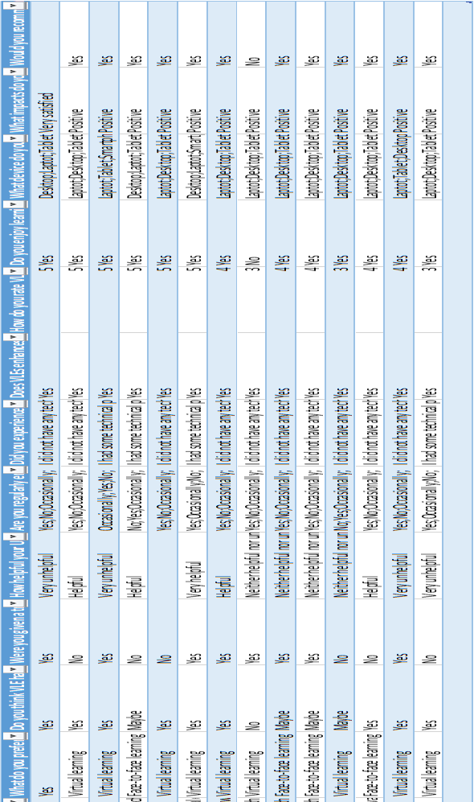
Appendix 2 (Excel Result table)

