MANAGING SOFTWARE DEVELOPMENT IN THE ORGANIZATION IN THE TIME OF PANDEMIC
Student:Ioan Enache 2011896
  - Managing project in the organization BMSW5104

A project is defined as a sequence of tasks with a particular aim or deliverable to be accomplished within a prescribed duration. Upon achievement, a service or product is carried out. Projects are peculiar because they terminate, unlike other entrepreneurial purposes that replicate or pursue frequently.
Project management is the field of organizing and implementing projects. The project administration aims at achieving goals by using missions, timetables, and assets to accomplish project pursuits within a prescribed schedule. Stakeholders and clients describe project aims and missions. The project manager utilizes modes of project management to design a plan that initiates the assets, projects, achievements, and deliverables crucial to accomplishing the prerequisite of stakeholders. This project must also stand for the triple limitation, which stands for the constraints of duration, price, and aim that relate to every mission. To stabilize the limitations, demands, and planning, managers employ project management software to carry out missions. Online software manages to keep projects on record and team members more creative.
The project manager monitors and administers plans, assets, values and squads in one online instrument. A project manager manages his tasks keeping in mind the resources. He also maintains coordination and cooperation among his teammates. A project manager makes tasks simpler using online tools in the contemporary era. A project manager creates timetables and schedules for the project. He assigns tasks keeping in mind accurate time and available resources. Moreover, the team members have a crucial role in task completion, planning of projects, managing updates, analyzing the progress of tasks, and resource allocation, keeping in view the budget and associated needs and essential demands.
Sciforma is a company in which I have been working for twenty years. So basically, before the spread of the Covid 19 virus, it was a part of my job to do home-based tasks. But Covid 19 becomes a major challenge for various organizations. Experimenting with remote work in the absence of preliminary arrangements is a difficult task for a company that has no such experience in the past, as a company had to deal with high scale projects, plans that encompass thousands of people for its operation (Suci, Suyanta, Darna, Wijoyo, and Setyawati, 2020).
Obstacles can be avoided using the right tools, methods and proper organization. According to an analysis of Global Workplace Analytics' that was conducted in 2018, it was interpreted that five million employees who account for 3.6% of the labour force work by sitting at home. Moreover, according to facts, 173% of work-at-home has risen since 2005.
The ongoing crisis can assess a welcome reality check. From this analysis, all small issues can be viewed that we witness or come across in our daily routine. Moreover, we will apprehend and realize the tasks that can be done appropriately. This crucial time indicates that it is a moment of the need to initiate solutions to the problems. At this moment, we should pave the way for a better future by employing an effective project management strategy. Remote project management issues are not different from that PM crisis.
In this uncertain time, a company should be well prepared to face PM issues and search for better solutions. In this context, even if the team is geographically apart, most crises belong to old pain points that we are witnessing in the past.
Project managers have an efficient role, but they can't be available all the time due to daily routine matters. A company faces physical obstacles that remain the same for almost every company, but it is the responsibility of an organization to manage things remotely using an appropriate manner. There are three keys to victorious project management. One is lucid communication & association. The second is data consolidation. The third is effective surveillance.
Adapting our ways for quick recovery from the challenges of the COVID-19 is a need of the moment. Managing things in the contemporary era is a difficult task. A project manager sometimes finds it difficult to keep the teams associated and united. For this purpose, a proper setup is required. It is a difficult task for the managers to administer principles during the pandemic. Still, some software has been developed in a crisis that is essential for appropriate project management.
Firstly JIRA Software is the technology that is usually paid tool across the world. It encompasses a variety of integrations having amazing tools. Their accessible API can give boundless possibilities. It can be made from simpler to complex size irrespective of the size of the team. JIRA was introduced to give valuable knowledge and data to all members who participated in a project. It is a transparent medium that provides project outlines through dashboards for project managers. It is a transparent medium that gives built-in reports to collaborators. It serves the task of management employing boards for constructors. So it can be interpreted that JIRA performs the tasks according to the user's will. Moreover, anything about which we are thinking can be performed through JIRA.
JIRA has various pros and cons. It is highly suitable for bigger teams or projects. It has a better association with the Atlassian suite. However, JIRA workflow can be made automatic and largely customizable. It is free of cost for people who are less than ten. But its disadvantage is that it is not suitable most times for smaller teams. Moreover, it can be more user-friendly during the configuration of the portal at times. Another disadvantage is it can become costly sometimes.
Trello is another tool employed by my organization as it is free of cost and the most accessible tool for project management. It appropriately makes task management. It is highly suitable for small range projects. It encompasses a wide range of integrations and is easy to employ. Trello is a suitable alternative for project management. It is not costly. It has a proper schedule, aim. More sections can be added. Documents can be attached along with the proper requirements of the tasks. Trello is suitable for small teams. Its functions are easy to use. In the initial stage, it offers a free version.
Moreover, progress can be monitored by creating proper columns and boards. The disadvantage of Trello is it's a tool that has fundamental mechanized workflows. It is not suitable for multiple projects, and it is difficult for Trello to prepare reports for shareholders.
Azure DevOps is the third technology that was used in my organization. At first, it was recognized as Visual Studio Team Services. It is an important tool used for collaboration and development. Azure DevOps associates technical staff and administration in the same place.
Azure DevOps has a proper setup for software project development. It offers various services like git repositories, source control, and much more. It has default functionality that manages teams to get up and governs projects. Moreover, it mechanizes workflow. It can raise creativity with a brief learning curve. To start, this tool is straightforward. Its version control system is built-in along with default CI/CD that helps build, monitor, and distribute codes using the Azure DevOps applications. It has management techniques, tools, agile project administration, IDE for in time editing, test management tools by default. It is free of cost for five teammates. It carries disadvantages in its application as well. It is associated with non-Microsoft services that are difficult to use. It has a straightforward workflow that makes the workflow complicated. Its certification can be minimized. It is sometimes not suitable for searching for things. It is not tailored like other tools. In some situations, it has low performance. Moreover, it is not cost-effective and transparent for users.
Monday.com is the fourth technology used in a company. It is a very famous and common tool that has a significant role in project management during a pandemic. It was rebranded after 2017. It involves two times investment in the year 2018 and 2019, respectively. It makes the team members accountable for tasks that need to be done in the allocated time. Its platform is user-friendly. Its color-coded tasks make it easy to use. Monday.com offers an association with different services that makes life facile utilizing mechanized flows. It carries an extension of all famous and popular tools that are used in the contemporary era.
Monday.com carries the latest UI. It offers a close association with the famous techniques. It has the chance of forming mechanized workflows. Moreover, it is suitable for any team irrespective of size. It has a disadvantage as well. It can be costly at times depending upon the length of the team members. Task tracking can be fundamental, depending upon the complexities of the plan.
The smart sheet is similar to the Excel spreadsheet that is mostly employed in times of COVID19. Every project manager's wish and utmost desire to form a Gantt chart and schedules with some clicks. It has the option of various operations such as Microsoft Excel, formation of various files, an association of folders, alteration in privacy settings, and many other tasks. Folders can be associated with each other. This technique develops correlation with other tools like JIRA. It benefits from updating that manages the schedule according to the current status. It has an estimation operation like JIRA (Bushuyev, Bushuiev, and Bushuieva, 2020).
This technology is safe and easy to use as it can organize and arrange files accordingly. It has an efficient way to create an always up-to-date Gantt chart. It is convenient and easy to form updates, view changes and alter privacy settings. It has many disadvantages as well. It has no free version presently. Its organizations and incorporations are not that uncomplicated. It can be inordinate due to all feasible alternatives.
From my personal experience, these tools are feasible to use, and I have good experience in utilizing these tools and contemporary technology. According to my encounter, a project manager needs to apprehend the needs of team members.
Moreover, it is necessary to understand the requirements of a project before taking any decision. I have come across various tools and technologies during a pandemic. Still, the tools that carry significant priority is for the startup companies an amalgamation of Trello and Slack should be employed. At the same time, the corporate projects demand a combination of JIRA, Smart sheet and Slack.
Trello has notable performance for initiating any plan or project as it gives all essential functionalities for conveying an MVP. But at the moment the team increases in size, we can conveniently relocate all the tasks to JIRA and carry on from there.
Although it has become hard to customize JIRA the correct way and make its task impeccable, it is by far my most favoured project management tool. Nonetheless, there is a learning loop, but once a person understands it, the chances are unlimited.
Communication is a significant feature in the educational and informational field. It has a crucial and basic role in fundamental features of growth and development. It provides basic knowledge and enlightenment for people to make rational and well-informed decisions on a crisis that can affect their lives. When knowledge is absent, people make undermined and, most of the time, false decisions that are ineffective. Resultantly it slows down or hinders the entire process of growth. The success and efficacy of any communication largely rely on the attitude and way in which such kind of communication is delivered. Moreover, important information needs to be kept in mind that the information is delivered and who the target audience is. This communication amalgamation of verbal and non-verbal skills is laid together with the foundation of communicational strategies.
Communication strategy aims to advance pursuits that have connection and association to sustainable administration and betterment of two environs. The communication strategy aims to advance awareness of victorious stories and success highlights of the ongoing work or the project that has been done already. Moreover, the project highlights the participating initiatives and supporting factors that deal with hard trade-offs that rural households witness. These difficulties are followed by decisions regarding utilizing natural assets, conflicting needs, and management because of the surrounding atmosphere. It is also based on the economic condition of the household.
The communication strategy highlights levers to attract investors. This strategy tackles a scenario where external and internal communications could give interested shareholders. Communication strategy holds significant information by developing the software technology and the project management tools and techniques. This strategy enhances the information on the work-related crisis with its appropriate solutions. It gives people a sense of understanding the betterment of the individuals and environment. It targets team members and project managers that make the managerial process easy. This communication technology maintains a balance by properly allocating resources even in the post-Covid time and Covid crisis. This communication strategy raises awareness regarding the management of goods and services. It highlights the threats the members might face and raises possible solutions and the impact that COVID 19 may pose to remote workers.
As my project management is based on software development, it is necessary to define it properly. Software development can be defined as a group of computer science pursuits that can be helpful in the process of creating, designing and placing software.
The main functions are creating databases, software systems and their related applications. Moreover, it is involved in the testing and debugging of software. Software development is the highest growing industry of the contemporary era that contributes to £ 17 billion to the domestic economy. Despite its success rate annually, COVID 19 has also impacted the software industry. So it can be interpreted that the software industry has shown prominent resilience, and in particular cases, its growth has also been affected. COVID 19 has raised creativity from home-based working. Remote working has obstructed direct communication. However, it has the capability of managing output and its related distractions. This software development offers a hybrid system that gives variations and works under suitable conditions. Thus the implementation for the new project requires a hybrid working model that gives variations in tasks and support to workers in carrying out their pursuits.
The implementation plan is two steps that are based on hybrid working and government-led assistance. In the first step of hybrid working technological advancement is involved. This plan doesn't require in-person labour. It enables software developers for remote working to carry out their projects. This implementation plan involves collaboration, brainstorming, and networking of larger masses. Then the second step deals with the productivity and creativity of the labour forces; thus, it deals with innovation. The hybrid system in the third step reveals secrets for victory by offering a set of worthy recommendations. Then this implementation plan becomes more effective when it involves the official assistance of the government. Executives allocate a suitable budget for technological advancement. Thus project based on software development offers a variety of initiatives, valuable plans that led to the development of the technology and the whole growth of the state (Ng, Navaretnam, and Wei, 2020).
The project development involves many variations after the pandemic. Before the pandemic, people at times travel miles to work from home. There were no advanced technological features that could make the work easier. Moreover, following proper schedule and timing was a prerequisite by software development involve a hybrid system that assists workers by sitting at home. It involves tools and techniques that hold the capacity to do hectic work in seconds. It saves time and money.
Moreover, COVID 19 brings social distancing, so this project is designed keeping in mind the safety and hygienic conditions. So the post-COVID 19 conditions optimize the project portfolio rather than cancellation. Software development remotes leadership and enhances skills by sitting at home. Thirdly this project management ends up in better results using these collaborative tools. Lastly, this plan involves disciplined agility that results in program schemes, planned results, and better administration structures that are highly significant in post COVID times. Thus it is the responsibility of the government to allocate a proper budget for technological advancement. A change towards hybrid working models secures the future of software development and will lead a company or any organization for sure towards success and prosperity.

References:
- Suci, I., Suyanta, I.W., Darna, I.W., Wijoyo, H. and Setyawati, E., 2020. A Measure Of Effectiveness Level Of Online Learning Amid Covid-19 Pandemic In The Course Of The Project Management Information Systems (Case Study In STIKOM Yos Sudarso Purwokerto). Available at SSRN 3873720.
- Bushuyev, S., Bushuiev, D. and Bushuieva, V., 2020. Project management during the Infodemic of the COVID-19 Pandemic. Innovative Technologies and Scientific Solutions for Industries, (2 (12)), pp.13-21.
- Ng, J.J., Navaretnam, S. and Wei, J.L.Q., 2020. Considerations for IT Management in a COVID-19 World. IEEE Engineering Management Review, 48(3), pp.16-18.

TASK 2
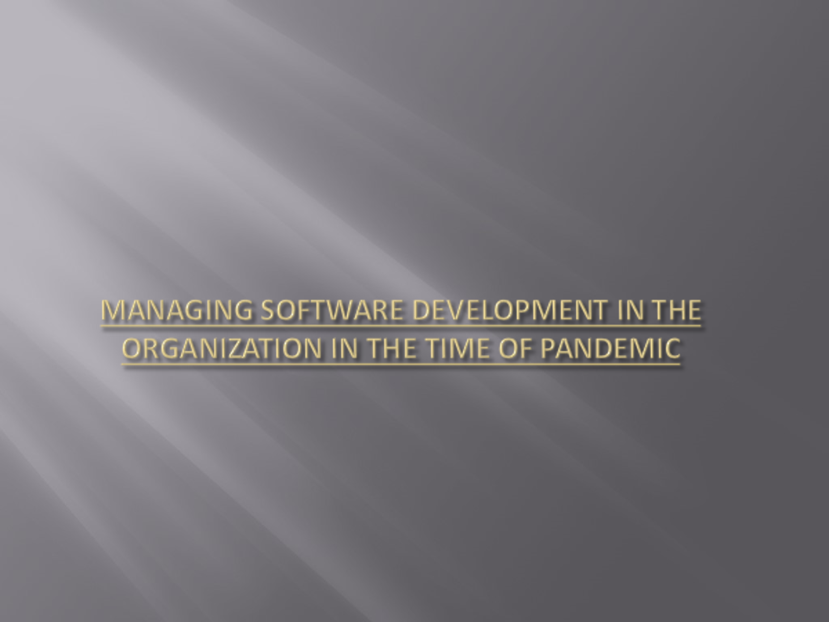
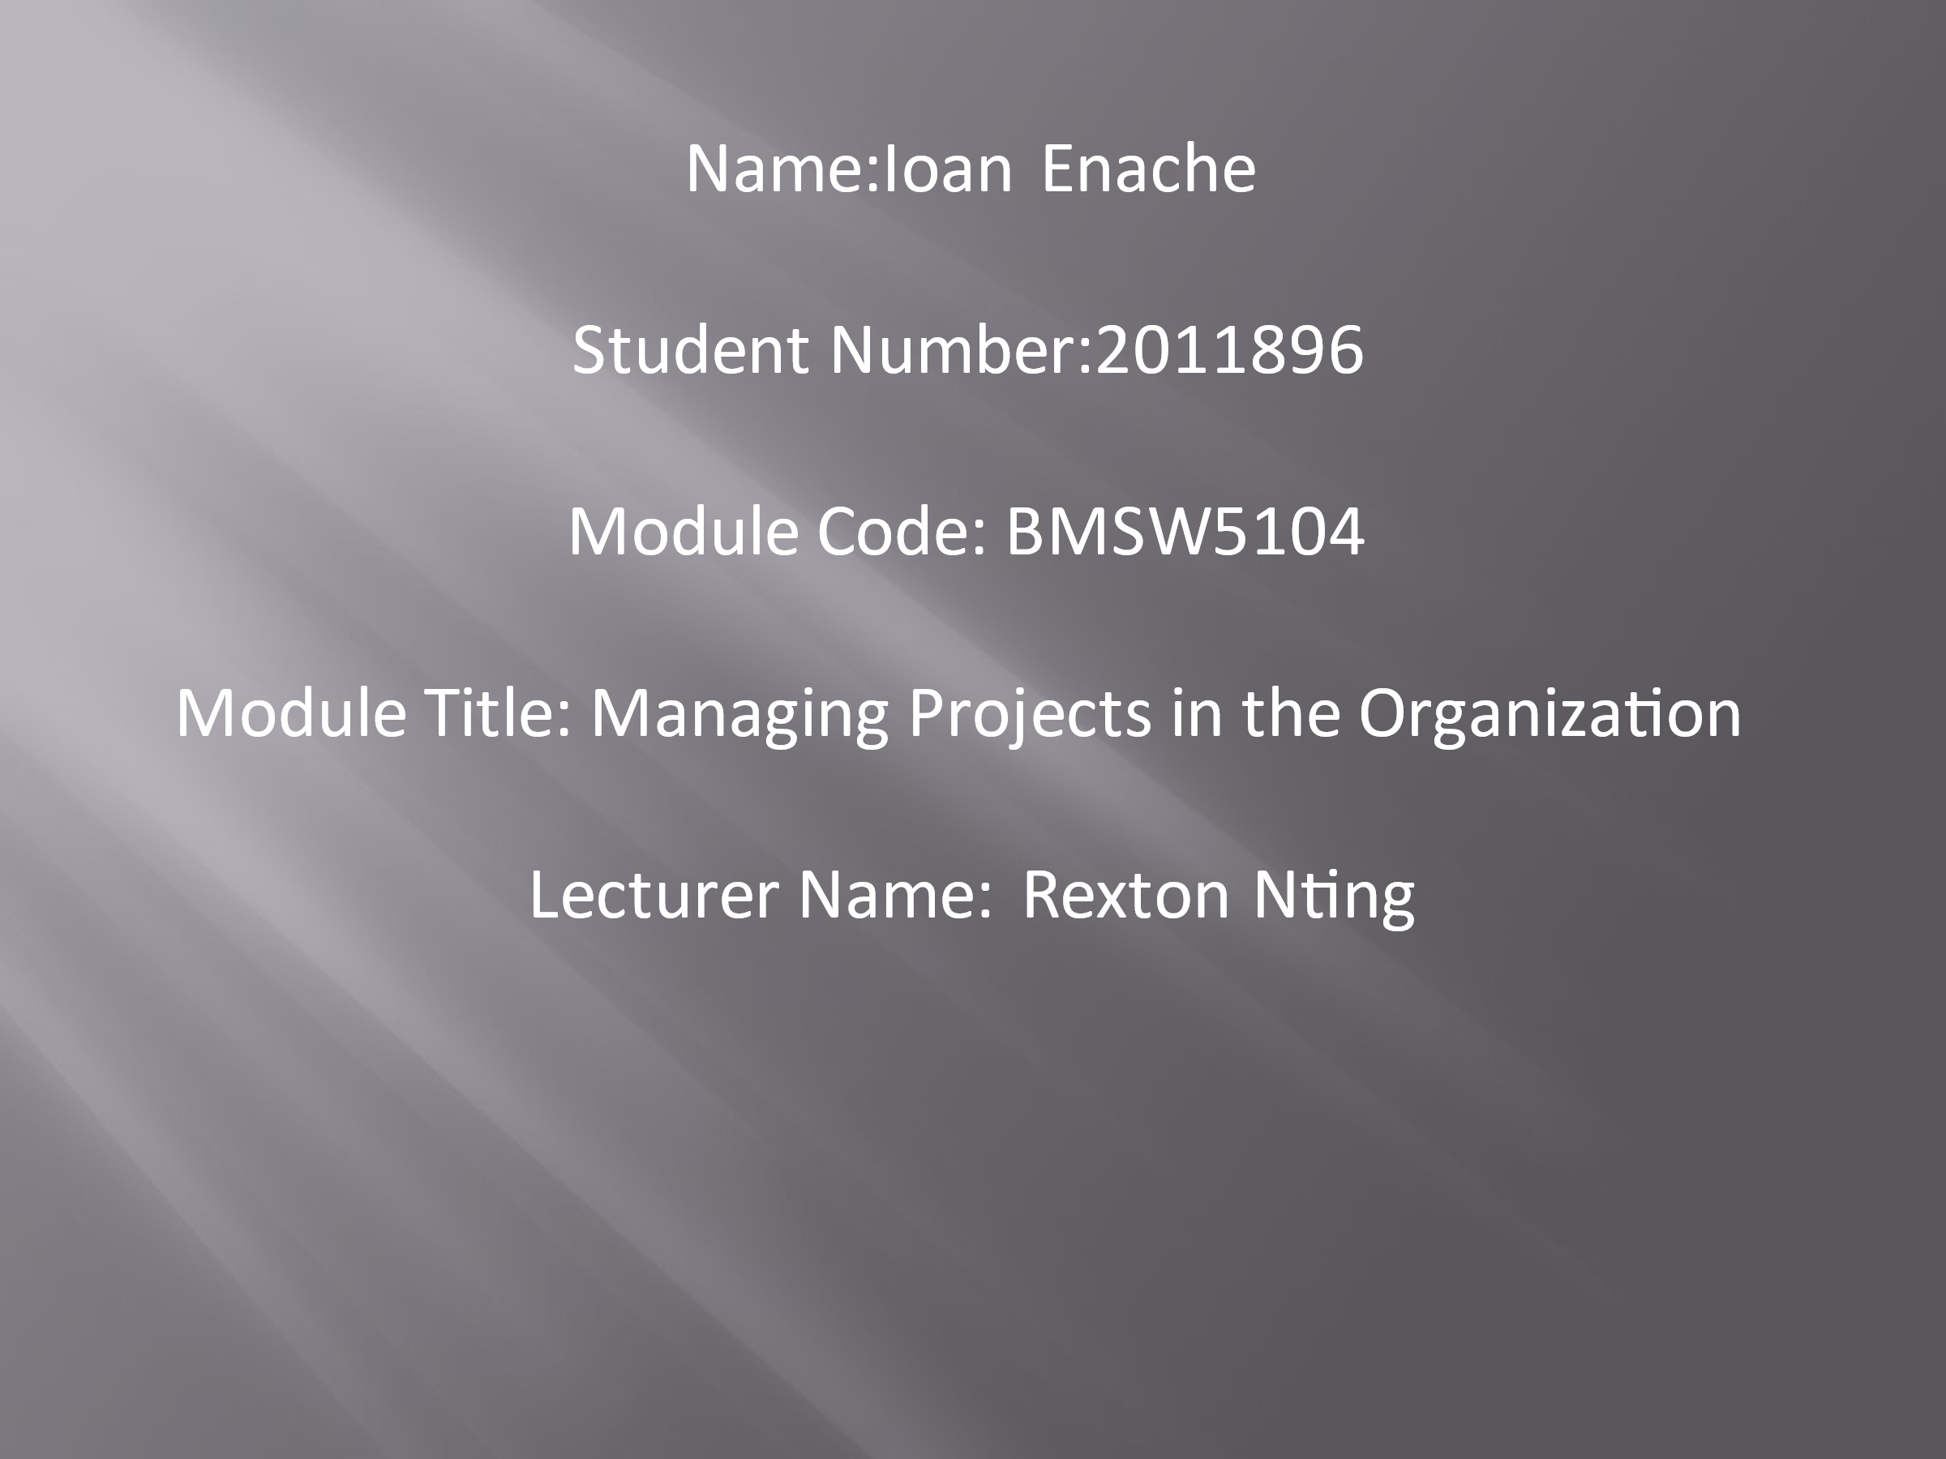
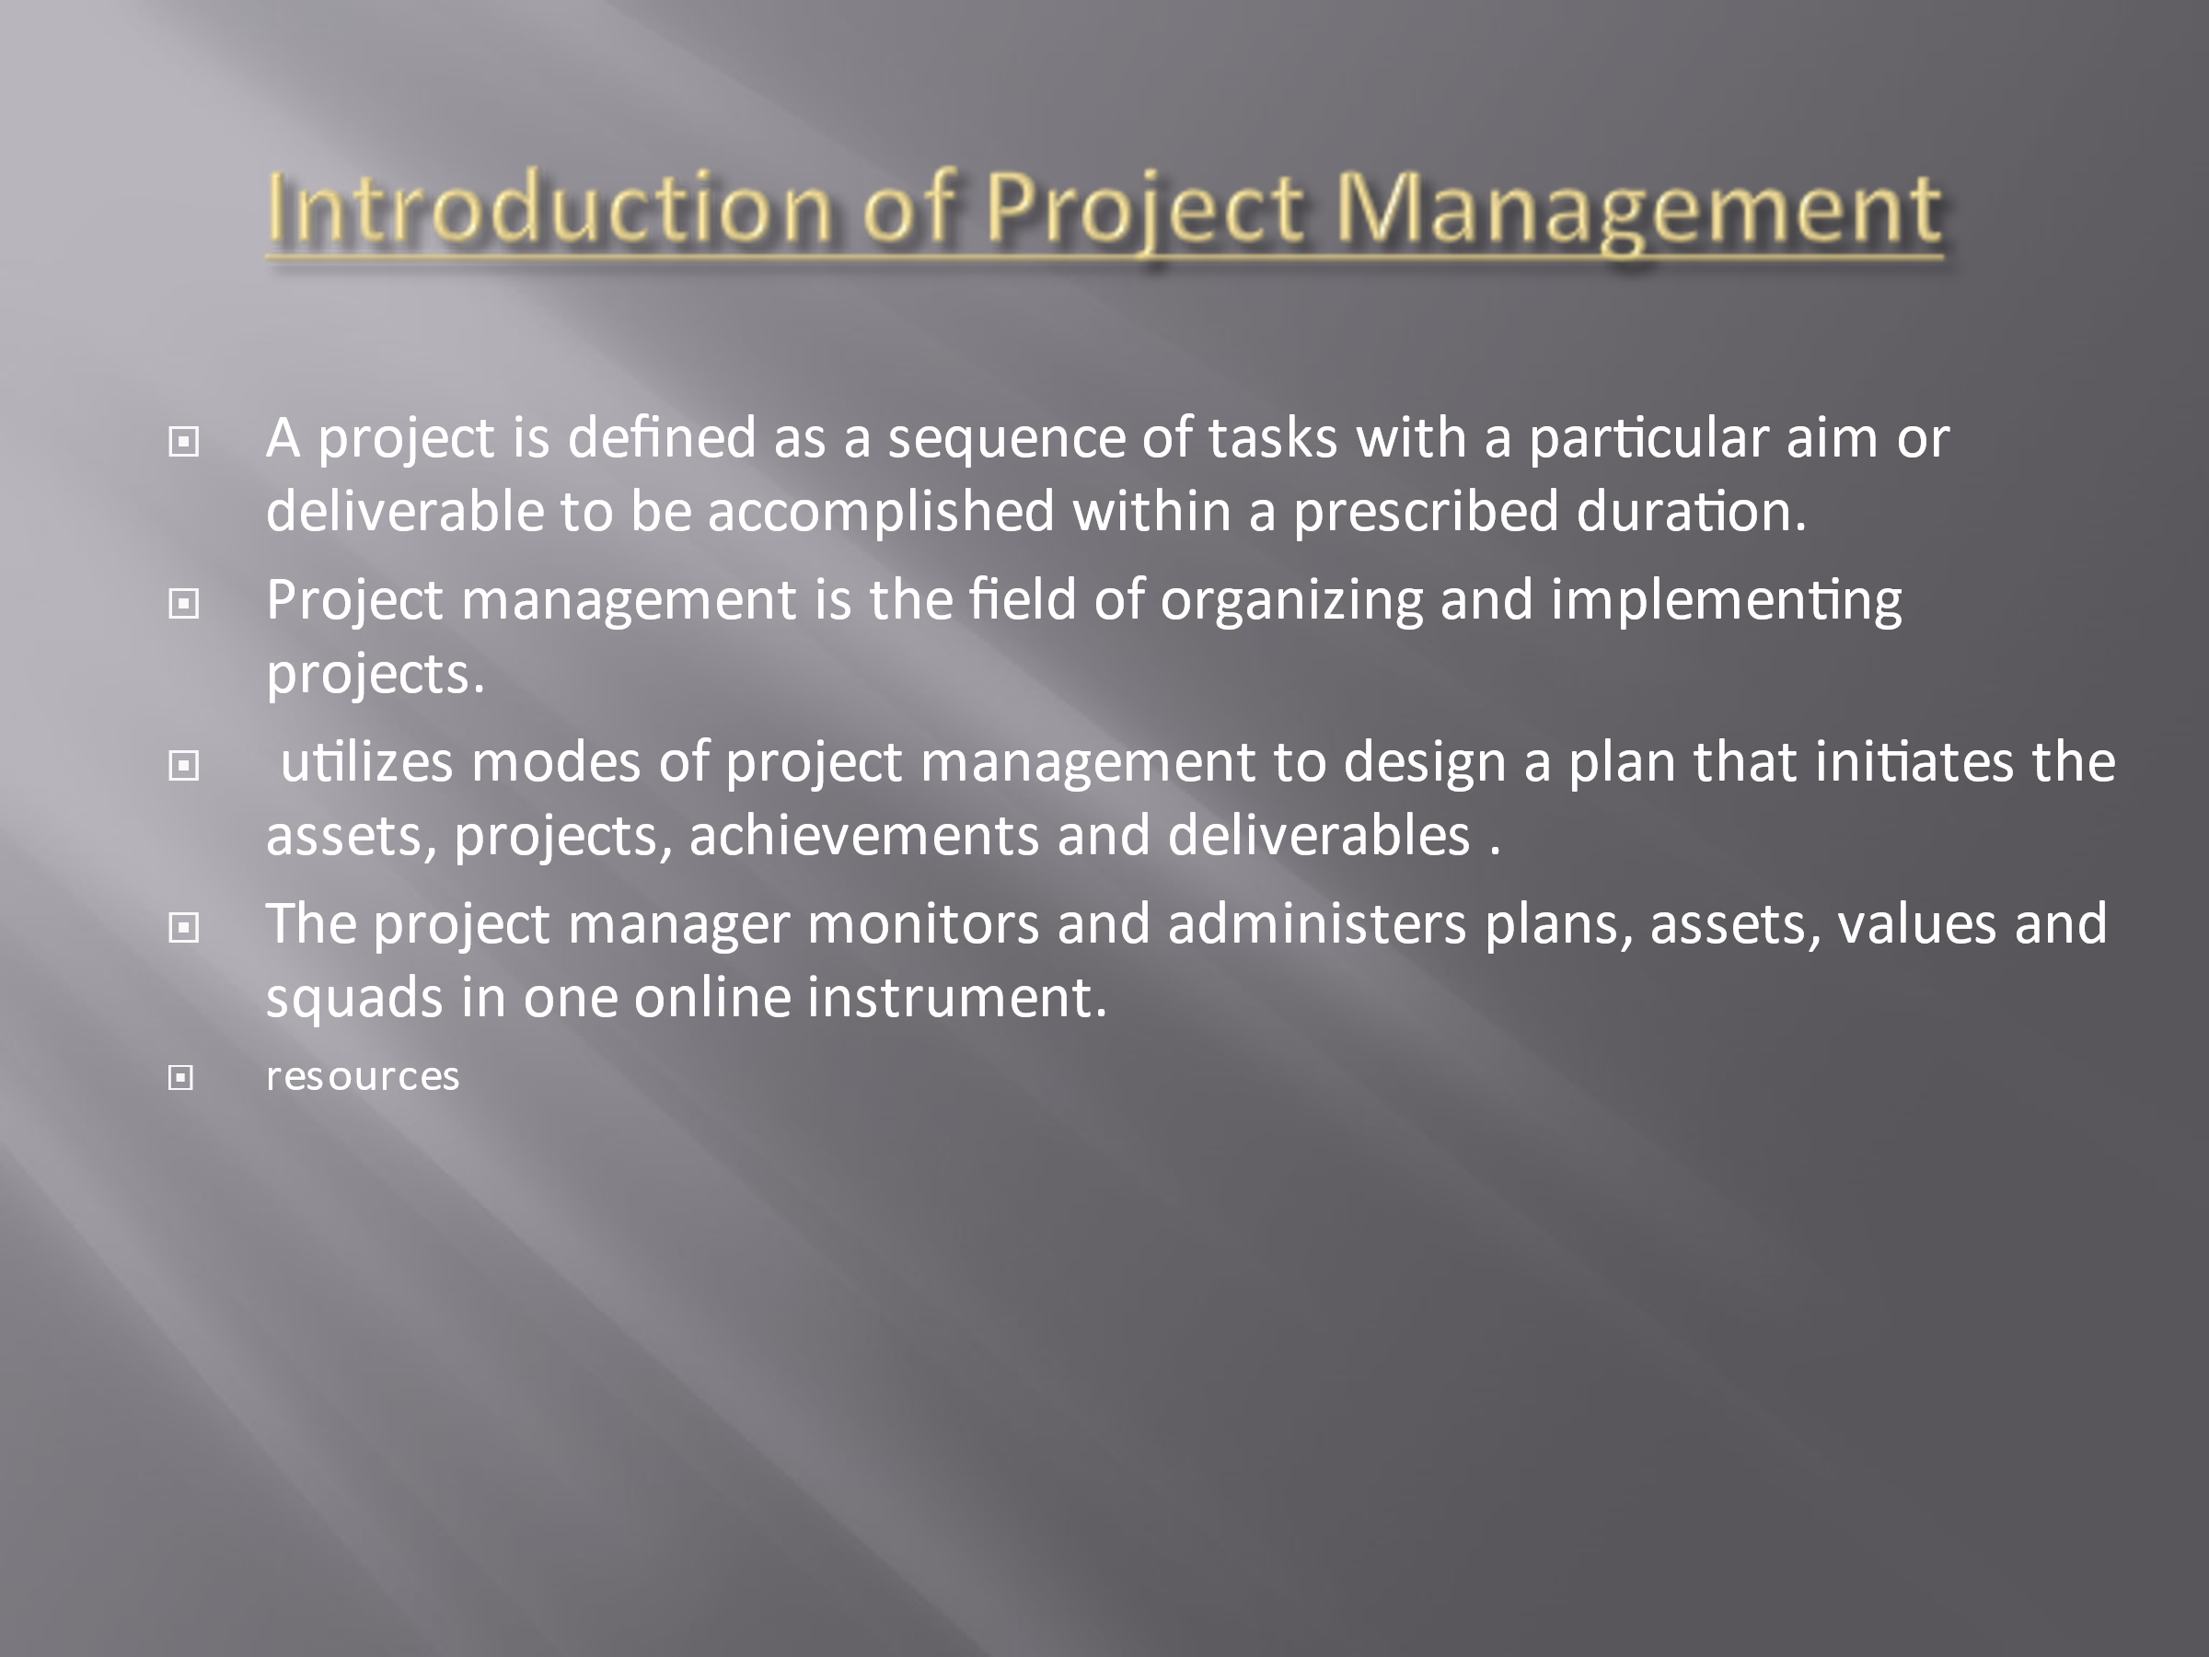
- The project administration aims at achieving goals by using missions, timetables and assets to accomplish project pursuits within a prescribed schedule. The project manager utilizes modes of project management to design a plan that initiates the assets, projects, achievements and deliverables .crucial to accomplish the prerequisite of stakeholders. The project manager monitors and administers plans, assets, values and squads in one online instrument. A project manager manages his tasks keeping in mind the resources. He also maintains coordination and cooperation among his teammates.
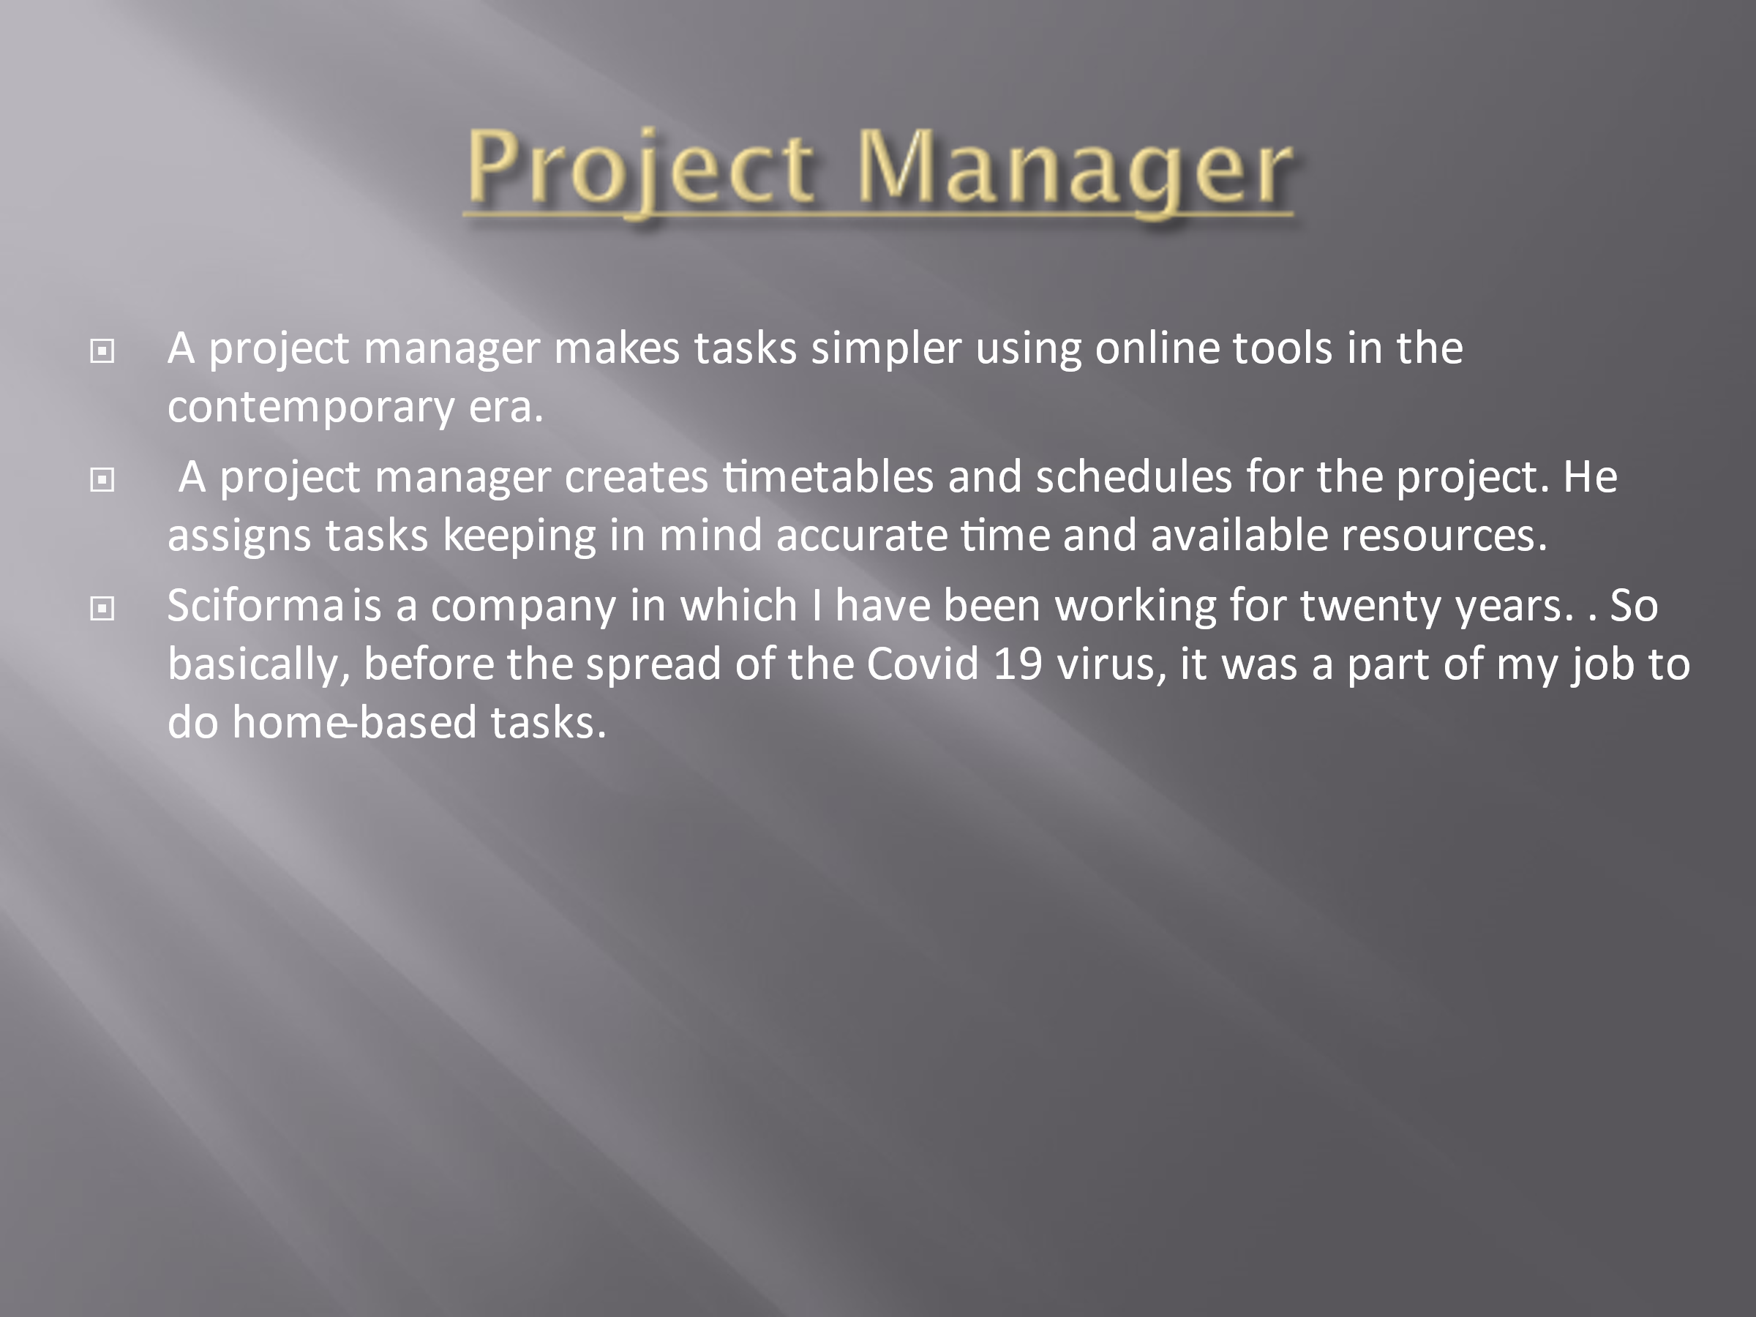
- A project manager manages his tasks keeping in mind the resources. He also maintains coordination and cooperation among his teammates. Moreover, the team members have a crucial role in task completion, planning of projects, managing updates, analyzing the progress of tasks, and resource allocation, keeping in view the budget and associated needs and essential demands.
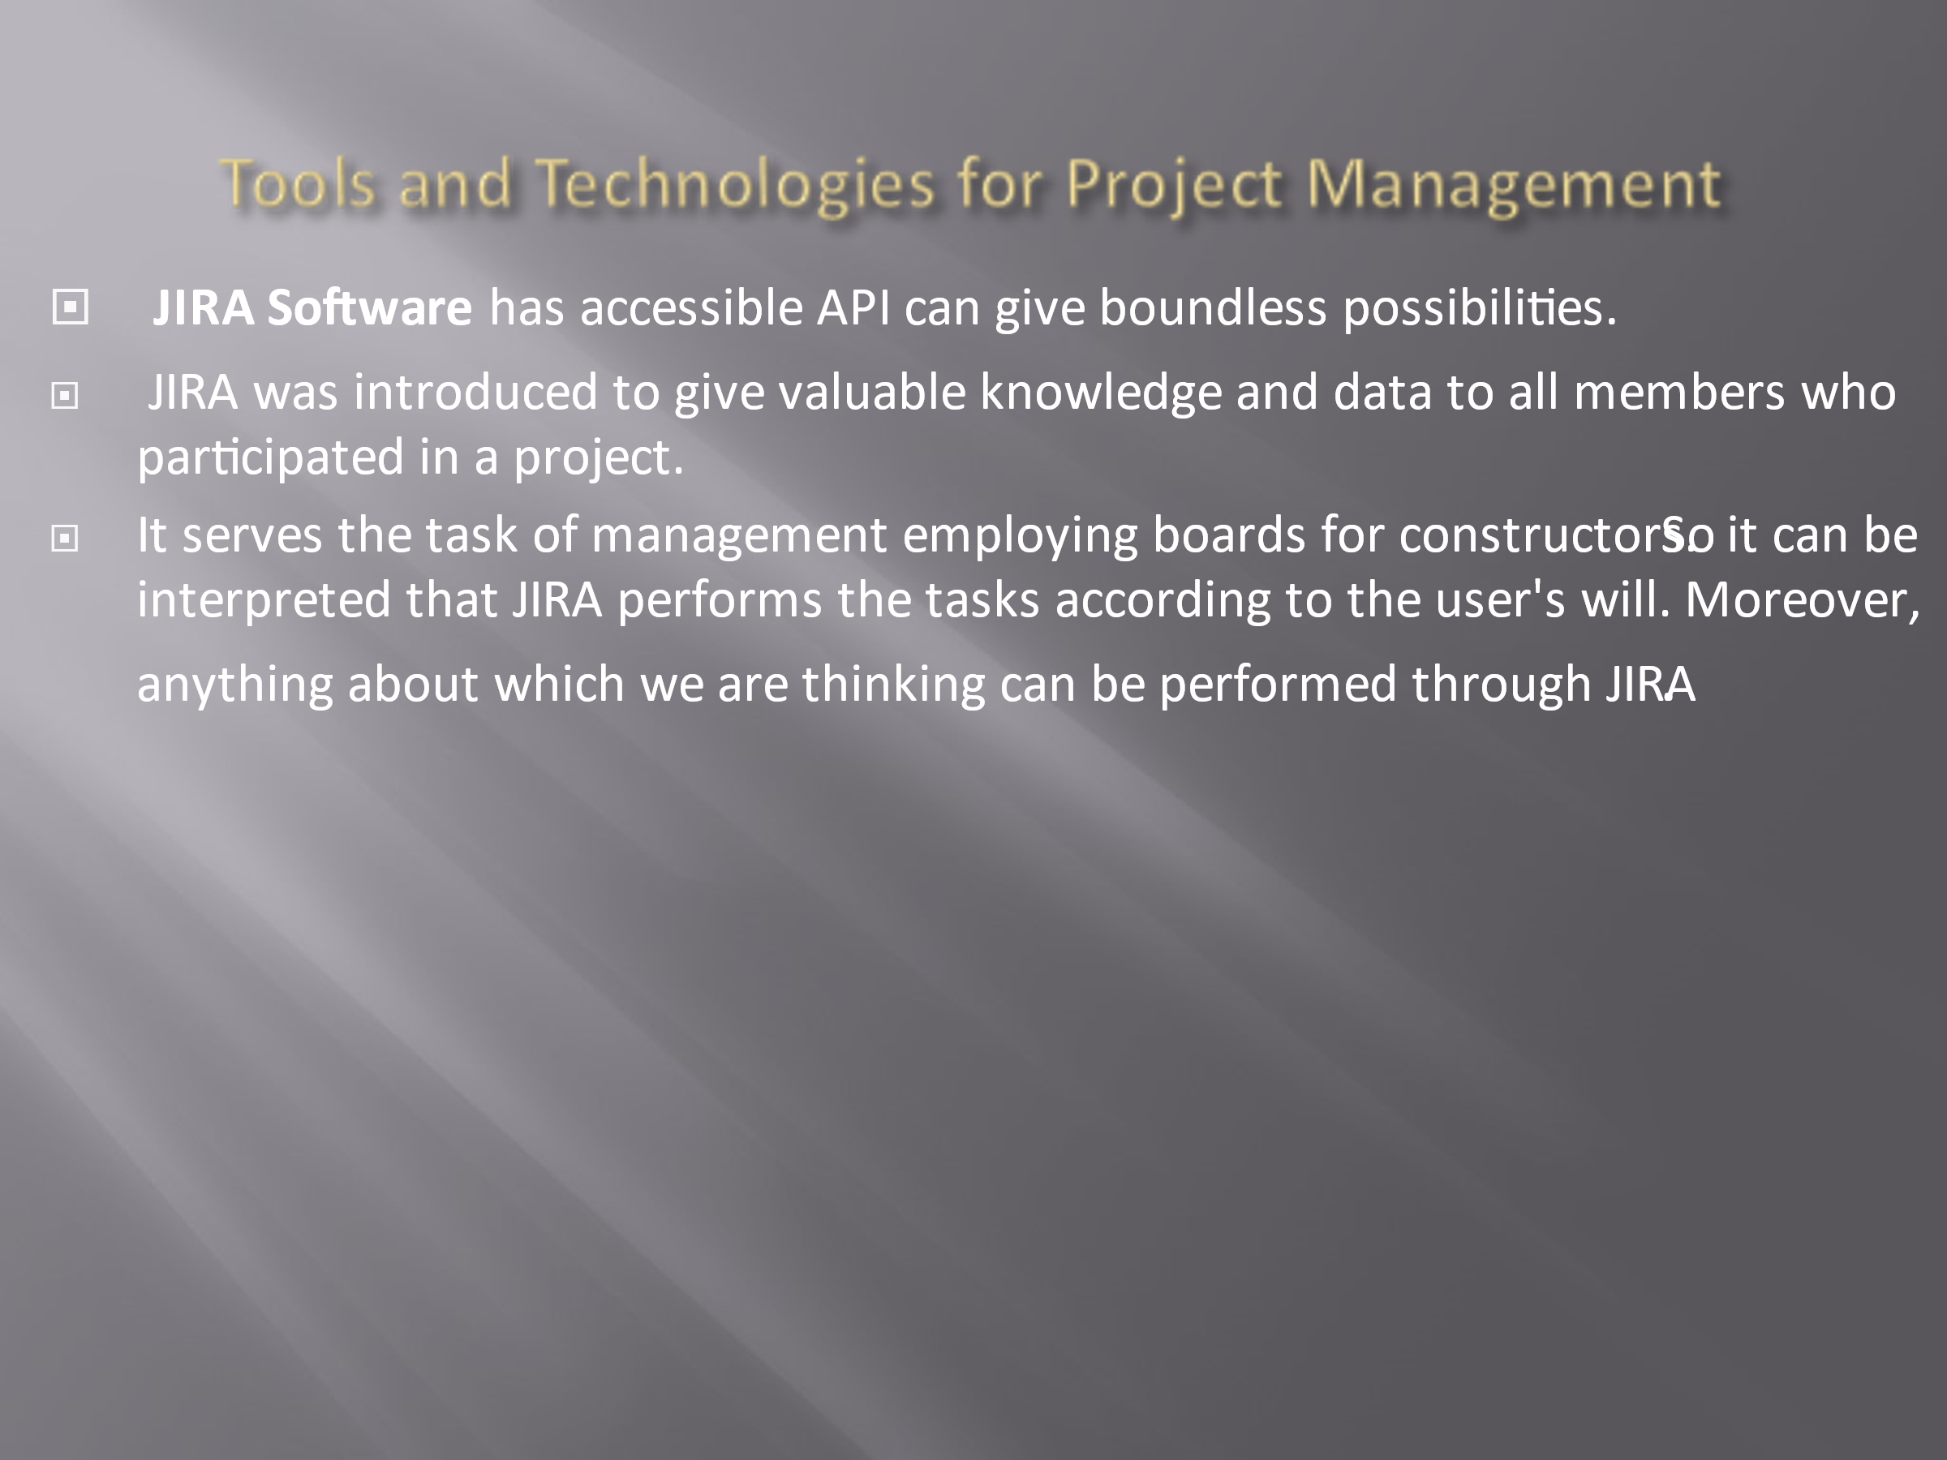
- JIRA Software is the technology that is usually paid tool across the world. It encompasses a variety of integrations having amazing tools. It is a transparent medium that provides project outlines through dashboards for project managers.
- It is a transparent medium that gives built-in reports to collaborators.
- JIRA has various pros and cons. It is highly suitable for bigger teams or projects. It has a better association with the Atlassian suite. However, JIRA workflow can be made automatic and largely customizable.
- It is free of cost for people who are less than ten. But its disadvantage is that it is not suitable most times for smaller teams. Moreover, it can be more user-friendly during the configuration of the portal at times. Another disadvantage is it can become costly sometimes.
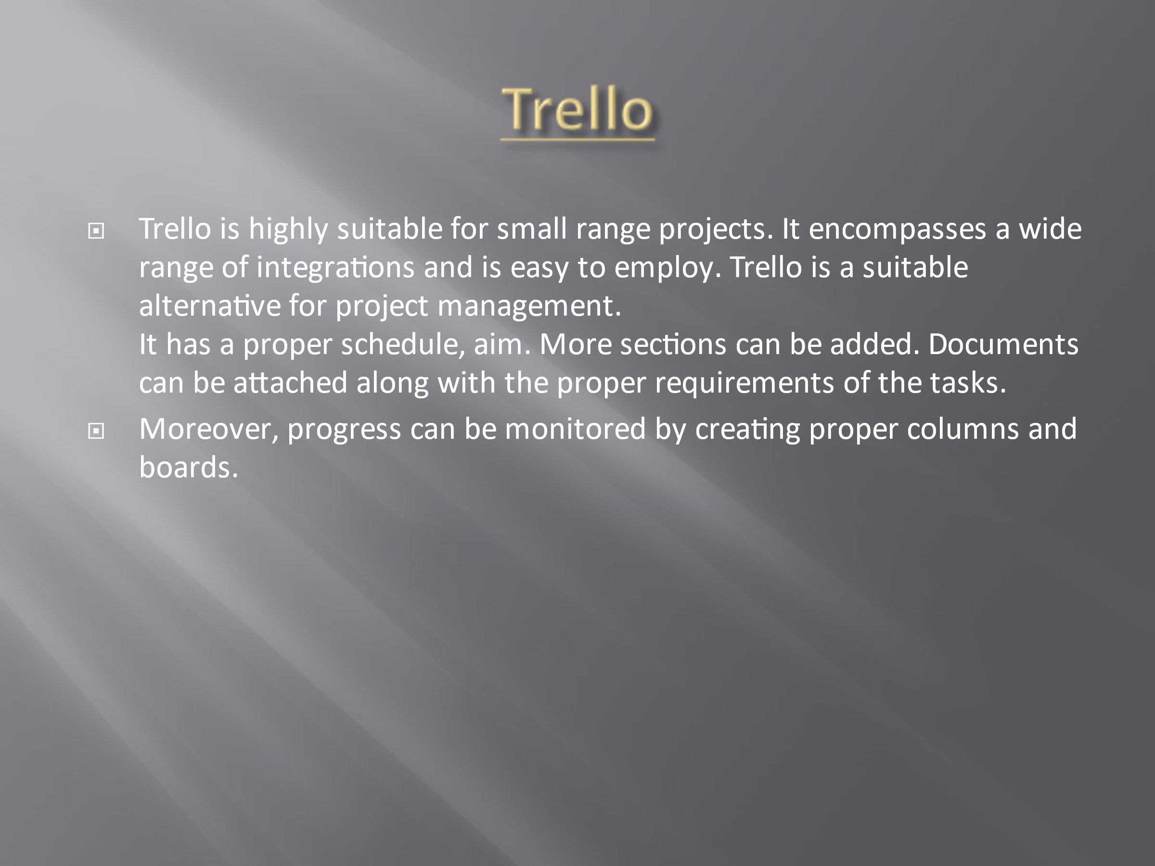
- Trello is another tool employed by my organization as it is free of cost and the most accessible tool for project management. Trello is suitable for small teams. Its functions are easy to use. In the initial stage, it offers a free version. The disadvantage of Trello is it's a tool that has fundamental mechanized workflows. It is not suitable for multiple projects, and it is difficult for Trello to prepare reports for shareholders.
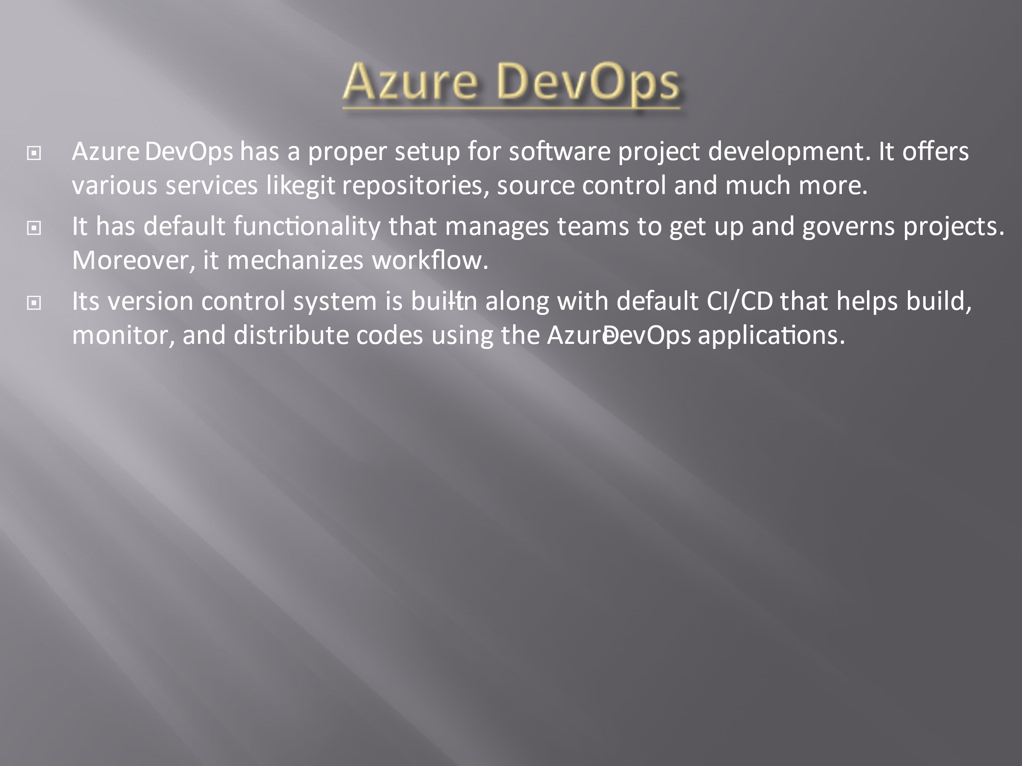
- Azure DevOps was recognized as Visual Studio Team Services. It is an important tool used for collaboration and development..
Azure DevOps associates technical staff and administration in the same place. It has management techniques, tools, agile project administration, IDE for in time editing, test management tools by default.
It is associated with non-Microsoft services that are difficult to use. It has a straightforward workflow that makes the workflow complicated. Its certification can be minimized. It is sometimes not suitable for searching for things.
It is not tailored like other tools. In some situations, it has low performance. Moreover, it is not cost-effective and transparent for users.
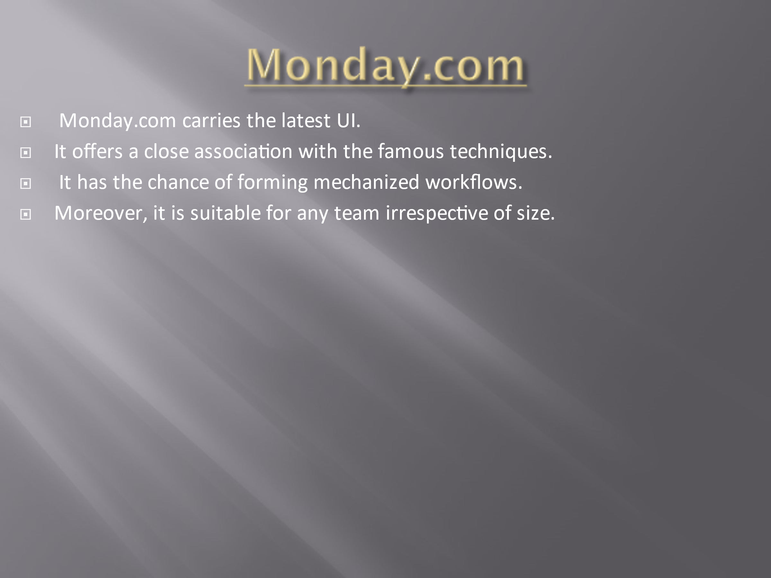
- Monday.com is the fourth technology used in a company. It is a very famous and common tool that has a significant role in project management during a pandemic. Monday.com makes the team members accountable for tasks that need to be done in the allocated time. Its platform is user friendly. Its colour-coded tasks make it easy to use.
- Monday.com offers an association with different services that makes life facile utilizing mechanized flows. It carries an extension of all famous and popular tools that are used in the contemporary era. It has a disadvantage as well. It can be costly at times depending upon the length of the team members. Task tracking can be fundamental, depending upon the complexities of the plan.
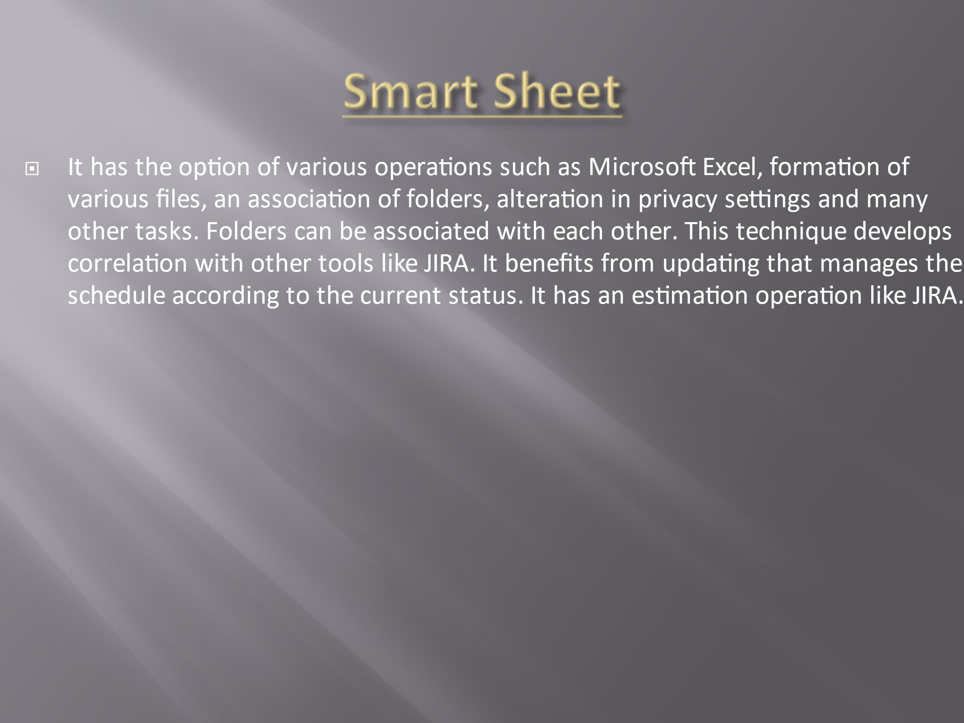
- The smart sheet is similar to the Excel spreadsheet that is mostly employed in times of COVID19 and has capacity to form a Gantt chart and schedules with some clicks. This technology is safe and easy to use as it can organize and arrange files accordingly. It has an efficient way to create an always up-to-date Gantt chart. It is convenient and easy to form updates, view changes and alter privacy settings. It has many disadvantages as well. It has no free version presently. Its organizations and incorporations are not that uncomplicated. It can be inordinate due to all feasible alternatives.
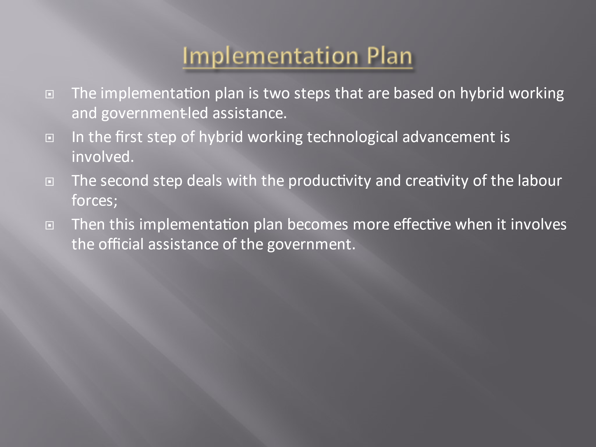
- The implementation for the new project requires a hybrid working model that gives variations in tasks and support to workers in carrying out their pursuits.
- In first step this plan doesn't require in-person labour. It enables software developers for remote working to carry out their projects. This implementation plan involves collaboration, brainstorming and networking of larger masses.
- Second step deals with innovation. The hybrid system in the third step reveals secrets for victory by offering a set of worthy recommendations.
- Lastly the Executives allocate a suitable budget for technological advancement. Thus project based on software development offers a variety of initiatives, valuable plans that led to the development of the technology and the whole growth of the state
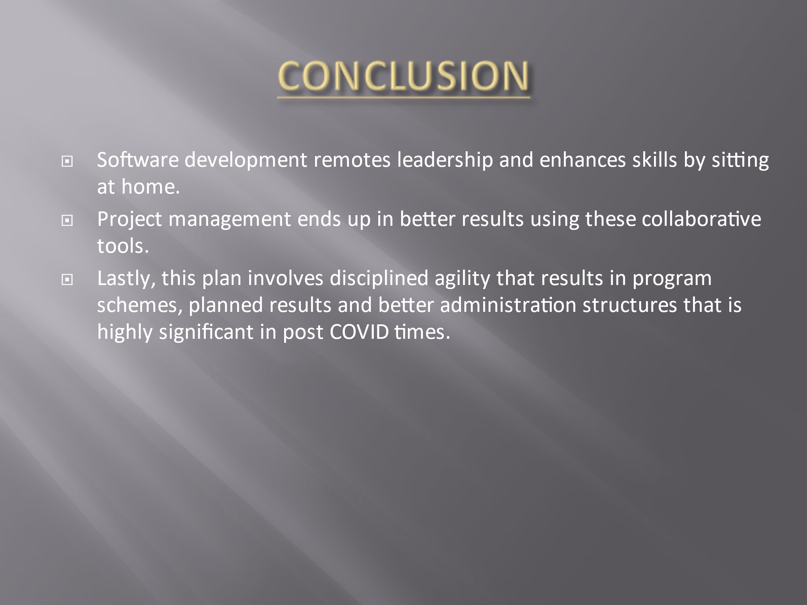
- COVID 19 brings social distancing, so this project is designed keeping in mind the safety and hygienic conditions.
So the post-COVID 19 conditions optimize the project portfolio rather than cancellation.

