UWTSD Version of The Traitors –

Initial User Research and Interface Design Report

Student Name: Amy Harrison
Student Number: 2133368

Module name: Usability Engineering

Module code: ACCB6017
Date: 05/03/2026

Contents
1. Introduction 3
2. Methodology – ~400 words 3
2.2 Participant Overview 4
3. Persona Development 4
3.2 Persona 2 – Corey harrison 5
3.3 Persona 3 – Natalie (Low Technical Confidence User) 6
3.4 Persona 4 – Alex 6
4. User & Experience Requirements (MoSCoW) 7
5. Designing for Usability 8
5.1 Simplicity and Cognitive Load 8
5.2 Visibility of System Status 8
5.3 Accessibility Considerations 8
6. Wireframe Storyboards 9
6.2 Appendix: Full Wireframes 9
7. Prototype Feedback 9
8. Conclusion 10
9. References 10
10. Appendices 12

1. Introduction
This report outlines the initial user research and early stage interface design for a mobile adaptation of The Traitors, tailored specifically for students at the University of Wales Trinity Saint David (UWTSD). The purpose of this assignment is to understand the needs and expectations of potential users, and to use those insights to inform low-fidelity wireframes that illustrate the key interactions and screens of the proposed application. The approach is grounded in user-centred design principles and established usability research, recognising that mobile interfaces must balance functionality with simplicity to support effective, efficient and satisfying experiences [1].
A small qualitative study was undertaken using structured interviews with participants who reflect aspects of the intended user base. The study explored participant motivations for playing, their experiences with mobile games, preferences for interface design and any accessibility concerns. These findings were synthesised into representative personas, which guided subsequent design decisions [2].

The report also draws on relevant academic literature to justify the design choices made. Research on first-time user experiences in mobile games highlights the importance of clear guidance and intuitive onboarding to support engagement. Building on these insights, this report presents user requirements, wireframe designs and early feedback to provide a solid foundation for developing a full-colour, interactive version of the game in the next assignment [3].

2. Methodology
2.1 Research Approach
To guide the design of the UWTSD version of The Traitors, a small-scale qualitative study was carried out to explore the needs, behaviours and preferences of potential users. Due to time constraints, a convenience sampling method was employed, targeting former students and individuals familiar with university life and mobile gaming contexts. This allowed the collection of relevant insights without requiring a large sample while still capturing characteristics of the intended audience.
Structured interviews were used to gather data, focusing on participants’ motivations for playing games, technical confidence, accessibility requirements, and typical frustrations with mobile applications. The questions were designed to uncover information directly relevant to social deduction gameplay and mobile interface interactions.
The insights from the interviews were synthesised to identify recurring themes and patterns, which informed the creation of representative personas and low-fidelity wireframe designs. This approach aligns with established user-centred design principles, ensuring that early design decisions are grounded in user needs rather than assumptions [4], [5]. Human–computer interaction literature further emphasises that involving users early helps prevent usability issues and supports efficient, effective, and satisfying interface design [6]. All participants provided informed consent, and no sensitive personal data beyond that necessary to create personas was collected.

2.2 Participant Overview
Four participants took part in the study, each selected to reflect different aspects of the intended user base. All participants were former or current students with varying levels of technical confidence and mobile gaming experience. The group included a new mother with high technical confidence but limited gaming time, a former IT student with a strategic approach to gaming, a mature student with lower technical confidence who uses mobile games casually, and a current university student who regularly uses mobile applications. Participants ranged in age from 21 to 35, providing a diverse range of perspectives on usability, accessibility, and gameplay preferences. The insights gathered from these interviews directly informed the persona development outlined in Section 3.
3. Persona Development
3.1 Persona 1 – Emily Harrison
Age: 28
Status: Former Student
Technical Confidence: 5/5 – Very confident
Mobile Game Usage: Rarely, due to limited time as a new mother
Background:
Emily is a 28-year-old former computing student and new mother. She enjoys gaming and is a fan of The Traitors television programme, but her current lifestyle limits her leisure time. She values casual gaming experiences that are easy to access and do not require long sessions. Emily also experiences anxiety, which influences her use of mobile applications; she prefers clear, simple interfaces that do not create stress.
Goals:
- Play short, engaging sessions to unwind.
- Experience a university-themed adaptation of The Traitors.
- Enjoy social gaming without feeling pressured.
Frustrations / Barriers:
- Complex or cluttered interfaces.
- Games requiring high social engagement when she may prefer low interaction.
- Overly intricate options or confusing navigation.
Accessibility Considerations:
- Anxiety management through limited session lengths and simple design.
- Colour-coded navigation and minimal cognitive load.
Scenario:
Emily logs into the UWTSD version of The Traitors after putting her child to bed. She wants to join a short game, quickly understand her role, and participate in voting without feeling overwhelmed by options or social pressure.
Design Implications:
- Keep the interface simple, intuitive, and low-stress.
- Use clear labels and colour coding.
- Limit unnecessary social interactions and maintain short, manageable game sessions.

3.2 Persona 2 – Corey Harrison
Age: 26
Status: Former Student
Technical Confidence: 4/5 – Confident
Mobile Game Usage: Rarely, mainly when younger
Background:
Corey is a 26-year-old former IT student and father of two. He enjoys strategic and psychological games that challenge his thinking. While he rarely plays mobile games now, he values mobile access for convenience and short gaming sessions.
Goals:
- Engage in psychological and social deduction gameplay.
- Analyse other players’ actions and plan strategic moves.
Frustrations / Barriers:
- Connectivity issues such as lag or glitches.
- Limited time for extended gameplay.
Accessibility Considerations:
- Clear instructions, visual cues, and reliable performance to support quick understanding and decision-making.
Scenario:
Corey logs in during a short break and wants to quickly understand his role, anticipate other players’ moves, and make tactical decisions without being disrupted by technical issues.
Design Implications:
- Ensure smooth performance
- Concise instructions
- Intuitive visual cues to support fast decision-making and strategic play.

3.3 Persona 3 – Natalie
Age: 35
Status: Former Student
Technical Confidence: 2/5 – Limited confidence
Mobile Game Usage: Occasionally
Background:
Natalie is a 35-year-old former computing student and mother of six. Due to her busy lifestyle, she tends to use mobile games as a quick form of relaxation during short periods of free time. While she is familiar with smartphones and everyday apps, she does not consider herself highly confident with technology and prefers applications that are simple and easy to understand.
Goals:
- Play quick, casual games during short breaks.
- Enjoy simple entertainment that does not require complex setup or learning.
Frustrations / Barriers:
- Complicated menus or too many options.
- Confusing instructions or unclear navigation.
Accessibility Considerations:
- Clear instructions and simple navigation.
- Larger buttons and readable text.
Scenario:
Natalie opens the game in the evening after her children are asleep. She wants to quickly join a match and understand what she needs to do without spending too long learning the interface.
Design Implications:
Prioritise simple layouts, clear instructions, and easy navigation to support users with lower technical confidence.

3.4 Persona 4 – Alex
Age: 21
Status: Current Student
Technical Confidence: 3/5 – Average
Mobile Game Usage: Regularly
Background:
Alex represents a typical university student who regularly uses mobile apps and games during free time between lectures or while travelling. As a student, Alex is comfortable using smartphones and digital platforms but prefers apps that are quick to understand and easy to navigate. Mobile games are usually played in short bursts rather than long sessions, so accessibility and simplicity are important.
Goals:
- Play short, engaging games between lectures or during downtime.
- Interact with other players in a fun and competitive way.
Frustrations / Barriers:
- Complicated sign-up processes or slow loading times.
- Games that require long sessions or too much commitment.
Accessibility Considerations:
- Clear instructions and intuitive navigation.
- Simple layouts that make it easy to understand what to do next.
Scenario:
Alex logs into the UWTSD version of The Traitors while waiting for a lecture to begin. The aim is to quickly join a match, understand the role assigned, and take part in the game without spending too much time learning how the app works.
Design Implications:
- Focus on quick onboarding, simple navigation, and short gameplay sessions that fit around a student schedule.

4. User & Experience Requirements (MoSCoW)
The design of the UWTSD version of The Traitors must cater to a variety of users, including those with limited time, differing technical confidence, and varying social preferences. To prioritise functionality and ensure a user-centred approach, the MoSCoW framework has been applied to separate essential features from desirable or optional ones.
Must have features include a simple, intuitive interface with clearly labelled navigation to minimise confusion and cognitive load. Essential screens, such as login, role assignment, and voting, must provide straightforward interactions with minimal steps, allowing users to quickly understand their objectives and participate effectively. The system should provide immediate feedback during each game phase, confirming actions such as role assignment, vote submission, or treasure collection, to maintain clarity and reduce errors. Accessibility considerations, including colour contrast, readable fonts, and concise instructions, are critical to support users with minor visual, cognitive, or anxiety-related challenges [7].
Should have features include optional tutorials or onboarding to guide first-time users, as evidence shows that structured guidance improves engagement and reduces early-stage errors [8]. Visual cues and colour coding to differentiate roles and game phases enhance clarity and reduce cognitive load. Social interactions, such as chat or discussion boards, should be available but not mandatory, allowing users to engage at their preferred level. Tooltips or brief instructions can assist navigation without overwhelming the user.
Could have features involve customisable avatars or minor gamification elements to increase engagement while maintaining simplicity. Optional sound cues or notifications could enhance immersion without distracting from core gameplay, and short-session rewards can support users with limited time [9].
Won’t have features include complex microtransactions, global open chats, or excessive customisation, as these may distract from gameplay and increase cognitive load. By applying these priorities, the design ensures usability, accessibility, and engagement while addressing common challenges in social deduction mobile games.

5. Designing for Usability

5.1 Simplicity and Cognitive Load
In mobile interface design, simplicity is essential for reducing cognitive load and improving usability, especially for users with varying experience levels and limited time [10]. Cognitive load theory suggests that interfaces should minimise unnecessary information, group related elements, and use consistent visual structure to help users process tasks without confusion. In the context of The Traitors, players need to make strategic decisions quickly — for example, understanding their role, navigating to the voting screen, or interpreting game status — without being overwhelmed by too many interactive elements. A simple layout with clear labels, logical groupings, and minimal distractions supports efficient task completion and strengthens perceived ease of use. This approach aligns with research showing that mobile users prefer straightforward interfaces that focus attention on essential actions rather than ornamental features [11]. By prioritising simplicity, the design accommodates users like Emily, Natalie and Corey, enabling quick comprehension and seamless interactions across game phases.

5.2 Visibility of System Status
Effective interfaces communicate ongoing processes and user actions with timely feedback, reinforcing users’ sense of control and reducing uncertainty [11]. For mobile games, especially those with strategic phases and waiting periods, clear indicators — such as loading feedback, highlighted active buttons, and status notifications — help users understand the current state of the game. For example, after a vote is submitted or a role assigned, a brief confirmation or visual change reassures the player that their input has been registered. This practice reduces anxiety and improves user confidence, particularly valuable in multiplayer scenarios where the next action depends on system responsiveness.

5.3 Accessibility Considerations
Accessibility ensures that games are usable for people with a range of needs, including visual, cognitive, and time-related constraints [12]. For mobile interfaces, accessibility best practice includes readable fonts, high contrast between interface elements, and appropriately sized interactive targets for touch input. Optional tutorials or help overlays can assist first-time users without dominating the interface. In The Traitors, social interaction features such as chat or discussion prompts should be optional, allowing users who prefer a less social experience to engage comfortably. Many players may experience anxiety or limited time, so screen designs focus on clarity and flexible pacing rather than fast-paced requirements that may frustrate or exclude some users. These considerations reflect inclusive design principles that improve accessibility and broaden potential engagement with the game.

6. Wireframe Storyboards
Refer to appendix B for full wireframes and appendix C for flowchart.
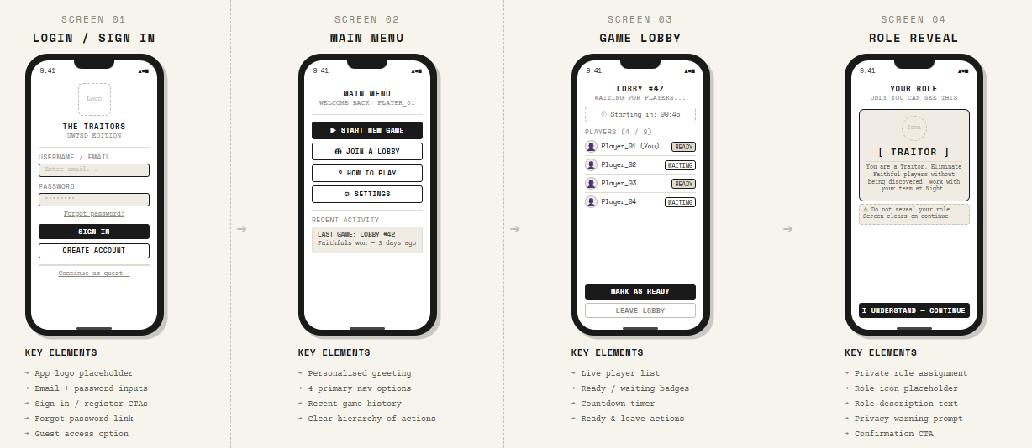
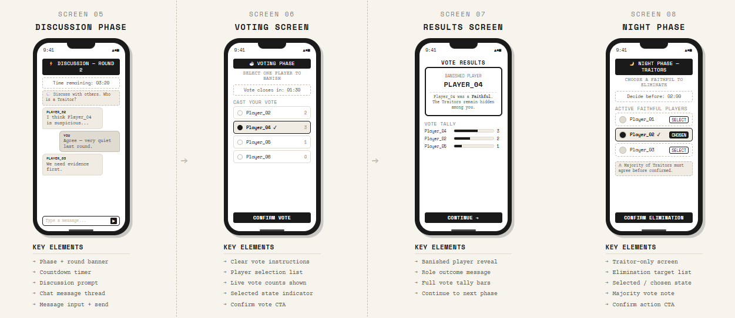
6.1 Key Screens Discussion
Wireframes were created to explore the layout and interaction flow of the proposed UWTSD version of The Traitors mobile game. At this stage, the focus is on functionality rather than visual design, allowing key interactions to be considered before detailed graphics are added. Low-fidelity wireframes were chosen to enable rapid development and to highlight potential usability issues early [13].
The first screen is the login interface, providing clear input fields and large buttons for signing in or creating an account, suitable for users with lower technical confidence. From here, users access the main menu, offering options to start a game, join a lobby, view a tutorial, or adjust settings. The game lobby screen displays player lists and a ready button before moving to the role reveal screen, where players learn if they are traitor or faithful. Gameplay continues through discussion, voting, results, and night phase screens, forming a logical flow that supports simple navigation, quick understanding, and minimal cognitive load. This approach supports user-centred design by focusing on navigation, clarity and task completion before visual styling is introduced [14].
6.2 Appendix: Full Wireframes
The complete set of wireframe designs is provided in the appendix. These low-fidelity prototypes illustrate the layout and navigation flow of the mobile application. Each screen has been designed at an approximate mobile device size and focuses on structure rather than visual styling.
The wireframes include the login screen, main menu, game lobby, role reveal interface, discussion phase, voting screen, results display, and night phase interaction. Arrows and labels have been included to demonstrate how users move between screens during gameplay. Presenting the full set of wireframes in the appendix allows the main report to focus on key design decisions while still providing a clear overview of the complete interface structure.

7. Prototype Feedback
To evaluate the initial wireframe designs, a small group of participants representing the defined personas were asked to review the prototype screens. Participants were shown the wireframe storyboards and asked to comment on the clarity of the layout, ease of understanding, and overall usability of the proposed interface. Early usability feedback is important because it allows designers to identify problems in navigation and user understanding before the system is fully developed [15].
Feedback was gathered informally through short discussions and structured questions. Participants were asked whether they could easily identify the purpose of each screen and whether the navigation between stages of the game was clear. The aim was to determine whether users could understand the flow of the application without detailed instructions.
Overall, the feedback was largely positive. Participants reported that the screens appeared simple and easy to follow, particularly the login interface and main menu layout. The use of clearly labelled buttons and minimal content was seen as beneficial for reducing confusion. One participant also highlighted that the voting screen was easy to understand, as it clearly displayed the list of players.
However, some suggestions for improvement were also identified. One participant noted that the discussion phase may require clearer prompts to encourage interaction between players. Another comment suggested that the results screen could include a short message explaining the outcome of the vote. These observations will help inform further refinements in the next stage of development.

8. Conclusion
In this report, I have presented the initial research and design concepts for a mobile version of The Traitors set within the UWTSD university environment. User research informed the development of personas that represent different types of potential players, highlighting a range of usability and accessibility considerations. These insights were used to establish user requirements and guide the creation of low-fidelity wireframe storyboards.
My wireframes demonstrate a clear interaction flow designed to support simple navigation, quick understanding, and engaging gameplay. Feedback from early prototype evaluation suggests the interface is generally easy to follow while also highlighting areas for improvement. These findings will support the development of more detailed visual designs in the next stage of the project.

9. References
[1] L. Barnett, C. Harvey, and C. Gatzidis, "First time user experiences in mobile games: An evaluation of usability," Entertain. Comput., vol. 27, pp. 82–88, Aug. 2018. [Online]. Available: https://doi.org/10.1016/j.entcom.2018.04.004
[2] R. Harrison, D. Flood, and D. Duce, "Usability of mobile applications: Literature review and rationale for a new usability model," J. Interact. Sci., vol. 1, no. 1, 2013. [Online]. Available: https://journalofinteractionscience.springeropen.com/articles/10.1186/2194-0827-1-1
[3] P. Weichbroth, "Usability issues with mobile applications: Insights from practitioners and future research directions," arXiv, Feb. 2025. [Online]. Available: https://arxiv.org/abs/2502.05120
[4] K. Holtzblatt and H. Beyer, "Contextual inquiry: A foundational UX research method," in The Encyclopedia of Human-Computer Interaction, 2nd ed., M. Soegaard and R. F. Dam, Eds. Aarhus, Denmark: Interaction Design Foundation, 2014.
[5] A. Cooper, R. Reimann, D. Cronin, and C. Noessel, About Face: The Essentials of Interaction Design, 4th ed. Indianapolis, IN, USA: Wiley, 2014.
[6] C. K. Coursaris and D. J. Kim, "A meta-analytical review of empirical mobile usability studies," J. Usability Stud., vol. 6, no. 3, pp. 117–171, May 2011. [Online]. Available: https://uxpajournal.org/a-meta-analytical-review-of-empirical-mobile-usability-studies/
[7] J. Nielsen, Usability Engineering. San Francisco, CA, USA: Morgan Kaufmann, 1994.
[8] B. Shneiderman, C. Plaisant, M. Cohen, S. Jacobs, and N. Elmqvist, Designing the User Interface: Strategies for Effective Human-Computer Interaction, 6th ed. Hoboken, NJ, USA: Pearson, 2017.
[9] R. S. Pressman and B. R. Maxim, Software Engineering: A Practitioner's Approach, 9th ed. New York, NY, USA: McGraw-Hill, 2019.
[10] P. Weichbroth, "Usability of mobile applications: A systematic literature study," IEEE Access, vol. 8, pp. 55563–55577, 2020. [Online]. Available: https://doi.org/10.1109/ACCESS.2020.2981892
[11] D. Norman, The Design of Everyday Things, revised ed. New York, NY, USA: Basic Books, 2013.
[12] J. Abascal and A. Civit, "Universal accessibility of human-computer interfaces," in Proc. Int. Conf. Computers Helping People with Special Needs, Linz, Austria, 2000, pp. 1–8.
[13] H. Sharp, Y. Rogers, and J. Preece, Interaction Design: Beyond Human-Computer Interaction, 5th ed. Hoboken, NJ, USA: Wiley, 2019.
[14] B. Buxton, Sketching User Experiences: Getting the Design Right and the Right Design. San Francisco, CA, USA: Morgan Kaufmann, 2007.
[15] J. S. Dumas and J. C. Redish, A Practical Guide to Usability Testing, revised ed. Exeter, UK: Intellect Books, 1999.

10. Appendices
Appendix A.
Requirement | Description | Priority (MoSCoW) | Related Screen
Simple login system | Users must be able to quickly create an account or log in with minimal steps | Must | Login Screen
Clear navigation menu | Main menu must clearly display options such as Play Game, Join Game, Tutorial and Settings | Must | Main Menu
Player lobby system | Users must be able to see other players joining and confirm readiness before the game begins | Must | Game Lobby
Role assignment display | Players must be clearly informed whether they are a traitor or faithful before gameplay begins | Must | Role Reveal
Voting interface | Users must be able to easily select and confirm a player they suspect | Must | Voting Screen
Game status feedback | The interface should show confirmations when actions such as voting or joining a game occur | Should | Multiple Screens
Tutorial option | A short explanation of gameplay should be available for new users | Should | Main Menu
Visual cues | Colour indicators or icons should help users identify roles and game phases | Should | Role Reveal / Game Screens
Avatar customisation | Players could personalise their character avatar | Could | Profile
Sound notifications | Audio cues could notify users when phases change | Could | Gameplay Screens
Micro transactions | In-game purchases will not be included in the design | Won’t | N/A
Complex menus | Overly complicated navigation will not be included | Won’t | All Screens
Appendix B.
  - Login/signup page.
  - Main menu
  - Lobby page
  - Role reveal
  - Discussion phase
  - Voting screen
  - Results screen
  - Night phase
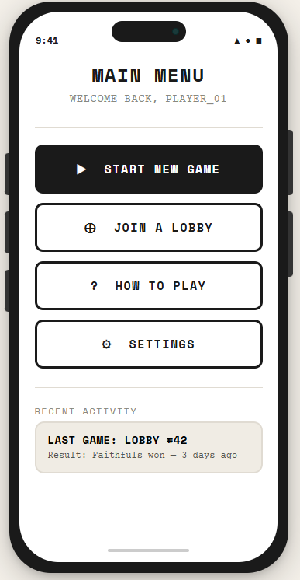
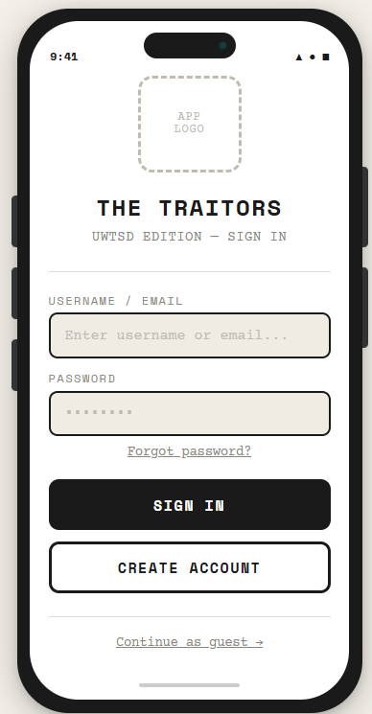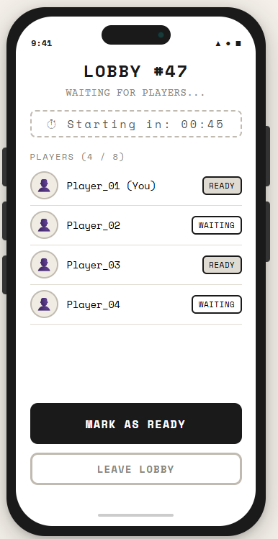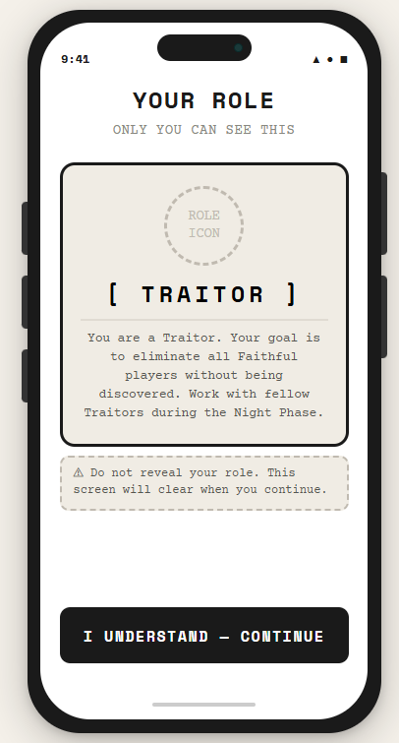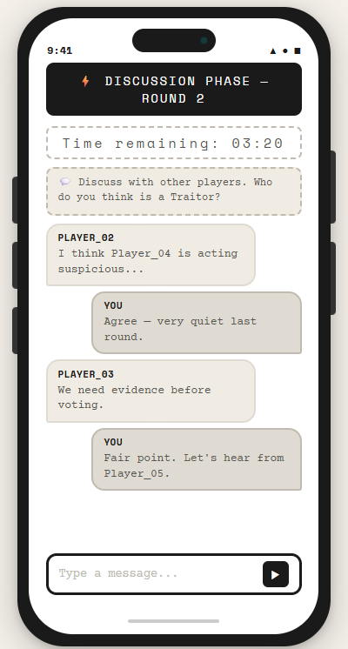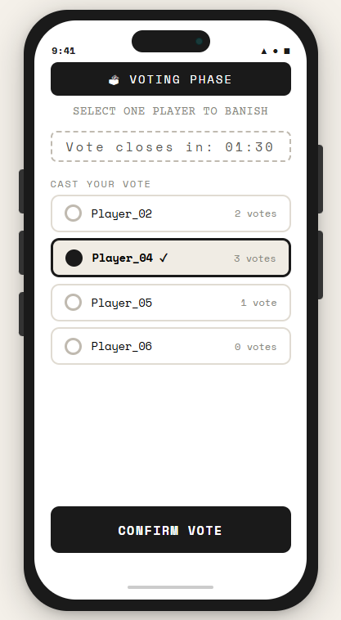
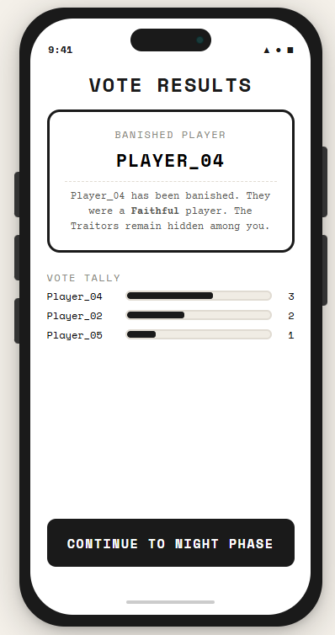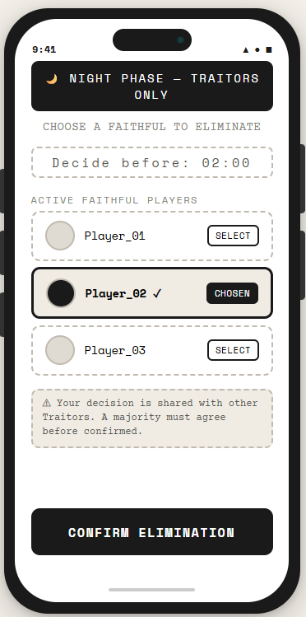

Appendix C.

