Student Name: Britney Heywood
P Number: 1802547
Programme of study: Surface Pattern Design
Tutors: Julia Lockheart and Gwenllian Beynon
Word Count: 1’537

My exhibition titled “walls that reminisce” is based in a house where every room has a certain theme which draws directly on personal memories. The exhibition is open to the public but the wallpaper and artifacts will only relate to the individual participant’s life events. So it is private and personal. Almost like the participant is dreaming back to treasured memories. The memories will be shown through wallpaper being inspired by my course Surface Pattern Design. In the rooms the wallpaper will show life events to encourage reminisce about good and bad times. The living room will show happy memories captured throughout the participant’s life . Then the front room will show sad times that may not want to be seen. Then upstairs will be a room dedicated to artist Ainsley Hillard, who creates textile installations with sound.
For Bachelard the house is a metaphor which reveals the inner working of the person. In his book The Poetics of Space (1994) he talks about being in a home and the space around it with the emotions you can feel. He writes “The house shelters day-dreaming, the house protects the dreamer, the house allows one to dream in peace.” (1994, p.6). This means that a house protects memories that can last a life time, every memory made there will always be in that house. It is relevant as that is what is wanted for the exhibition, as if it is a treasured childhood home. Dreaming can bring your imagination to life and make you want to reach your goals but you should always cherish what you have in life.
Through dreams, the various dwelling-places in our lives co-penetrate and retain the treasures of former days. And after we are in the new house, when memories of other places we have lived in come back to us, we travel to the land of motionless childhood. (Bachelard, 1994, p.5).
This suggests that when you move house and think of the memories from your childhood home, you go back to that time where anything was possible and without any care in the world because you feel like a child again. That is the emotion wanted for the audience. Day dreaming can help remember memories and make you happier.
When looking at Phenomenology I want my exhibition be more than what it appears to be as it want it to captures people’s attention and different emotions as “Phenomenology focuses not on what appears, but how it appears.” (Lewis and Staehler, 2010, p.1). To people it will appear to be a house with wallpaper showing memories and exhibiting an artist. But how it appears is what matters, it has a greater meaning where special memories are shown, so personal that it will be emotional throughout. Phenomenology focuses on how it appears to the audience and not what originally appears which is the aim for the exhibition.
The wallpaper will show your life events but will also narrate the events too. The voice will have different tones so it is not all one tone throughout. It will have a sad voice when showing the sad events and a happy voice when showing the good life events. The voice may shout or yell. Shouting or yelling can affect emotions differently to the way whispering can. In this way, this exhibition will capture people’s attention and effect their emotions. Whispering allows you to be calm and relaxed. It is said that whispering can be “known as Autonomous Sensory Meridian Response (ASMR), sometimes referred to as “brain tingles” or “brain orgasms”. Such a sensation is often followed by calm and relaxation” (Azzollini, 2018). The ASMR calms and relaxes you so the audience will feel this way when watching back on their good memories. This relates to the Phenomenology of ASMR (Roberts, 2019) as it is determined on “whether ASMR represents a unique experience” (Roberts, 2019, p.22).
The second emotional element is yelling. There is a lot of evidence that shows the effect of yelling at human development.
Being frequently yelled at changes the mind, brain and body in a multitude of ways including increasing the activity of the amygdala (the emotional brain), increasing stress hormones in the blood stream, increasing muscular tension and more. (Hendel, 2018).
Hendel narrates that being yelled yet changes your mind and attitude and increases your blood flow causing severe stress and anxiety. Yelling is such an emotional expression that it increases emotions which can cause distress. Hendel continues that children are severely effected by yelling.
Being frequently yelled at as children changes how we think and feel about ourselves even after we become adults and leave home. That’s because the brain wires according to our experiences—we literally hear our parents’ voices yelling at us in our heads even when they’re not there.
Being yelled at effects hormones and can bring back bad times from childhood or throughout life. This was researched to see what the technical differences between whispering and yelling were. I want a room where one is showing life events and whispering and want another where it is yelling, to show the different emotions throughout the exhibition and through the audience.
The main aspect for this exhibition is for the audience to reminisce about the good and bad times but mainly the good times. In an article titled “9 reasons why reminiscing can benefit seniors” (Cemental, ND), it explains reasons why it can benefit you. Many were that it improves your quality of life, can reduce depression in the future and it can reduce stress. It intrigued me as I would have never of thought that thinking about memories could help you mentally and not just make you happy for that second. Even though that article is about seniors, I think this can happen to all ages, especially if there was something in the past that wasn’t solved or you felt guilty about.
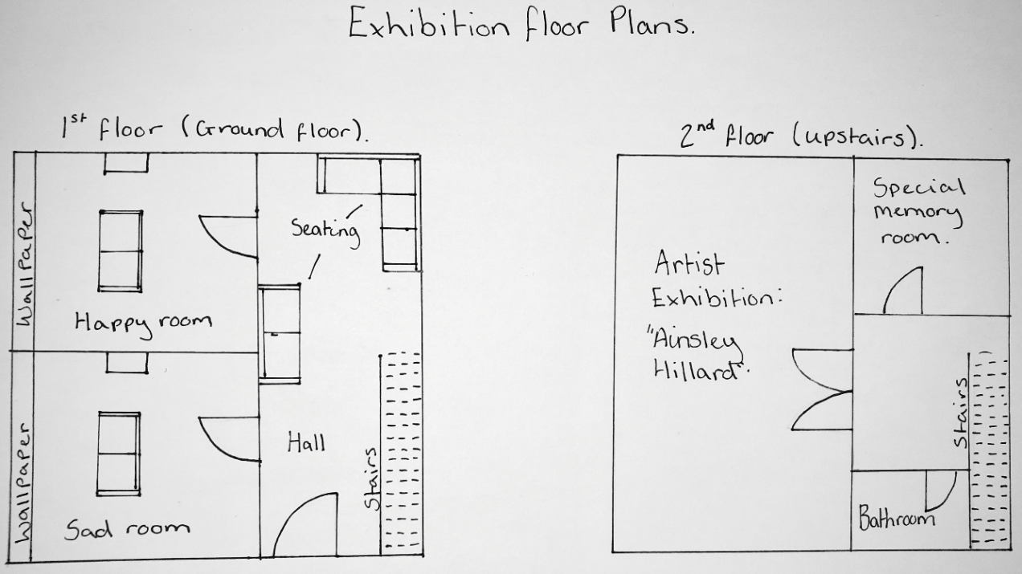
Reminiscing can help uplift spirits and can reduce depression. People need to see these memories to bring them happiness and to realise what they got in life and how lucky they are.

Figure 1: Exhibition floor plans. First and Second floor. (Heywood, 2019)
The exhibition will be set in any ordinary home in an ordinary town as it needs to feel like home for the audience and take them back to their childhood. There will be two main rooms, the living room and the front room. One room will have whispering calm happy memories and the other being the shouting sad memories. Then up the stairs you will see your family photos like a normal house which only you would see. As mentioned previously there will be one huge room upstairs dedicated to the artist “Ainsley Hillard” displaying her work and in the remaining room there will be a special memory to you. The house will have seating in all rooms except the artist’s room. Each room will provide objects related to the emotions in the room, such as tissues. It is a free exhibition and is open to anyone at any age. Wallpaper was the main textile piece in the exhibition as wallpaper shows your personality and it is as if the wall is speaking and showing your personality which is where I got the idea from.
I have chosen Ainsley Hillard to be the artist upstairs as I was given a talk by her in April (2019) explaining her profession and all the work and exhibitions she has created. I found her work fascinating and relatable and she needed to be in my exhibition. One of her exhibitions that stood out was titled “Traces” (2008). It was exhibited in the mission gallery, Swansea. The exhibition was of hand-woven structures with images in them. They were inspired by the gallery and had audio where the sounds would be in intervals as the audience’s moves throughout the exhibition. This is relatable as I want a similar exhibition upstairs where her work can connect to the audience and will relate to a family home. In the talk she spoke about a poet Norman Nicholson saying “I have heard it said... that sounds made by the human voice last longer than we aware of” continues on “if we could hold to our ear the stones of the Millom houses and streets, as we hold a sea-shell, we should catch, still vibrating, the songs of many years...”. I think of this as hearing the human voices and joyful memories you want to hear can last with you for a lifetime.
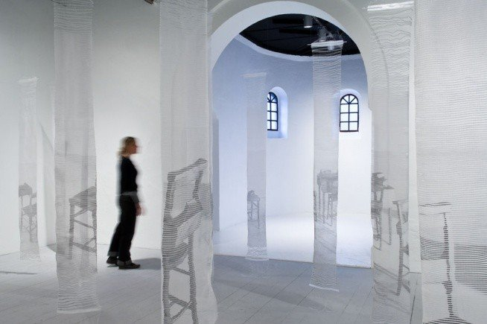
Figure 2: “Traces” by Ainsley Hillard (2001)
The aim is to capture the audience’s emotions and to be able to cherish the good and bad memories. Reminiscing makes you dream about the happiest moments in your life and takes you back to your childhood. Sometimes people need to remember these to remind themselves what they have in life and to count themselves lucky. Dreaming about your lifetime helps with health, physically and mentally which is the most important. Exhibiting Ainsley Hillard is a fantastic opportunity to show her amazing work as she relates so much to this exhibition and by having the two tonal voices will make a difference to emotions which is what was needed for the exhibition.

Bibliography

Azzollini, M. (2018) The physiological effects of whispering on your brain. Available at: https://www.wellbeing.com.au/at-home/physiological-effects-whispering-brain.html (Accessed on: 23rd March 2019).
Bachelard, G. (1994) The Poetics of Space. Boston: Beacon Press.
Cemental, R. (ND) 9 reasons why reminiscing can benefit seniors. Available from: https://www.caringseniorservice.com/blog/9-reasons-why-reminiscing-can-benefit-seniors. (Accessed on: 26th March 2019).
Figure 2: Hillard, A. (2001) Traces [Exhibition]. Swansea, Mission Gallery. Available from: https://www.missiongallery.co.uk/exhibitions/traces/ (accessed on :19th April 2019).
Hendel, H.J. (2018) The problem with yelling. [Blog]. Available at: https://www.nami.org/Blogs/NAMI-Blog/February-2018/The-Problem-with-Yelling (Accessed on: 23rd March 2019).
Heywood, B. (2019) Exhibition floor plans. First and second floor. [Floor plans].
Hillard, A. (4th April 2019) Talk in Alex reading room, UWTSD.
Lewis, M. And Staehler, T. (2010) Phenomenology. London and New York; Continuum International Publishing Group.
Roberts, N.(2019). "Autonomous Sensory Meridian Response: Scale Development and Personality Correlates." Psychology of Consciousness: Theory, Research, and Practice, 6(1) p.22-40. (Accessed on: 29th April 2019). ISSN: 23265523. DOI:10.1037/cns0000168.

