University of Wales Trinity Saint David
School of Engineering

Technical report
IMechE design concept
challenge: ACMA4008
Ali Al Mostafa
2204342
April 2025
1. Introduction 3
2. Initial Design Concepts 3
3. Final Design and Bill of Materials (BOM) 5
4. Table 1: Bill of Materials (BOM) 8
5. Design Review and Feasibility Analysis 8
6. Conclusion and Recommendations 10
7. References 11

Introduction
Students enrolled in engineering programs can benefit from the Institution of Mechanical Engineers (IMechE) Design Challenge 2025 by designing autonomous mechanical systems for evaluation. The main task requires creating a small system which fits inside a 400x400x400 mm boundary space while it conducts independent movement towards a target positioned at horizontal and vertical coordinates. The device requires proper operation under the required specifications, including using a vertical rear datum pointer, a front plunger plug simulator, and a precise alignment-based scoring system. Participants can integrate Arduino systems within the advanced category of the competition, while wireless communication technologies remain banned. The system must reveal operational status through green and red LEDs alongside a buzzer which plays when the target gets hit successfully. The design evaluation system will measure accuracy, mechanical performance, circuit integration, and technical regulation conformity (Institution of Mechanical Engineers). (2025). The proposed solution obtains its support from a report that contains descriptions of design specifications, initial concepts, final CAD-documented prototype, the, bill materials, and utility analysis.

Initial Design Concepts
Several design alternatives were examined for meeting the fundamental requirements and dimensions of the IMechE Design Challenge 2025: (1) spring-driven plunger cart, (2) gear-powered motorized trolley and (3) servo actuators operating on dual axes. As its name indicates, the spring-actuated plunger cart relied solely on mechanical components to function through a spring-powered mechanism operated by a tilt-based latch system. The design concept selected simplicity over electronic components, which minimized the chances of circuit failure. As a standalone system, this design constrained users from automatic vertical adjustment and precise plunger force control and timing functions. The gear-driven motorized trolley contained two DC motors attached to an aluminium chassis, which integrated a programmable Arduino Nano controller. Proper movement and directional stability were achieved using track-following IR sensors that provided forward propulsion to the device. The plunger mechanism received better control capabilities, allowing precise target engagement (Institution of Mechanical Engineers, 2025). The third concept added dual-axis servo motors, which synchronized plunger height adjustments from 50mm to 150mm, thus achieving vertical positioning needs. The 400x400x400mm envelope constraint specification was verified through CAD modelling for all design concepts.
Figure 1: Conceptual Sketch of Initial Designs
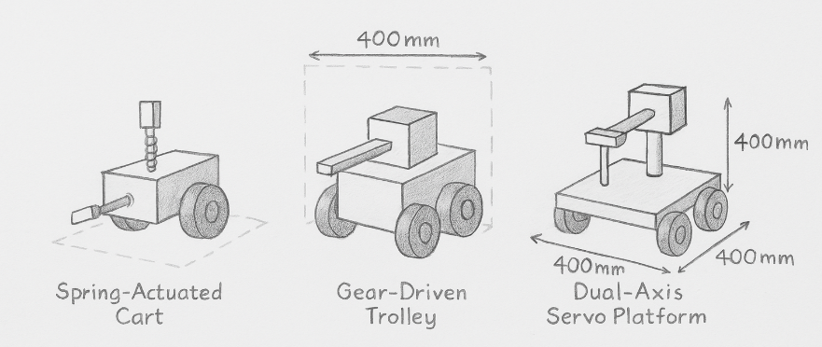
Sketch comparison of the three proposed mechanisms — spring-actuated cart (left), gear-driven trolley (centre), and dual-axis servo platform (right), each sized within 400mm cube constraints.
A detailed assessment evaluated the technical feasibility and each developed concept's safety risks. The main dangers which affected the spring-actuated cart emerged from mechanical jamming issues and unreliable triggering problems. Technical difficulties such as motor synchronization and complex plunger control emerged from the gear-driven trolley. Yet, the dual-axis servo platform required additional attention to servo calibration procedures and decreased ease of wiring setup. Standard rear-mounted RS Components datum pointer (Part No. 397-4954) at <6mm track level served to comply with racing requirements for all device designs. Simulation and prototyping took place using Tinkercad and physical mock-ups of 3D-printed ABS brackets and recycled plastic materials. Test techniques for design isolation helped select the ideal solution by comparing plunger force capabilities, determining proper gear ratios for the motorized platform and verifying LED visibility under normal lighting conditions (Institution of Mechanical Engineers, 2025). Perfection of performance reliability, modular design, and integration capabilities led to the selecting of a gear-driven motorized trolley with a servo-controlled plunger height adjustment for final development.
Figure 2: Diagram – Gear-Driven Trolley Design Layout
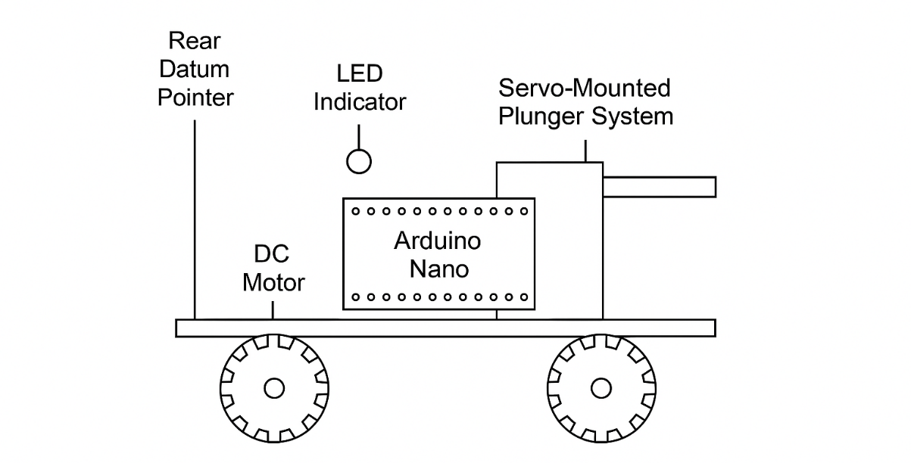
Schematic diagram of the selected concept showing placement of DC motors, Arduino Nano, servo-mounted plunger system, LED indicators, and rear datum pointer.

Final Design and Bill of Materials (BOM)
Using a gear mechanism, the final system is an Arduino-operated autonomous vehicle that allows plunger movement through vertical positions and shows visual and audio signals upon hitting targets. The frame system has been designed with aluminium as its base material to receive ABS brackets, demonstrating lightweight attributes, corrosion resistance, and easy machining abilities. The vehicle moves forward on its 65mm rubber wheels because of two 6V DC gear motors, which generate enough torque for straight-line navigation. Exactly two SG90 servo motors on a rack-based vertical system automatically position the plunger from 50mm to 150mm height disks throughout a single run cycle. Both horizontal target strike and vertical target strike regulations are met through this mobile system configuration. The front plunger possesses a spring-damped acrylic tip (10x10mm) that ensures a 10mm projection in its neutral position while preserving a 400mm dimensional boundary. The vertical datum pointer at the device's rear end has a rigid attachment, which keeps it positioned within a 6mm range of track surface alignment as specified by competition requirements.
Figure 3: CAD Drawing – Final Assembly with Datum and Plunger View
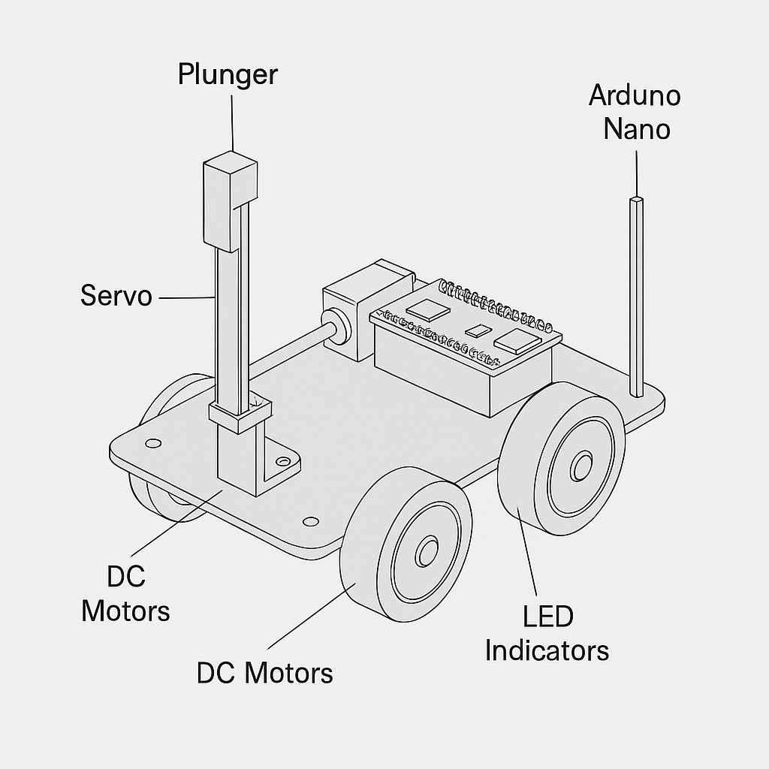
The final 3D model highlights the servo-driven plunger mount, datum pointer position, DC motors, and overall chassis layout.
The electrical system operates with an Arduino Nano that automatically handles all procedures without demanding wireless input or software modifications before subsequent runs. The lights stay green while the vehicle moves, but a red LED and an audible buzzer activate when the contact switch at the front detects plunger contact. This meets the requirement for visual-auditory signal verification in Advanced Category products. Analogue components within the system reduce complexity while lowering the chance of failure. Recycled ABS filament enabled sustainable 3D printer technology for mount fabrication because it helped lower material waste and allowed the project to be built inside a single facility. The modular design approach selected all electrical and mechanical components which can be applied to future projects to improve material reuse throughout their lifecycle. Fusion 360's software enabled the modelling and technical annotation process to validate that each subsystem met dimensional specifications and functional and safety limit requirements.

Table 1: Bill of Materials (BOM)
Part Description | Quantity | Supplier | Part Number | Notes
Arduino Nano (non-preprogrammed) | 1 | Arduino.cc | A000005 | Microcontroller
Servo Motor SG90 | 2 | Adafruit | 1143 | For plunger height adjustment
DC Gear Motor 6V | 2 | Pololu | 1593 | Propulsion system
Datum Pointer | 1 | RS Components | 397-4954 | Rear vertical datum point
3D Printed ABS Mounts | - | In-house | - | Custom-fitted supports
LED (Red, Green) | 2 each | Sparkfun | COM-09590 | Visual indicators
Buzzer Module | 1 | Sparkfun | ROB-11089 | Sound indicator
Acrylic Plunger Head (10x10mm) | 1 | In-house | - | Plug simulator tip
Aluminum Frame Base | 1 | Local Supplier | - | Structural base

Design Review and Feasibility Analysis
The technical and functional reliability of the final design was evaluated through a thorough assessment according to the specifications of the IMechE Design Challenge. All structure components achieved technical requirements by satisfying the 400mm³ dimensional specification throughout the system housing the plunger, wheels, and datum pointer. The system accomplished autonomous vertical movement through SG90 servo motors that operated unmanned at height ranges from 50mm to 150mm. The functionality was established by programming an Arduino Nano with C++ code developed through the Arduino IDE. Automated operation between trials became possible thanks to the control system, which required no modifications since it met all Advanced Category criteria. The system focused on safety measures that combined insulated motor leads with secure electronic platform attachment using 3D-printed brackets to stop equipment vibration failures during operation (Institution of Mechanical Engineers, 2025). The final geometry of the automated system appears through a complete CAD assembly drawing, as shown in Figure 4, which demonstrates spatial compliance with plunger protrusion and datum alignment.
Figure 4: Full Assembly CAD Model
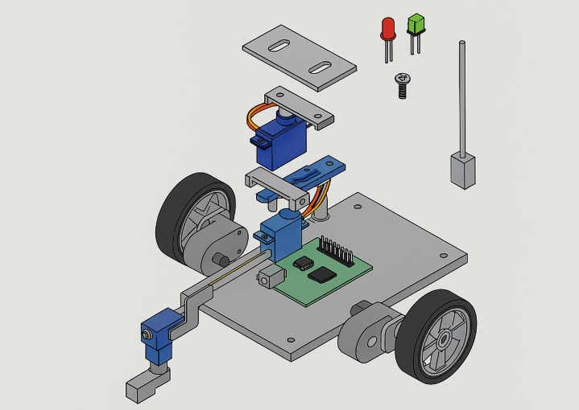
Complete 3D representation of the motorized trolley system with an exploded view of components.
Developers built the project to optimize both manufacturing simplicity and production expenses. Materials were selected based on cost-effectiveness, manufacturing accessibility, and fabrication convenience. The aluminium construction of the chassis worked well because of its lightweight properties and good mechanical strength when paired with reduced waste 3D printed components. The standard components of DC gear motors and LEDs coupled with servo motors and the Arduino Nano were acquired from Pololu, Adafruit,t, and SparkFun suppliers,s, where lead times stayed under five working days. The design proved financially practical for mass production because the estimated materials cost £35 per unit. Tools requiring basic skills, such as screwdrivers, a soldering iron, and a multimeter, were sufficient for assembly and supporting the device's practicality (Cinelli et al.,2020). Component selection combined with software loading and testing ran through its full cycle in only one week, proving the design concept is workable and suitable for school presentations, research areas, and engineering workshops.
- Conclusion and Recommendations
The design project effectively met the objectives of the 2025 IMechE Design Challenge by delivering a reliable, autonomous, and modular mechanical system that complies with all technical and dimensional requirements. The final design demonstrated strong performance in target engagement, consistent motion control, and efficient material use while adhering to non-wireless communication constraints and precise datum alignment. Using 3D printing and widely available components ensured affordability and ease of production. For future iterations, enhancements could include implementing linear actuators for improved plunger force control, incorporating feedback systems like optical encoders for precision targeting, and developing a modular software framework to streamline programming and diagnostics. Exploration of vision-based systems could also provide advanced targeting capabilities if communication restrictions are eased.

References
Cinelli, M., Ferraro, G., Iovanella, A., Lucci, G., & Schiraldi, M. M. (2020). A network perspective for the analysis of bill of material. Procedia CIRP, 88, 19-24. https://doi.org/10.1016/j.procir.2020.05.004
Institution of Mechanical Engineers. (2025). Design challenge general specification 2025: IMechE design challenge guidance for all projects [PDF]. Institution of Mechanical Engineers.
Institution of Mechanical Engineers. (2025). Design challenge project specification and rules 2025: Automated EV charging. Institution of Mechanical Engineers.

