

PERFORMANCE ANALYSIS OF UNITY’S MACHINE LEARNING AGENTS, UNITY’S NAVIGATION MESH AND A BESPOKE ASTAR IMPLEMENTATION WHEN PATHFINDING THROUGH A DYNAMIC AND CHANGING ENVIRONMENT

By: James Millns

Supervisor: Tim Bashford
Second Marker: Gordon Dickers

Project submitted as part of the requirements for the award of BSc(Hons) Computing (Software Engineering) with a Year in Industry

April 2021

Declaration FORM AND FORM OF CONSENT
DECLARATION

I, James Millns declare that I am the sole author of this Project; that all references cited have been consulted; that I have conducted all work of which this is a record, and that the finished work lies within the prescribed word limits.

This work has not previously been accepted as part of any other degree submission.


Signed: .............................................

Date: .......20/04/2021.......................

FORM OF CONSENT

I James Millns hereby consent that my Project, submitted in candidature for the BSc(Hons) Computing (Software Engineering) with a year in industry degree, if successful, may be made available for inter-library loan or photocopying (subject to the law of copyright), and that the title and abstract may be made available to outside organisations.

Signed: .............................................

Date: .......20/04/2021.......................

ABSTRACT
Artificial Intelligence has been a growing field of study since its inception during 1943 with Alan Turing’s Enigma Code cracking computer [1]. It has grown to the point where modern Artificial Neural Networks can be trained to perform increasingly complex tasks [2]. This project aims to test whether an Artificial Neural Network can be applied to the pathfinding problem in a meaningful way, whereby it performs comparatively to more deterministic pathfinding solutions and algorithms.
The MLAgents framework library in the Unity Game Engine gives developers the ability to design and implement Artificial Neural Networks and use Reinforcement Machine Learning to train the network to perform a task [3]. This project aims to use said framework to implement a solution capable of testing whether an Artificial Neural Network is a capable solution to the pathfinding and navigation problem by comparing its accuracy and efficiency performance to that of more conventional pathfinding and navigation solutions.
In the solution it was found that the MLAgents implementation managed to perform comparatively to Unity’s built-in navigation system, NavMesh, but was outperformed by the A-Star algorithm implementation. The results supported the hypothesis that a Neural Network can be used to navigate a dynamic and changing environment.

Contents

Declaration FORM AND FORM OF CONSENT i
ABSTRACT ii
Contents iii
Table of Figures v
Table of Tables vii
Table of Definitions viii
1 Introduction 9
1.1 Aims 10
1.2 Objectives 11
1.3 Structure of the Report 12
2 Research and Review of Literature 13
2.1 Artificial Intelligence 13
2.1.1 Historical Milestones 13
2.1.2 Artificial Decision Making 18
2.1.3 Artificial Neural Networks 23
2.2 Machine Learning 28
2.2.1 Supervised Learning 28
2.2.2 Unsupervised Learning 30
2.2.3 Reinforcement Learning 31
2.3 Pathfinding and Navigation 32
2.3.1 Dijkstra’s Algorithm 32
2.3.2 A-Star Algorithm 34
2.4 Available Game Engines 35
2.4.1 GoDot 35
2.4.2 Unreal Engine 4 36
2.4.3 Unity 37
2.5 Conclusion 41
3 Research and Development Methods 42
3.1 Research Overview 42
3.1.1 Philosophy 42
3.1.2 Approach 42
3.1.3 Strategies 42
3.1.4 Deliverables 42
3.2 Development Overview 43
3.2.1 Methodology 43
3.2.2 Time Management Plan 45
3.2.3 Required Resources 47
3.2.4 Deliverables 48
3.3 Conclusion 49
4 Design and Implementation 50
4.1 Problem Formulation 50
4.2 Design 51
4.3 Implementation 56
4.4 Conclusion 63
5 Results and Analysis 64
5.1 Results 64
5.2 Analysis of Accuracy and Efficiency 66
5.3 Conclusion 73
6 Evaluation 74
7 Conclusions and Recommendations 75
7.1 Summary 75
7.2 Conclusion 76
7.3 Recommendations for Further Research and Development 77
8 Reflection 78
References 79
Appendices 90
A-Star Pie Charts 90
NavMesh Pie Charts 98
ANN Pie Charts 105
Comparison Graphs 112
Results 117
Implementation 118

Table of Figures
Figure 1: Military Enigma Machine as displayed at Museo Scienza e Tecnologia Milano, Italy 13
Figure 2: Example Conversation with Eliza [11] 14
Figure 3: Shakey the Robot in its display case at the Computer History Museum. 14
Figure 4: BigDog from DARPA Strategic Plan [23] 16
Figure 5: Go Board [27] 16
Figure 6: Sophia in 2018 17
Figure 7: Example of a fuzzy set [38]. 19
Figure 8: Conceptual implementation of fuzzy logic in an automatic braking system [37]. 19
Figure 9: Evolutionary Computation steps [45]. 20
Figure 10: Framework of a Simple Reflex Agent [50] 21
Figure 11: Comparison of biological and artificial neuron [53]. 23
Figure 12: McCulloch-Pitts Neuron [57]. 24
Figure 13: Schematic of Rosenblatt’s Perceptron [59] 24
Figure 14: Heaviside Step Function [61] 25
Figure 15: Sigmoid Function [63] 25
Figure 16: Hyperbolic Tangent [64] 26
Figure 17: ReLU function [63] 26
Figure 18: Multi-layered neural network [60] 27
Figure 19: Example Regression Model [73] 28
Figure 20: Gradient Descent Example [79] 29
Figure 21: Supervised Learning versus Unsupervised Learning [80] 30
Figure 22: Example Cluster Analysis [84] 30
Figure 23: Example Reinforcement Learning model [89] 31
Figure 24: Example Q-Learning setup [85] 31
Figure 25: Dijkstra’s Algorithm used on example graph [94]. 32
Figure 26: Priority Queue Data Structure [97]. 33
Figure 27: Euclidian and Manhattan Distance comparison [101]. 34
Figure 28: GoDot User Interface. 35
Figure 29: Unreal Engine Blueprint system example [109]. 36
Figure 30: Unity User Interface [114]. 37
Figure 31: Visual overview of Unity Navigation Mesh [118]. 38
Figure 32: Unity's MLAgent Virtual Learning Environment Interface [123] 39
Figure 33: Examples of MLAgents being used within Unity [124]. 39
Figure 34: Chosen Development Methodology Flowchart. 43
Figure 35: Trello Kanban board [135]. 44
Figure 36: Time Management Gantt Chart 46
Figure 37: Design Kanban Board 51
Figure 38: Design Environment Kanban Card 52
Figure 39: Implement NavMesh Kanban Card 52
Figure 40: Implement A-Star Kanban Card 53
Figure 41: Implement ANN Kanban Card 54
Figure 42: Create Test Harness Kanban Card 54
Figure 43: Test Implementation Kanban card 55
Figure 44: Analyse Results Kanban Card 55
Figure 45: Base Environment Design 56
Figure 46: NavMesh Environment 56
Figure 47: A-Star Environment 57
Figure 48: ANN Environment 58
Figure 49: ANN Training Farm 59
Figure 50: First training session with 0 obstacles 60
Figure 51: Second training session with 1 obstacle 60
Figure 52: Third Training Session with 2 obstacles 60
Figure 53: Fourth Training Session with 4 obstacles 60
Figure 54: Fifth Training Session with 8 obstacles 61
Figure 55: Sixth Training Session with 16 obstacles 61
Figure 56: Seventh Training Session with 20 obstacles 61
Figure 57: Basic Testing Harness 62
Figure 58: Testing At Five Obstacles 62
Figure 59: Testing At Twenty Obstacles 62
Figure 60: A-Star Performance Benchmarks (Full results available in appendix) 66
Figure 61: NavMesh Performance Benchmarks (Full results available in appendix) 67
Figure 62: ANN Performance Banchmarks (Full results available in appendix) 68
Figure 63: Success Rate Comparison (Full results available in appendix) 69
Figure 64: Reward Rate Comparison (Full results available in appendix) 70
Figure 65: Step Rate Comparison (Full results available in appendix) 71
Figure 66: Adjusted Step Rate Comparison (Full results available in appendix) 72

Table of Tables
Table 1: Symbolic Logic Operators 18
Table 2: Example Compound Statement Truth Table Definitions. 18
Table 3: A-Star Statistics 64
Table 4: NavMesh Statistics 65
Table 5: ANN Statistics 65

Table of Definitions

Acronym | Definition
ANN | Artificial Neural Network
AI | Artificial Intelligence
DARPA | Defence Advanced Research Projects Agency
ESport | Electronic Sport
NPC | Non-Playable Character
ReLU | Rectified Linear Units
MLP | Multi-Layer Perceptron
C# | C Sharp
FDD | Feature Driven Development
XP | Extreme Programming

Introduction
This section intends to outline the aims that are to be met through the project. The aims will be specific about the hypothesis of the project. They will detail the measures that will be used to determine the success of the implementation. They will outline what needs to be attained to complete the project. They will be realistic as to avoid any over scoping.
The objectives that will be used as steppingstones to reach the aims will be detailed. These objectives will also be specific, measured, achievable, realistic, and timed (SMART).
Finally, a structure plan of the report will be discussed to outline the planned journey through the project to determine the validity of the initial hypothesis identified in the aims section.

Aims
The Hypothesis of the project is it is possible to make an Artificial Neural Network (ANN) based pathfinding artificial intelligence (AI) that can navigate a path through a dynamic and changing environment with similar performance to more deterministic algorithm-based pathfinding solutions.
The ANN should be able to read information from its surroundings to make decisions in real time to navigate a path through to a target location in a comparable time to an algorithm-based pathfinding solution.
The aim of the project is to design, develop, train and test such an AI to prove the validity of the hypothesis. To test the capabilities of the AI, multiple levels will be created each with increasing complexity to find if there are limits to its ability. If the finished implementation produces a pathfinding AI that can calculate the route to direct itself to the desired destination in under a second, then it will be considered a success.
Current literature on the topic needs be explored to investigate the mechanics behind AI and more specifically pathfinding techniques. This research will act as the backbone of the project that will often be referred to when evaluating the requirements and when developing and improving the solution.
Once completed, the results of the AI’s ability to meet the requirements will be analysed and an evaluation of the validity of the initial hypothesis will be made, whether it is true or false.

Objectives
- Research and investigate the mechanics that drive artificial intelligence, drawing a focus to the method in which to implement a pathfinding AI into a game which runs in real time. This needs to be completed by the 25th of February 2021.
- Design a set of puzzle levels that will increase in difficulty and complexity to test the capability of the AI to navigate through in real time. This will be an ongoing task through the development but needs to finish by the 15th of March 2021.
- Experiment with available software and learn how to efficiently use it to create a suitable prototype which can potentially perform the task. This needs to be done at the start of the development cycle.
- Develop a capable solution that is based off the initial prototype and the initial requirements, using a development methodology that lends itself to the restrictions of the project’s resources. This needs to be finished by the 31st of March.
- Test the finished AI’s performance and analyse the accuracy and efficiency results to get an indication of the validity of the initial hypothesis. This needs to be finished by the 15th of April 2021.
- Evaluate the process taken to test the initial hypothesis and conclude whether it be true or false, with any recommendations for future improvements. This needs to be finished by the 23rd of April 2021.
- Document all findings and results in an appropriate academic fashion for marking and future reference purposes. This needs to be finished by the 23rd of April 2021.

Structure of the Report
The report will follow the structure outlined below: -
- Introduction to the projects aims and objectives including a hypothesis that will be tested.
- Research and Review of literature that will look at relevant and trusted sources with the aim to perform an in-depth comparison and discussion into the mechanics of artificial intelligence.
- Research methodology that will outline the adopted research philosophy, the approach that will be used, the strategies that will be followed and the deliverables that will be produced.
- Development methodology that will outline the chosen development workflow, the time management plan, the resources required to complete the project and the deliverable that will be produced.
- Documentation of the design and implementation of the project, including initial specifications and requirements and screenshots of the development process.
- An analysis of the accuracy and efficiency results of the game to determine the validity of the initial hypothesis.
- Evaluation of the overall process taken with a conclusion of the success of the game and recommendations for further development and improvement.

Research and Review of Literature

Artificial Intelligence

Historical Milestones
During 1943 in the middle of World War II, British mathematician and computer science pioneer, Alan Turing developed a machine that helped crack the Enigma code after the Germans increased the security of their messages by changing the encryption cipher daily [1][4].
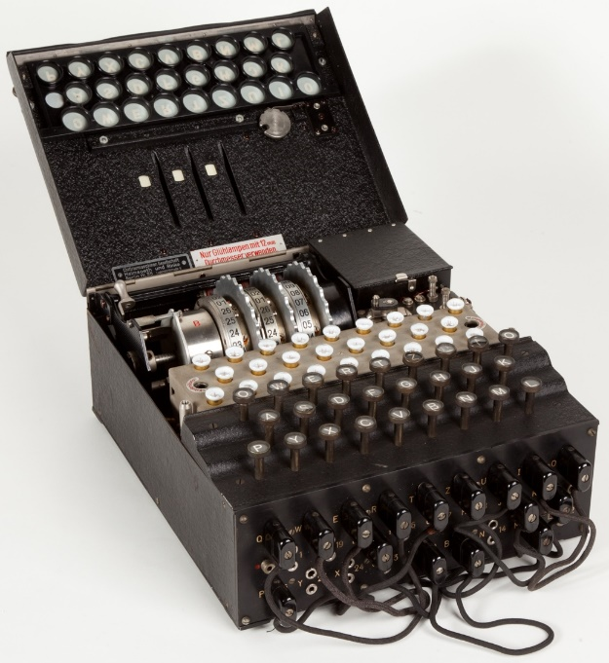
Figure 1: Military Enigma Machine as displayed at Museo Scienza e Tecnologia Milano, Italy
Turing was instrumental in laying the groundwork for computing in the modern day, while also setting the stage for Artificial Intelligence and decision making. In 1950, Turing conjured the imitation game, now more popularly known as the Turing Test, a method to test a machines ability to show intelligent behaviour; if it can act in a way that is equivalent to, or undistinguishable from human behaviour from the perspective of another human, then it can be considered intelligent [5].
In early years, the study of using computer systems to imitate human intelligence was vaguely referred to as “Automata studies”. It was not until summer 1956 that computer scientists J. McCarthy, M. Minsky, N. Rochester, and C. E. Channon coined the term “Artificial Intelligence” in a proposal for the Dartmouth conference. This conference resulted in the academic field of AI being recognised and legitimised [6].
Backpropagation is at the core of modern machine learning and will be discussed further in this report, but it was first conceptualized during the early 1960s, having many researchers independently discovering the method. H. J. Kelley and A. E Bryson first derived the basics from Control Theory independently in 1960 and 1961 respectively [7][8] with S. Dreyfus then publishing a simpler method based on the chain rule in 1962 [9].
J. Weizenbaum created the first autonomous chat bot, ELIZA, between 1964-1966. He created ELIZA to demonstrate that conversations between humans and machines can appear to be real or true on the surface, but when examined more closely can be reduced to an input output system. ELIZA was designed to play the part of a psychiatric doctor conducting an interview with a patient. Weizenbaum insisted that the program had no real intelligence or knowledge, but instead was just a program which reflected the users statements back to them, but to his surprise, many early users found it difficult to distinguish ELIZA from a real human, making ELIZA one of the first programs capable of taking the Turing Test [10][11].
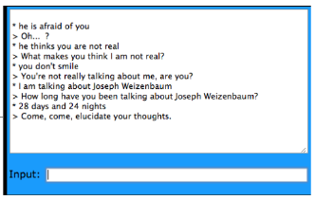
Figure 2: Example Conversation with Eliza [11]
During 1966-1972, DARPA funded a project to create the first general purpose AI, Shakey the robot, which had awareness of its surroundings and the ability to logically reason and make decisions in the limited environment it was programmed to interact with [12]. The operators would give Shakey commands via a terminal like “turn off the lights”, which would then prompt Shakey to scan the room, identify the light switch, find a path to the switch, to then turn it off to complete the mission [12].
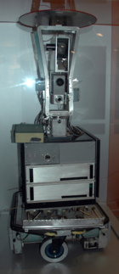
Figure 3: Shakey the Robot in its display case at the Computer History Museum.
In 1978 Texas Instruments released an educational toy called the “Speak & Spell” which was able to synthesise word pronunciation without the use of tapes or phonographs [13]. The device would use game cartridges which allowed users to play different spelling games like spelling a word the device said or hangman [13].
Commercialised AIs called “Expert Systems” saw a rise in the 1980s as they promised intricate decision-making skills on the same level as a human expert. Expert Systems enjoyed wide public interest ranging from Universities offering expert system specific courses, to two thirds of Fortune 500 companies incorporating the technology, to international interest from Japan and Europe. Unfortunately, the Expert Systems were so overhyped by enthusiasts, that it was impossible for it to live up to the hype, and subsequently saw a drop in popularity in the late 1980s-early 1990s [14], [15].
A major field of research in the AI field was that of game bots with it being easy to track the progress of the AI by observing its effectiveness in finding victory. Chess AI was given a lot of attention with programs dating back to the 1950s being able to best novice players [16]. It was not until the late 1980s that the field made the leap into the territory of the masters with chess master David Levy being bested by “Deep Thought” in 1989 [16]. The field saw even more improvement in 1996 with IBMs “Deep Blue” achieving the first single-game win versing the world chess champion Garry Kasparov [17]. While “Deep Blue” lost the game in 1996, a rematch in 1997 resulted in a win for “Deep Blue” causing controversy in the chess community after Kasparov suspected foul play on IBMs end [18], suggesting there may have been background human interference when saying the following:
“I suspect there were things in the match that were well beyond my understanding, and when a big corporation with unlimited resources would like to do so, there are many ways to achieve the result, and the result was achieved” Gary Kasparov 1997 [19]
2000-2010 saw a lot of advancements in AI. The public was challenged to consider the morality of AI with the release of the Stephen Spielberg’s movie “A.I. Artificial Intelligence” in 2001 depicting the story of a humanoid robot who instead of being programmed to improve itself was programmed to yearn for family and love [20]. 2002 saw the release of the Roomba, an automatic domestic vacuum cleaner robot capable of navigating its environment by using sensors and pathfinding algorithms [21] and in 2005 was the release of the BigDog, a quadrupedal robot which could traverse uneven surfaces while being able to support heavy payloads to assist human exploration [22].
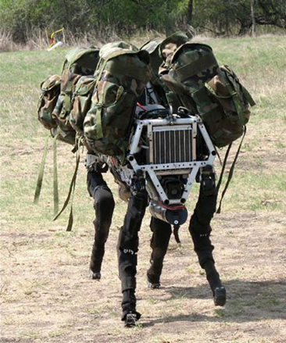
Figure 4: BigDog from DARPA Strategic Plan [23]
IBM continued to develop AIs capable of beating humans, and in 2010 and 2011 were able to beat two former “Jeopardy!” champions Ken Jennings and Brad Rutter with “Watson”, an AI that was fitted with advanced “Natural Language Processing” with the goal of understanding the question and returning a precise answer instead of just searching for a documented answer from a keyword [24].
2010 also saw the founding of “DeepMind Technologies”, currently one of the leading companies in AI research [25]. The company created neural networks capable of learning, which they applied to video games, designing them to learn in a similar fashion to how a human player would learn [26]. In 2014 they published research on computer systems capable of playing Go, a game like chess but with more complexity due to the larger number of possible moves available at any given time, (chess games lasting on average 40 turns with 30-40 average choices per turn [27], while Go games can last 150 turns with 250 average choices per turn [27]). In 2015 they beat the European Go champion Fan Hui with their “AlphaGo”, which is the first time an AI was able to defeat a Go Professional [27].
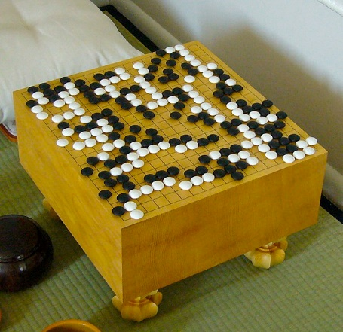
Figure 5: Go Board [27]
DeepMind also developed “AlphaStar”, an AI with the ability to play the real-time strategy game “Starcraft II”, a popular electronic sport (Esport) [28]. AlphaStar used a style of deep learning called “Reinforcement learning”, which involved playing against itself to improve its skills [28][29]. Early versions were able to beat professional players due to it having an unfair advantage against the human player, for example it had a wider range of view of the game allowing it to respond faster and it had the ability to make 1000s of micro decisions in a second while a human player could only make ~100 in a minute [28][29]. Later versions had the unfair advantages fixed so further improvements could be made, ending up with AlphaStar becoming the first AI to reach the top of the online ladder of a popular Esport [28][29].
In 2014, Vladimir Veselov, Eugene Demchenko and Sergey Ulasen developed an advanced chatbot that imitated the personality of a 13-year-old Ukrainian boy, which they called “Eugene Goostman” [30][31]. Eugene won the Turing Test competition at the Royal Society after 10 of the 30 judges were convinced that Eugene was a human, not a bot [30][31]. This was the first time an AI has been verified to pass the Turing test, although this has been met with some scepticism as to the validity of the Turing test as a true test of intelligence [30][31].
2016 saw the first appearance of the social humanoid robot “Sophia”, developed by Hanson Robotics [32]. Sophia was equipped with cameras, facial expression simulators and internal reasoning algorithms that allowed her, with the help of some pre-programmed responses, to partake in televised interviews [32]. In 2017 she became the first robot to receive citizenship of any country when Saudi Arabia granted her citizenship [32].
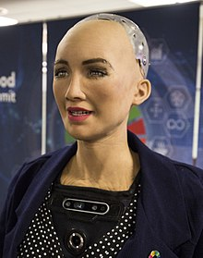
Figure 6: Sophia in 2018

Artificial Decision Making
The purpose of creating an artificially Intelligent system is to imitate human reasoning and decision making, albeit in a limited way [33]. There are a variety of paradigms that can be used to simulate decision making such as symbolic logic, fuzzy systems, evolutionary computing and intelligent agents [33].
Symbolic logic works by summarising Boolean statements as input symbols, for example the statement “My apple is red” can either be true or false, so would be written as ‘A’. Symbolic logic uses a plethora of Boolean logic operators to create compound statements which have their own truth tables. The operators are Negation, Conjunction, Disjunction, Implication and Equivalence [34].
Table 1: Symbolic Logic Operators
Operator symbols | Name | Read as | Explanation
¬ ~ ! | Negation | Not | The statement ¬A is only true when A is false.
∧ · & | Conjunction | And | The statement A ∧ B is only true when both A and B are true.
∨ + ∥ | Disjunction | Or | The statement A ∨ B is true when A or B (or both) are true.
⇒ → ⊃ | Implication | if … then … | The statement A ⇒ B is only false when A is true, and B is false.
⇔ ≡ ↔ | Equivalence | If and only if | The statement A ⇔ B is only true when A and B are the same.

Compound statements can be defined based on their truth table as tautological (unconditionally true), contradictory (unconditionally false) or contingent (conditionally true or false). Symbolic logic can be implemented to create semi-intelligent systems which can decide on outputs based on the inputs [35].
Table 2: Example Compound Statement Truth Table Definitions.
A | B | (A ⇒ B) ∨ (B ⇒ A)  Tautological example | (A ∧ B) ∧ (~A)  Contradiction example | ~A ∧ (A ⇒ B)  Contingent example
True | True | True | False | False
True | False | True | False | False
False | True | True | False | True
False | False | True | False | True

Unlike traditional logic systems which work off Boolean logic giving values of 1 (true) or 0 (false), Fuzzy systems calculate the gradient degree of membership (between 0-1) an element has to a set [36], [37]. An example of fuzzy logic is when considering the temperature of water without having a clear definition between hot and cold, instead having a fuzzy set where a temperature will have a degree of membership with each [36], [37].
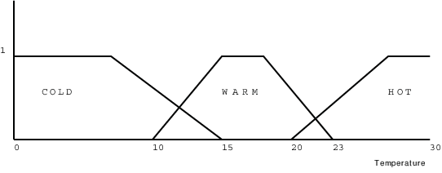
Figure 7: Example of a fuzzy set [38].
Fuzzy logic is useful in scenarios where a system needs to decide how much it wants to perform an action, for example, how much a car needs to break to keep a safe distance from a vehicle in front. In a Boolean system there would be a clear definition between close and far, and when the car detects it is close, it may hard brake [37], [39].
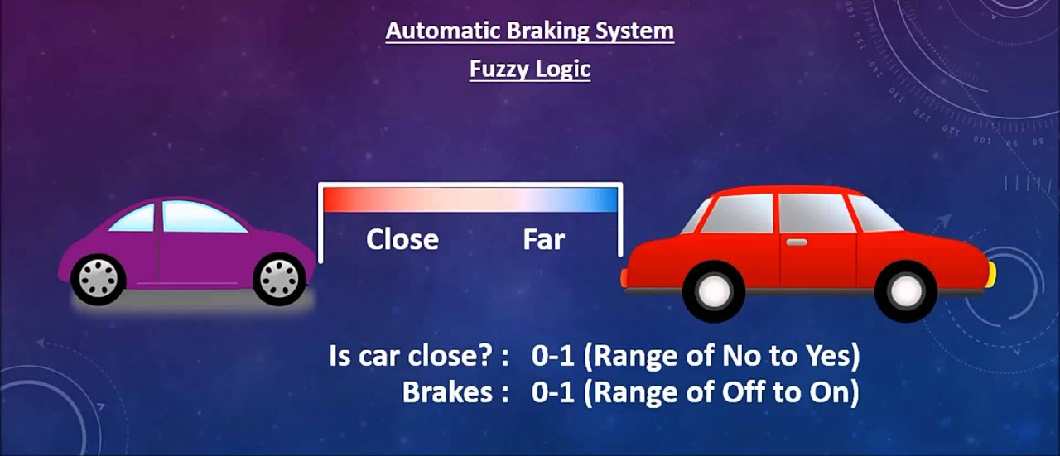
Figure 8: Conceptual implementation of fuzzy logic in an automatic braking system [37].
Fuzzy logic works by fuzzifying the input values into fuzzy membership functions, then perform the relevant rules in the rule set to calculate the fuzzy output functions and finally de-fuzzifying the output functions to calculate the crisp output [36], [37], [39], [40].

Evolutionary computation is a method of developing problem-solving algorithms which takes inspiration from nature and Darwin’s theory of evolution through survival of the fittest to approach an optimal solution [41]. Evolutionary computation has been applied to a variety of fields ranging from military and healthcare to video games and SMART home systems [41], [42].
It is a useful technology that can improve the design of a system or solution, which can make a big impact on the productivity and safety of others. One example being Dr Shanin Rostami who used it to develop a system which could detect whether a person was wearing a concealed weapon [43]. It is particularly useful in creating a system which has a preference towards a particular goal, for example a system which can gather as many collectibles as possible in a video game level [41], [43], [44].
Evolutionary computation can be broken down into five steps. The first being initialisation where it will generate a population of members with random attributes. The second is an evaluation step where each member of the population is tested against the problem and its “fitness” is evaluated based on how well it performed. The third is to decide whether to terminate the iteration based on if a goal has been met, the number of generations has reached a specific amount, or if the performance of the population has plateaued. The fourth step would be selecting half of the population, ideally the half which performed the best and then disposing of the worse half. The fifth step is a variation step which involves combining random attributes from the top performing members of the remaining population and then applying some random alterations to random new members that were “birthed” as this will then introduce new attributes in the population which may be beneficial. Once the fifth step is complete the second step will be performed again to evaluate the new population and so on [41], [43], [44].
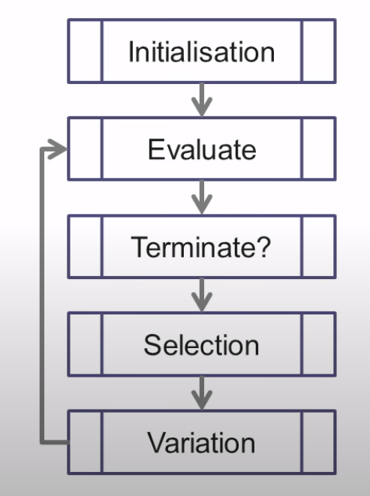
Figure 9: Evolutionary Computation steps [45].
An agent refers to an entity which has preceptors feeding it information of its environment and can interact with and/or alter its environment with actuators allowing it to act independently [46], [47]. An intelligent agent, in the context of artificial intelligence, is an artificial agent that aims to act in its environment to fulfil a specified goal that it has been given, for example, a Roomba will review its environment for any dirt to clean to reach the goal of having a dirt-free environment [46], [47].
There are five main types of intelligent agents: Simple reflex agents, model-based reflex agents, goal-based agents, utility-based agents and learning agents [46], [48]. Simple reflex agents act only based on what its current percept is at any given time without having a memory of its percept history [46], [48]. A model-based reflex agent can retain a memory of its previous perceptions which it can use to create an internal model of its environment without it being fully observable at any given time [46], [48].
A Goal-based agent is a further extension of the model-based category where, in addition, it uses “goal” information to make a desirable change to its environment [48], [49]. Utility-based agents further build on goal-based agents, but instead of only looking a “goal state”, it can further predict how preferable that state would be if it made the change with a utility function, indicating how “happy” the agent would be with that environment [48], [49].
Learning agents instead begin in an unknown environment where it can gain knowledge and learn how to best interact with its environment, leading to more efficient actions compared to its initial knowledge [48], [49].
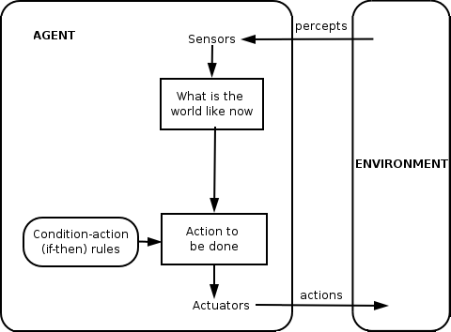
Figure 10: Framework of a Simple Reflex Agent [50]
Intelligent agents have a wide scope of applications, from real world robotic solutions to software solutions [48], [49], [51]. Some examples being self-driving cars, satellite navigation units, AI assistants like Apple’s Siri and Microsoft’s Cortana and video game non-playable characters (NPCs) [48], [49], [51].

Artificial Neural Networks
Artificial Neural Networks (ANNs) are an input-output machine which estimates to the best of its ability which output to give depending on the input it was given [2], [52]. The architecture of an ANN mimics that of a brain in the sense that a brain consists of cells with branching tendrils connecting to other cells forming synapses and in an ANN there are layers of nodes which connect to other nodes forming synapses, in both systems the node/cell of any given layer will only give an output if the inputs it has received from the nodes/cells in the previous layer meet the criteria for it to “fire” [2], [52].
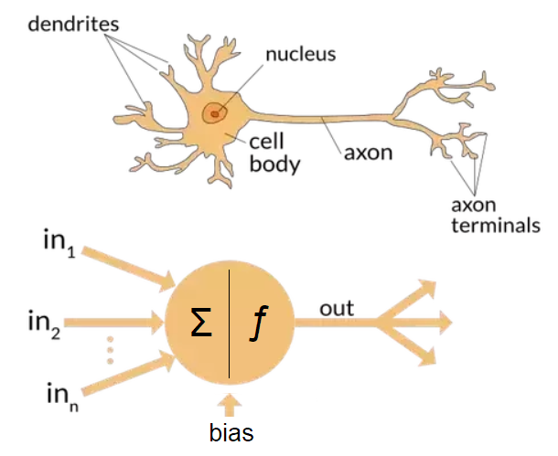
Figure 11: Comparison of biological and artificial neuron [53].
ANNs are used for their ability to learn how to perform their function based on the sample inputs it has been given [2], [52], [54]. The applications of neural networks are essentially limitless if applied correctly, some of their strengths include their ability to reasonably produce an output for an input it has not been shown before, recognising patterns so they can classify objects, and extracting features from incomplete or low-resolution inputs [2], [52], [54].
The first ANNs were conceptualised in 1943 by Warren McCulloch and Walter Pitts, dubbed the McCulloch-Pitts Neuron [55], [56]. The McCulloch-Pitts Neuron worked by receiving inputs which were separated into two groups, Excitatory inputs and Inhibitory inputs, where if the sum of all the excitatory inputs were greater than a threshold value and none of the inhibitory inputs were active, then the neuron would fire [55], [56].
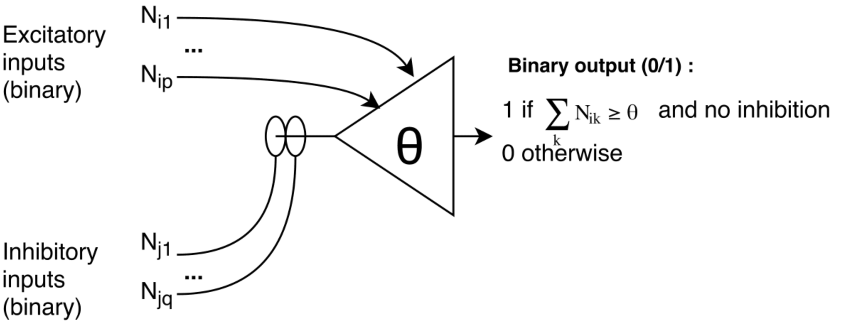
Figure 12: McCulloch-Pitts Neuron [57].
The main disadvantage of a McCulloch-Pitts neuron is its lack of ability to learn due to the fact the inputs it receives, from both excitatory and inhibitory, are in binary. If the inputs were a gradient instead, they could be adjusted to perform a task more efficiently, but due to their binary nature there is no way to train an ANN comprised of them [55], [56].
In 1957, Frank Rosenblatt published a paper introducing his variant on the McCulloch-Pitts neuron, the Perceptron, which instead of using binary inputs and outputs used weights associated with the inputs [58].
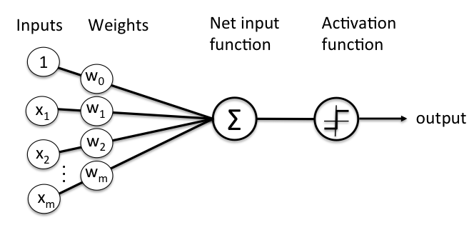
Figure 13: Schematic of Rosenblatt’s Perceptron [59]
With the introduction of the perceptron came the perceptron learning rule, a method devised to train the perceptron to improve its internal biases and weights to learn how to produce more accurate outputs. The rule works by first initialising the weights of the ANN to either 0 or small random numbers, then for each training sample calculating the output value, and then based on the outputs, adjusting the weights to give a more accurate answer [59].

The activation function defines the output of the node. How the activation function is calculated, and its output can give variance to the learning efficiency of the network when working with a gradient descent algorithm like backpropagation. A step function which is either 0 or 1 before and after a threshold does not lend itself to learning through gradient descent as there is no gradient [60].
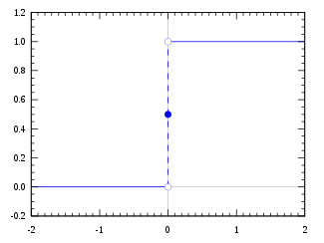
Figure 14: Heaviside Step Function [61]

The sigmoid function is often used as the activation function as it exists between 0 to 1. This makes it especially useful when applied to problems which need a prediction of probability as an output. Another advantage that sigmoid has is the fact it is differentiable, meaning the slope can be found on the curve at any two points. This allows for learning through gradient descent. The issue with sigmoid is the gradients for large and small numbers is saturated, becoming almost parallel with the x-axis making gradient descent difficult. Also, the issue of it not being zero-centred can give gradient descent difficulty differentiating between positive and negative inputs [62].
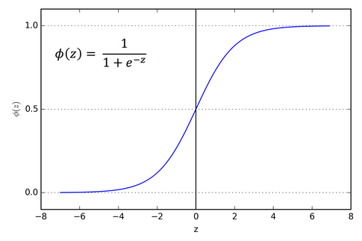
Figure 15: Sigmoid Function [63]
Tanh or hyperbolic tangent is another activation function that is like sigmoid with an improvement of existing between -1 and 1. The main advantage is that negative inputs will give negative values that can be mapped as strongly negative, while positive inputs will be mapped positively. The caveat is that Tanh, like sigmoid, also suffered from gradient death when values become very large or small [2], [62], [63].
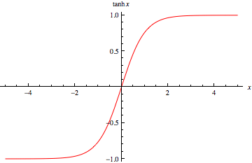
Figure 16: Hyperbolic Tangent [64]
An approach used to solve the gradient death exhibited by sigmoid and Tanh was the introduction of the rectified linear units (ReLU) function, which acts like a linear function better allowing for gradient descent, while also being nonlinear allowing for complex relationships in the data to be learned [65].
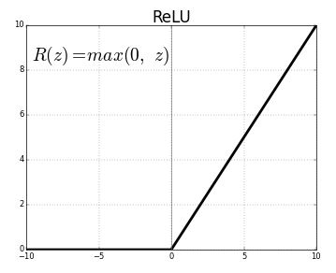
Figure 17: ReLU function [63]

With the advantage of having weighted inputs, the perceptron can improve itself to perform more optimally to a specific task, making it more valuable than the McCulloch-Pitts neuron. The issue arose during the time of its origination, where Rosenblatt oversold his idea. The over hype of the concept ended up in it gaining unrealistic expectations from the computer science community and media, leading to losing popularity when people were disappointed by the limited application and functionality [52]. The Perceptron was further criticised in 1969 when Marvin Minsky and Seymour Papert published the book Perceptrons: an introduction to a computational geometry, which demonstrated how limited the perceptron was with its inability to learn the logical XOR function [66].
Since the defamation of the perceptron in 1969, it has since been shown that the issue was a symptom of being a single layer perceptron which can be remedied by including additional neurons to form a multi layered network which can learn how to achieve an XOR logical function [2].
Multi-layer perceptron (MLP) networks have since been used to perform more complex problems and are still used today. Some examples include image recognition and classification, speech recognition and machine translation software [52].
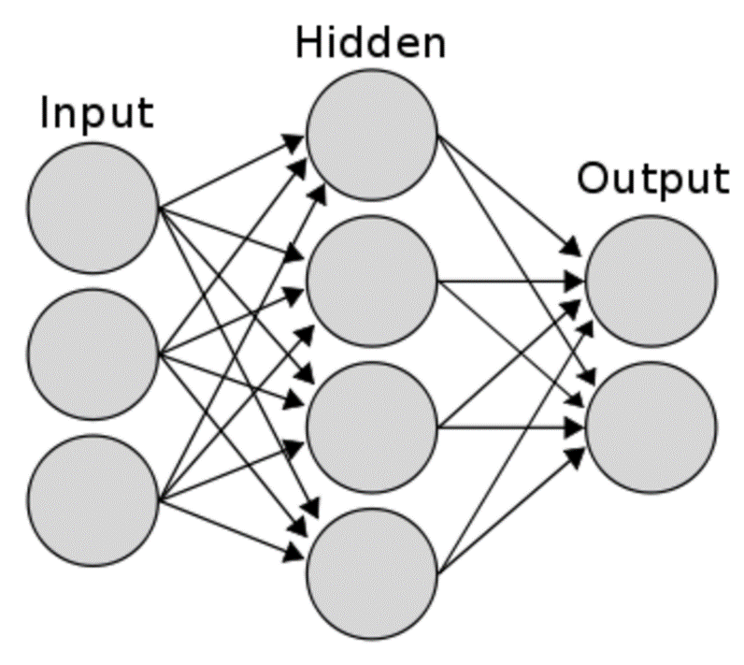
Figure 18: Multi-layered neural network [60]
A modern technique of training a neural network is backpropagation which is a type of deep learning algorithm that uses labelled data sets to teach the network through gradient descent. This is especially useful in examples where the network needs to be trained to classify data and recognise patterns [2], [67], [68]. The backpropagation algorithm is too complex to explore in detail in this paper, however M Nielsen summarised the algorithm below: -
“At the heart of backpropagation is an expression for the partial derivative ∂C/∂w of the cost function C with respect to any weight w (or bias b) in the network.” – Michael Nielsen [2]

Machine Learning

Supervised Learning
Supervised learning is an approach to machine learning that aims to train an AI system to detect underlying patterns and relationships between data. It works by giving it labelled input data and the expected output result. This tells the AI system what it should be looking for when making decisions so it can improve its answers to give adequate outputs when presented with new, previously unseen data [69]–[72].
Linear Regression is a type of supervised learning that aims to predict the behaviour of data based on specific variables of that data. The variable that is to be predicted is the “dependent variable”. The variable that is used to predict the other variable is the “independent variable”. The algorithm attempts to find a relationship line between the two variables. It does this by using observations of the dependent data when the independent data changes. It then fits a regression line to the data by using the least squares method. The least squares method works by minimising the difference, or errors, between the estimated values of the regression line to their respective actual values [73], [74].
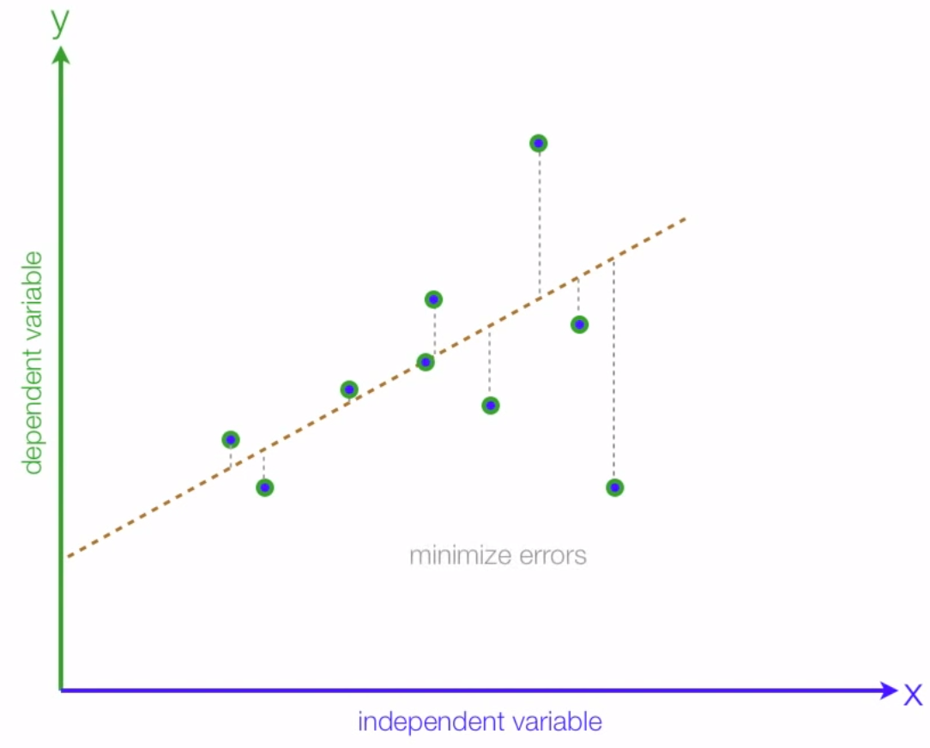
Figure 19: Example Regression Model [73]

Gradient Descent is an iterative machine learning algorithm that searches for a local minimum in a search space or differentiable function. It achieves this by repeatedly taking steps opposite to the steepest gradient of the current point. Gradient Ascent does the same but instead searches for a local maximum by taking steps in the direction of the steepest gradient. The size of the steps taken each iteration is referred to as the “learning rate”. When the learning rate is too high, the risk of overshooting the local optimum is high. When the learning rate is too low, the algorithm becomes very time inefficient as it must recalculate the gradient at each step. A disadvantage of gradient optimising is it can become stuck in a local optimum that may not be the most optimal solution. Another issue can be caused when there is little to no gradient at the current position, making it difficult for the algorithm to decide which should be the best direction to move [75]–[78].
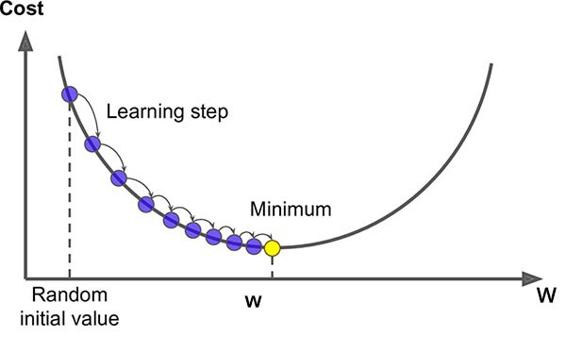
Figure 20: Gradient Descent Example [79]

Unsupervised Learning
Unsupervised learning is a subset of machine learning, where the AI is exposed to a dataset which has no labels or tags for the data. The goal for the AI is to interpret the data by grouping instances with similar attributes. This approach attempts to identify any patterns or relationships that may exist in the dataset [80], [81].
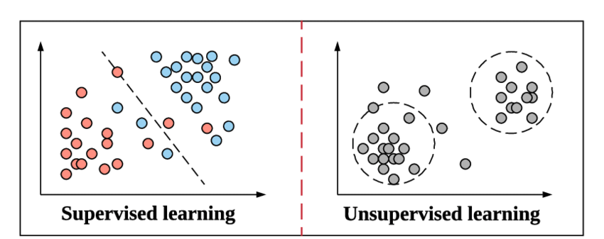
Figure 21: Supervised Learning versus Unsupervised Learning [80]
Clustering or cluster analysis is one main method of unsupervised learning, whereby the dataset is organised into groups or segments based on instances with shared attributes. With the common attributes identified, the AI then analyses new data which has or does not have those same commonalities to detect any outlying data that may not fit into either group [82], [83].
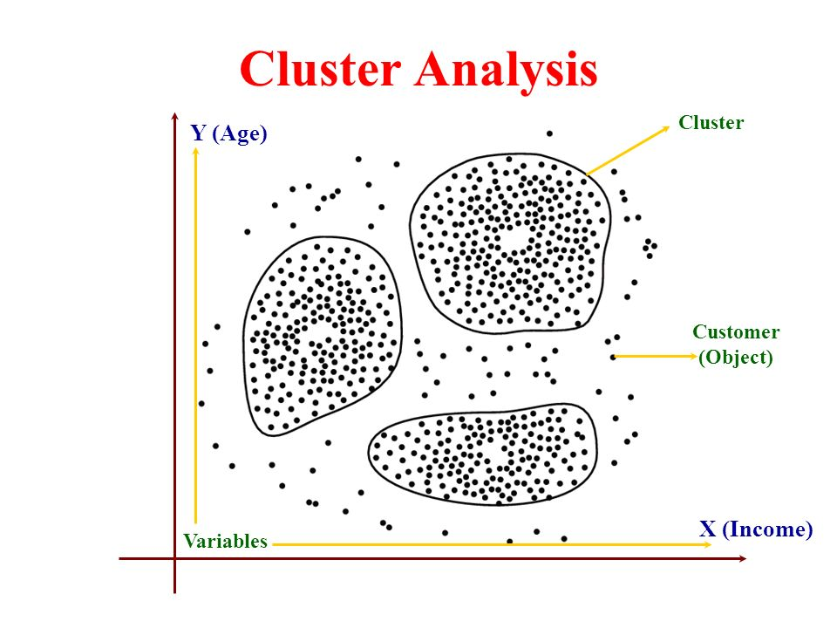
Figure 22: Example Cluster Analysis [84]

Reinforcement Learning
Reinforcement learning is a subset of machine learning that aims to train an intelligent agent by giving it the task of maximising a reward metric. Reinforcement learning differs from supervised learning in that it does not require labelled data to learn, or for any incorrect or sub-optimal behaviour to be corrected. Instead, it works by taking actions inside its environment to create a model of which actions are beneficial or harmful to the reward score given to it by an observer. This method allows the agent to learn which actions are preferable to take to maximise its reward [85]–[88].
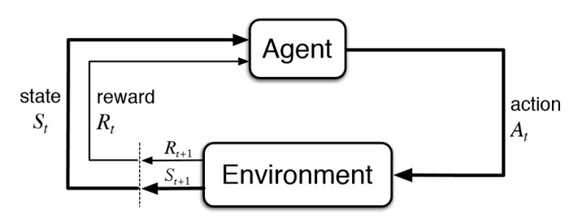
Figure 23: Example Reinforcement Learning model [89]
Quality learning or Q-learning is a reinforcement algorithm that learns the quality of the actions it can take at a given state within its environment. It works by iteratively exploring its environment, noting the rewards gained from taking each action within the states it progresses through. It uses this information to build a model of its environment which it can later exploit to maximise its reward. An important issue to consider when implementing a Q-Learning system is deciding when to explore or exploit, as if the agent only exploited then it may dedicate itself to performing the same set of actions, when other actions may end up with better rewards. To combat this, the epsilon-greedy strategy can be used where a decaying probability determines whether the agent will choose to explore or exploit at any given state [87], [90], [91].
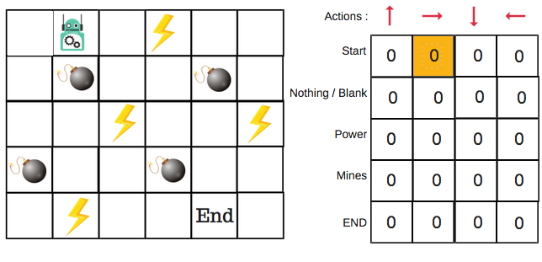
Figure 24: Example Q-Learning setup [85]

Pathfinding and Navigation

Dijkstra’s Algorithm
Dijkstra’s algorithm is a pathfinding algorithm used to find the shortest path from one node to all other nodes in a graph. It was invented by Edsger Dijkstra in 1956 [92], [93].
The algorithm takes the following steps:-
- fixing a single node as the start point, then adding all other nodes to the unvisited set.
- All nodes are then assigned a provisional distance value, the start node is set to zero and the other nodes are initialised to infinity.
- The start node is then set as the current node to initialise the algorithm.
- It then iterates the following.
  - look at all the adjacent unvisited nodes to the current node and add their distance to the current nodes provisional distance. If the new value for that node is lower than its current provisional value, replace is with the lower value.
  - When all adjacent nodes have been checked, mark the current node as visited and remove it from the unvisited set.
  - If a goal node has been marked as visited, or there are no unvisited nodes remaining, or the lowest provisional value of the unvisited nodes is infinity, then end the algorithm.
  - Otherwise, make the node with the lowest provisional value the next current node.
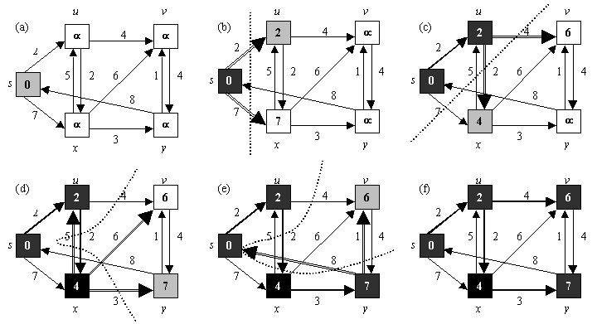
Figure 25: Dijkstra’s Algorithm used on example graph [94].

Dijkstra’s algorithm is a greedy algorithm, in that it will choose the most optimal local choice at any time, when it may find the globally optimal choice if it chose differently. The algorithm does not take an optimal path to find the shortest path, instead it explores its surroundings until it terminates by finding a pre-set goal or running out of nodes to visit [92], [95], [96].
In terms of Big-O notation, the following can be said:
The algorithm’s time complexity upper bound is O(|E|+|V|log|V|) where |E| is the number of edges and |V| is the number of vertecies [92], [93], [95], [96].
The algorithm’s space complexity upper bound is O(|V|^2), which can be improved to O(|E|log|V|) if a priority queue is used [92], [93], [95], [96].
A priority queue is an abstract data type that functions similarly to a normal queue except each element has a priority. The priority of the elements determines the order in which the elements are removed from the queue [92], [93], [95], [96].
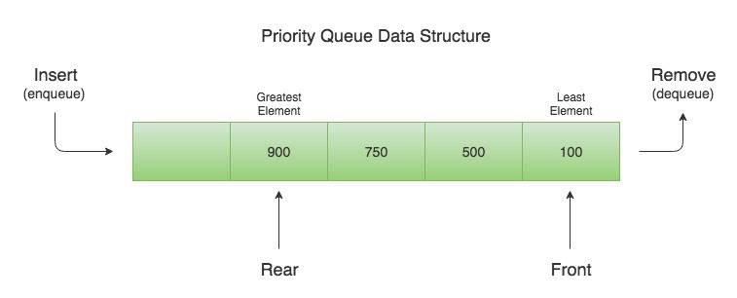
Figure 26: Priority Queue Data Structure [97].

A-Star Algorithm
The A-Star algorithm was first invented in 1968 by P Hart, N Nilsson and B Raphael as a path planner for the “Shakey” Project [98]. It is a searching algorithm which explores a graph much like Dijkstra’s to find the shortest path from an initial node to a target node. It differs by the fact it is an informed search, whereby it uses a heuristic value at each node to determine the priority of the nodes to visit. This heuristic is often the Euclidean or Manhattan distance the current node is from the target node [98]–[100].
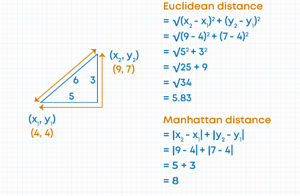
Figure 27: Euclidian and Manhattan Distance comparison [101].
A-star, like Dijkstra’s algorithm, takes an iterative approach to reach the destination, where at each iteration it evaluates the least expensive path the expand upon with the function:
f(n) = g(n) + h(n),
where
- f(n) = Cost total to travel through to node n.
- g(n) = Sum of all costs taken through to node n.
- h(n) = Estimated heuristic cost from node n to target node.
It is important to use a heuristic that estimates the distance as close as possible. Ideally the heuristic would be the actual distance and cost the path needs to travel, but this is not possible to know when the path is not known, so a close approximation is used. The heuristic also needs to give a value that is less than the actual cost taken to reach the goal, otherwise the path the algorithm finds may not be the most optimal [98]–[100].

Available Game Engines

GoDot
GoDot is a computer game engine made for the creation of computer games. It can support the development of both 2D and 3D games. GoDot has a unique approach to game architecture, in that it divides everything into scenes. A scene is a collection of components like avatars/sprites, sounds clips and/or behaviour scripts. These scenes can then be integrated with other scenes to make a larger, more complex scene, which can then compound further with other large scenes. This hierarchical design approach allows for an easy to organise environment with the ability to modify and expand components and scenes intuitively [102]–[105].
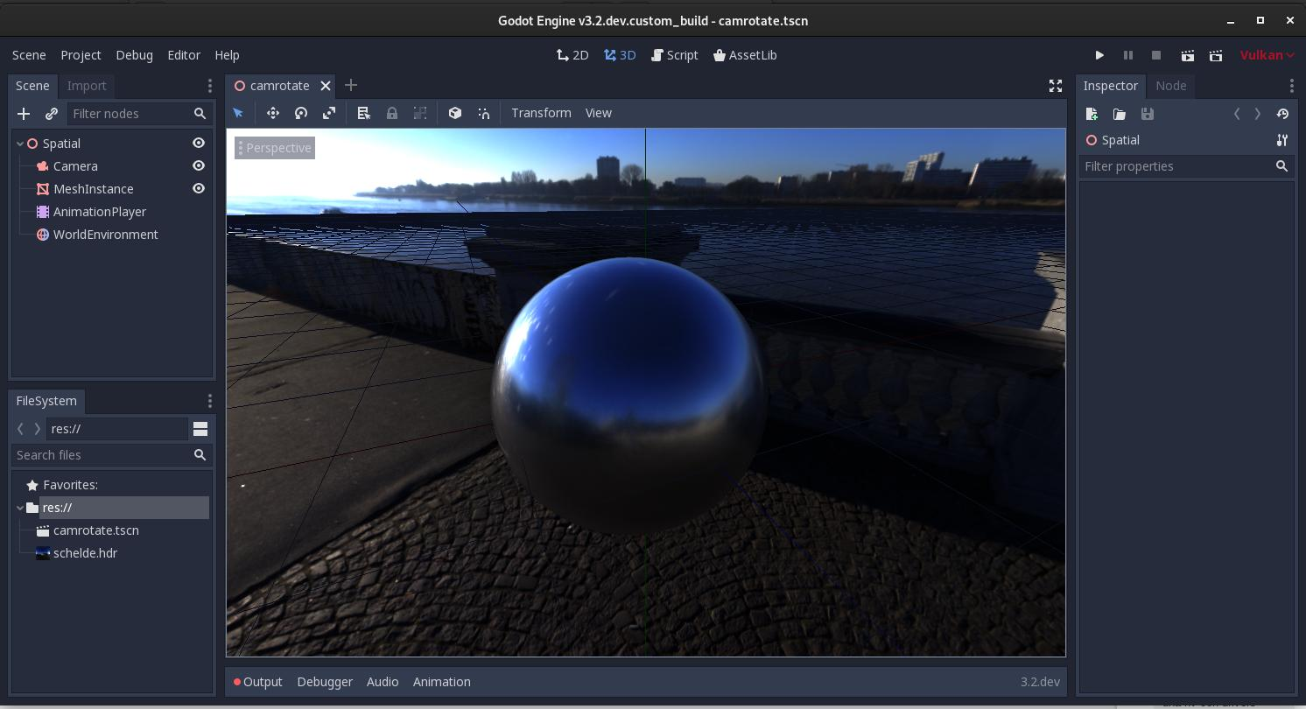
Figure 28: GoDot User Interface.
The user interface is simple and easy to navigate, making it a powerful tool for new developers. When writing a behaviour script, the engine uses a native, Python like language called GDScript [102]–[105].
Unfortunately, with the time constraints, access constraints (financial wall) and the lack of knowledge on the platform and the language, GoDot may not be the most suitable option for the development of the pathfinding AI implementation [102]–[105].

Unreal Engine 4
Unreal engine is a design suite for computer games much like GoDot. It can be used to allow developers to create games, simulations, and visualisations [106], [107]. It is one of the most popular game engines in both professional industry and individual hobbyist. It has a unique scripting feature called Blueprints, which are an object-oriented widget-based scripting system which enabled developers with poor programming skills to create gameplay elements without any written code [106]–[108].
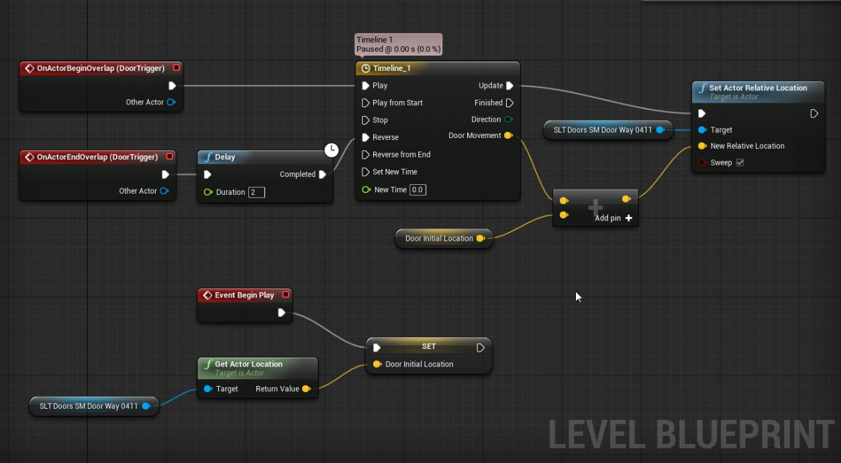
Figure 29: Unreal Engine Blueprint system example [109].
Before the version 4.15 was released, if a developer wanted to fully optimise the game they were designing, the developers needed an understanding of C++, as the blueprint system would not be as efficient, making it only useful for prototyping, and the way to produce a final product efficiently was with the use of C++. Since version 4.15 however, blueprint Nativization was introduce which reduced the virtual overhead in runtime by compiling the blueprints into native C++ executable code [108], [110], [111].
Unreal engine has a vast library of documentation, and a video tutorial channel on YouTube which has hundreds of entries, showing users how to use every tool and nuance within the game editing suite and in-depth guides on the use of the blueprint system [106], [110], [111].

Unity
Unity is a game engine which facilitates the design and development for 2D and 3D computer games, simulations, and visualisations for multiple platforms like social media, mobile, game consoles and virtual reality. It is used commercially and privately by professionals and hobbyists alike, offering an environment of fine control with its integration of C# (C Sharp), an object-oriented C like language which is widely used and well documented [112], [113].
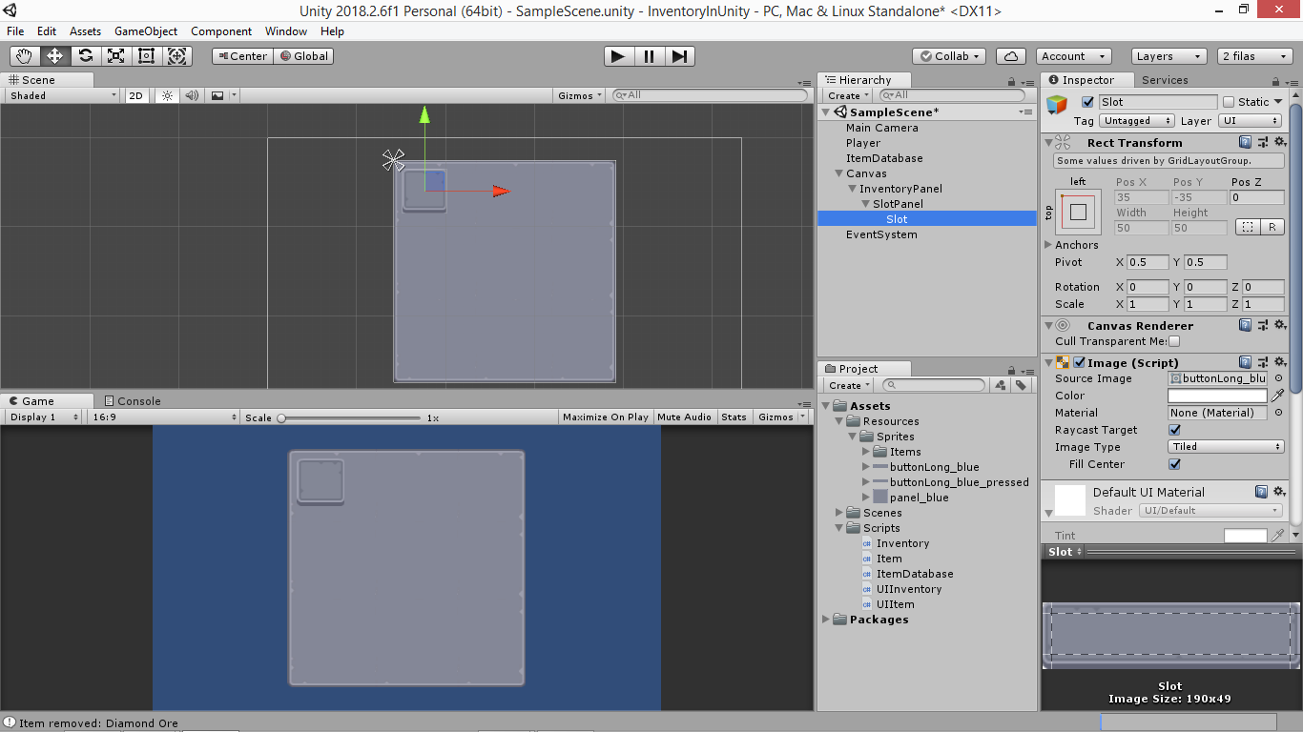
Figure 30: Unity User Interface [114].
Much like Unreal Engine, Unity has a vast library of documentation and guiding material to inform users how to use the software efficiently and effectively. Unity also incorporates an Asset Store where developers can create their own assets like scripts, textures, models, and environments and sell them to other developers on the store page [112], [113], [115].
Unity incorporates an abstract data structure which aids agents in games or simulations in pathfinding through complex and dynamic environments. This data structure is called a navigation mesh, or navmesh for short, and it has been popularised in video game engines since the 2000s. The navmesh is a convex polygon mesh that defines the space in which an agent can move, where each polygon is connected at an edge. The connections between the polygons are stored in a graph data structure, on which a nativized variant of the A* algorithm is performed to find the shortest path from one polygon to another [116], [117].

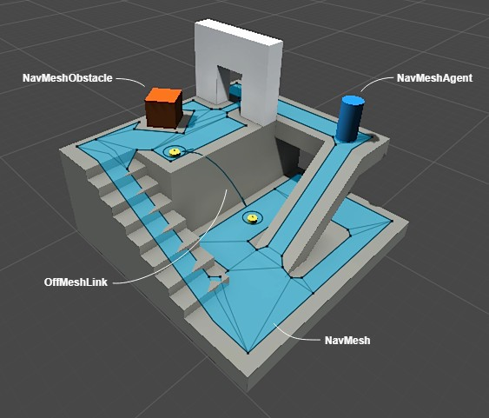
Figure 31: Visual overview of Unity Navigation Mesh [118].
One of the advantages of this approach is the navmesh can be generated ahead of time, or in real time, allowing for the possibility of traversing a dynamic environment. As the mesh is created, or “baked”, around non-traversable objects, the system can avoid computationally expensive tasks like collision checks [116], [117].
As Unity is based on C#, a language the developer of this project is familiar with, it will be the game engine of choice that will be used to design and develop the implementation of the environments, agents, and behaviour scripts to achieve a pathfinding agent that can navigate through a dynamic and changing environment [112], [113], [115], [119].

Unity also has access to a high functioning library, called MLAgents, that give users the ability to implement an ANN within the engine and train the model with a reinforcement learning approach [120]–[122]. The MLAgents library uses a python-based machine learning library that runs through a virtual environment that is initiated through the command prompt [120]–[122].
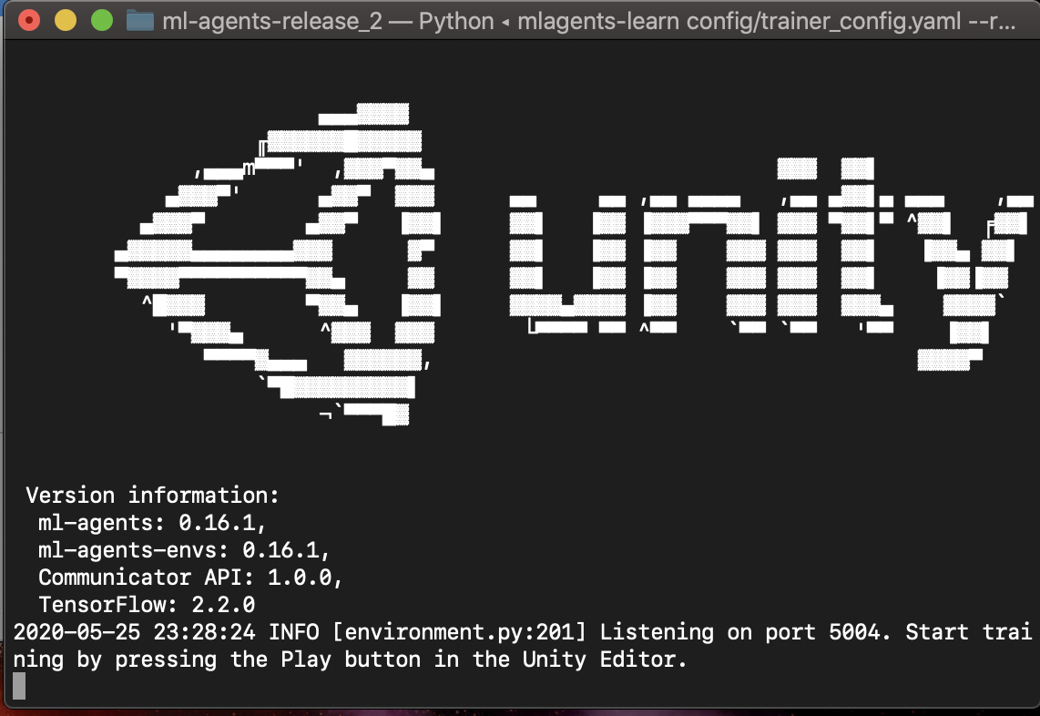
Figure 32: Unity's MLAgent Virtual Learning Environment Interface [123]
The MLAgents library required the agent to be given observation metrics that help it understand its environment. These observations are numerical values that will act as the input of the neural network [120]–[122].
The agent then needs to be given action vectors which allow it to change desired properties like position or rotation of an object, or on or off for a switch. These actions are the output of the neural network [120]–[122].
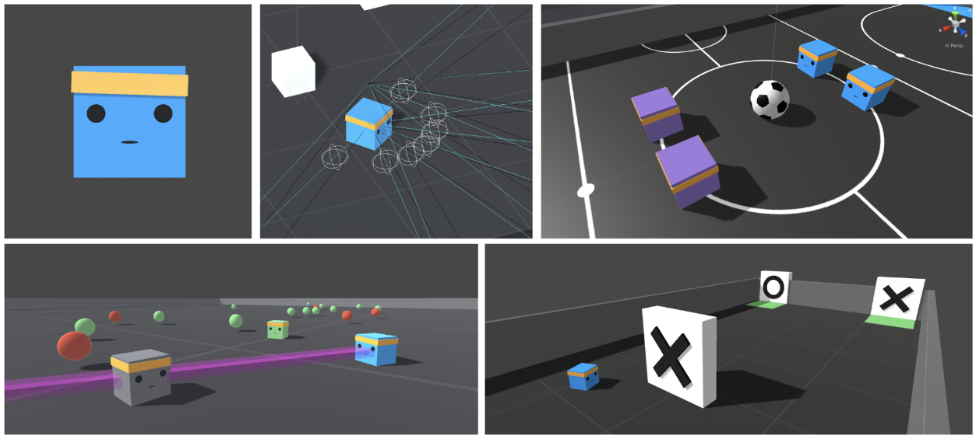
Figure 33: Examples of MLAgents being used within Unity [124].
To train the ANN, a reward system needs to be established inside an agent script. These rewards will be triggered when the agent does a desirable or undesirable action like reaching a target or walking off the platform. When these actions occur, a positive or negative reward need to be given to allow for the network to learn where positive rewards indicate desired behaviours and negative indicate undesired behaviours [120]–[122].
When the reward system is established, the MLAgents virtual environment can be executed to run a training simulation, where the ANN begins with random hidden layer values. As the training simulation runs the ANN will attempt to maximise the reward it receives during the training episodes. When the training session ends it will save the model of the ANN for later use. The saved model can be used to initialise another training session to allow for further improvement of an existing model [120]–[122].

Conclusion
From the literature review, the fundamentals of AI and machine learning were explored. AI is a specialised field of study that focuses on creating technological solutions that behave in an intelligent way. There are many ways to achieve and implement an AI, from a deterministic approach with algorithms to more complex approaches like neural networks and machine learning. The goal of this project is to implement and compare these approaches to the pathfinding problem.
The literature review revealed different approaches that can be taken to solve the pathfinding problem, the main solution being the A* algorithm. It is the aim of this project is to create an ANN which can be trained to navigate a dynamic environment and compare the effectiveness of the ANN to a more deterministic approach like A* to determine whether the ANN can perform as well as the A* Algorithm.
From the literature, it was found that to train an ANN in an environment that is unpredictable or unknown, a Reinforcement learning technique would be most suitable. This could be done with a reward system approach which trains the ANN over multiple generations to improve its decision-making abilities when navigating a space by positively rewarding desired behaviour and negatively rewarding undesired behaviour.
To make this work, the ANN will need to take in parameters which describe its surrounding environment. Unity has a vast library of tools which can be used and explored to find the best solution for this problem. The literature showed that to train the agents, a reward system will need to be established. This system would give a positive reward when the agent reaches the desired target, and a cumulative negative reward over time to encourage it to find the target quickly. If the agent hits an obstacle or boundary or runs out of time, then a further negative reward should be given to discourage it from colliding with them. In the case that the agent runs out of time in a training simulation, it should be rewarded based on how close it came to the target, which can be calculated with the A* algorithm.

Research and Development Methods

Research Overview

Philosophy
The research philosophy of this project will take on a positivist philosophy as it will be viewing sources based in factual knowledge gained from observation and confirmation. Due to the nature of the project’s aim to create a solution which utilises an AI that can navigate a dynamic and changing environment, the success of the AI will be interpreted in an objective view being whether it can or cannot perform the task [125].
The aim of the research review in this project is to explore the mechanics behind AI and machine learning to gain an understanding on which approaches will be suitable to achieve the task of implementing a pathfinding AI.

Approach
A deductive approach will be taken for the research, meaning the project will work “top down”, whereby an initial theory or idea will be formulated from pre-existing material, leading to a testable hypothesis. The observations from the tests will be analysed to determine whether the hypothesis can be confirmed [126].

Strategies
With the deductive research approach, it is important to review existing literature to find existing theories on the subject. Multiple documents will be critically reviewed to find a common theory which will be used to deduce a new hypothesis which can be tested.
To test the hypothesis, a solution will be developed which will follow a cycle of planning and designing the solution, implementation of the designs in code, testing the solution in a suitable environment, and finally reflecting on and analysing the results of the tests before going back to the planning stage. This strategy will likely take multiple cycles to complete the full development of the system [127].
When testing the hypothesis made from the existing theory, the experiment strategy will allow the model to reveal the effectiveness of the game and highlight any errors or issues that require attention [127].

Deliverables
The research deliverables of this project will be a comprehensive literature review based on secondary research in the form of articles, journals, books, and websites [128]. This literature review will function as a basis for the initial theory and will serve as a fall-back in the event the theory needs to be re-evaluated and when planning for further improvements for the solution [129].

Development Overview

Methodology
The development methodology for this project will be a custom variant based on Feature Driven Development (FDD) that will allow for a flexible but structured workflow that focuses on implementing one new feature at a time. This will leave the project in a state that is submissible when either the time assigned to the project runs out or all the planned features have been implemented [130]–[132].
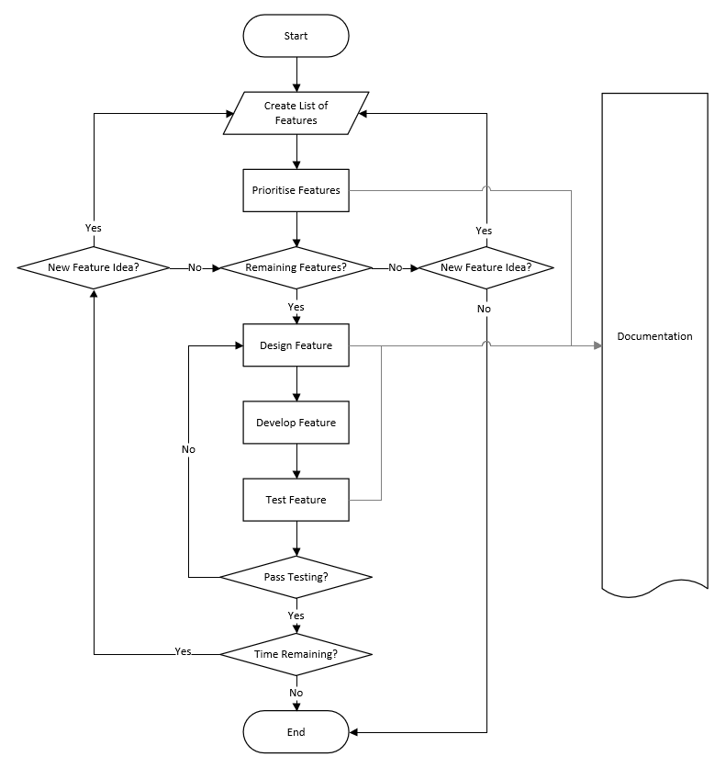
Figure 34: Chosen Development Methodology Flowchart.
This methodology has been designed to accommodate the fact that one developer will be working on the project. Development methodologies that are designed to facilitate team coherence like Agile, Spiral and Extreme Programming (XP) will not be suitable for this style of project as scrums, meetings and collaboration will not be possible without the presence of a team of business analysts, developers, and testers [130]–[132].
The advantage of this method is the straightforward structure that has been designed to accommodate a single developer on a constrained time limit, while also giving opportunity to expand the project if there is time. Having a step where the features will be ordered in priority means that the most important elements will be completed before any features that may not be crucial to the performance. This means that after a certain point in development the solution will always be in a submissible state. After that point, any further iterations will be adding extra features that improve and/or optimise the solution.
To keep track of the features that need to be implemented to meet the initial requirements, a Kanban development board will be used [133], [134]. The chosen service to implement the Kanban board will be Trello, a flexible and easy to use web application that will be used in such a way that the features can be categorised into backlog, in development, in testing and passed testing, with the ability to track their progress through the steps [135].

Figure 35: Trello Kanban board [135].

Time Management Plan
To ensure the project is completed in a timely manner, a time management plan has been created in the form of a Gantt chart shown in figure 34 on page 45 This plan begins with the research phase where research materials will be gathered and reviewed in a written literature review. This phase will continue for most of the project, ideally ending before 25th February 2021.
The documentation phase will include detailed development documentation, illustrating the design and implementation, the testing and analysis of results and the conclusions and recommendations for further development. This phase will start before the development phase and needs to be finished by the hand in date on 23rd April 2021.
The development phase will incorporate the chosen methodology, allowing for multiple iterations where features will be implemented. This time schedule is flexible as some features may take less or more time than others, but development overall needs to finish on 31st March 2021.
Preparation time has been allotted to both interim viva and final viva on the 20th January 2021 and 28th April 2021, respectively. These schedules will include time to prepare the presentation and time to practise. The preparation for the presentation of the final viva will also include the design of a showcase board which will be displayed at an exhibition.


Figure 36: Time Management Gantt Chart

Required Resources
The physical resources required to design, develop, and test the solution are as follows: -
Software Suites:
- Microsoft Office for presentation.
- Microsoft Visio for presentation.
- Microsoft Project for time management.
- Visual Studio for programming environment.
- Unity for development and testing environment.
Programming languages:
- C#.
Learning resources
- IEEE and ACM for academic research.
- Internet access for online research.
- Library.
Facilities & Services
- Y Forum for private and quiet workspace.
- Trello for Kanban management.
The human resources required to design, develop, test and guide the project are as follows: -
- James Millns (Developer)
- Tim Bashford (Mentor)
- Gordon Dickers (AI Tutor)
- David Williams (Academic Support)

Deliverables
The deliverables the project will produce are as follows:
- Initial Designs: This will include problem solving exercises, code planning, environment designs and game mechanic plans.
- Implementation: This will be the software implementation of the project being the simulation that implements a pathfinding AI to traverse a dynamic and changing environment.
- Documentation: This will be the report which details the design and development process, and the tests and results which were used to further improve the implementation.

Conclusion
To conclude, the research philosophy to be taken will be positivist philosophy, where factual and peer reviewed documents and papers will be used to gain an insight into the field of AI to assist in the implementation of the ANN to test the hypothesis. A deductive approach will be taken to deduce the validity of the hypothesis with said ANN implementation by experimenting to test the accuracy and efficiency of the model compared to other pathfinding methods. These will result in the deliverables being a literature review on the current and relevant sources and papers which will function as the backbone of the design and development.
The development methodology used is a custom variant of FDD which has been altered to suit a single developer with a constrained time resource to allow for smooth and structured development with the best chance of producing a viable solution to test the validity of the initial hypothesis.
A time management plan was made with the intention of using a Gantt chart as the guideline to complete the project, while also using a Kanban board to aid with task management and completion of tasks to meet the aims of the project.
The resources required to achieve this have been identified and the expected deliverables have also been outlined to be the designs of the solution, the implementation of the solution and the documentation and results from the experimental testing.

Design and Implementation

Problem Formulation
The aim of the project is to design an AI agent which can navigate through a dynamic and changing environment. The Unity game engine has access to some very useful libraries that allows developers to implement neural network solutions and train them with reinforcement learning [121], [122].
With the “MLAgents” library, it is possible to set up a learning environment with an agent object and feed the agent information about its environment which it can then use to make decisions [121], [122]. The ideal information the agent would need would be its own position vector in the environment, a position vector describing the target, and possibly position vectors of obstacles in the environment, or ray casts emitted from the agent that intersect with obstacles acting like echo location.
To train the agent, the library requires the agent to be given positive or negative rewards from its actions [3], [120]–[122]. In this scenario the agent should be given a large positive reward for reaching the target, while also being given negative rewards for colliding with obstacles or boundaries. It would also be beneficial to the training to give a cumulative negative reward over time to encourage the agent to reach the target in as little time as possible.
The training simulations will need to start simple to give the agent a chance to learn that it needs to find the target in an empty environment. When it has achieved a threshold reward average, then the complexity of the simulation can be increased until the next threshold is reached. This approach will be iterated until the agent no longer improves when more complexity is added.
When this final threshold has been reached, the agent can be put through testing simulations inside increasingly complex environments alongside other pathfinding solutions like NavMesh and A-Star to compare the performance and evaluate the validity of the hypothesis.

Design
While in the design phase of the project, the required features that needed to be implemented were broken down into separate tasks and again further broken down into sub tasks. The project needed to implement a multitude of pathfinding solutions for comparison, so individual tasks for the three chosen methods were made. These tasks were all documented and tracked on the Trello website with a Kanban board [135].

Figure 37: Design Kanban Board
The project requires a test environment. The environment was to be built in the Unity game engine, and would contain a floor, obstacles, boundaries, and an agent. The game engine offers an intuitive interface to quickly set up simple shapes and polygons. With that it was decided that a square environment with cuboid obstacles and agents would be best as the visual presentation should preferably be simple to save time, whereas spending more time on making the environment visually appealing was not in the interest of time.

Figure 38: Design Environment Kanban Card
Once a common test environment has been created, the pathfinding methods can be implemented on top of it. The NavMesh method needs to have a mesh baked onto the floor of the environment while also having the obstacles cut into the mesh. A script to determine how the agent should move through the mesh and how it finds the target needs to be written also.

Figure 39: Implement NavMesh Kanban Card
To implement the A-Star method, a grid or graph of some sorts needs to be created which holds an array of interconnected nodes. This graph also needs to have obstacles cut into it so nodes that are overlapping them cannot be used by the algorithm. A script that finds the shortest path between two points using the A-Star algorithm needs to be written, this will ideally return a list of nodes that represents the path that the agent can use to traverse. The script which governs the movement of the agent also needs to be written, this script ideally needs to receive a list of nodes that describe the path.

Figure 40: Implement A-Star Kanban Card
To set up the ANN implementation, the inputs need to be defined. In the MLAgents library within the Unity engine, these inputs are defined as observations. For the ANN in this context to function, the observations should be the position vectors of the agent and the target, so it knows where it is, and where it is going. It also needs to receive information of the environment; this would ideally be ray casts emitted from the agent that intersect with obstacles and boundaries. This would let the agent know when it is too close to an obstacle it needs to avoid.
Action vectors also needs to be created, these act as the output of the ANN. In this context, the ANN needs to be able to change the position of the agent, so the action vectors should change the x and z position of the agent.
The MLAgents library also needs a reward structure for the ANN to learn effectively. This reward is accumulated in training episodes which are the moment it spawns in a random location to the moment it either collides with another object or runs out of time for that episode which should be 1000 steps. If the agent collides with an obstacle or boundary then the reward needs to be negative to discourage the ANN from that behaviour. Also, a small negative reward needs to be accumulated over the course of each episode to encourage the agent to find the target as quickly as it can. Finally, a positive reward should be given when it collides with a target, this reward should be large so the training time is reduced.
Once the setup has been done, the agent needs to be training in an iterative process, where the initial complexity of the environment is as simple as possible i.e., with no obstacles. This initial training will allow the agent to learn to move towards the target. Once the reward average has reached a plateau, then the complexity of the environment can be increased i.e., adding obstacles. This process of training until plateau and increasing complexity for next training session will be continued until the complexity of the environment increasing prevents the agent from improving any further. In this case the expected level of complexity before this happens is 20 obstacles in the environment.

Figure 41: Implement ANN Kanban Card

Once the three methods have been implemented, the testing environment needs to be altered to write the data of the performance to a file for later analysis. The script needs to also have a max run stop implemented which will allow for a specific number of test runs to be conducted for consistency of results.

Figure 42: Create Test Harness Kanban Card
Once the three methods and the test environment have all been implemented, the test simulations need to be run. For the test, each implementation is going to run 1000 times in each of the 21 environments. The first environment will have 0 obstacles present; the next will have 1, the next will have and so on until the final environment has 20 obstacles. This approach should give a good sample of results which will fairly outline the respective performance of each method.
Ideally more tests would be run with different levels of complexity, but in the interest of time, the tests outline will be sufficient to identify the comparative performances. If there is time, then further test environments, possibly with moving obstacles, could be made and tested to identify how dynamic complexity affects the performance of the approaches.

Figure 43: Test Implementation Kanban card

Finally, once the tests have been conducted, the data will need to be analysed and drawn up into tables, charts, and graphs to illustrate the comparative performance between the three pathfinding methods. With the results, comments and speculations can be made which will appear in the Results and Analysis section of the project.

Figure 44: Analyse Results Kanban Card

Implementation
The following screenshots show the progression of the implementation. Figure 43 is the environment design that was chosen and used for all the different implementations. The grey blocks act as the obstacles, the blue cube acts as the agent, and the yellow disc acts as the target the agent must reach to end the episode.
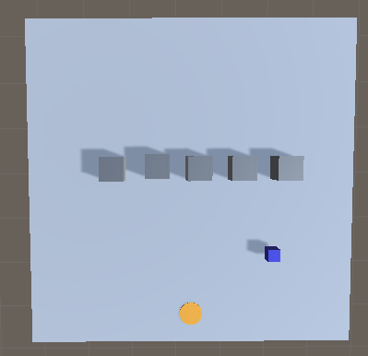
Figure 45: Base Environment Design
First the NavMesh was implemented onto a copy of the base environment design, having the obstacles set to cut into the mesh. The implementation required a script that would set the destination of the agent to the target location. The script uses a update function which refreshes every frame that refreshed the destination if the target has moved. This implementation was the most straight forward as expected as there are native tools to help setup the NavMesh.
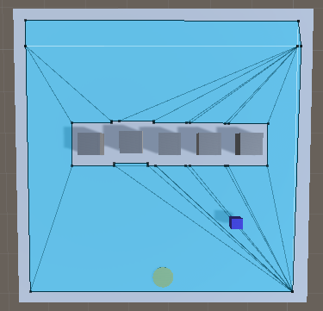
Figure 46: NavMesh Environment

To implement the A-Star method, a script was made that would create a grid of nodes over the top of the environment floor. The nodes sizes can be adjusted in the object inspector of the grid. Below in Figure 45 is a visual representation of the nodes in the grid, where the yellow nodes represent obstacles, the green nodes represent the agent, the blue nodes represent the target, and the red nodes represent the shortest path.
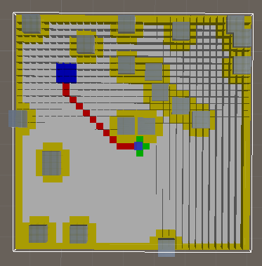
Figure 47: A-Star Environment
To calculate the shortest path, a script was written that implements the A-Star algorithm. This algorithm uses the Euclidian distance as the heuristic measure to the target. The Manhattan distance was also implemented but was not used in the final version due to the path taking preference to right angled routed in one direction but taking the direct route in the other direction.
Finally, a script was written that would move the agent along the path created by the algorithm script. This was done by moving the agent towards the first node in the path list. The path would then be recalculated every step so the next node would be at the end of the list. This was implemented this way as the agent needed to be aware of any changes in the environment. If there were moving objects and the path did not recalculate, then the agent may collide with an obstacle.

Lastly was the implementation of the ANN method. This required the MLAgents library to be installed into the Unity engine [3]. As per the design, the agent was fitted with a radial ray cast that bounces off obstacles and boundaries. The agent was also given details of its own position and the position of the target.
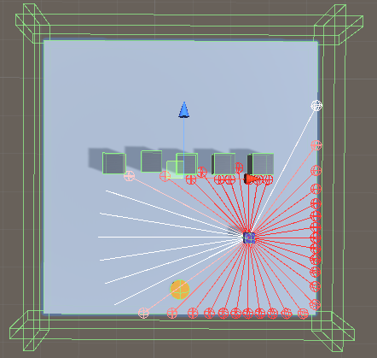
Figure 48: ANN Environment
Two issues occurred during development. During the initialisation for a new episode, all the entities inside the environment would have their positions randomised, and sometimes the target or agent would spawn inside a wall which would either make the target impossible to reach or end the episode immediately. To work around the issue of the target, it would check if it was inside a wall and randomise its position again until it was not in contact with a wall. To work around the issue of the agent, a check was put into the collision event with a wall that would end the episode without a reward change if the step count were below 5. This would prevent the learning algorithm considering these events in its training sessions. If they were left in, then there was a possibility that the agent would learn to avoid obstacles more than finding the target.
Once the ANN environment had been setup, the next step was the training. For the training to complete faster, multiple environments were setup in the same scene. This would be the training farm that the ANN brain would use to learn how to maximise the rewards. As a visual representation of the ANN’s progress through training, the floor colour would change depending on how the previous episode ended. If the target was reached, then the floor would change green to indicate success, while if an obstacle or boundary were hit, or the episode timed out, then the floor would change red to indicate failure. This is purely aesthetic and has no weighting on the functionality or performance of the ANN.
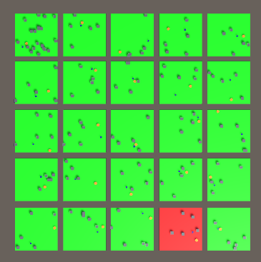
Figure 49: ANN Training Farm
The training sessions were set to be 500,000 steps each. Once one session ended, if the average reward were above 1.8 then the complexity of the environment would be increased and the next session would be carried out, initialising from the previous session.
Figure 48 shows how the model performed during training in the first session which had no obstacles. The cumulative reward has a maximum of 3, which is how much was rewarded when the agent reached the target. This value was set somewhat arbitrarily, the purpose of it being three was for it to be relatively large compared to the negative rewards the agent could receive if it failed the episode, which was a negative one reward.
The Cumulative reward graph on the left of the figure indicated better performance the higher the value is, while the Episode length graph on the right indicates better performance the lower the value is. Figures 48 - 54 show the progress the model made through each training session where each session had increased complexity, ending with session seven on the highest complexity with 20 obstacles.
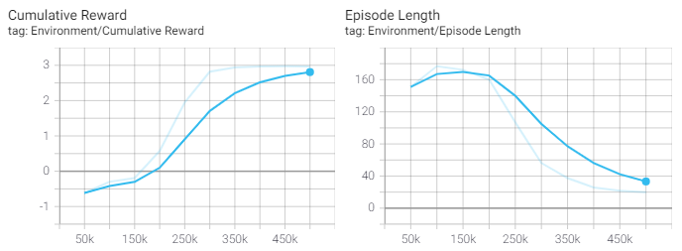
Figure 50: First training session with 0 obstacles
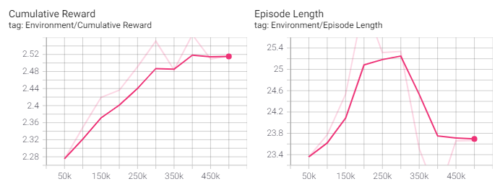
Figure 51: Second training session with 1 obstacle
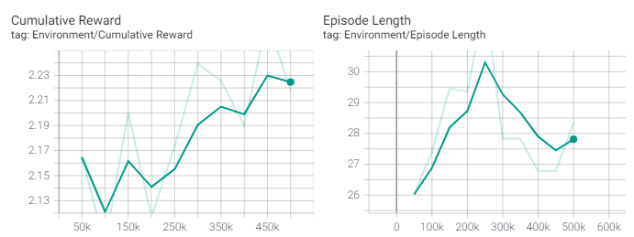
Figure 52: Third Training Session with 2 obstacles
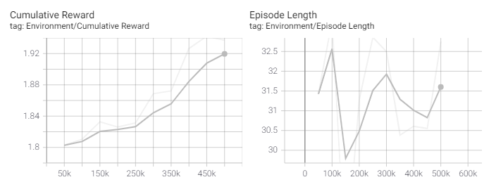
Figure 53: Fourth Training Session with 4 obstacles

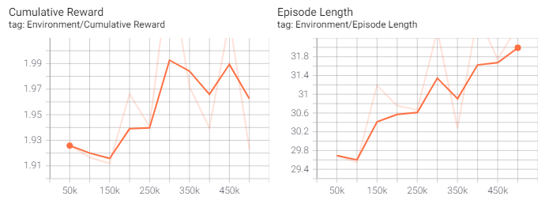
Figure 54: Fifth Training Session with 8 obstacles
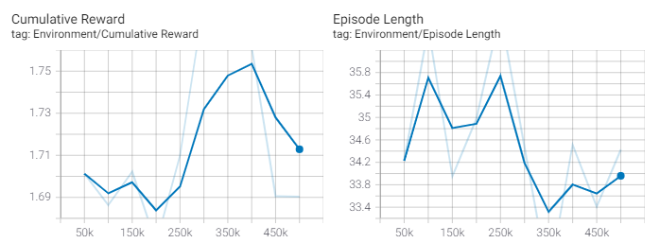
Figure 55: Sixth Training Session with 16 obstacles
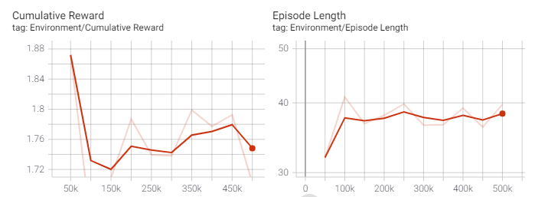
Figure 56: Seventh Training Session with 20 obstacles
The seventh session was the last session to be run as the agent was not making any major improvements in the level of complexity present. If any more complexity were added it would likely not result in any further improvements.
Once the three methods had been implemented successfully and had all the bugs fixed, a test harness was made that would be used to record the performance data of the methods. The test harness used some of the attributes of the ANN environment like the step count and cumulative reward. This would give a controlled setting of comparing performance results. The tests would record the pathfinding method and the episode’s step count, cumulative reward, reason for finishing and finally the time stamp for the episode. A max count was implemented to prevent the testing sessions from exceeding 1000 episodes. To speed up the testing in the interest of time, the test harness was fitted with four duplicate environments as shown in Figure 55
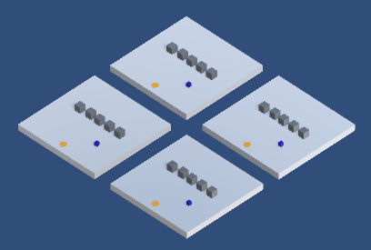
Figure 57: Basic Testing Harness
To run the tests, each pathfinding method was tested 1000 on 21 different complexity levels, making that 21,000 total tests per method, and 63,000 total tests overall.
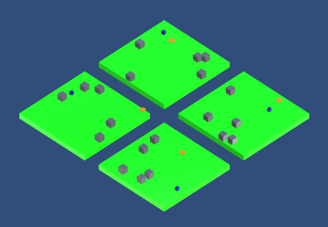
Figure 58: Testing At Five Obstacles
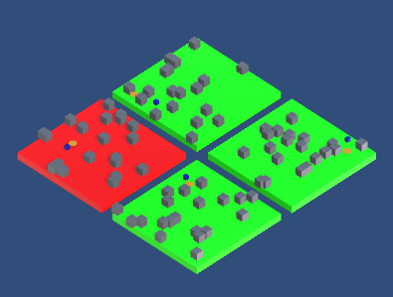
Figure 59: Testing At Twenty Obstacles

Conclusion
The aims set out prior to development were to implement a pathfinding ANN that could perform comparatively to other pathfinding solutions inside a simulated environment. This was achieved by using the Unity game engine and the MLAgents machine learning library, which made it possible to create a 3D visual environment which could be used to train and test an ANN to properly navigate through.
The Unity game engine also all made it possible to implement two other pathfinding methods, NavMesh and the A-Star algorithm, which could be used to compare results to determine the accuracy and efficiency of the ANN. The goal was to test the three solutions in the same environment to determine whether the hypothesis could be supported or refuted by the results.
During development, many different approaches to training the ANN were taken as learning exercises before the final model lineage was implemented. An issue was found with the environment spawning the target and agent inside walls, ruining the episode’s training. This was fixed by respawning the target when it collided with a wall and restarting the episode when the agent spawned inside a wall.
With the finished implementations, the simulated testing was carried out, recording thousands of simulations to a spreadsheet, which allowed for extrapolated statistics that could be used to better determine the accuracy and efficiency of the pathfinding approaches, and answer the question of the main hypothesis:
“It is possible to make an Artificial Neural Network (ANN) based pathfinding artificial intelligence (AI) that can navigate a path through a dynamic and changing environment with similar performance to more deterministic algorithm-based pathfinding solutions.”

Results and Analysis

Results
From the tests carried out, the results produced have been extrapolated into tables 3-5. The main statistics that were extrapolated from the results constitute of how the 1000 runs concluded in that specific environment where the three possible outcomes would be “Target Reached” where the episode was ended by the agent making contact with the target, “Timed out” where the episode ended because the max step value of 1000 had been reached (not related to the 1000 runs in each environment), and “Wall collision” where the episode ended when the agent made contact with an obstacle or boundary.
The other stats were the reward stats. Upon investigation it was found that the reward value written to the report during the testing did not include the cumulative negative reward from the steps it was taking. To avoid having to do the tests again, the value was calculated with.
Avg Actual Reward = Avg Raw Reward – (Avg Steps / Max Steps)
Where the Max Steps was 1000.
Finally, a value for the average steps taken on the episodes that ended in the target being reached was pulled from the data to give an indication to how well the method performed in successfully finding the target. This value may not be strictly useful as the sample size the average is pulled from will not be consistent across the board, due to there being a varying number of episodes ending with that criteria, but it may be interesting to see as it may give an indication to the overall accuracy and efficiency of the method.
Table 3: A-Star Statistics
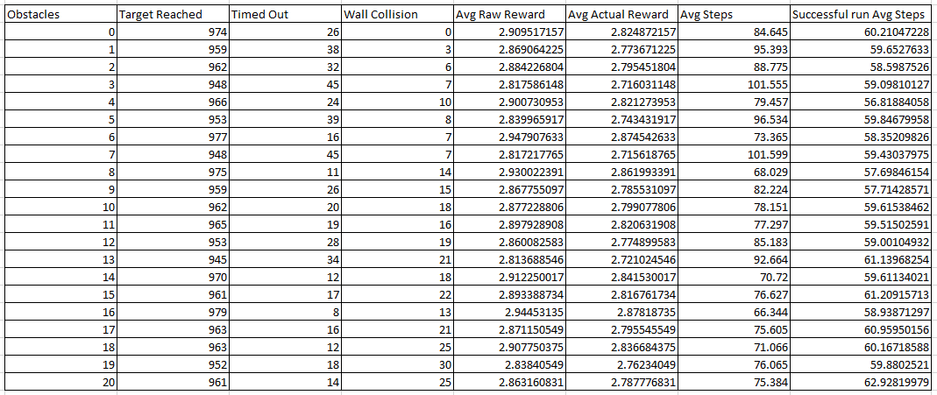
Table 4: NavMesh Statistics
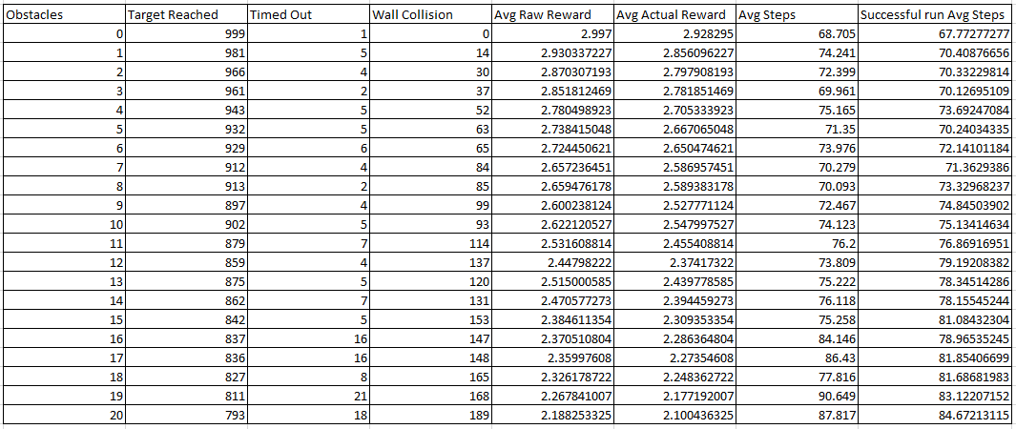
Table 5: ANN Statistics
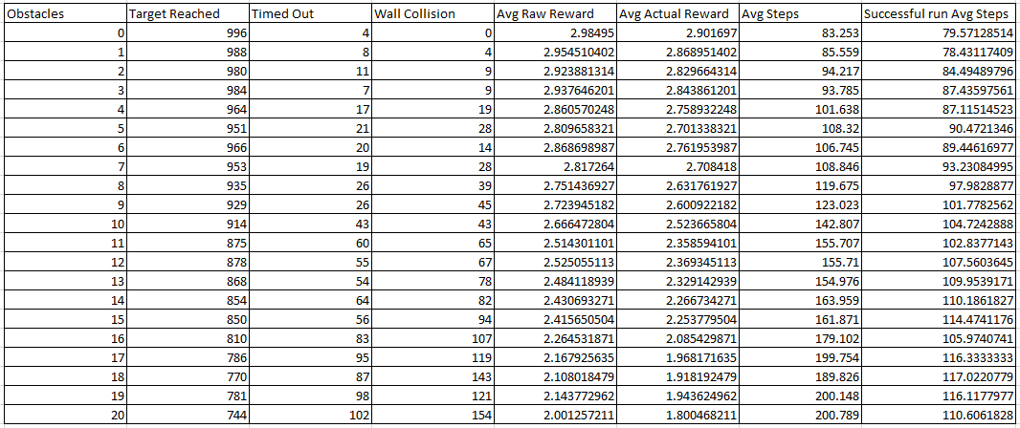
Once the test results had concluded and the above tables had been extrapolated, further investigation into the comparative accuracy and efficiency was performed, resulting in further observations that are detailed in the Analysis of Accuracy and Efficiency.

Analysis of Accuracy and Efficiency
The results gained from the testing of the pathfinding methods has outlined very stark differences between their respective performances. When analysing the accuracy of the methods, the episode breakdown in each difficulty level was illustrated in the pie charts below. The first set shown here depicts the accuracy of the A-Star method, which at first observation seems to be very consistent throughout, regardless of difficulty. Another observation is how the method had time-out results even in low difficulty levels. Upon further inspection this was a result of the implementation failing under certain situations, where the agent froze in place, even when there was a clear path to the target. Fortunately, this only presented in a small sample of tests, but further investigation into this issue for rectification could be made to make the results more reliable.
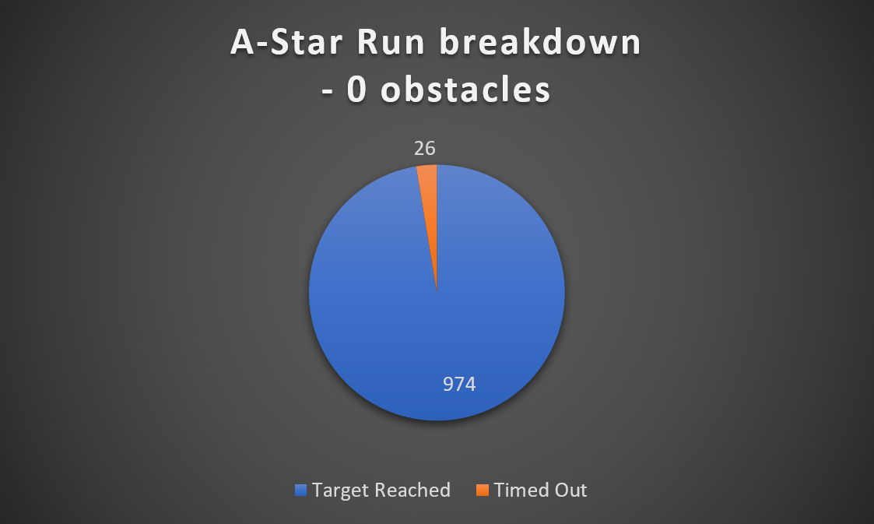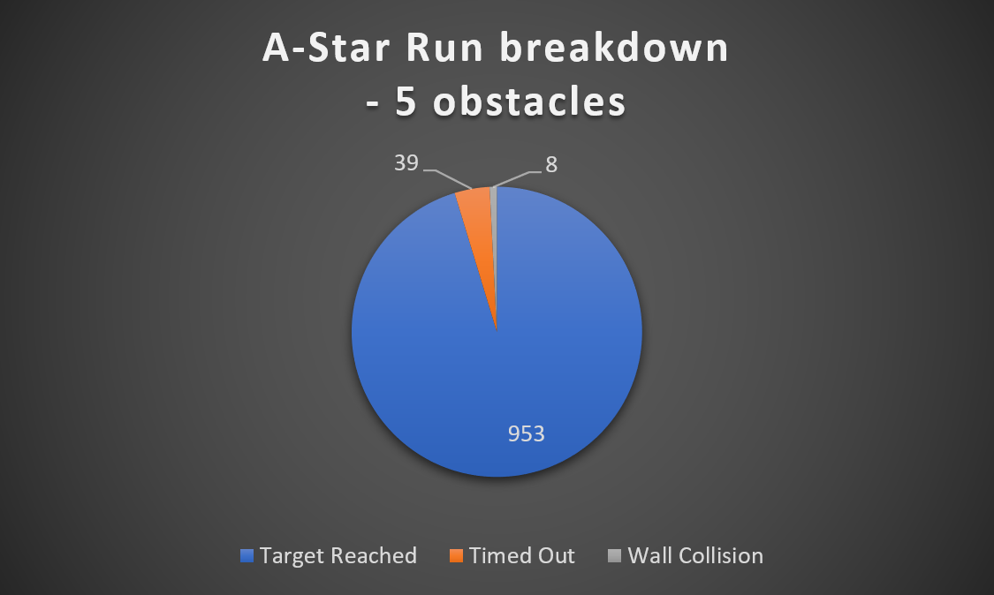
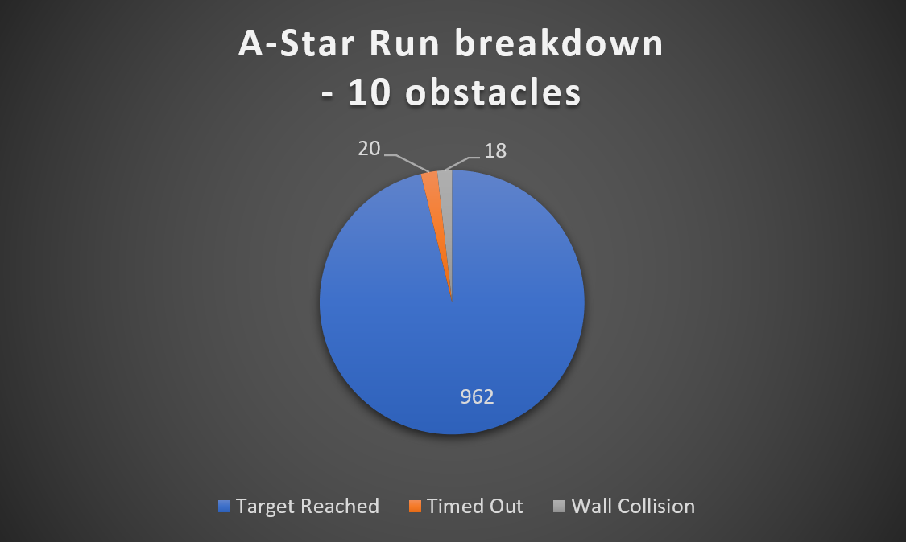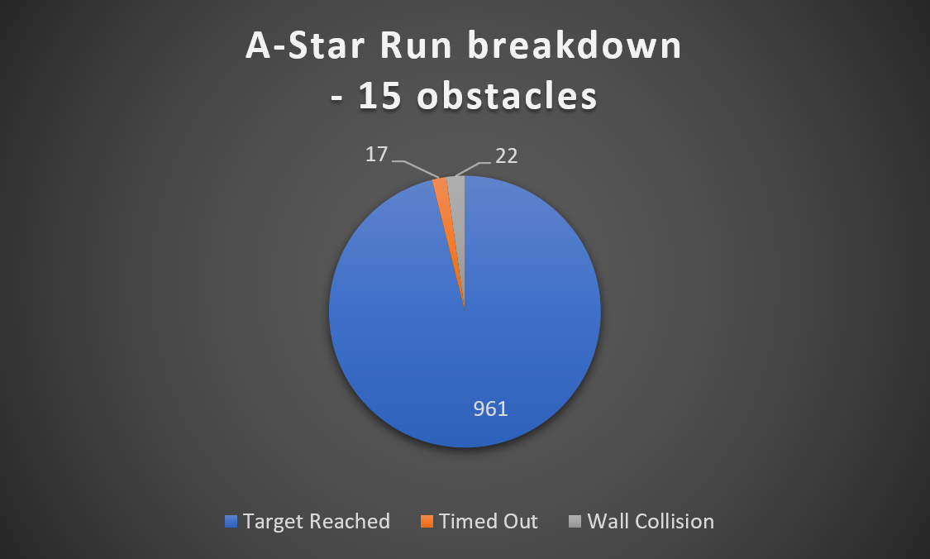
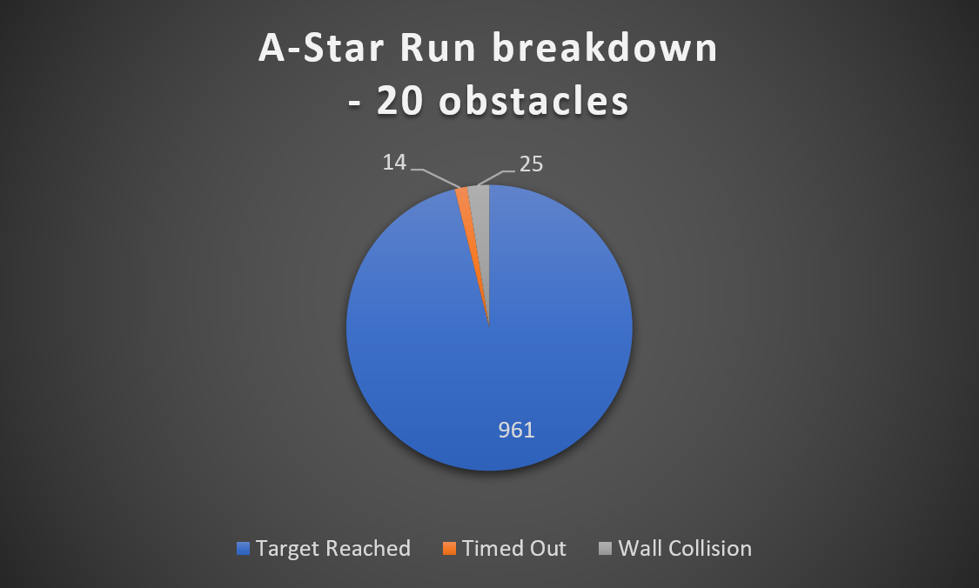
Figure 60: A-Star Performance Benchmarks (Full results available in appendix)

The NavMesh implementation performed considerably worse than the A-Star, which was to be expected. One observation is the wall collision episodes are most of the failed episodes, which means that the implementation was able to find a path to the target, but it was colliding with obstacles on the way. When this was further investigated it was found that the most likely reason for this was when the episode began. At the beginning of the episodes the NavMesh would take a few milliseconds to refresh the cut outs for the obstacles that had been randomly positioned in the environment. This window meant the agent would make a direct path to the target without avoiding an obstacle because the mesh would not warn it that an obstacle was there.
Another observation was in some episodes, the agent would carry the momentum of the previous episode instead of starting at a complete stand still. These issues could be fixed with further implementation by resetting the momentum at the beginning of the episode and pausing the episode until the mesh has fully loaded the obstacle cut outs.
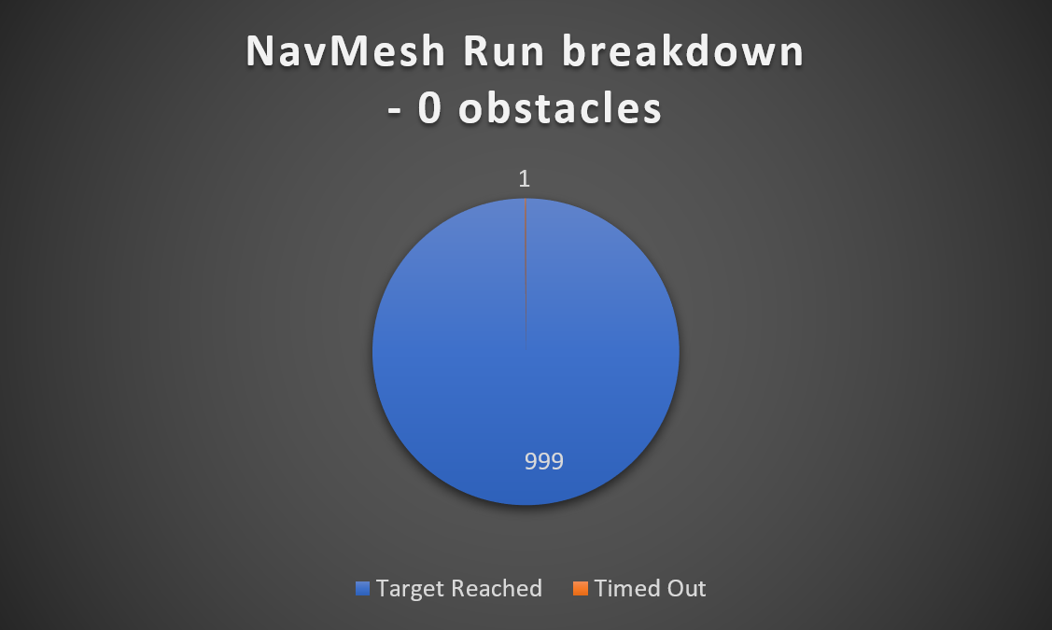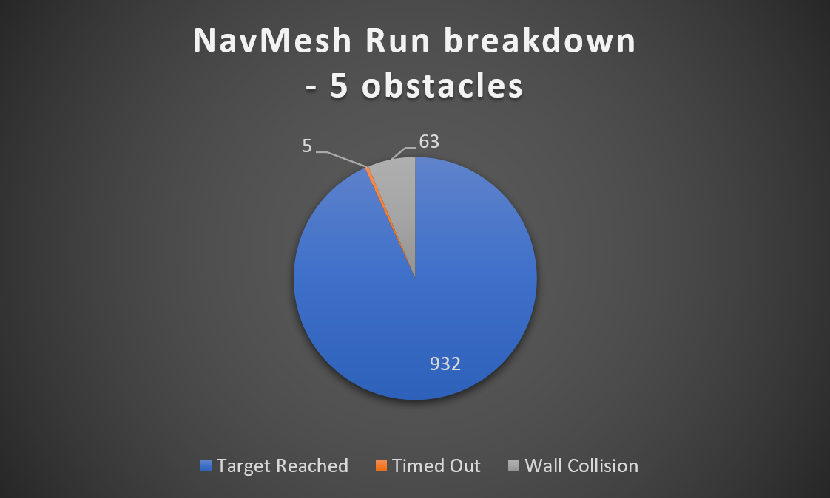
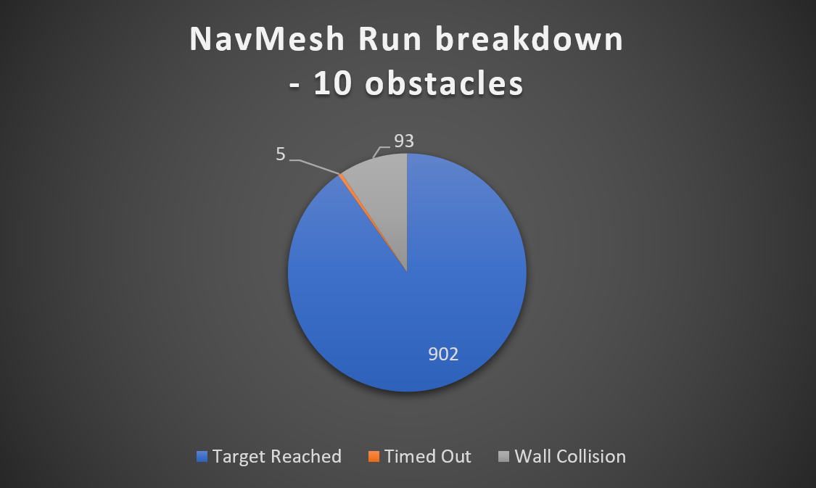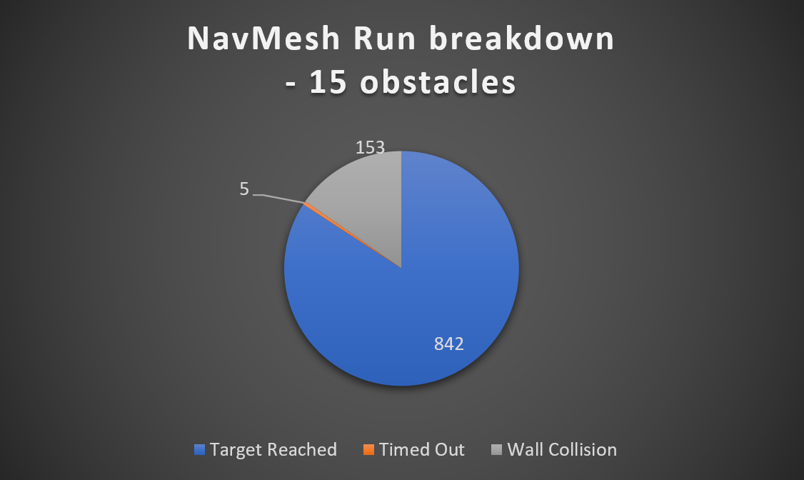
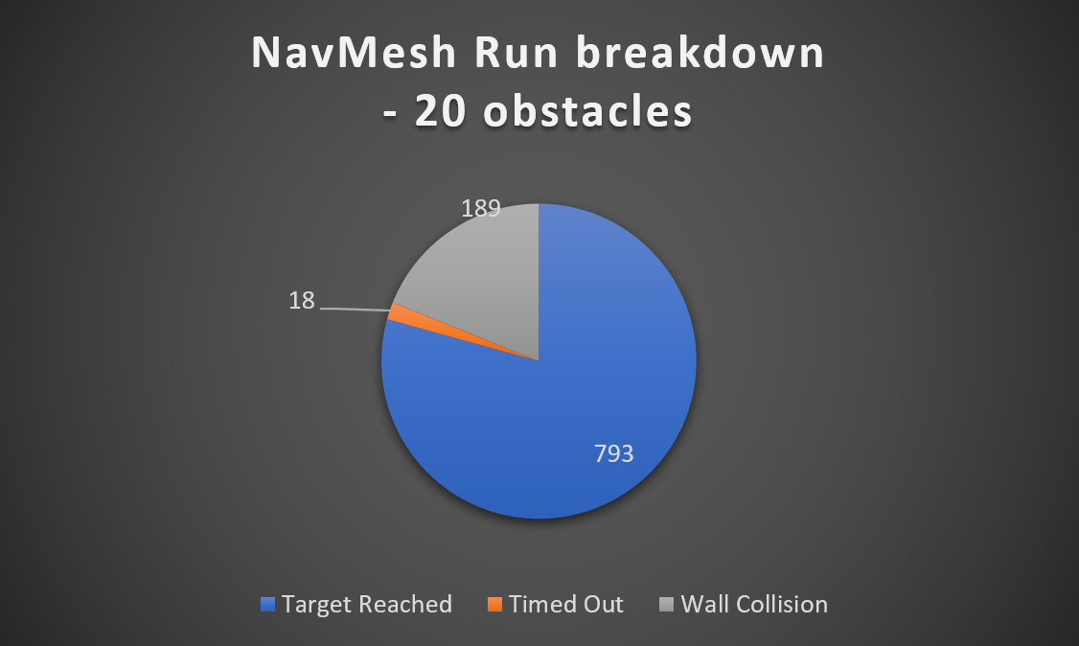
Figure 61: NavMesh Performance Benchmarks (Full results available in appendix)

The ANN implementation performed the worst out of the three, which was also to be expected. Even so, the method was able to correctly navigate to the target ~75% of the time in the most difficult environment which could be considered a success. Observing method’s progress through the different difficulties, its apparent that the episodes that ended in failure have an evenly distribution between timed out and wall collision, with a slight bias towards wall collisions. Upon further investigation it was noted that the ANN would find its way into a position where the target was on the other side of a wide wall, and instead of finding a way around it, it would wobble around the closest point to the target on the other side and either move into the wall, or time out.
This is fundamentally an issue with the current approach as there is no way currently for the agent to remember where it has already been. Without that knowledge of position history, the agent will not be able to navigate out of those situations. It is uncertain how this position history would be delivered to the agent, further research and investigation is required.
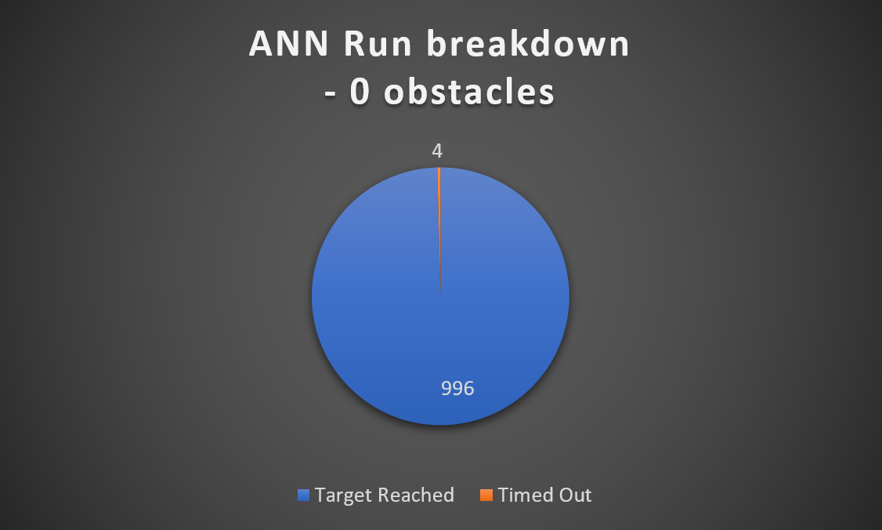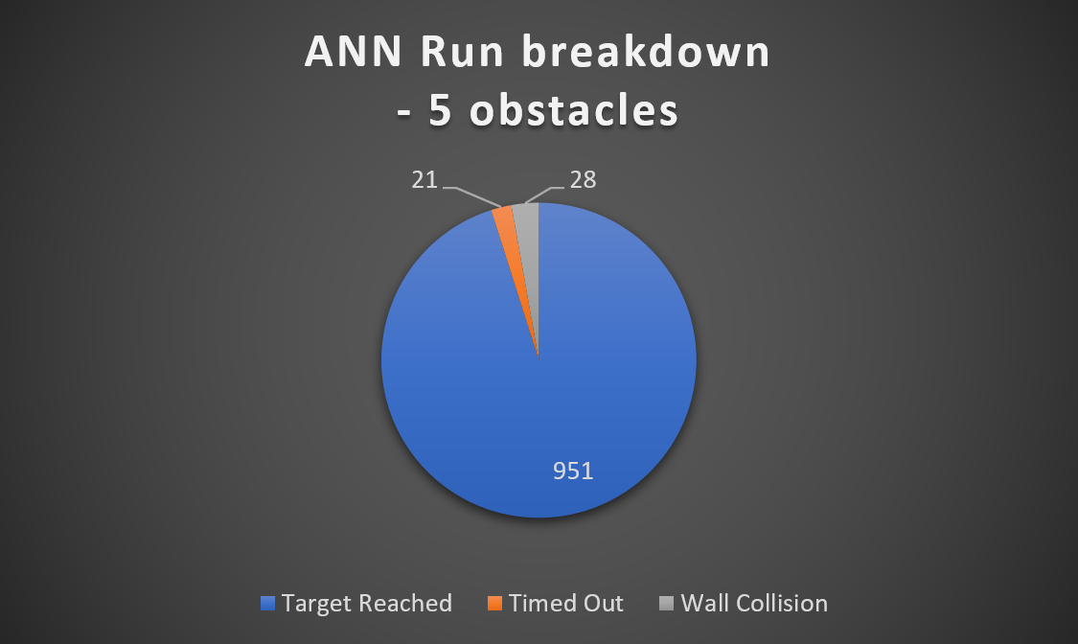
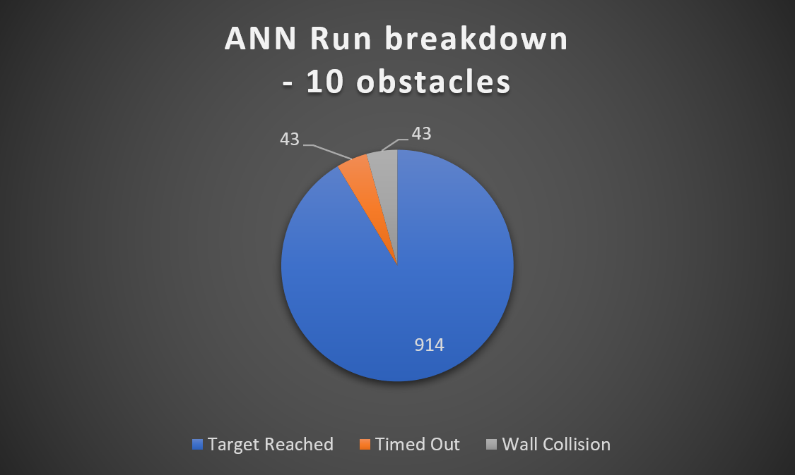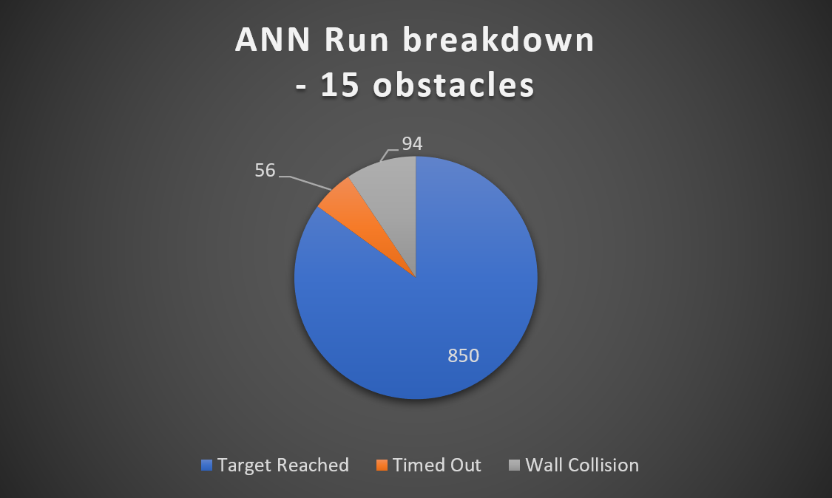
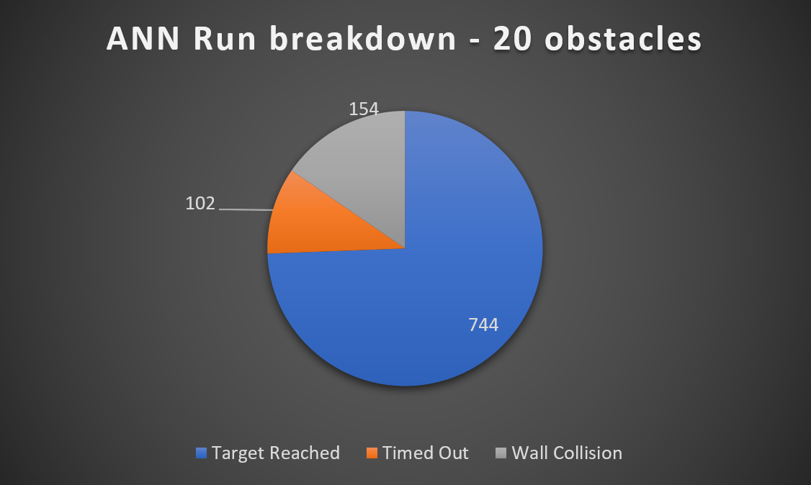
Figure 62: ANN Performance Banchmarks (Full results available in appendix)

To analyse the efficiency of the implementations, a comparison of the key statistics was used. A direct comparison between the implementations would allow for observations to be made that may identify correlations, outliers or improvements that could be made.
The first statistical comparison made was the percentage of completed runs to illustrate how well the methods performed comparatively.
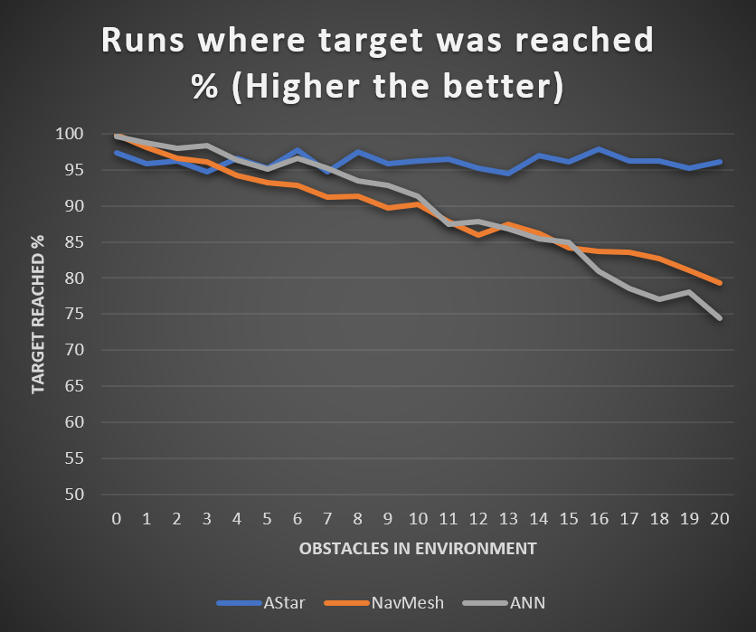
Figure 63: Success Rate Comparison (Full results available in appendix)
Figure 61 shows how well the A-Star method performs throughout the tests. In fact, A-Star outperforms both other methods considerably aside from the environments with five or less obstacles. This is due to the error identified in the A-Star implementation earlier in the report which could not be corrected due to time constraints. If the error were able to be corrected, then the results would likely be far closer to 100% for A-Star throughout the difficulties.
NavMesh and ANN both performed similarly. This seems to indicate the validity of the ANN method, however a reason for the down trend in performance with the NavMesh results may be due to the issue identified where the mesh would not reset instantly, meaning with more obstacles being introduced, there would be a higher chance for the agent to collide with an obstacle before the mesh had updated. With further improvements to the NavMesh testing environment, these errors could be lesser meaning the results could be improved considerably.
The ANN method had more fundamental issues where it would get caught in situations where it could not find a path when one did exist. The issue could only be fixed if the ANN were aware of previous positions so it would look to find new routes. That aside, the ANN method was still capable of navigating roughly 75% of the episodes in the most difficult environment.

Another metric used for comparison was the actual reward the methods achieved in each episode, where the maximum reward possible per episode was three. The graph in figure 62 illustrates the average reward percentage achieved by each method through the increasingly complex environments. The trends the curves take is very similar to the percentage of successful episodes in figure 61
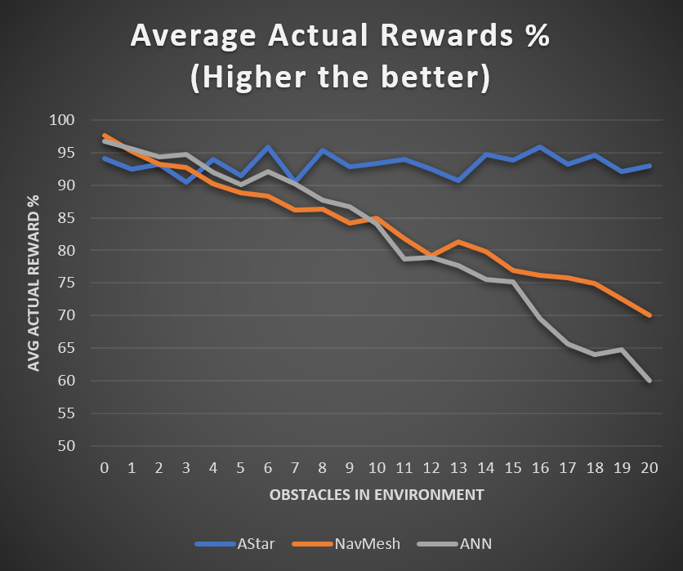
Figure 64: Reward Rate Comparison (Full results available in appendix)
This metric being so closely coupled with the previous metric is an interesting and intuitive observation, as the high rewards are tied to the target being reached. One difference is the spikes in each curve tend to be more exaggerated. This is likely due to the smaller scale of the reward structure, where the possible rewards range from -2 to +3, where the worst case was the agent stalling for the whole episode before colliding with an obstacle on the opposite end of the environment at the last step, and the best scenario being spawning immediately next to the target and colliding with it in the first step.
The last metric to compare is the average steps taken in each environment for the three methods. The graph in figure 63 illustrates the comparison between the three methods in their average steps.
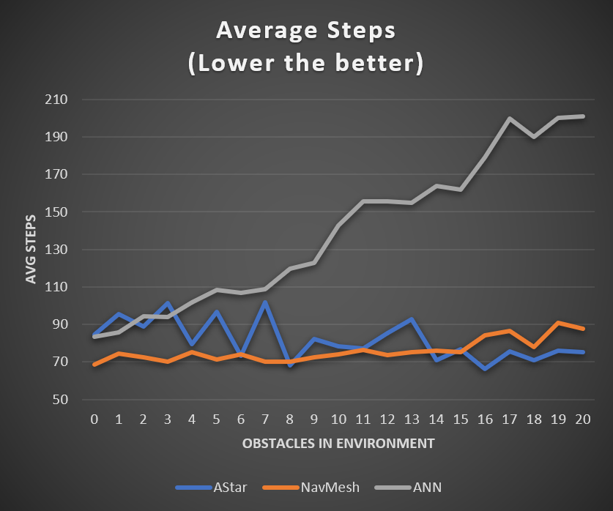
Figure 65: Step Rate Comparison (Full results available in appendix)
An observation to make is the comparative performance between A-Star and NavMesh, where NavMesh outperforms A-Star up until the 15 obstacles. This is due to the issue where the A-Star implementation had an issue where it would freeze in a small number of episodes. Although this number of episodes was relatively low, each of those episodes were time-outs which means they used the full 1000 steps before ending the episode, which has skewed the results negatively for the A-Star implementation.
To adjust the results so they are more useful, a better metric to compare would be the average steps for the episodes that ended in the target being reached, as this would eliminate the erroneous episodes where the implementation failed, rather than the algorithm itself.
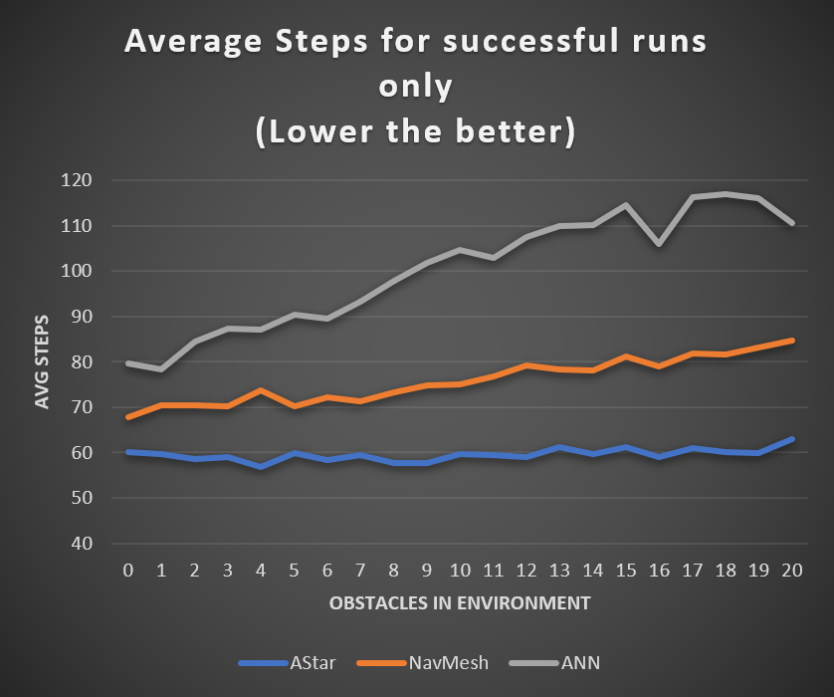
Figure 66: Adjusted Step Rate Comparison (Full results available in appendix)
With the adjusted metric, the trend can be observed clearly. A-Star is by far the best performing method which was to be expected. The interesting insight is the difference between the NavMesh and ANN implementations, where in previous comparisons they performed far more comparatively, where in this metric the NavMesh has a distinct advantage.
When this is investigated further, it was found that the ANN implementation, although able to navigate towards the target, would often hover around the target before moving in for a collision. This hesitation on the part of the ANN is likely an artefact of the training where the reinforcement learning technique taught the ANN to avoid obstacles and approach the target. This manifests in these moments where the ANN appears to be considering the move before making it.
This is a disadvantage of the ANN method compared to the other methods. The A-Star and NavMesh methods do not consider the positions of the obstacles, they only see the eligible areas they can move within and use that to navigate to the space where the target exists in that area. This disadvantage prevents the ANN from making concise movements towards the target and means it will likely never be able to perform as accurately or efficiently as the other methods with the setup of using raycasts.

Conclusion
Upon analysing the results, the accuracy and efficiency of the three methods, A-Star, NavMesh and ANN, the A-Star method clearly outperforms the other methods which was to be expected as it is a deterministic algorithmic approach that calculates the shortest path in the least amount of time. Although there were issues with the A-Star implementation, resulting in some skewed results where the method appeared to perform worse in less complex environments. This issue would be corrected with more time.
The NavMesh and ANN method performed very similarly to each other, which gives the impression that the ANN was just as good. Unfortunately, upon further inspection it was found that the NavMesh results were lower than they should be due to an error with the mesh not loading fast enough at the start of each episode, making it more likely for the agent to collide with an obstacle when there were more obstacles in the environment. This could be considered a disadvantage of the NavMesh implementation and perhaps not an error of the implementation. A fix could be implemented, but this may give a bias towards the NavMesh results.
The ANN method performed the worst out of the three methods, which was due to the fundamental setup of the implementation, where it views the environment as ray casts and positions, instead of areas or grids it can traverse through. This setup resulted in the ANN hesitating to move towards the target if the target were close to an obstacle or getting stuck in positions where it could not navigate from when a possible path did exist. Despite these issues, the ANN was able to successfully navigate to the target ~75% of the time in the most complex environments used for the tests, which could be considered a small success.

Evaluation
Overall, the implementation has performed well in identifying the performance differences between the three pathfinding methods used. The ANN implementation performed surprisingly well considering the nature of the implementation. It was exceedingly outperformed by the A-Star algorithm which was to be expected because A-Star calculates a shortest route while the ANN makes decisions in real time by moving toward the target while avoiding obstacles on the way. However, the ANN performed comparatively to the NavMesh implementation which is an achievement. The NavMesh implementation suffered with failing to process the environment and produce an accurate mesh fast enough in some of the tests which is more a disadvantage to the method than an error.
The Unity game engine served well as a development platform as it allowed for an intuitive visual representation of the problem while being intuitive and easy to learn for someone who does not have prior knowledge or experience with the platform.
The ANN implementation was able to meet all the aims set out in the beginning of the project. It was able to navigate through a dynamic and changing environment with comparable performance to other algorithm-based pathfinding solutions by reading information from its surroundings and making decisions in real time to find a path.
With the results gained from the testing of the methods, the validity of the hypothesis of the project has been supported. While the implementation was not perfect, it was still capable of navigating through a dynamic and changing environment whilst also having room for improvement.

Conclusions and Recommendations

Summary
In Summary, the project began with a hypothesis that postulated that Artificial Neural Networks could be used to navigate through a dynamic and changing environment. The aims that needed to be met to effectively test the hypothesis were described and the objectives were laid out as a road map of how the project would achieve the aims.
To test this hypothesis, a review of literature in the field of artificial intelligence was completed to gain an in depth understanding of the different approaches that are appropriate for navigation and pathfinding. The literature showed that the existing pathfinding techniques were deterministic algorithm approaches like A-Star and NavMesh. These two approaches would be used as the test candidates to determine the validity of the hypothesis by comparing their results to an implemented ANN that could navigate the same environment.
From the literature review, it was also found that a good environment to implement and test the pathfinding approaches would be the Unity game engine which has an intuitive user interface and compatibility with the C# language. The Unity game engine also has access to a machine learning library that was used to implement an ANN with the ability to train it with the reinforcement learning method.
After the relevant information was found from the literature review, design and implementation of the project began. The Unity game engine was used to implement an environment which all the pathfinding methods could use as a test harness. After the base environment was made, the A-Star, NavMesh and ANN approaches were implemented on top of it.
The ANN was then trained in a training farm simulation with multiple iterations to produce a smarter agent each iteration that could navigate through increasingly complex environments. This was done with the MLAgents library that was compatible with the Unity game engine.
Once the training of the ANN had been completed, the three methods were extensively tested with their results being written to an external file. Each method was tested in 21 different environments 1000 times each, where each of the 21 environments was more complex than the last, giving a total of 63,000 test results, each test result containing crucial data that could be used to form statistical information on the performance and accuracy of the respective method.
After the test results were compiled and statistical information was extrapolated, the three methods were compared, and it was found that the ANN implementation was severely outperformed by the A-Star method while also performing comparably to the NavMesh implementation. Despite the comparisons, the ANN was able to navigate through ~75% of the most complex environments it was put through.

Conclusion
In conclusion, the project has successfully tested and supported the initial hypothesis.
This was achieved by setting out aims that were specific, measured, achievable, relevant and time constrained. The objectives set out to achieve the aims were clear and concise with a focus to thoroughly research the topic of artificial intelligence to allow for an informed implementation that could test the initial hypothesis.
The literature review gave insight on the origins of AI and machine learning. The literature review also explored the methods used to solve the pathfinding problems like A-Star and NavMesh. These approaches would be used as the test candidates for comparison against the ANN that was intended to be implemented. The literature review also explored the possible avenues that could be taken when implementing and training an ANN model, with the reinforcement training method being the approach of choice. The literature was intended to act as a backbone for reference during the implementation, as the research methodology took a positivist philosophy which aimed to collect factual, peer reviewed sources which were written by experts in the field of artificial intelligence.
The development method used for this project was a custom variant of the feature driven development methodology. It allowed for a flexible workflow that had a defined structure which was focussed on designing, developing, and testing features like creating a test harness, and training the ANN model. This methodology worked well with the project as it made it easy to get to a point of a minimum viable product with opportunity to develop further if time allowed.
The design and implementation of the project was able to meet the specifications set out in the aims and objectives and in the problem formulation section of the report. An ANN model was developed and trained to navigate through a dynamic and changing environment successfully by using the reinforcement training method.
The testing and results gained gave insight on the respective performances of the three methods in a controlled environment. These test results identified that A-Star was the best implementation, followed by NavMesh and ANN performing very similarly to each other, with ANN successfully navigating through ~75% of the most complex testing environments used. This could be further improved with a different approach to the ANN setup by giving it a memory of its position history, or a different setup entirely where it is aware of the whole environment like the other implementations were.
These results and insights support the initial hypothesis that an ANN can be trained and used to successfully navigate a dynamic and changing environment.

Recommendations for Further Research and Development
With more time and resources, further development, and research could be undertaken to improve upon the current state of the project. Further research into ANN would be undertaken to find out how plausible a position history being supplied to the ANN would be. This may require a rework of the ANN architecture and require further development and training.
With the current state of the project, there are a few issues that would be corrected with further time. These issues include the A-Star implementation failing to find a path in a small percentage of the runs. Another issue that would be fixed is the NavMesh not fully recalibrating the mesh when the episode starts.
Further development would also include creating a test harness with more dynamic obstacles that move during the episodes. This would further test the capabilities of the pathfinding implementations to determine their effectiveness. Another development would include the creation of a test environment that was more a maze, with an intended path to be taken which would give opportunity to more in-depth testing.
One other possible future development would be a real-world physical application of the ANN which uses optical apparatus as the ray casts to determine whether the implementation could be applied to a self-driving vehicle.

Reflection
Reflecting on the progress made through the project, approaches or actions that would be taken differently in hindsight would include using resources more efficiently, as during the literature review, a large amount of the research was not specifically used to support the implementation.
Another consideration for what would have been done differently if the opportunity to redo the project would be the implementation of more robust pathfinding agents that did not have the issues that were found during testing.
With better use of time and resources, further development could have been done, producing more dynamic environments which could be used as test harnesses to further determine the validity of the hypothesis.
Another consideration for variance would be using different game development engines like the Unreal and GoDot engines. These differences could have produced similar or different results and will not be fully known without further investigation.

References
[1] “Alan Mathison Turing, 1912-1954,” Biogr. Mem. Fellows R. Soc., vol. 1, pp. 253–263, Nov. 1955, doi: 10.1098/rsbm.1955.0019.
[2] R. E. Neapolitan and R. E. Neapolitan, “Neural Networks and Deep Learning,” in Artificial Intelligence, Determination Press, 2018, pp. 389–411.
[3] A. Juliani et al., “Unity: A general platform for intelligent agents,” arXiv. arXiv, Sep. 07, 2018.
[4] J. Ottaviani, The imitation game---{A}lan {T}uring decoded, vol. 263, no. 5. 2016.
[5] A. Turing, “Alan Turing Scrapbook - Turing Test,” Turing.org. 1950, Accessed: Oct. 28, 2020. [Online]. Available: https://www.turing.org.uk/scrapbook/test.html.
[6] J. Roberts, “Thinking Machines: The Search for Artificial Intelligence | Science History Institute,” Distillations, 2016. https://web.archive.org/web/20180819152455/https://www.sciencehistory.org/distillations/magazine/thinking-machines-the-search-for-artificial-intelligence (accessed Oct. 26, 2020).
[7] H. J. KELLEY, “Gradient Theory of Optimal Flight Paths,” ARS J., vol. 30, no. 10, pp. 947–954, Oct. 1960, doi: 10.2514/8.5282.
[8] S. E. Dreyfus, “Artificial neural networks, back propagation, and the kelley-bryson gradient procedure,” J. Guid. Control. Dyn., vol. 13, no. 5, pp. 926–928, May 1990, doi: 10.2514/3.25422.
[9] S. Dreyfus, “The numerical solution of variational problems,” J. Math. Anal. Appl., vol. 5, no. 1, pp. 30–45, 1962, doi: 10.1016/0022-247X(62)90004-5.
[10] C. Ireland, “Alan Turing at 100 – Harvard Gazette,” 2012. https://news.harvard.edu/gazette/story/2012/09/alan-turing-at-100/ (accessed Oct. 28, 2020).
[11] C. Bassett, “The computational therapeutic: exploring Weizenbaumâ€TMs ELIZA as a history of the present,” vol. 34, pp. 803–812, 2019, doi: 10.1007/s00146-018-0825-9.
[12] “12 AI Milestones: 1. Shakey The Robot.” https://www.forbes.com/sites/gilpress/2020/01/20/12-ai-milestones-shakey-the-robot/?sh=5b65833b5400 (accessed Nov. 01, 2020).
[13] “DATAMATH.” http://www.datamath.org/Speech/SpeaknSpell.htm (accessed Nov. 01, 2020).
[14] H. Tan, “A brief history and technical review of the expert system research,” in IOP Conference Series: Materials Science and Engineering, 2017, vol. 242, no. 1, doi: 10.1088/1757-899X/242/1/012111.
[15] D. C. Brock, “Learning from artificial intelligence’s previous awakenings: The history of expert systems,” AI Magazine, vol. 39, no. 3. pp. 3–15, 2018, doi: 10.1609/aimag.v39i3.2809.
[16] B. P. Bloomfield and T. Vurdubakis, “IBM’s chess players: On AI and its supplements,” Inf. Soc., vol. 24, no. 2, pp. 69–82, Mar. 2008, doi: 10.1080/01972240701883922.
[17] S. Levy, “Man vs. machine.,” Newsweek, vol. 129, no. 18, pp. 50–57, 1997.
[18] S. Gimbel, “Get with the program: Kasparov, deep blue, and accusations of unsportsthinglike conduct,” J. Appl. Philos., vol. 15, no. 2, pp. 145–154, 1998, doi: 10.1111/1468-5930.00082.
[19] “Deep Blue, IBM’s supercomputer, defeats chess champion Garry Kasparov in 1997 - New York Daily News.” https://www.nydailynews.com/news/world/kasparov-deep-blues-losingchess-champ-rooke-article-1.762264 (accessed Feb. 07, 2021).
[20] T. Morrissey, “Growing Nowhere: Pinocchio Subverted in Spielberg’s A.I. Artificial Intelligence,” Extrapolation, vol. 45, no. 3, pp. 249–262, 2004, doi: 10.3828/extr.2004.45.3.05.
[21] T. Habib, J. N. Kristiansen, M. B. Rana, and P. Ritala, “Revisiting the role of modular innovation in technological radicalness and architectural change of products: The case of Tesla X and Roomba,” Technovation, vol. 98, p. 102163, Dec. 2020, doi: 10.1016/j.technovation.2020.102163.
[22] D. V. Lee and A. A. Biewener, “BigDog-inspired studies in the locomotion of goats and dogs,” in Integrative and Comparative Biology, Jul. 2011, vol. 51, no. 1, pp. 190–202, doi: 10.1093/icb/icr061.
[23] A. For, P. Release, and D. Unlimited, “DEFENSE ADVANCED RESEARCH PROJECTS AGENCY STRATEGIC PLAN,” Distribution, no. February. 2007.
[24] R. Chandrasekar, “Elementary? Question answering, IBM’s Watson, and the Jeopardy! challenge,” Resonance, vol. 19, no. 3, pp. 222–241, Mar. 2014, doi: 10.1007/s12045-014-0029-7.
[25] “A brief history of DeepMind: EBSCOhost.” https://web-b-ebscohost-com.ezproxy.uwtsd.ac.uk/ehost/detail/detail?vid=1&sid=fbd52fb6-0c9a-429a-8d22-37e1f8cf51a8%40sessionmgr101&bdata=JnNpdGU9ZWhvc3QtbGl2ZQ%3D%3D#AN=147891054&db=aph (accessed Feb. 07, 2021).
[26] E. Gibney, “DeepMind algorithm beats people at classic video games,” Nature, vol. 518, no. 7540. Nature Publishing Group, pp. 465–466, Feb. 26, 2015, doi: 10.1038/518465a.
[27] N. M. Curran, J. Sun, and J. W. Hong, “Anthropomorphizing AlphaGo: a content analysis of the framing of Google DeepMind’s AlphaGo in the Chinese and American press,” AI Soc., vol. 35, no. 3, pp. 727–735, Sep. 2020, doi: 10.1007/s00146-019-00908-9.
[28] C. Stokel-Walker, “AI thrashes human StarCraft II pros…,” New Sci., vol. 241, no. 3215, p. 14, Feb. 2019, doi: 10.1016/s0262-4079(19)30183-6.
[29] O. Vinyals et al., “Grandmaster level in StarCraft II using multi-agent reinforcement learning,” Nature, vol. 575, no. 7782, pp. 350–354, Nov. 2019, doi: 10.1038/s41586-019-1724-z.
[30] D. Aamoth, “Interview with Eugene Goostman, the Fake Kid Who Passed the Turing Test,” Time, pp. 1–3, 2014, Accessed: Feb. 07, 2021. [Online]. Available: http://time.com/2847900/eugene-goostman-turing-test/.
[31] “Artificial intelligence ‘Eugene’ passes Turing Test.,” Eng. (Online Ed., pp. 1–2, 2014.
[32] U. Pagallo, “Vital, Sophia, and Co.-The quest for the legal personhood of robots,” Inf., vol. 9, no. 9, p. 230, Sep. 2018, doi: 10.3390/info9090230.
[33] G. Phillips-Wren and L. Jain, “Artificial intelligence for decision making,” in Lecture Notes in Computer Science (including subseries Lecture Notes in Artificial Intelligence and Lecture Notes in Bioinformatics), 2006, vol. 4252 LNAI, pp. 531–536, doi: 10.1007/11893004_69.
[34] J. Łukasiewicz, A. Trybus, and B. Linsky, “The Principle of Contradiction and Symbolic Logic,” Hist. Philos. Log., vol. 41, no. 2, pp. 154–182, Apr. 2020, doi: 10.1080/01445340.2019.1693246.
[35] M. Balser, C. Duelli, W. Reif, and G. Schellhorn, “Verifying concurrent systems with symbolic execution,” J. Log. Comput., vol. 12, no. 4, pp. 549–560, Aug. 2002, doi: 10.1093/logcom/12.4.549.
[36] L. Biacino, L. Biacino, and G. Gerla, “Fuzzy Logic, Continuity and Effectiveness,” 2001, Accessed: Jan. 02, 2021. [Online]. Available: https://citeseerx.ist.psu.edu/viewdoc/summary?doi=10.1.1.2.8029.
[37] T. Arnett, “An Introduction to Fuzzy Logic,” YouTube Video, 2015. https://www.youtube.com/watch?v=rln_kZbYaWc&ab_channel=TimArnett (accessed Jan. 02, 2021).
[38] “Temperature Fuzzy sets: COLD, NORMAL, HOT Modeling Fuzzy Systems with... | Download Scientific Diagram.” https://www.researchgate.net/figure/Temperature-Fuzzy-sets-COLD-NORMAL-HOT-Modeling-Fuzzy-Systems-with-FCCS-We-can-now-use_fig1_221399564 (accessed Jan. 02, 2021).
[39] B. C. Arabacioglu, “Using fuzzy inference system for architectural space analysis,” Appl. Soft Comput. J., vol. 10, no. 3, pp. 926–937, Jun. 2010, doi: 10.1016/j.asoc.2009.10.011.
[40] G. Gerla, “Effectiveness and multivalued logics,” J. Symb. Log., vol. 71, no. 1, pp. 137–162, Mar. 2006, doi: 10.2178/jsl/1140641166.
[41] Z. Du, “Special issue on Intelligence Computation Evolutionary Computation: ICEV2018,” Evolutionary Intelligence, vol. 12, no. 3. Springer Verlag, pp. 321–322, Sep. 01, 2019, doi: 10.1007/s12065-019-00271-0.
[42] R. Kicinger, T. Arciszewski, and K. De Jong, “Evolutionary computation and structural design: A survey of the state-of-the-art,” Comput. Struct., vol. 83, no. 23–24, pp. 1943–1978, Sep. 2005, doi: 10.1016/j.compstruc.2005.03.002.
[43] S. Rostami, D. O’Reilly, A. Shenfield, and N. Bowring, “A novel preference articulation operator for the Evolutionary Multi-Objective Optimisation of classifiers in concealed weapons detection,” Inf. Sci. (Ny)., vol. 295, pp. 494–520, 2015, doi: 10.1016/j.ins.2014.10.031.
[44] “Evolutionary computation (Online) - University of Wales Trinity Saint David.” https://whel-primo.hosted.exlibrisgroup.com/primo-explore/fulldisplay?docid=44UWTSD_ALMA51168829490002421&context=L&vid=44WHELF_UWTSD_VU1&lang=en_US&search_scope=CSCOP_EVERYTHING&adaptor=Local Search Engine&tab=tab1&query=any,contains,evolutionary computation&mode=basic (accessed Apr. 18, 2021).
[45] D. B. Fogel, “What is evolutionary computation?,” IEEE Spectr., vol. 37, no. 2, Feb. 2000, doi: 10.1109/6.819926.
[46] C. A. Knoblock, J. L. Ambite, M. Carman, M. Michelson, P. Szekely, and R. Tuchinda, “Beyond the Elves: Making intelligent agents intelligent,” AI Mag., vol. 29, no. 2, pp. 33–42, 2008.
[47] A. J.M. and E. Oliveir, “Disruption Management in Airline Operations Control – An Intelligent Agent-Based Approach,” in Web Intelligence and Intelligent Agents, InTech, 2010.
[48] Z.-U.-H. Usmani, Web Intelligence and Intelligent Agents. InTech, 2012.
[49] J. Tweedale, N. Ichalkaranje, C. Sioutis, B. Jarvis, A. Consoli, and G. Phillips-Wren, “Innovations in multi-agent systems,” J. Netw. Comput. Appl., vol. 30, no. 3, pp. 1089–1115, Aug. 2007, doi: 10.1016/j.jnca.2006.04.005.
[50] “Agents in Artificial Intelligence - GeeksforGeeks.” https://www.geeksforgeeks.org/agents-artificial-intelligence/ (accessed Jan. 04, 2021).
[51] R. M. JONES, “Comparative analysis of frameworks for knowledge-intensive intelligent agents,” AI Mag., vol. 27, no. 2, pp. 57–70, 2006.
[52] P. D. Wasserman and T. Schwartz, “Neural Networks, Part 1: What are they and why is everybody so interested in them now?,” IEEE Expert. Syst. their Appl., vol. 2, no. 4, pp. 10–14, Jan. 1987, doi: 10.1109/MEX.1987.5006524.
[53] R. Nagyfi, “The differences between Artificial and Biological Neural Networks | by Richard Nagyfi | Towards Data Science,” 2018. https://towardsdatascience.com/the-differences-between-artificial-and-biological-neural-networks-a8b46db828b7 (accessed Apr. 19, 2021).
[54] F. Demirci, P. Akan, T. Kume, A. R. Sisman, Z. Erbayraktar, and S. Sevinc, “Artificial neural network approach in laboratory test reporting: Learning algorithms,” Am. J. Clin. Pathol., vol. 146, no. 2, pp. 227–237, Aug. 2016, doi: 10.1093/ajcp/aqw104.
[55] P. beim Graben and J. Wright, “From McCulloch-Pitts Neurons Toward Biology,” Bulletin of Mathematical Biology, vol. 73, no. 2. pp. 261–265, Mar. 2011, doi: 10.1007/s11538-011-9629-5.
[56] Y. Nagai and Y. Aizawa, “Rule-dynamical generalization of McCulloch-Pitts neuron networks,” in BioSystems, Dec. 2000, vol. 58, no. 1–3, pp. 177–185, doi: 10.1016/S0303-2647(00)00121-0.
[57] “McCulloch&Pitts | 2017.” https://ulginge0012.wixsite.com/2017/mcculloch-pitts (accessed Apr. 19, 2021).
[58] F. Rosenblatt, “The perceptron: A probabilistic model for information storage and organization in the brain,” Psychol. Rev., vol. 65, no. 6, pp. 386–408, 1958, doi: 10.1037/h0042519.
[59] B. Recht and C. Ré, “Toward a noncommutative arithmetic-geometric mean inequality: Conjectures, case-studies, and consequences,” in Journal of Machine Learning Research, 2012, vol. 23, Accessed: Jan. 06, 2021. [Online]. Available: https://sebastianraschka.com/Articles/2015_singlelayer_neurons.html.
[60] “A typical two layer neural network. Input layer does not count as the... | Download Scientific Diagram.” https://www.researchgate.net/figure/A-typical-two-layer-neural-network-Input-layer-does-not-count-as-the-number-of-layers-of_fig4_282997080 (accessed Jan. 25, 2021).
[61] Wiki, “Heaviside step function,” pp. 1–4, 2012.
[62] H. Kumar, “Don’t use sigmoid: Neural Nets,” 2018. https://kharshit.github.io/blog/2018/04/20/don%27t-use-sigmoid-neural-nets (accessed Jan. 25, 2021).
[63] S. Sagar, “Activation Functions in Neural Networks | by SAGAR SHARMA | Towards Data Science,” Towards data science, 2017. https://towardsdatascience.com/activation-functions-neural-networks-1cbd9f8d91d6 (accessed Jan. 25, 2021).
[64] H. T. Method, “Hyperbolic Tangent Method,” vol. 20, pp. 1–3.
[65] J. Brownlee, “A Gentle Introduction to the Rectified Linear Unit (ReLU),” in Machinelearningmastery.Com, 2019, pp. 1–21, Accessed: Jan. 25, 2021. [Online]. Available: https://machinelearningmastery.com/rectified-linear-activation-function-for-deep-learning-neural-networks/.
[66] J. Mycielski, “Book Review: Perceptrons, An Introduction to Computational Geometry,” Bull. Am. Math. Soc., vol. 78, no. 1, pp. 12–16, Jan. 1972, doi: 10.1090/s0002-9904-1972-12831-3.
[67] H. Zhang, W. Wu, and D. Wang, “Multi-instance multi-label learning of natural scene images: Via sparse coding and multilayer neural network,” IET Comput. Vis., vol. 12, no. 3, pp. 305–311, Apr. 2018, doi: 10.1049/iet-cvi.2016.0338.
[68] R. Rojas, “The Backpropagation Algorithm 7.1 Learning as gradient descent,” 1996. Accessed: Jul. 25, 2019. [Online]. Available: https://page.mi.fu-berlin.de/rojas/neural/chapter/K7.pdf.
[69] C. K. Leung, “AI-Based Sensor Information Fusion for Supporting Deep Supervised Learning,” Sensors (Basel)., vol. 19, no. 6, pp. 1345-, Mar. 2019.
[70] M. Rouse, “What is Supervised Learning? - Definition,” 2018. https://searchenterpriseai.techtarget.com/definition/supervised-learning (accessed Jan. 26, 2021).
[71] C. Leung, P. Braun, and A. Cuzzocrea, “AI-Based Sensor Information Fusion for Supporting Deep Supervised Learning,” Sensors, vol. 19, no. 6, p. 1345, Mar. 2019, doi: 10.3390/s19061345.
[72] C. K. Leung, P. Braun, and A. Cuzzocrea, “Ai-based sensor information fusion for supporting deep supervised learning,” Sensors (Switzerland), vol. 19, no. 6, p. 1345, Mar. 2019, doi: 10.3390/s19061345.
[73] statisticsfun, “An Introduction to Linear Regression Analysis,” vol. 2, pp. 1–65, 2018, Accessed: Jan. 26, 2021. [Online]. Available: https://www.youtube.com/watch?v=zPG4NjIkCjc&ab_channel=statisticsfun.
[74] S. Shang, E. Nesson, and M. Fan, “INTERACTION TERMS IN POISSON AND LOG LINEAR REGRESSION MODELS,” Bull. Econ. Res., vol. 70, no. 1, pp. E89–E96, Jan. 2018, doi: 10.1111/boer.12120.
[75] Q. Zheng, X. Tian, N. Jiang, and M. Yang, “Layer-wise learning based stochastic gradient descent method for the optimization of deep convolutional neural network,” J. Intell. Fuzzy Syst., vol. 37, no. 4, pp. 5641–5654, 2019, doi: 10.3233/JIFS-190861.
[76] P. L. Bartlett, D. P. Helmbold, and P. M. Long, “Gradient descent with identity initialization efficiently learns positive-definite linear transformations by deep residual networks,” Neural Comput., vol. 31, no. 3, pp. 477–502, Mar. 2019, doi: 10.1162/neco_a_01164.
[77] Y. Chen, Y. Chi, J. Fan, and C. Ma, “Gradient descent with random initialization: fast global convergence for nonconvex phase retrieval,” Math. Program., vol. 176, no. 1–2, pp. 5–37, 2019, doi: 10.1007/s10107-019-01363-6.
[78] D. Needell, N. Srebro, and R. Ward, “Stochastic gradient descent, weighted sampling, and the randomized Kaczmarz algorithm,” Math. Program., vol. 155, no. 1–2, pp. 549–573, 2016, doi: 10.1007/s10107-015-0864-7.
[79] B. Wilkinson, “Social Network for Programmers and Developers.” 2018, Accessed: Jan. 26, 2021. [Online]. Available: https://morioh.com/p/15c995420be6.
[80] Z. Wen, “Examples of Supervised Learning (Linear Regression) and Unsupervised... | Download Scientific Diagram,” 2019. https://www.researchgate.net/figure/Examples-of-Supervised-Learning-Linear-Regression-and-Unsupervised-Learning_fig3_336642133 (accessed Jan. 27, 2021).
[81] D. Wang, “Unsupervised Learning: Foundations of Neural Computation: A review,” AI Mag., vol. 22, no. 2, pp. 101-, Jul. 2001.
[82] M. C. Thrun, Projection-Based Clustering through Self-Organization and Swarm Intelligence Combining Cluster Analysis with the Visualization of High-Dimensional Data. 2018.
[83] F. Guo et al., “Exploration of the mechanism of traditional Chinese medicine by AI approach using unsupervised machine learning for cellular functional similarity of compounds in heterogeneous networks, XiaoErFuPi granules as an example,” Pharmacol. Res., vol. 160, p. 105077, Oct. 2020, doi: 10.1016/j.phrs.2020.105077.
[84] “How many types of Cluster Analysis and Techniques using R – AnalyticsBuddhu.” https://analyticsbuddhu.wordpress.com/2016/11/01/types-of-cluster-analysis-and-techniques-using-r/ (accessed Jan. 27, 2021).
[85] E. F. Morales and J. H. Zaragoza, “An introduction to reinforcement learning,” in Decision Theory Models for Applications in Artificial Intelligence: Concepts and Solutions, 2011, pp. 63–80.
[86] R. Hafner and M. Riedmiller, “Reinforcement learning in feedback control : Challenges and benchmarks from technical process control,” Mach. Learn., vol. 84, no. 1–2, pp. 137–169, Jul. 2011, doi: 10.1007/s10994-011-5235-x.
[87] V. François-Lavet, P. Henderson, R. Islam, M. G. Bellemare, and J. Pineau, “An introduction to deep reinforcement learning,” Found. Trends Mach. Learn., vol. 11, no. 3–4, pp. 219–354, Dec. 2018, doi: 10.1561/2200000071.
[88] Reinforcement Learning. 2008.
[89] “5 Things You Need to Know about Reinforcement Learning.” https://www.kdnuggets.com/2018/03/5-things-reinforcement-learning.html (accessed Jan. 27, 2021).
[90] B. Kiumarsi, F. L. Lewis, H. Modares, A. Karimpour, and M. B. Naghibi-Sistani, “Reinforcement Q-learning for optimal tracking control of linear discrete-time systems with unknown dynamics,” Automatica, vol. 50, no. 4, pp. 1167–1175, Apr. 2014, doi: 10.1016/j.automatica.2014.02.015.
[91] M. W. Akhtar, R. Ghaffar, and I. Rashid, “A Q Learning and Fuzzy Q Learning Approach for Optimization of Interference Constellations in Femto–Macro Cellular Architecture in Downlink,” Wirel. Pers. Commun., vol. 88, no. 4, pp. 797–817, Jun. 2016, doi: 10.1007/s11277-016-3206-z.
[92] K. C. Ciesielski, A. X. Falcão, and P. A. V. Miranda, “Path-Value Functions for Which Dijkstra’s Algorithm Returns Optimal Mapping,” J. Math. Imaging Vis., vol. 60, no. 7, pp. 1025–1036, Sep. 2018, doi: 10.1007/s10851-018-0793-1.
[93] Introduction to algorithms. 2009.
[94] “GitHub - peloyeje/map543-dijkstra-mapreduce-spark: [MAP543] Hadoop Streaming (MapReduce) and Spark implementations of the Dijkstra shortest path algorithm.” https://github.com/peloyeje/map543-dijkstra-mapreduce-spark (accessed Feb. 01, 2021).
[95] J. Zhang et al., “Vehicle routing in urban areas based on the Oil Consumption Weight ‐Dijkstra algorithm,” IET Intell. Transp. Syst., vol. 10, no. 7, pp. 495–502, Sep. 2016, doi: 10.1049/iet-its.2015.0168.
[96] H. Ortega-Arranz, The shortest-path problem : analysis and comparison of methods. 2015.
[97] R. K. Singh, T. P. Queue, and P. Queue, “Java Priority Queue Tutorial with Examples,” pp. 1–7, 2018, Accessed: Feb. 03, 2021. [Online]. Available: https://www.callicoder.com/java-priority-queue/.
[98] B. Kuipers, E. A. Feigenbaum, P. E. Hart, and N. J. Nilsson, “Shakey: From conception to history,” AI Magazine, vol. 38, no. 1. AI Access Foundation, pp. 88–103, Mar. 31, 2017, doi: 10.1609/aimag.v38i1.2716.
[99] E. Fernandes, P. Costa, J. Lima, and G. Veiga, “Towards an orientation enhanced astar algorithm for robotic navigation,” in Proceedings of the IEEE International Conference on Industrial Technology, Mar. 2015, vol. 2015-June, no. June, pp. 3320–3325, doi: 10.1109/ICIT.2015.7125590.
[100] M. G. H. Bell, “Hyperstar: A multi-path Astar algorithm for risk averse vehicle navigation,” Transp. Res. Part B Methodol., vol. 43, no. 1, pp. 97–107, Jan. 2009, doi: 10.1016/j.trb.2008.05.010.
[101] “What is Hierarchical Clustering and How Does It Work?” https://www.mygreatlearning.com/blog/hierarchical-clustering/ (accessed Feb. 03, 2021).
[102] “GODOT 3.0 released,” Linux Format, no. 235, pp. 8–8, Apr. 2018.
[103] І. Доброскок, Н. Ржевська, Х. Айїлдиз, Д. Заімова, and Г. Желязков, “GAME DEVELOPMENT SOFTWARE TOOLS IN HIGHER EDUCATIONAL INSTITUTIONS: EXPERIENCE OF UKRAINE, TURKEY AND BULGARIA,” Inf. Technol. Learn. Tools, vol. 78, no. 4, pp. 90–104, Sep. 2020, doi: 10.33407/itlt.v78i4.3370.
[104] C. Littler, “A Game Engine for All,” Beanz, vol. 5, no. 6, pp. 12-, Jun. 2018.
[105] “Foss Bytes: Godot Engine Adds VR Support,” Open Source You, Mar. 2018.
[106] A. Cookson, R. DowlingSoka, and C. Crumpler, Sams Teach Yourself Unreal Engine 4 Game Development in 24 Hours. 2016.
[107] T. Meigs, Ultimate Game Design: Building Game Worlds. 2003.
[108] T. Shannon, Unreal Engine 4 for design visualization : developing stunning interactive visualizations, animations, and renderings. 2018.
[109] “Opening Doors | Unreal Engine Documentation.” https://docs.unrealengine.com/en-US/ProgrammingAndScripting/Blueprints/UserGuide/Timelines/Examples/OpeningDoors/index.html (accessed Feb. 05, 2021).
[110] P. Skop, “Comparison of performance of game engines across various platforms,” J. Comput. Sci. Inst., vol. 7, pp. 116–119, Sep. 2018, doi: 10.35784/jcsi.657.
[111] C. B. Price, “Unreal PowerPointTM: Immersing PowerPoint presentations in a virtual computer game engine world,” Comput. Human Behav., vol. 24, no. 6, pp. 2486–2495, Sep. 2008, doi: 10.1016/j.chb.2008.03.009.
[112] I. Buyuksalih, S. Bayburt, G. Buyuksalih, A. P. Baskaraca, H. Karim, and A. A. Rahman, “3D MODELLING AND VISUALIZATION BASED ON THE UNITY GAME ENGINE – ADVANTAGES AND CHALLENGES,” ISPRS Ann. Photogramm. Remote Sens. Spat. Inf. Sci., vol. IV-4/W4, no. 4W4, pp. 161–166, Nov. 2017, doi: 10.5194/isprs-annals-IV-4-W4-161-2017.
[113] A. Thorn, Unity 4 fundamentals : get started at making games with Unity. 2014.
[114] “Create an Unity inventory: part 4: Display items in UI | by Yone Moreno Jiménez | Medium.” https://medium.com/@yonem9/create-an-unity-inventory-part-4-display-items-in-ui-6cdac8f734b7 (accessed Feb. 06, 2021).
[115] S. Blackman, Beginning 3D game development with Unity : the world’s most widely used multi-platform game engine. 2011.
[116] M. Zikky, “Review of A* (A Star) Navigation Mesh Pathfinding as the Alternative of Artificial Intelligent for Ghosts Agent on the Pacman Game,” Emit. Int. J. Eng. Technol., vol. 4, no. 1, Aug. 2016, doi: 10.24003/emitter.v4i1.117.
[117] Z. He, M. Shi, and C. Li, “Research and application of path-finding algorithm based on unity 3D,” in 2016 IEEE/ACIS 15th International Conference on Computer and Information Science (ICIS), Jun. 2016, pp. 1–4, doi: 10.1109/ICIS.2016.7550934.
[118] “Build VR: Using Unity NavMesh for First Person Movement in VR | by Dave Johnston | Medium.” https://medium.com/@davijoh73/build-vr-using-unity-navmesh-for-first-person-movement-in-vr-64efe0909d84 (accessed Feb. 06, 2021).
[119] J. Hocking, Unity in action : multiplatform game development in C#. 2015.
[120] B.-C.-Z. Blaga, “Performance Analysis in Implementation of a Dodgeball Agent for Video Games,” Int. J. User - Syst. Interact., vol. 12, no. 4, pp. 225–240, Oct. 2019.
[121] C. Urrea, F. Garrido, and J. Kern, “Design and implementation of intelligent agent training systems for virtual vehicles,” Sensors (Switzerland), vol. 21, no. 2, pp. 1–25, Jan. 2021, doi: 10.3390/s21020492.
[122] “Unity Technologies Unveils Machine Learning Agents,” Dataquest, Sep. 2017.
[123] “Cant connect to trainer on port 5004 - Unity Forum.” https://forum.unity.com/threads/cant-connect-to-trainer-on-port-5004.845557/ (accessed Apr. 21, 2021).
[124] “Announcing ML-Agents Unity Package v1.0!ML-Agents Unity 패키지 v1.0 출시ML-Agents Unity パッケージ v1.0 を発表しました - Unity Technologies Blog.” https://blogs.unity3d.com/cn/2020/05/12/announcing-ml-agents-unity-package-v1-0/ (accessed Apr. 21, 2021).
[125] P. McNeill, Research methods. 2005.
[126] M. Barinaga, “The foundations of research,” Science, vol. 253, no. 5025. pp. 1200–1202, 1991, doi: 10.1126/science.1891710.
[127] J. Fjermestad and S. R. Hiltz, “An assessment of group support systems experimental research: Methodology and results,” J. Manag. Inf. Syst., vol. 15, no. 3, pp. 7–149, 1998, doi: 10.1080/07421222.1998.11518216.
[128] “Secondary Research- Definition, Methods and Examples. | QuestionPro.” https://www.questionpro.com/blog/secondary-research/ (accessed Apr. 19, 2021).
[129] K. Sudheesh, D. R. Duggappa, and S. S. Nethra, “How to write a research proposal?,” Indian Journal of Anaesthesia, vol. 60, no. 9. pp. 631–634, 2016, doi: 10.4103/0019-5049.190617.
[130] R. Mahdavi-Hezave and R. Ramsin, “FDMD: Feature-Driven Methodology Development,” doi: 10.5220/0005384202290237.
[131] A. Firdaus, I. Ghani, and N. I. M. Yasin, “Developing Secure Websites Using Feature Driven Development (FDD): A Case Study,” J. Clean Energy Technol., vol. 1, no. 4, pp. 322–326, 2013, doi: 10.7763/jocet.2013.v1.73.
[132] A. F. Chowdhury and M. N. Huda, “Comparison between adaptive software development and feature driven development,” in Proceedings of 2011 International Conference on Computer Science and Network Technology, ICCSNT 2011, 2011, vol. 1, pp. 363–367, doi: 10.1109/ICCSNT.2011.6181977.
[133] M. Lage Junior and M. Godinho Filho, “Variations of the kanban system: Literature review and classification,” International Journal of Production Economics, vol. 125, no. 1. pp. 13–21, May 2010, doi: 10.1016/j.ijpe.2010.01.009.
[134] M. Thürer, N. O. Fernandes, M. Stevenson, T. Qu, and C. D. Li, “Centralised vs. decentralised control decision in card-based control systems: comparing kanban systems and COBACABANA,” Int. J. Prod. Res., vol. 57, no. 2, pp. 322–337, Jan. 2019, doi: 10.1080/00207543.2018.1425018.
[135] H. A. Johnson, “Trello,” J. Med. Libr. Assoc., vol. 105, no. 2, Apr. 2017, doi: 10.5195/jmla.2017.49.

Appendices

A-Star Pie Charts

NavMesh Pie Charts

ANN Pie Charts

Comparison Graphs

Results
Please see full listings of results in an Excel workbook “statistics.xlsx” in the implementation folder.

Implementation
Please see the full implementation in the implementation folder including the.
- Project files
- Code files
- Executable files.
- Neural Network models

