Student Profile

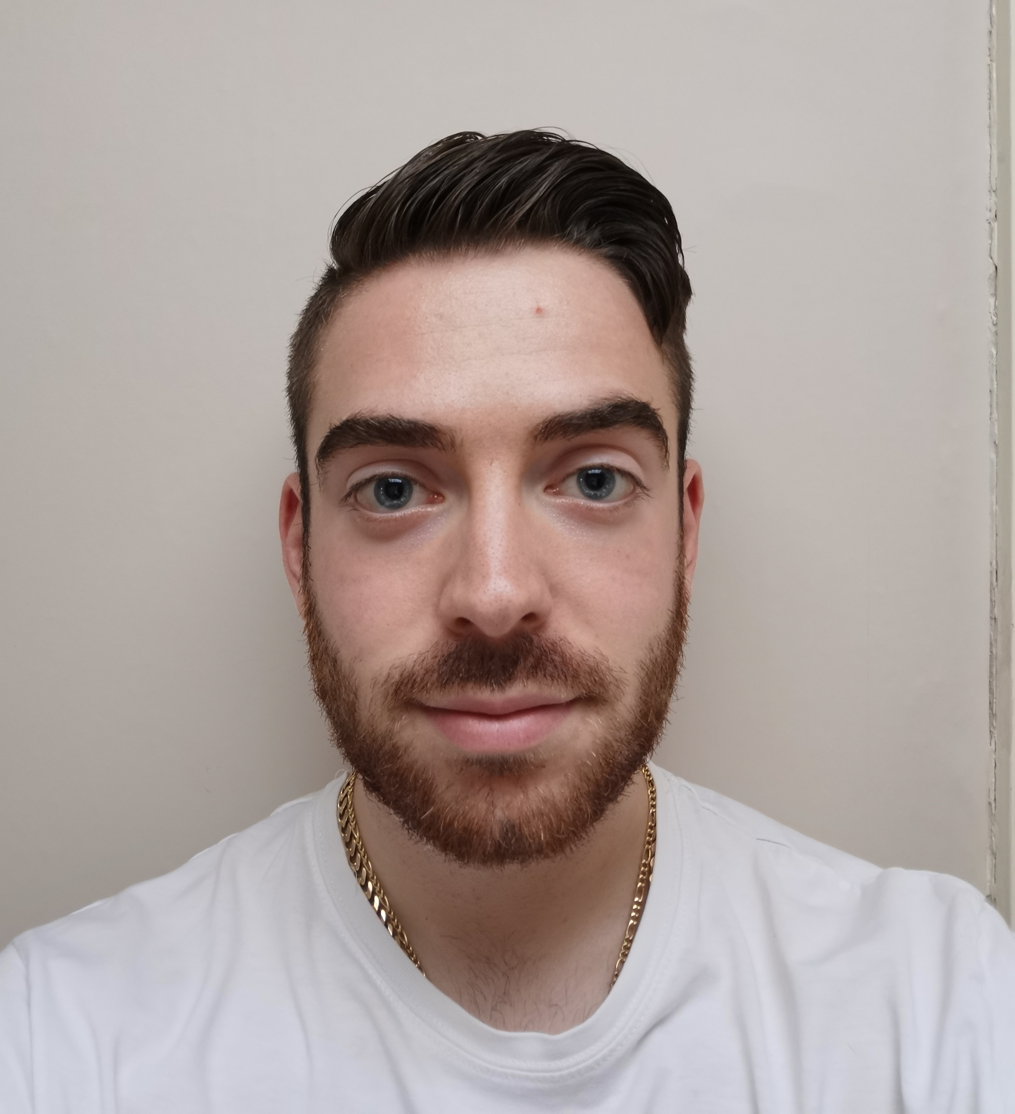

Name: Steve Raffaele Tiramani

Student number: 1902138

Student email address: 1902138@student.uwtsd.ac.uk

Contact number: 07969395791

I have chosen to do the Health Nutrition and Lifestyle course as nutrition is a huge interest of mine from personal experiences and experiences related to my family.

Many people in my family suffer from dietary related problems. Quite a few people in my family have diabetes and are overweight or have obesity. Two family members passed away at a fairly young age due to heart complications.

I had obesity for quite some time. However, in the last 3 years I have gone from 15 stone 4 pounds to 10 stone 7 pounds. I experimented on myself with various food and workout plans that I tested and created. This helped me find out what worked for me and what didn’t as well as giving me an appreciation of how difficult it is to lose that amount of weight and how dedicated one needs to be.

Now that I have done it myself, I want to be able to help others lose weight, feel happy about themselves and to live a long and happy life.

