

Assessment 1 – Reading Task Template
Upload your photo of your A3 in-class notes here:
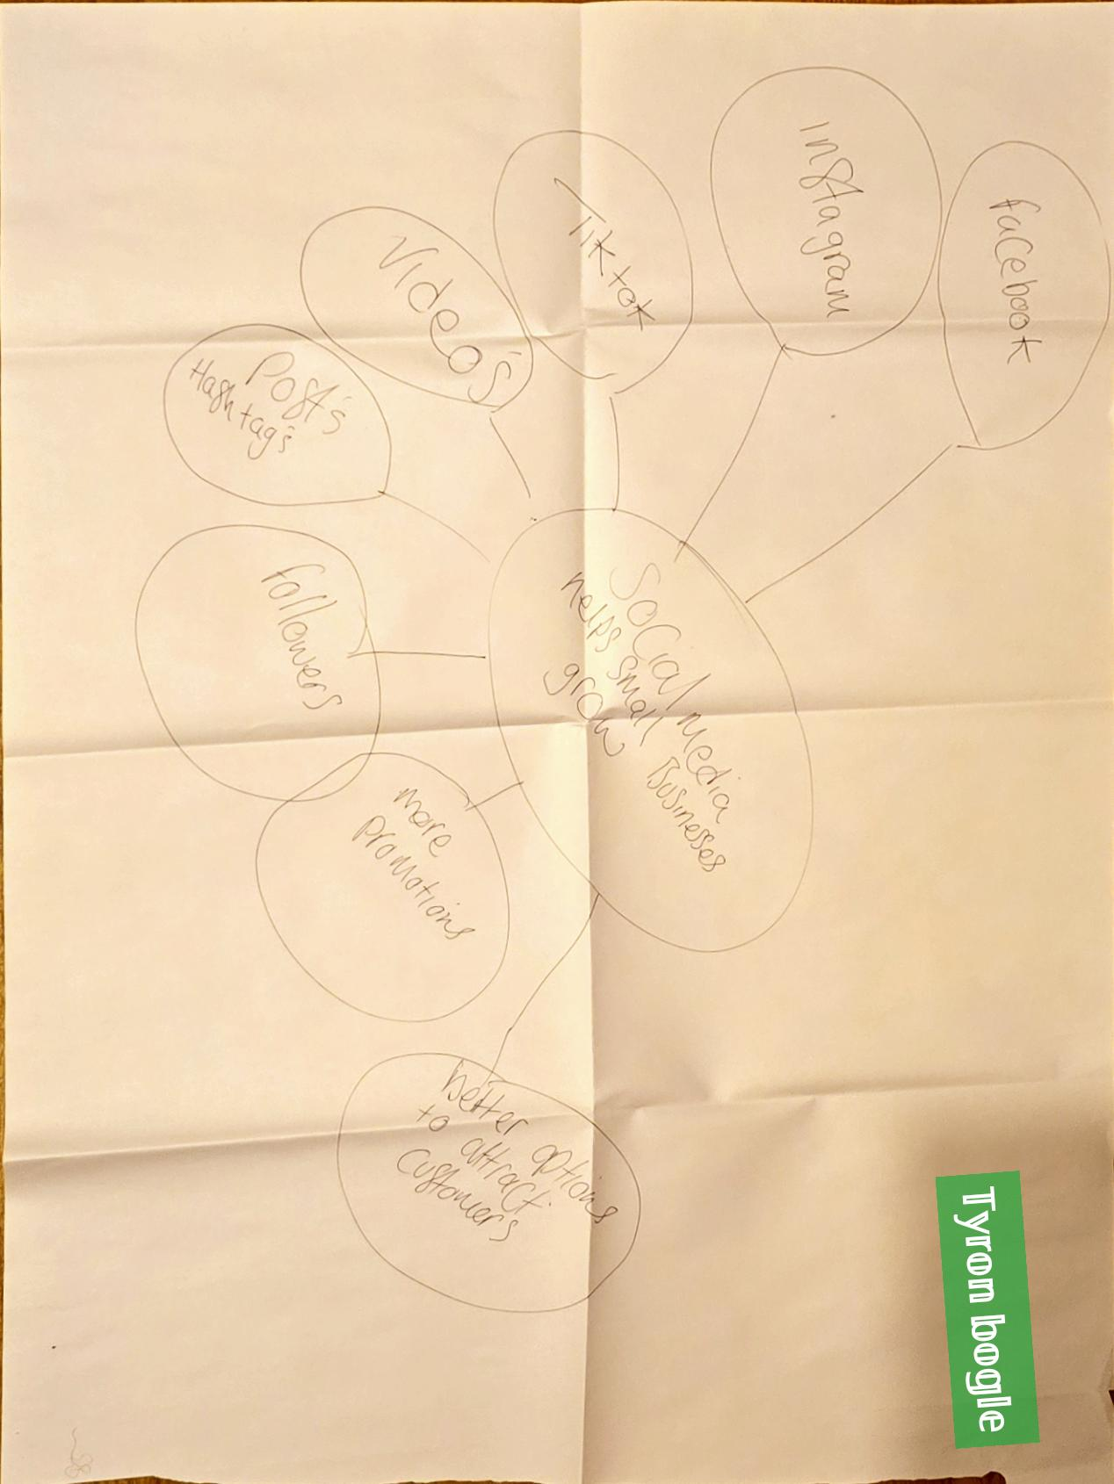

1. Answer these questions using the sentence starters below
a. What is the main idea of the text?
The main idea is 𝕥𝕠 𝕤𝕙𝕠𝕨 𝕙𝕠𝕨 𝕓𝕦𝕤𝕚𝕟𝕖𝕤𝕤𝕖𝕤 𝕚𝕞𝕡𝕣𝕠𝕧𝕖𝕕 𝕔𝕠𝕞𝕡𝕒𝕟𝕪 𝕘𝕣𝕠𝕨𝕥𝕙 𝕥𝕙𝕣𝕠𝕦𝕘𝕙 𝕤𝕠𝕔𝕚𝕒𝕝 𝕞𝕖𝕕𝕚𝕒 𝕡𝕣𝕖𝕤𝕖𝕟𝕥𝕤
b. What are two key points?
One key point is 𝕤𝕠𝕔𝕚𝕒𝕝 𝕞𝕖𝕕𝕚𝕒 𝕙𝕖𝕝𝕡𝕖𝕕 𝕓𝕚𝕟𝕝𝕖𝕪 𝕞𝕖𝕘𝕒 𝕔𝕙𝕚𝕡𝕡𝕪𝕤 𝕣𝕖𝕧𝕖𝕟𝕦𝕖 𝕚𝕟𝕔𝕣𝕖𝕒𝕤𝕖 𝕥𝕖𝕟𝕗𝕠𝕝𝕕 𝕥𝕙𝕒𝕟𝕜𝕤 𝕥𝕠 𝕧𝕚𝕕𝕖𝕠𝕤 𝕠𝕟 𝕤𝕠𝕔𝕚𝕒𝕝 𝕞𝕖𝕕𝕚𝕒
Another key point 𝕚𝕤 𝟙. 𝟝 𝕞𝕚𝕝𝕝𝕚𝕠𝕟 𝕦𝕜 𝕓𝕦𝕤𝕚𝕟𝕖𝕤𝕖𝕤 𝕠𝕡𝕖𝕣𝕒𝕥𝕖 𝕠𝕟 𝕤𝕠𝕔𝕚𝕒𝕝 𝕞𝕖𝕕𝕚𝕒 & 𝟚𝟘𝟘 𝕞𝕚𝕝𝕝𝕚𝕠𝕟 𝕓𝕦𝕤𝕚𝕟𝕖𝕤𝕖𝕤 𝕨𝕠𝕣𝕝𝕕𝕨𝕚𝕕𝕖 𝕦𝕤𝕖 𝕀𝕟𝕤𝕥𝕒𝕘𝕣𝕒𝕞 𝕥𝕠 𝕣𝕖𝕒𝕔𝕙 𝕔𝕦𝕤𝕥𝕠𝕞𝕖𝕣𝕤
c. What part of the text did you find most important? Why?
The most important part 𝕚𝕤 𝕥𝕙𝕖 𝕚𝕞𝕡𝕣𝕠𝕧𝕖𝕞𝕖𝕟𝕥𝕤 𝕞𝕒𝕕𝕖 𝕥𝕠 𝕖𝕟𝕤𝕦𝕣𝕖 𝕔𝕦𝕤𝕥𝕠𝕞𝕖𝕣𝕤 𝕒𝕣𝕖 𝕙𝕒𝕡𝕡𝕪 𝕒𝕟𝕕 𝕨𝕚𝕝𝕝 𝕥𝕠 𝕔𝕠𝕞𝕖 𝕓𝕒𝕔𝕜 𝕒𝕟𝕕 𝕤𝕡𝕣𝕖𝕒𝕕 𝕥𝕙𝕖 𝕨𝕠𝕣𝕕 𝕒𝕓𝕠𝕦𝕥 𝕥𝕙𝕖 𝕓𝕦𝕤𝕚𝕟𝕖𝕤𝕤 . 𝕂𝕣𝕪𝕤𝕥𝕒𝕝𝕃'𝕤 𝕓𝕠𝕦𝕥𝕚𝕢𝕦𝕖 𝕙𝕒𝕕 𝕔𝕦𝕤𝕥𝕠𝕞𝕖𝕣𝕤 𝕔𝕠𝕞𝕚𝕟𝕘 𝕗𝕣𝕠𝕞 𝕒𝕣𝕠𝕦𝕟𝕕 𝕥𝕙𝕖 𝕨𝕠𝕣𝕝𝕕
d. Was anything unclear or difficult to understand?
I was not sure 𝕒𝕓𝕠𝕦𝕥 𝕨𝕙𝕒𝕥 𝕨𝕒𝕤 𝕖𝕩𝕡𝕖𝕔𝕥𝕖𝕕 𝕚𝕟 𝕥𝕙𝕚𝕤 𝕒𝕤𝕤𝕚𝕘𝕟𝕞𝕖𝕟𝕥
e. How did your group help you understand the text better?
My group helped me by
2. One sentence reflection
Question: What did you find challenging about this task?
The hardest part 𝕨𝕒𝕤 𝕦𝕟𝕕𝕖𝕣𝕤𝕥𝕒𝕟𝕕𝕚𝕟𝕘 𝕨𝕙𝕒𝕥 𝕥𝕙𝕖 𝕥𝕒𝕤𝕜 𝕔𝕠𝕟𝕤𝕚𝕤𝕥𝕤 𝕠𝕗 𝕒𝕟𝕕 𝕙𝕠𝕨 𝕥𝕠 𝕘𝕖𝕥 𝕚𝕥 𝕕𝕠𝕟𝕖

