Programme: BA International Hotel Management
Module: Financial Management for the Hotel Industry
Module code: BMIH5007
Assignment Title: Business Report - Comparison of Two Hospitality Organisations
Student Name: Klaudia Modrzejewska
Student ID: 2243846
Word count:2032

AI guidance acknowledgement
I confirm that I have not presented any AI generated text as my own work. I confirm I have copies of my drafts, notes, and other resources I used before, and after the use of AI tools which I may be asked to provide in evidence.

Executive Summary
The title of the assignment is a business report that includes a comparison of two hospitality organisations. The report's main aim is to conduct an analysis of the organisations which are Premier Inn Hotels and Shangri-la hotels. Analysing the revenue and costs of both the companies, both Premier Inn and Shangri-la hotels started recovering after the losses they faced during the pandemic. Based upon market share, Premier Inn is more popular in the UK whereas Shangri-la hotels are popular on a worldwide scale. Shangri-la hotels have the opportunity to expand into the Asian market compared to Premier Inn that might focus on making their expansion in the German market. Lastly, the recommendations state that Premier Inn hotels needs to adopt a financial plan for creating realistic budgets and Shangri-La hotels needs to put priority in earning more revenue.

Table of Contents
“Introduction” 4
“Main Body” 4
“Total Revenue” 4
“Market Position” 8
“Growth Potential” 9
“Financial Commitment to CSR (Corporate Social Responsibility)” 10
“Conclusion” 10
“Recommendations” 10
Reference List 12
Appendices 15
Appendix 1 - Income statement of Shangri-La Hotels from 2018 to 2024 15
Appendix 2 - Income Statement of Premier Inn from 2018 to 2024 21

“Introduction”
Financial management reports need to have flexibility so that the operators of different restaurants and other hospitality organisations can use them for decision-making processes (Walker, 2017, p.315). The report aims to analyse and compare two organisations within the UK hotel industry that are Premier Inn Hotels and Shangri-La Hotels. The overview of the report is to make comparisons of revenue and the costs generated by each organisation along with their sources of revenues and their trends. The next section is to outline the market position of each organisation followed by their respective growth potential, market opportunities and potential growth barriers. The last section will outline the financial commitment of CSR opportunities of both companies.
“Main Body”

“Total Revenue”
“Analyse and compare the key revenues and costs generated by each organisation”
The revenue of Shangri-La Hotels in the year 2018 was observed at $2,517.9 million (£1,895.7 million) and the total costs were £1,757.28 million. However, the revenue decreased to £1,830.35 million with a downfall of -3.4% (Shangrila, 2019). On the other hand, there was a revenue increment of Premier Inn from £874.907 million in 2018 to £905.086 million in 2019. The total costs incurred by Premier Inn in 2018 including the operating costs, non-underlying items, finance costs and tax expenses amount to £678.6 million (Gov, 2024). The classification of costs that are included in a financial statement are product costs, direct materials and labour, period costs, manufacturing and non-manufacturing costs, and administrative, marketing and selling costs (Seal et al. 2018, p.33). However, there was a downfall in the revenue for Shangri-La hotels in 2021 and 2020 where the figures were retrieved at £935.87 million and £779.31 million respectively (Shangrila, 2021). The total expenses of the company in the year 2020 were observed at £1,164.83 million (Shangrila, 2020). Similarly, there was a downfall in the revenue of Premier Inn where figures fell from £911.501 million in 2020 to £249.627 million in 2021.
Premier Inn’s revenue started increasing from 2021 to 2022 increasing to £772.806 million followed by a further rise in both 2023 and 2024 at £1210.845 million and £1,357.054 million respectively. There was a rise in the overall costs to £1,067.615 million in 2024 from £941.87 million (Gov, 2024). The revenue of Shangri-La hotels started increasing in 2022 which saw growth from £935.87 million in 2021 to £1,103.44 million in 2022 at 17.8% (Shangrila, 2022). It significantly increased to £1,615.11 million in 2023 followed by total costs occurring at £1,463.36 million (Shangrila, 2023). This concludes that both companies have undergone revenue downfall during the pandemic and slowly started recovering based on the policies given out by the UK government.
“Sources of revenue”
Shangri-La hotels and resorts have a wide range of resources such as room rentals, services from food and beverages, amenities and space rentals for any special events. Other sources of the revenue earned by the group are the demand for travel being strong in 2023 and hotel management services. Some examples of their hotel management services are a 24-hour concierge service, butler services, express check-ins and check-outs, in-room spa services and laundry and valet services (Shangrila, 2024). Similarly, even the revenue of Premier Inn is generated from the accommodation services, their mobile application, food and beverage and any other services. As per the statement of Drury (2018, p.47), a firm is capable of identifying its sources of profits or losses by accurately measuring the resources invested in a product. It is also applicable to the management team of both Shangri-La and Premier Inn in identifying the loopholes based on which the company is not able to earn enough revenue and profits.
“Revenue trends”
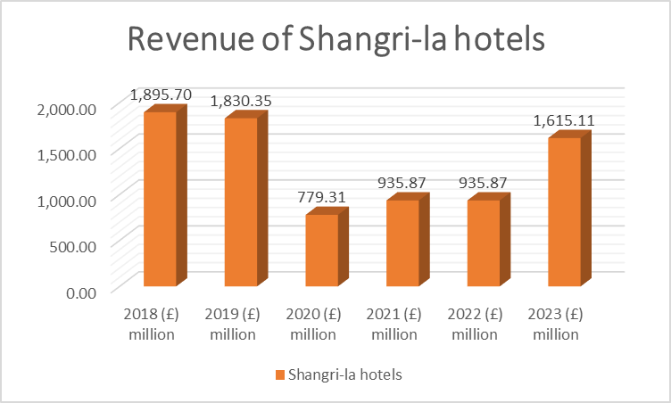
Figure 1: Revenue of Shangri-La hotels
(Source: Created by the learner)
In the trends observed in the revenue earned by Shangri-La hotels from 2018 to 2023, there was a downward slope from £1,895.70 million in 2018 to £779.31 million in 2020. The growth in revenue of a company is mainly characterised due to the boost in the loyalty levels of the company’s existing customers by regularly adjusting to different prices that reflect the trends in the market (Amajuoyi et al., 2024). The revenue figures stated increasing steadily from 2021 onwards indicating a steady rise in the revenue from £935.87 million in 2021 to £1615.11 million in 2023 due to the excessive demand in travel.
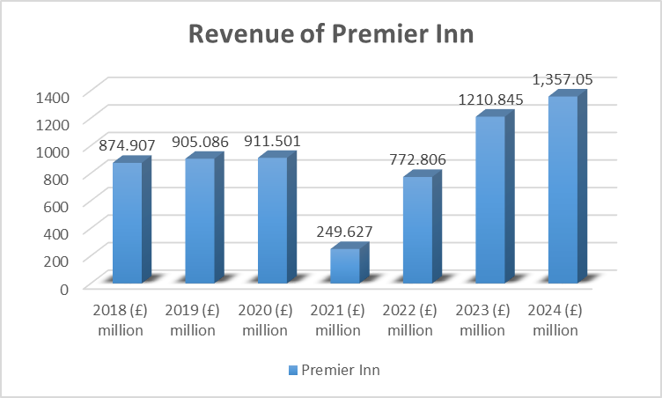
Figure 2: Revenue of Premier Inn
(Source: Created by the learner)
The trends observed in the revenue of Premier Inn underwent both upward and downward based on the market situation. The revenue of Premier Inn increased to £911.501 million in 2020 after being at £874.907 million in 2018 due to the rise of operations in the UK hospitality sector. However, those values drastically fell to £249.627 due to the onset of the COVID-19 pandemic. It was followed by a massive rise in revenue figures that skyrocketed from £249.627 million to £1357.05 million within 3 years.
“Factors driving revenue growth or decline”
The decline in the revenue for both hotels during the period 2020 and 2021 was during the pandemic which had a negative impact on the entire hospitality sector. However, the hospitality sector in the UK went through a significant amount of recovery which resulted in a rise in the revenue of both companies. The UK government brought in a Hospitality strategy that included reopening, resilience and recovery of the entire hospitality sector. This was solely designed to address the pressures arising due to higher costs and maintain financial sustainability in the entire sector (Gov, 2021). This helped the entire UK hospitality sector including Shangri-La hotels and Premier Inn to enhance the customer retention rate to provide a boost in their overall revenue. According to the findings of Redjeki et al. (2021), a company can undergo growth in its revenue due to a variety of reasons such as expanding into newer markets or attracting newer customers, improving its products and services and overall price optimisation.

“Market Position”
“Market share”
The market share of Premier Inn in the UK market is 11% which is a demonstration that the company is considered to be the largest hotel chain in the entire country. For instance, the total number of premier inn hotels in the UK increased from 649 in 2012 / 13 to 853 in 2023 / 2024 (Statista, 2024). On the other hand, Shangri-La Hotels has over 100 luxury hotels and resorts all across the world.
“Customer demographics”
The customer demographics of Premier Inn are leisure seekers, business travellers and individuals who are looking for longer stays belonging to the age category of 25 to 34. The target market set by the company includes adults in their working lives, businesses and families where leisure travellers belong to the age category of 25 to 44. On the other hand, while operating in both the UK, Chinese and the global market, the customer demographics are Chinese and Asian business travellers. The company is also responsible for the development of brand loyalty among Asian travellers and corporate programmes for those travellers who put the utmost value on quality and efficiency.
“Brand perception”
Brand perception is represented based on what the customers need to believe regarding the characteristics of its product instead of what the company owns regarding the description stated by the brand. The brand awareness of Premier Inn in the UK is 93% out of which 53% of the overall UK customers stated that they liked Premier Inn (Statista, 2023). On the other hand, the brand perception of Shangri-La Hotels is mainly known for its hospitality that is Asian-inspired, world-class service and tranquil environment.

“Growth Potential”
“Expansion strategies”
Premier Inn is strongly looking to grow internationally by penetrating newer markets. They have made numerous investments in centrally located plots, top locations, and many other trusted partners. Also, a network strategy can be initiated for the company to react to what is happening within a particular market and acquire freeholds or leaseholds to enter the Turkish markets through joint ventures. The company is mainly interested in expanding in places like Berlin, Munich and Berlin all across Germany (Premierinn, 2024). In comparison, Shangri-La Resorts and Hotels have a shared services model that mainly aims to bring improvements to both controllership and accounting qualities and drive synergy across all the hotels.
“Market opportunities”
For Premier Inn, there are numerous places where the company can gain success on an international scale specifically in the German Market which is larger than the UK market. The parent company of Premier Inn which is Whitbread Plc also made an announcement in increasing the headcount of the hotel by 25% before 2030. In comparison, Shangri-La Hotels have the opportunity to expand beyond their origins in Asia to numerous international destinations. For instance, the company opened at the Shard in London. Also, the company follows an approach which is mainly customer-centric for finding innovative solutions for catering to the needs of modern travellers.
“Potential barriers to growth”
There are several barriers to growth a company can face which are competition from other companies, competition, downturns in the economy, poor leadership and a lack of overall skills or resources (Cantú et al., 2021). The major issues to growth that were faced by Shangri-La hotels were the difficulties expanding their operations in North America, the UK and in the entire Europe. The company was also focused on expanding into the Chinese market where the front-line workers were not accustomed to exercising any decision-making processes. In comparison, Premier Inn has been facing a shortage of labour and cost inflation that has the potential to create challenges related to operations (Barnes, 2023). Also, Whitbread Plc has its expectations for the shrinkage of its overall supply of budget hotels based on its pricing power.

“Financial Commitment to CSR (Corporate Social Responsibility)”
The ESG Strategy of Shangri-La Hotels indicates their Triple S strategy that includes Stay, Savour and Shine. This mainly helps to ensure that the sustainability aspects are included in each of the aspects of their business operations (Shangrila, 2024). The CSR strategies of Premier Inn are focused on reaching net zero carbon which has efficiently designed its hotels with the help without a proper gas supply. Also, the company’s biggest achievement in its CSR policies is providing support to Great Ormond Street Hospital (GOSH) Charity for children by raising more than £23 million with the help of fundraising and donations.
“Conclusion”
Summarising the overall report, Shangri-La hotels have a larger brand recognition on a worldwide scale especially in China and lesser popularity in the UK. Despite being a standard hotel, Premier Inn is the most popular hotel in the UK having significantly higher brand recognition than Shangri-La Hotels. However, both companies faced a shortage of revenue due to the onset of the pandemic which then slowly started rising based on the UK government’s strategies for improving the hospitality sector in the UK. While Premier Inn has the opportunity to expand into the German Market, Shangri-La hotels can look into those markets that are outside of the Asian Origins. Therefore, the recommendations highlight Premier Inn for improving its ability to expand in newer markets and enhancing the ability of Shangri-La hotels to increase its revenue.
“Recommendations”
“Premier Inn Hotels”
For Premier Inn Hotels, a proper growth strategy can be adapted by creating a financial plan that will help the company in the creation of realistic budgets. Also, the company needs to adapt to the local preferences of the consumers in their target market. From the views of Khuntia et al. (2021), companies can create stronger connections with suppliers and other local partners during the market expansion procedure. It will allow Premier Inn to build relationships with local partners, customers and employees were partnering with local companies is also an important element.
“Shangri-La Hotels”
For Shangri-La Hotels, the company’s priority is to enhance its revenue while operating in the UK or in the global market. Hotels can take the responsibility of diversifying their revenue by offering unique experiences to their guests. Acquiring customers from the marketplace can be cheaper than other sources (Maier and Wieringa, 2021). This will help Shangri-La Hotels in not only expanding to newer places but also enhance their overall customer base which can also increase their overall revenue.
Reference List
Amajuoyi, C.P., Nwobodo, L.K. and Adegbola, A.E. (2024) ‘Utilizing predictive analytics to boost customer loyalty and drive business expansion.’ GSC Advanced Research and Reviews, 19(3), pp.191-202. Available at: https://doi.org/10.30574/gscarr.2024.19.3.0210
Barnes, O. (2023) Premier Inn owner says inflation and labour shortages offer ‘growth opportunities’ [Online] Available at: <https://www.ft.com/content/e4c6f668-cfeb-466a-8db9-3e68d49612f5> [Accessed on 3 October 2024]
Cantú, A., Aguiñaga, E. and Scheel, C. (2021) ‘Learning from failure and success: The challenges for circular economy implementation in SMEs in an emerging economy.’ Sustainability, 13(3), p.1529. Available at: https://doi.org/10.3390/su13031529
Drury C. (2018) Management and Cost Accounting. 10th Edition. London, Prentice Hall.
Gov (2021) Hospitality Strategy: Reopening, Recovery, Resilience. [Online] Available at: <https://assets.publishing.service.gov.uk/media/60f14bd7e90e0764ca40656b/1200-APS-CCS0621819592-002-BEIS-Accessible2.pdf> [Accessed on 3 October 2024]
Gov (2024) PREMIER INN HOTELS LIMITED [Online] Available at: <https://find-and-update.company-information.service.gov.uk/company/05137608/filing-history> [Accessed on 3 October 2024]
Khuntia, J., Kathuria, A., Andrade-Rojas, M.G., Saldanha, T. and Celly, N. (2021) ‘How foreign and domestic firms differ in leveraging IT-enabled supply chain information integration in BOP markets: the role of supplier and client business collaboration.’ Journal of the Association for Information Systems, 22(3), p.6. Available at: https://www.researchgate.net/profile/Abhishek-Kathuria-2/publication/344729637_How_Foreign_and_Domestic_Firms_Differ_in_Leveraging_IT-Enabled_Supply_Chain_Information_Integration_in_BOP_Markets_The_Role_of_Supplier_and_Client_Business_Collaboration/links/601e912f458515893984f479/How-Foreign-and-Domestic-Firms-Differ-in-Leveraging-IT-Enabled-Supply-Chain-Information-Integration-in-BOP-Markets-The-Role-of-Supplier-and-Client-Business-Collaboration.pdf
Maier, E. and Wieringa, J. (2021) ‘Acquiring customers through online marketplaces? The effect of marketplace sales on sales in a retailer's own channels.’ International Journal of Research in Marketing, 38(2), pp.311-328. Available at: https://doi.org/10.1016/j.ijresmar.2020.09.007
Premierinn (2024) International development [Online] Available at: <https://www.premierinn.com/gb/en/business/international-development.html#:~:text=To%20move%20ahead%20with%20our,and%20other%20cities%20across%20Germany.> [Accessed on 3 October 2024]
Redjeki, F., Fauzi, H. and Priadana, S. (2021) ‘Implementation of appropriate marketing and sales strategies in improving company performance and profits.’ International Journal of Science and Society, 3(2), pp.31-38. Available at: http://download.garuda.kemdikbud.go.id/article.php?article=2510774&val=23933&title=Implementation%20of%20Appropriate%20Marketing%20and%20Sales%20Strategies%20in%20Improving%20Company%20Performance%20and%20Profits
Seal, W., Rohde, C., Garrison, R. and Noreen, E. (2018) Management Accounting, 6e. McGraw-Hill Education (UK).
Shangrila (2018) Annual Report 2018 [Online] Available at: <https://sitecore-cd.shangri-la.com/-/media/Project/Shangri-La-Group/Investor/Files/Public-Disclosures/Financial-Information/Financial-Reports/2018_Annual_Report.pdf> [Accessed on 3 October 2024]
Shangrila (2019) Annual Report 2019 [Online] Available at: <https://sitecore-cd.shangri-la.com/-/media/Project/Shangri-La-Group/Investor/Files/Public-Disclosures/Financial-Information/Financial-Reports/2019Annual-Report-Eng.pdf> [Accessed on 3 October 2024]
Shangrila (2020) Annual Report 2020 [Online] Available at: <https://sitecore-cd.shangri-la.com/-/media/Project/Shangri-La-Group/Investor/Files/Public-Disclosures/Announcements-and-Circulars/2021/2021-04-26-AR_E.pdf> [Accessed on 3 October 2024]
Shangrila (2021) Annual Report 2021 [Online] Available at: <https://sitecore-cd.shangri-la.com/-/media/Project/Shangri-La-Group/Investor/Files/Public-Disclosures/Latest-Top-Publications/2021_Annual-Report_E.pdf> [Accessed on 3 October 2024]
Shangrila (2022) Annual Report 2022 [Online] Available at: <https://sitecore-cd.shangri-la.com/-/media/Project/Shangri-La-Group/Investor/Files/Public-Disclosures/Latest-Top-Publications/e0069_230418_AR.pdf> [Accessed on 3 October 2024]
Shangrila (2023) Annual Report 2023 [Online] Available at: <https://sitecore-cd.shangri-la.com/-/media/Project/Shangri-La-Group/Investor/Files/Public-Disclosures/Latest-Top-Publications/2023_Annual_Report_E.pdf> [Accessed on 3 October 2024]
Shangrila (2024) Services & Facilities [Online] Available at: <https://www.shangri-la.com/london/shangrila/about/services-facilities/> [Accessed on 3 October 2024]
Shangrila (2024) Shangri-la Sustainability [Online] Available at: <https://www.shangri-la.com/group/sustainability/> [Accessed on 3 October 2024]
Statista (2023) Premier Inn brand awareness, usage, popularity, loyalty, and buzz among hotel customers in the UK in 2022 [Online] Available at: <https://www.statista.com/forecasts/1335699/premier-inn-hotels-brand-profile-in-the-uk> [Accessed on 3 October 2024]
Statista (2024) Number of Premier Inn (Whitbread) hotels in the United Kingdom and Ireland from 2012/13 to 2023/24 [Online] Available at: <https://www.statista.com/statistics/739855/whitbread-premier-inn-hotels/> [Accessed on 3 October 2024]
Walker, J. (2017) Introduction to Hospitality. Global Edition. 7th Edition. Harlow Pearson.

Appendices

Appendix 1 - Income statement of Shangri-La Hotels from 2018 to 2024
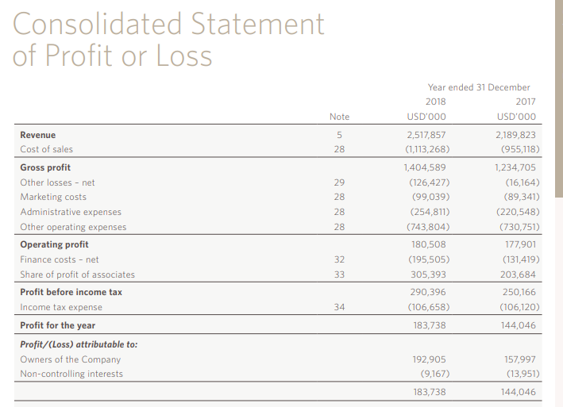
Figure 3: Income statement of Shangri-La hotels in 2018
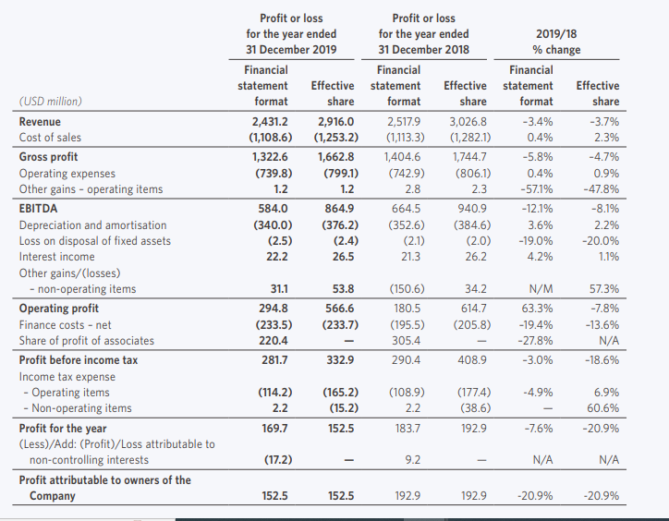
Figure 4: Income statement of Shangri-La hotels in 2019

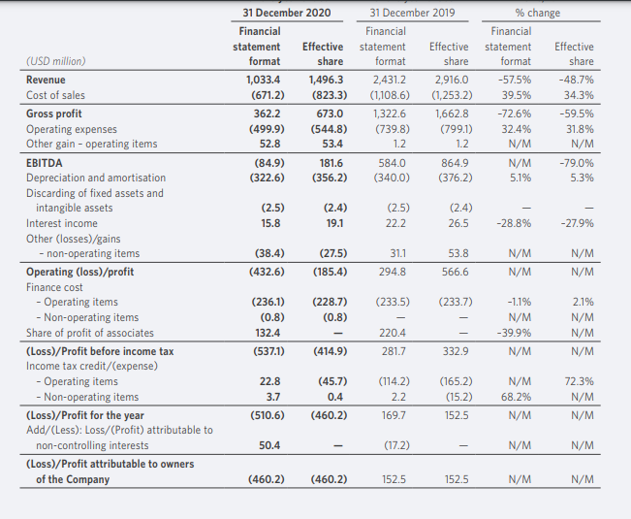
Figure 5: Income statement of Shangri-La hotels in 2020

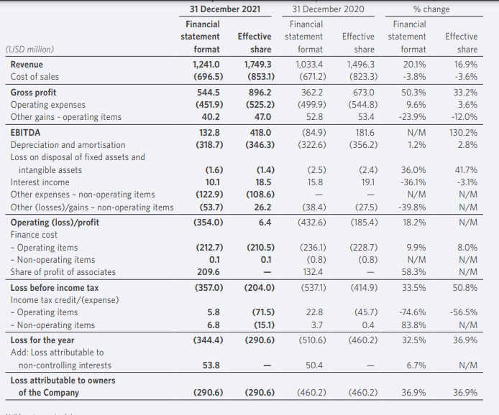
Figure 6: Income statement of Shangri-La hotels in 2021

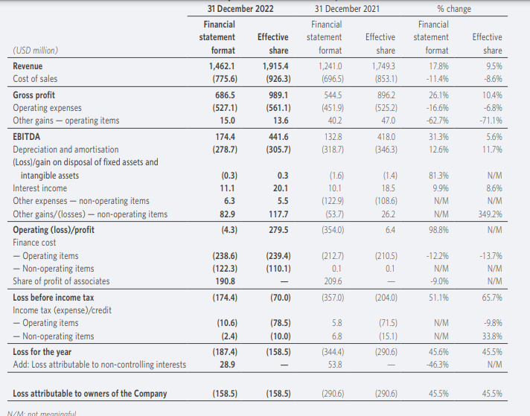
Figure 7: Income statement of Shangri-La hotels in 2022
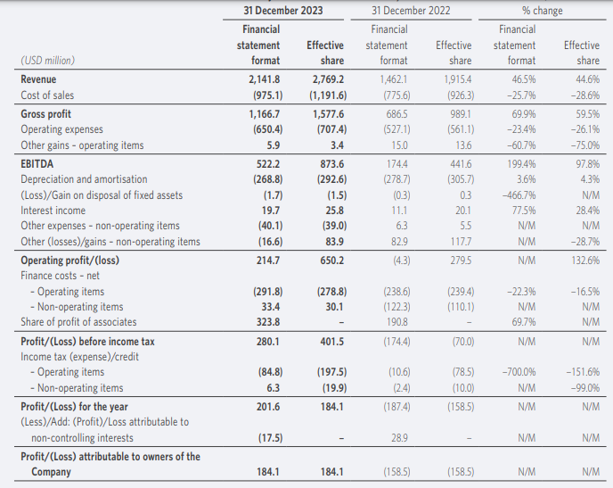
Figure 8: Income statement of Shangri-La hotels in 2023

Appendix 2 - Income Statement of Premier Inn from 2018 to 2024
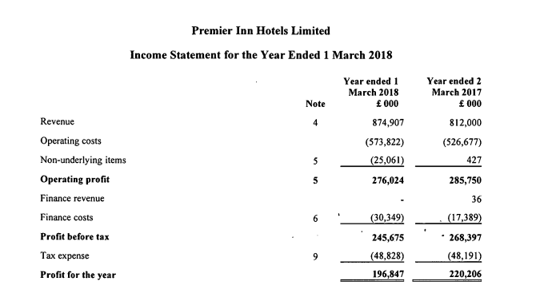
Figure 9: Income Statement of Premier Inn in 2018
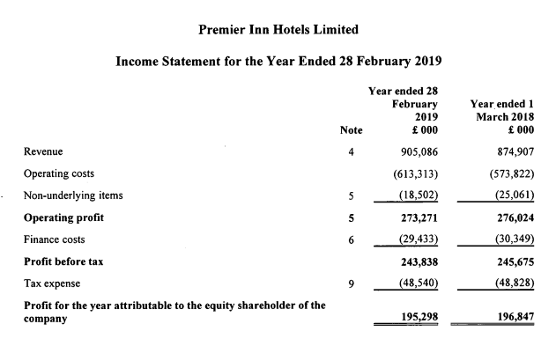
Figure 10: Income Statement of Premier Inn in 2019
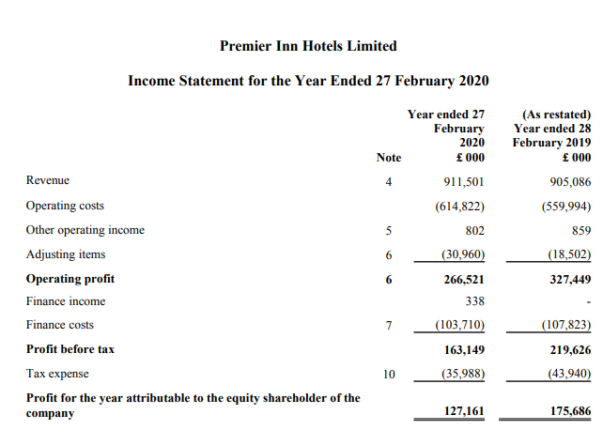
Figure 10: Income Statement of Premier Inn in 2020
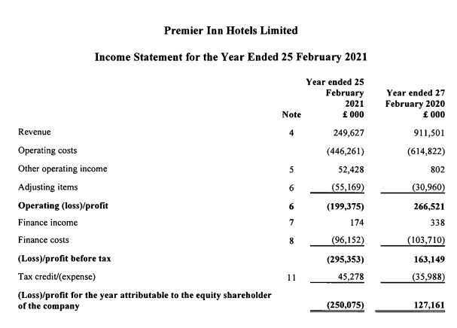
Figure 11: Income Statement of Premier Inn in 2021
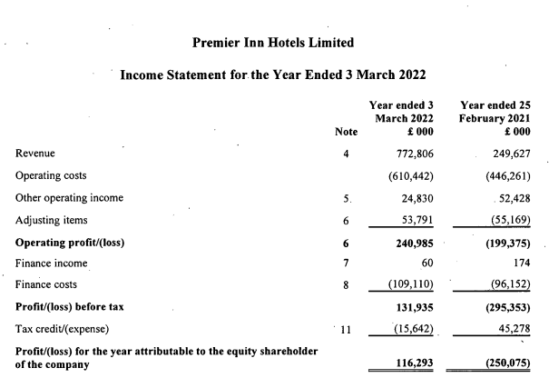
Figure 12: Income Statement of Premier Inn in 2022
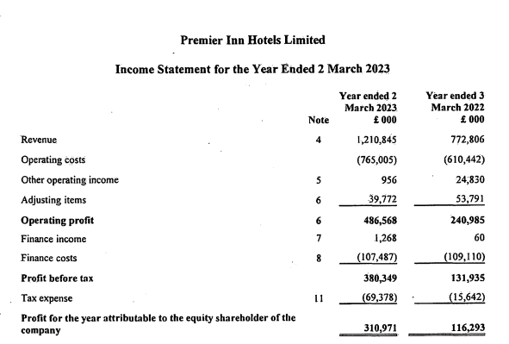
Figure 13: Income Statement of Premier Inn in 2023
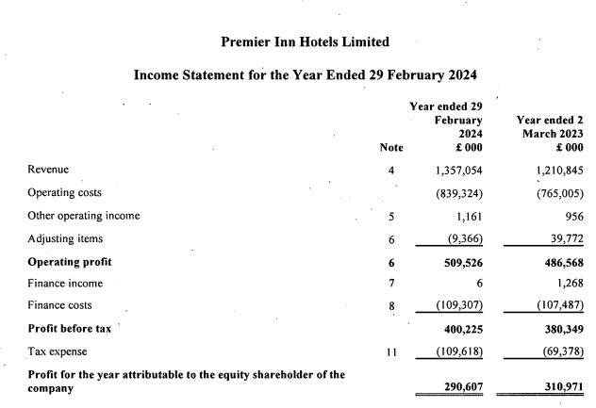
Figure 14: Income Statement of Premier Inn in 2024

