Marketing plan for Six senses hotels and resorts
Module name: Marketing Essentials Module code: BMIH4005
Word count: 1302

Student name: Diana Elena Radu
Student number: 2240776

Marketing plan for the Six senses hotel and resorts

Introduction
Six Senses Hotels and Resort’s marketing plan of creating an educational marketing plan to attract non-eco-conscious travellers and increase hotel sales (Moise, Ruiz 2021). It emphasises high-quality service and innovative wellness programmes to boost Six Senses' luxury hospitality reputation. The plan targets affluent clients who value luxury and sustainability in a competitive market. This strategy relies on local community and global environmental organisation collaborations which external impact of PESTEL analysis adaptation to dynamic external factors. This comprehensive approach aligns brand values and market trends using the brand SWOT analysis to highlight the company values.

5 C’s

Company | High-quality service, and innovative wellness programmes are their strengths.
Customers | Typically wealthy, value luxury, and care about sustainability and wellness.
Competitors | Other luxury resorts and hotels that emphasise wellness and sustainability compete for ex Four seasons.
Collaborators | Local communities, suppliers, tourism boards, and global environmental organisations.
Climate | Is affected by external factors of PESTLE.

Climate: PESTEL (Macro analysis)
Political | Economical | Social | Technological | Environmental | Legal
Regulatory frameworks, policy changes, and geopolitical stability (Boyles 2022). | Economic fluctuations, currency exchange rates, and local economic conditions (Gonzalez, mozo, Bustos 2021) | Cultural and social differences across its global operations adaptation (Wilson, Dutt 2022). | Ali, Dwivedi (2023) technological advances allow analytics, promotions, and customer engagements | Carbon footprint reduction (Six Senses 2023). | Legal compliance to diverse locations (O’Halloran 2021).

Company: SWOT analysis (Micro analysis)
Strength | Weaknesses | Opportunities | Threats
A globally recognised brand with a solid reputation for luxury and sustainability | Accessibility is constrained by a high price point and reliance on travel industry dynamics. | Product development in which an education-focused marketing strategy is implemented | Neglecting to provide education regarding sustainability may result in a brand being perceived as attention-seeking due to the prevailing sentiment regarding sustainability.

Customers: Segmentation and Targeting/ Customer profile’s’ SimilarWeb
According to Similar Web (2023) report currently the majority of interest is arriving from millennials as this report shows millennials phase a big importance on sustainability which is also mentioned in the Forbes magazine by Cheng (2019).
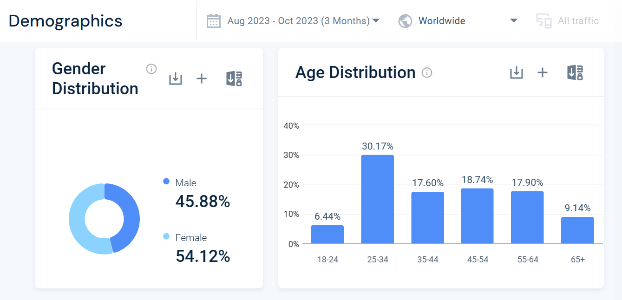

Competitors: Perceptual positioning map, Bowman’s strategy clock
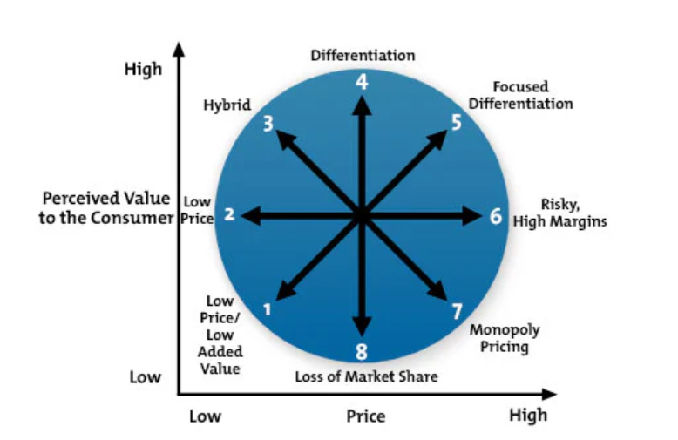
Four seasons
Six senses
Six senses position on the Bowman’s strategy clock vs biggest competitor the Four seasons hotels and resorts.

Six senses
Partner with IHG (2023), a strong luxury hospitality brand Six Senses works with local communities and suppliers to ensure a sustainable and ethical supply chain. Six Senses (2023) operational success and global expansion depend on its franchising partners and community-centric collaborations.

Marketing Mix
Prioritising exclusivity, quality, and a distinctive brand philosophy centred on sustainability and well-being, the Six Senses marketing mix targets affluent, environmentally aware tourists.
Product | Price | Place | Promotion
Luxury wellness, Sustainability, wellbeing. | High price reaches nesh market only. | Strategic places whit vibrant cultural background. | Promotes wellbeing culture and luxury.

Objectives
By emphasising education, Six Senses’ new content marketing strategy seeks to establish the brand as an authority on sustainable luxury travel. This strategy entails the development and dissemination of compelling educational materials that emphasise the brand's dedication to wellness and sustainability. The assortment of materials provided including comprehensive articles, videos, interactive webinars, and on-site workshops is intended to enlighten and motivate attendees with regards to sustainable practises and comprehensive wellness. By incorporating this educational component into each aspect of the guest experience, Six Senses strengthens its value proposition and appeals to a specific demographic of health-conscious and environmentally conscious travellers. As a result, the brand fosters greater customer loyalty and attracts a fresh customer base that is well-informed.

SMART target
This strategy aims to create a marketing plan to increase Six Sense’s brand awareness among non-conscious travellers by 25% within one year, leveraging an education-focused content marketing strategy to enhance engagement and foster sustainable travel practices.

Strategy
By implementing an education-oriented content marketing strategy, Six Senses modifies its value proposition to position itself as an authority on sustainable luxury travel. This contributes to the brand's reputation for thought leadership while remaining consistent with its ethos, this approach is classified as 'Product Development' in Ansoff's Matrix.
Through this method, Six Senses enriches its offerings with educational materials, thereby increasing the value for its current clientele without fundamentally modifying the service itself.
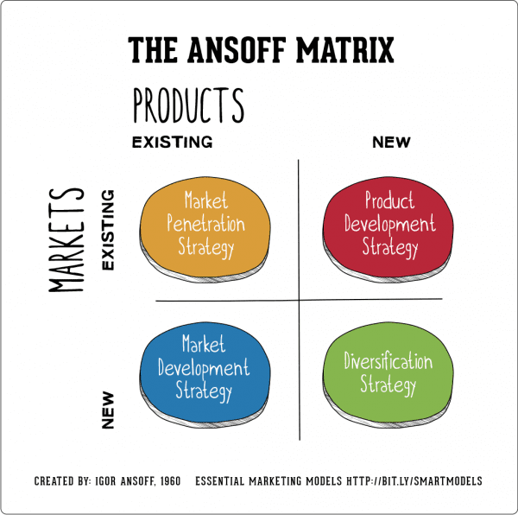
This approach necessitates the expansion of the marketing mix.
'Product' will now encompass educational resources, including webinars, in-depth articles, and videos pertaining to wellness and sustainability. The term 'place' encompasses digital platforms that provide convenient access to this content. The continued premium pricing reflects the value added by the educational content.
"Promotion" entails emphasising this novel educational facet, potentially via collaborative efforts with academic establishments or targeted advertising campaigns.
"People" refers to the training of personnel to exemplify and convey these academic principles,
"Process" entails the incorporation of educational materials into the interaction with customers, badges or certificates awarded to attendees of educational programmes, thereby strengthening the brand's dedication to sustainability and education.

Tactics
According to Chaffey (2023) a comprehensive approach is imperative for the effective execution of a content marketing strategy that revolves around education at Six Senses.
- It is essential to construct a content calendar that has been meticulously planned.
- Consistent with the brand's fundamental principles and the interests of its target audience, it ought to provide comprehensive information on a range of wellness and sustainability subjects on a consistent basis.
- By employing diverse content formats such as infographics, videos, podcasts, and webinars, in addition to blog posts and infographics, one can accommodate the preferences of a given audience.
- Potential content for this platform may consist of engaging infographics offering wellness advice or the production of high-quality videos showcasing the brand's sustainability initiatives.
- The content's credibility can be enhanced through expert collaborations, which may involve wellness professionals, sustainability experts, or local community leaders.
- Promoting the brand's dedication to sustainable living and wellness practises can be achieved through the provision of interactive online workshops that deliver an enlightening and immersive experience.
- Implementing a strategic approach to social media promotion can significantly expand the audience reach of collected content.
- Engagement and audience reach can be maximised by customising content to correspond with the unique characteristics of each platform.
- To comprehend audience engagement and make necessary adjustments to the strategy in light of performance metric analysis and search engine optimization.
- Maintaining the audience informed and engaged regarding the most recent developments in sustainability and wellness can be accomplished through the distribution of educational newsletters that offer regular updates and content.
Six Senses can position itself as an authority on sustainability and wellness by methodically implementing these strategies and captivating its audience with informative material that embodies its brand values.

Action
The new strategy communication will be electronic same as most of the current communications.
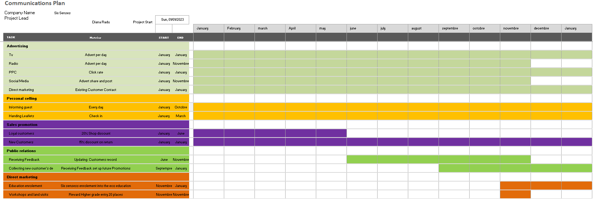

Control
The success of the new marketing plan for Six Senses will be measured through key performance indicators (KPIs) including increased website traffic, higher engagement rates on educational content, growth in social media followers, and enhanced email newsletter open rates. Additionally, tracking new customer acquisition rates, especially among eco-conscious demographics, will be crucial. Monitoring changes in customer attitudes towards the brand through surveys and online sentiment analysis will provide insights into brand perception (Emmert 2021). Finally, a key metric will be the direct impact on bookings and revenue, assessing whether the educational content marketing has translated into increased profits, thereby indicating the plan's overall effectiveness.

Conclusion
Educative content is Six Senses Hotels and Resorts' innovative marketing strategy to attract non-eco-conscious travellers and boost hotel sales. The plan emphasises high-quality service and wellness programmes to boost Six Senses' luxury hospitality reputation. It competes with Four Seasons and other luxury and sustainability brands for affluent customers. This strategy, based on partnerships with local communities and global environmental organisations, effectively addresses PESTEL external factors. Six Senses' comprehensive approach, aligned with its SWOT analysis, highlights its core values and adapts to market trends, positioning it as a sustainable luxury travel leader.

References

Alcalde-González, V., Gálvez Mozo, A. and Valenzuela Bustos, A. (2021) ‘No clean rooms, no hotel business: Subversion tactics in Las Kellys’ struggle for dignity in hotel housekeeping’. Annals of Tourism Research, 91, p.103315. doi:https://doi.org/10.1016/j.annals.2021.103315 [Accessed on 11 Nov. 2023].
Ali, O. and Dwivedi, Y.K. (2023) ‘The impact of technological innovation on marketing: individuals, organizations and environment: a systematic review’. Economic Research-Ekonomska Istraživanja, [online] 36, p.2210661. doi:https://doi.org/10.1080/1331677X.2023.2210661 [Accessed on 15th Nov 2023].
Boyles, M. (2022) Understanding How Politics Can Affect Your Business. [online] Harvard Business School Online. Available at: https://online.hbs.edu/blog/post/politics-and-business [Accessed 11 Nov. 2023].
Chaffey, D. (2023) Marketing strategy vs tactics - why the difference matters | Smart Insights. [online] Smart Insights. Available at: https://www.smartinsights.com/marketing-planning/marketing-strategy/marketing-strategy-vs-tactics-difference/ [Accessed 11 Nov. 2023].
Cheng, M. (2019) 8 Characteristics Of Millennials That Support Sustainable Development Goals (SDGs). [online] Forbes. Available at: https://www.forbes.com/sites/margueritacheng/2019/06/19/8-characteristics-of-millennials-that-support-sustainable-development-goals-sdgs/ [Accessed 11 Nov. 2023].
Emmert, A. (2021) The rise of the eco-friendly consumer. [online] Strategy Business. Available at: https://www.strategy-business.com/article/The-rise-of-the-eco-friendly-consumer [Accessed 11 Nov. 2023].
EPM (2022) Ansof market. [online] www.bing.com. Available at: https://www.bing.com/videos/riverview/relatedvideo?q=ansof+market&mid=80A8C63ED114CB196BB380A8C63ED114CB196BB3&FORM=VIRE [Accessed 11 Nov. 2023].
Hanlon, A. (2021) The Ansoff Model [Image]. [online] Smart Insights. Available at: https://www.smartinsights.com/marketing-planning/create-a-marketing-plan/ansoff-model/ [Accessed 11 Nov. 2023].
IHG (2023) About us. [online] InterContinental Hotels Group PLC. Available at: https://www.ihgplc.com/en/about-us [Accessed 11 Nov. 2023].
MindTools (2023) MindTools marketing mix image | Home. [Image] [online] www.mindtools.com. Available at: https://www.mindtools.com/a2rq300/bowmans-strategy-clock [Accessed 11 Nov. 2023].
Moise, S. and Ruiz, E. (2021) The importance of green practices for hotel guests: does gender matter? Economic Research-Ekonomska Istraživanja, [online] 34, pp.3508–3529. doi:https://doi.org/10.1080/1331677X.2021.1875863.
O’Halloran, R. (2021) The Changing Hotel Legal Environment: Being Aware and Prepared | By Robert O’Halloran. [online] Hospitality Net. Available at: https://www.hospitalitynet.org/opinion/4108245.html [Accessed 11 Nov. 2023].
Similar Web (2023) Six senses competitors. Report produced on 11th Nov 2023 available at: sixsenses.com Competitors - Top Sites Like sixsenses.com | Similarweb [Accessed on 11 Nov. 2023].
SimilarWeb (2023) Website Performance. [online] Similarweb.com. Available at: https://pro.similarweb.com/#/digitalsuite/websiteanalysis/overview/website-performance/ [Accessed 11 Nov. 2023].
Wilson, M. and Dutt, C.S. (2022) Expatriate adjustment in hotels in Dubai, UAE. Journal of Human Resources in Hospitality & Tourism, [online] 21, pp.463–481. doi:https://doi.org/10.1080/15332845.2022.2064187 [Accessed 15 Nov 2023].

Appendices
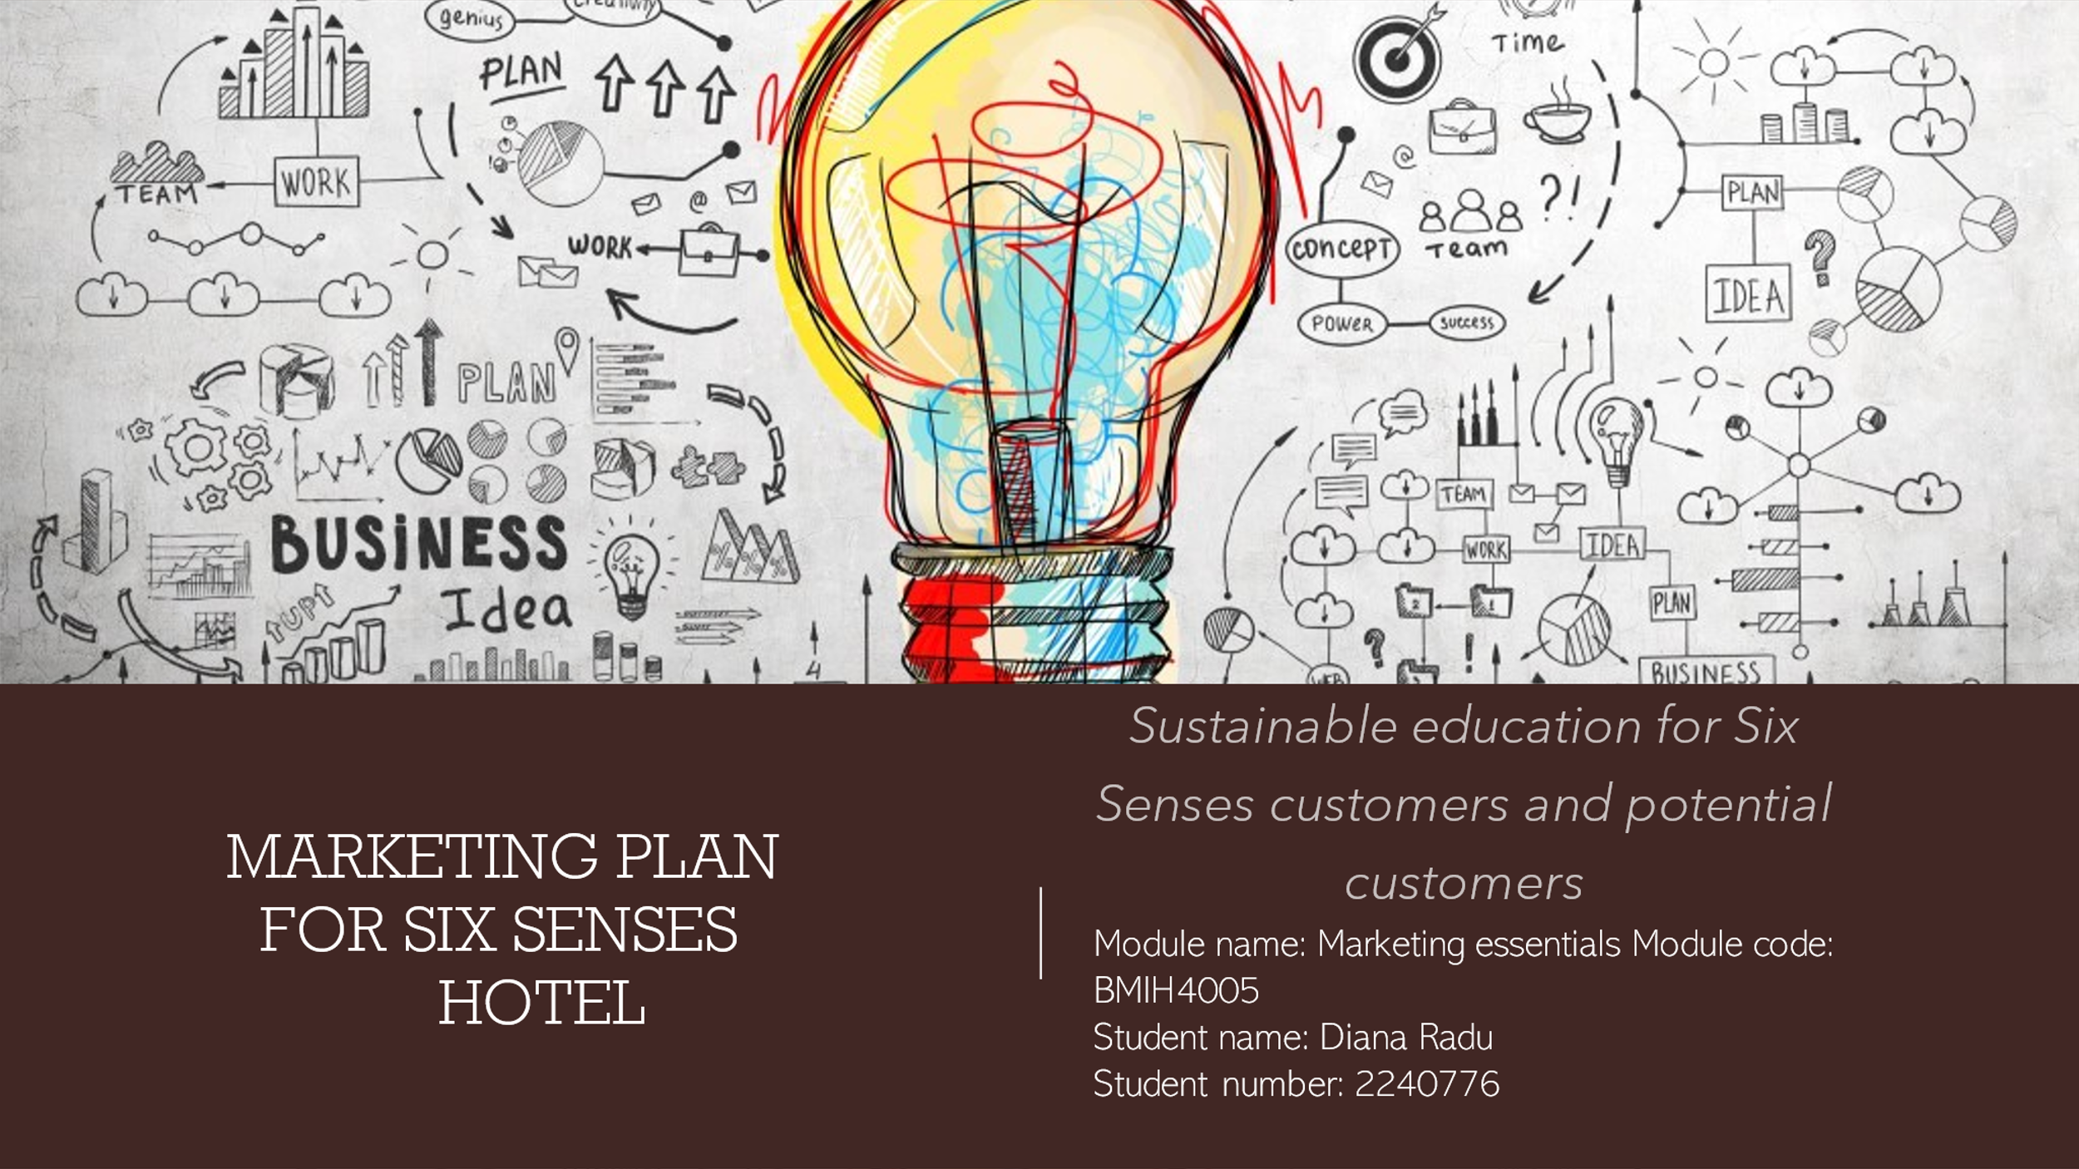
This is a marketing plan for SixSenses hotels in order to educate customers and potential customers about sustainability in the hospitality industry. The aim is to help customers gain more knowledge about the impact and importance of sustainability.
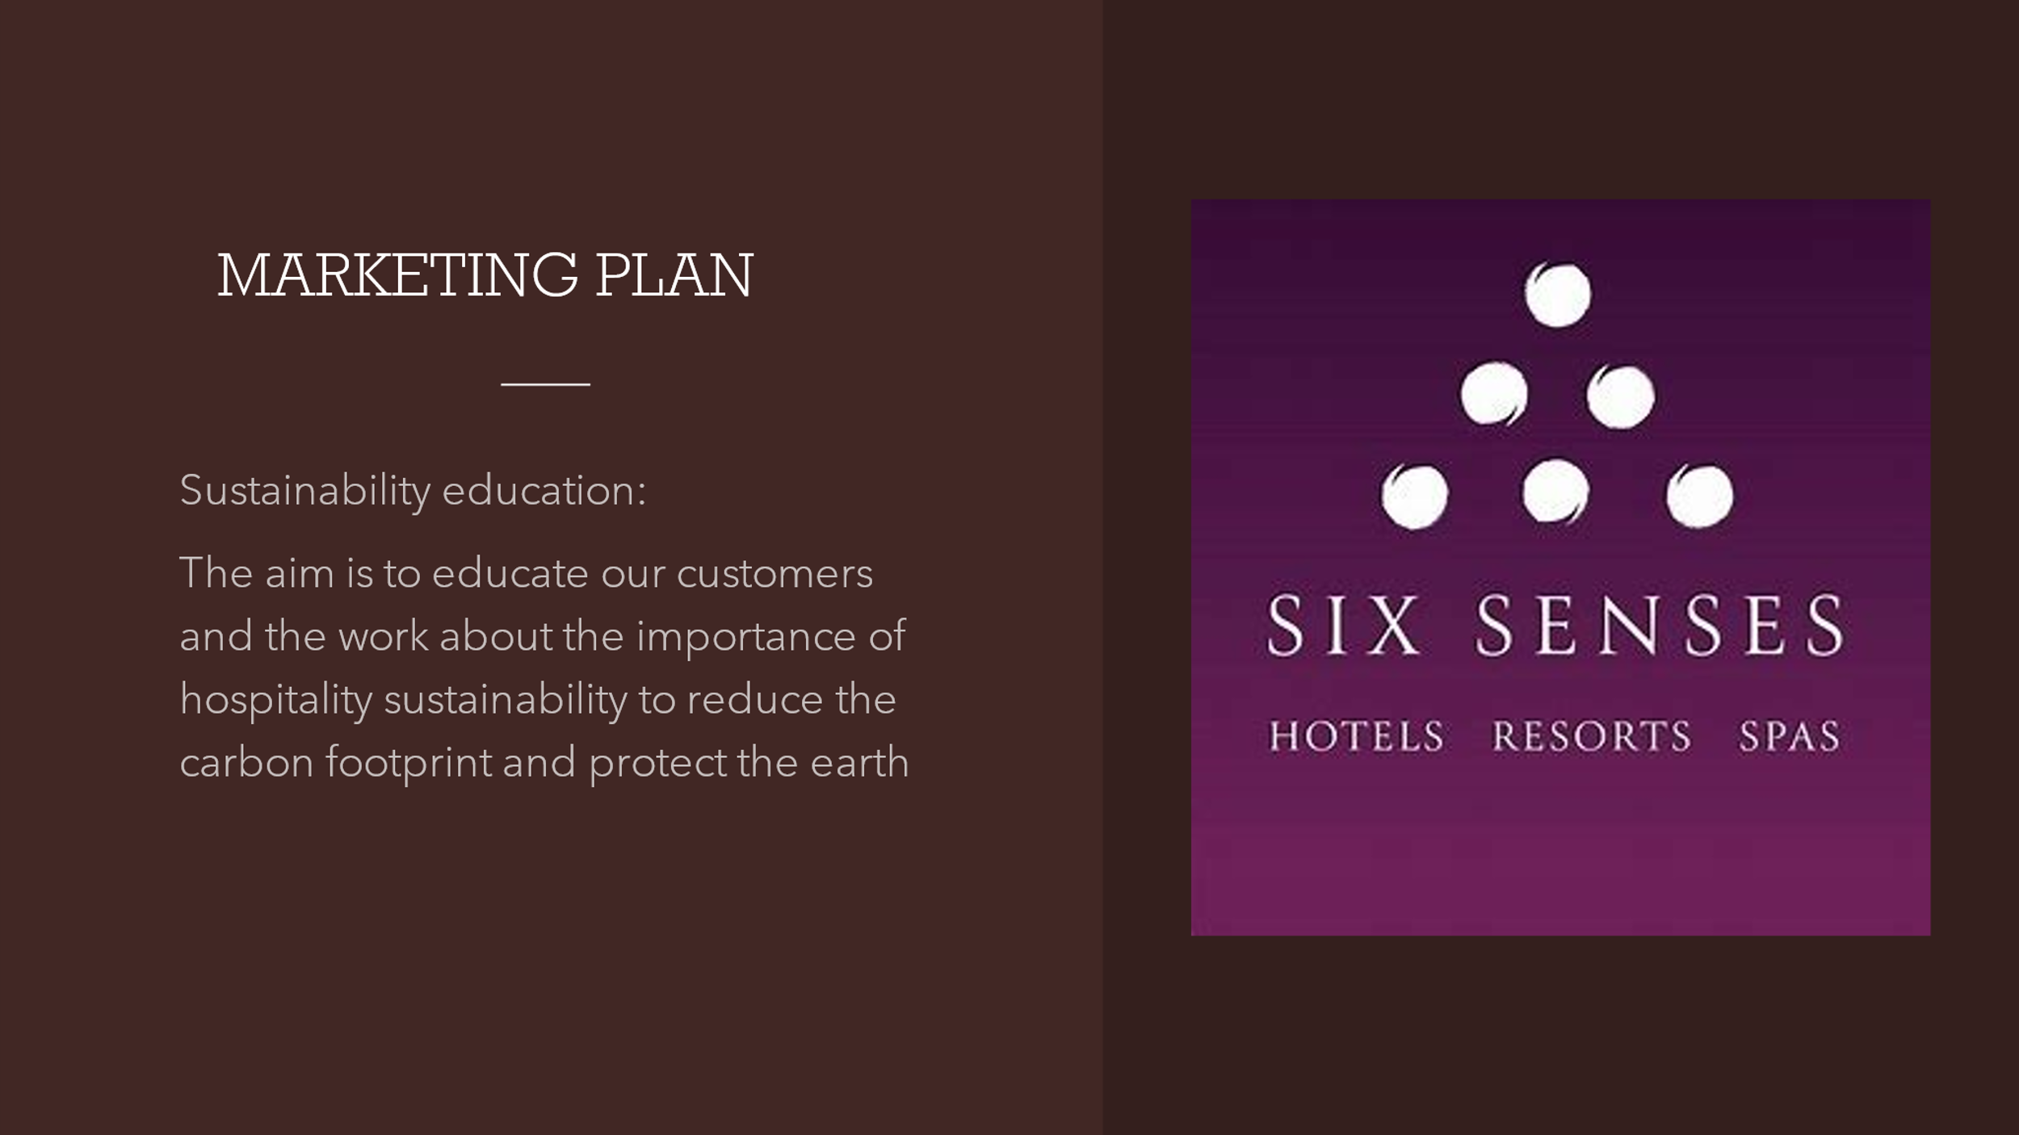
Sustainability education underlines SixSenses commitment to inform both customers and the wider community about the vital role hospitality sustainability plays in reducing carbon footprints and safeguarding our planet.
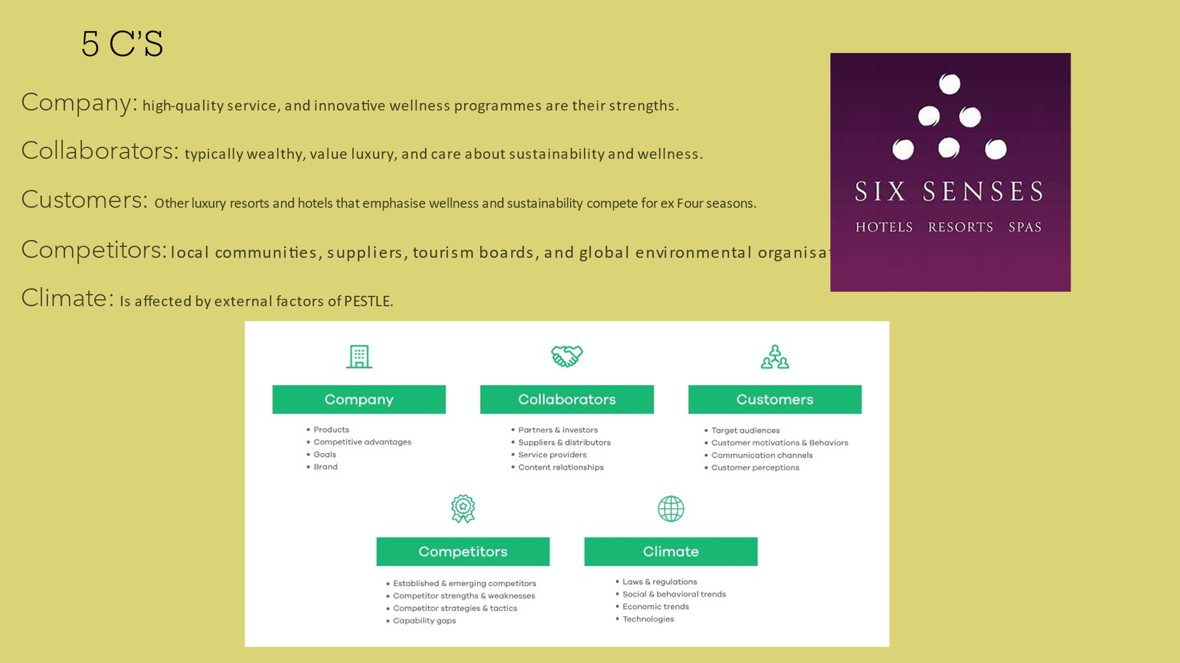
Turning to the 5 C's of our strategic framework: Our company's strengths lie in delivering high-quality service and innovative wellness programs, while we engage with affluent collaborators who prioritise luxury, sustainability, and wellness. Understanding our customer base, which includes other luxury resorts focused on wellness and sustainability, allows us to position ourselves uniquely against competitors like local communities, suppliers, tourism boards, and global environmental organizations, all within the broader context shaped by PESTLE factors.
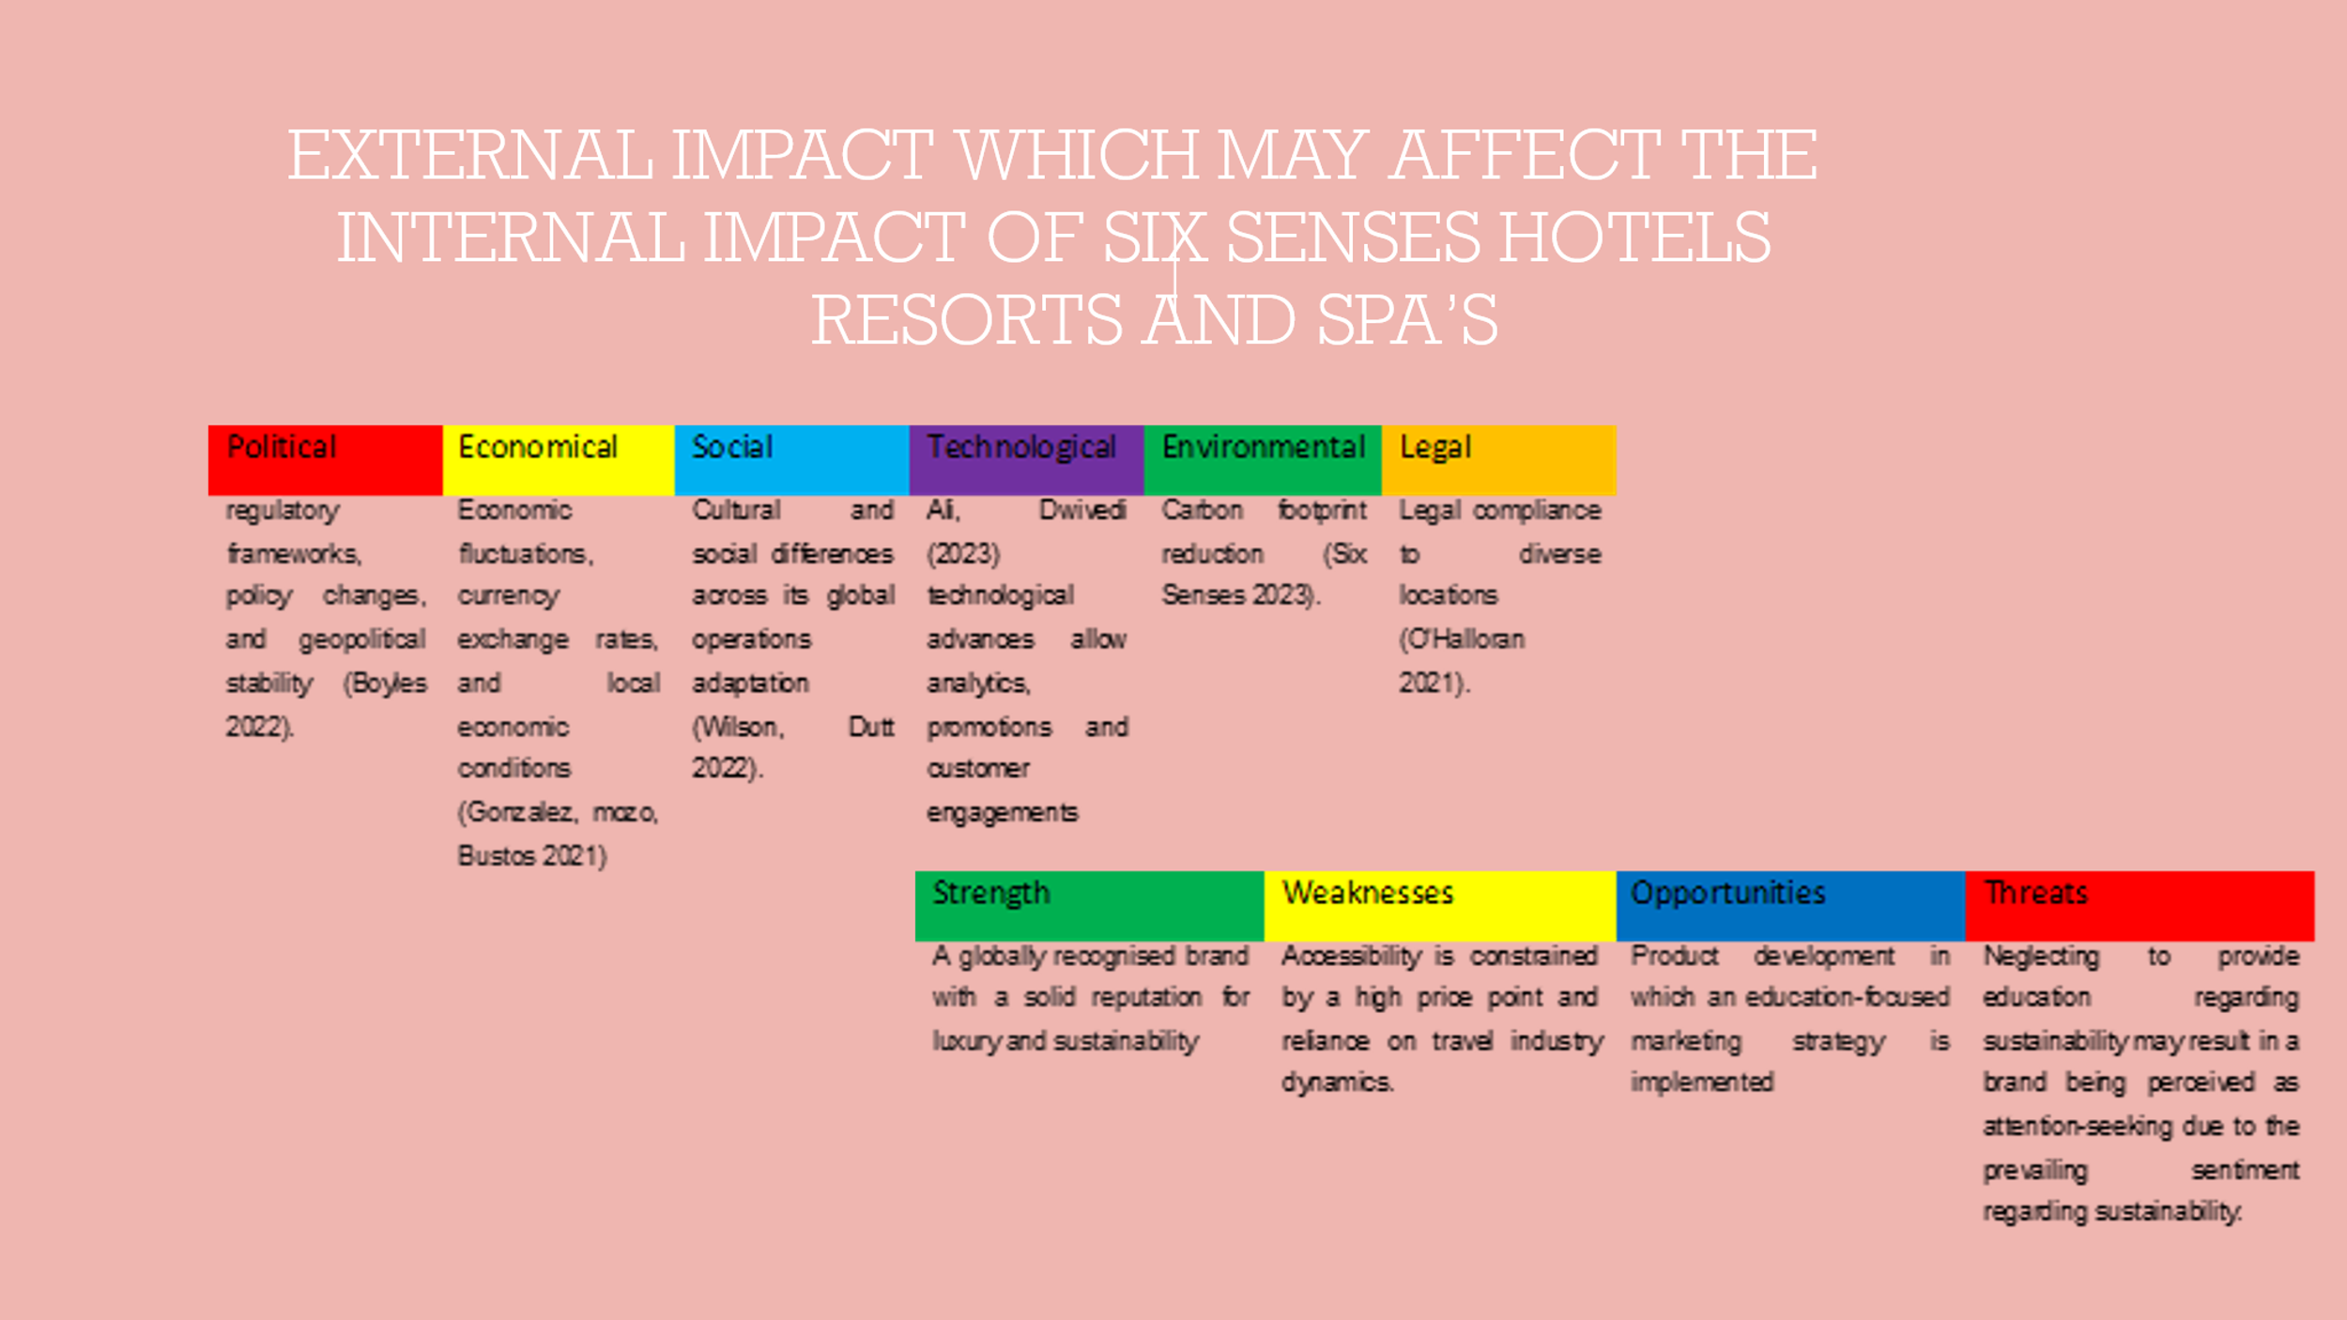
The external and internal factors impact Six Senses Hotels, Resorts, and Spas, with external elements ranging from political regulatory changes to economic fluctuations and social adaptations up to technological, environmental, and legal challenges. Internally, our strengths lie in our globally recognised brand and commitment to luxury and sustainability, while we must be cautious of weaknesses such as high price sensitivity and stay vigilant of opportunities in education-focused marketing, as well as threats like perception issues related to sustainability efforts.
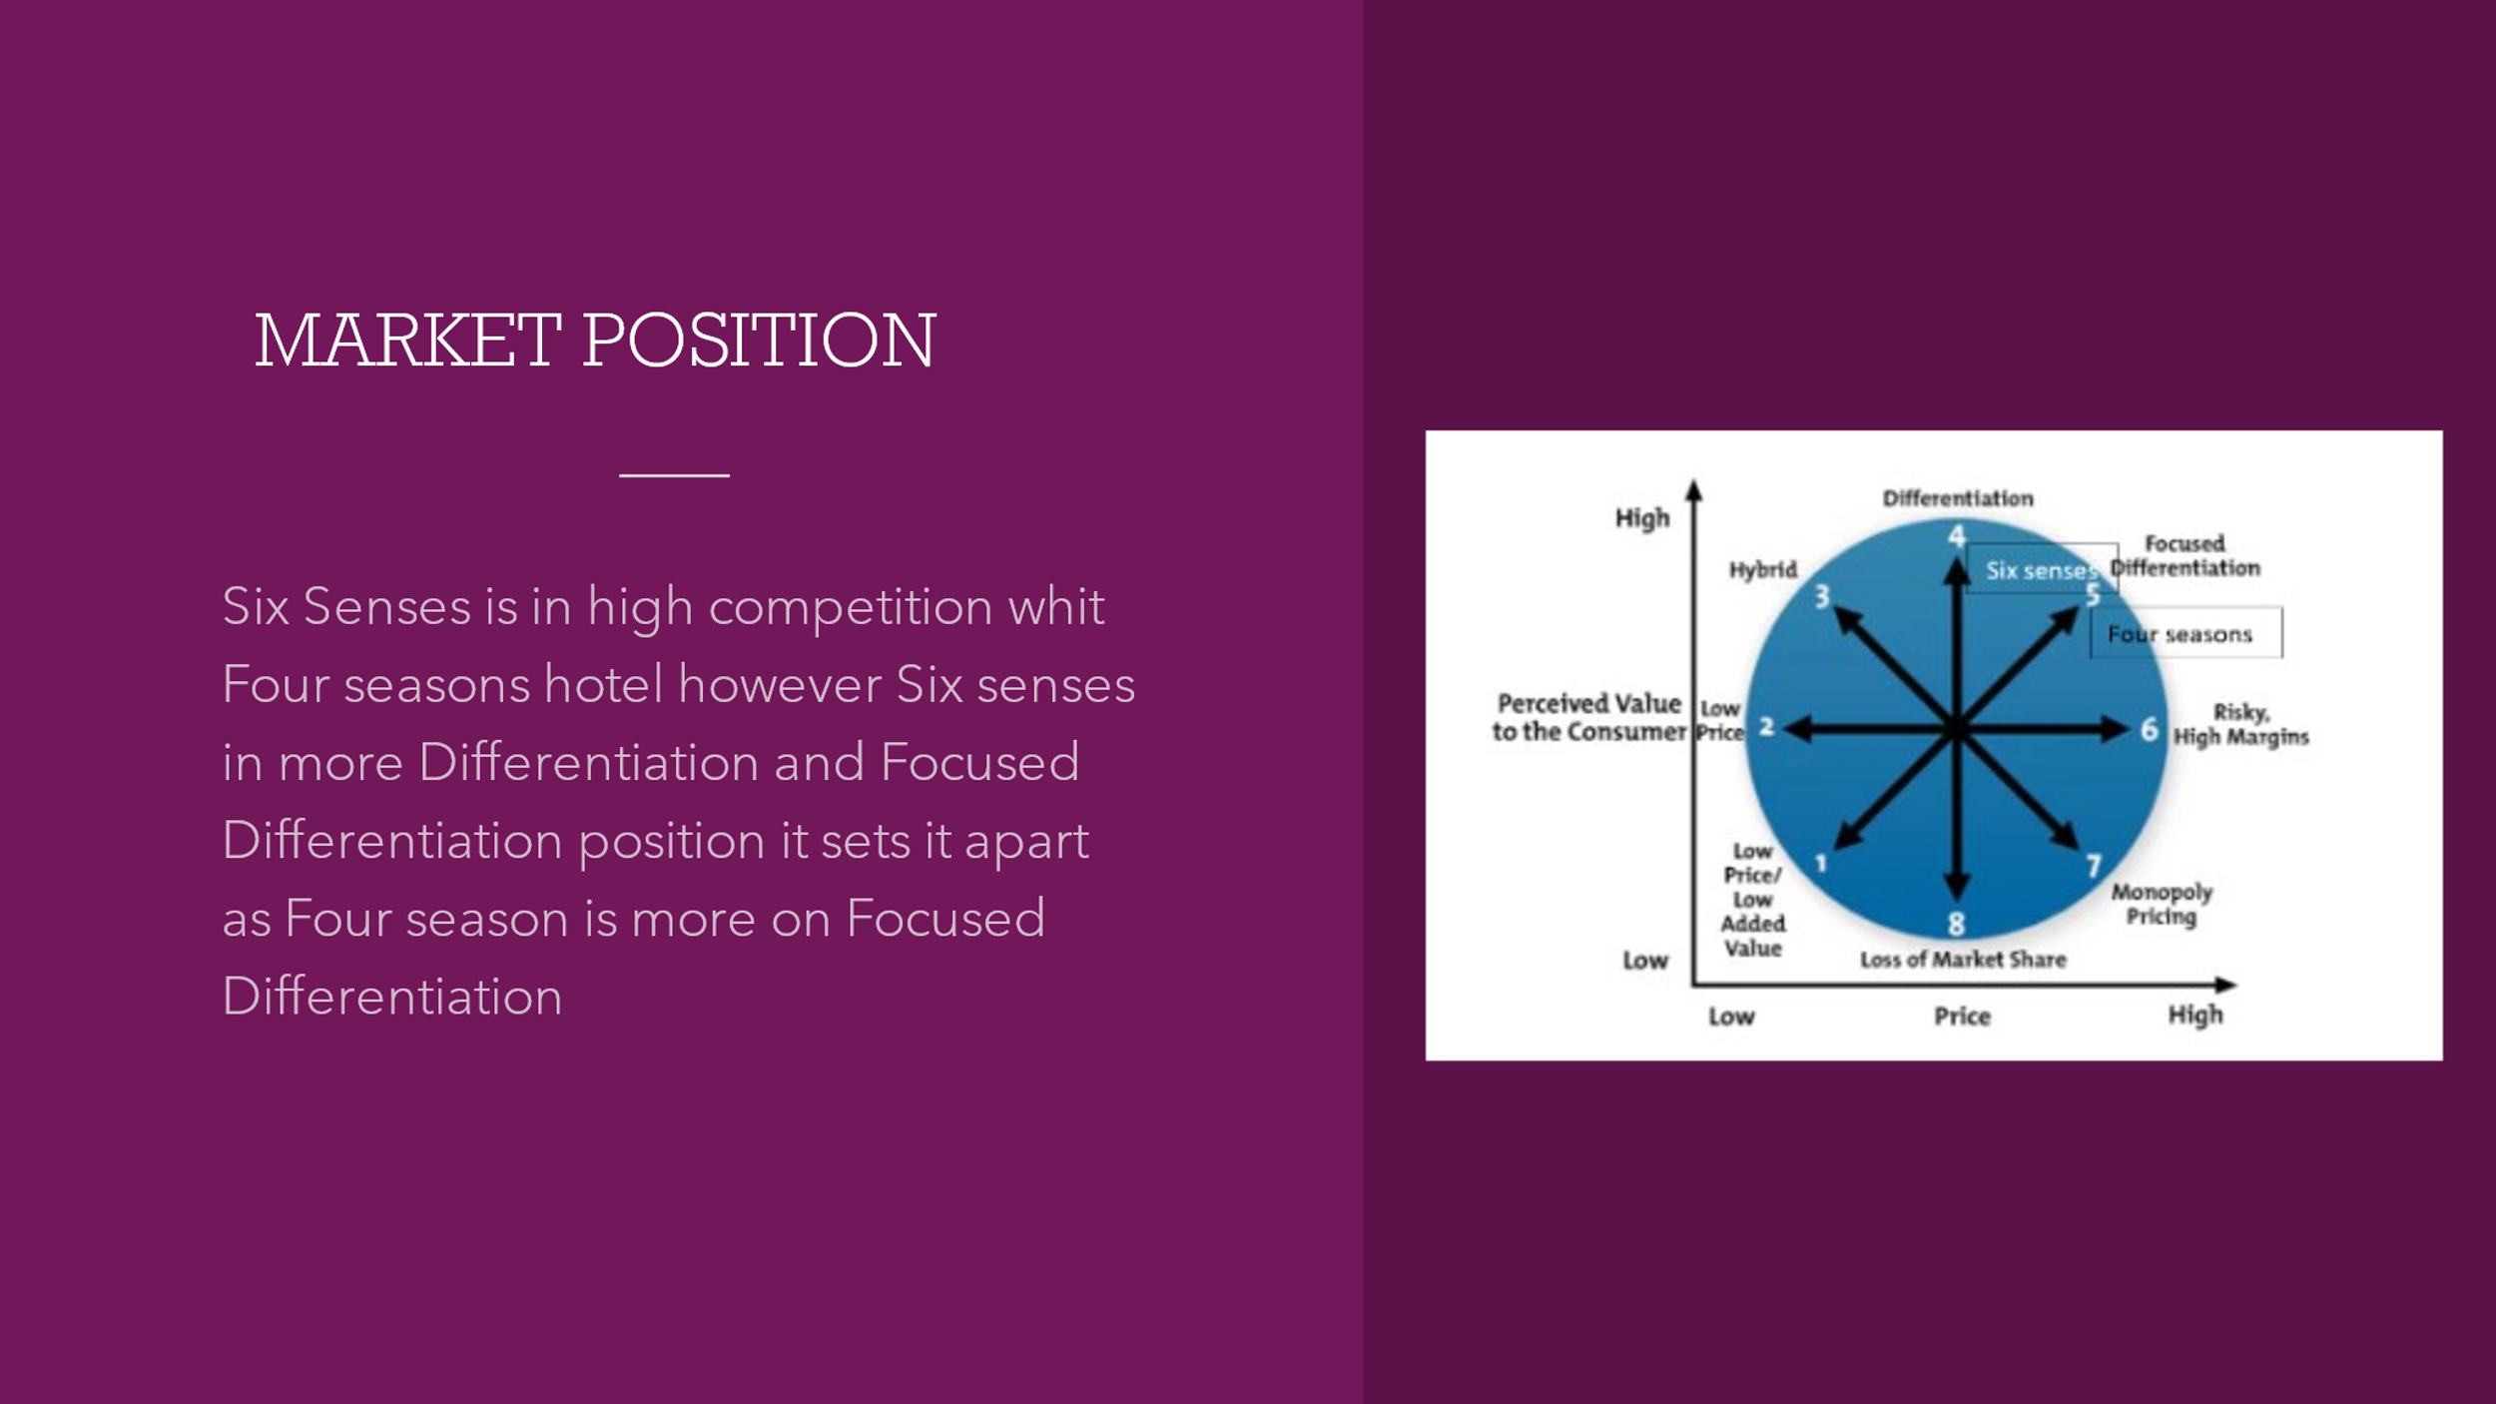
Six Senses faces stiff competition from the Four Seasons yet distinguishes itself through a strategy of both differentiation and focused differentiation, offering unique value that sets it apart in the luxury hospitality market. This strategic placement is contrasted with the Four Seasons, which leans more heavily towards focused differentiation, indicating different market approaches within the high-end segment.
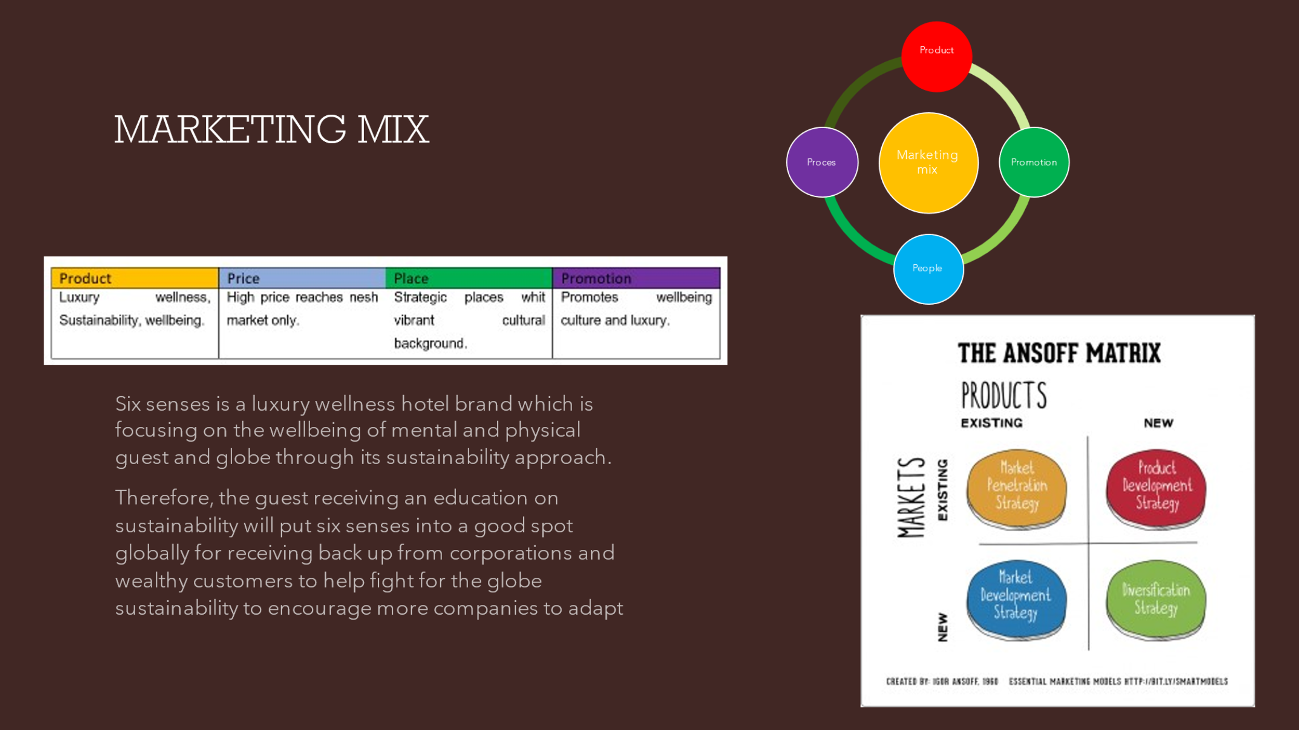
Our marketing mix centres on the luxury wellness experience Six Senses offers, with a pricing strategy that targets the niche market and a placement in vibrant, cultural locales. The promotion of wellness and sustainability not only enhances guest wellbeing but also positions Six Senses as a leader in corporate responsibility, encouraging other companies to follow suit in sustainable practices.
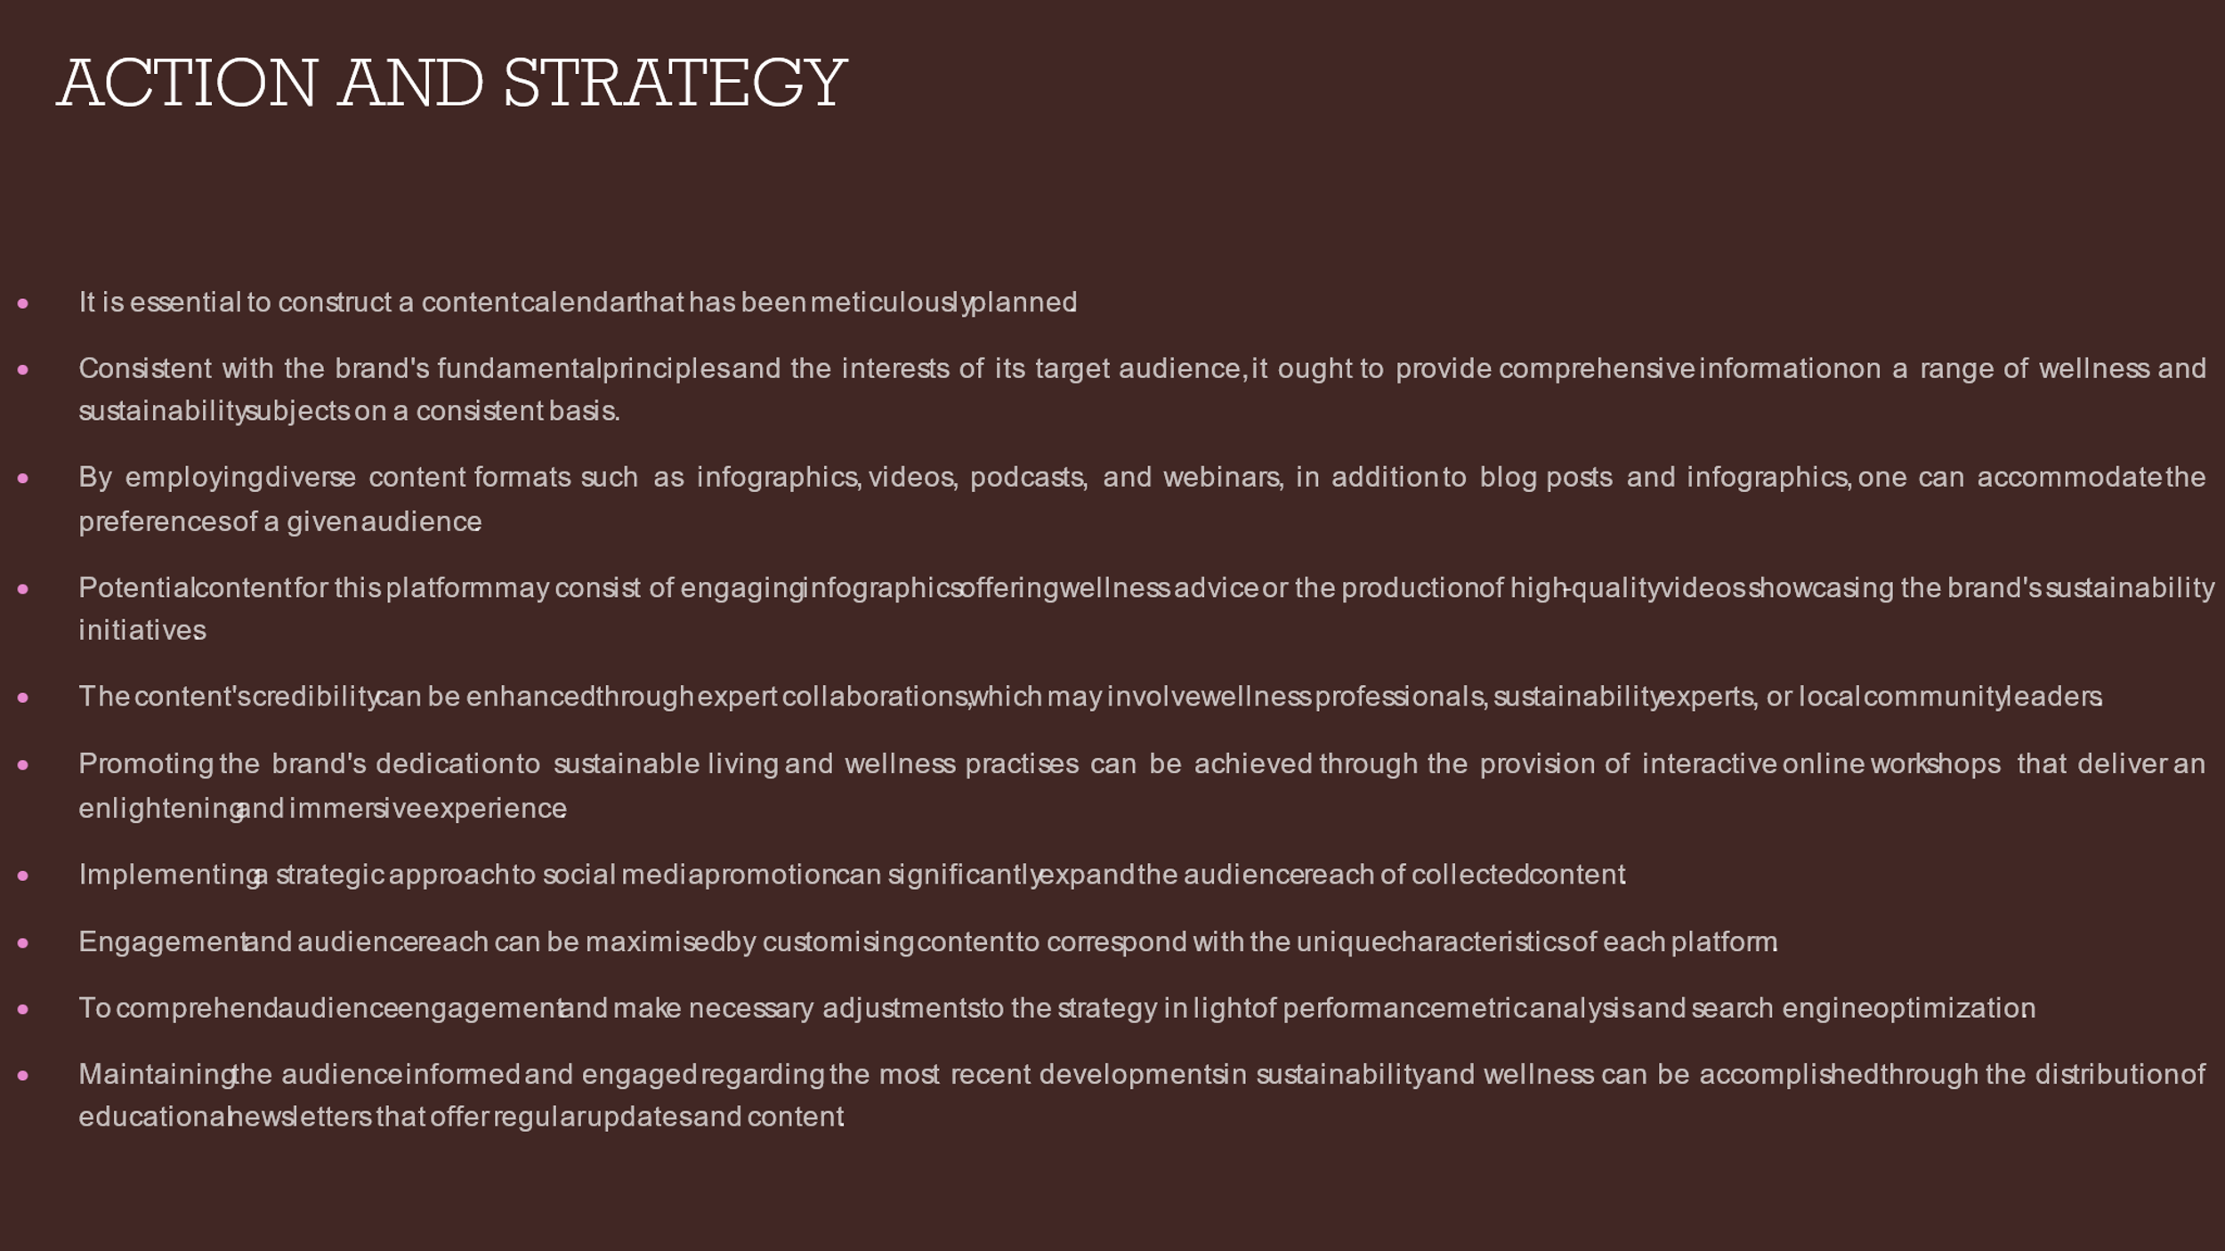
To execute our action and strategy effectively, we must establish a carefully curated content calendar to deliver consistent and diverse wellness and sustainability information to our audience. Leveraging various content formats and expert collaborations, we aim to deepen engagement, enhance credibility, and optimise our outreach efforts, ensuring our audience stays informed and involved with up-to-date and educational content on sustainability and wellness initiatives.
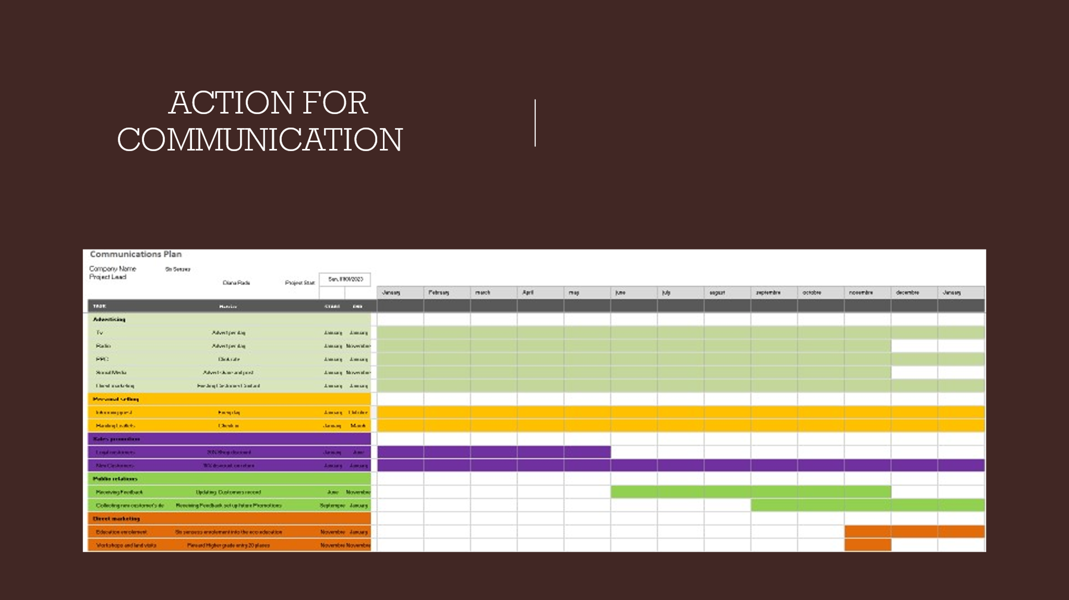
For our communication action plan, we've laid out a structured timeline detailing strategic initiatives across various channels throughout the year. This schedule ensures that our key messages are delivered effectively, aligning with our overarching marketing and public relations objectives to enhance brand visibility and engagement.

