7/24/2026
University of Wales Trinity Saint David
London campus
E-Portfolio Link: https://25390269.wixsite.com/olaportfolio2539026
Module Name: Learning In the Digital Era
Module Code: ACCA 4025

Student Name: Olamide Akintunde
Student ID: 2539026
Group: 1

Lecturer’s Name: Koushik Modak

LDE Assignment 1
E-Portfolio
Table of Contents
Introduction 2
Main Body 2
Task 1: Essential Academic and Employment Skills for the Future Career Path 2
Task 1 (a): Report on Essential Academic and Employment Skills 2
Task 1 (b): Evaluation of Task 1 (a) based on Similarity Report 7
Task 2: Collaborative Mind Map and Individual Poster [10]. 8
Mind Map (Collaborative) 9
Poster (Individual) 10
Task 3: Virtual Collaboration and RefWorks 10
Report on Virtual Collaboration 10
Step-by-step process of using RefWorks with visuals 12
Task 4: E-Portfolio Creation and Evaluation 17
Task 4 (a): E-Portfolio Creation 17
Task 4 (b): Illustrative Review of E-Portfolio Tool Selection 17
Conclusion 18
References 19
Task 1 References: 19
References 19

Introduction
I have chosen to pursue a career in cybersecurity, starting from the very basics to build a strong foundation. I firmly believe that every significant journey begins with a single step, and in this field, mastering the fundamentals is crucial for long-term success. By gaining a solid understanding of core principles and skills, I am positioning myself to tackle the complex challenges of cybersecurity. I am excited about the opportunities ahead and committed to continually learning and growing in this dynamic and essential field.
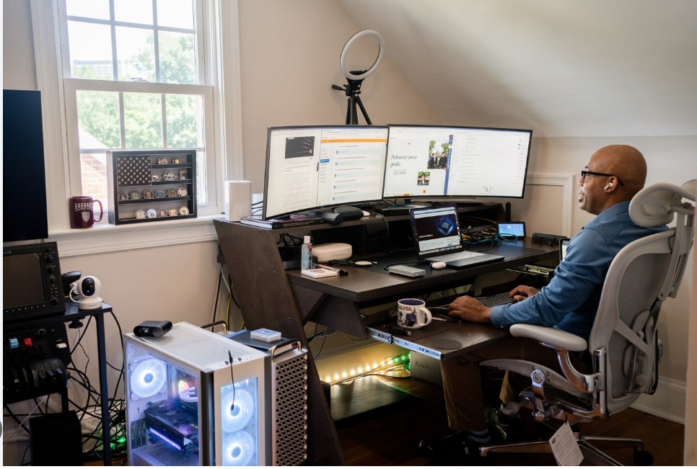
Figure 1: An example of a workspace for a cybersecurity professional. [1].

Main Body

Task 1: Essential Academic and Employment Skills for the Future Career Path

Task 1 (a): Report on Essential Academic and Employment Skills
Definition of Cybersecurity: Cybersecurity encompasses the concept of "cyber," which pertains to digital technologies, alongside "security," which focuses on safeguarding digital assets. It’s important to differentiate between protecting against unauthorised electronic access and securing data from various legitimate threats that may compromise its integrity, availability, or confidentiality [2].

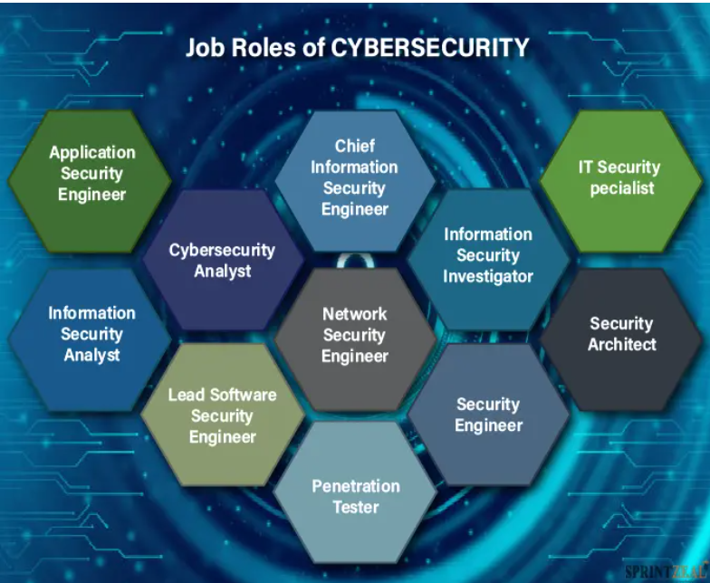
Figure 2: Cybersecurity Action Plan [3].

Cybersecurity involves preventing intentional acts that wrongfully acquire or misrepresent resource rights, including cyberattacks, insider threats, and errors. Its goal is to protect legitimate property rights from unauthorised exploitation, essential for maintaining trust and integrity in the digital realm [4].

Key Skills for Cybersecurity Careers
Academic Knowledge: A degree in computer science or IT is foundational, covering network operations, security, and programming languages such as Python, JavaScript, SQL, and C++.
Technical Expertise: Practical experience, certifications, and familiarity with cybersecurity tools are crucial.
Interpersonal Skills: Effective communication, critical reasoning, adaptability, and sound decision-making enhance the ability to respond to cybersecurity challenges.
A successful career requires a blend of academic, technical, and social skills. Pursuing advanced studies, such as an MSc in cybersecurity, allows for specialisation in areas like ethical hacking and digital forensics.
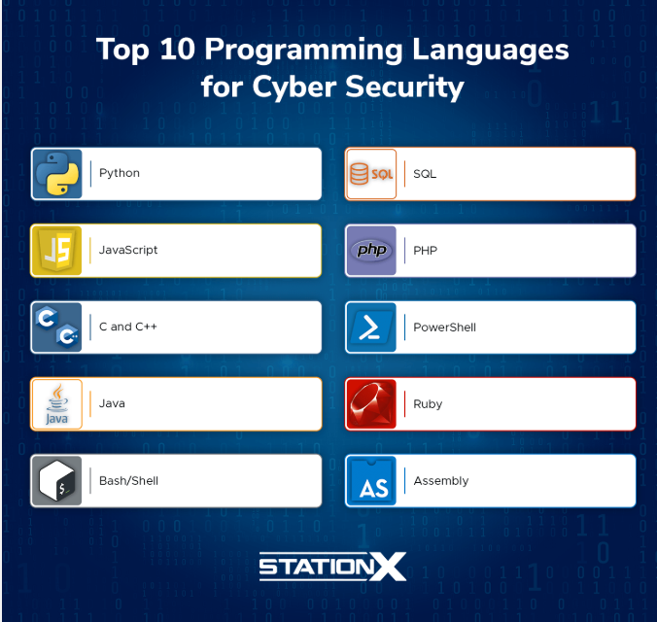
Figure 3: Programming language in Cyber security [5].
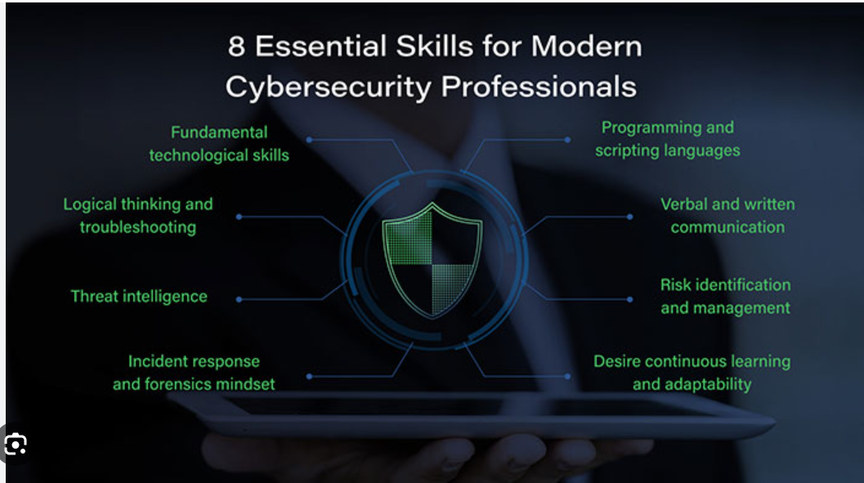
Figure 4 Image supporting potential skills in cybersecurity: [5].

Technical proficiency is essential in cybersecurity, often requiring knowledge of tools like SIEM and EDR. Certifications such as CompTIA Security+, CEH, or OSCP are valuable. Moreover, 65% of roles demand cross-domain knowledge in cloud security and incident response.

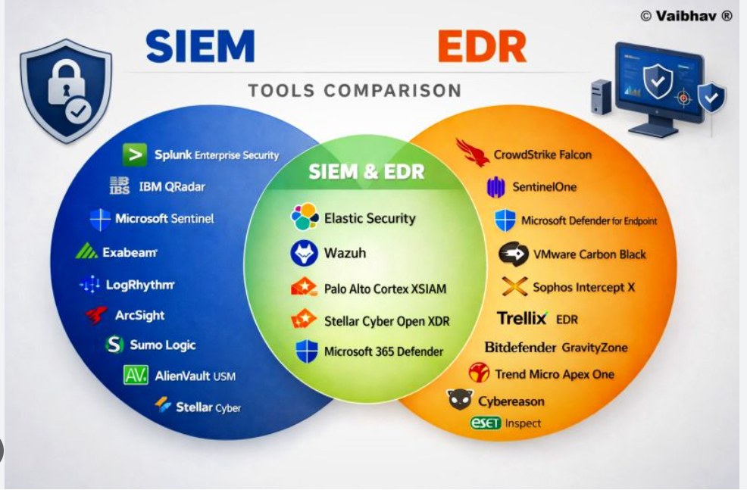
Figure 5: supporting Tools/Software used in Cyber security as mentioned

Human Skills: Security professionals need situational awareness to identify critical assets and threats, as well as an understanding of their business implications. Fostering a security culture requires promoting safe behaviours and addressing human error. Ethical decision-making and stakeholder influence are also crucial.
Career Support: Developing these skills can elevate your career from Junior Analyst (£40,000) to Senior Engineer (£80,000+) in ten years. Gaining practical experience through platforms like TryHackMe, apprenticeships, or entry-level IT roles can help you bridge the experience gap in this high-demand field.
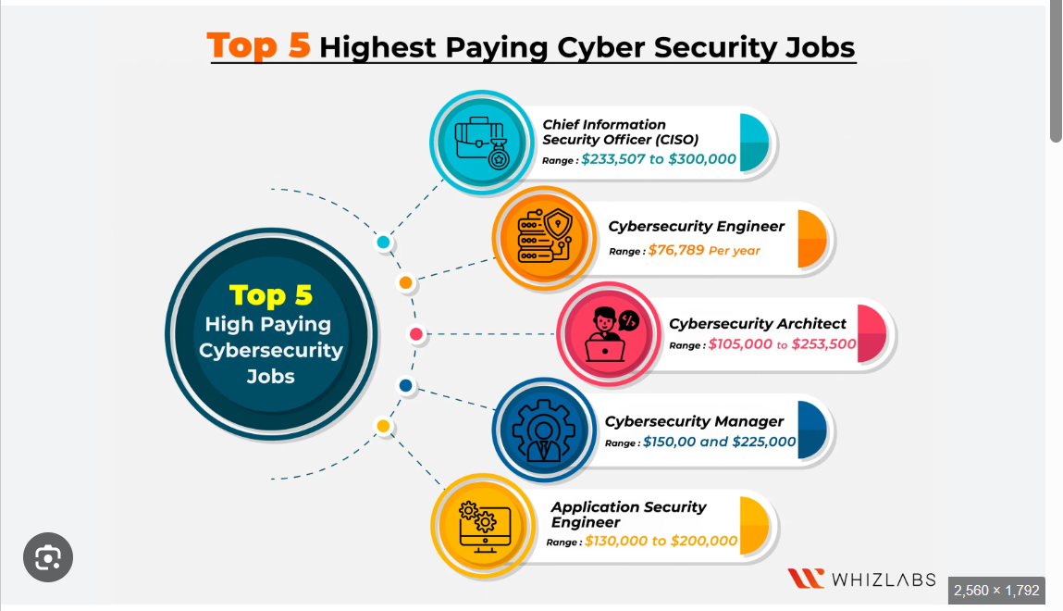
Figure 6: Image below showing Potential Pay in cybersecurity: [6].

Task 1 (b): Evaluation of Task 1 (a) based on Similarity Report

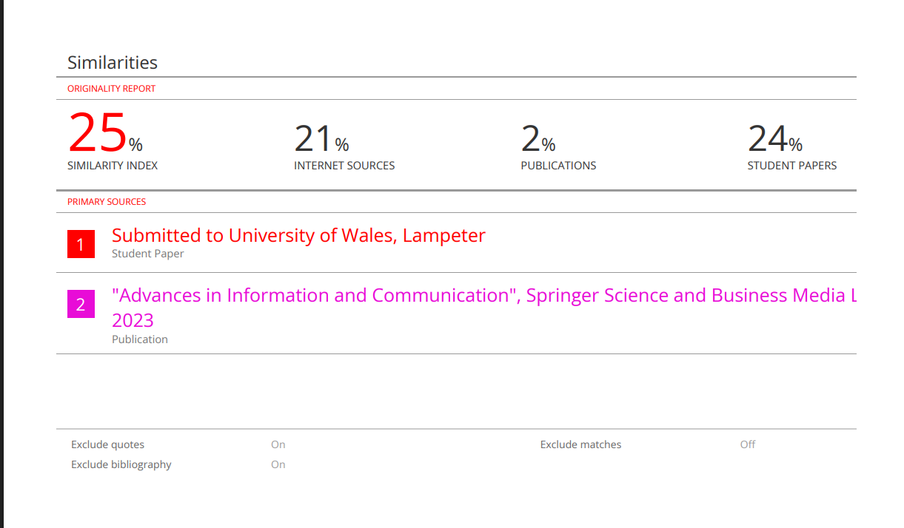
Figure7: Similarity score is 25%, supporting score image from Turnitin below: [7].
My score is higher than normal, but I see room for improvement, particularly in my paraphrasing. I need to avoid using direct phrases from sources, not out of laziness but to stay focused. I aim to enhance my analysis and critical thinking while incorporating my ideas. Although I paraphrased most points, some information requires using exact terms. To reduce matches and uphold academic integrity, I’ll diversify my vocabulary and sentence structures in references.

My self-assessment mark: 81
I chose this mark because my summary is structured, with clear definitions, solid evidence, and correct citations. While my references are accurate, I can improve my paraphrasing to better express my own ideas. Strengthening my writing will help me achieve a higher grade.

Task 2: Group Mind Map and Personal Poster.
My Teams: Group 1
Olamide Akintunde - 2539026
Begum Eldek - 2542321
Rajeep Maharjan - 2538568
Roberto Carlos Vidal Cabrera - 2539028

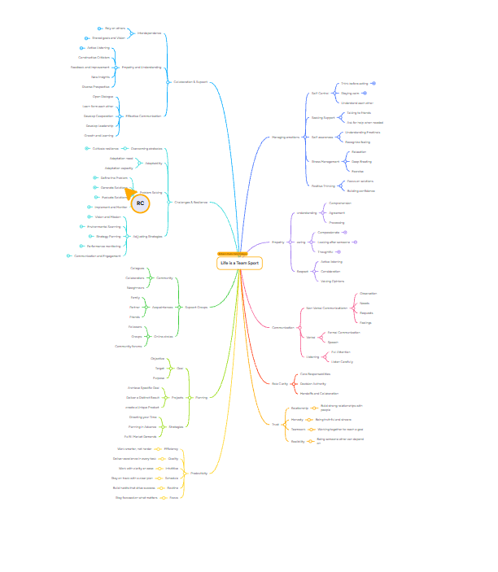
Click the link below to access the mind map. The image may be blurry, but it's accessible through the link and can be expanded.
https://www.mindmeister.com/app/map/4030976520?t=W733O9Thx6&m=focus
Figure 8: Mind Map image
Mind Map (Collaborative)
My Group 1 Team collaborated and brainstormed using MindMeister to create a map summarising the key considerations for effective teamwork. The central theme assigned to our group was "Life is a Team Sport," reflecting our belief that teamwork is essential not only in professional settings but throughout every aspect of life and in any situation you may encounter.
Our Mind Map is organised around core branches, each representing a critical aspect of successful teamwork.

Poster (Individual)

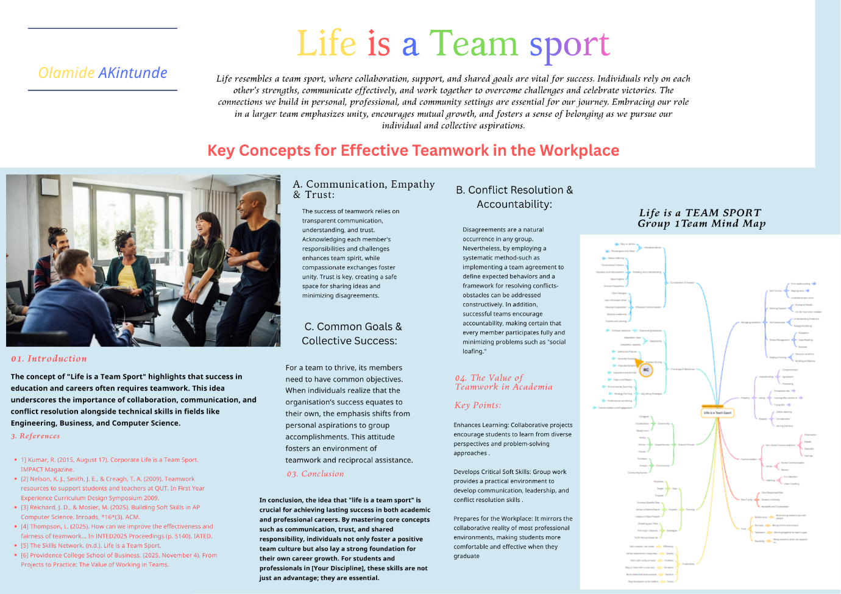
Figure 9: Life is a team sport Image
Link to Poster - https://canva.link/ywafrwir3p09eit

Task 3: Virtual Collaboration and RefWorks

Report on Virtual Collaboration
Unit 3 Topic 1: Forming a Team
The Five Dysfunctions of a Team
Establishing a healthy organisation begins with forming a united leadership team. This undertaking necessitates a careful assessment and resolution of five key dysfunctions that can severely impede a team's capacity to function effectively. These dysfunctions include a lack of trust among team members, fear of conflict, inadequate commitment to team decisions, evasion of accountability, and neglect of results. By addressing these concerns, leaders create an environment that encourages collaboration and individual empowerment. Resolving these dysfunctions allows the leadership team to work cohesively and more effectively toward organisational goals. [1].

1. Absence of Trust: Trust is essential for team collaboration. It requires team members to be open with each other, sharing their identities, strengths, weaknesses, and even mistakes. Without this foundation of trust, a team cannot function effectively, which leads to the second dysfunction: the fear of conflict. [1].

2. Conflict: Conflict, often seen negatively, can benefit a team by encouraging constructive disagreements that lead to better solutions. However, without trust, these conflicts may become unproductive, resulting in a lack of commitment. [1].

3. Commitment: Commitment arises when team members genuinely support a decision because they have been involved in the discussion and understand the reasoning behind it. When commitment is lacking, team members may become disengaged, setting the stage for the fourth dysfunction: failure to hold one another accountable. [1].

4. Accountability: Accountability is a vital aspect of teamwork. When team members are genuinely committed to the team's goals, they are more likely to address each other's shortcomings in behaviour and performance. A lack of accountability leads to the final dysfunction: neglecting results. [1].

5. Results: Ultimately, team members might prioritise personal achievements over the team's collective success, focusing more on their individual responsibilities rather than the group’s overall objectives. For a team to achieve true success, it is crucial to establish trust, engage in constructive conflict, commit to decisions, and maintain accountability to one another.

By addressing these five dysfunctions, teams can foster an environment that promotes collaboration and leads to successful outcomes[1].
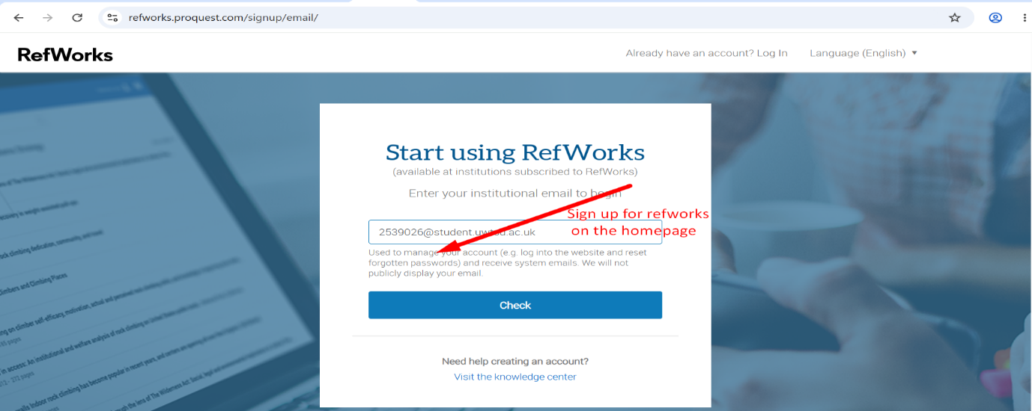
Figure1: Image showing a RefWorks signup page.

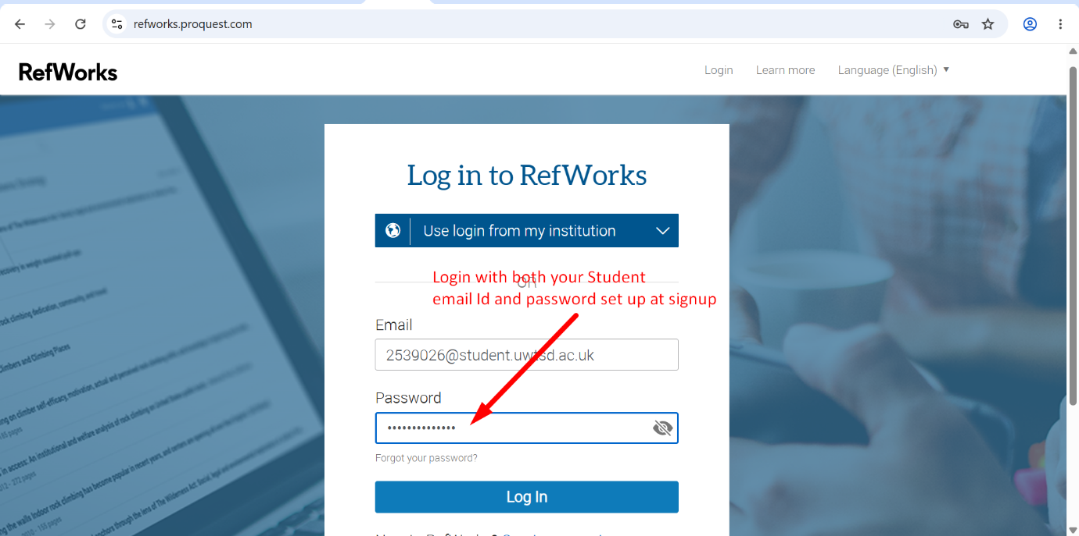
Figure2: Image describing how to log in after signup.

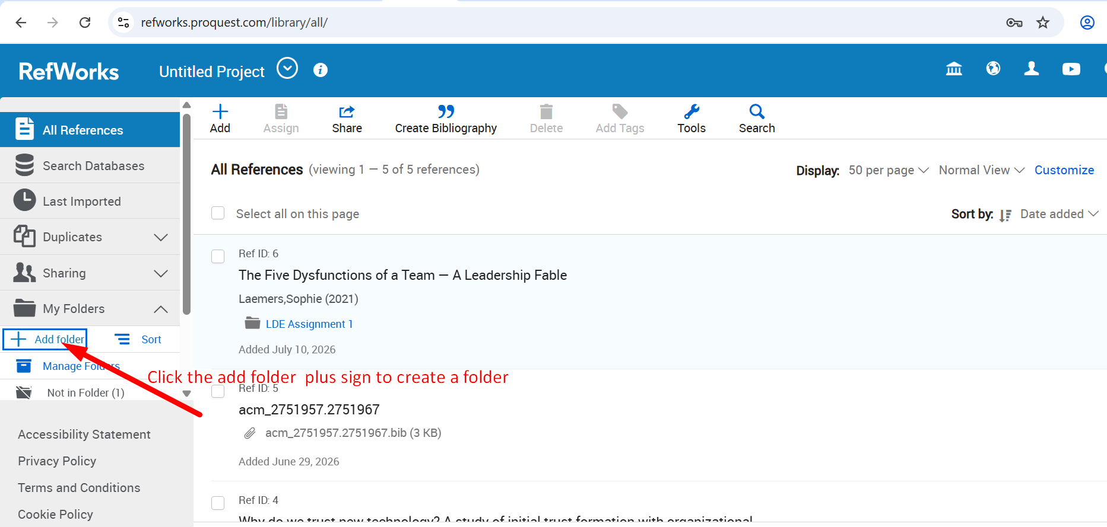
Figure3: Image describing how to create and add a folder.
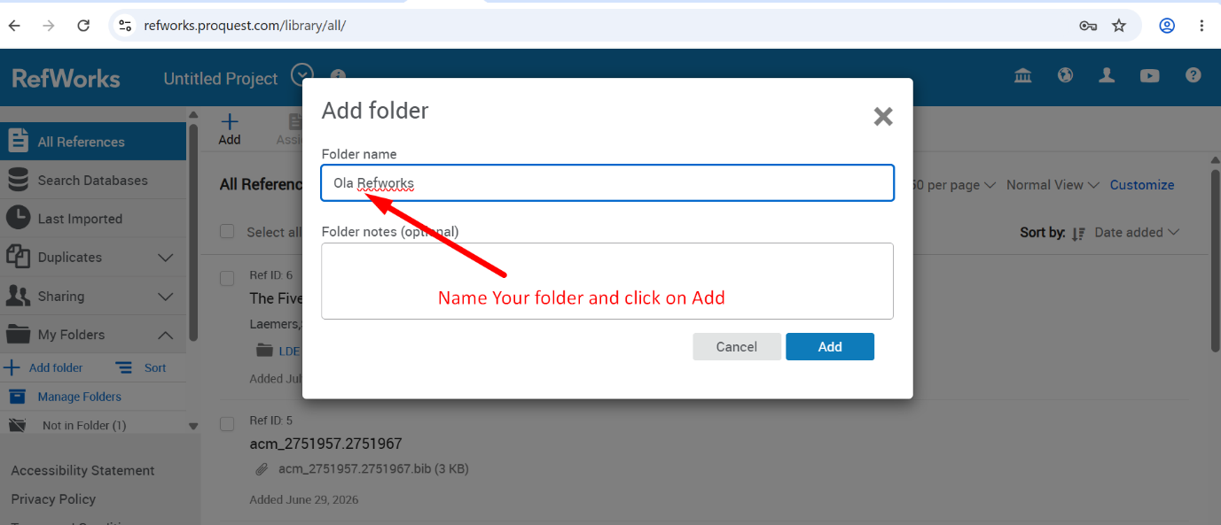
Figure4: Image describing how to name a folder.

A detailed procedure for utilising RefWorks that includes images.
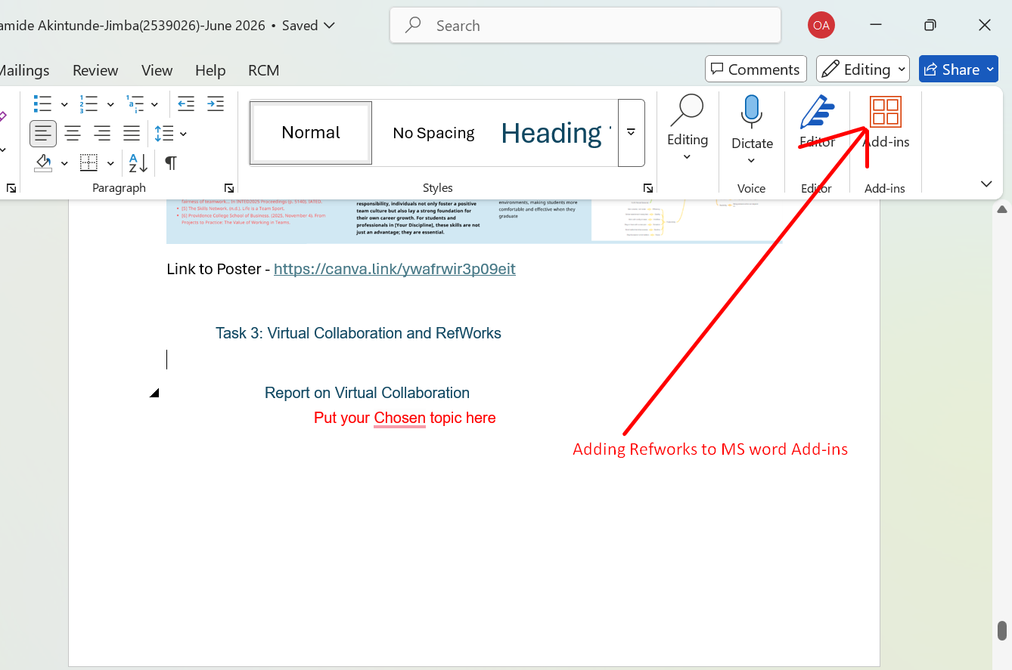
Figure 5: showing RefWorks in Microsoft Office Add-Ins
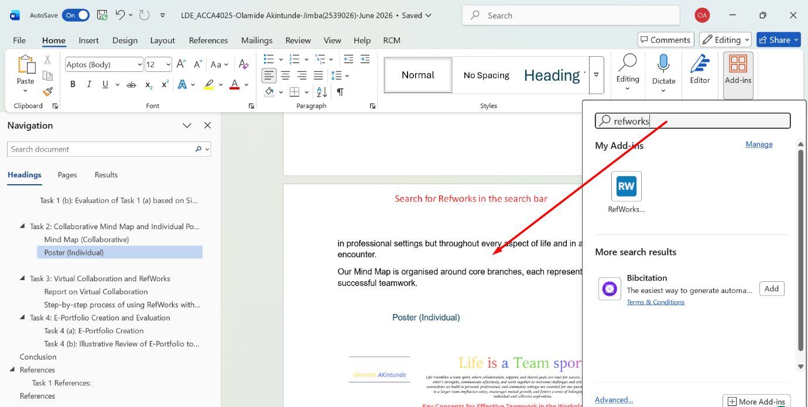
Figure 6: Showing how to include RefWorks in Microsoft Word Add-Ins
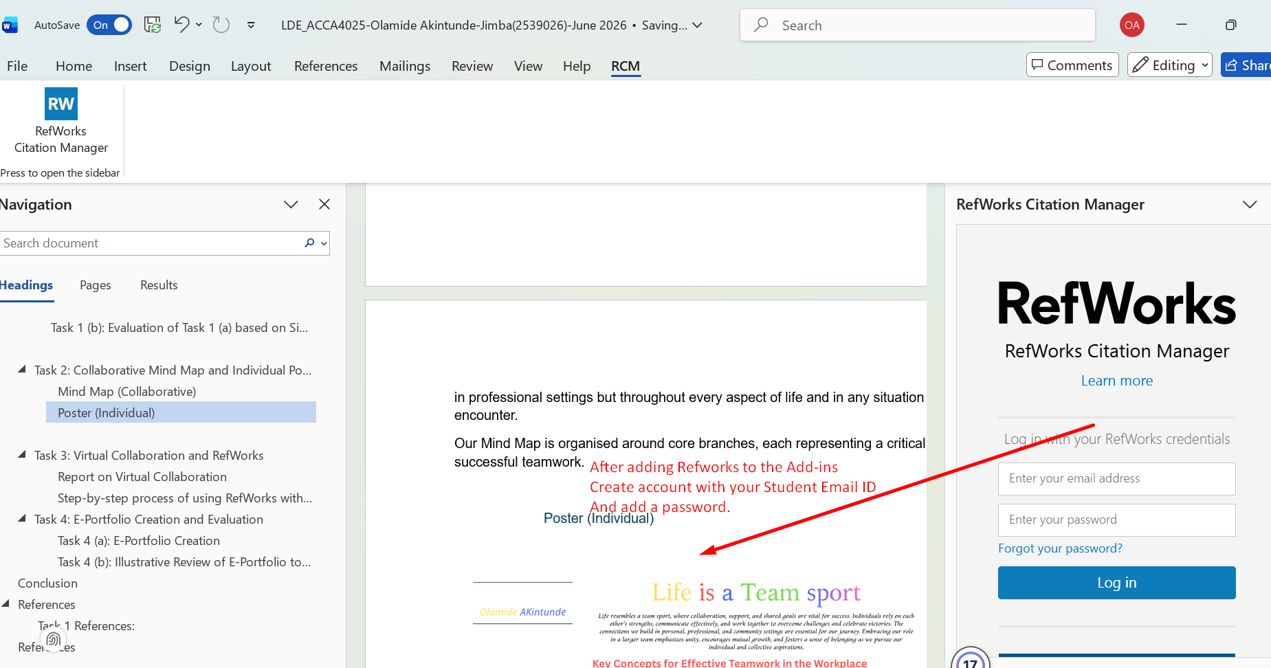
Figure 7: Image describing how to log in to Microsoft Word with the email and password set up at sign-up.
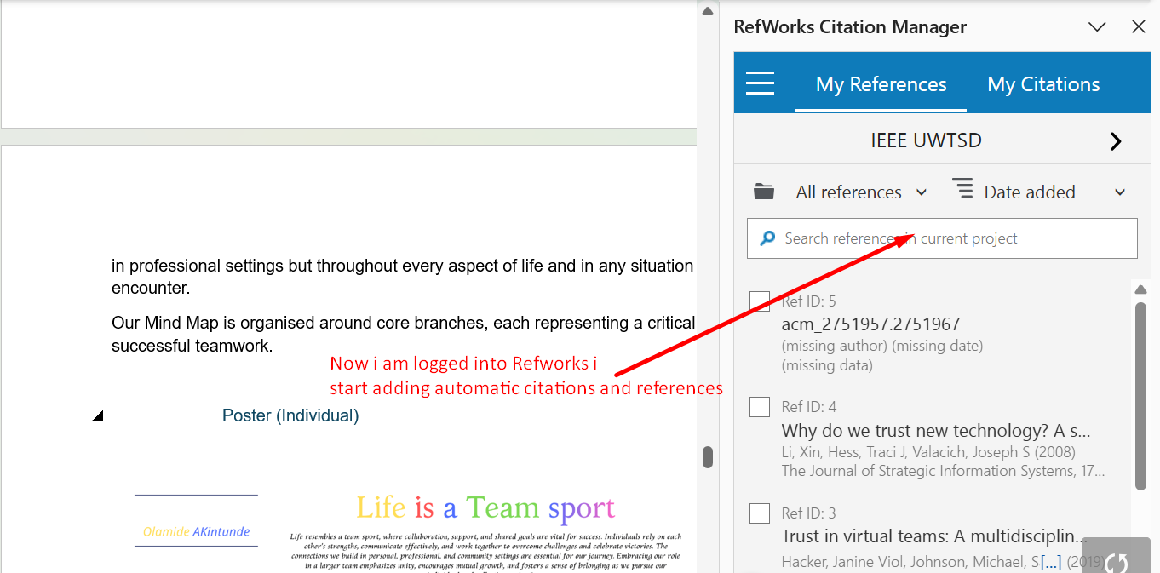
Figure 8:Image showing how to automatically add citations

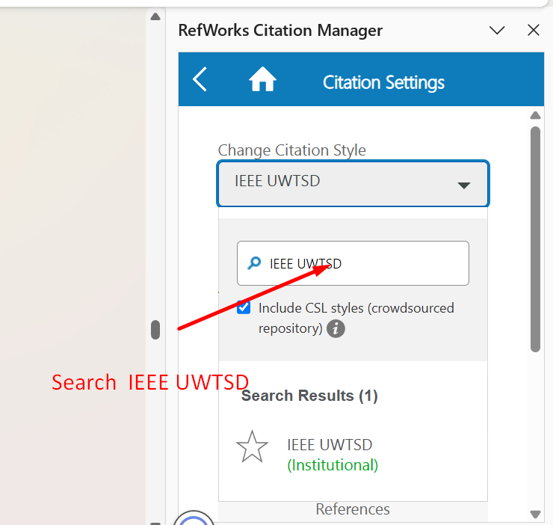
Figure 9: Image showing how to search and change Citation style.

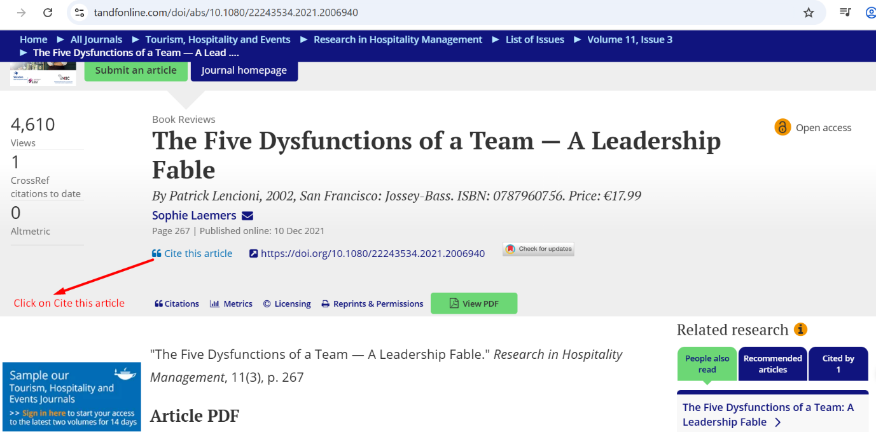
Figure 10: Image showing how to import citations.
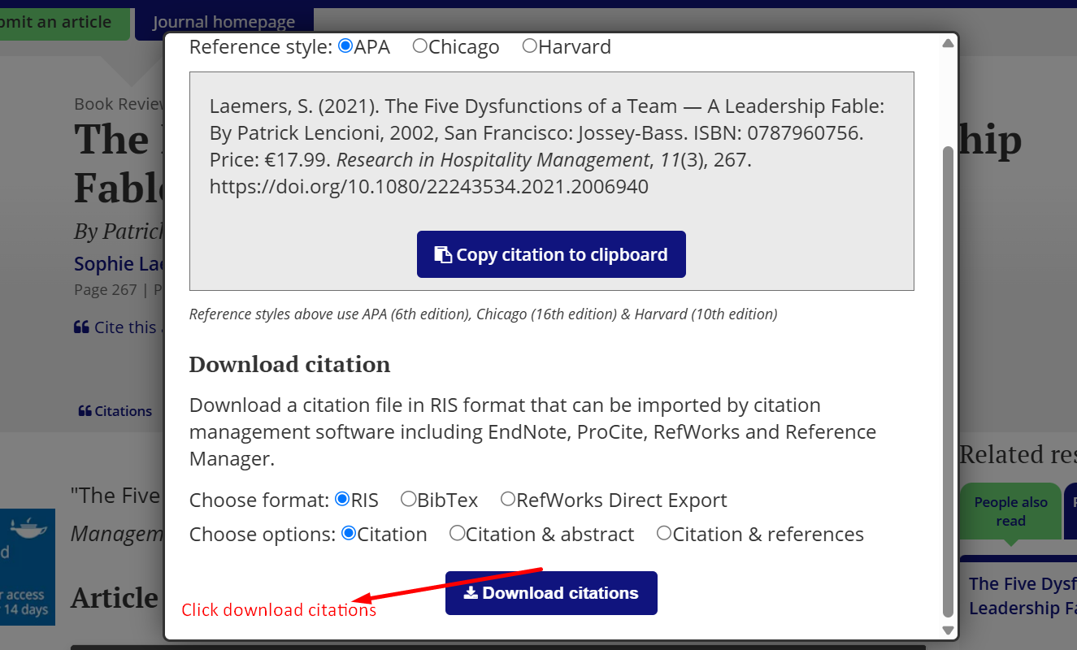
Figure 11: Image showing how to download citations.
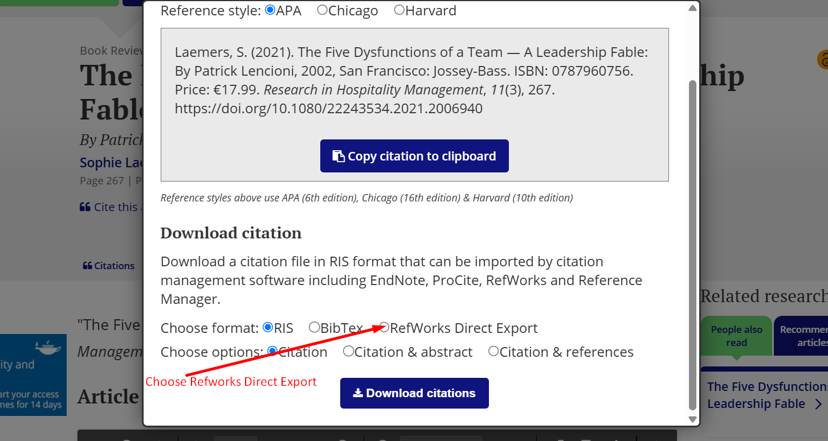
Figure 12: Image showing RefWorks direct export.
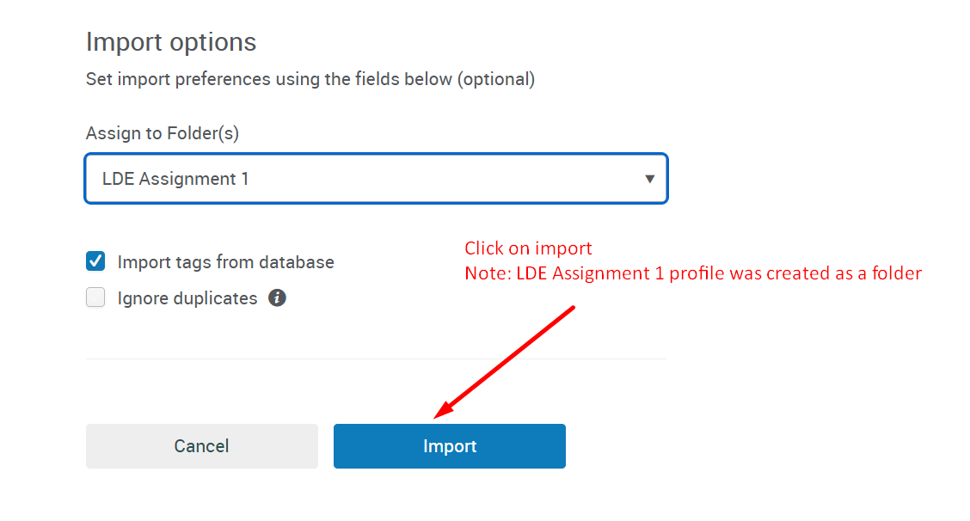
Figure 13: Image showing how to import and the folder to import to.
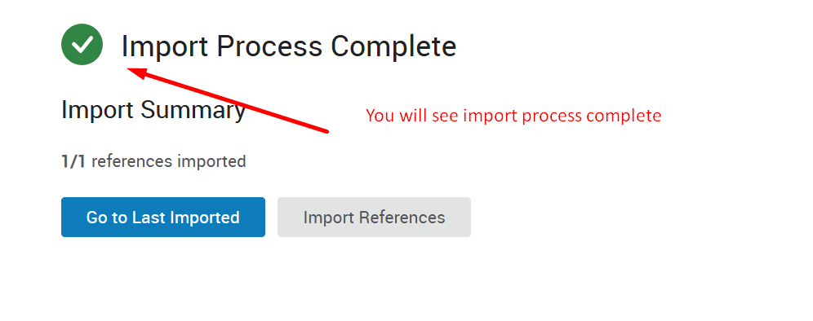

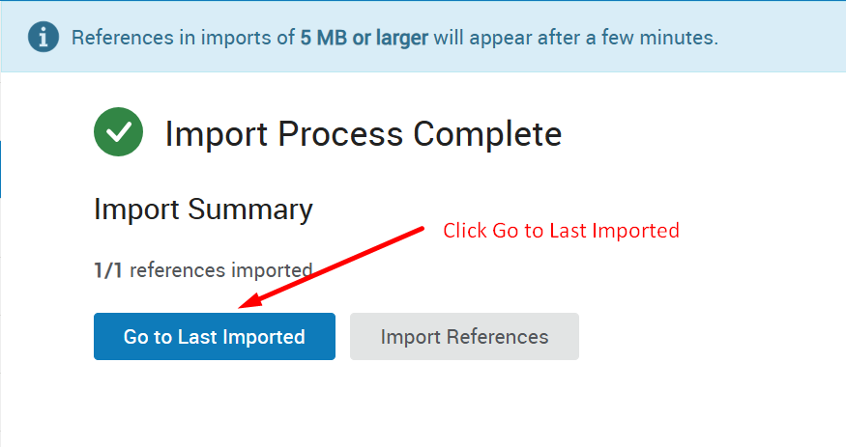
Figure 14: Image showing Import completed.
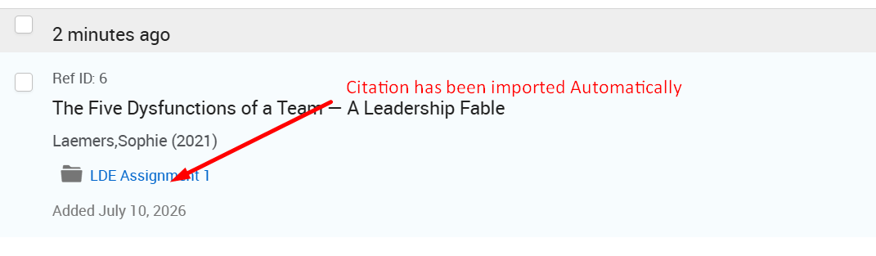
Figure 15: Image showing Imported Citation.
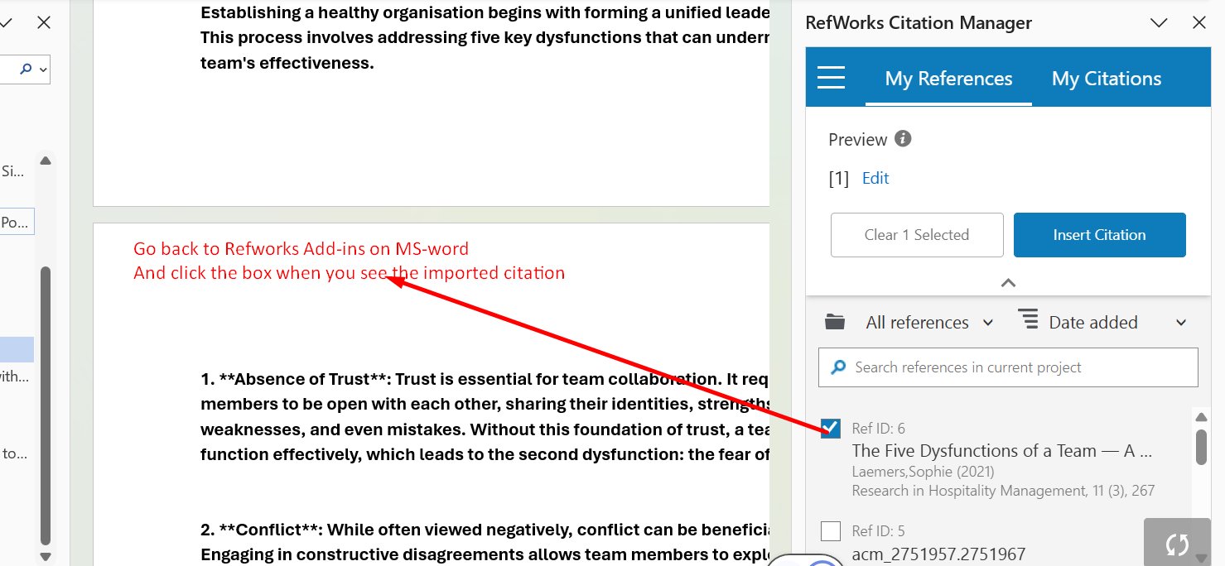
Figure 16: Image showing the RefWorks automatically showing in Microsoft Word Add-ins

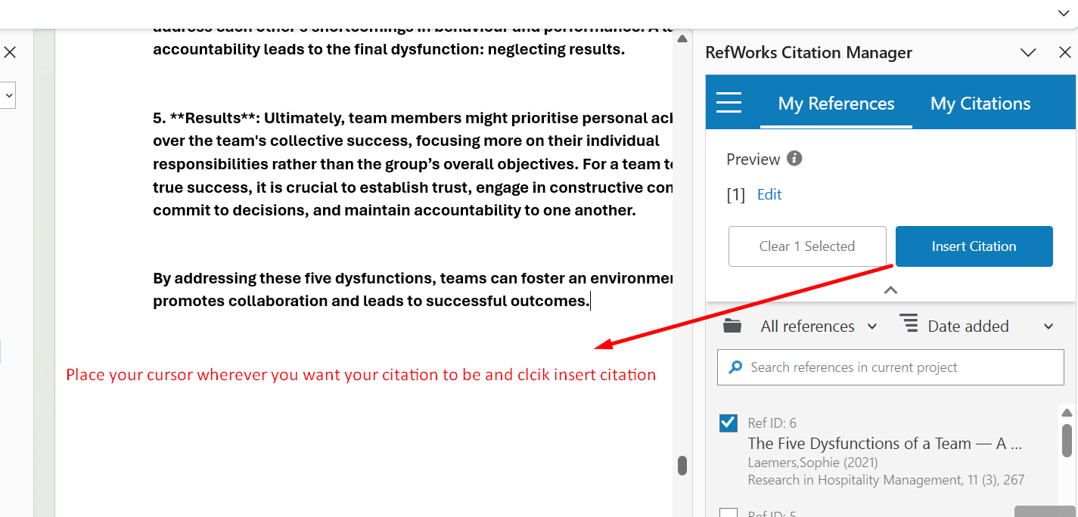
Figure 17: Image showing where to place the cursor and how to insert citations.

RefWorks Citation Management Process
I started by locating the RefWorks add-in in the "Add-ins" section of Microsoft Word and installed it. After that, I set up a RefWorks account using my student email and password. Subsequently, I found a relevant article titled "The Five Dysfunctions of a Team" online and chose "RefWorks Direct Export" for importing the citation (Steps 5-7). I saved it into a folder named "LDE Assignment 1" and verified that the import was successful (Steps 8-11). Finally, I went back to MS Word, opened the RefWorks Citation Manager (RCM) tab, selected my imported reference, and inserted it at the cursor position in my document (Steps 12-14).

Task 4: E-Portfolio Creation and Evaluation

Task 4 (a): E-Portfolio Creation
https://25390269.wixsite.com/olaportfolio2539026

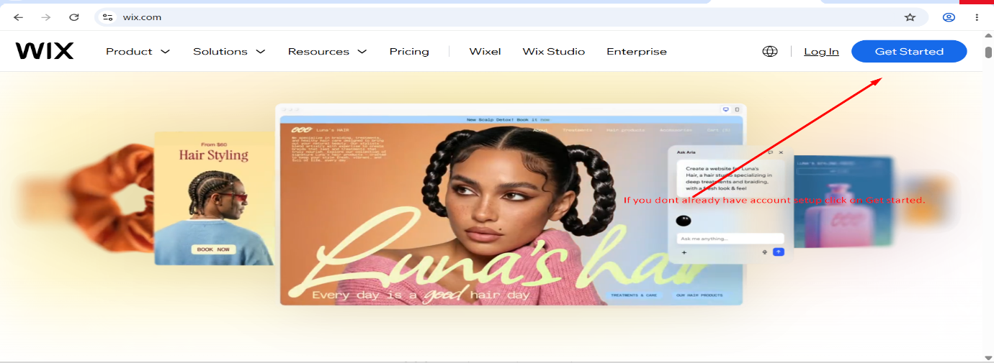
Figure 1: Wix.com home page, Get started.
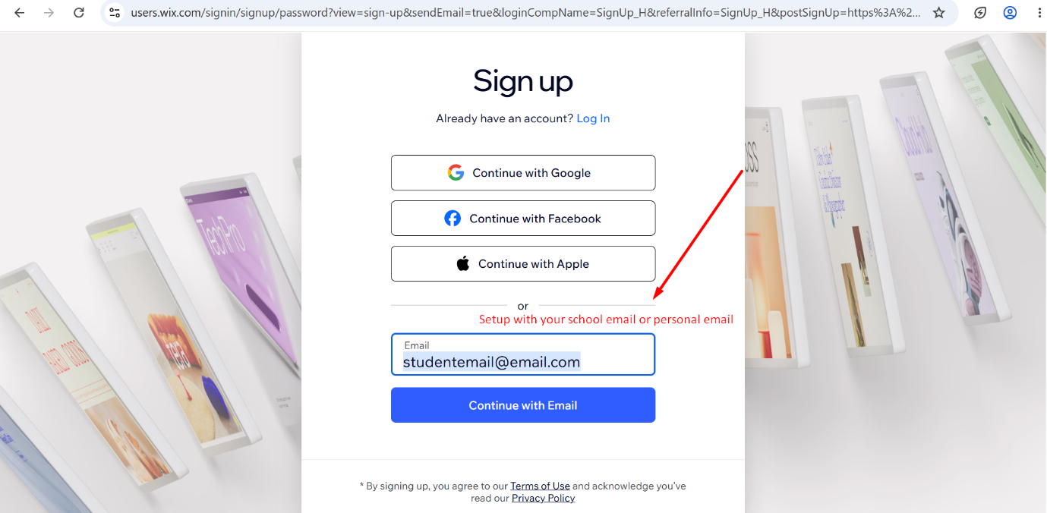
Figure 2: Wix.com Registration with personal email or school email.

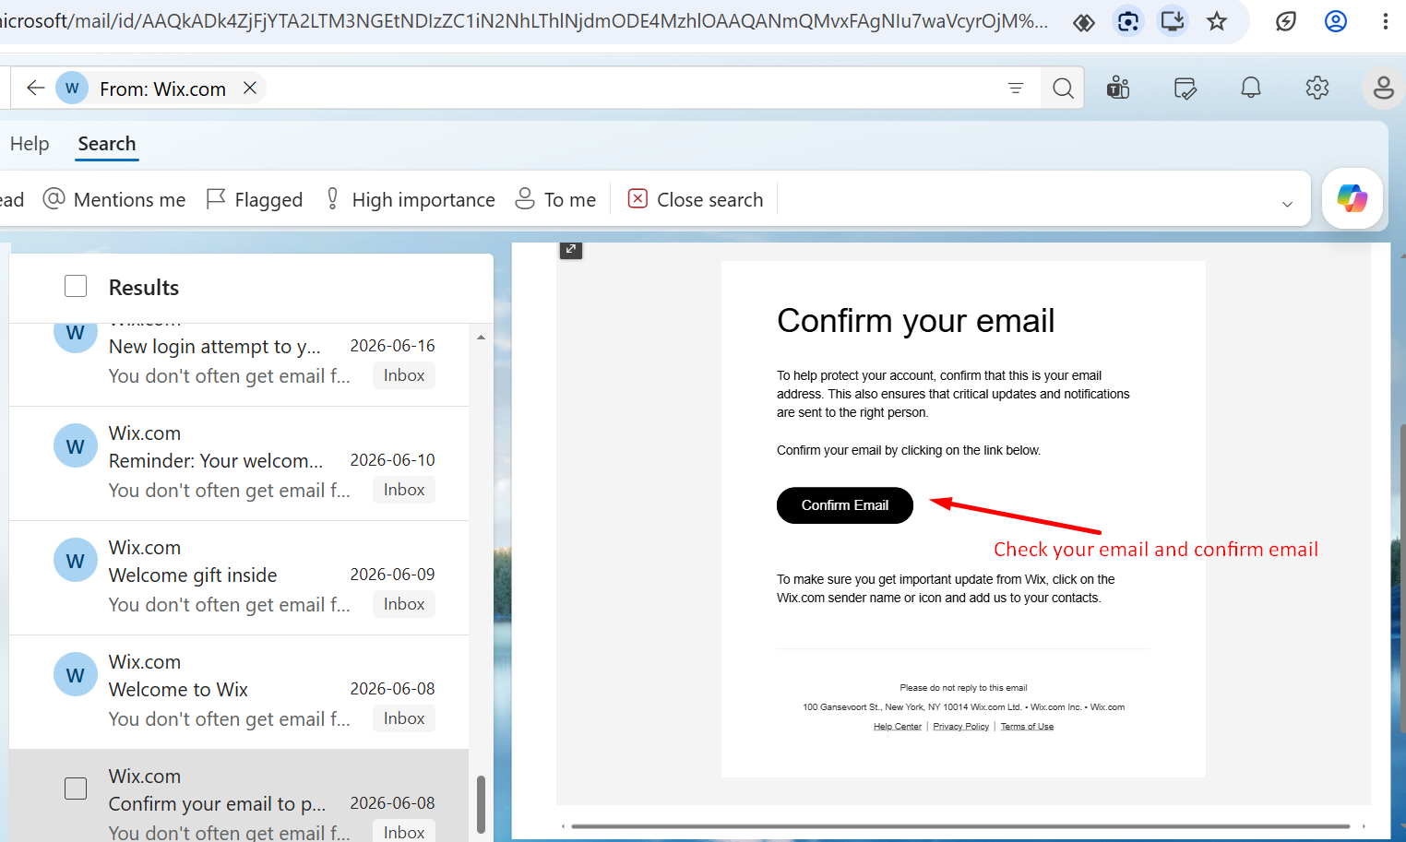
Figure 3: Shows Email confirmation after registration.

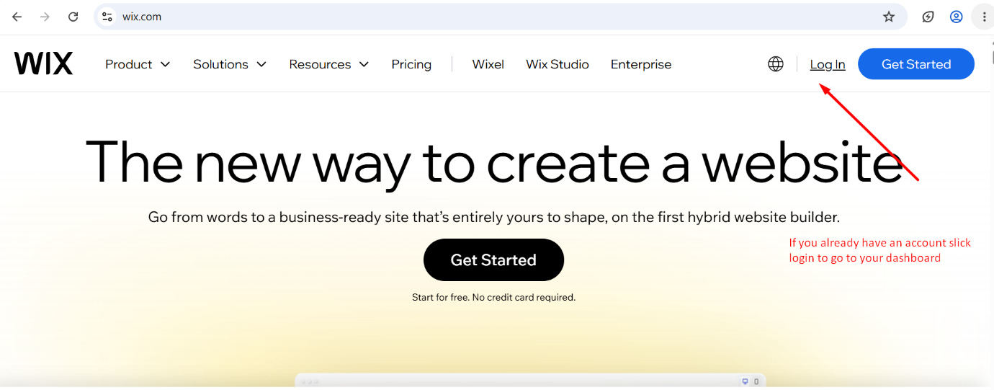
Figure 4: Shows how to click log in if you already have an account with wix.com.

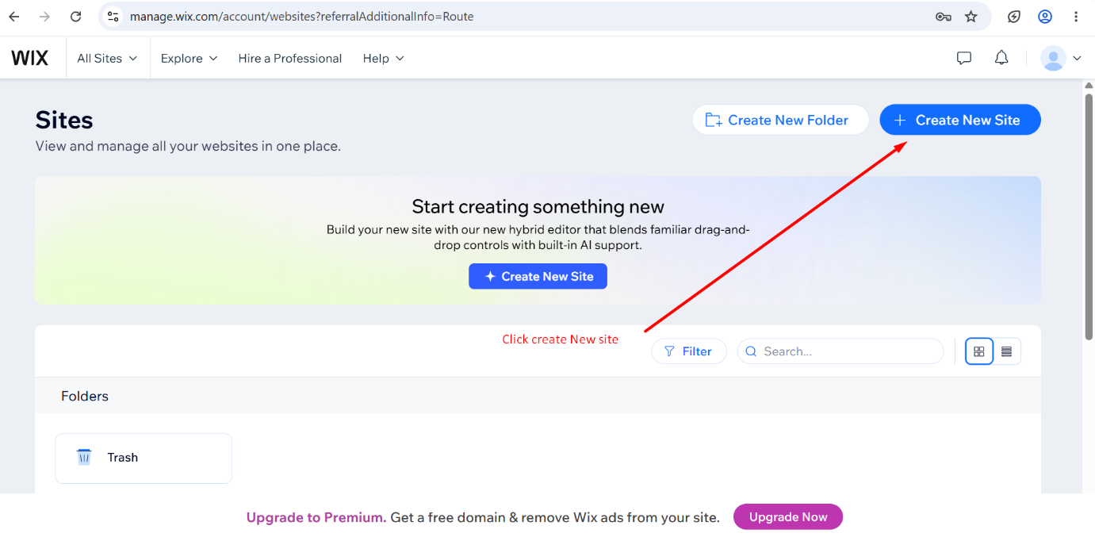
Figure 5: Shows how to create a new website.

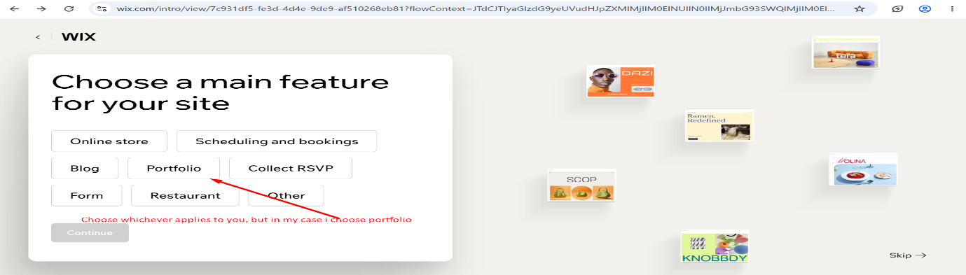
Figure 6: Shows different choices of website to create; in my case, I chose Portfolio.
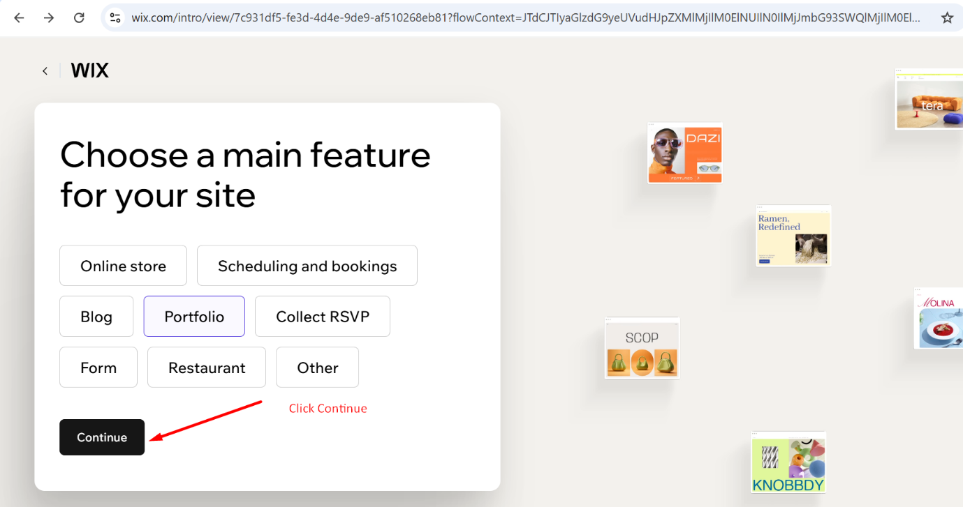
Figure 7: Click Continue.

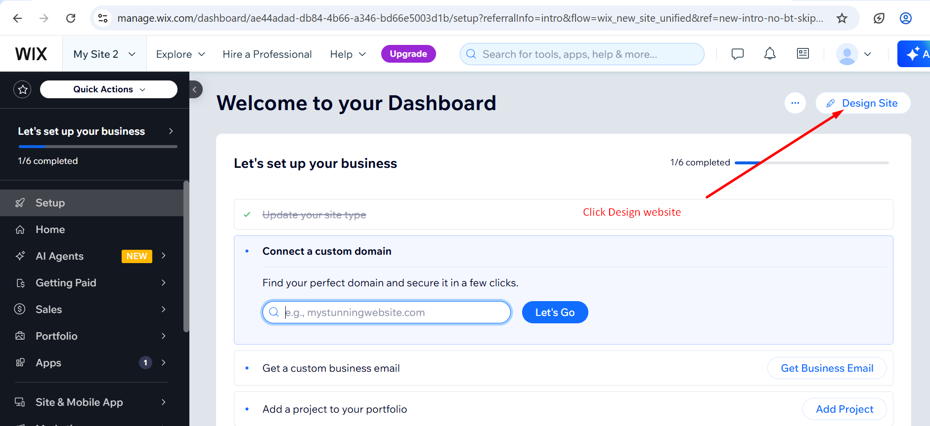
Figure 8: Click Design Website to start designing your website.

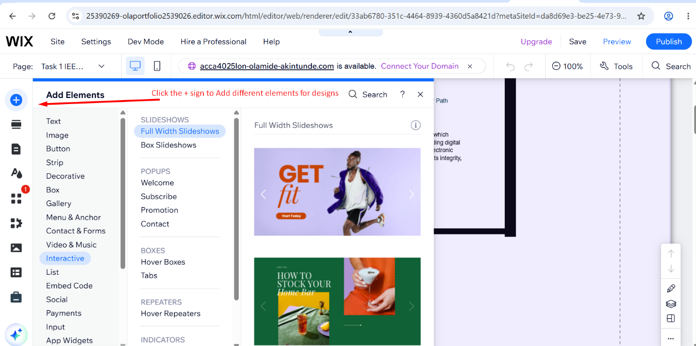
Figure 9: Click on + (Plus sign) to start adding different elements to your website design.
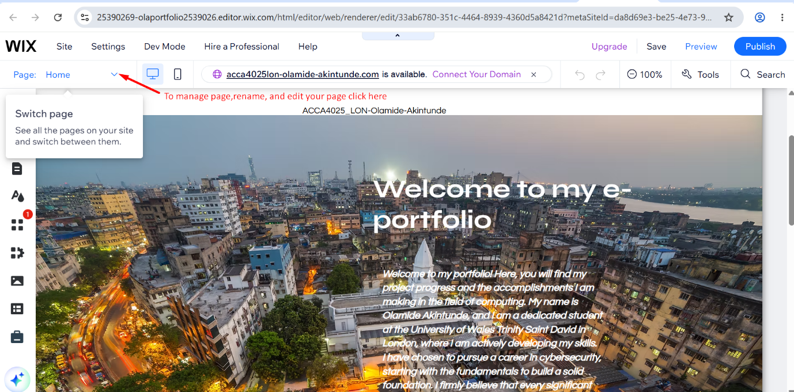
Figure 10: Click on the dropdown sign to manage pages.
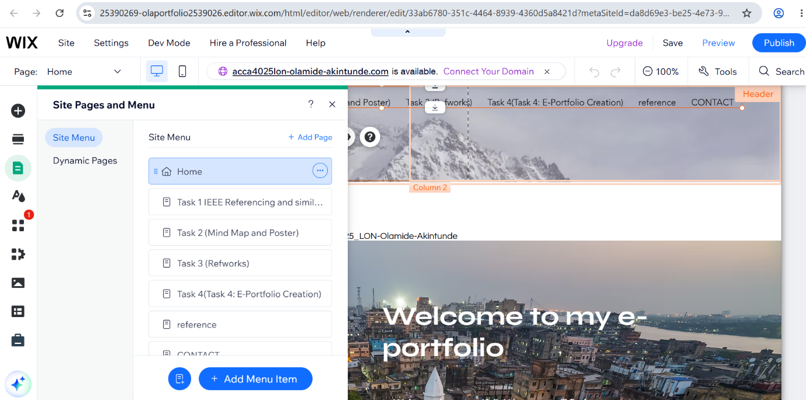
Figure 11: Showing an example of already created pages showing after clicking the drop-down.
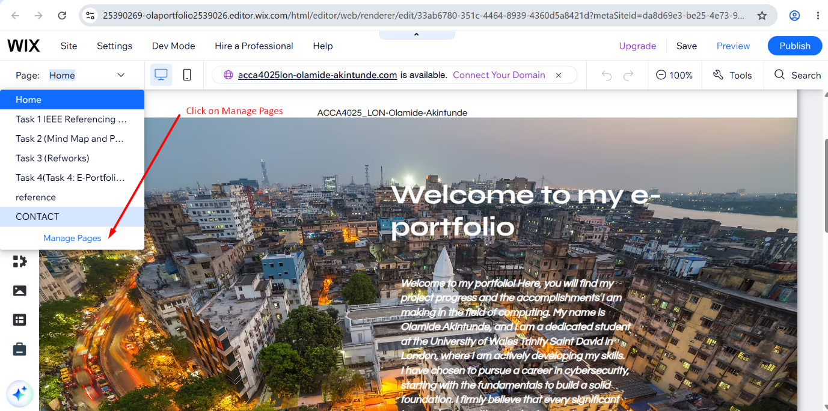
Figure 12: Click on Manage Page.
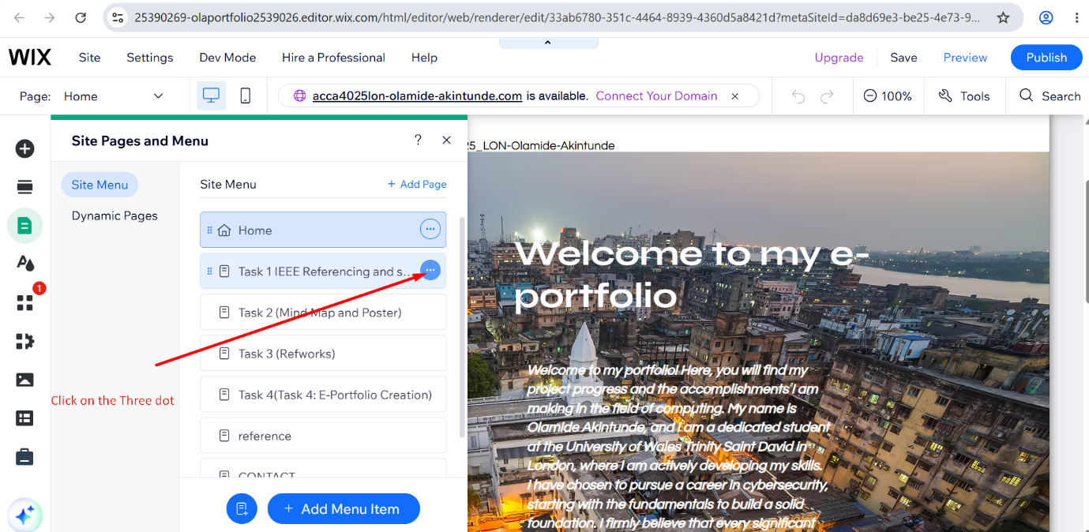
Figure 13: Click on the three dots (…)

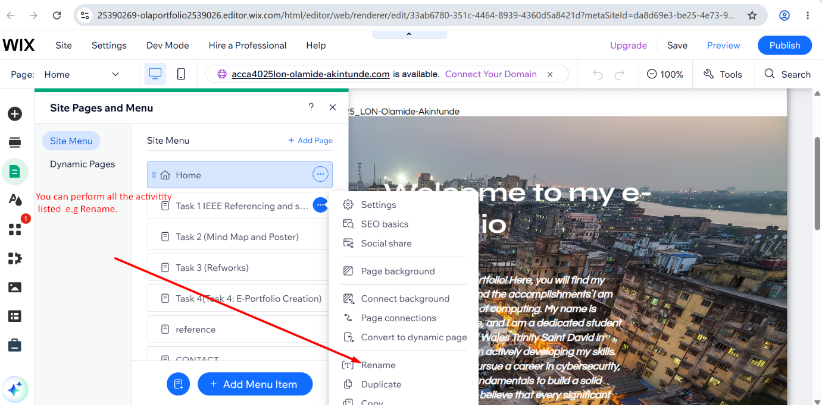
Figure 14: After clicking on the three dots (…), it shows different options to choose from, e.g. Rename your Page.
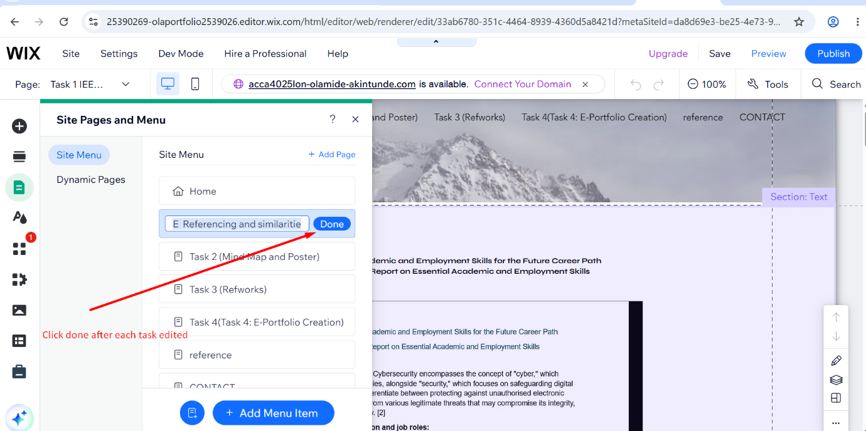
Figure 15: Click Done after performing any changes to your page.

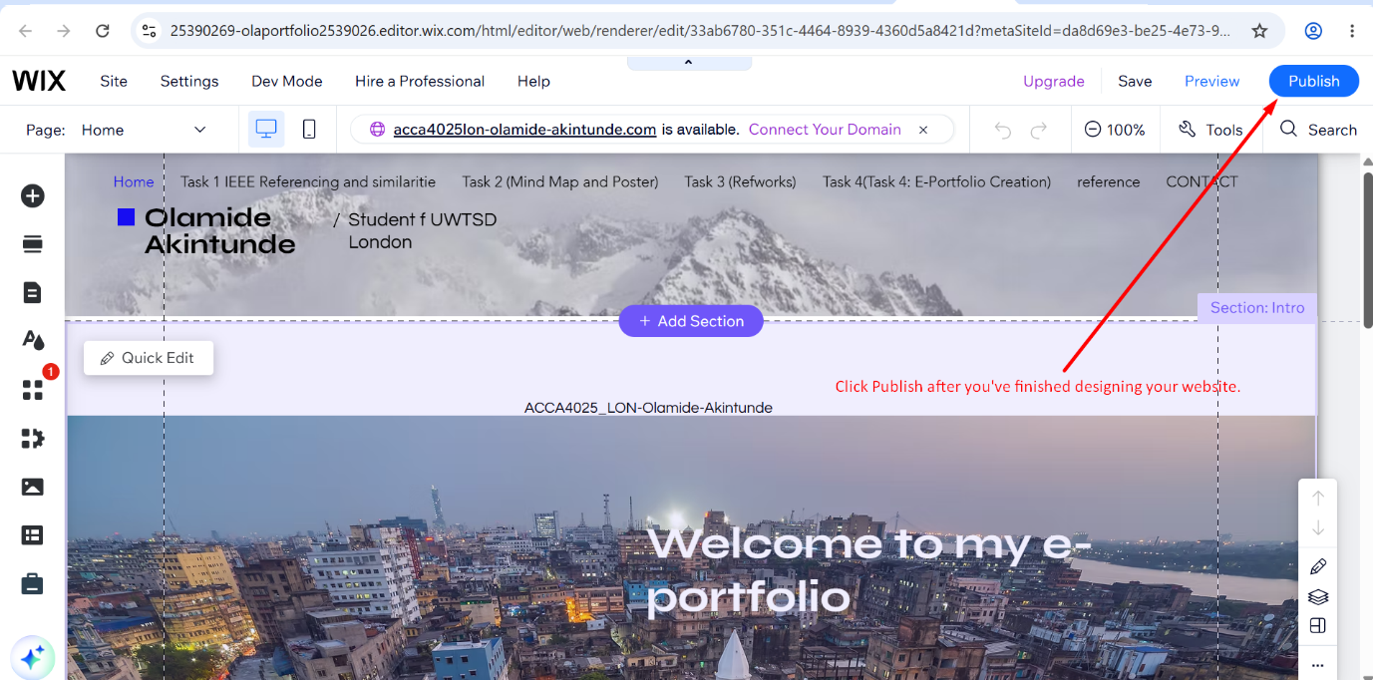
Figure 16: Click Publish after you’ve finished designing your website.
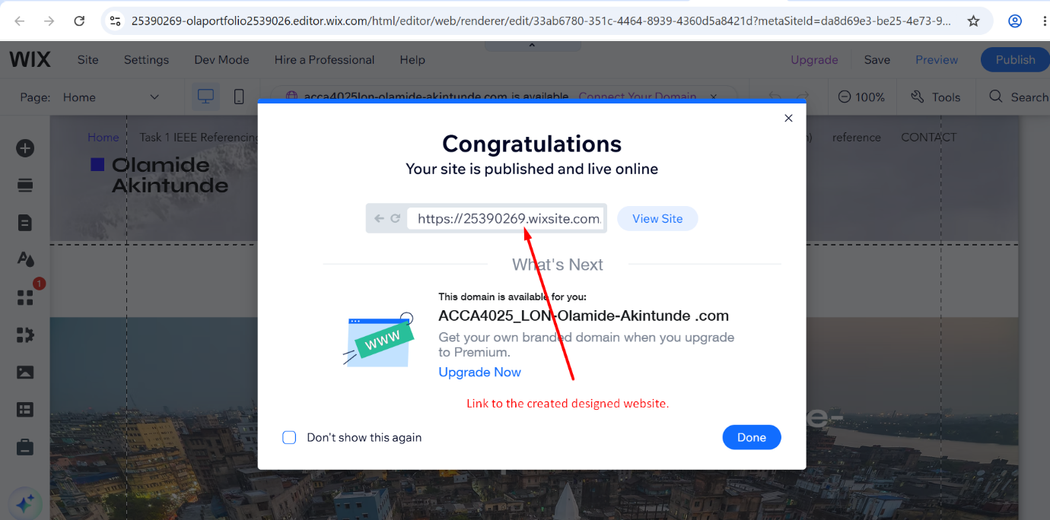
Figure 17: After publishing, you have a shareable link to access the newly created and designed website.
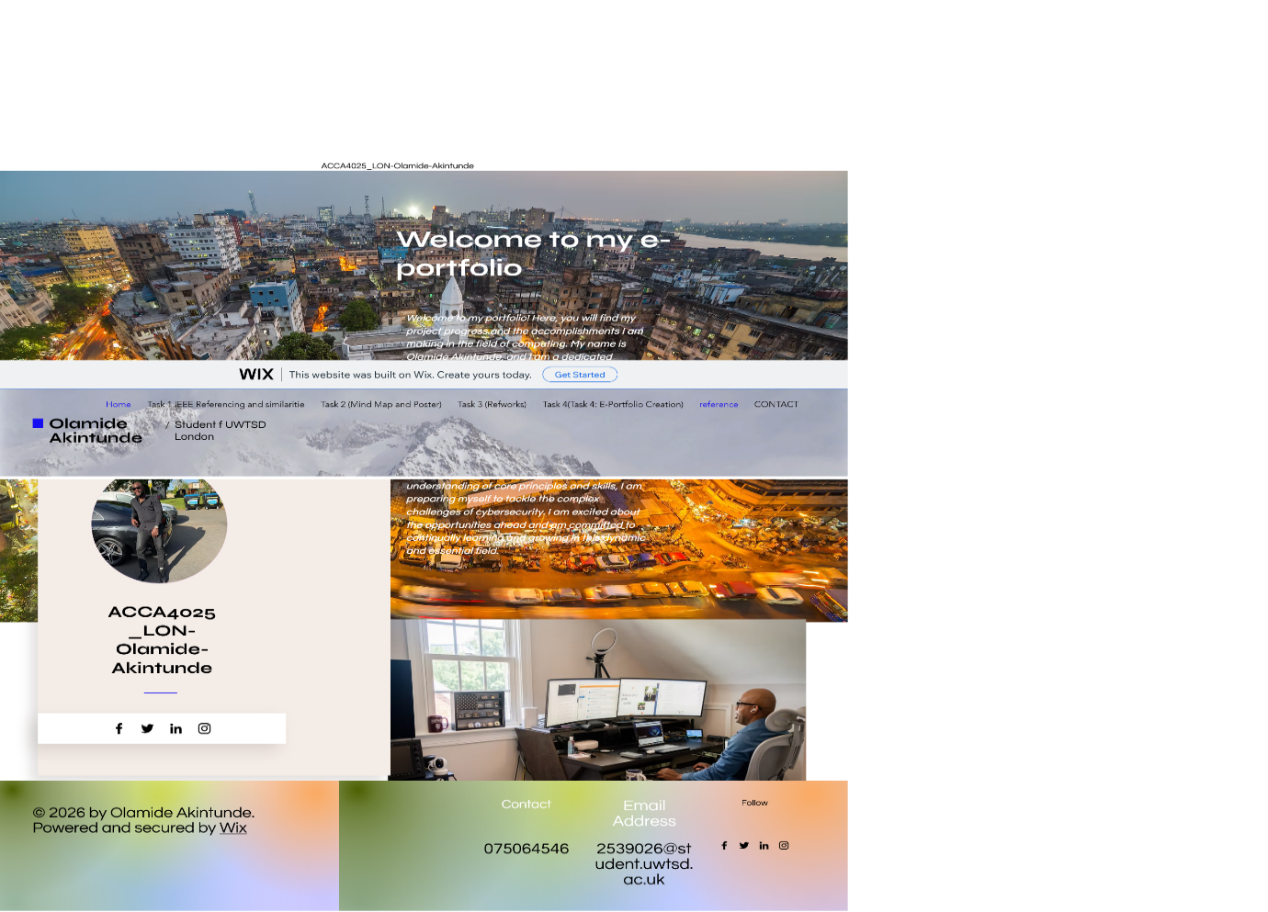
Figure 18: Illustration of a homepage designed using wix.com. This is a fully published website; hold the Ctrl key on your keyboard. Then click on the image to take you to the published website.

Task 4 (b): Illustrative Review of E-Portfolio Tool Selection

I chose to use Wix.com to build my e-portfolio for several convincing reasons. First and foremost, Wix is a free platform that offers a wide range of features without requiring any coding skills. This user-friendliness is crucial for someone like me who aims to create a professional website without the challenging learning curve typically associated with web development.

One of Wix's most impressive features is its easy-to-use drag-and-drop interface, which makes the design process straightforward. This functionality allows me to effortlessly position elements on the page, including text, images, and videos, to effectively display my work. Additionally, Wix offers a vast selection of customizable templates suited to different styles and professions, helping craft an attractive and well-organised portfolio [8].

Furthermore, as a popular platform, Wix offers comprehensive documentation and numerous online resources. This enables users to resolve issues or discover how to fully utilise the platform’s features. Importantly, academic studies have confirmed Wix's effectiveness in creating e-portfolios, emphasising its strengths in facilitating educational and professional presentations.
In summary, my decision to use Wix.com was guided by its blend of ease of use, design versatility, and strong academic support, making it an excellent choice for my e-portfolio [9].

Conclusion
To sum up, this project has been an enriching experience that has honed the academic and professional skills necessary for my future career in cybersecurity. Through Task 1, I recognised the essential combination of technical know-how, scholarly understanding, and interpersonal skills needed to thrive in this domain, and acknowledged the need to enhance my paraphrasing and academic writing to maintain integrity. [2], [3]., [3], [4]...
Task 2 illustrated the strength of teamwork: my group collaborated on MindMeister to explore the theme "Life is a Team Sport," and I developed an individual poster to visually convey the importance of cooperation in the workplace. [1].
Task 3 provided me with practical skills in virtual collaboration and taught me how to effectively utilise RefWorks to manage citations, an essential tool for academic research. [1].
Task 4 enabled me to construct and assess my own e-portfolio on Wix.com, creating a professional platform to present my work and development. In summary, this project has reinforced the idea that success-whether in academia or in a cybersecurity career-hinges on continuous learning, effective teamwork, and the ability to communicate and present one’s work professionally. [8].

References

[1] | “Google,” [Online]. Available: https://www.washingtonpost.com/wp-apps/imrs.php?src=https://arc-anglerfish-washpost-prod-washpost.s3.amazonaws.com/public/UJ3J36QRFAGRZRV7Z4R2UHRIYA_size-normalized.jpg&w=1440&impolicy=high_res.
[2] | D. S. A and a. K. S. Kohnke, “What the profession of cyber security needs to know and do,” Routledge, 2020, p. 88.
[3] | “Aniruddha,” Monday March 2023. [Online]. Available: https://www.sprintzeal.com/blog/cybersecurity-roles.
[4] | “Google,” [Online]. Available: https://www.slideteam.net/media/catalog/product/cache/1280x720/c/y/cyber_security_action_plan_process_slide01.jpg.
[5] | “stationx,” Monday July 2026. [Online]. Available: https://www.stationx.net/wp-content/uploads/2024/01/1.-Top-10-Programming-Languages-for-Cyber-Security.png.
[6] | “google,” [Online]. Available: https://www.whizlabs.com/blog/wp-content/uploads/2023/04/Highest-Paying-Cybersecurity-Jobs-scaled.webp.
[7] | “Turnitin,” [Online]. Available: https://ev.turnitinuk.com/app/carta/en_us/?student_user=1&ro=103&o=286309066&lang=en_us&u=25355531&s=1. [Accessed 06 July 2026].
[8] | W. i. W. P. a. h. t. b. yours, “wix.com,” Friday July 2026. [Online]. Available: https://www.wix.com/blog/what-is-and-how-to-use-wix-portfolio.
[9] | “Yaoo.com,” How to create an online portfolio: Steps to curating your own corner of the web, Friday July 2026. [Online]. Available: https://tech.yahoo.com/general/articles/create-online-portfolio-steps-curating-090004487.html;_ylt=Awr93Vrvye9oyPUDKM_QtDMD;_ylu=Y29sbwNncTEEcG9zAzUEdnRpZAMEc2VjA3Ny.
[10] | D. Craigen and N. Diakun-Thibault, “Technology Innovation Management Review,” Defining Cybersecurity.
[11] | D. A. Assistant., “ DeepSeek. (2026). [Response to user query on cybersecurity employment skills].,” [Online]. Available: https://chat.deepseek.com/share/fjvy1vno4atl1j30la.
[12] | I. Grammarly, “Grammerly,” Grammarly: Writing assistant* [Online]. , [Online]. Available: https://www.grammarly.com. [Accessed 06 07 2026].
[13] | “Mindmeister,” 06 07 2026. [Online]. Available: https://mm.tt/map/4030976520?t=W733O9Thx6.
[14] | Ola, “Mindmeister,” 06 July 2026. [Online]. Available: https://eur01.safelinks.protection.outlook.com/?url=https%3A%2F%2Fmm.tt%2Fmap%2F4030976520%3Ft%3DW733O9Thx6&data=05%7C02%7C2539026%40student.uwtsd.ac.uk%7Cc5f8580328174409ecd608dedb3fad40%7C4e0f11f9046e45059cb8db2152311e21%7C0%7C0%7C639189263694267264%7CU.
[15] | A. Ananth, “Netsurion,” Netsurion, co-creator of Netsurion's Open XDR platform, [Online]. Available: https://www.netsurion.com/assets/content/uploads/essential-skills-blog-graphic.jpg.
[16] | Vaibhav, “Cybersecurity Tools SIEM EDR and Hybrid Platforms Compared,” May 2026. [Online]. Available: https://www.linkedin.com/posts/rstgvaibhav_%F0%9D%97%96%F0%9D%98%86%F0%9D%97%AF%F0%9D%97%B2%F0%9D%97%BF%F0%9D%98%80%F0%9D%97%B2%F0%9D%97%B0%F0%9D%98%82%F0%9D%97%BF%F0%9D%97%B6%F0%9D%98%81%F0%9D%98%86-%F0%9D%97%A7%F0%9D%97%BC%F0%9D%97%BC%F0%9D%97%B9%F0%9D%.
[17] | “whizlabs,” [Online]. Available: https://www.whizlabs.com/blog/wp-content/uploads/2023/04/Highest-Paying-Cybersecurity-Jobs-scaled.webp.

