Food and Beverage Operation – BMIH4002

Menu Development
Special MENU for New Year Party 2023
TRINITY HOTEL 4 ****

Student name: Mihaela Suruianu
Student number: 2226557
Lecturer name: Jaliya De Silva
Word count: 400
Special Menu for New Year Party 2023

One of the fundamental components of a hotel business that must be owned is the restaurant. For humans' need for nutrition to thrive, a restaurant is a location where services for food and beverages are offered. Customers are given a menu, which lists various food and drink selections, and their prices, and often includes a brief description of what is being served at each establishment. The menu is essential at a restaurant or other food-related facility since it informs customers of the things that are being sold (Juliana et al., 2021). The food should have a suitable visual design and layout that meets the expectations of the customers in terms of how it is presented, arranged, and colored (Barreto, 2010). These restaurants draw guests by providing high-quality meals at affordable prices in a casual setting. A full-service restaurant offers a variety of meal options together with expert services from staff education in elite or affordable dining. Restaurants with full services draw patrons who think the significance of emotional value to be a crucial factor while dining out (Chua et al., 2020).
This essay will highlight a menu structure for a special occasion, namely the 2023 New Year's party, in a 4-star restaurant.
The presentation of the menu is simple, typical, and structured in starters, main dishes, desserts, and drinks, also offering a brief presentation of the dishes as well as their price (Bahattin and Osman, 2015). Moreover, the menu highlights the products specific to people with various food allergies, but for the other dishes, there is the possibility of replacing the allergen with a product suitable for safe consumption. Also, the menu includes several types of meat so that consumers can choose according to their preferences and promotional drink packages. The products used to prepare the menus are of very good quality because, as Sulek and Hensley (2004) say, food quality is significant for consumer satisfaction.
The menu is not a long one, it is a menu with enough dishes to celebrate the entry into the new year, a menu suitable for all age groups and which can be adapted according to the preferences of many consumers.
The event menu can either bring in new clients or keep its current audience because of the rates of the promotional packages. The costs are in line with the menu's concept, the restaurant's aesthetic, and the standard of the goods (Remar et. al., 2022).

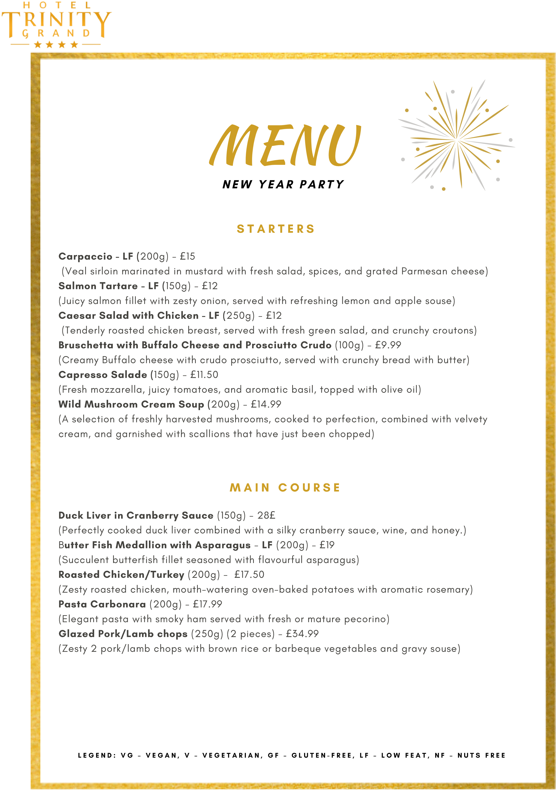
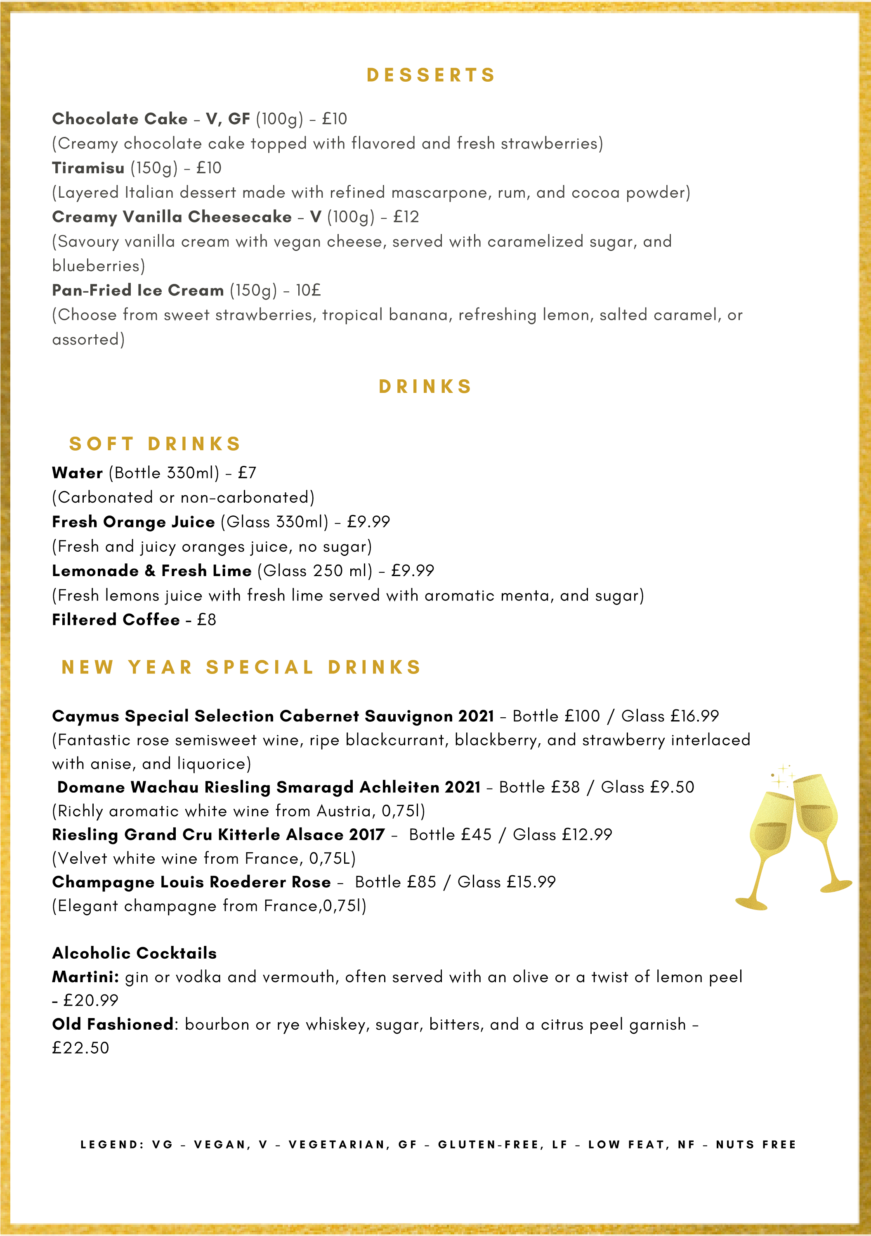

Margarita:
tequila, lime juice, and triple sec or another orange-flavored liqueur, served
with salt on the rim of the glass - £
21.50
Non-alcoholic cocktails
Piña Colada:
pineapple juice, coconut cream or milk, and ice, blended until smooth and
served with a pineapple slice garnish -
£17.99
Mint Mojito:
:
lime juice, sugar, mint leaves, and soda water, served over ice with a sprig:
of mint as a garnish - £
17.99

Promotional packages
A delicious traditional 3-course festive dinner accompanied by a
good bottle of wine and filtered coffee is just
£94.99
/Adult.
A delicious traditional 3-course festive dinner accompanied by a
bottle of good champagne and filtered coffee is just
£164.99
/Adult.

Reference List
Bahattin, O., and Osman, C., (2015). Menu Design: A review of Literature. Journal of Foodservice Business Research, 18:189-206.
Barreto, R. L. P. (2010). Passport To Flavor: Technology for Preparing Menus, 8th Ed., Senac, Sao Paulo. Bps, B. (2021). Badan Pusat Statistik.
Chua, B. L., Shahrim, K., SanghyeoP, L., and Heesup, H. (2020). Customer Restaurant Choice: An Empirical Analysis of Restaurant Types and Eating-out Occasions, International Journal of Environmental Research and Public Health.
Glanz, K., Ken R., Jennifer S., Kathy H., Hayden S., Mark L., and Jeanne G., (2007). How Major Restaurant Chains Plan Their Menus. The Role of Profit, Demand, and Health. American Journal of Preventive Medicine 32 (5): 383–388. https://doi.org/10.1016/j.amepre.2007.01.003.
http://www.canva.com/templates- new year party menu/ (Accessed: 17 May 2023).
Juliana, J., Pramezwary, A., Nukak, N. A., & Situmorang, J. M. H. (2021). Using Contribution of Menu Engineering in Upscale Restaurants to Enhance Sales Volume. International Journal of Social and Management Studies, 2(4), 1–12. Available at: https://doi.org/10.5555/ijosmas.v2i4.45.
Regina, S. Baraban and Joseph, F. Durocher (2010). Successful Restaurant Design, 3rd Edition, John Wiley & Sons, INC.
Remar, D., Sukhu, A. and Bilgihan, A. (2022), "The effects of environmental consciousness and menu information on the perception of restaurant image", British Food Journal, Vol. 124 No. 11, pp. 3563-3581. https://doi.org/10.1108/BFJ-06-2021-0666.
Sulek, J. M., & Hensley, R. L. (2004). The relative importance of food, atmosphere, and fairness of wait: The case of a full-service restaurant. Cornell Hotel and Restaurant Administration Quarterly, 45, 235-247.
www.food.gov.uk (Accessed: 17 May 2023).
www.canva.com (Accessed: 16 May 2023).

