Unit name:
Module code:
Exploring the Gender Pay Gap: Data-Driven Insights into Pay Disparities

Prepared for:
Written by: HUAN GENG
Student ID: 2000319
Date submitted: 7 October 2024

Abstract
This study investigates the gender pay gap within an organization, utilizing a data-driven approach to identify the factors contributing to wage disparities between male and female employees. Using a dataset of 1,000 employees sourced from Glassdoor, this analysis explores horizontal and vertical gender segregation across various roles and levels of seniority. The study adopts a regression-based methodology, incorporating descriptive statistics and multiple regression models to examine the role of job-specific factors in explaining the gender pay gap. Key findings indicate that gender segregation in both roles (horizontal) and career progression (vertical) significantly contribute to pay inequalities. While the regression models demonstrate that gender is a significant predictor of base salary, controlling for variables such as job title and department reduces this effect, suggesting that wage disparities are driven more by structural inequalities in job roles than direct gender-based pay discrimination. The study concludes by offering recommendations for addressing these structural barriers, such as promoting gender diversity in higher-paying roles, enhancing transparency in recruitment and promotion processes, and conducting regular pay audits. These insights provide a foundation for organizational strategies to achieve greater gender equity in the workplace.

Key words: Gender pay gap, Horizontal Segregation, Horizontal Segregation, Regression Analysis

Table of Contents
INTRODCTION 3
1.1 Overview 3
1.2 Research Objective 3
1.3 Organization of the Report 4
LITERATURE REVIEW 5
2.1 Overview of the Gender Pay Gap 5
2.1.1 Occupational Segregation 6
2.1.2 Differences in Working Hours 7
2.1.3 Educational Attainment and the Gender Pay Gap 7
2.2. Empirical Approaches to Studying the Gender Pay Gap 8
2.2.1 Regression Analysis 8
2.2.2 Oaxaca-Blinder Decomposition 9
2.3 Legal and Ethical Implications 10
2.3.1 Legal Frameworks 10
2.3.2 Ethical Considerations 11
2.4 Gaps in the Literature 12
METHODOLOGY 13
3.1 Research Questions and Hypothesis Development 13
3.2 Data Source and Variables 15
3.3 Statistical Techniques 17
3.4 Model Performance 19
FINDINGS AND DISCUSSION 22
4.1 Gender Diversity Overview 22
4.2 Independent T test 26
4.3 The Regression Analysis 29
4.4 Main Findings for the Organization 31
4.5 Discussion on Research Questions and Hypothesis 33
4.6 Ethical Concerns 35
CONCLUSION 37
5.1 summary of the Findings 37
5.2 Limitations and Ethical Concerns 38
5.3 Further Research 41
RECOMMENDATIONS 43
REFERENCES 45

INTRODCTION

1.1 Overview
Understanding labor market disparities is critical due to their wide-ranging social, economic, and psychological impacts on individuals and society(Biegert, 2019). One of the most researched forms of employment inequality is the gender pay gap, which has attracted significant global attention from researchers and policymakers alike(Sampson, 2020). In recent decades, countries like the UK have made progress in reducing the gender pay gap. However, recent data indicates that these improvements have slowed, with the gap in the UK now surpassing both OECD and EU averages(Arabadjieva, 2021). As of April 2023, the Office for National Statistics reported that the median hourly wage for full-time female employees was 7.7% lower than that of their male counterparts, representing a slight increase from 2022. When all employees, including part-time workers, are considered, the gap widens further, with women earning 14.3% less than men (ONS, 2023). The disparity is particularly evident in higher-paying sectors and among women aged 40 and above, where the wage gap reaches 14.2% (ONS, 2023). These figures underscore the persistent and entrenched nature of gender-based pay disparities across various sectors and age groups.

1.2 Research Objective
This report aims to analyze the gender pay gap in the UK using Glassdoor data to examine how job-related and demographic factors contribute to wage disparities. The objective is to provide empirical insights and offer practical recommendations for businesses and policymakers on how to address and reduce gender-based pay differences, particularly in sectors where the disparities are most pronounced.

1.3 Organization of the Report
This report is structured as follows: Section 2 presents a comprehensive literature review on the gender pay gap, including its causes, patterns, and key methodological approaches. Section 3 outlines the methodology, covering the data source and statistical techniques applied. Section 4 discusses the results of the analysis and their implications for UK businesses. Section 5 offers recommendations to mitigate the gender pay gap, and Section 6 concludes the report with a reflection on the value of the analysis and potential directions for future research.

LITERATURE REVIEW
The gender pay gap remains one of the most pervasive issues in labor markets worldwide(Litman et al., 2020). Despite significant advancements in educational attainment, labor participation, and equal pay legislation, women continue to earn less than men across nearly every sector and occupation(Budig, Lim and Hodges, 2021). The gender pay gap is typically expressed as a percentage of men’s earnings, and the disparity reflects not only structural inequalities in the labor market but also the impact of social and cultural norms on women's work choices(Ciminelli, Schwellnus and Stadler, 2021). Numerous factors contribute to the pay gap, including occupational segregation, differences in working hours, educational choices, and the undervaluation of work predominantly performed by women(Blau and Kahn, 2017). This review explores the primary causes of the gender pay gap, the methodologies used in its empirical analysis, and the legal and ethical frameworks designed to mitigate it. The review also highlights existing gaps in the literature and suggests areas for future research.

2.1 Overview of the Gender Pay Gap
The gender pay gap is influenced by a variety of factors that are often interrelated and cumulative. Key contributors include occupational segregation, working hour differences, educational attainment, and the societal undervaluation of female-dominated professions(Blau and Kahn, 2017).

2.1.1 Occupational Segregation
Occupational segregation remains a major factor in explaining the gender pay gap. This refers to the division of men and women into different sectors or roles that often differ in prestige and pay(Borrowman and Klasen, 2020). Blau and Kahn (2017) argue that women are more likely to work in lower-paid industries, such as healthcare, education, and social services, while men dominate higher-paying sectors like finance, technology, and engineering. Within the same industry, vertical segregation also exists, with men more often occupying high-status, well-paid managerial or executive roles, while women are concentrated in lower-status, lower-paid jobs (ONS, 2023).

This phenomenon is exacerbated by cultural and societal expectations about gender roles. For example, women are often expected to perform caregiving duties, which can steer them towards part-time, flexible, or lower-paying jobs to accommodate family responsibilities(Landivar, Woods and Livingston, 2022). As a result, even in fields where women make up a significant portion of the workforce, such as healthcare and education, men tend to hold the higher-paying, senior roles(Brown, 2019). The undervaluation of work predominantly done by women also plays a significant role. Fields such as nursing, teaching, and caregiving are socially important but often lower paid compared to male-dominated sectors that are perceived as more specialized or valuable, like finance and technology(Müller, 2019). This societal undervaluation of female-dominated industries perpetuates income inequality across sectors(O'Connor, 2020).

2.1.2 Differences in Working Hours
Another significant factor contributing to the gender pay gap is the difference in working hours between men and women. Women are more likely to work part-time or take career breaks, particularly for childcare, eldercare, or other caregiving responsibilities(Pech, Klainot-Hess and Norris, 2021). These interruptions in their careers have long-term impacts on earnings potential and career progression, a phenomenon often referred to as the “motherhood penalty”(Yu and Hara, 2021).

Research shows that the gender pay gap widens significantly after women have children. This is particularly pronounced in high-paying professions, where extended career breaks can have a more lasting impact on promotion opportunities and wage growth(Querejeta and Bucheli, 2023). Men, on the other hand, are more likely to work full-time and take on overtime, further exacerbating income disparities(Munsch, O'Connor and Fisk, 2024). The COVID-19 pandemic has further highlighted the issue, as women have disproportionately borne the burden of additional caregiving responsibilities, leading to reduced working hours and increased career interruptions(Collins et al., 2021). This has exacerbated pre-existing inequalities and highlighted the need for more supportive workplace policies, such as flexible working arrangements and paid parental leave, to mitigate the negative impact on women’s earnings(Corekcioglu, Francesconi and Kunze, 2020).

2.1.3 Educational Attainment and the Gender Pay Gap
While educational attainment has increased for women, surpassing that of men in many developed countries, it has not been sufficient to close the gender pay gap(Forth, 2023). This paradox is due in part to the differing fields of study chosen by men and women. Men are more likely to pursue degrees in high-paying fields such as STEM (Science, Technology, Engineering, and Mathematics), while women are more likely to choose fields such as social sciences, education, and healthcare, which offer lower average wages(Blau and Kahn, 2017).

Even within the same educational qualifications, men tend to occupy higher-paying roles. For example, Ceci and Williams (2015) found that in STEM fields, women are underrepresented in the most lucrative specializations, such as computer science and engineering. Moreover, women are often subject to gender biases and stereotypes that limit their opportunities for advancement, even in fields where they are equally qualified(Gangwani and Kolokythas, 2019). Furthermore, studies have shown that while women may enter the labor market on an equal footing with men in terms of education and experience, their earnings potential diminishes over time due to career interruptions and slower promotion rates(Kucharski and Rutkowska, 2021). This suggests that while education is a critical factor in reducing the gender pay gap, it is not enough to eliminate the disparities entirely.

2.2. Empirical Approaches to Studying the Gender Pay Gap

2.2.1 Regression Analysis
Regression analysis is one of the most common methods used to study the gender pay gap. This approach allows researchers to isolate the impact of gender on wages while controlling for other factors such as education, experience, occupation, and working hours. By doing so, researchers can estimate the portion of the pay gap that can be attributed to gender alone, independent of other variables(Roshchin and Yemelina, 2021). A study by Hansen, Rand and Win (2020) used regression analysis to show that even after controlling education, experience, and occupation, a significant portion of the gender pay gap remains unexplained, suggesting the presence of implicit bias or discrimination. Similarly, Combet and Oesch (2019) found that the gender pay gap widens over time, particularly after women have children, and that much of this gap is not accounted for by observable factors such as education or job type.

2.2.2 Oaxaca-Blinder Decomposition
The Oaxaca-Blinder decomposition method is another widely used approach for studying wage disparities. This technique decomposes the wage gap into two components: one that can be explained by differences in observable characteristics such as education and experience, and another that cannot be explained and is often attributed to discrimination(Słoczyński, 2020).

Jewell, Razzu and Singleton (2020) used this method to analyze the gender pay gap across various industries and found that a significant portion of the gap remains unexplained, even after accounting for differences in education, experience, and job type. This unexplained portion is often interpreted as evidence of discrimination or structural barriers that prevent women from reaching the same earnings potential as men. More recent studies, have used advanced versions of this decomposition method to examine the gender pay gap over time, showing that while the gap has narrowed in some industries, it persists in others, particularly in high-paying sectors such as finance and technology(Roshchin and Yemelina, 2021).

2.3 Legal and Ethical Implications

2.3.1 Legal Frameworks
Efforts to address the gender pay gap have been supported by a range of legal frameworks aimed at ensuring equal pay for men and women(Whitehouse and Smith, 2020). In the UK, the Equal Pay Act of 1970 was one of the first major legislative efforts to address wage disparities, mandating that men and women receive equal pay for equal work. The Equality Act of 2010 further reinforced this requirement by mandating pay transparency for companies with over 250 employees, requiring them to report their gender pay gap data(Benedí Lahuerta, Rejchrt and Patrick, 2023).

While these laws have been instrumental in raising awareness about the gender pay gap, enforcement remains a challenge. Many companies comply with the requirement to report their pay data but fail to take substantive action to address the underlying causes of the gap(Raghunandan and Rajgopal, 2021). This has led to calls for more robust enforcement mechanisms and the introduction of penalties for companies that fail to demonstrate progress in closing the gap.

2.3.2 Ethical Considerations
From an ethical standpoint, the gender pay gap raises critical questions about fairness and justice in the workplace. According to Equity Theory(Adams, 1965), employees expect to be compensated fairly in relation to their contributions and the compensation of others. When this expectation is unmet, it often results in dissatisfaction, lower productivity, and increased turnover rates(Blundell, 2021). Despite decades of legal reforms aimed at addressing the issue, the persistence of the gender pay gap indicates that many organizations are failing to meet this fundamental ethical standard(Raghunandan and Rajgopal, 2021). Research shows that while gender pay gap reporting has led to increased transparency, it has not consistently resulted in meaningful action to close the gap, further highlighting the ethical shortcomings of many companies(Sharkey, Pontikes and Hsu, 2022).

Public awareness campaigns, such as “Equal PayDay”, have significantly contributed to raising awareness about the ethical issues surrounding the gender pay gap. These movements have put pressure on companies to take greater responsibility in ensuring pay transparency and fairness, highlighting not only the internal implications for businesses but also the broader societal consequences. For instance, they emphasize how the gender pay gap undermines women's economic independence and has long-term negative effects on their retirement security, as unequal pay throughout a woman's career can result in diminished lifetime earnings and lower pension savings(Bosch and Barit, 2020). Research has shown that gender pay gaps can persist even in sectors with high transparency, indicating that awareness alone is insufficient to fully close the gap; companies must take concrete, systemic actions to address it(Olarewaju, Gideon and Koay, 2023). Furthermore, evidence suggests that while public awareness campaigns are effective in sparking discussions, they must be accompanied by legal frameworks and organizational accountability to enact lasting change(Mwaseba, Arthur and Mnasi, 2023).

2.4 Gaps in the Literature
While there has been extensive research on the gender pay gap, several gaps remain in the literature. One of the most significant is the lack of attention to intersectionality. Intersectionality, a concept introduced by Crenshaw (1991), highlights how multiple social identities—such as race, gender, and class—interact to create unique experiences of discrimination and disadvantage. Many studies on the gender pay gap focus exclusively on gender, without considering how factors such as race, sexual orientation, and socioeconomic background compound pay disparities.

Another gap in the literature is the limited use of new data sources to study the gender pay gap. Most existing research relies on traditional labor market data, which may not capture the full complexity of the issue. Newer data sources, such as crowdsourced platforms like Glassdoor, provide employee-reported data that allows for more granular analysis of pay disparities across companies, industries, and job roles(Penz et al., 2023). Future research should explore the potential of these data sources to provide a more comprehensive understanding of the gender pay gap.

METHODOLOGY

3.1 Research Questions and Hypothesis Development
The primary objective of this study is to examine the factors contributing to the gender pay gap within the organization, with a particular focus on horizontal and vertical gender segregation. Horizontal segregation refers to the unequal distribution of men and women across different occupations, while vertical segregation highlights gender disparities in career advancement opportunities and representation in higher-level roles. These forms of segregation are widely acknowledged as critical factors that influence gender-based pay disparities (Meulders et al., 2010; Eurofound, 2022).

Based on the findings from existing literature and the organizational context, two key research questions and Hypothesis have been formulated:
Research questions:
- How does gender segregation, both horizontal and vertical, contribute to the gender pay gap within the organization? | - Does controlling for job-related factors such as education, seniority, and department reduce the observed gender pay gap?
Hypothesis development:
Number | Related literature(concepts)
- Horizontal and vertical gender segregation significantly contribute to the gender pay gap, with men more concentrated in higher-paying technical and managerial roles, while women are underrepresented in these positions. | This hypothesis aligns with the concept of occupational segregation as a major driver of wage inequality. It assumes that gender segregation in roles and career progression is a key determinant of the gender pay gap, particularly in organizations where recruitment and promotion processes lack transparency(Adeleken and Bussin, 2022).
- After controlling education, seniority, and department, the gender pay gap will be reduced, indicating that these job-related factors explain a substantial portion of the observed wage disparities. | This hypothesis builds on the idea that while controlling for education, seniority, and department can account for some of the wage disparities, a residual pay gap may persist, which can be attributed to gender-based discrimination or biases in the workplace(Castellano, Punzo and Rocca, 2018). This aligns with studies that suggest that structural factors alone may not fully explain gender pay disparities, and that informal practices such as "social cloning"(Delauzun, 2020)and unequal access to career development opportunities contribute to the gender wage gap.
Table 3-1: Research Questions and Hypotheses Development

3.2 Data Source and Variables
The dataset utilized for this research was sourced from Glassdoor, a widely recognized platform that aggregates employee-generated data on wages, bonuses, and job roles across various industries. This dataset provides valuable insights into the structure of salaries within organizations, with a focus on pay differentials and workforce demographics. The dataset selected for this study includes a sample of 1,000 employees working in the UK, covering a broad range of industries and professional sectors. It encompasses essential variables required for a robust analysis of the gender pay gap, such as job title, department, seniority, job performance, educational qualifications, base salary, and bonus pay. In addition to these work-related variables, demographic factors such as gender and age are included to facilitate a nuanced understanding of the potential disparities between male and female employees.

Prior to conducting the statistical analysis, the dataset underwent a rigorous cleaning process to ensure the validity and reliability of the findings. This process involved addressing missing data, identifying and handling outliers, and converting non-numeric variables into formats suitable for statistical analysis. For example, categorical variables such as job title and department were transformed into dummy variables, which is a standard procedure when incorporating categorical predictors into regression models(Hosmer, Jovanovic and Lemeshow, 1989). This step is essential to avoid the "dummy variable trap" and ensure accurate interpretation of regression coefficients(Stock and Watson, 2014).

To address missing data, cases with incomplete information were either removed or imputed, depending on the proportion and importance of the missing data to the overall analysis. Additionally, the dataset was examined for outliers that could potentially skew the results, particularly in terms of extreme salary values. Outliers were identified based on statistical rules such as interquartile range (IQR) and standard deviation thresholds, and appropriate steps were taken to mitigate their impact, either through transformation or exclusion(Fields et al., 2015).

The variables included in the analysis can be classified into dependent and independent categories. The dependent variable in this study is the base salary of employees, which is a continuous variable representing the primary measure of wage inequality. Additionally, bonus pay is analyzed separately to determine whether gender disparities exist in this aspect of compensation. The key independent variables are gender (a binary variable coded as 0 for female and 1 for male), job title (categorical, converted into dummy variables), department (categorical, converted into dummy variables), seniority level (ordinal), and educational qualifications (ordinal, ranging from high school diploma to PhD).

3.3 Statistical Techniques
This study employs Glassdoor’s gender pay-gap data for an empirical analysis, incorporating a sample of 1,000 UK workers. To analyze the data, a range of statistical techniques are applied. First, bar charts are used to visualize gender diversity across job titles, education levels, and seniority categories, providing an overview of how men and women are distributed across different business functions. Next, the mean base salary and bonus pay by gender are calculated, and statistical tests are performed to assess whether the observed differences between male and female employees are statistically significant.

If a gender pay gap is identified, a linear regression analysis is then conducted to estimate the magnitude of this gap and to investigate how job-related and demographic factors contribute to wage disparities. Categorical variables such as job title, gender, education, and department are transformed into dummy variables for inclusion in the regression models. For instance, the gender variable is coded as a binary indicator (1 for male and 0 for female). The regression coefficient for this variable provides a quantitative estimate of the gender pay gap, controlling for factors like job performance, years of experience, and the employee’s department.

Descriptive Statistics:
Descriptive statistics are used initially to provide an overall snapshot of the dataset, summarizing key features such as central tendencies and distributions. Measures like the mean, median, and mode are calculated for both base salary and bonus compensation across genders to offer a clear picture of how pay is distributed between male and female employees. These statistics will indicate whether pay disparities exist in aggregate form and will guide the subsequent inferential analyses.

In addition to numeric summaries, bar charts and other visual tools are employed to illustrate the gender distribution across different departments, job titles, education levels, and seniority tiers. This step is crucial for visualizing patterns of horizontal and vertical segregation, which refer to the concentration of men and women in specific job roles and hierarchical positions, respectively(Gedikli, 2020). These visualizations provide preliminary insights into the structural dynamics of gender representation in the organization.

Regression Analysis:
If statistically significant gender pay gaps are detected through inferential tests, multiple regression analysis is performed to quantify these disparities and explore the contributing factors. The goal of the regression analysis is to estimate the extent of the gender pay gap while controlling for various job-related and demographic variables such as job title, department, education, and seniority level.

By applying multiple regression models, the analysis seeks to control for potential confounders and isolate the independent effect of gender on pay. This approach ensures that any observed wage disparities are not simply the result of differing job roles, educational backgrounds, or seniority levels but are attributable to gender itself. The statistical significance of each regression coefficient is assessed using p-values and confidence intervals, ensuring the robustness and reliability of the findings(Cotilla and Campos-Soria, 2021).

3.4 Model Performance
In this study, multiple statistical models will be evaluated using standard metrics to assess their performance in explaining the gender pay gap within the organization. The following methods will be used to determine the robustness and reliability of the models:

Adjusted R-squared
The Adjusted R-squared value will be used to evaluate the goodness-of-fit of each regression model. Unlike the standard R-squared, which can increase as more variables are added regardless of their relevance, the Adjusted R-squared penalizes for the inclusion of unnecessary predictors, making it a more reliable metric when comparing models with different numbers of independent variables(Kutner et al., 2005). This measure will help determine how well the independent variables (e.g., gender, seniority, department, job title) explain the variance in base salary, accounting for the complexity of the models.

P-values
The p-value for each independent variable will be examined to assess statistical significance. A p-value of less than 0.05 will indicate that the variable has a significant effect on the dependent variable (base salary) at the 5% significance level(Andrade, 2019). The primary focus will be on the p-value associated with the gender variable to determine whether gender is a significant predictor of salary after controlling for other factors like seniority, department, and education.

F-statistics
The F-statistic will be used to evaluate the overall significance of each regression model. This statistic tests whether the independent variables, as a group, have a statistically significant impact on the dependent variable. A high F-statistic, combined with a low p-value, will indicate that the model is a good fit and that the variables collectively explain a significant portion of the variance in base salary(Stock and Watson, 2014).

Multicollinearity Check
To ensure the reliability of the regression coefficients, Variance Inflation Factors (VIF) will be calculated to check for multicollinearity among the independent variables. Multicollinearity occurs when independent variables are highly correlated with each other, which can distort the estimated coefficients and reduce the reliability of the model(O’brien, 2007). A VIF value exceeding 10 will indicate problematic multicollinearity, and corrective measures, such as removing or combining variables, will be taken if necessary.

Model Comparison
Multiple regression models will be developed, each progressively adding additional control variables such as department, education, and job title. These models will be compared based on their Adjusted R-squared values, F-statistics, and p-values. The model that best balances explanatory power and simplicity, without introducing multicollinearity, will be selected as the preferred model for analyzing the gender pay gap.

FINDINGS AND DISCUSSION

4.1 Gender Diversity Overview
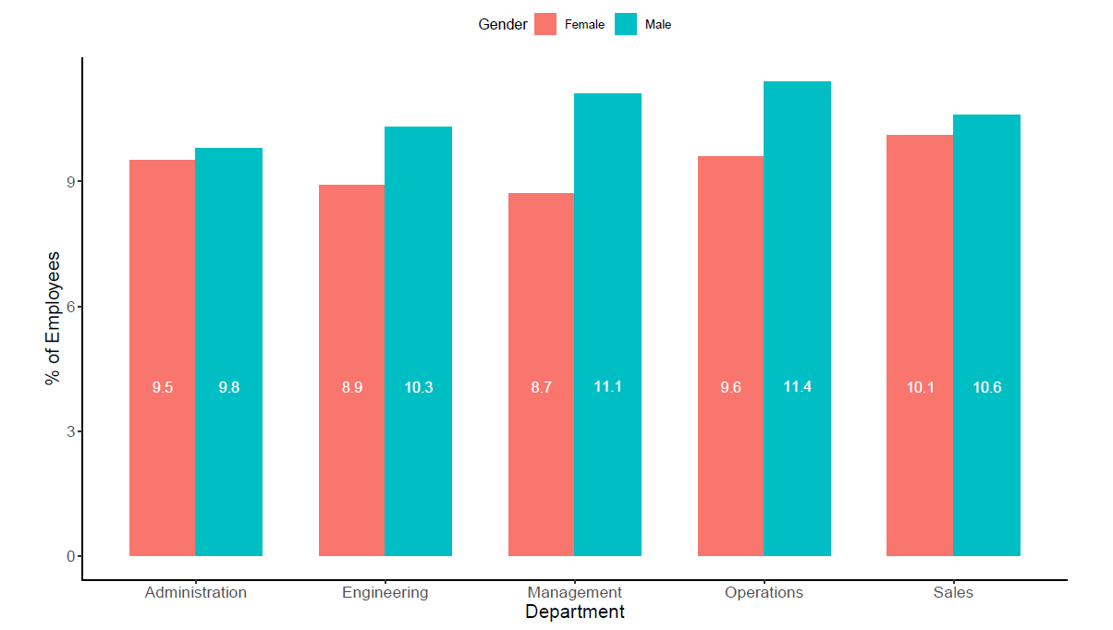
Figure 4-1: Dender Diversity in different department

The distribution of male and female employees across various business departments is shown in Figure 4-1. In total, there are 532 men and 468 women, highlighting an overall gender disparity within the organization. This imbalance is evident across individual departments, where male workers outnumber their female counterparts in every business function.

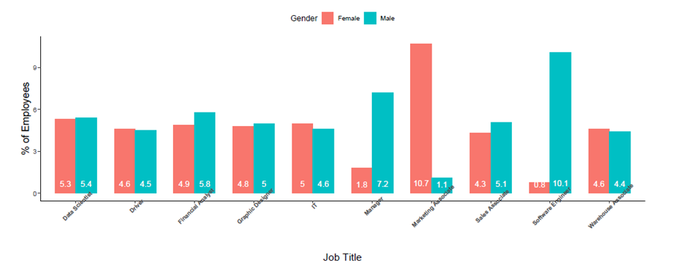
Figure 4-2: Job Title Across Gender

The dataset reveals a striking gender imbalance in job roles, with marketing associates being predominantly female, while software engineering positions are overwhelmingly filled by males. This indicates a clear pattern of occupational gender segregation within these fields. Another noteworthy observation is the underrepresentation of women in managerial roles within the organization. Specifically, 9% of the employees hold managerial positions, out of which 72 are men and only 18 are women. This highlights the significant gender disparity at the management level.

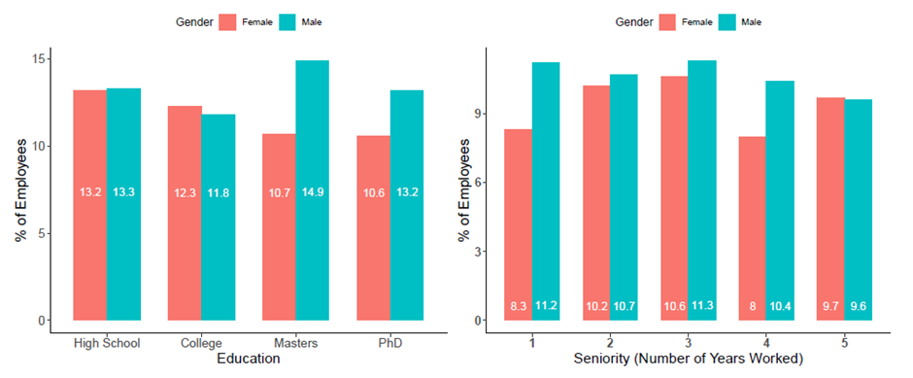
Figure 4-3: Gender Diversity Between Education and Seniority

Figure 4-3 illustrates the distribution of gender across various levels of educational attainment and seniority. The data suggests that a larger proportion of men hold advanced qualifications, such as master’s and PhD degrees, indicating that more males are engaged in professions that require higher educational qualifications, like software engineering. Conversely, the data shows a slightly higher percentage of women with a college degree compared to their male counterparts. Additionally, the figure reveals that, apart from the highest seniority tier, men generally occupy more senior positions within the workforce than women.

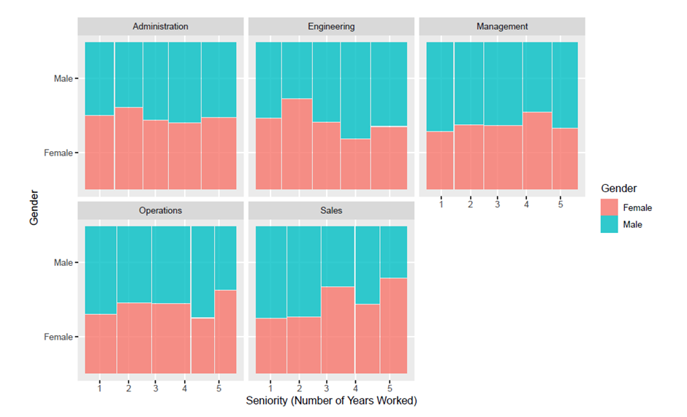
Figure 4-4: Gender Diversity Between Department and Seniority

In addition, Figure 4-4 illustrates gender diversity across departments and levels of seniority. A key observation is that males not only dominate management roles but also tend to occupy more senior positions compared to their female counterparts. A similar trend is noticeable within the operations department, although there are more senior female employees with over five years of experience in the organization. Conversely, in the sales department, female employees appear to hold more senior roles compared to their male colleagues.

4.2 Independent T test
To conduct a more thorough analysis of the gender pay gap within the organization, this study employed an independent samples t-test to evaluate whether the differences in base pay and bonus compensation between male and female employees are statistically significant. As indicated in Table 4-1, the average base salary for male employees is $98,457.55, while for female employees, it stands at $89,942.82. This results in a difference of $8,514.73, with men earning more on average than their female counterparts. The t-test results, performed under both equal and unequal variance assumptions, confirm that this difference in base salary is statistically significant.

In contrast, Table 4-2 reveals that the average bonus for male employees is $6,461.13, while female employees receive a slightly higher average bonus of $6,474.01. However, the t-test for independent samples shows no statistically significant difference between the bonus pay for male and female employees, indicating that bonus compensation is similar across genders.

Table 4-1: Gender-based differences in Average base pay
Table 4-2: Gender-based differences in Average bonus pay

4.3 The Regression Analysis
Table 4-3: Gender Wage Gap Analysis
Regression analysis was performed to estimate the gender pay gap within the organization and to examine how the gap changes when controlling for various job-related and demographic factors. As shown in Table 4-3, four regression models were developed. Model 1 serves as the baseline, incorporating only age, seniority, performance, and gender. The subsequent models expand upon this by adding department (Model 2), education (Model 3), and job title (Model 4) as dummy variables. This multi-model approach was employed to address concerns about multicollinearity and the dummy variable trap, issues common when using many categorical variables(Stock and Watson, 2014). The dependent variable is base salary, as statistically significant gender differences were only observed in base pay.

The coefficient for the male dummy variable in each model represents the gender pay gap in the organization. In Models 1 through 3, this coefficient is statistically significant at the 1% level. The estimated gender pay gap is £10,187.43 in Model 1, £10,149.72 in Model 2, and £9,778.02 in Model 3. Additionally, employees in the sales department earn the highest average base salary, with a coefficient of £6,178.64 (with administration as the reference category). Model 3 also shows an education premium, where employees holding a PhD or master's degree earn £8,073.01 and £6,128.69 more, respectively, than those with only a high school diploma.

A notable observation in Model 4 is that, after controlling for job roles, the gender pay gap becomes statistically insignificant. This suggests that the observed wage differences are more attributable to job-specific factors than to gender. In Model 4, drivers serve as the reference category for comparison. Managers are the highest earners in the organization, with an average base salary £35,604.46 higher than drivers. Software engineers also rank high, earning £17,134.55 more than drivers on average. Conversely, marketing associates are among the lowest earners, with an average income £12,675.40 lower than drivers.

4.4 Main Findings for the Organization
A key finding from the statistical analysis reveals a clear gender segregation in job roles within the organization. As noted by Meulders et al. (2010), gender segregation refers to the trend where men and women are disproportionately represented in certain sectors and occupations. In this company, nearly all software engineer roles are held by male employees, while female employees predominantly occupy marketing associate positions. This exemplifies horizontal segregation, where men and women are concentrated in distinct roles, with males in software engineering and females in marketing(Meulders, 2010).

Additionally, the analysis highlights significant vertical segregation. As described by Eurofound (2022), vertical segregation refers to limited opportunities for career progression for a particular gender within an organization or industry. This restriction often results in gender inequalities, including pay disparities. Figure 4-2 shows that the managerial positions in the organization are overwhelmingly occupied by men, providing strong evidence of vertical segregation, as women seem to face more barriers in ascending to higher-level roles.

Both horizontal and vertical segregation contribute significantly to the organization’s gender pay gap. To address this, the company must work toward reducing the concentration of women in lower-paying roles, such as marketing associates, and men in higher-paying roles, like software engineering. Furthermore, expanding career advancement opportunities for women is crucial to increasing their representation in management positions. Organizational change is necessary to reduce gender bias in both recruitment and promotion processes.

Moratti (2020) highlights that women often face disadvantages in companies where recruitment, promotion, and salary negotiations lack formal structures and transparency. Without clear criteria, decisions may be influenced by "social cloning", where those in power favor individuals like themselves for promotion or wage increases. Moreover, informal networks, often male-dominated, can further hinder women’s access to advancement opportunities. Implementing formal human resource procedures is essential for change, including developing clear and objective criteria for recruitment and promotion(Lalanne and Seabright, 2022).

Additionally, providing clear information on salary ranges may help to reduce gender disparities during wage negotiations. Bowles et al. (2005) found that men typically achieve better outcomes in negotiations, but when both genders are given transparent information about salary ranges, this advantage disappears. Similarly, Dobbin et al. (2015) found that formal career planning, job ladders, and internal job postings increase transparency about promotion opportunities, making advancement paths clearer to all employees. This approach is expected to remove some barriers to women’s progression in the workplace.

4.5 Discussion on Research Questions and Hypothesis
Research Question 1: How do horizontal and vertical gender segregation contribute to the gender pay gap within the organization?
The descriptive analysis, as reflected in Figure 4-1 and Figure 4-2, clearly indicates the presence of horizontal segregation, with male employees dominating roles such as software engineers, while female employees are predominantly marketing associates. This occupational segregation is significant in driving the gender pay gap, as highlighted by the differences in average base salaries across job roles. Moreover, vertical segregation is evident from the underrepresentation of women in managerial positions, as shown in Figure 4-3 and Figure 4-4. With only 18 out of 90 managerial roles occupied by women, there are barriers preventing women from advancing to senior positions.

These findings align with Hypothesis 1, which suggested that gender segregation—both horizontal and vertical—would significantly contribute to the gender pay gap. The regression models, particularly Model 4, show that the gender pay gap becomes statistically insignificant once job title is controlled for, indicating that job roles are key in explaining the observed pay disparities.

Research Question 2: Does controlling job-related factors such as education, seniority, and department diminish the observed gender pay gap?
The regression analysis supports the idea that job-related factors play a substantial role in explaining the gender pay gap. As demonstrated in Model 3 and Model 4, controlling for education, department, and job title progressively reduces the effect of gender on base salary. In the earlier models (Model 1), the coefficient for the male variable was statistically significant, with male employees earning approximately £10,187 more on average. However, after controlling for job-specific factors, the gender variable becomes statistically insignificant, as shown in Model 4, where the difference drops to £1,132 and is no longer significant (p = 0.137).

This outcome aligns with Hypothesis 2, which posited that controlling for education, seniority, and department would reduce the gender pay gap. The analysis confirms that a significant portion of the pay gap can be explained by differences in job roles and other job-related factors, rather than gender discrimination in pay practices.

The findings from the descriptive and regression analyses provide substantial support for both hypotheses. Horizontal and vertical segregation play a critical role in shaping the gender pay gap within the organization, and controlling for job-related factors significantly reduces the observed disparities. These results emphasize the need to address structural inequalities, such as unequal access to higher-paying roles and limited career progression opportunities for women, to close the gender pay gap.

4.6 Ethical Concerns
This research does not require participants to engage in activities outside of their normal routines, nor does it involve any behaviors that could be considered intrusive to their personal privacy. Additionally, there is no risk posed to either participants or the researcher. As the data being analyzed is secondary, there is no need for the researcher to conduct primary research or collect personal information from employees. Consequently, employee consent or authorization is not necessary for this study. The dataset is fully anonymized, containing no identifying details that could link the information back to individual employees. The researcher will securely store the data on both the university's cloud system and their personal computer, with password protection applied to ensure its safety. Moreover, the researcher will not share the dataset with any third party without prior approval from the course leader or the university. In conducting the analysis, the researcher has adhered to academic standards and regulatory guidelines. The dataset remains unaltered to fit any predetermined results, ensuring that any replication of the analytical approach used in this study would yield the same outcomes.

CONCLUSION

5.1 summary of the Findings
This study provides a comprehensive analysis of the gender pay gap within the organization, examining the role of horizontal and vertical gender segregation in contributing to wage disparities. Descriptive statistics show a clear pattern of horizontal segregation, where male employees are disproportionately represented in higher-paying technical roles, such as software engineering, while female employees are concentrated in lower-paying roles like marketing associates. These findings are consistent with previous research that highlights gender-based occupational segregation as a primary factor driving wage disparities(Finley, Hall and Marino, 2022).

Moreover, the analysis uncovered evidence of vertical segregation, where women are underrepresented in managerial positions. Despite making up a substantial portion of the workforce, women hold far fewer leadership roles, limiting their upward mobility and contributing to long-term wage inequalities. This aligns with studies suggesting that structural barriers, including limited career advancement opportunities for women, perpetuate gender wage gaps in organizations(Cortes, Oliveira and Salomons, 2020).

The regression analysis further supports the notion that gender is a significant determinant of base salary until job-related factors are controlled for. In Model 1, which does not include job-specific variables, the male coefficient indicates a statistically significant pay difference, with men earning considerably more than women on average. However, as Models 2 through 4 progressively control for variables such as department, education, and job title, the effect of gender diminishes, becoming statistically insignificant in Model 4. This suggests that job-specific factors, such as occupational role and level of education, largely explain the gender pay gap within the organization. These findings are in line with Blau and Kahn (2017) research, which argues that while direct gender discrimination in pay-setting has decreased, structural inequalities in job roles and career paths continue to drive wage disparities.

In conclusion, although the regression models show that the direct effect of gender on salary decreases when job-specific factors are controlled, the persistent gender segregation in job roles and the underrepresentation of women in senior positions highlight significant structural challenges that contribute to the gender pay gap. Addressing these barriers is essential for achieving true pay equity in the organization.

5.2 Limitations and Ethical Concerns
While this study provides valuable insights into the gender pay gap within the organization, several limitations should be acknowledged. The first limitation concerns the reliance on secondary data from Glassdoor, which may introduce self-reporting bias. Employees may have inaccurately reported their salaries, either intentionally or unintentionally, which could affect the validity of the wage data. Self-reported data often lacks the rigor and verification that accompanies primary data collection methods, and the resulting analysis may therefore not fully capture the actual salary structures within the organization(Gideon et al., 2019). This limitation is particularly relevant when exploring sensitive topics like wage inequality, where respondents may be influenced by social desirability bias.

Another limitation is the inability of the dataset to account for non-monetary compensation or performance-based bonuses that may vary by gender. While the regression models controlled for base salary and department-specific factors, they did not include more nuanced aspects of compensation, such as stock options, long-term incentives, or performance reviews, which are often key drivers of overall compensation. Excluding these variables from the analysis may overlook potential areas of disparity that contribute to the broader wage gap(Hirsch and Lentge, 2022).

Also, the analysis did not control for personal characteristics such as hours worked, family responsibilities, or preferences for flexible work arrangements. Research has shown that these factors can significantly impact career progression and pay disparities, particularly for women(Bear, 2021). Without access to such variables, the current study may not fully capture the complex interplay between gender, work-life balance, and compensation. Including these variables in future studies would provide a more comprehensive understanding of the gender pay gap.

Ethical Concerns
This study adhered to ethical guidelines for the use of secondary data, ensuring that all data remained fully anonymized and that no personally identifiable information was included. The Glassdoor dataset was obtained from publicly available sources, which reduces the risk of privacy violations. However, it is essential to consider the ethical implications of using self-reported data. Since employees voluntarily submit salary information, there is a risk that their motivations for reporting may not align with the goals of the research, potentially introducing bias into the dataset(Tempini, 2023).

Furthermore, the analysis must be conducted with transparency and honesty. It is critical to avoid manipulating data to achieve desired results or conclusions, particularly when dealing with sensitive issues like gender inequality. The researcher must take care to present findings objectively, while also acknowledging potential limitations in the data and methodology(Hodgins and O’Connor, 2021). In line with the principles of academic integrity, the study-maintained transparency throughout the analytical process and did not engage in any practices that could mislead stakeholders or participants.

Lastly, there are broader ethical considerations related to the use of such findings in organizational settings. While the study highlights gender disparities, it is important that organizations use this data to promote equity rather than reinforce stereotypes. Any recommendations derived from the analysis should aim to foster inclusivity and equal opportunity, aligning with best practices in human resources and ethical decision-making(Cho et al., 2021).

5.3 Further Research
This study offers valuable insights into the gender pay gap, yet several areas warrant further exploration to deepen understanding. Future research should extend to non-monetary compensation and performance metrics, such as stock options or long-term incentives, which can provide a fuller picture of total compensation disparities between genders(Hirsch and Lentge, 2022). Moreover, an investigation into negotiation behavior and the influence of gender norms on wage negotiations would facilitate the identification of how these factors contribute to disparities in pay(Reyes, Dinh and Salas, 2021).

A key direction for further research is exploring intersectionality—how factors like race, age, and ethnicity intersect with gender to influence wage disparities. This would enable a more nuanced understanding of how multiple forms of inequality affect pay gaps(Budig, Lim and Hodges, 2021). Longitudinal studies tracking the effectiveness of equity initiatives over time are also crucial to evaluate whether diversity interventions lead to sustained improvements in pay equity(Wright et al., 2022).

Cross-industry and cross-country comparisons would offer broader insights into the structural drivers of wage inequality, while investigating how organizational culture and leadership impact gender disparities could inform more inclusive practices(Borrowman and Klasen, 2020).

RECOMMENDATIONS
Based on the findings of this research, several recommendations are proposed to address the gender pay gap and its contributing factors, particularly focusing on horizontal and vertical segregation within the organization.

Establish Transparent Recruitment and Promotion Processes
The organization should develop and implement transparent recruitment and promotion procedures to reduce gender bias. A formalized hiring process with clear criteria for job roles and career advancement will help ensure that all employees, regardless of gender, are evaluated based on merit. The organization should conduct regular pay equity audits to monitor compensation across departments and roles, identifying potential gender-based discrepancies. Establishing pay transparency, where salary ranges are disclosed during recruitment and performance reviews, would reduce negotiation-related disparities and ensure fairness in pay-setting.

Address Horizontal Segregation by Encouraging Gender Diversity in High-Paying Roles
To reduce horizontal segregation, targeted initiatives should be put in place to increase the representation of women in higher-paying, male-dominated fields such as software engineering and IT. Mentorship programs and targeted training initiatives should be implemented to support women in transitioning to technical roles and acquiring the necessary skills. To address vertical segregation, the organization should create leadership development programs aimed at women, providing equal access to training, mentorship, and networking opportunities that are often critical for career advancement. Ensuring that women have access to formal leadership pipelines will enhance their representation in senior roles. The organization should also conduct regular reviews of promotion practices to identify and eliminate potential barriers that may be preventing women from advancing to managerial positions.

Foster an Inclusive Work Culture
Creating an inclusive work culture is essential to support gender diversity and mitigate structural barriers. The organization should invest in unconscious bias training for all employees, particularly those involved in recruitment, promotion, and performance evaluation processes. Additionally, establishing employee resource groups (ERGs) focused on gender equality could provide a platform for women to voice their concerns, share experiences, and access support from peers and mentors. Organizational leaders should actively participate in these initiatives to demonstrate their commitment to gender inclusivity and equality.

REFERENCES
Adams, J. S. (1965) 'Inequity in social exchange', Advances in experimental social psychology: Elsevier, pp. 267-299.
Adeleken, A. and Bussin, M. H. (2022) 'Occupational segregation and gender pay gap dynamics in the formal sector of South Africa', SA Journal of Human Resource Management, 20, pp. 1660.
Andrade, C. (2019) 'The P value and statistical significance: misunderstandings, explanations, challenges, and alternatives', Indian journal of psychological medicine, 41(3), pp. 210-215.
Arabadjieva, K. (2021) 'Time to Close the Gender Pay Gap: The Need for an EU Directive on Pay Transparency', ETUI Research Paper-Policy Brief, 2.
Bear, J. B. (2021) 'Forget the “Mommy Track”: Temporal flexibility increases promotion aspirations for women and reduces gender gaps', Psychology of Women Quarterly, 45(3), pp. 294-307.
Benedí Lahuerta, S., Rejchrt, P. and Patrick, A. (2023) 'The UK Pay Transparency Regulations: apparent transparency without accountability?', Legal Studies (forthcoming in 2023), UCD Working Papers in Law, Criminology & Socio-Legal Studies Research Paper, (15).
Biegert, T. (2019) 'Labor market institutions, the insider/outsider divide and social inequalities in employment in affluent countries', Socio-Economic Review, 17(2), pp. 255-281.
Blau, F. D. and Kahn, L. M. (2017) 'The gender wage gap: Extent, trends, and explanations', Journal of economic literature, 55(3), pp. 789-865.
Blundell, J. (2021) 'Wage responses to gender pay gap reporting requirements'.
Borrowman, M. and Klasen, S. (2020) 'Drivers of gendered sectoral and occupational segregation in developing countries', Feminist Economics, 26(2), pp. 62-94.
Bosch, A. and Barit, S. (2020) 'Gender pay transparency mechanisms: Future directions for South Africa', South African Journal of Science, 116(3-4), pp. 1-6.
Brown, D. (2019) 'Gender Pay Gaps, the UK Experience: How Do We Close Them, How Do We Bring Research Into Practice?', Compensation & Benefits Review, 51(4), pp. 144-161.
Budig, M. J., Lim, M. and Hodges, M. J. (2021) 'Racial and gender pay disparities: The role of education', Social science research, 98, pp. 102580.
Castellano, R., Punzo, G. and Rocca, A. (2018) 'The generational perspective of gender gap in wages and education in southern Europe', Review of Social economy, 76(2), pp. 227-258.
Cho, Y., Kim, S., You, J., Moon, H. and Sung, H. (2021) 'Application of ESG measures for gender diversity and equality at the organizational level in a Korean context', European Journal of Training and Development, 45(4/5), pp. 346-365.
Ciminelli, G., Schwellnus, C. and Stadler, B. (2021) 'Sticky floors or glass ceilings? The role of human capital, working time flexibility and discrimination in the gender wage gap'.
Collins, C., Landivar, L. C., Ruppanner, L. and Scarborough, W. J. (2021) 'COVID‐19 and the gender gap in work hours', Gender, Work & Organization, 28, pp. 101-112.
Combet, B. and Oesch, D. (2019) 'The gender wage gap opens long before motherhood. Panel evidence on early careers in Switzerland', European sociological review, 35(3), pp. 332-345.
Corekcioglu, G., Francesconi, M. and Kunze, A. (2020) 'Do generous parental leave policies help top female earners?', Oxford Review of Economic Policy, 36(4), pp. 882-902.
Cortes, G. M., Oliveira, A. and Salomons, A. (2020) 'Do technological advances reduce the gender wage gap?', Oxford Review of Economic Policy, 36(4), pp. 903-924.
Cotilla, M. M. and Campos-Soria, J. A. (2021) 'Decomposing the gender wage gap in the hospitality industry: A quantile approach', International Journal of Hospitality Management, 94, pp. 102826.
Crenshaw, K. (1991) 'Race, gender, and sexual harassment', s. Cal. l. Rev., 65, pp. 1467.
Delauzun, A. (2020) 'Change it up, change the system! Exploring career development learning and social justice through action research', Journal of the National Institute for Career Education and Counselling, 44(1), pp. 13-20.
Fields, A. P., Rodriguez, E. H., Jovanovic, M., Stern-Ginossar, N., Haas, B. J., Mertins, P., Raychowdhury, R., Hacohen, N., Carr, S. A. and Ingolia, N. T. (2015) 'A regression-based analysis of ribosome-profiling data reveals a conserved complexity to mammalian translation', Molecular cell, 60(5), pp. 816-827.
Finley, A. R., Hall, C. M. and Marino, A. R. (2022) 'Negotiation and executive gender pay gaps in nonprofit organizations', Review of Accounting Studies, 27(4), pp. 1357-1388.
Forth, J. T. (2023) 'Employers and the gender wage gap', IZA World of Labor.
Gangwani, P. and Kolokythas, A. (2019) 'Gender gap in leadership in academic medicine and dentistry: what are the barriers? What can be done to correct it?', Journal of Oral and Maxillofacial Surgery, 77(8), pp. 1536-1540.
Gedikli, C. (2020) 'Occupational gender segregation in Turkey: The vertical and horizontal dimensions', Journal of Family and Economic Issues, 41(1), pp. 121-139.
Gideon, M., Heggeness, M. L., Murray-Close, M. and Myers, S. L. (2019) 'The Returns to Education and the Determinants of Race and Gender Earnings Gaps Using Self-Reported versus Employer-Reported Earnings Data', Journal of Income Distribution®.
Hansen, H., Rand, J. and Win, N. W. (2020) 'Development Economics Research Group'.
Hirsch, B. and Lentge, P. (2022) 'Non‐base compensation and the gender pay gap', Labour, 36(3), pp. 277-301.
Hodgins, M. and O’Connor, P. (2021) 'Progress, but at the expense of male power? Institutional resistance to gender equality in an Irish university', Frontiers in Sociology, 6, pp. 696446.
Hosmer, D. W., Jovanovic, B. and Lemeshow, S. (1989) 'Best subsets logistic regression', Biometrics, pp. 1265-1270.
Jewell, S. L., Razzu, G. and Singleton, C. (2020) 'Who works for whom and the UK gender pay gap', British Journal of Industrial Relations, 58(1), pp. 50-81.
Kucharski, L. and Rutkowska, A. (2021) 'The situation of women on the Polish labour market compared to the situation of men', Wiadomości Statystyczne. The Polish Statistician, 66(8), pp. 46-67.
Kutner, M. H., Nachtsheim, C. J., Neter, J. and Li, W. (2005) Applied linear statistical models. McGraw-hill.
Lalanne, M. and Seabright, P. (2022) 'The old boy network: are the professional networks of female executives less effective than men's for advancing their careers?', Journal of Institutional Economics, 18(5), pp. 725-744.
Landivar, L. C., Woods, R. A. and Livingston, G. M. (2022) 'Does part-time work offer flexibility to employed mothers?', Monthly Labor Review, pp. 1-19.
Litman, L., Robinson, J., Rosen, Z., Rosenzweig, C., Waxman, J. and Bates, L. M. (2020) 'The persistence of pay inequality: The gender pay gap in an anonymous online labor market', PloS one, 15(2), pp. e0229383.
Meulders, M. (2010) Helmholtz: from enlightenment to neuroscience. MIT Press.
Moratti, S. (2020) 'Do low-openness, low-transparency procedures in academic hiring disadvantage women?', Social Sciences, 9(6), pp. 89.
Müller, T. (2019) 'She works hard for the money: tackling low pay in sectors dominated by women–evidence from health and social care', ETUI Research Paper.
Munsch, C. L., O'Connor, L. T. and Fisk, S. R. (2024) 'Gender and the disparate payoffs of overwork', Social Psychology Quarterly, 87(1), pp. 22-43.
Mwaseba, N., Arthur, B. and Mnasi, H. (2023) 'Effectiveness of Legal Framework on the Prevalence of Malpractices in Public Procurement of LGAs: A Case of Kasulu District Council, Kigoma Tanzania', International Journal of Leadership and Governance, 3(3), pp. 1-16.
O'Connor, P. (2020) 'Why is it so difficult to reduce gender inequality in male-dominated higher educational organizations? A feminist institutional perspective', Interdisciplinary Science Reviews, 45(2), pp. 207-228.
O’brien, R. M. (2007) 'A caution regarding rules of thumb for variance inflation factors', Quality & quantity, 41, pp. 673-690.
Olarewaju, V., Gideon, J. and Koay, A. 2023. Mandatory pay gap reporting is key to achieving workforce gender equality in the global health sector. British Medical Journal Publishing Group.
Pech, C., Klainot-Hess, E. and Norris, D. (2021) 'Part-time by gender, not choice: the gender gap in involuntary part-time work', Sociological Perspectives, 64(2), pp. 280-300.
Penz, D., Almeida, M. P. d., Amorim, B. C., Cembranel, P. and Rolt, C. R. d. (2023) 'Crowdsourced employer branding: an analysis from the platform glassdoor', Revista de Administração da UFSM, 16(1), pp. e7.
Querejeta, M. and Bucheli, M. (2023) 'The effect of childbirth on women’s formal labour market trajectories: Evidence from uruguayan administrative data', The Journal of Development Studies, 59(2), pp. 209-223.
Raghunandan, A. and Rajgopal, S. (2021) 'Mandatory Gender Pay Gap Disclosure in the UK: Did Inequity Fall and Do these Disclosures Affect Firm Value?', Columbia Business School Research Paper.
Reyes, D. L., Dinh, J. and Salas, E. (2021) 'Can gender-disposed personality traits explain who initiates negotiations?', Group Decision and Negotiation, 30(5), pp. 1057-1083.
Roshchin, S. and Yemelina, N. (2021) 'Gender wage gap decomposition methods: Comparative analysis', Applied Econometrics, 62, pp. 5-31.
Sampson, D. (2020) 'Investigation On How The Gender Pay Gap Is Formed', Advances in Social Sciences Research Journal, 7(11).
Sharkey, A., Pontikes, E. and Hsu, G. (2022) 'The impact of mandated pay gap transparency on firms’ reputations as employers', Administrative science quarterly, 67(4), pp. 1136-1179.
Słoczyński, T. (2020) 'Average gaps and Oaxaca–Blinder decompositions: A cautionary tale about regression estimates of racial differences in labor market outcomes', ILR Review, 73(3), pp. 705-729.
Stock, J. H. and Watson, M. W. (2014) 'Estimating turning points using large data sets', Journal of Econometrics, 178, pp. 368-381.
Tempini, N. (2023) 'The ethics of data self-reporting: important issues and best practices', F1000Research, 12, pp. 485.
Whitehouse, G. and Smith, M. (2020) 'Equal pay for work of equal value, wage-setting and the gender pay gap', Journal of Industrial Relations, 62(4), pp. 519-532.
Wright, F., Malone, S. K., Wong, A., Melkus, G. D. E. and Dickson, V. V. (2022) 'Addressing challenges in recruiting diverse populations for research: practical experience from a P20 center', Nursing research, 71(3), pp. 218-226.
Yu, W.-h. and Hara, Y. (2021) 'Motherhood penalties and fatherhood premiums: Effects of parenthood on earnings growth within and across firms', Demography, 58(1), pp. 247-272.

