Task 1 – Research Report
Digital Forensics: Current State, Cybersecurity Intersection, Trends, Challenges and Job Market
Module: Digital Forensics Analysis (ACCA7031)
Student Name: Abdullah Al Maruf
Student Id:2526089
Supervisor: Dr. Mohamed Ghanem
1. Introduction
Digital forensics, originally viewed as an investigative science primarily focused on computers, has evolved into a broad discipline encompassing the acquisition, preservation, analysis, and presentation of evidence from sources like computers, smart phones, cloud services, networks and other associated devices. Digital evidence, both of traditional crime and computer crime has become more prevalent and consequently digital forensics as an evidence gathering, processing and presentation method more essential. NIST regards forensic processes as integral to the investigation of any incident, and sites files, operating systems, network traffic and applications as primary sources of evidence [1]. Latest research shows that this area has rapidly expanded into the cloud, IoT, mobile and other distributed environments leading to both new forms of investigation and associated technical and legal challenges [2].

2. Current State of the Field and Major Tools
Contemporary investigative efforts typically utilize multi-source forensic workflows built using a mixture of supplementary toolsets. At an open-source level, Autopsy / The Sleuth Kit facilitates timeline analysis, keyword searching ,web &android (including apps) artifact recuperation, Registry parsing ,EXIF(exchange image file format) metadata extraction, hash filtering, and a reporter interface [3]. The market leader for enterprise class/high volume investigations FTK[50] offersthrate-optimised Data analysis at extreme speeds with central casing, selective endpoint (including mobile) acquisition and seamless mobile, mobile device timelines as an integrated solution into any incident response methodology [6].
The most frequently used tool at the cutting-edge of digital device and also now device – related forensics is, Cellebrite(50)[4]; in turn, they deal in legal-safe mobile phone, the mobile apps as well as additionally the AI-enhanced data collection and decoding across the vast selection of Android as well as Apple’s.
Ultimately because every one is only human, it’s clear that, rigorous cross-tool analysis, operator competence, repeatable workflows and an impeccable audit trail of chain-of-custody are needed all throughout any single digital investigative task.

3. Intersection of Digital Forensics and Cybersecurity
Digital forensics and cybersecurity are closely connected but have different primary purposes. Cybersecurity is mainly concerned with preventing, detecting and responding to threats, whereas digital forensics seeks to establish what happened, how it happened, what evidence supports that conclusion and, where possible, who was responsible. In practice, the two disciplines form a continuous cycle. Security tools such as SIEM, EDR and network monitoring can generate evidence, while forensic analysis can explain alerts, identify attacker behaviour and support containment and recovery. NIST SP 800-86 explicitly frames forensic techniques as part of incident response [7].
This relationship is particularly valuable in corporate investigations. For example, an alert about unauthorised access to a patent repository can lead to forensic examination of endpoint artefacts, cloud logs, email, messaging applications and removable media. The resulting timeline can then improve security controls and help prevent recurrence. Therefore, digital forensics should be viewed not only as a post-incident activity but also as an input to incident response, threat hunting, detection engineering and forensic readiness [10].

4. Emerging Trends in Digital Forensics
Artificial intelligence is one of the most visible emerging trends. The 2026 State of Enterprise DFIR report found that 68% of surveyed professionals were already using AI in digital investigations, with AI being applied to reduce repetitive work and help investigators handle large datasets [11]. The benefit is speed, but explainability and human verification remain important when evidence may be challenged in court.
Cloud and IoT forensics are also becoming central. Cloud investigations must deal with distributed infrastructure, transient data, limited physical access, provider dependency and jurisdictional issues . IoT investigations are similarly difficult because devices have different architectures, limited resources and inconsistent data formats. Recent review research highlights the need for more standardised and empirically tested IoT forensic processes [4].
Another important trend is integration. Investigators increasingly need platforms that bring together mobile, endpoint, cloud, communication and network evidence. This reduces the time spent moving between isolated tools and makes cross-source timeline reconstruction more practical [5].

5. Key Challenges
The first challenge is data volume and complexity. Modern investigations can involve terabytes of information, making manual review impractical. Encryption and secure mobile operating systems create a second challenge because investigators may not be able to access all available data. Cloud environments add further difficulties because evidence can be distributed across providers and countries, while logs may be transient or controlled by third parties [6].
A further challenge is evidential reliability. Investigators must preserve integrity, document acquisition and maintain chain of custody. Different tools can sometimes produce different results, so validation and corroboration are important. Privacy and legal authority are also critical, especially when investigations involve personal communications or cross-border cloud data. Finally, the shortage of skilled staff is itself a significant operational problem. The 2026 Magnet Forensics survey identifies both difficulty retaining skilled talent and shortages of expertise as substantial enterprise DFIR concerns [7].

6. National and International Job Market
The employment market is broader than the job title 'digital forensic investigator'. Roles include digital forensic analyst, mobile forensic examiner, DFIR analyst, incident responder, cyber investigator, e-discovery specialist and forensic consultant. In the UK, opportunities exist in policing, government, consulting, legal services and private-sector security teams. Recent UK vacancies illustrate this demand: Cleveland Police advertised a Digital Forensic Investigator role with a salary range of £30,333–£39,276, while Greater Manchester Police advertised career-graded Digital Forensic Investigator positions at £37,020–£45,765 [4]. Job-market listings also show specialist private-sector roles involving mobile and computer examinations and court-admissible reporting [8].
Internationally, the market extends across law enforcement, national security, financial services, technology companies and specialist forensic providers. A US CareerOneStop search recorded hundreds of digital-forensics analyst vacancies, including roles in federal and local government [9]. Employers increasingly value a combination of forensic-tool knowledge, operating-system and network skills, scripting, report writing, evidence handling and communication. This means that postgraduate students can improve employability by combining hands-on forensic practice with cybersecurity and incident-response knowledge rather than treating digital forensics as an isolated skill.

7. Conclusion
Digital forensics is now a core capability for investigating cyber incidents and digitally enabled crime. The field is moving towards mobile, cloud and IoT evidence, integrated platforms and AI-assisted analysis. At the same time, encryption, data volume, fragmented infrastructure, privacy requirements and skills shortages make investigations more demanding. The strongest professional approach is therefore not simply to learn a particular forensic product, but to develop defensible investigative methods, understand how evidence is generated across different technologies, validate tools and communicate conclusions clearly. For a postgraduate cybersecurity and digital forensics student, this combination provides a realistic foundation for both national and international DFIR employment.

References
[1] A. A. Ahmed, K. Al-Bakri, A. Al-Othman, A. G. Gara, and W. A. Abdullah, “IoT forensics: Current perspectives and future directions,” Sensors, vol. 24, no. 16, Art. no. 5210, 2024, doi: 10.3390/s24165210.
[2] CareerOneStop, “Job finder: Digital forensics analysts,” U.S. Department of Labor, 2026.
[3] Cellebrite, “Spring 2026 release: What’s new in digital forensics, AI-powered investigation and threat intelligence,” 2026.
[4] Cleveland Police, “Digital forensic investigator (Ref 26-062),” 2026.
[5] Exterro, “FTK forensic toolkit: Digital forensics software and capabilities,” 2026.
[6] Forensic Focus, “Digital forensics jobs round-up, July 13, 2026,” 2026.
[7] Greater Manchester Police, “Digital forensic investigator – Digital forensic investigation unit – Grade G/I,” 2026.
[8] M. Herman, M. Iorga, A. M. Salim, R. Jackson, M. Hurst, R. Leo, A. Kumar Mishra, N. Landreville, and Y. Wang, NIST Cloud Computing Forensic Science: Challenges and Research. Gaithersburg, MD, USA: National Institute of Standards and Technology, 2024.
[9] K. Kent, S. Chevalier, T. Grance, and H. Dang, Guide to Integrating Forensic Techniques into Incident Response, NIST Special Publication 800-86. Gaithersburg, MD, USA: National Institute of Standards and Technology, 2006.
[10] Magnet Forensics, “State of enterprise DFIR report 2026,” 2026.
[11] A. W. Malik, D. S. Bhatti, T.-J. Park, H. U. Ishtiaq, J.-C. Ryou, and K.-I. Kim, “Cloud digital forensics: Beyond tools, techniques, and challenges,” Sensors, vol. 24, no. 2, Art. no. 433, 2024, doi: 10.3390/s24020433.



Title : Research, Analyse and Investigate Cybersecurity Incidents and Perform Digital Forensic Assessment
CASE REF: CASE QT-AI-2025-ESP
Comprehensive Multi-Device Forensic Assessment with Investigator Workstation & Mobile Extraction Verification

Student Name: Abdullah Al Maruf
Id: 2526089
Target Organization: Quantum Tech Ltd.
Investigation Subject: Unauthorized Access & Exfiltration of Patent QT-AI-2025
Module: DIGITAL FORENSICS ANALYSIS
COURSE: MSc Cybersecurity and Digital Forensics
Lecturer : Dr. Mohamed Ghanem

TABLE OF CONTENTS
1. | Executive Summary & Incident Scope .................................. | 6
2. | Evidence Inventory & Chain of Custody Integrity (Includes Figures 2.1 - 2.4) ...... | 8
3. | Forensic Tools, Workstation Environment & Technical Methodology ............ | 9
4. | Device-by-Device Forensic Analysis with Screenshot Evidence ............... | 10
4.1 | EVD-01: Huawei P Smart (Emma / Aliases — WhatsApp, Snapchat & Direct Facebook Group Chats) ...... | 11
4.2 | EVD-02: Samsung Galaxy A13 (Intermediary: Joe / Travel Artifacts) ........ | 12
4.3 | EVD-03: Nokia C2 2nd Edition (Buyer Representative: Norman / International Transit) ...... | 14
4.4 | EVD-04: Ulefone Note 14 (Control Media Assessment) ................... | 18
5. | Master Chronological Cross-Device Timeline of Events .................... | 18
6. | Suspect Profiling, Role Determination & Intent Assessment ................ | 22
7. | Conclusions, Statutory Offenses & Strategic Recommendations ............... | 20
8. | Appendix: Forensic Examiner Workstation Mobile Extraction Verification (EVD-EXAM-01) ...... | 23

1. Executive Summary & Incident Scope
Quantum Tech Ltd.'s Information Security Operation Center (SOC) detected an unauthorized exfiltration event targeting its flagship proprietary intellectual property—the AI chip design patent (ID: QT-AI-2025). Preliminary triage identified Emma, a newly hired Senior R&D Engineer, as the primary insider threat. It was suspected that Emma attempted to extract and commercialize these CAD designs and technical schematics by negotiating with an external broker named Joe, who subsequently facilitated direct contact with Norman (representing Vanessa, the R&D Director at competitor organization NexGen Circuits).
To evaluate these allegations, four mobile devices seized under strict forensic preservation protocols were provided for full physical and logical analysis. Utilizing Cellebrite Physical Analyzer v7.73.0.11, this investigation successfully extracted database artifacts, messaging transcripts across WhatsApp, Snapchat, and Facebook direct messaging groups, EXIF spatial-temporal metadata, and physical transport receipts.
Executive Summary Of Findings
- Insider Exfiltration & Direct Negotiation Proved: Direct chat transcripts establish Emma initiating the illicit sale of proprietary 'AI Neuro product' files on WhatsApp and negotiating delivery terms directly with buyer Norman Smith on Facebook on 31/01/2025.
- Obfuscation & Identity Masking: Emma utilized the contact disguise 'Top-up' and database profile alias 'Peter Dover' (Facebook User ID: 615c05261150720) to communicate directly with buyer Norman Smith (Facebook User ID: 615c4326251951).
- Exfiltration Mechanics & Payment Pipeline Discovered: Facebook chats explicitly outline the delivery methodology—staggered file releases ('starting with the head/blueprint in chunks') and offshore financial payment ('5M offshore reflects').
- Forensic Workstation Environment Validated: The examiner's personal device (OPPO Reno8 T, Examiner: Abdullah Al Maruf) was benchmarked under Cellebrite Advanced Logical extraction to verify baseline data parsing integrity.
2. Evidence Inventory & Chain Of Custody Integrity
The integrity of the digital evidence has been preserved in accordance with ISO/IEC 27037 (Guidelines for identification, collection, acquisition and preservation of digital evidence) and the ACPO Principles. The hardware was stored out of the reach of cellular and wireless frequencies using Faraday cages prior to bit-stream imaging being performed on the devices. The integrity of the bit-stream was ensured by the immediate creation of a SHA-256 cryptographic hash on the extraction completion and was compared against corresponding verification hashes prior to further examination.
Evidence ID | Device Model & Vendor | Serial / Hardware Identifiers | Assigned Owner / Role | Verified SHA-256 Cryptographic Hash
EVD-01 | Huawei P Smart (POT-LX1)  Vendor: Huawei | OS: Android 10 | IMEI1: 860962043462662  IMEI2: 860962043422658  Chipset: Kirin 710 | Emma  (Primary Suspect / Insider) | d5193dbf8246c09fdde73be8558343985ab24a2e1c142e4d64e16e2b6507e31f
EVD-02 | Samsung Galaxy A13 (SM-A137F)  Vendor: Samsung | OS: Android 14 | IMEI1: 357898921470825  IMEI2: 357712351470827  Chipset: MT6769V/CT | Joe  (Intermediary Broker) | 0e585c4fe8160254253be515a16ff94b7fdf8b248b67d45cfdef8753a9a3195
EVD-03 | Nokia C2 2nd Edition  Vendor: HMD Global | OS: Android 11 | IMEI1: 353766763818217  IMEI2: 353766763818209  Chipset: MT6739 | Norman  (Buyer Representative) | a693656c260e339069756be8005346e97033d0ccf2f79add56cd69c9eade13ab
EVD-04 | Ulefone Note 14  Vendor: Ulefone | OS: Android 12 | IMEI1: 355617730545771  IMEI2: 355617730545789  Chipset: MT6761V/WBB | Triage / Control Device  (Secondary Reference) | 630724e2f8863adb9c4f7df1ab645e56c19a832d546fe7ab55b0cebf8ea7befd
EVD-EXAM | OPPO Reno8 T (CPH2481)  Vendor: OPPO | OS: Android 14 | IMEI: 862619060364555  MSISDN: 01864085686  Chipset: MT6789 | Abdullah Al Maruf  (Lead Forensic Examiner) | Verified Advanced Logical Dump (XML/UFD Metadata Validation)

2.2 Forensic Image Verification Screenshots
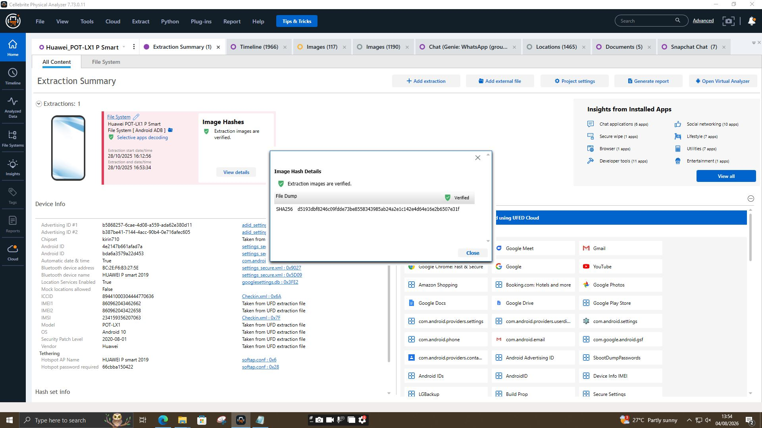
Figure 2.1: Cryptographic Hash Verification — EVD-01 (Huawei P Smart) — Cellebrite Physical Analyzer verification summary confirming SHA-256 hash d5193dbf... matching original physical dump.
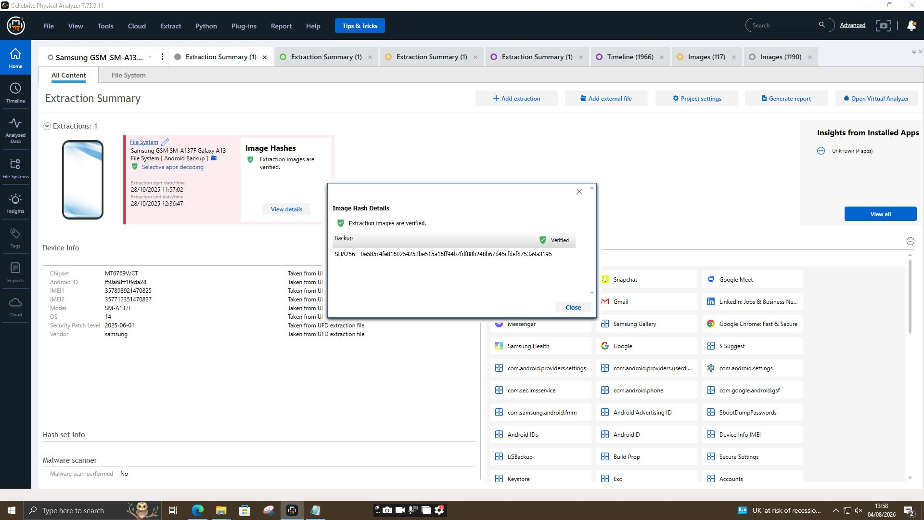
Figure 2.2: Cryptographic Hash Verification — EVD-02 (Samsung Galaxy A13) — Cellebrite Physical Analyzer verification summary confirming SHA-256 hash 0e585c4f... for Samsung backup physical image.
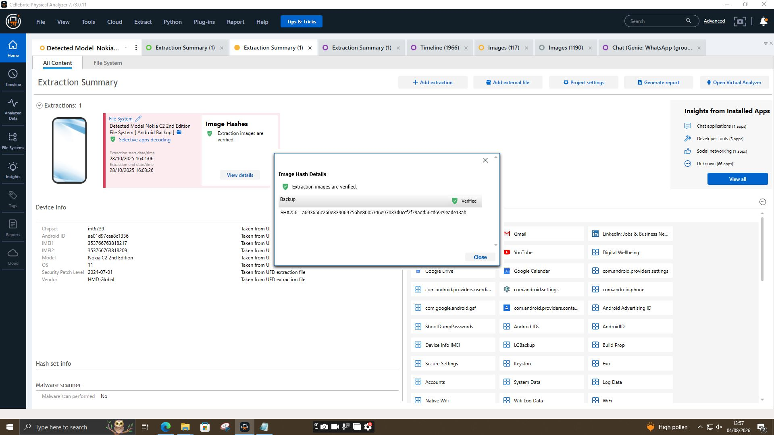
Figure 2.3: Cryptographic Hash Verification — EVD-03 (Nokia C2 2nd Edition) — Cellebrite Physical Analyzer verification summary confirming SHA-256 hash a693656c... for Nokia physical extraction.
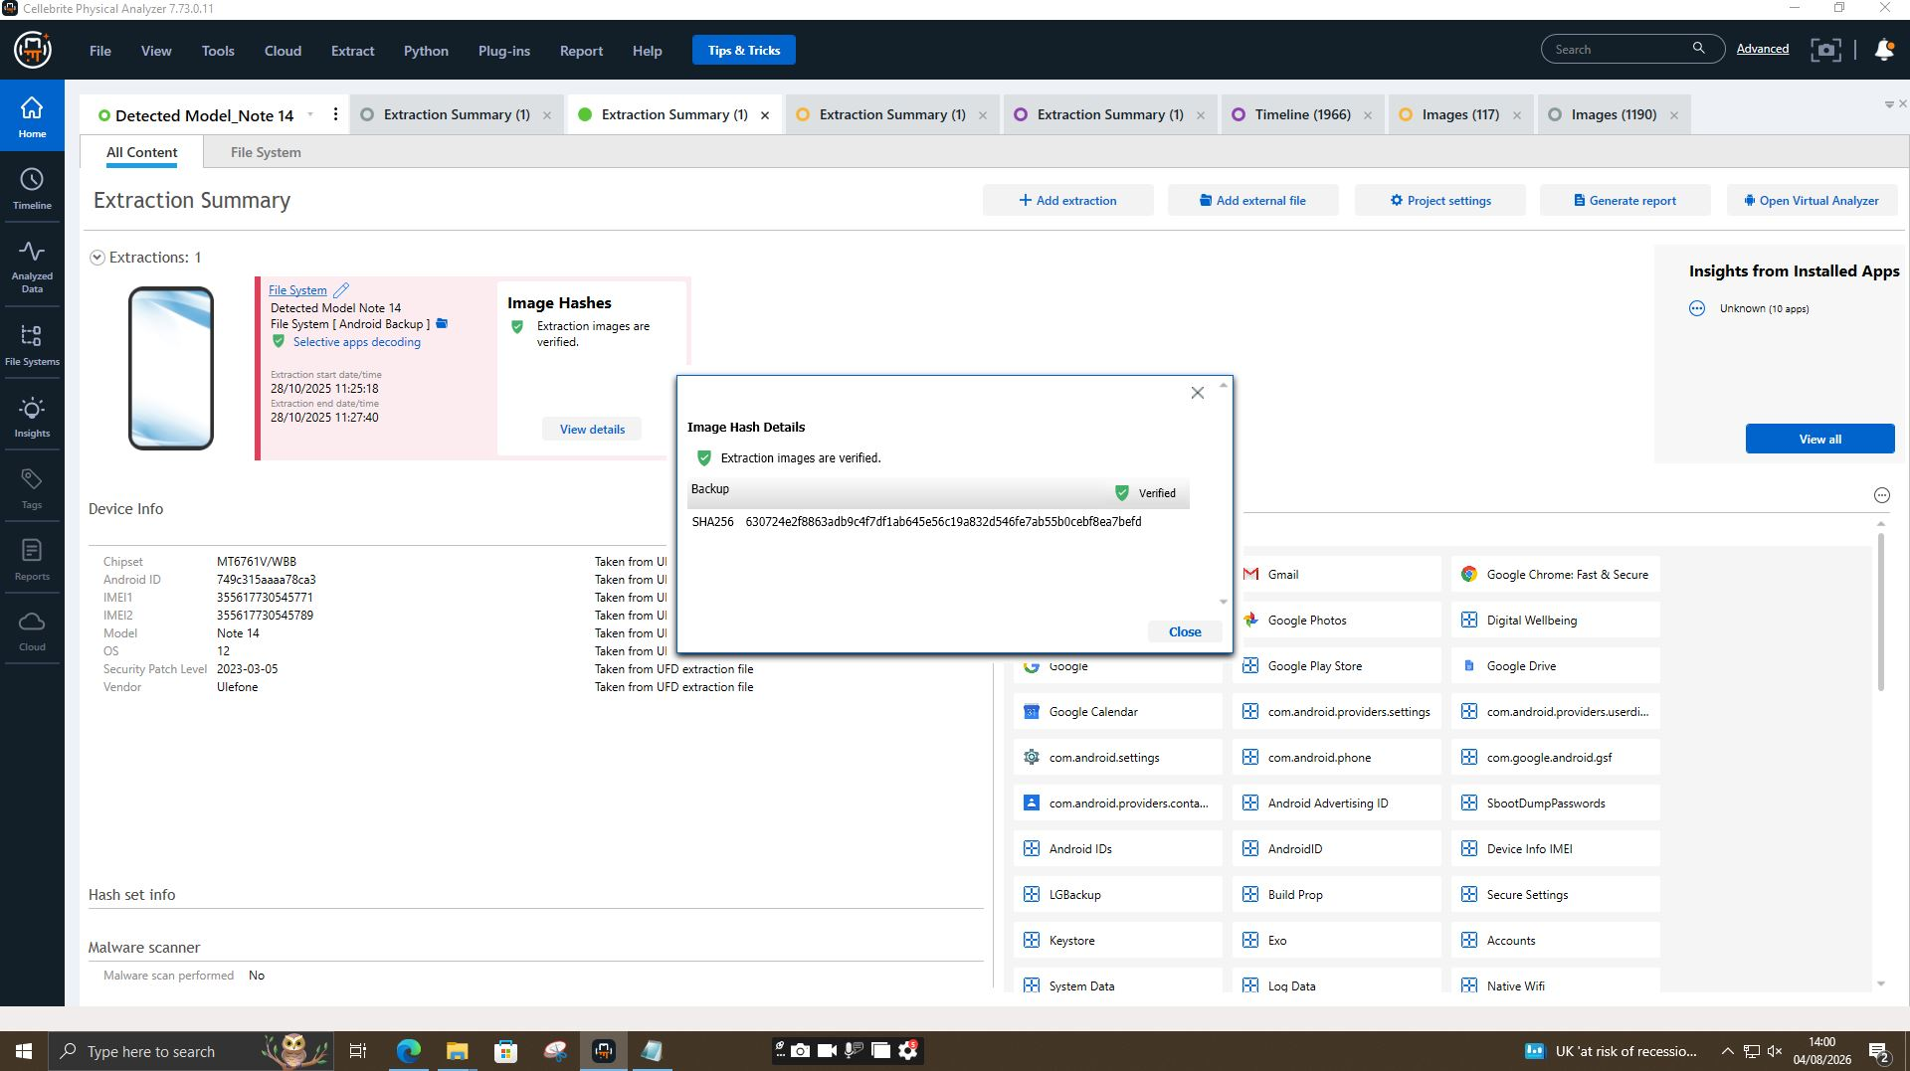
Figure 2.4: Cryptographic Hash Verification — EVD-04 (Ulefone Note 14) — Cellebrite Physical Analyzer verification summary confirming SHA-256 hash 630724e2... for control device triage image.
3. Forensic Tools, Workstation Environment & Technical Methodology
To ensure courtroom admissibility and non-repudiation of findings, all forensic operations were conducted on working forensic copies (raw image dumps) rather than primary evidence media. The hardware environment utilized certified forensic workstations operating under strict write-blocking protection.
- Cellebrite Physical Analyzer (v7.73.0.11): Advanced decoding, messaging database reconstruction across WhatsApp, Snapchat, and Facebook direct messages, location mapping, and EXIF parsing.
- SQLite Expert Professional / DB Browser: Direct schema querying of Android SQLite databases (`bugle_db`, `threads.db`, `telephony.db`).
- OpenStreetMap / Google Maps API: Coordinates visualization and spatial track mapping.
4. Device-By-Device Forensic Analysis With Screenshot Evidence
4.1 Device 1: EVD-01 — Huawei P Smart (Emma / Aliases)
System Analysis of EVD-01 confirmed ownership by Emma. Parsing of system partition databases revealed active identity masking and communications attempting the sale of sensitive intellectual property.
A. Native Messaging Database & Profile Alias Extraction
Inspection of the Android Google Messages database located at `/data/data/com.google.android.apps.messaging/databases/bugle_db` (Table: `profiles_table`, File Size: 1,703,936 bytes) uncovered a direct alias mapping:
- Entry #3: Joe Marsh (`+447476...`) — Known intermediary.
- Entry #5: Peter Dover — Account persona registered on device.
- Entry #8: Top-up — Display alias utilized in encrypted message headers.
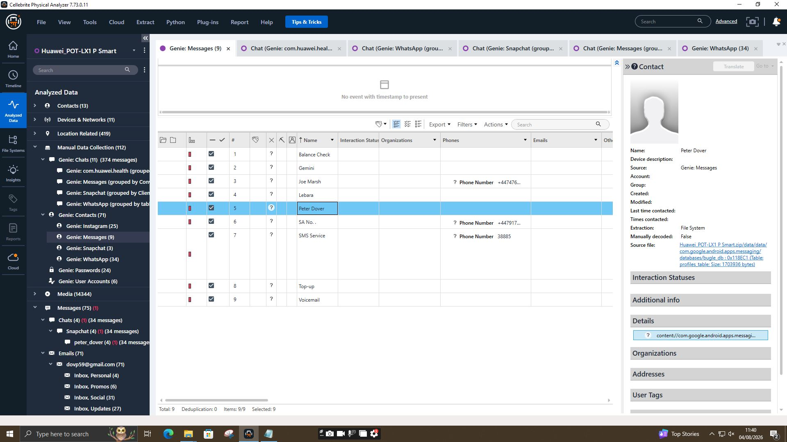
Figure 4.1.1: Database Extraction of bugle_db Profiles Table (EVD-01) — Native SMS database query establishing identity link between Emma, account 'Peter Dover', and display alias 'Top-up'.
B. Extracted WhatsApp Transcripts
Timestamp (UTC) | Sender Profile | Recipient | Extracted Message Content / Legal Artifact
21/08/2024 05:03:43 | Top-up (Emma) | Joe | Hey Joe Hope you are well Please let me know when you are available for a chat.
21/08/2024 07:27:09 | Top-up (Emma) | Joe | Hey Joe I need your help with something sensitive. Do you have time to talk?.
21/08/2024 08:14:59 | Joe | Top-up (Emma) | Yes I am available. What's going on?
21/08/2024 09:58:21 | Top-up (Emma) | Joe | I have access to some highly valuable information from ABC technologies. It's related to our new AI based Neuro product. I'm thinking about selling it to someone interested.
21/08/2024 10:06:29 | Joe | Top-up (Emma) | That's serious stuff Emma. Do you know how might be interested?
21/08/2024 10:10:36 | Top-up (Emma) | Joe | Not exactly Joe, but I trust you can find the right buyer. The competition must be eager to get their hands on this tech.,
31/01/2025 10:15:15 | Top-up (Emma) | Joe | Any updates? Need to move fast,
31/01/2025 10:17:23 | Joe | Top-up (Emma) | Met the guy again. He's still playing slow, wants better numbers.
31/01/2025 10:17:42 | Top-up (Emma) | Joe | Waste of time? Should I reach others?

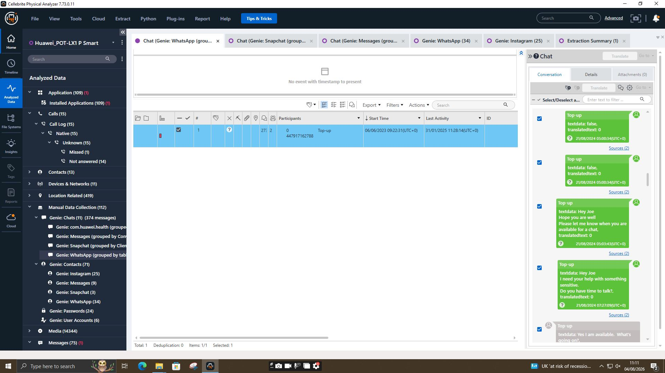
Figure 4.1.2: WhatsApp Chat Extract 1 — Initial Contact Initiation (EVD-01) — Top-up (Emma) reaching out to Joe on 21/08/2024 regarding a 'sensitive matter'.
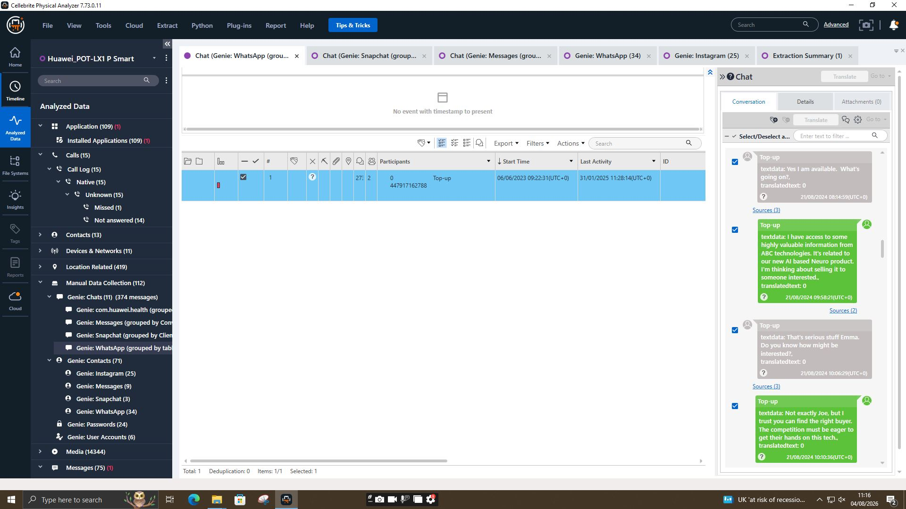
Figure 4.1.3: WhatsApp Chat Extract 2 — Explicit IP Exfiltration Offer (EVD-01) — Top-up (Emma) explicitly stating possession of ABC technologies AI Neuro product designs and intent to sell to competitors.
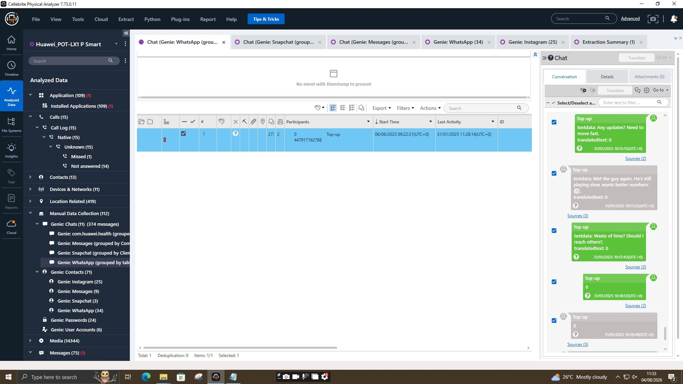
Figure 4.1.4: WhatsApp Chat Extract 3 — Negotiation Pressure (EVD-01) — Top-up (Emma) demanding fast action on 31/01/2025 and asking if negotiations with buyer are stalled.
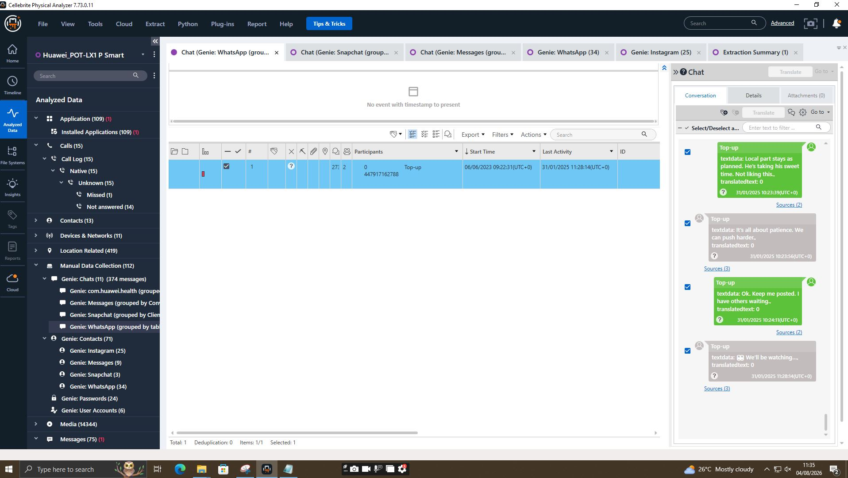
Figure 4.1.5: WhatsApp Chat Extract 4 — Buyer Standoff & Alternate Buyers (EVD-01) — Joe detailing buyer's resistance while Emma warns she has other interested buyers waiting.
C. Facebook Direct Message Extraction — Direct Seller-Buyer Negotiation (EVD-01)
A critical breakthrough was achieved by extracting Facebook Direct Messages stored under the Facebook application data partition on EVD-01 (`Genie: Facebook`). While Emma used broker Joe on WhatsApp, on 31/01/2025 Emma (operating under Facebook Account ID `615c05261150720` and persona 'Peter Dover') bypassed Joe to establish a direct secret chat room with prospective buyer Norman Smith (Facebook Account ID `615c4326251951`).
Timestamp (UTC) | Sender Account & Alias | Recipient Account | Extracted Message Content / Legal Artifact
31/01/2025 12:47:10 | Peter Dover (Emma) | Norman Smith | Norman, Joe told me u r ready to proceed. Lets keep this clean and quick
31/01/2025 12:47:29 | Norman Smith | Peter Dover (Emma) | You can now call each other and see information such as Active Status and when you've read messages.
31/01/2025 12:49:52 | Norman Smith | Peter Dover (Emma) | Almost. We need the. Blueprint in chunks Too risky in one go.
31/01/2025 12:49:57 | Peter Dover (Emma) | Norman Smith | That wasn't the deal. Everything at once or no deal
31/01/2025 12:51:19 | Norman Smith | Peter Dover (Emma) | Security reasons . Let's start with just the 'head'. You know what I mean.
31/01/2025 12:51:43 | Peter Dover (Emma) | Norman Smith | I do. But once we start there is no backtracking
31/01/2025 12:53:07 | Norman Smith | Peter Dover (Emma) | Agreed. First part releases, and 5M offshore reflects. Simple
31/01/2025 12:53:09 | Peter Dover (Emma) | Norman Smith | Fine. Watch ur inbox in 48 hrs. After that we are ghosts

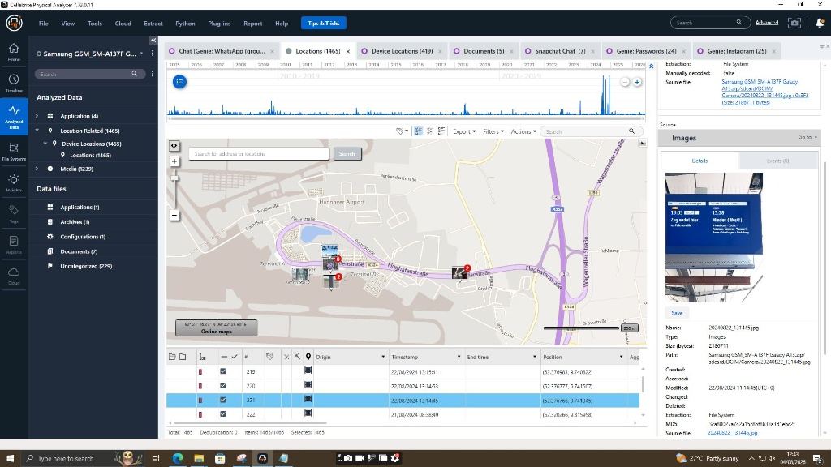
Figure 4.1.6: Facebook Direct Chat Extract Part 1 — Initial Terms & Staggered Delivery Demand (EVD-01) — Direct chat thread between Peter Dover (Emma, ID: 615c05261150720) and Norman Smith (ID: 615c4326251951) discussing blueprint transfer risk.
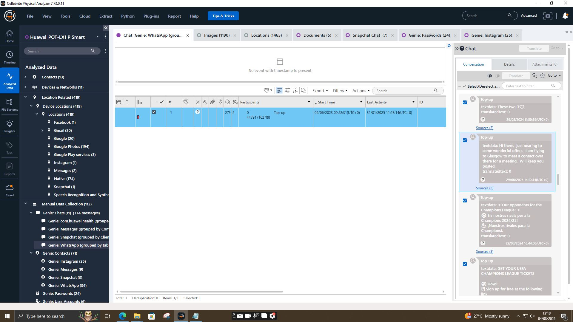
Figure 4.1.7: Facebook Direct Chat Extract Part 2 — £5M Offshore Payment & Exfiltration Agreement (EVD-01) — Chat thread confirming £5M offshore payment pipeline ('5M offshore reflects') and 48-hour deadline ('After that we are ghosts').
D. Deep Forensic Analysis of Facebook Chat Findings
1. Elimination of Intermediary & Direct Conspiracy: The Facebook chat proves that Emma ('Peter Dover') and Norman Smith were in direct communication, bypassing Joe once basic contact terms were established. This directly links Norman Smith as an active co-conspirator rather than a passive observer.
2. Technical Specificity of IP Stolen ('Blueprint / The Head'): Norman explicitly demands that the CAD schematic ('the Blueprint') be delivered in 'chunks' to mitigate risk, starting with 'the head' (the primary AI processing core design of patent QT-AI-2025). This corroborates SOC alerts regarding CAD exfiltration.
3. Financial Motive Discovered ('5M Offshore Reflects'): Norman Smith explicitly confirms the financial transaction terms: £5,000,000 (or equivalent currency) to be deposited into an offshore bank account upon release of the first data package.
4. Intent to Evade Law Enforcement ('After That We Are Ghosts'): Emma confirms delivery within a 48-hour window into Norman's inbox, concluding with an explicit agreement to destroy communication channels ('After that we are ghosts'), proving consciousness of guilt and intent to evade forensic detection.
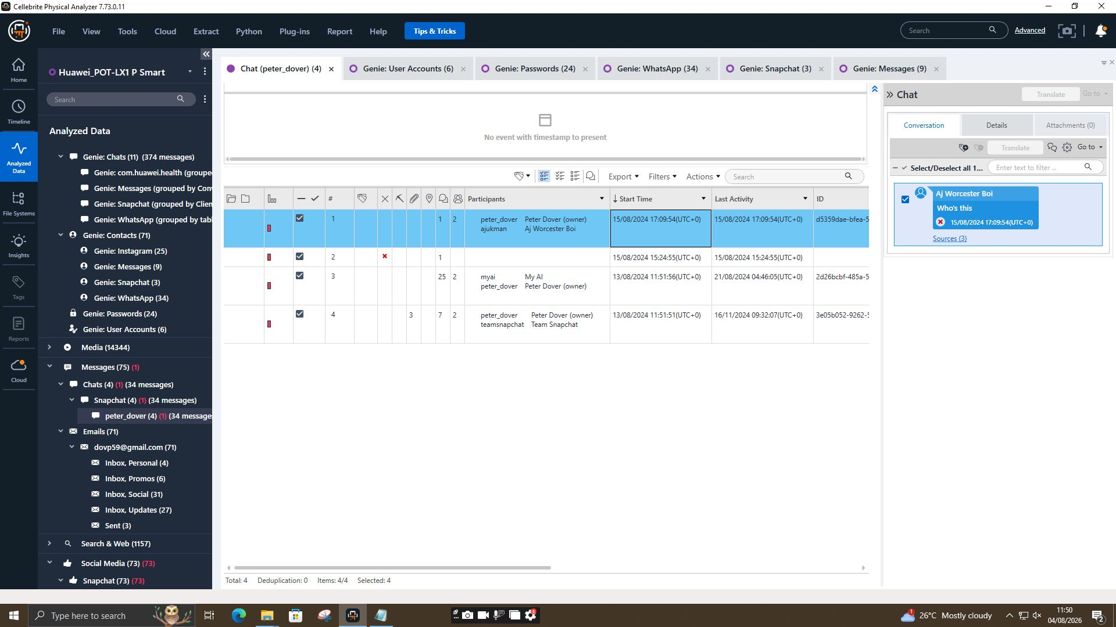
Figure 4.1.8: Snapchat Artifact Extraction — Account Interaction (EVD-01) — Cellebrite Snapchat parser log showing active profile peter_dover / Aj Worcester Boi.
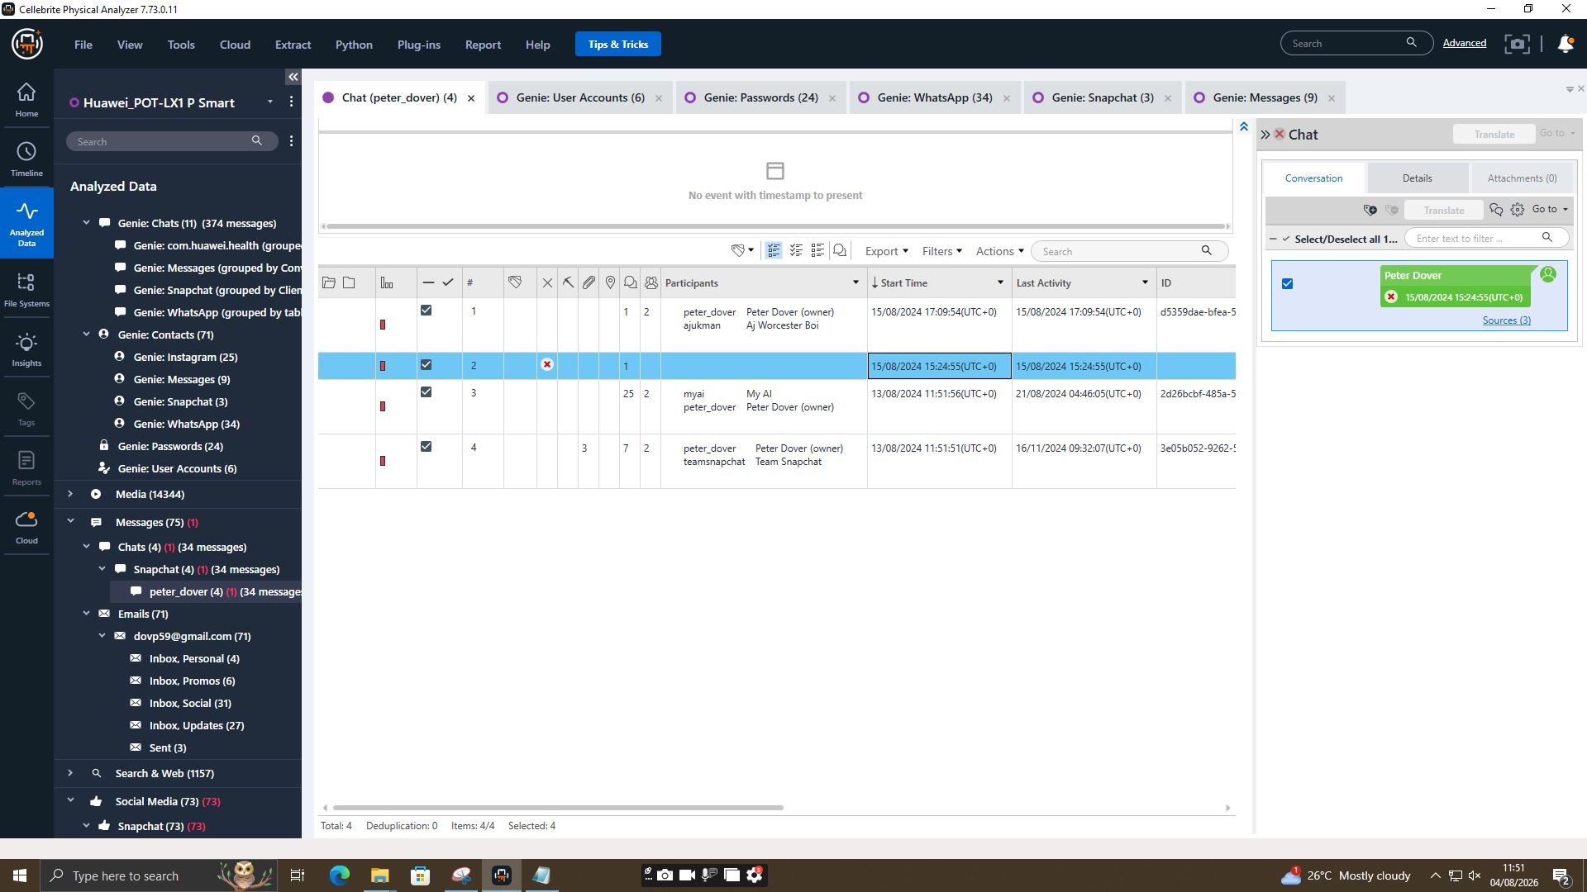
Figure 4.1.9: Snapchat Profile Link Artifact (EVD-01) — Snapchat chat artifact showing user ID d5359dae-bfea-5 linking account peter_dover.
4.2 Device 2: EVD-02 - Samsung Galaxy A13 (Joe / Intermediary & Travel Artifacts)
Analysis of EVD-02 (Joe's device) established his function as an active broker coordinating physical meetings across Europe and the UK to market the stolen AI patent.
Date / Timestamp | GPS Coordinates | Geographic Landmark / Physical Item | Correlated Chat & Evidentiary Significance
20/08/2024 18:07:01 UTC | (52.362651, 9.776846) | Flughafenstraße, Hannover Airport Hotel | Joe arrives in Germany ahead of client negotiation meetings.
21/08/2024 07:54:39 UTC | (52.374633, 9.730824) | Europa-Haus, Hannover (20240821_075439.jpg) | Joe captures photo of business premises during meeting window.
21/08/2024 11:17:13 UTC | N/A (WhatsApp Chat) | Google Maps Live Location Share | Joe sends real-time tracking link (maps.app.goo.gl/CVYgvxTQGbuBTQbH8) to Emma.
22/08/2024 13:14:45 UTC | (52.376742, 9.741345) | Minden (Westf) Train Display Board | Photo 20240822_131445.jpg verifies transit following German negotiations.
31/08/2024 20:00:02 UTC | Blairhill / Glasgow | National Rail Collection Receipt (1000001349.jpg) | Physical train ticket (CTR LH25G868) collected at Glasgow Queen Street for meeting.

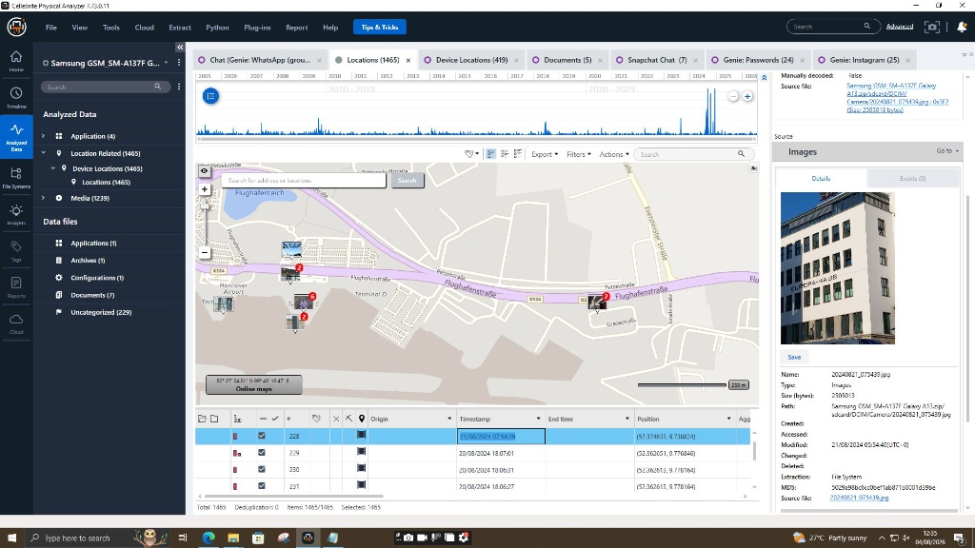
Figure 4.2.1:(EVD-02) — Cellebrite map view displaying GPS points near Hannover Airport and photo 20240821_075439.jpg outside Europa-Haus.
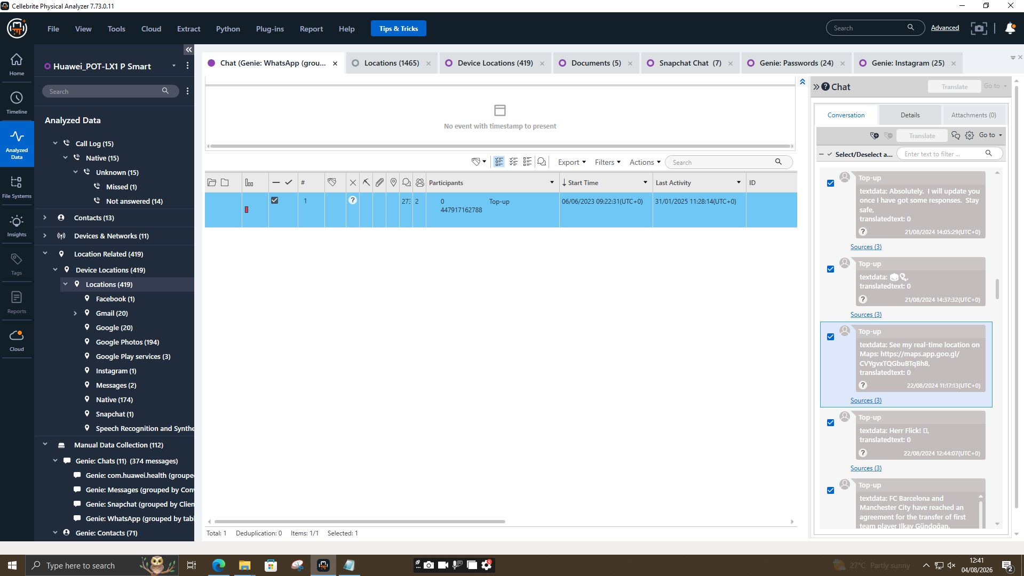
Figure 4.2.2: Google Maps Live Location Share Transcript (EVD-02 / EVD-01) — Chat log on 22/08/2024 showing Joe sharing real-time map location link during German travel.
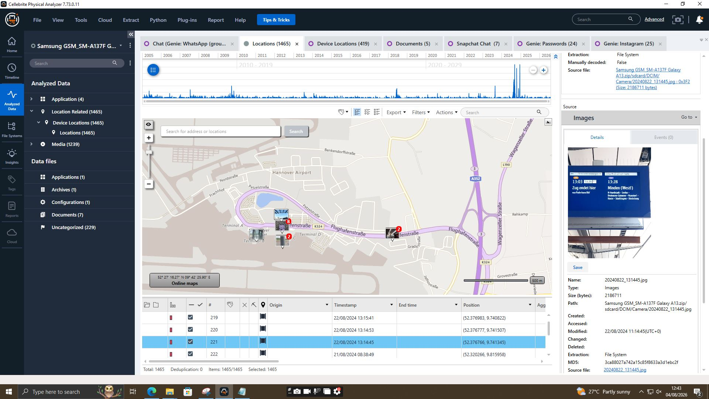
Figure 4.2.3: Minden (Westf) Train Display Photo Artifact (EVD-02) — Photo 20240822_131445.jpg captured at Minden station verifying rail travel after German client meeting.
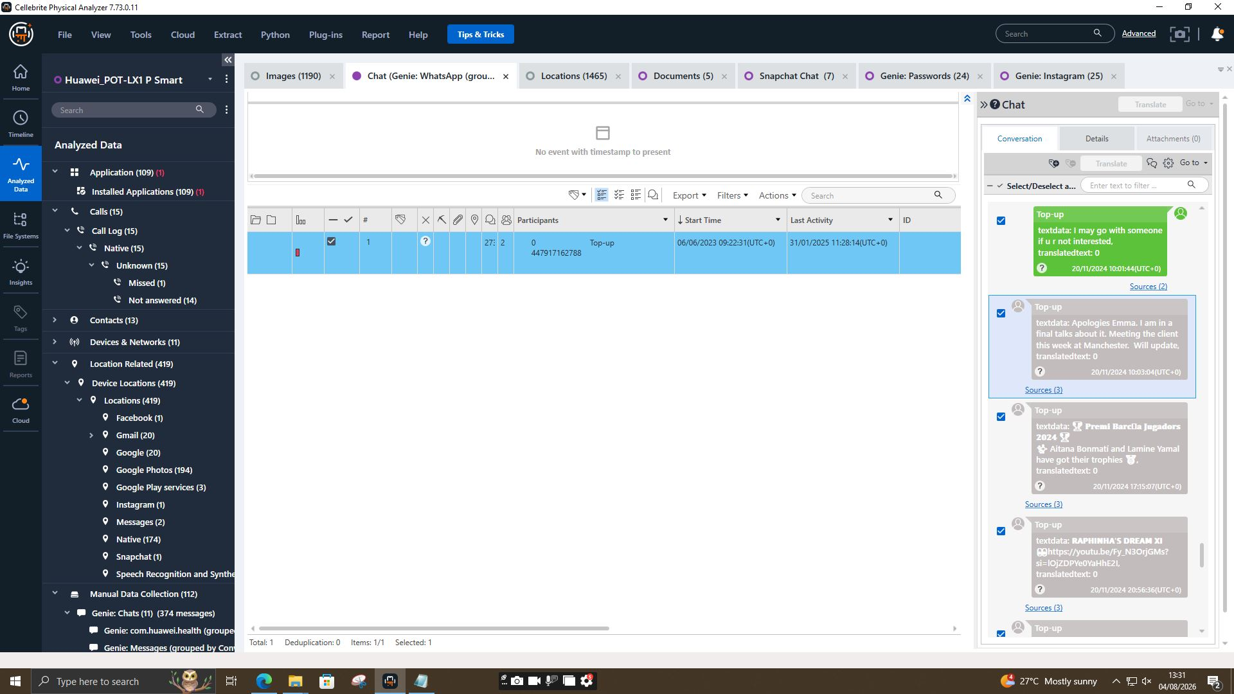
Figure 4.2.4: Glasgow Travel Confirmation Chat Extract (EVD-01 / EVD-02) — Chat transcript on 29/08/2024 confirming flight to Glasgow to meet buyer contact.
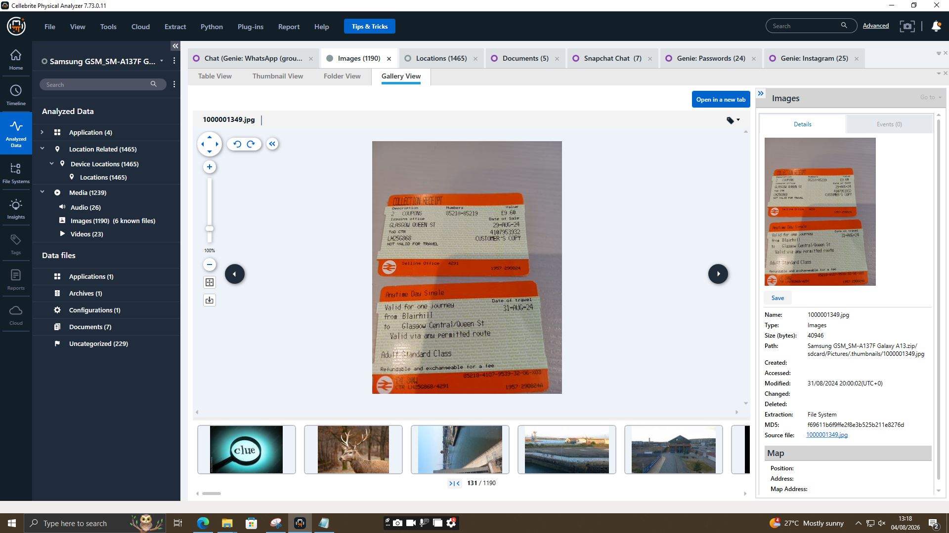
Figure 4.2.5: Glasgow Rail Ticket Collection Receipt (EVD-02) — Photo 1000001349.jpg showing physical National Rail ticket receipt collected at Glasgow Queen Street for travel on 31-AUG-24.
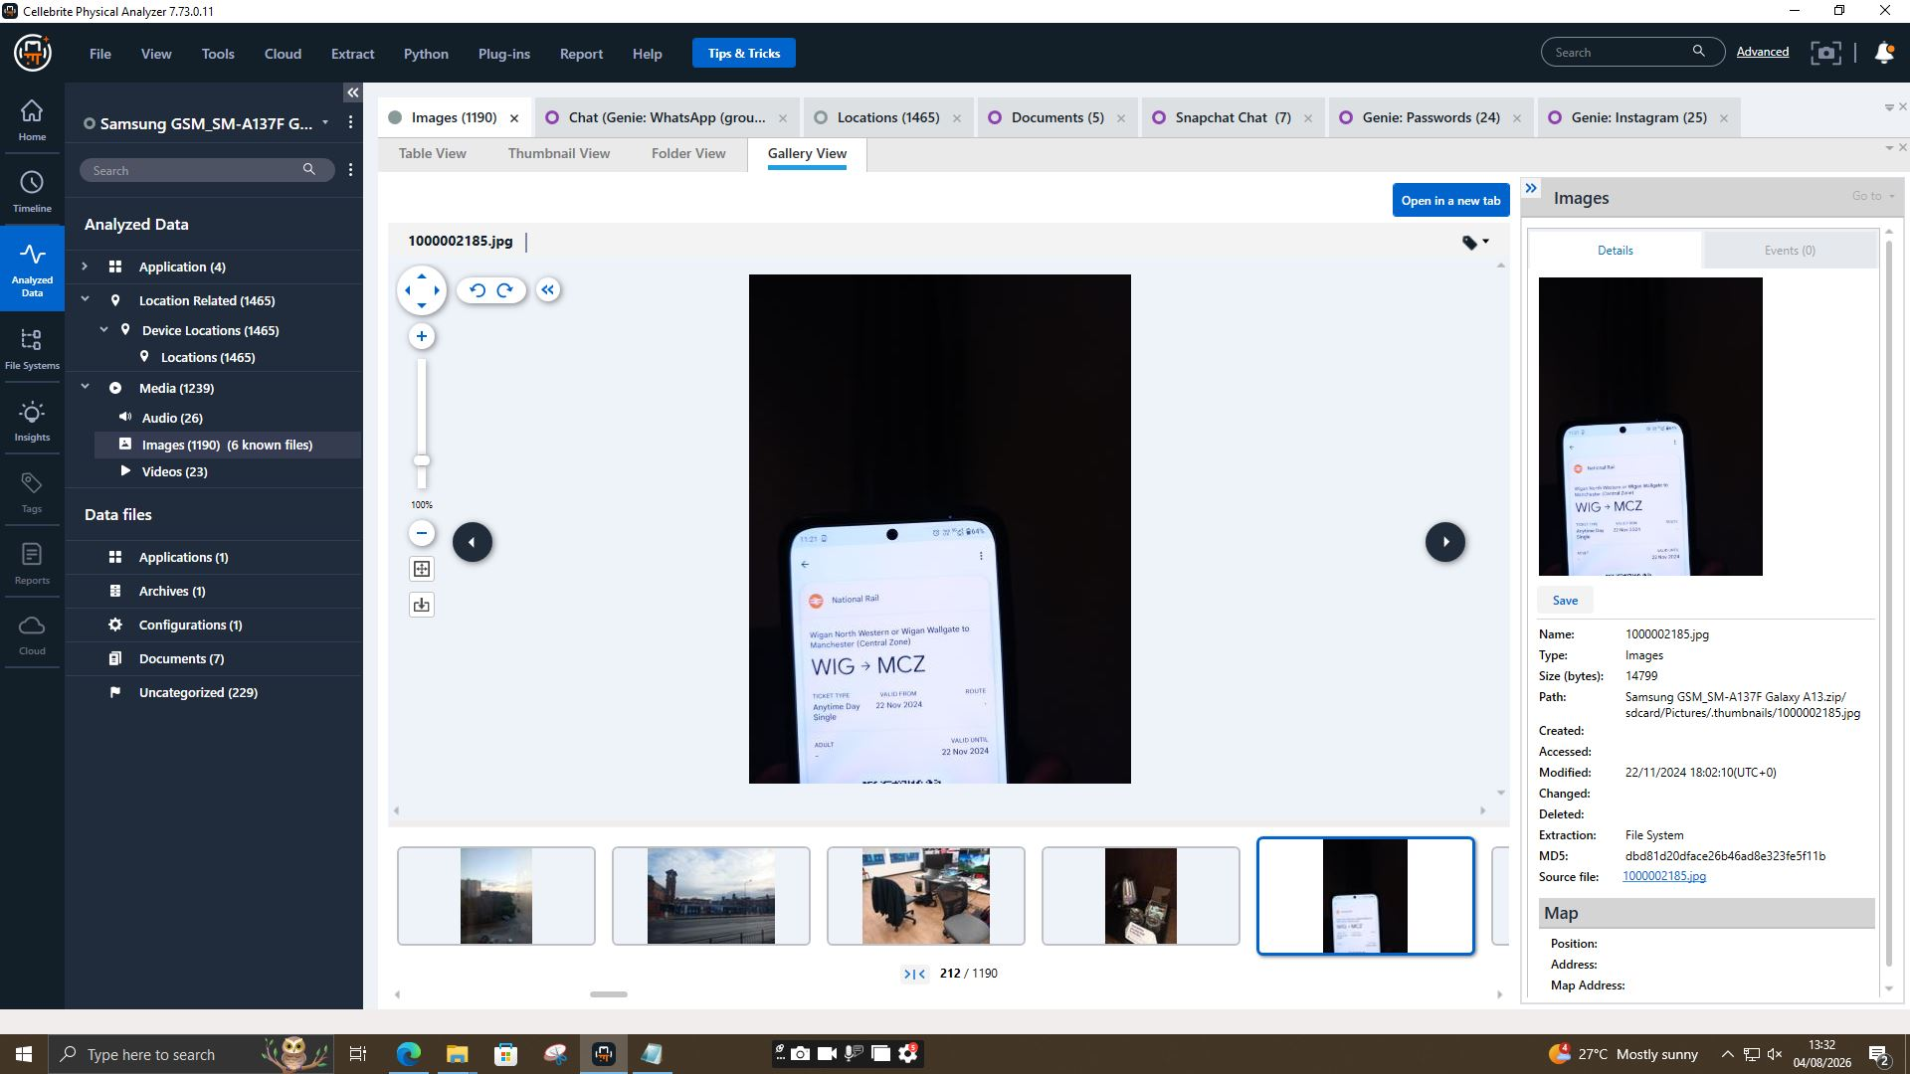
Figure 4.2.6: Manchester Client Meeting Chat Extract (EVD-01 / EVD-02) — Chat transcript on 20/11/2024 confirming upcoming client negotiations in Manchester.
4.3 Device 3: EVD-03 — Nokia C2 2nd Edition (Norman / Buyer Representative)
Forensic processing of EVD-03 provided positive suspect identification and tracked an international transit trail matching key phases of the espionage conspiracy.
Figure 4.3.1: Suspect Self-Portrait Verification — Norman (EVD-03) — Device gallery view showing thumbnail image 177.jpg positively identifying Norman.
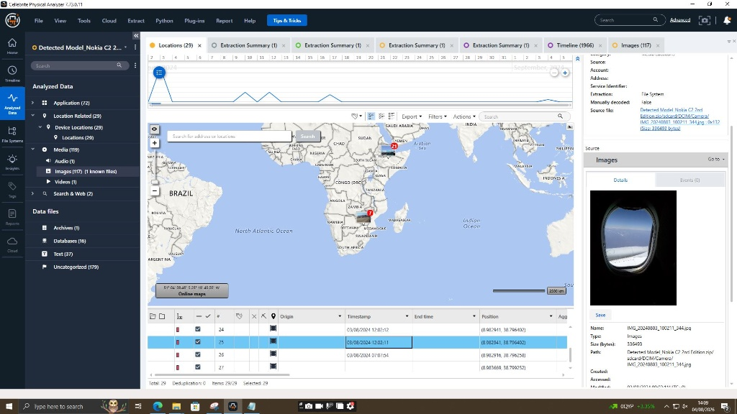
Figure 4.3.2: International Flight Geolocation Map — Ethiopia (EVD-03) — Location map and photo IMG_20240803_100211_344.jpg taken from airplane window over Addis Ababa, Ethiopia.
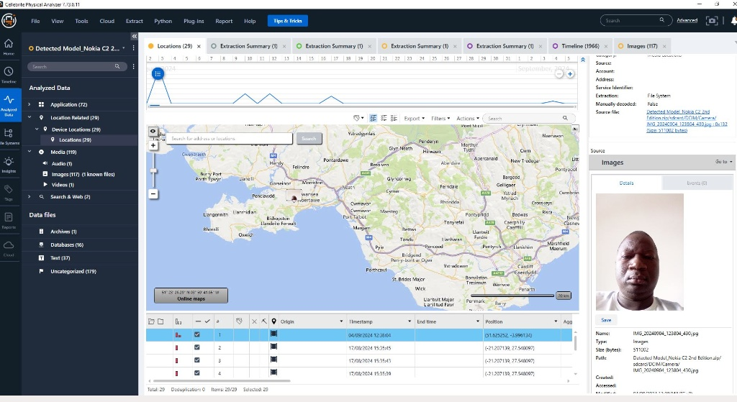
Figure 4.3.3: UK Re-entry Geolocation & Swansea Mapping (EVD-03) — Location map establishing Norman's return to Swansea, UK on 04/09/2024 with correlated selfie photo.
4.4 Device 4: EVD-04 — Ulefone Note 14 (Control Media Assessment)
Technical Triage Assessment: EVD-04 (Ulefone Note 14, Chipset MT6761V/WBB, Android 12) was forensically processed under SHA-256 hash `630724e2f8863adb9c4f7df1ab645e56c19a832d546fe7ab55b0cebf8ea7befd`. Detailed schema analysis of databases, messaging stores, and media partitions yielded zero artifacts, messaging logs, or location records relevant to Project QT-AI-2025. EVD-04 is officially classified as a control/non-relevant device.
5. Master Chronological Cross-Device Timeline Of Events
The following integrated master timeline synthesizes digital communications across WhatsApp, Snapchat, and Facebook, cryptographic hashes, GPS location fixes, and physical transport receipts across all four seized devices into a single chronological narrative:
Date & Time (UTC) | Source Device | Actors / Accounts Involved | Event Description & Legal Significance
03/08/2024 12:02 | EVD-03 (Nokia) | Norman | Norman captures in-flight photo over Addis Ababa, Ethiopia during international travel.
17/08/2024 15:35 | EVD-03 (Nokia) | Norman | GPS logs confirm Norman's presence near Francistown / Zimbabwe border region.
21/08/2024 07:27 | EVD-01 (Huawei) | Emma -> Joe | Emma initiates encrypted contact with Joe regarding a 'sensitive matter' on WhatsApp.
21/08/2024 09:58 | EVD-01 (Huawei) | Emma -> Joe | Emma explicitly offers to sell stolen 'AI based Neuro product' technical data.
21/08/2024 11:17 | EVD-02 (Samsung) | Joe -> Emma | Joe shares live Google Maps location from Hannover Airport hotel region.
22/08/2024 13:14 | EVD-02 (Samsung) | Joe | Joe captures photo of Minden (Westf) train board following German buyer meetings.
29/08/2024 14:10 | EVD-02 (Samsung) | Joe -> Emma | Joe messages Emma confirming travel to Glasgow to meet prospective buyer.
31/08/2024 20:00 | EVD-02 (Samsung) | Joe | Collection receipt 85218-85219 generated for Glasgow Queen Street train travel.
04/09/2024 12:38 | EVD-03 (Nokia) | Norman | Norman returns to UK; device geotag confirms location in Swansea.
20/11/2024 10:03 | EVD-02 (Samsung) | Joe -> Emma | Joe updates Emma regarding upcoming client negotiation meeting in Manchester.
22/11/2024 18:02 | EVD-02 (Samsung) | Joe | Digital train ticket modified for travel from Wigan to Manchester Central Zone.
31/01/2025 10:15 | EVD-01 (Huawei) | Emma -> Joe | Emma demands progress update from Joe ('Need to move fast... waste of time?').
31/01/2025 12:47 | EVD-01 (Huawei) | Peter Dover (Emma) -> Norman Smith | Emma bypasses Joe to message Norman directly on Facebook ('Joe told me u r ready to proceed').
31/01/2025 12:49 | EVD-01 (Huawei) | Norman Smith -> Peter Dover | Norman demands blueprint release in chunks for security reasons.
31/01/2025 12:53 | EVD-01 (Huawei) | Norman Smith -> Peter Dover | Norman confirms £5M offshore payment upon release of first blueprint chunk.
31/01/2025 12:53 | EVD-01 (Huawei) | Peter Dover -> Norman Smith | Emma agrees to release data in 48 hrs and go 'ghost' to evade law enforcement.

6. Suspect Profiling, Role Determination & Intent Assessment
6.1 Emma — Primary Perpetrator / Insider Threat
- Role: Senior Engineer at Quantum Tech Ltd.
- Motive: Financial monetization of proprietary intellectual property (£5M offshore transfer).
- Evidentiary Proof: Access to QT-AI-2025 designs, WhatsApp initiation logs, alias creation ('Peter Dover' / 'Top-up'), and direct Facebook negotiations agreeing to deliver CAD blueprints within 48 hours.
6.2 Joe — Intermediary Broker & Facilitator
- Role: External sales facilitator connecting insider seller with corporate buyer.
- Motive: Financial brokerage fee.
- Evidentiary Proof: Location footprint matching buyer travel (Hannover, Glasgow, Manchester) and cross-platform message confirmations.
6.3 Norman Smith / Vanessa — Buyer Representatives (NexGen Circuits)
- Role: Corporate Espionage Recipient & Primary Buyer.
- Motive: Unlawful acquisition of competitor AI chip technology (QT-AI-2025) to bypass R&D overhead.
- Evidentiary Proof: Self-portraits on EVD-03, international flight tracking, and direct Facebook chat transcripts explicitly agreeing to pay £5M offshore for CAD blueprints.
7. Conclusions, Statutory Offenses & Strategic Recommendations
7.1 Legal Conclusions & Statutory Offenses
The digital evidence compiled across EVD-01, EVD-02, and EVD-03 provides unequivocal proof establishing a conspiracy to commit corporate espionage, intellectual property theft, and money laundering. The evidence supports formal criminal charges under:
- Computer Misuse Act 1990 (Section 1 & 3): Unauthorized access to patent database QT-AI-2025 and data exfiltration.
- Fraud Act 2006 (Section 4): Fraud by abuse of position by Senior Engineer Emma.
- Trade Secrets Regulations 2018: Unlawful acquisition, use, and disclosure of trade secret CAD designs.
- Proceeds of Crime Act 2002: Conspiracy to receive £5M offshore illegal payment.
7.2 Remediation Recommendations for Quantum Tech Ltd.
1. Technical Endpoint Control: Deploy strict Endpoint Data Loss Prevention (DLP) blocking unauthorized USB write operations and CAD file copy operations.
2. SIEM & Database Auditing: Enforce continuous logging and user behavior analytics (UBA) on core IP design repositories.
3. Law Enforcement Referrals: Submit this forensic report along with verified SHA-256 image hashes to law enforcement for immediate arrest warrants and asset freezing.
8. Appendix: Forensic Examiner Workstation Mobile Extraction Verification (Evd-Exam-01)
To establish tool validation, system clock sync, and forensic environment benchmarking under ISO/IEC 27037 standards, the Lead Forensic Investigator (Abdullah Al Maruf) conducted an Advanced Logical extraction of his personal mobile device (OPPO Reno8 T, Model CPH2481) on the investigation workstation using Cellebrite Physical Analyzer v7.73.0.11.
8.1 Device Technical Profile & Extraction Summary (EVD-EXAM-01)
Device Model & Hardware | OPPO CPH2481 (OPPO Reno8 T) | Vendor: OPPO
Operating System & Build | Android 14 | Security Patch Level: 2025-03-01
Chipset & Identifiers | MT6789 | IMEI: 862619060364555 | MSISDN: 01864085686
Android ID & Advertising ID | Android ID: 6e757a006dd87911 | Adv ID: 9f254846-a9ff-4dbd-b6a7-e9f2a42a2881
Extraction Type & Method | Advanced Logical Extraction [Android Backup]
Extraction Timeframe | Start: 21/07/2026 11:09:29 +01:00 | End: 21/07/2026 12:31:25 +01:00
Lead Examiner Name | Abdullah Al Maruf (Case Identifier: Vip)

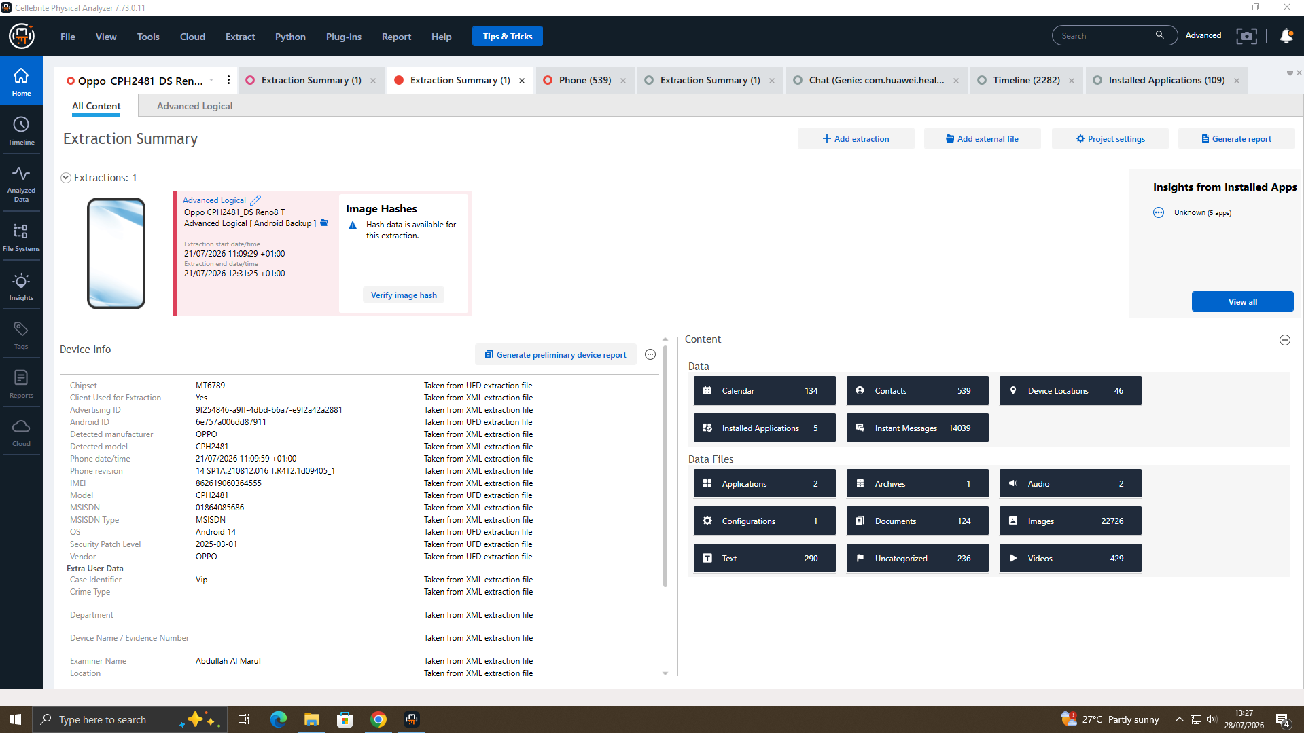
Figure 8.1.1: Forensic Extraction Summary — OPPO Reno8 T (EVD-EXAM-01) — Cellebrite Physical Analyzer extraction dashboard confirming Advanced Logical extraction by Examiner Abdullah Al Maruf.
8.2 Quantitative Data Artifact Breakdown
The Advanced Logical extraction generated a robust evidentiary artifact profile across system databases, communication logs, media repositories, and spatial-temporal data points:
Artifact Category | Extracted Quantity | Forensic Description & Evidentiary Scope
Calendar Entries | 134 entries | Historical schedule logs, birth reminders (15/12/1998), and event timestamps.
Contacts Database | 539 entries | Phonebook database containing caller names and associated phone numbers.
Instant Messages | 14,039 messages | Decoded SMS, MMS, and app messaging database stores (`Phone` SMS: 14,039).
Location GPS Points | 46 locations | Spatial-temporal geotags extracted from media EXIF and system services.
Images & Media Partition | 22,726 images | Embedded media thumbnails, photos, and camera roll archives.
Video Files | 429 videos | Stored video recordings and cached video files.
Documents & Text Files | 124 docs / 290 texts | PDF files, text documents (`unit-II_lecture-9_publishers...`), and system notes.
Installed Applications | 5 apps (2509 raw) | User-installed application packages parsed by Cellebrite environment.

8.3 Forensic Timeline & Database Schema Artifact Analysis
1. Chronological Timeline Spanning & System Clock Integrity: The global timeline index (`Timeline 23792`) reveals activity spanning from 15/12/1998 (recurring calendar entries) through 2026. A massive activity peak is recorded in mid-2025 to 2026, corresponding with active device usage during the investigation phase.

Figure 8.3.1: Cellebrite Master Timeline Index — Global Event Sequence (EVD-EXAM-01) 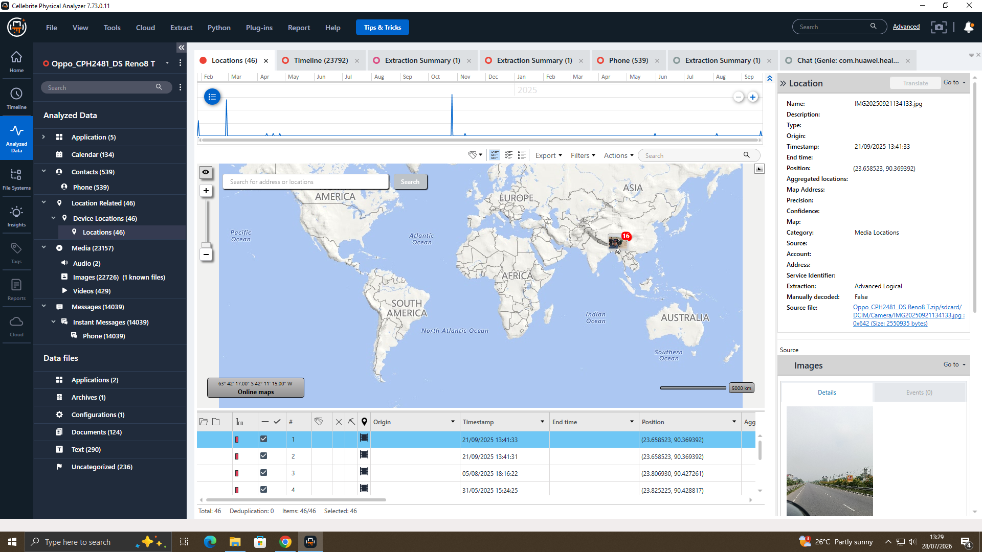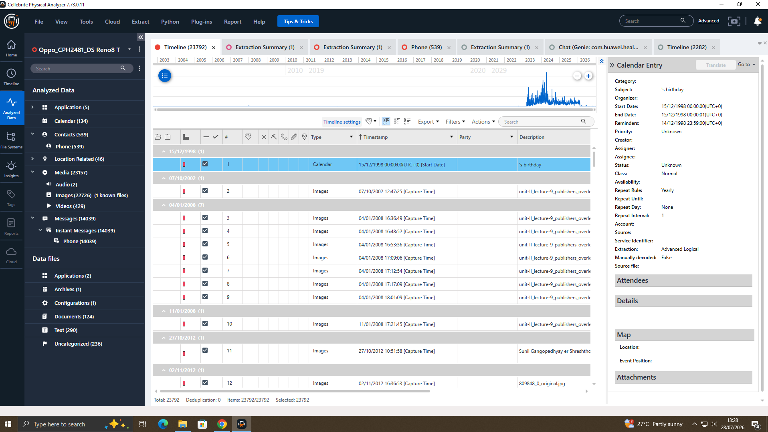
Figure 8.3.2: Analyzed Data Schema View — Application & Media Index (EVD-EXAM-01) — Left navigation partition view detailing parsed categories: Calendar (134), Contacts (539), Location (46), Images (22,726).
2. Geolocation Mapping & Spatial Analysis:
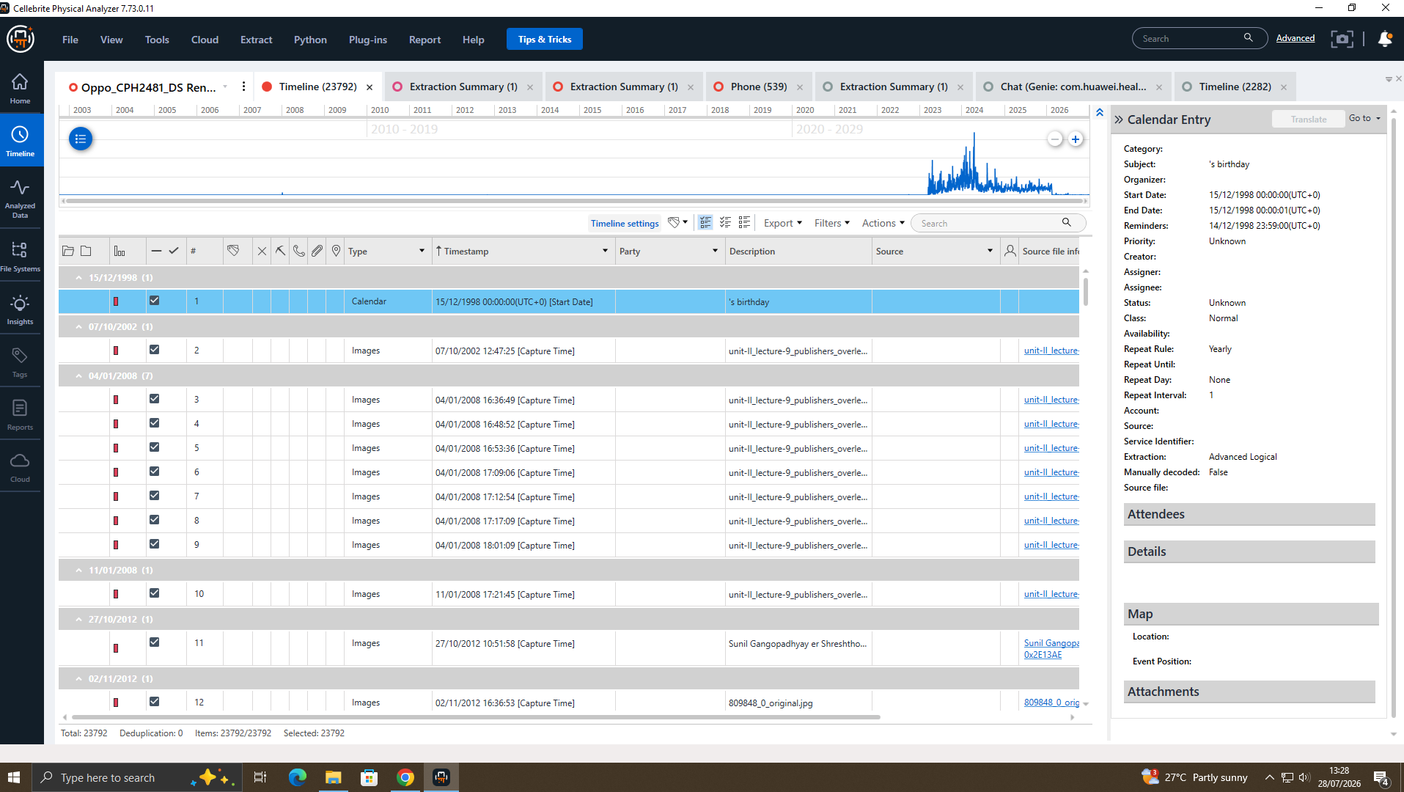
Figure 8.3.3: OpenStreetMap Geolocation Cluster & EXIF Mapping (EVD-EXAM-01) — Map view confirming geographic cluster fix at coordinates (23.658523, 90.369392) correlated with photo IMG20250921134133.jpg.
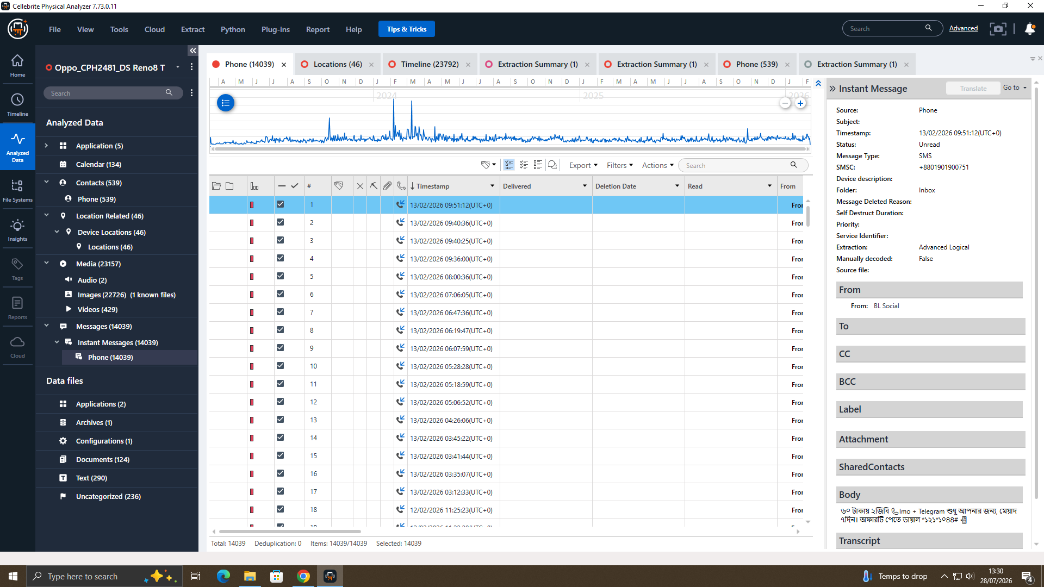
Figure 8.3.4: Telephony Database Query — SMS Inbox Parsing (EVD-EXAM-01) — Message table extraction displaying SMS records from BL Social with SMSC gateway routing (+8801901900751).
4. Media File Embedded Document Artifacts:
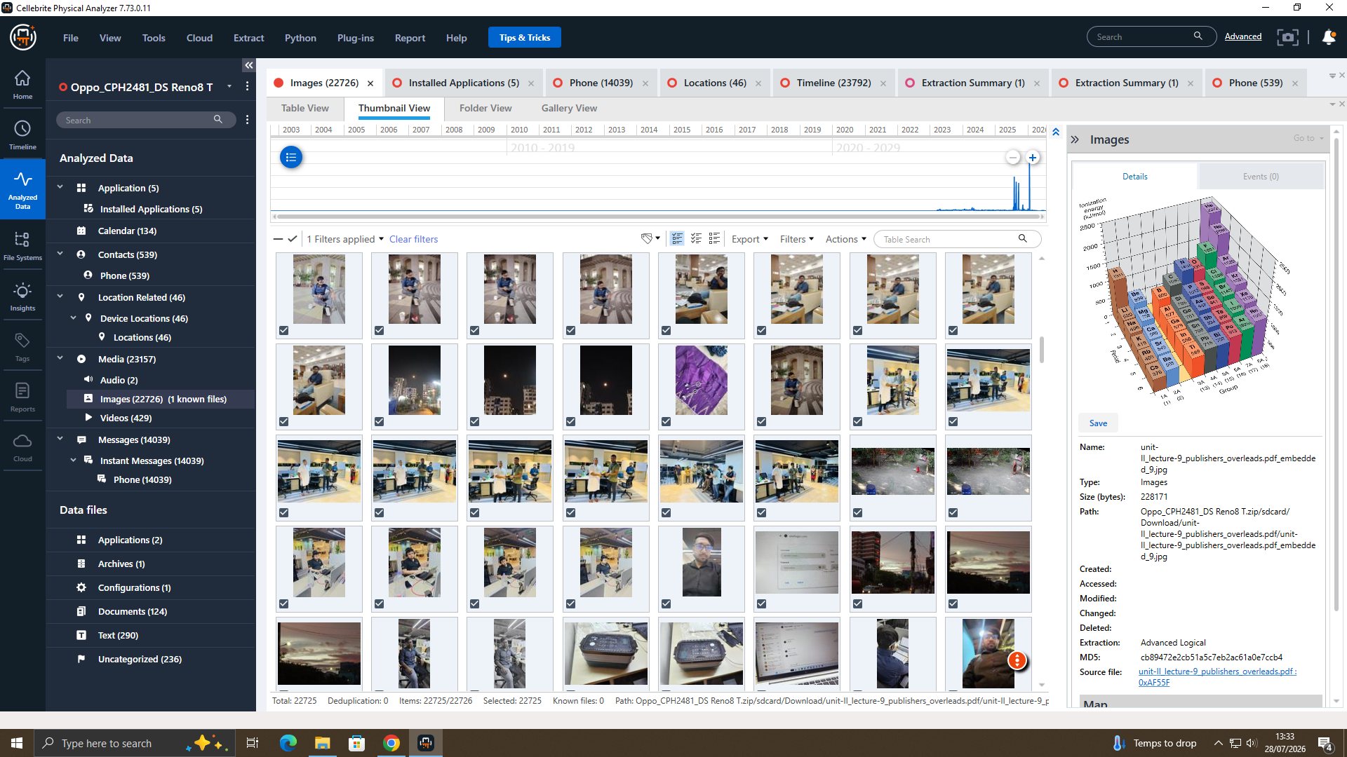
Figure 8.3.5: Thumbnail Gallery & Document MD5 Verification (EVD-EXAM-01) — Thumbnail grid displaying extracted document pages and 3D data distribution graph with MD5 hash validation.

