RUNAWAY SLAVES IN GEORGIAN LIVERPOOL
- Via University of Glasgow, Runaway Slaves in Britain database <https://www.runaways.gla.ac.uk/> [accessed 20 January 2020]
Williamson’s Liverpool Advertiser and Mercantile Register, 8 September 1758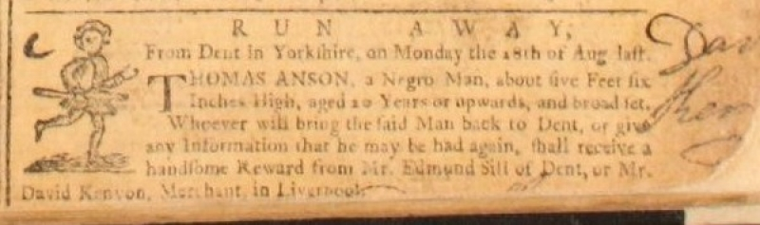
Williamson’s Liverpool Advertiser and Mercantile Register, 30 January 1761
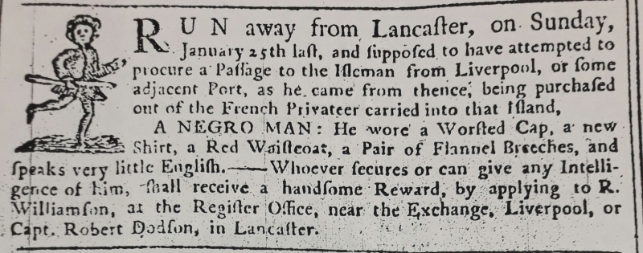
Williamson’s Liverpool Advertiser and Mercantile Register, 17 September 1762
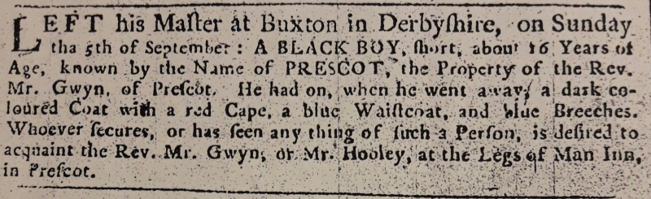

Williamson’s Liverpool Advertiser and Mercantile Register, 12 October 1764
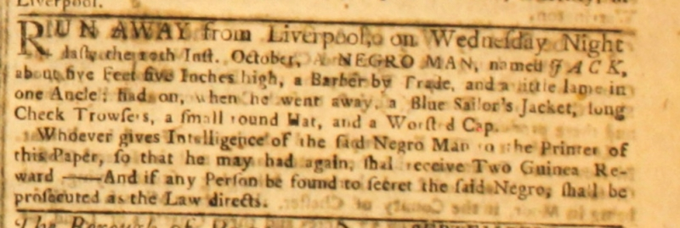
Williamson’s Liverpool Advertiser and Mercantile Register, 30 November 1764
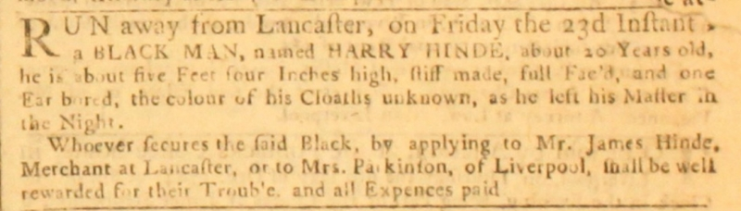
Williamson’s Liverpool Advertiser and Mercantile Register, 30 August 1765
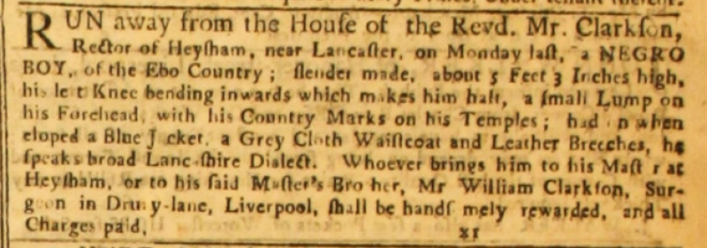

Liverpool General Advertiser, or the Commercial Register, 21 August 1767
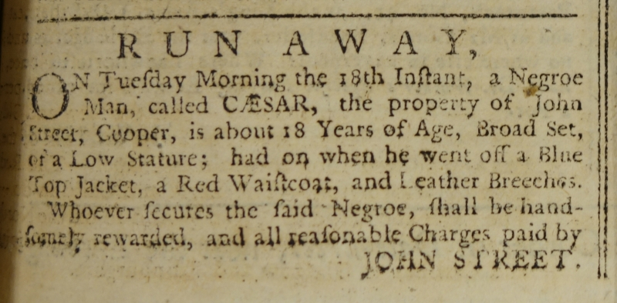
Liverpool General Advertiser, or the Commercial Register, 2 September 1768
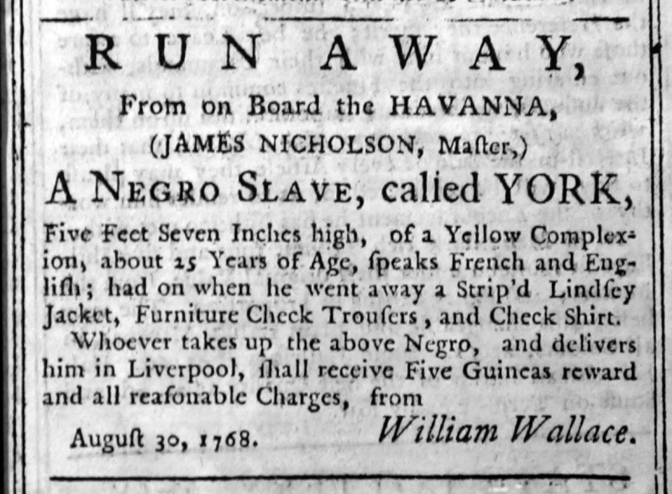

Liverpool General Advertiser, or the Commercial Register, 25 August 1769
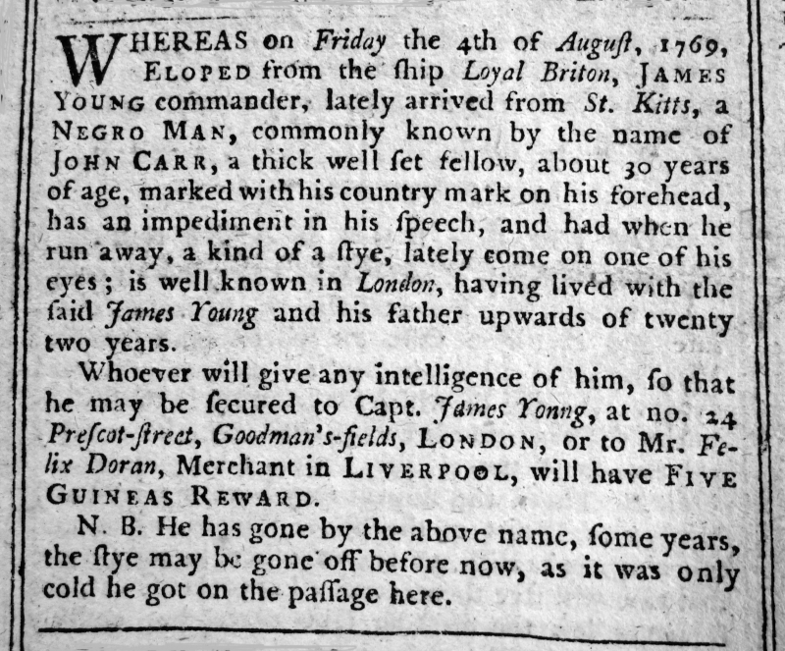
Liverpool General Advertiser, or the Commercial Register, 14 September 1770
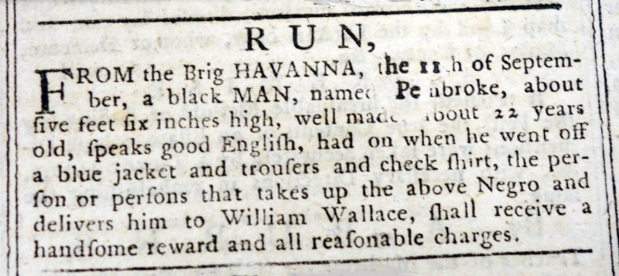

Liverpool General Advertiser, or the Commercial Register, 30 November 1770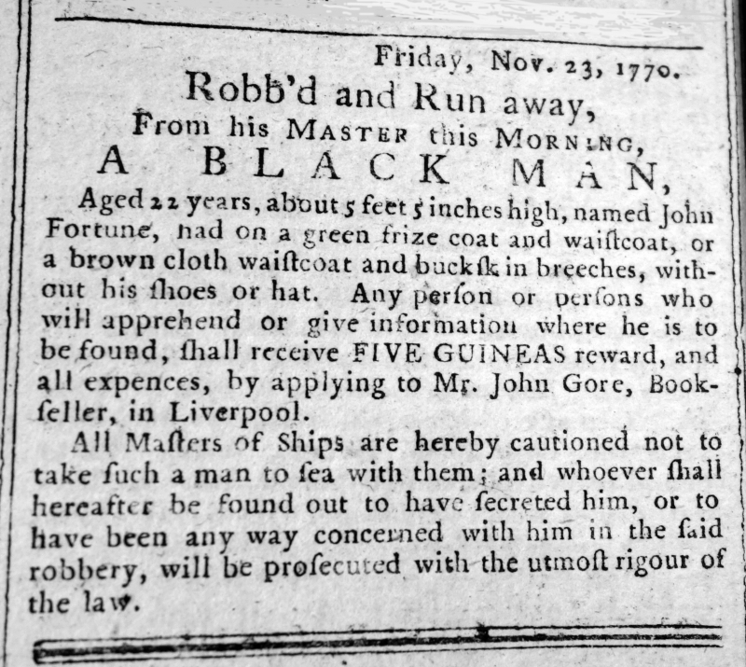
Liverpool General Advertiser, or the Commercial Register, 31 May 1771
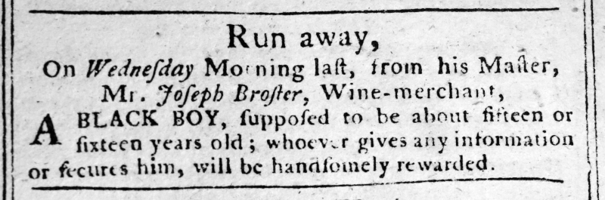

Liverpool General Advertiser, or the Commercial Register, 15 May 1772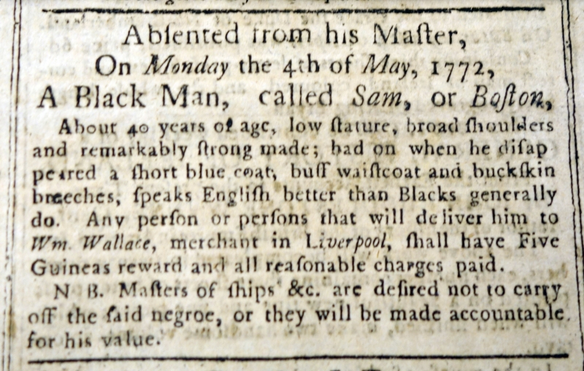
Liverpool General Advertiser, or the Commercial Register, 2 October 1772
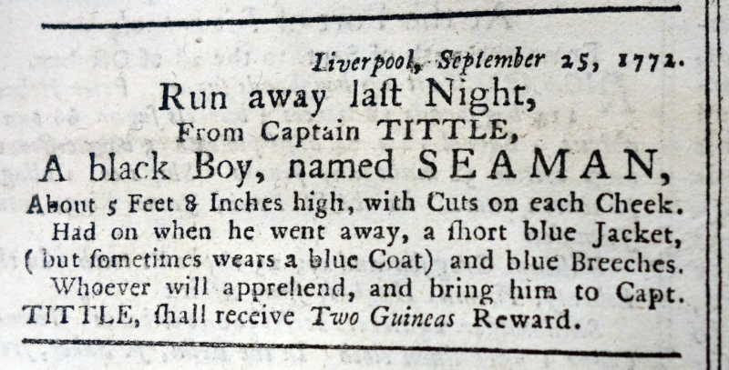

Liverpool General Advertiser, or the Commercial Register, 31 July 1778


