Random number generation applied in Turtle

The following demo shows how we can integrate our existing Turtle knowledge with our new knowledge of how to generate random numbers.

1. Let's draw a standard circle, 30 radius, with Turtle:

import turtle
myTurt = turtle.Turtle() # create turtle
myTurt.circle(30)
turtle.done() # keeps screen open

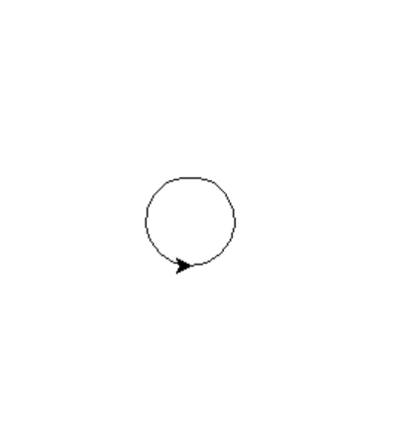

2. Let's make the width of the circle random, between 10 and 100. We will generate the random number and then feed it in to the circle:

import random
import turtle
myTurt = turtle.Turtle() # create turtle
width = random.randint (10,100)
myTurt.circle(width)
turtle.done() # keeps screen open

Sample output:
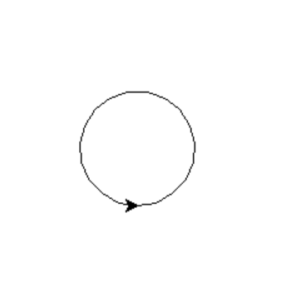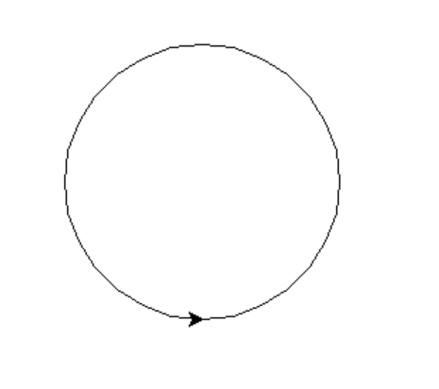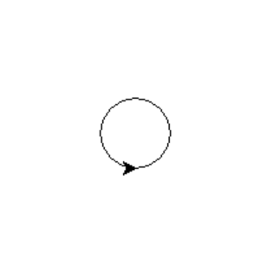

3. We could also change the start point for the circle randomly, generating co-ordinates within a 500 x 500 square:

import random
import turtle
myTurt = turtle.Turtle() # create turtle
width = random.randint(10,100)
x = random.randint(-250, 250)
y = random.randint(-250, 250)
myTurt.penup()
myTurt.goto(x, y)
myTurt.pendown()
myTurt.circle(width)

Sample output:
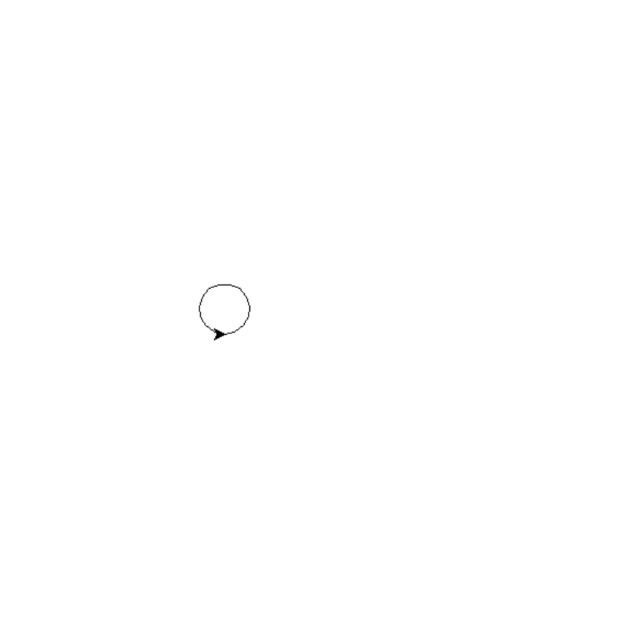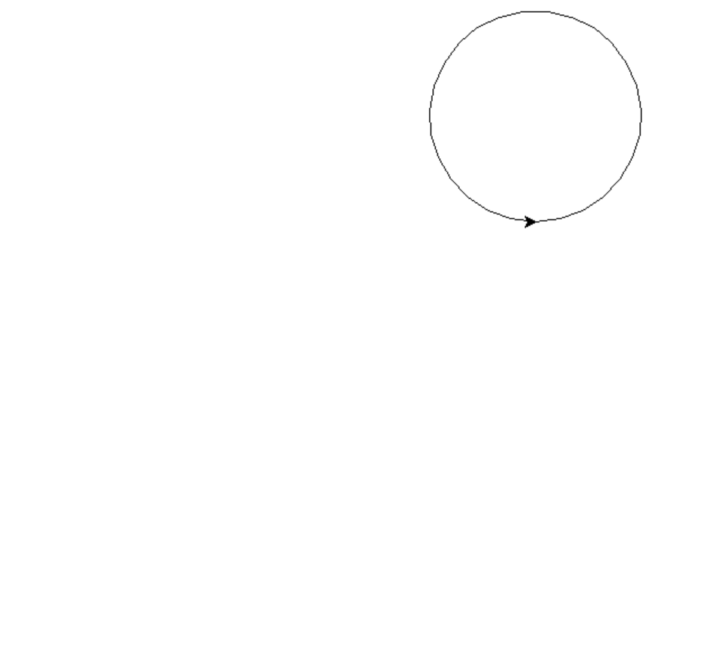
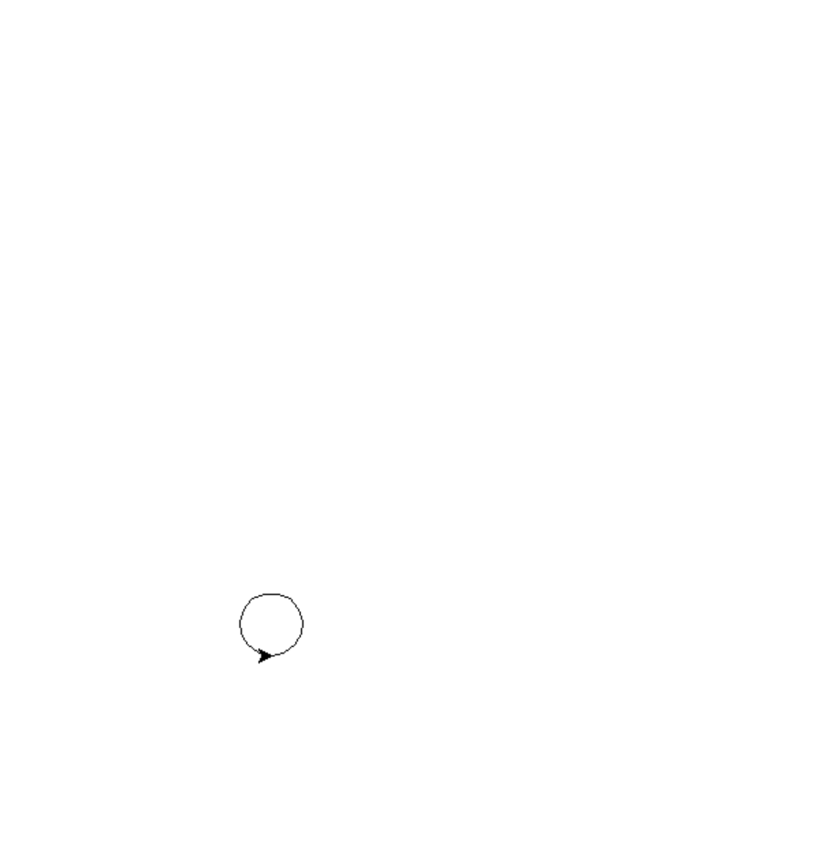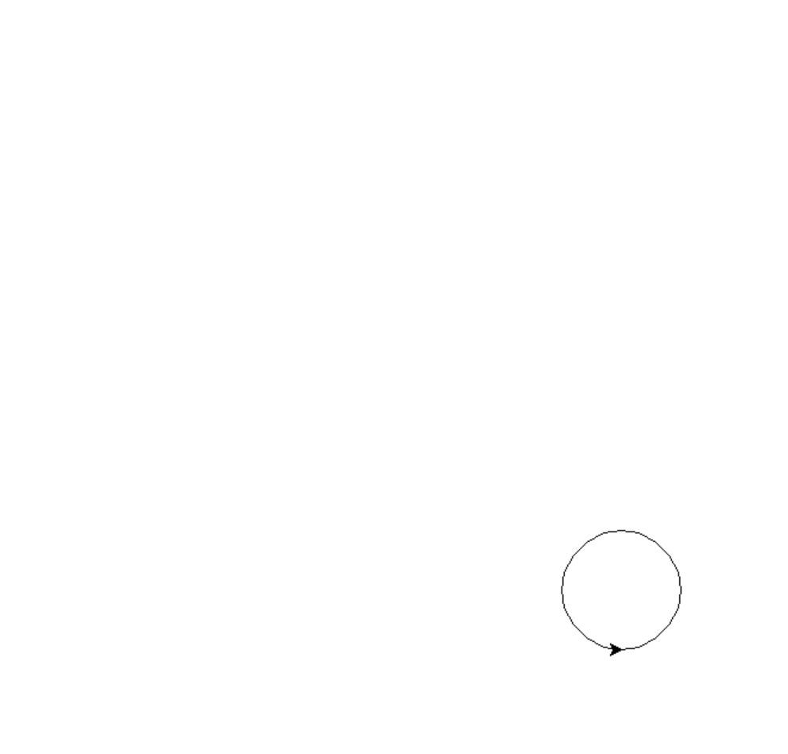

4. I could then loop my code so I get more than one circle (a randomized animation!):

import random
import turtle
myTurt = turtle.Turtle() # create turtle
for counter in range (1, 10, 1):
width = random.randint(10,100)
x = random.randint(-250, 250)
y = random.randint(-250, 250)
myTurt.penup()
myTurt.goto(x, y)
myTurt.pendown()
myTurt.circle(width)
turtle.done() # keeps screen open

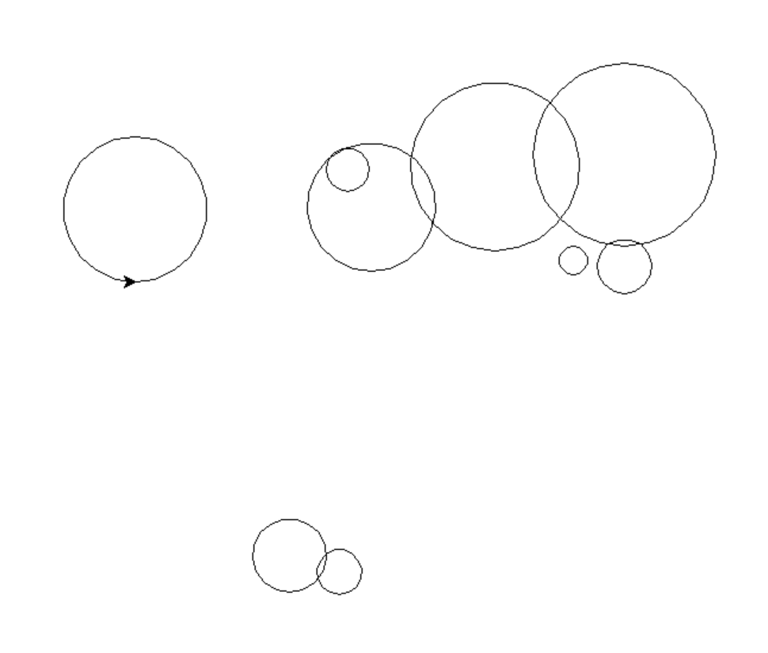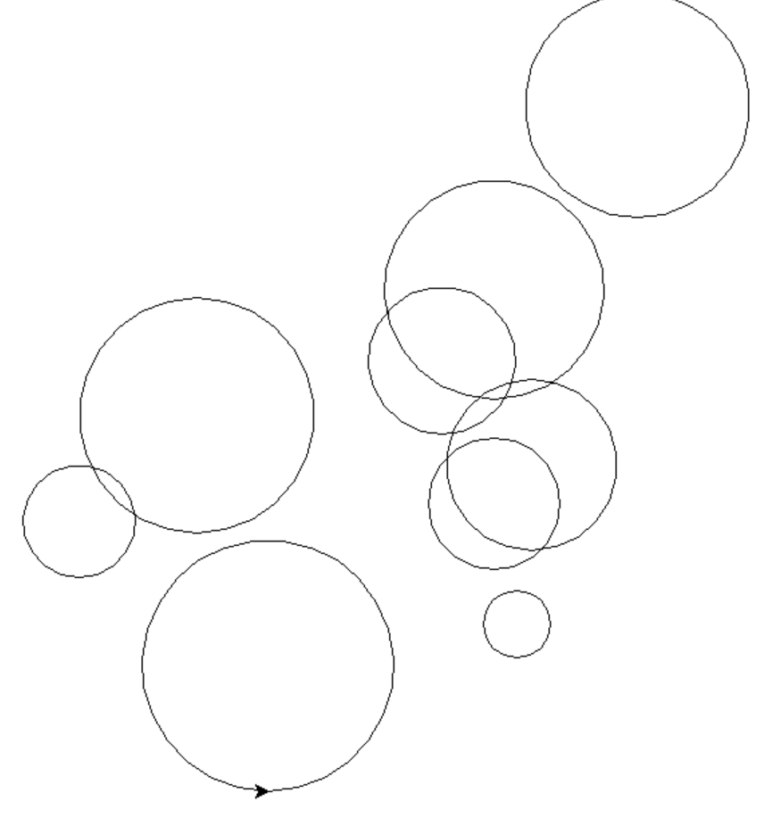

5. I'll keep going with the random theme and loop for a random number of times, rather than 10 as I did before….say between 5 and 100:

import random
import turtle
myTurt = turtle.Turtle() # create turtle
noOfCircles = random.randint(5,100)
for counter in range (0, noOfCircles):
width = random.randint(10,100)
x = random.randint(-250, 250)
y = random.randint(-250, 250)
myTurt.penup()
myTurt.goto(x, y)
myTurt.pendown()
myTurt.circle(width)
turtle.done() # keeps screen open

Sample output:

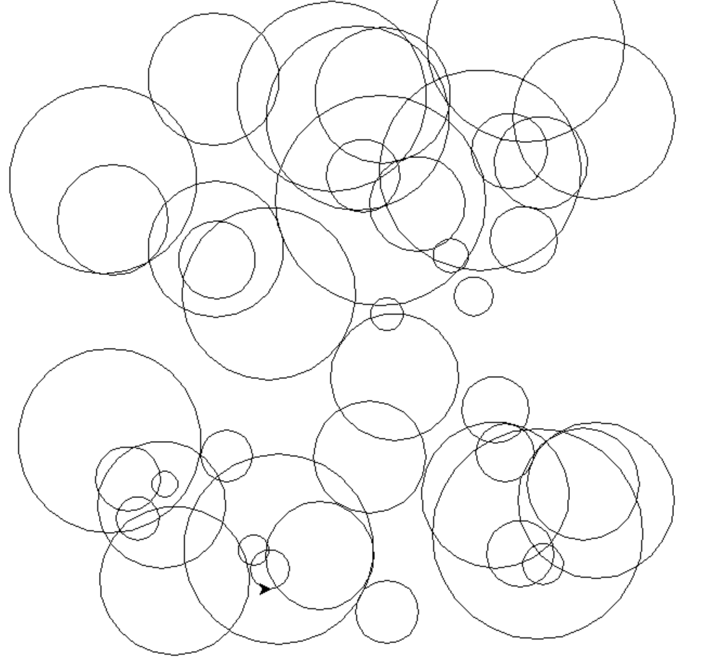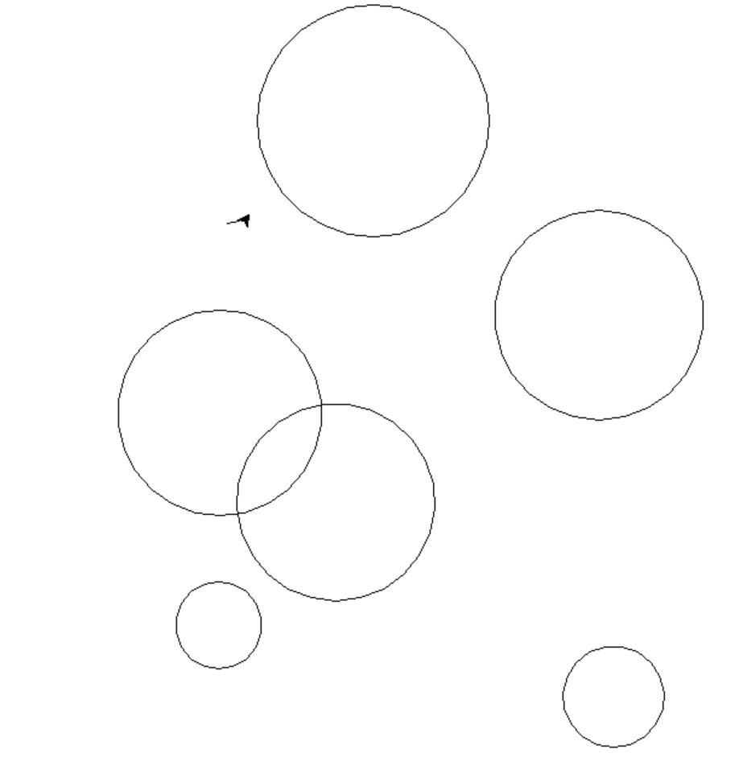

0…34 0…6
6. You start to be limited only by your own imagination

Here's another extension where the fill colours for the circle are randomised using a list to help:

import random # imports the turtle command functions from library
import turtle
myTurt = turtle.Turtle() # create turtle
noOfCircles = random.randint(5,100)
for counter in range (1, noOfCircles):
width = random.randint(10,100)
x = random.randint(-250, 250)
y = random.randint(-250, 250)
myTurt.penup()
myTurt.goto(x, y)
myTurt.pendown()
mycolours=["red", "blue", "green", "purple", "yellow"]
colourchoice = random.randint(0, 4)
myTurt.fillcolor(mycolours[colourchoice])
myTurt.begin_fill()
myTurt.circle(width)
myTurt.end_fill()
turtle.done() # keeps screen open



