Targed/Target 1 | You need to revise your understanding of the apostrophe as you make many errors that you can easily remedy.
Targed/Target 2 | Check your referencing technique as you should, for example, include page references with direct quotes.
Targed/Target 3 | Proof read your work and use educational texts to model a more academic style of writing.

ECAD4008-C Cycle 1: Leading the Learning: What, How and Why Am I Teaching?

Pedagogic Principles (Donaldson, 2015;68)
- Good teaching and learning means employing a blend of approaches including direct teaching.
- Good teaching and learning sets tasks and selects resources that build on previous knowledge and experience.
- Good teaching and learning ranges within and across Areas of Learning and Experience.

Consider the 3 pedagogic principles outlined above.
Discuss these principles in relation to your experience in school showing secure understanding, identifying strengths and areas for development for each principle.

Donaldson’s (2015) Successful Futures review includes twelve pedagogical principles that detail the interdependency between the curriculums pedagogy and four purposes. The pedagogy outlines the needs and stages of developing children and effective methods for teaching and learning. This explanation is fundamental to the curriculums effectiveness as good teaching is vital to pupils’ learning (Donaldson, 2015). Therefore, the teacher’s understanding of the pedagogical principles will influence their delivery of Donaldson’s (2015) purposes. The Professional standards for Teaching and Leadership (2019) also state that pedagogy is paramount to teaching and learning and explain that the best learning outcomes are achieved when the teacher progressively refines their teaching, advances learning and influences learners. The elements underlying in these three components of pedagogy are indirectly referred to within the three pedagogical principles, I will be discussing in relation to my experience in school, which are (Donaldson, 2015, pp. 65-68):
- Good teaching and learning means employing a blend of approaches including direct teaching.
- Good teaching and learning sets tasks and selects resources that build on previous knowledge and experience and engage interest.
- Good teaching and learning ranges within and across Areas of Learning and experience.
Play has been described as paramount to childhood education by Froebel (cited in Bruce, 2011), who initiated the idea that play is important to children’s development and learning. Hence, the emphasises of play being the driving force for development and learning in the foundation phase philosophy (FPP) (Department of education and Skills, 2015). This element of play is also evident in the Reggio Emelia approach, where there is an emphasis on a play based approach for 3-7 year olds, due to evidence that indicated excessive amounts of formal teaching and learning can result in lower attainment (Taylor et al, 2015). These theorists are just some of those who influenced the FPF pedagogy (Department for Children, Education, Lifelong Learning and Skills, 2008).
There is a continuation of the Area’s of learning in Successful Futures due to teachers expressing that the separation of subjects as it created barriers to pupils’ cross-curricular learning (Estyn, 2017). However, they are now called Areas of Learning and Experience (AoLEs). The addition of ‘experience’ is to emphasise the importance of it in stimulating and making learning enjoyable (Donaldson, 2015). This has been implemented across all ages in education to allow for continuation of learning as pupils develop. This was decided as many schools have already continued the Foundation phase philosophy and pedagogy onto ages 7-11 due to it engaging the pupils more than when implementing the subject-based curriculum (Estyn, 2017).

The first of the pedagogical principles above, “Good teaching and learning means employing a blend of approaches including direct teaching” (Donaldson, 2015, pp. 65), indicates that teaching and learning should include a wide range of experiences to implement the curriculums purposes. Donaldson (2015) explains that direct teaching should be used by the teacher, in conjunction with constructivist and discovery learning, to ‘scaffold’ pupils learning in the new curriculum.
The third of the pedagogical principles above, “Good teaching and learning ranges within and across Areas of Learning and Experience” (Donaldson, 2015, pp.68), can be achieved alongside the first, as it infers that the teacher should make use of a blend of approaches, in order to support pupils in making meaningful connections in their learning of the AoLEs.
It is important these two principles are thought of in partnership as the Department for Children, Education, Lifelong Learning and Skills (2008) and Barnes (2015) explained how neuroscience identified that connections between cells are achieved through multisensory experiences and repeated use. However, if these different cells lack use, the information is disposed of. The Department for Children, Education, Lifelong learning and Skills (2008) also explains that learning styles have a large role in a pupil’s capacity to remember information, thus, employing a blend of approaches is vital as it allows pupils to access the information in the style that is suitable for them. Therefore, if there is a lack in approaches of teaching, the learning style may not suit the pupil, meaning they may lack the ability to activate prior knowledge or take in new information. Thus, meaningful connections in their learning of the AoLEs will be much harder to make.
My placement school employ teaching that will suit all learning styles to ensure connections can be made within pupils learning by using lesson triads. This allows for a blend of approaches to be used as the pupils rotate every twenty minutes to another station for learning; teacher activity, learning support assistant activity and ‘Amser Dysgu’. This allows them to learn the lesson focus through different experiences, thus, encouraging them to apply what they have learnt in different contexts, such as in the digital corner, the designated continuous provision areas in the classroom or outside when being on the station of ‘Amser Dysgu’. Most lessons work on a twenty-minute rotation for each activity. The pedagogical principles of Successful Futures outlined in this section could be implemented through enhanced and continuous provision as its use in the FPF been applauded by Estyn (2017). It applies to these principles as it allows for the knowledge pupils have learnt and stored to be used, so it does not be disposed of, as neuroscience suggests, and allows them to make connections using the knowledge learnt in different experiences.
During my placement experience, I believe I implemented the first and third pedagogy as I successfully planned, delivered and assessed many lesson triads. For example, I delivered a lesson which involved both the Mathematics and Numeracy AoLE and Humanities AoLE. The lesson included a teacher focus activity, where the pupils’ experienced Hattie’s description of direct teaching as the weighing of rubbish, that we had collected on a beach clean the previous week, was carried out (See Appendix A). Barnes (2015) explains that the pedagogy of cross-curricular learning can be implemented through creativity with visits, visitors and drama, for example. Although, the beach clean was carried out a week previous to this lesson, it was the element of creativity as it engaged the pupils with the topic of recycling and rubbish. During the lesson, the rubbish from the beach clean was discussed and sorted into categories of materials and then weighed. There was discussion about why it might have been on the beach, how it would be harmful to sea life, what type of material it is and how much it weighed. Evidently, there were many cross-curricular themes in this discussion. However, the cross-curricular pedagogy continued throughout all activities and was done so with a blend of approaches. For example, I employed the Reggio Emeilia approach as well as Vygotsky’s and Frobel’s approaches.
The Reggio approach was implemented through my use of groups and environment as a third teacher (Cadwell, 1997) in the continuous provision. This is because the pupils were in small groups which is frequently used in Reggio schools and it allowed the pupils to consolidate their learning by role playing which category a certain object was in in the recycling centre (Estyn 2017).
The role play was an implementation of Vygotsky’s approach to learning approach as it gave opportunity for the ZPD to be implemented. Vygotsky believed that when children participate in pretend play, it gives them opportunity to operate in the ZPD as they are able to practice the appropriate behaviour for that activity (Crowley, 2017). Thus, by learning the correct way to recycle in this activity, they are working towards one of Donaldson’s (2015, pp. 30) four purposes, in that they are learning how to become “Ethically, informed citizens who: show their commitment to the sustainability of the planet”.
Froebel believed that modelling and playing with shapes, such as, spheres, cubes and cylinders was key to learning, thus, this approach was implemented in the enhanced provision activity, as the pupils were given a model of the ‘recycling rabbit’ they were to produce (Department for Children, Education, Lifelong Learning and Skills, 2008). The pupils had to look at and feel the different shapes of recycled materials to choose what would be best together.
I believe this lesson was successful in implementing the first and third pedagogical principle as I successfully implemented cross-curricular themes of the Science and Technology and Mathematics and Numeracy AoLE through Barnes (2015) suggested technique of creativity, as there was a visit to the beach and drama carried out in the role play area. There was also consideration of neuroscience as the enhanced and continuous provision was implemented. Barnes (2015) also details that neuroscience indicates approaches that are integrated and meaningful are important to learning as they engage pupils. The beach clean and discussion of how rubbish harms sea life in the teacher activity allowed the pupils to understand the effects that incorrectly disposing of rubbish can have. This lesson was also successful in suiting most learning types as there was opportunity for visual learning was made during completion of the chart showing how much material weighed. Additionally, kinaesthetic learning took place when the pupils completed a ‘recycling rabbit’ as they needed to be physical with their hands and auditory learning took place in the role play area where the pupils would need to discuss options. All three of these learning types have been describes as the main ways children are able to process information (Department for Children, Education, Lifelong learning and Skills, 2008). I am certain that the techniques I used were effective in implementing these principles as the assessment for learning (AFL) strategy I used demonstrated this as all pupils were able to show understanding of what they learnt on the independent activities. I assessed the pupils learning at the different activity stations through ‘ticket to leave’ questioning which is a particularly effective formative assessment Education Services Australia, N.D).
Although my lesson appropriately implemented both pedagogical principles, there are aspects that could be developed in order to fully implement these principles. Per neuroscience’s suggestion, the pupils’ information was recapped with use of the lesson triad. However, the U.S Department of Education (2007) suggest that spacing learning of knowledge over time is more effective than visiting it short space of time. Therefore, my approach to delivering the two AoLEs may have been better taught and learnt had I completed the focus activity first and then implemented another related activity towards the end of my placement. As my placement was only four weeks, I could have made use of the ‘Flipped Learning’ approach the school uses which involves the pupils completing a task independently at home, before covering the activity in an interactive environment with the class teacher present (FLN, 2014). For example, the focus activity for the weighing plan could have taken place at the beginning of my placement along with the use of the continuous provision. The pupils could then have watched a video at home explaining the effects that inappropriately disposing of rubbish can have and how much rubbish is found in the sea annually.

The Flipped Learning approach to my teaching would also have effectively implemented the second pedagogy, “Good teaching and learning sets tasks and selects resources that build on previous knowledge and experience and engage interest” (Donaldson, 2015, pp. 67), as it ensures that knowledge is being built on through different activities. Bruner introduced the ‘spiral-curriculum’ which involves a topic being re-introduced with more complexity, once pupil’s skills have developed (Department for Children, Education, Lifelong Learning and Skills, 2008). Thus, using Flipped Learning could have been used as a ‘spiral-curriculum’ which would have allowed me to effectively implement all three pedagogical principles.
The second pedagogical principle highlights the democratic aspect of Successful Futures, much alike to the FPF in that they offer a child-centred curriculum as they note the importance the child’s interests (Taylor et al, 2015). Dewey’s philosophy is that for a curriculum to be democratic it must have an element of freedom for the pupils’ that allow for links to be made between experiences from the past and the future and that they must show the growth of each pupil (Hopkins, 2014).
There is clear links between this pedagogical principle and the Te Whariki (Ministry of Education, 2017) curriculum as they both place emphasis on engaging pupils in experience, by seeking pupils’ interests, to make teaching and learning relevant to each pupil and their needs. Donaldson (2015) stresses that the as part of this principle, the progression steps in Successful Futures will help employ teaching and learning that allows the pupils to develop from one skill to the next, but allow for freedom in doing so. This characteristic of freedom in the progressions steps is vital to be able to implement this pedagogy as they allow the teacher to plan lessons in accordance to the pupils’ needs (Donaldson, 2015).
My placement school demonstrated this as they very clearly link pupils work to the progression steps, which was always available for the pupils to see. For example, hey used ‘skills slips’ (See Appendix B) which demonstrates to the pupils which of the four purposes form Successful Futures they were working towards and which skills they were going to use to do so. This was made evident as the relevant progression steps were used as the lesson objectives and stuck at the top of every pupil’s workbook. I implemented this principle by also using the skills slips in many of my lessons, such as to accompany the weighing lesson plan discussed earlier (See Appendix B).
My placement school also sought to plan and deliver lessons that engaged pupils’ interests as a part of implementing this principle; identity days and voting for themes were some of the ways in which the teachers decided upon mid-term plans. I decided to plan and deliver a lesson based on discussing mine and the classes interests in order to follow through with implementing this principle during my time there. The lesson (See Appendix C) created meaningful links between the Health and Wellbeing AoLE and the Languages, Literacy and Communication AoLE as it involved discussion of our interests, their similarities and differences and why they should be respected. Hopkins (2014) explains that the sharing of the curriculum aims is fundamental to a democratic curriculum, thus, the skills slip allows for the democratic element of Successful Futures pedagogy to be implemented as the pupils can see what they need to do next in order to progress. Brough (2012, cited in Hopkins, 2014) would approve of my approach to a democratic curriculum, stating that it must involve the teacher and pupils’ co-constructing the curriculum, which this lesson enabled me to do.
The skills slip implemented both AFL and Bruner’s theory about teaching and learning. Bruner identified that learning occurs when the teacher ‘scaffolds’ the pupil’s learning to ensure they make progress, much like the ZPD. To do this, they must be aware of what the pupil knows and needs to learn (Department for Children, Education, Lifelong Learning and Skills, 2008). Sadler (1998) explains that effective AFL tailored feedback for pupil’s that is comprehended by the student both orally and written. During my placement, I implemented AFL within this principle by differentiating the tasks set so that my lesson was matched the pupils’ needs, as advised by Donaldson’s (2015) description of the principle. The progression steps are colour coded on the skills slip to match the differentiated activity. I would then describe which each activity would involve the pupils were able to make the choice themselves. The AFL techniques used in the school assisted the pupils in choosing an activity appropriate for their ability. For example, each pupil marks their work, along with the teacher, discussing whether they think they have met the progression steps and comprising some feedback comments. They are then able to refer to this when choosing which level to do the following lesson and explain why they chose what they did. This AFL strategy also helps the teacher to show what they have learnt over a time, as requested by Donaldson (2015) and to know what skills need to be learnt in future lessons, thus, implementing Bruner’s theory.

My perspective on the FPF and Successful futures is one of positivity. The FPF has many effective elements such as the AoLs which allow for a holistic education, which Froebel would support, as many links can be created between topics (Department for Children, Education, Lifelong Learning and Skills, 2008), thus, meaning the third pedagogy is being implemented to an extent already. Due to the emphasis on exploration and child-led activity, the use of indoor outdoor environments are now having more consideration of the effect they can have on learning. Learning zones have been adopted in many classes (Taylor et al, 2015), similarly to in my placement school and are consequently already beginning to implement the first pedagogy due to the blend of approaches. The FPF also places importance on providing children with equal opportunities and celebrating diversity (Maynard et al, 2013). However, studies have found that outcomes between pupils based on their gender, ethnicity or eligibility for free school meals have worsened (Taylor et al, 2015). Thus, I believe this is something that needs to be addressed in the new curriculum as Article 29 (UNICEF, 1990, pp.2) states that “education must develop every child’s personality, talents and abilities”. The FPF has also been criticised as although it encourages developmentally appropriate practice, it still includes use of national statutory assessments. I believe there is good reason to use standardised tests as they allow for the pupil to know what they need to learn next and help the teacher to provide the correct level of support (Hattie and Brown, 2012).
I think the range in which child-led teaching and learning has been widened in Successful Futures by the encouragement of experience, which will encourage the first principle of having a blend of teaching and learning approaches. The second principle discussed earlier, which encourages planning to be greatly determined by the pupils’ will also help with this. However, a challenge to implementing this pedagogy is highlighted by Brough (2012, cited in Hopkins, 2014), as they detail how it can be problematic due to teachers viewing teacher-pupil shared planning as a loss of control. However, I think this will be successful from, firstly, reflecting on my experience in my placement school where this principle was implemented and secondly, reviewing the Te Whariki curriculum. Their curriculum emphasises the ‘Kaiako’; a partnership between the teacher and child and home, for example (Ministry of Education, 2017). Pedagogy has been described by the as enabling parents, carers and society

From researching and reflecting on my use of the principles outlined above, I have begun to upstand the importance of pedagogy in teaching. I will continue to work on implementing the pedagogy to improving teaching and learning as studies show, schools with greater use of pedagogies achieve better outcomes in the foundation phase (Taylor et al, 2015). The links between what we teach, how we teach it, and why we teach it are influenced by pedagogy. The Scottish Government (2005) explain that pedagogy also enables parents, carers and society to understand this also, thus, I will continue too research and reflect on the principles to ensure my practice is effective. An approach I will use to implement the principles and continue to improve my effectiveness in doing so is ‘reflective dialogue’. Joyce (1991, cited in Department of Education and Skills, 2002) detailed that this approach involves discussion with someone knowledgeable in order to discover innovative ideas and is effective in improving pedagogical effectiveness. A school has implemented an approach similar to this which has proved effective and involves teachers sharing their subject knowledge and excellent practice (Estyn, N.D).

Appendix

- Weight lesson plan (Lloyd, 2020)

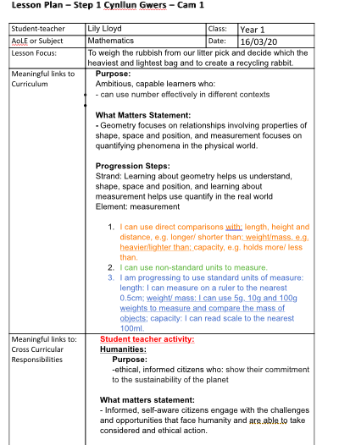

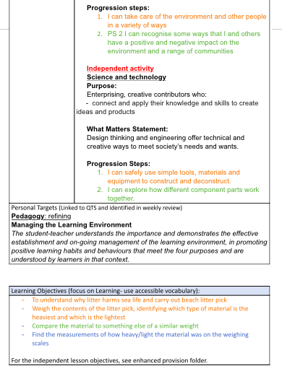

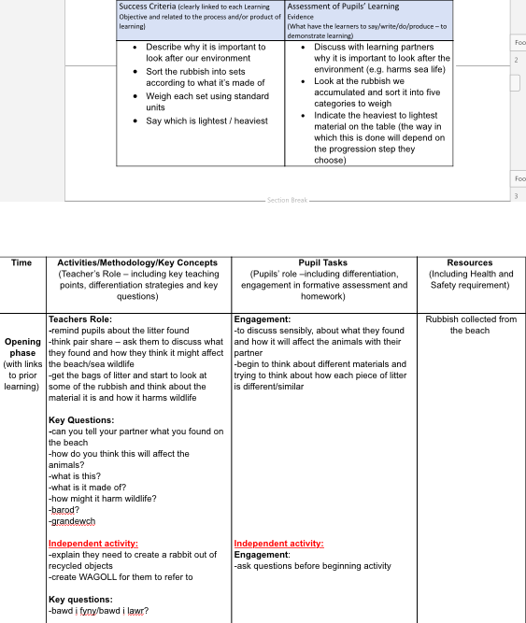

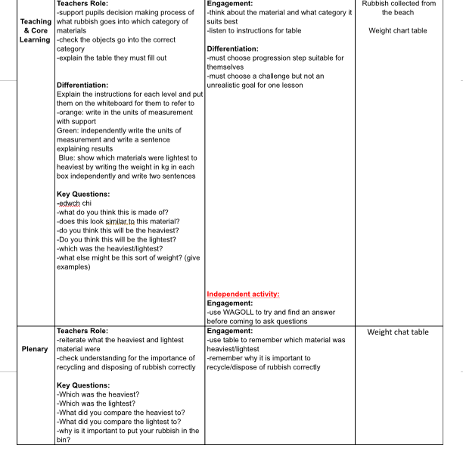

B) Weight lesson skills slip (Lloyd, 2020).
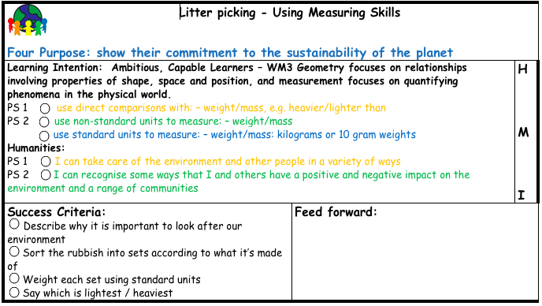

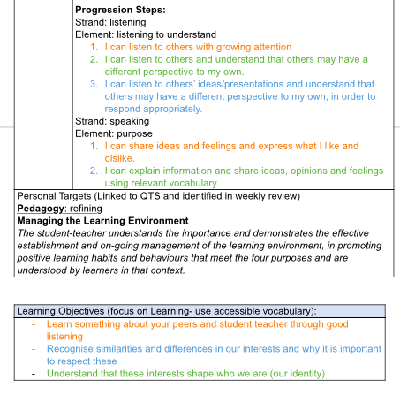
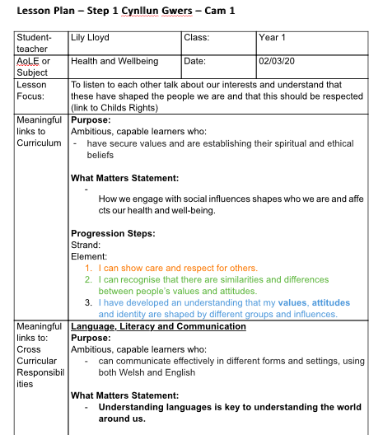
C) Interests lesson plan (Lloyd, 2020)

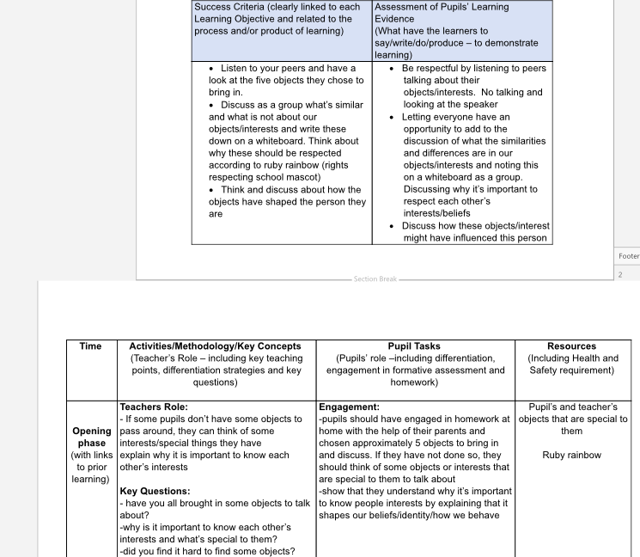

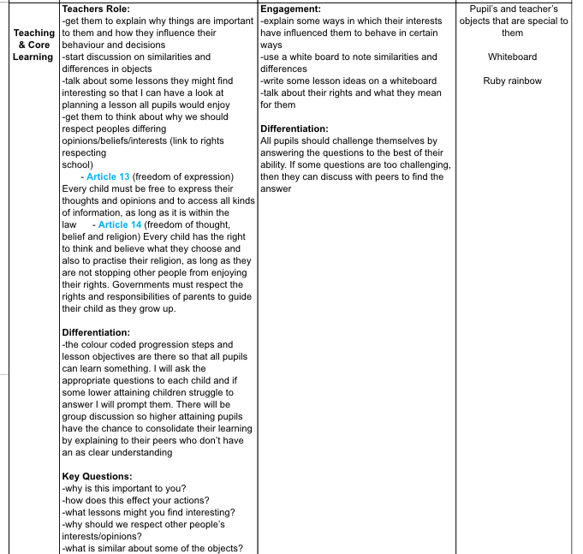

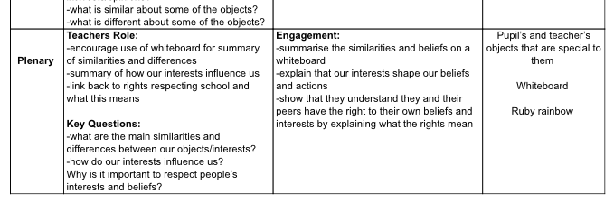

References

Boyd Cadwell, L. (1997) Bringing Reggio Emelia Home. New York: Teachers College Press.

Bruce, T. (2011) Learning Through play: For Babies, Children and Young People 2nd edition. London: Copyright Licensing Agency Limited.

Crowley, K. (2017) Child Development: a practical introduction. London: SAGE Publications Inc.

Department for Children, Education, Lifelong Learning and Skills. (2008). Learning and Teaching Pedagogy. Available at: https://hwb.gov.wales/storage/8f0b360f-f1f6-4bec-b11a-df88168007f9/learning-and-teaching-pedagogy.pdf (Accessed: 15 March 2020).

Department for Education and Skills (2002) Study of Pedagogical effectiveness in Early Learning. Available at: https://dera.ioe.ac.uk/4591/1/RR363.pdf?e=5305098/62475902 (Accessed: 27 march 2020).
Department for Education and Skills. (2015) Curriculum for Wales. Available at: https://hwb.gov.wales/storage/d5d8e39c-b534-40cb-a3f5-7e2e126d8077/foundation-phase-framework.pdf (Accessed: 1 march 2020).

Dolya, G. (2010) Vygotsky in Action in The Early Years. Oxon: Routledge.
Donaldson, G. (2015) Successful Futures. Available at: https://gov.wales/sites/default/files/publications/2018-03/successful-futures.pdf (Accessed: 18 February 2020). pp. 30-68.

Education Services Australia. (No Date) Professional learning. Available at: https://www.assessmentforlearning.edu.au/professional_learning/intro_to_afl/introduction_key_questions.html (Accessed 25 March 2020).

Estyn. (2017) Active and Experiential Learning: Effective Foundation Phase practice in delivering literacy and numeracy in year1 and year 2. Available at: https://www.estyn.gov.wales/sites/www.estyn.gov.wales/files/documents/Estyn%20Active%20and%20experiential%20learning_E_Accessible_1.pdf (Accessed: 20 March 2020).

Estyn. (No Date) Trusting Staff to Lead on Improving Pedagogy and Effective Practice. Available at: https://www.estyn.gov.wales/effective-practice/trusting-staff-lead-improving-pedagogy-and-practice (Accessed: 27 March 2020).
Flipped Learning Network. (2014) The Four Pillars Of F-L-I-P. Available at: https://flippedlearning.org/wp-content/uploads/2016/07/FLIP_handout_FNL_Web.pdf (Accessed: 24 march 2020).

Hattie, J and Brown, G (2012) The benefits of regular standardized assessment in childhood education: Guiding improved instruction and learning. Available at: https://www.researchgate.net/publication/233871126_The_benefits_of_regular_standardized_assessment_in_childhood_education_Guiding_improved_instruction_and_learning/citation/download (Accessed: 26 March 2020).
Hattie, J. (2009) Visible Learning: A Synthesis of Over 800 Meta-Analyses Relating to Achievement. Oxon: Routledge.

Hopkins, N (2014) ‘The Democratic Curriculum’, Journal of Philosophy of Education, 48(3), pp. 416-427. (Accessed: 15 March 2020). Available at: https://onlinelibrary.wiley.com/doi/pdf/10.1111/1467-9752.12088

Lloyd, L. (2020) Interests Lesson Plan. Available at: https://uowtsd-my.sharepoint.com/:w:/r/personal/1909965_student_uwtsd_ac_uk/_layouts/15/Doc.aspx?sourcedoc=%7B2255F44D-2B42-486F-85A1-C1467AA23191%7D&file=Interests%20and%20Rights%20Respecting%20Lesson.docx&action=default&mobileredirect=true (Accessed 23: March 2020).

Lloyd, L. (2020) Math’s weighing Plan. Available at: https://uowtsd-my.sharepoint.com/:w:/r/personal/1909965_student_uwtsd_ac_uk/_layouts/15/Doc.aspx?sourcedoc=%7BDF0AA965-C0F9-4936-B0BB-65B5E9495BE8%7D&file=Maths%20Weighing%20Plan.docx&action=default&mobileredirect=true (Accessed: 20 March 2020).

Lloyd, L. (2020) Weight Lesson Skills Slip. Available at: https://uowtsd-my.sharepoint.com/:w:/r/personal/1909965_student_uwtsd_ac_uk/_layouts/15/Doc.aspx?sourcedoc=%7B5DC40073-E51F-4196-8CCA-B291E270C7C4%7D&file=Skills%20slip%20Weighing.docx&action=default&mobileredirect=true (Accessed: 20 March 2020).

Maynard, T., Taylor, C., Waldron, S., Rhys, M., Smith, R., Power, S and Clement, J. (2013) ‘Evaluating the foundation Phase: Policy logic Model and programme Theory’, Welsh Government Social Research, 37(20). (Accessed: 15 March 2020). Available at: https://dera.ioe.ac.uk/18414/20/130318-evaluating-foundation-phase-policy-logic-model-programme-theory-en_Redacted.pdf (Accessed: 15 March 2020).

Ministry of Education (2017) Te Whariki: Early Childhood Curriculum. Available at: https://education.govt.nz/assets/Documents/Early-Childhood/ELS-Te-Whariki-Early-Childhood-Curriculum-ENG-Web.pdf (Accessed: 23 March 2020).

Pound, L. (2009) How Children Learn 3: Contemporary Thinking and Theorists. London: MA Education Ltd.

Professional Development. (2019) Professional Standards for Teaching and leadership. Available at: https://hwb.gov.wales/storage/19bc948b-8a3f-41e0-944a-7bf2cadf7d18/professional-standards-for-teaching-and-leadership-interactive-pdf-for-pc.pdf (Accessed 18 February 2020).

Sadler, Royce, D. (1998) ‘Formative Assessment: Revisiting the Territory’, Assessment in Education, 5(1), pp.77-84. (Accessed: 25 March 2020). Available at: https://search-proquest-com.ezproxy.uwtsd.ac.uk/docview/204050705/fulltextPDF/2CAD51F1EE9D4B86PQ/1?accountid=130472

Scottish Government. (2005) Let’s Talk about Pedagogy: Towards a shared understanding for early years education in Scotland. Available at: https://education.gov.scot/improvement/Documents/talkpedagogy.pdf (Accessed: 26 March 2020).
Smidt, S. (2009) Introducing Vygotsky: A Guide for Practitioners and Students In Early Years Education. London: Routledge.

Taylor, C., Rhys, M., Waldron, S., Davies, R., Power, S., Maynard, T., Moore, L., Blackaby, D and Plewis, I. (2015) Evaluating the Foundation Phase: Final Report. Available at: https://orca.cf.ac.uk/88753/1/150514-foundation-phase-final-en.pdf (Accessed: 20 February 2020).

Twomey Fosnot, C. (2005) Constructivism: Theory, Perspectives and Practice. New York: Teachers College Press.

U.S Department of Education. (2007) Organising Instruction and Study to Improve Student Learning. Available at: https://files.eric.ed.gov/fulltext/ED498555.pdf (Accessed: 23 March 2020).

UNICEF. (1990) The United Convention on the Rights of the Child. Available at: https://downloads.unicef.org.uk/wp-content/uploads/2016/08/unicef-convention-rights-child-uncrc.pdf?_ga=2.36598626.377267403.1576252467-618471270.1576252467 (accessed: 18 February 2020). pp.2.

