AHAC5008 Paleoenvironmental Archaeology Assessment One Course Work:
Paleoenvironmental archaeology is multi-disciplinary in nature. Illustrate your answer with reference to two contrasting urban archaeological sites.

Paleoenvironmental archaeology is the study of the people who inhabited the past and their impact and relationship with the environment they inhabited. “Environmental archaeology is the study of the past environment of man.” (Evans, J.G. 1978 Elek Books Ltd: preface page.) Paleoenvironmental archaeology is multi-disciplinary due to the large variety of archaeological specialists required by an individual site’s preserved material and artefacts. the number of different disciplines used by paleoenvironmental archaeology is going to have an even wider variety of specialists across different sites as well as the already extensive variety of specialists needed for a single archaeological site, due to multiple sites having a higher diversity of preserved materials and artefacts throughout them than a single site would have. This variation of specialists required by a site is also going to be affected by the wide range of different environments that paleoenvironmental archaeology takes place in. “Wetland investigations require a multidisciplinary approach or training in a number of fields not routinely studied or combined in university academic programs. (Mitsch and Gosslink 1993, 20)” (Lillie M. and Ellis S. 2007 Oxbow Books, Park End Place, Oxford edt Lillie M. and Ellis S. p.3)
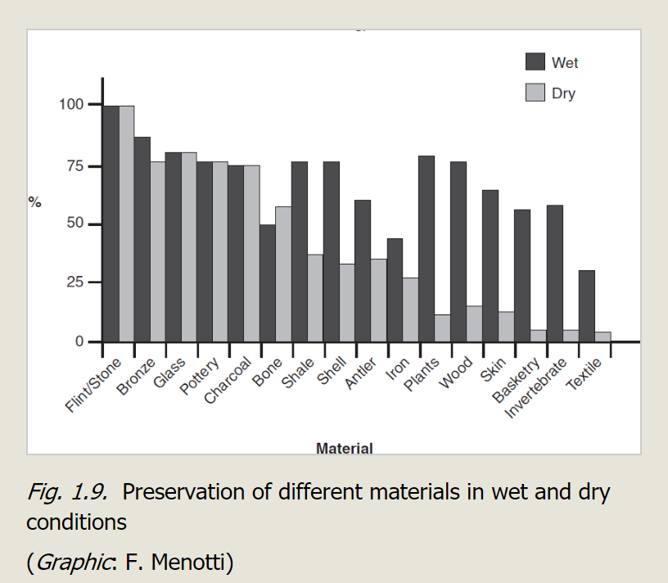
Depending on what environment an archaeological site is situated in, will preserve different types of material and artefacts with in the archaeological record to differing degrees affecting which different types of material will be available at the site and what will be taken as a sample. Depending on what material has been preserved and to what degree of preservation different materials have undergone will mean the types of samples taken from each site will vary greatly depending on where about on the globe the site is located. All of these differing factors will influence greatly who is hired and what type of specialist the site requires. For example, a wetland site is going to have some very well-preserved wood and pollen in the archaeological record where as a dry site, such as a desert, is going to be more likely to have bone preserved than a wetland site is. This is going to mean that on different sites there will be many different specialists all working with in the field of Paleoenvironmental archaeology despite being from different disciplines of study. The wetland site is more likely to have a taphonomy specialised archaeologist and dendroarchaeology specialist, along with other archaeobotanical specialists. Whereas the dry site is going to need more people who specialise in archaeozoology also a dry site is going to have some more well-preserved stone and will have more sediments and so, will quite possibly need archaeopedology specialists and archaeosedimentology specialists. These are all different disciplines with in paleoenvironmental archaeology making paleoenvironmental archaeology multi-disciplinary. The need for paleoenvironmental archaeology to be multi-disciplinary is clear when we look at a quote from John H. R. Gee and Paul S. Giller, “Representation of the local species composition of the local community will depend on: a) the probability of incorporation of corpses into sediments and the persistence of the remains in identifiable form, both of which vary with species identity and sedimentary conditions; b) the effects of disturbance on the reliability of the stratigraphy, and the extent of the input if allochthonous material (i.e. foreign to the site), both of which will vary between sites, time periods and community types.” (Gee, John H. R. and Giller, Paul S. 1989 Institute of Archaeology, University College London; edt Harris, David R. and Thomas, Kenneth D. p.1) This quote shows us that many different specialists will be needed in order to gather data from the sedimentary conditions, any corpses in the sediments and the reliability of the stratigraphy. alongside the many different disciplines within the archaeological disciplines of paleoenvironmental archaeology (Archaeobotany, Archaeozoology, dendroarchaeology, etc) the subject also requires the use of anthropological studies as well due to it’s study of human interaction with the environment. This multi-disciplinary view of paleoenvironmental archaeology is especially prevalent in urban archaeology as urban sites involve and require a diverse range of experts in areas such as materials, culture and environmental data, the fieldwork requires many of these different specialists to be present at the site and then again to do analysis of the samples taken from the urban sites in a laboratory. We can quite clearly see the multidisciplinary nature of paleoenvironmental archaeology through a quote from Malcom Lillie and Stephen Ellis, “The impacts of de-watering in relation to the archaeological and paleoenvironmental records and the global wetland ecosystem are increasingly intertwined, with management strategies now taking account of entire systems, as both natural and human activities impact upon them.” (Lillie M. and Ellis S. 2007 Oxbow Books, Park End Place, Oxford edt Lillie M. and Ellis S. p.3) This shows us quite clearly how many different disciplines with in the area of wetland archaeology all have differing points of view on certain practices as well as how management strategies for wetland areas are affecting the quality of the archaeology found at those sites, this will affect the amount of uncontaminated and well-preserved material and artefacts found at these particular sites. This will also have an affect on the types of specialists required for a sites excavation. For example, “Sampling is an attempt to represent reality with a few data points. It may be employed in the collection of finds for cultural analysis, environmental remains or laboratory study, or even existing records for the testing of dynamic trends.” (Branch N. Canti M. Clark P. Turney C. 2005 Oxford University Press Inc. p.41) This shows a distinct difference in the samples that can be taken from an archaeological site and a different specialist will be needed for each different type of sample taken, alongside one to analyse the sample in a laboratory.
One wetland site that shows how multidisciplinary paleoenvironmental archaeology is, is the Neolithic settlements of Sutz-Lattrigen, Lac de Bienne in Switzerland. this lake has many well-preserved wooden posts poking out from the lake floor. These wooden posts would require a dendroarchaeologist to have a look at them in order to determine what kind of wood it is as well as how old the wood is using dendrochronology dating. Not only this but any sediment taken from the lake floor would require archeosedimentologists and any bone found in the vicinity of the wooden posts would require an archaeozoologist, to determine what type of animal it was and whether it had been subject to human predation and butchery or just animal predation. There were also anthropologists who drew on current river towns and settlements in order to reach a conclusion as to what these posts meant, the conclusion they reached was of a stilted settlement that fished the lake and lived in stilted houses, however due to the large number of specialists involved and the sedimentology specialists along with archaeobotany specialists discovered that the lakes water level had risen and covered a previous settlement that had been there.
One of the best views on Paleoenvironmental Archaeology can be found in the writing Peter J. Fowler which he discusses at length in his book approaches to Archaeology. “The variety of the archaeological approaches to the past needs to be stressed at the outset.” (Fowler Peter J. 1977 A. &C. Black Limited p.13) Although Fowler is talking about Archaeology in general an awful lot of what he goes on to say and the list of different approaches or disciplines of archaeology he goes on to talk about can be put under the branch of paleoenvironmental archaeology as well. “the present diversity of the approaches to archaeology is suggested by a selection of some of the adjectives (or nouns used adjectively) in use today before the word ’archaeology’: prehistoric, Roman, Classical, medieval, post-medieval, historical, modern, current, contemporary; world, American, South Western, European, Near Eastern, Mediterranean, Old World; urban, rural, agrarian. Settlement, church, marine, nautical…” (Fowler Peter J. 1977 A. &C. Black Limited p.13-14) This quite clearly shows Fowler’s point of view on archaeology being multidisciplinary but we can also equate this to a branch of archaeology such as paleoenvironmental archaeology as many of the approaches Fowler listed are used in the study of paleoenvironmental archaeology. Fowler is writing forty years ago now and so his views may be slightly outdated however, many of these approaches that Fowler talks about (as he lists many more) go on to become disciplines of study with in their own right, not only this but since Fowler was writing forty years ago archaeology and the world at large has made great leaps forward in technology meaning that there are now even more disciplines that fall under the umbrella discipline of Archaeology which has many smaller subdisciplines such as paleoenvironmental archaeology which itself then has specialists working together and separate disciplinary practices.
Another site excavation that is a good showcase for the many different disciplines that come under paleoenvironmental archaeology is that of the Roman site found to be under the modern-day London known as Roman Londinium the site is not actually one site but many smaller sites such as the waterfront structures in Southwark which were made out of wood and would therefore require a dendroarchaeologist and could be dendrochronologically dated, another site would be site 1, which is a Roman Warehouse on the banks of the Thames, again this site would need a dendroarchaeologist to look at the wooden walls and struts that remained as well as to date them using dendrochronology, however being a storehouse this site would also have used pottery specialists and perhaps even anthropologists as well as historians in order to explain what the Romans were doing and what they may have kept in the site if there weren’t any remains of the stored materials. There are also many sewers throughout London and the Roman sites are no exception in these sewers there is going to be sediment and there will be material with in that sediment meaning that for the excavation of a Roman sewer in London the team would consist of many specialists. This is due to the fact that with in the sewers sediments we would expect to find: plant macrofossils and microfossils, insects, Ostracods, Molluscs, small vertebrates and potentially sponge spicules. Each of these is going to require a specialist from a different discipline with in the umbrella of archaeology, such as a archeaosedimentologist, an archeaozoologist and an archeaobotanist.
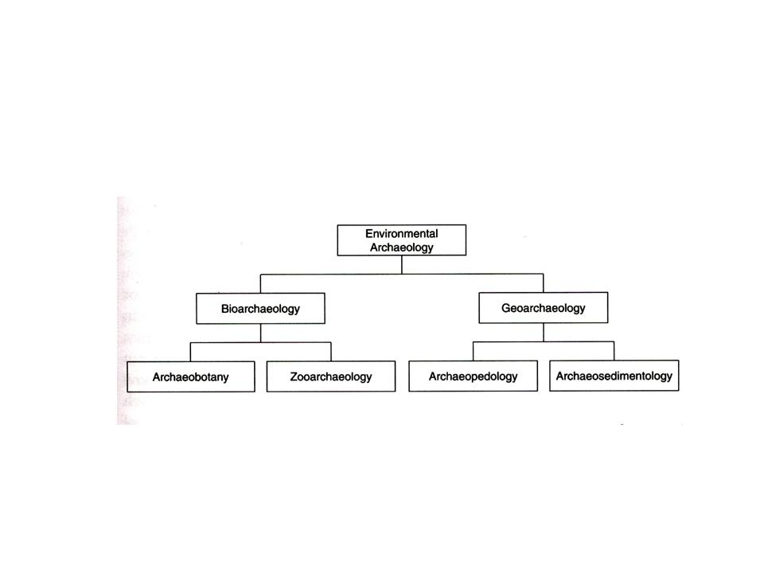
Paleoenvironmental Archaeology is a multi-disciplinary by its very nature as there is just so much that is needed to be done on any site and expecting one person to have all the knowledge of a botanist, zoologist and geologist needed to correctly identify everything that will appear in the site is more than a little extreme. Despite the fact that each of these disciplines are very different from one another, when they are out into an archaeological environment (e.g. archaeozoology as opposed to zoology) they are then argued to be merely approaches to archaeology. However, even if we were to treat them as approaches to archaeology and not independent disciplines in their own right Paleoenvironmental would still be multi-disciplinary in nature as it would still be comprised of bioarchaeology and geoarchaeology.

AHAC5008 Bibliography:

- Ashmore Wendy and Knapp A. Bernard 1999 Blackwell Publishers Ltd
- Branch N. Canti M. Clark P. Turney C. 2005 Oxford University Press Inc. Environmental Archaeology Theoretical and Practical Approaches
- Evans, John G.2003 Routledge: Environmental Archaeology and the Social Order
- Evans, John G. 1978 Elek Books Ltd: An introduction to environmental archaeology
- Fowler Peter J. 1977 A. &C. Black Limited: Approaches to Archaeology
- Greene Kevin, 1983 B.T. Batsford Ltd, London: Archaeology An Introduction, Third Edition fully revised
- Harris, David R. and Thomas, Kenneth D. published 1991 Institute of Archaeology University College London: Modelling Ecological Change Perspectives from Neoecology, Paleocology and Environmental Archaeology
- Johnson Matthew, 1999 Blackwell Publishing: Archaeological Theory An Introduction
- Knappett Carl 2005 University of Pennsylvania Press: Thinking through material Culture an interdisciplinary perspective.
- Lillie M. and Ellis S. 2007 Oxbow Books, Park End Place, Oxford edt Lillie M. and Ellis S. Wetland Archaeology and Environmennts

