An individual reflective response to the Professional Teaching Experience.

Throughout this essay, I will give an individual reflective response to the Professional Teaching Experience (PTE 1) of my first three weeks of placement, referring to a reflective method that best suits me and a range of others that have guided me through PTE 1. Reflective practice is “a process of thinking through professional issues problems or dilemmas, which do not have an obvious solution” (Welsh Government, 2015). Reflection is essential for improving skills that are associated with teaching as teaching needs to be flexible and suit all learners within the environment. Welsh Government (2015) supports this by saying that reflection is used to help improve the practice and respond positively when change occurs. The process of reflection is cyclical, meaning that, once you have reflected on the lesson, improvements will be implemented if necessary and then look at the outcome, if the changes made do not improve the lesson then the process must repeat itself. As a teacher it is vital that reflection is used as it helps the teacher develop their pedagogical method of teaching.
Reflection is a vital part of Bloom’s Taxonomy (Fig 1). The Evaluation category of Bloom’s Taxonomy is the level where teachers and students are “expected to bring in all they have learned to make informed and sound evaluations of material” (Kelly, 2017). This shows that Reflection or evaluation of an experience is vital in order to improve the experience.
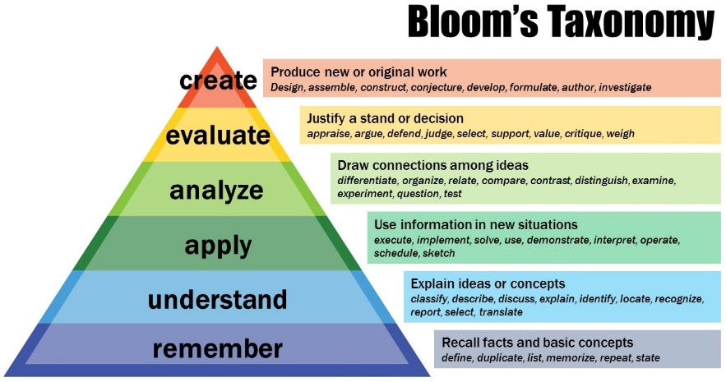

(Fig 1)
Another form of reflection that has impacted my teaching is the South West Wales Centre of Teacher Education (SWWCTE) website, allows the mentors to observe and comment on a variety of aspects of my practice. Reflecting on SWWCTE has impacted my teaching as it shows that my teaching has made an impact to the class. Therefore, reflection has been positive, and I will continue to use these methods. (Appendix 1).
Within my first week of PTE 1, it was important to individually find a reflection style that worked for me. I decided that the reflection styles that best suit me were observational notes on the children, tracking records of their progress and the Assisted Reflective Conclusions (ARC) Model, which will be completed after each lesson.
Throughout my PTE 1, I monitored and assessed the children as I believed that this would develop my teaching performance and the children’s learning and development. I became familiar with the Qualified Teaching Status (QTS) standard Section 3.2 – Monitoring and assessment. I could see following the observation and planning week that the children would assess their work through verbal feedback. Therefore, I focused on involving the learners in improving their own performance in the main activity and plenary. The QTS standard Section 3, standard 2.2 states that;
“They monitor and assess as they teach, giving immediate and constructive feedback to support learners as they progress. They involve learners in reflecting on, evaluating and improving their own performance”
(Welsh Government, 2009, p.9)
This gave me as a professional learner the chance to see from a first hand experience how the children would assess their own work and ways in which they could improve from immediate and constructive feedback. I focused on the way I would question the children during the activity to give immediate and constructive feedback. The questions asked were related to the lesson’s learning objective. I used the ARC Model to reflect on this teaching experience and with reflection I could see that by using the key questions from my lesson plan (Appendix 2), this proved to be a positive aspect of the experience. The children would reflect on their work, evaluate with support and improve. The reflection helped me immensely after the first lesson as I knew that the key questions used would benefit the children’s learning and development. Hall (2016) supports this as he believes that by questioning learners it will “scaffold the development of their understanding to enable them to close the gap between what they currently know and the learning goals”. With this activity, making sure that the children can improve their number formation further to what they already know. By concentrating on a number that they struggle to form. In addition, the reason why questioning was focused on was that it supports Vygotsky’s theory of the Zone of Proximal Development (ZPD). McLeod (2018) states that by “providing the appropriate assistant will give the student enough of a ‘boost’ to achieve the task”. I found that this was something I could include in my lesson with ease. I continued to use questioning as a method to give immediate and constructive feedback to the children throughout all my lessons during PTE 1. I believe that reflection using the ARC Model has helped to improve my teaching practice as it showed the areas of strength and areas of improvement.
During the reflection process of my teaching experience, it was important for me to base the reflection on my teaching practice. This is to ensure that the objective I set within my lesson plan was reached and if not, I would be able to make small changes to improve my practice. Hubball, Collins and Pratt (2005, p.60) states that reflection has a “positive effect on the improvement of teaching”. This means that reflecting on personal experience can only improve a person positively as it shows the best and weakest parts of an experience.
Furthermore, I became familiar with the QTS standard Section 3 – Teaching. The previous lesson influenced my decision to focus on this area of the QTS standards as I believed that it would benefit my teaching practice. By communicating with the class teacher, I was able to identify several children with Speech and Language difficulties (SpLD) and a child with English as an additional language (EAL). Therefore, I would be required to plan lessons that would support these learners to make good progress. The QTS standard Section 3, standard 1.2 states that;
“They use these teaching and learning objectives to plan lessons, and sequences of lessons, showing how they will assess learners’ knowledge, skills and understanding. They take account of and support learners’ varying needs so that all those they teach can make good progress”
(Welsh Government, 2009, p8)
By completing observations from the observation and planning week, I was able to watch and identify ways in which the children with SpLD and EAL would play with others, the type of language they used during play and how the other members of staff would plan and support them in their tasks. When planning lessons for children with SpLD and EAL it is important that all teachers think “about the pupils you will be teaching and constructing your own planning to meet their needs” (Conteh, 2015,p.74). This states that in order to plan for children with EAL and SpLD it is important to take the time to get to know the children in the class and their needs. I believe that by making observations on the children this gave me an advantage when planning and teaching lessons. I was able to identify the ways in which I believed was best to communicate with the children and what I could put in place for the children to make good progress. The task included group work which I believed was important for the children with SpLD and EAL as I found that when observing the children, they responded well by communicating with their peers and working in group situations. I used simple language and would repeat myself using a clear voice to make sure that the children could understand what I was asking them to do. Also, I used modelling to show the child with EAL what the task was and what they needed to do. Modelling supports Bandura’s social learning theory that children “imitate the behavior they have observed” (McLeod, 2016). This encourages my target in the lesson to help the children with SpLD and EAL to copy from the others by observing what they are doing. Also, I chose to include group work in my lesson as Cohen (1994) describes group work as “cooperative learning”. This suggests that by working in group situations it promotes the learning by allowing the children to help each other. C.I.R.T (no date) supports Cohen as they state that “Group work essentially creates an environment where students ‘teach’ and explain concepts to each other”. With reflection using the form of observational notes, I believe that this helped me improve my teaching practice as I could see the benefits of group work to the children with SpLD and EAL. However, I think that if I did not complete the observational notes beforehand then this could have resulted in a different outcome of the lesson, this is where reflection played an important part in my teaching practice as it showed that the observational notes were a positive aspect of improving my development as a teacher.
To conclude, I believe that reflection has a major role to play within the life of a teacher. Reflection helps the teacher improve their development, practice and improve the learning of the children in their class. Ferraro supports this by stating that “through reflective practice teachers can improve their effectiveness” (Ferraro, 2000, p.5). Also, by a teacher reflecting on their practice it will show the children that reflection is an important skill to develop. Donaldson 2015 states that part of the ‘wider skills in Wales’ children should be “monitoring and reflecting on results” which is becoming a major part of the new Welsh curriculum. This can be done by reflecting through methods using Blooms Taxonomy and the ARC Model. Throughout my PTE, reflection so far has helped me grow and improve my learning and practice by focusing on areas of improvement. Therefore, reflection will continue to play an important role in making me the best teacher I can be, by identifying ways in which I can improve my skills in providing the best quality of education.
Word Count excluding title and references – 1650.
Reference List
Center for Innovation in Research and Teaching (no date). Group Work in the Classroom. Available at: https://cirt.gcu.edu/teaching3/tips/groupwork (Accessed: 17th March 2019)
Cohen, E.G (1994). Restructuring the Classroom: Conditions for Productive Small Groups. Available at: https://journals.sagepub.com/doi/10.3102/00346543064001001 (Accessed: 17th March 2019)
Conteh. J (2015). The EAL Teaching Book. 2ndedn, London, SAGE Publications.
Donaldson. G (2015). Successful Futures. Available at: https://gweddill.gov.wales/docs/dcells/publications/150225-successful-futures-en.pdf (Accessed: 21st March 2019)
Ferraro, J.M. (2000). Reflective practice and professional development. ERIC Digest, No: ED449120
Hall. G (2016). The Importance of Questioning. Available at:
https://garyhall.org.uk/importance-of-questioning.html (Accessed: 16th March 2019)
Hubball. H, Collins. J and Pratt. D (2005). Enhancing Reflective Teaching Practices: Implications for Faculty Development Programs. Canadian Journal of Higher Education v35, n3.
Kelly. M (2017) Bloom’s Taxonomy – Evaluation Category. Available at: https://www.thoughtco.com/blooms-taxonomy-evaluation-category-8447 (Accessed: 17th March 2019)
McLeod, S. A (2016). Bandura – Social Learning Theory. Available at: https://www.simplypsychology.org/bandura.html (Accessed: 17th March 2019)
McLeod, S. A (2018). Zone of Proximal Development. Available at: https://www.simplypsychology.org/simplypsychology.org-ZPD.pdf (Accessed: 16th March 2019)
Welsh Government (2009). The Qualified Teacher Status Standards Wales 2009. Available at: https://gov.wales/legislation/subordinate/nonsi/educationwales/2009/3220099/?lang=en
(Accessed: 16th March 2019)
Welsh Government (2015). Reflective Practice. Available at: https://learning.gov.wales/docs/learningwales/publications/150611-reflective-practice-booklet-en.pdf (Accessed: 16th March 2019)

Appendix 1 – SWWCTE Formal Assessment report.
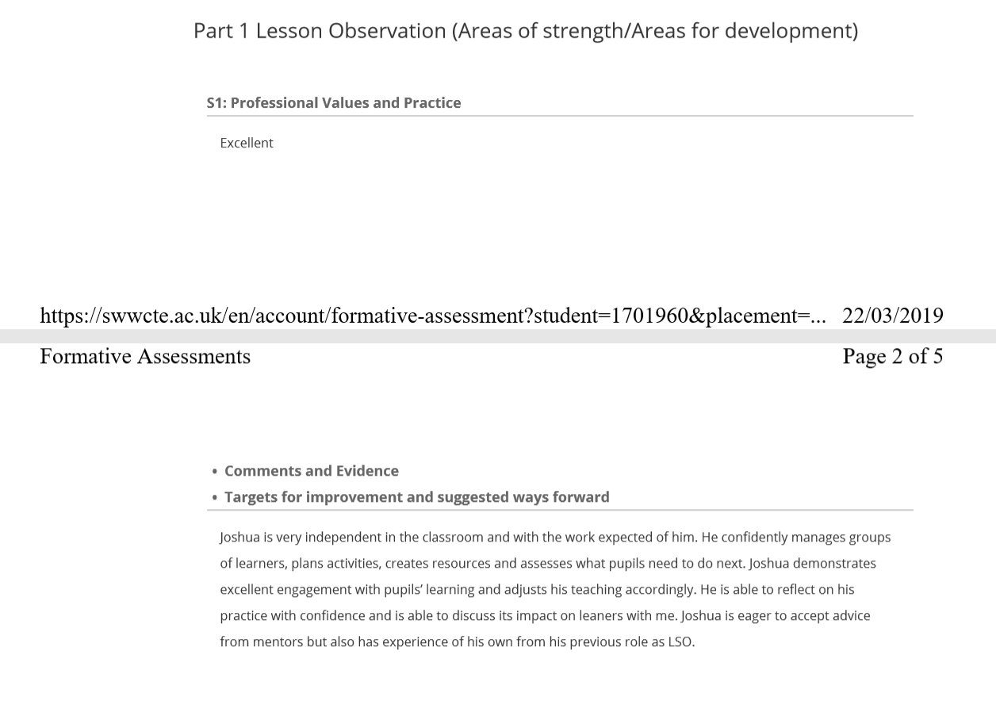

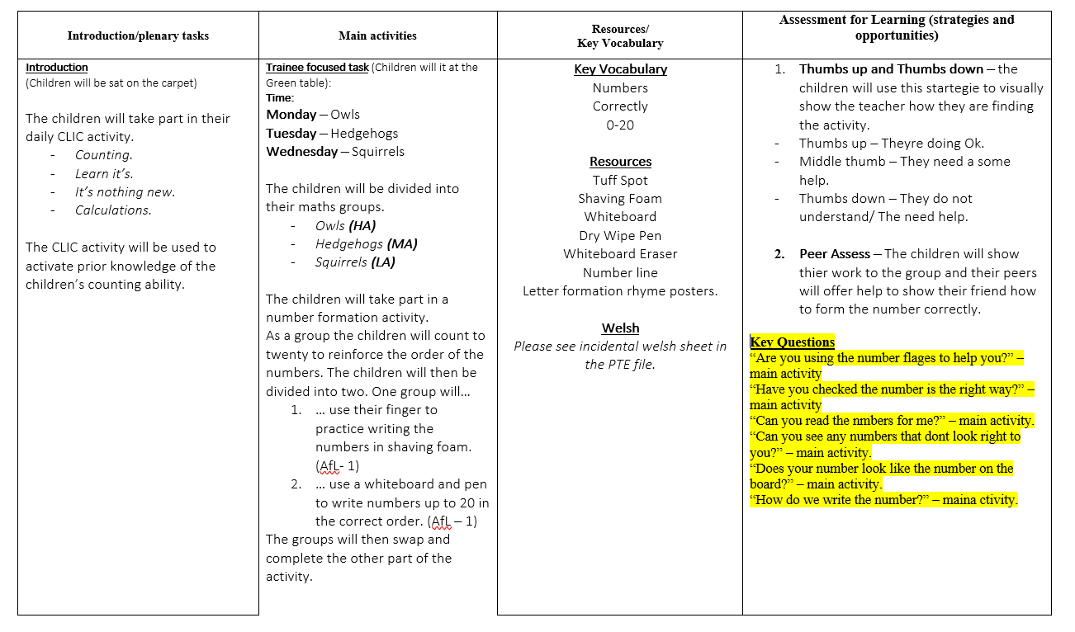
Appendix 2 – Lesson Plan showing Key Questions used to assess and monitor as I teach and give immediate and constructive feedback.

