ASSIGNMENT TITLE: History on Chickenpox
STUDENT NAME: Mariyum Munsha
STUDENT NUMBER: 2127038
MODULE NAME: Health and Social Care
MODULE CODE: LCHS4004_BIRM
LECTURER: Robert Ashford

Introduction
This report will be describing and explain what chicken pox is and how the approaches and strategies could be used to measure, monitor and control this infectious disease. Chicken pox is caused by the varicella-zoster virus it happens in 3 stages and how the disease is characterised by vesicular it is worldwide both endemic and epidemic. Chicken pox is usually a mild disease that most children will encounter at some point of their lives. Chicken pox is most common in children under the age of 10. In fact, chicken pox is so common in childhood that over 90%of adults are immune to the condition because they have had it before.

MEASURE
The strategies used in the UK to measure the acute disease is humans is by doing the most common used test. ELISA to determine if a person has antibodies to Varicella-zoster Virus (VZV) is done on blood samples. The most sensitive method for confirming a diagnosis of varicella is the use of polymerase chain reaction (PCR) to detect VZV in skin lesions vesicles, scabs, maculopapular lesions. Vesicular lesions or scabs, if present, are the best for sampling. Adequate collection of specimens from maculopapular lesions in vaccinated people can be challenging. Examples of varicella vaccine-adverse events for which PCR or VZV can be useful include varicella or a varicella-related complication in a vaccinated person 7 to 42 days after vaccination. In a vaccinated person, and suspected secondary vaccine-strain VZV transmission. Chickenpox used to be quite common in the United States. Each year, chickenpox caused about 4 million cases, about 10,600 hospitalizations and 100 to 150 deaths.
Your immune system is made of specialized white blood cells that search and destroy potential pathogens, but when the system is weak or lacking in resources, disease-causing microorganisms grow and spread virtually unchecked.

MONITOR
The strategies that are used in the UK to monitor chicken pox is an acute disease also known as varicella, caused by the varicella-zoster virus (VZV) it is highly contagious infection. It is viral illness it comes in stages before the rash begins, they may be fevering that last 3-5 days, loss of appetite, muscles or joint pain and a cough or runny nose you could end up being dehydrated. Then comes the following an itchy rash on the face, body and inside the mouth which can be very painful. It can spread or stay in small areas chicken pox symptoms can suddenly get worse so keeping an eye out will be idle. The rash will develop into fluid –filled blisters that will turn cloudy. The virus comes in the form of small spots, the spots become blisters and then the blisters become scabs. Chicken pox is one of the most infectious diseases transmissions happens through direct contact, sneezing, coughing or by air. The risk of contracting chicken pox and development of complications are extremely high with people with a weakened immune system. Doctors may prescribe medication or give him some advice on how you can reduce the itchiness and discomfort keeping your fingernails clean and short as possible. Drinking plenty of water to avoid dehydration taking pain relief for the pain, itching can become very severe it is important to avoid scratching to reduce the risk of scarring. There are several things that you can do at home to help relieve chickenpox symptoms and prevent skin infections. Calamine lotion and a cool bath with added baking soda, uncooked oatmeal, or colloidal oatmeal may help relieve some of the itching.
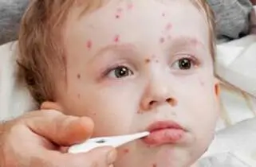

CONTROL
The strategies used in the UK to control the chicken pox are by not sending your child into nursery or until all their spots have crusted over. There is no cure for chicken pox, but a vaccine is available for VZV. The vaccine is 90% effective at preventing the disease for most people some people who are vaccinated can still get chickenpox. However, the symptoms are less mild. When you get vaccinated you protect yourself, community, family members especially particularly important for those who cannot get vaccinated due to weakened immune system, pregnancy. Children should receive the chickenpox vaccine as part of their regular vaccine The first dose should be received between 12 and 15 months of age. The second dose should be received between 4 and 6 years of age. Chicken pox by the age of 10 years is most common, in addition to vaccination, you can help prevent the spread of chickenpox by practicing good hygiene and washing your hands frequently. Reduce your exposure to people who have chickenpox. If you have the symptoms of chicken pox you are more likely to spread the virus. You will remain contagious until all your chickenpox blisters have dried out and scabbed over. This usually occurs after five to seven days and could take little longer, you should avoid close contact with anyone especially the Venerable low immune system, avoid sharing objects with them, isolate any household members of the family. Also use hand sanitisers and disinfect surfaces anything an infected person would have touched.

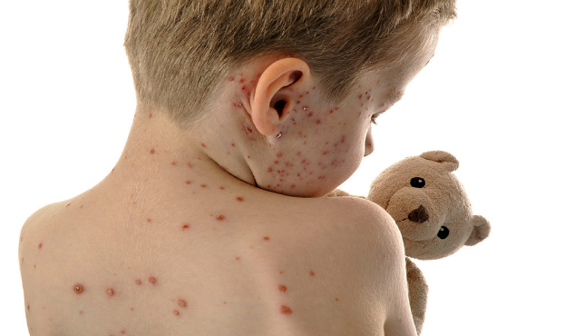

CONCLUSION
The study shows that chicken pox is an acute infectious disease caused by varicella-zoster virus (VZV). Most common in young children under the age of 10 and is very contagious, varicella is a primary infection with the (DNA) of herpesvirus.
It is characterised by a fever & pleomorphic rash in centripetal distribution, it causes many complications if it occurs in adults especially in pregnant women. It is an airborne disease which spreads easily through a cough and sneezes of an infected person. Chickenpox which is caused by the varicella-zoster virus, a type of herpes virus was considered just a normal part of growing up until the vaccine became available in 1995. Two doses of the vaccine are about 90% effective at preventing chickenpox. When you get vaccinated, you protect yourself and others in your community.

REFERENCES
Medical news today (2018) What you need to know about chicken pox Available at:Chickenpox: Symptoms, treatment, stages, and causes (medicalnewstoday.com) (Accessed 12 October)

Healthline (2018) How to prevent chickenpox Available at: Chickenpox Prevention: How to Avoid the Varicella-Zoster Virus (healthline.com) (Accessed 19 October)

CDC (2021) Centres for Diseases Control and Prevention Available at:Chickenpox (Varicella) Prevention and Treatment | CDC (Accessed 21 October)

Gov.UK (No date) Chickenpox public health management and guidance Available at:Chickenpox: public health management and guidance - GOV.UK (www.gov.uk) (Accessed 25 October)
NHS (2021) Chickenpox Available at:Chickenpox - NHS (www.nhs.uk) (Accessed 25 October)

