Manufacturing Design & Technology Assignment
ACMA5002
FESTO Cyber Physical Production System- Goods Dispatch Process Automation Development
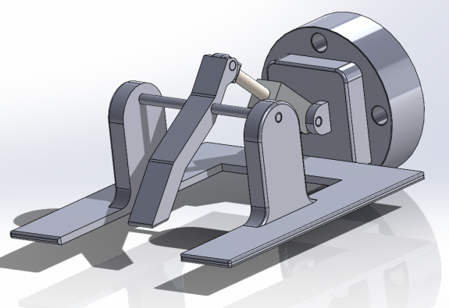

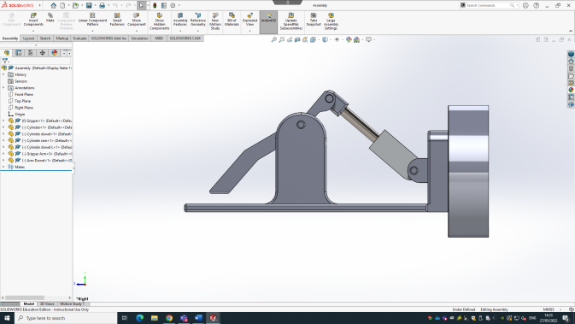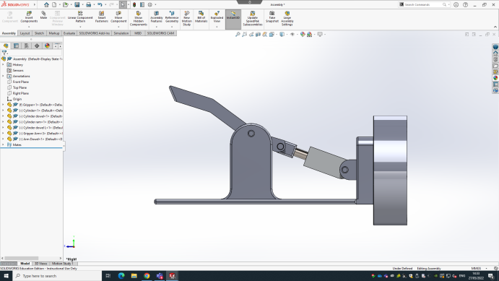
Morgan Baker 2111367

Table of Contents
Introduction 3
My Design 4
Materials & Manufacturing Processes 5
Materials 5
Manufacturing 6
Considerations 7
Locating 7
Confirmation 7
Pressure 8
Maintainability 9
Consumables 9
Greasing/Bushing 9
Planning 10
FMEA 11
References 13

Introduction
In this assignment will be a discussion on a designed gripper assembly to be used on a UR3 Cobot from Festo to be integrated within loading and an AVG robot with assemble mobile phone casings as an automated system. Automated guided vehicles are used to complete repeated transportation tasks which can save time and allow for employees to be based elsewhere in more efficient roles. The advantages of an automated system can be found in the 2006 survey by Iris F.A
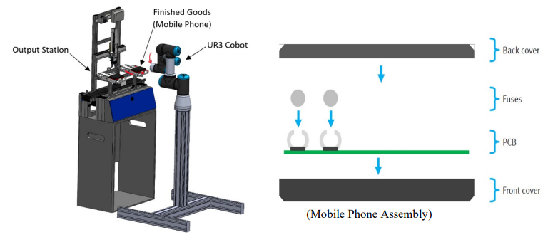
As you can see above the gripper system will be mounted onto the head or the final station of the Cobot which means it will be able to move in any direction and orientation, this design for the gripper itself should allow the system to precisely pick up, secure, transport and deliver each phone casing accurately and safely to the destination.
A mechanical gripper design must be used due to the nature of the production line and Cobot features, for example a suction cup design cannot reliably transfer the phone cases as the back cover (as seen above) is not fastened to the front cover securely enough to hold its own weight, therefore the gripper could drop the casing and caused damage to the products. Air can be used to actuate the gripper design also servos and motors is another possibility, however these designs will need regulating to not crush the casing.
The gripper must also be expected to withstand a sustained production environment and should be robust and capable of operating throughout said environment. It should perform faultlessly to safeguard the products coming off the assembly line, which will save time money for the components and people around to sort problems with loading and unloading.
In this report will be a discussion on considerations involving the reliability and operation of the gripper, discussing what materials and manufacturing processes will be involved, using planning tools such as FMEA’s to analyse possible failure outcomes. Finally, discussing the design’s limitations and if there is any possible improvements to be made.

My Design
The design in question is as seen below and features a gripper arm that is actuated via a pneumatic cylinder. The design is heavily influenced on how the phone cases are assembled and transferred to the output station where they are to be picked up and transferred with the Cobot.
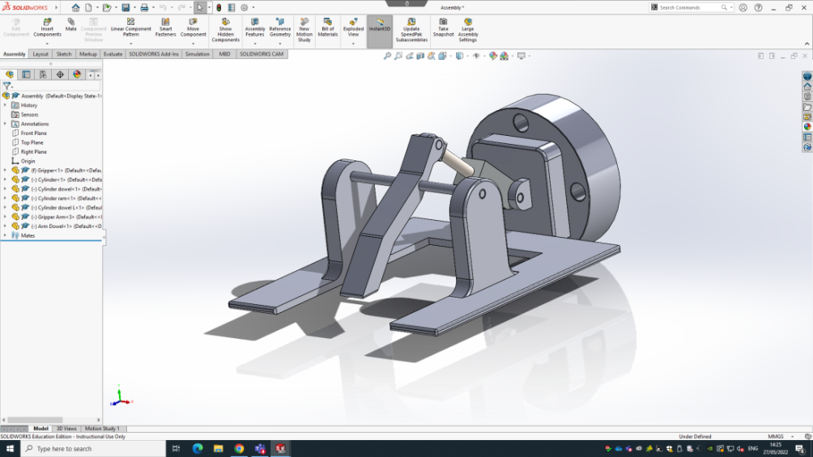
The two forks underneath will slide under the phone case and when fully in position the top gripper arm will gently come down to grip the case securely before lifting and manoeuvring to the AVG and releasing. The Cobot that the gripper system attaches to is programmable like all robot systems therefore it can be programmed to go to a series of exact locations within reach of the Cobot. This should ensure the system can pick up the casings accurately and precisely every time meaning this can be a fully automated system without human intervention or operation. As seen below is a side on view of the gripper arm open and closed, the gap between the bottom forks and arm will be where the phone case will be secured for transportation. Also seen is how the cylinder is retracted and then extended to lower the gripper arm. The angle of the cylinder will change during this action due to the nature of the operation meaning dowels are used in three locations. Rear of the cylinder, back of the gripper arm and middle of the arm to allow itself to pivot.

Materials & Manufacturing Processes

Materials
In total two different materials will be used in the construction of this gripper design. Aluminium will make up the majority of the components and structure of the gripper. Whereas steel will be used for the three dowels as previously mentioned.
The main reason for choosing aluminium for the majority of the design is because its light weight which has a number of advantages. Firstly it’s a cheap and easy material to work with and machine, machining aluminium is also a far quicker process than steel or brass as it’s quite a soft material meaning cutting speeds can be increase and a high quality finish can be obtained using coolant. Secondly the reduction in weight will put less stress on the Cobot’s bearing, motors and brakes as less momentum is generated during manoeuvres. Finally aluminium does not corrode like steel meaning it will retain a quality finish, no rust means it will be suitable for working environments such as a production line, and thus not need to be replaced due to changes of dimensions or lack of structural integrity caused by rust.
The only drawback to using aluminium is that the material itself is rather soft and can be damaged easily. For example in the unlikely event of a crash with the Cobot and the aluminium forks getting caught on the production line it is quite likely to shear, this means a new gripper will need to be made in replacement causing downtime for production and transportation of the phone casings. A steel structure would most likely be strong enough to withstand a crash and stop the Cobot from completing a cycle or arriving at next position. However long term issues like suggested above e.g. More wear and tear on the Cobot’s brakes and bearings etc. outweigh the cons for using aluminium as a crash should never occur if the Cobot is programmed correctly.
For the dowels it will be best to use steel as this material is hard wearing and again cheap is buy and quick to machine in small quantities such as the use of dowels. Steel can be bought in pre moulded forms designed specifically for dowels at varying diameters making it perfect for this design. Also as steel is hard wearing it will retain its diameter and concentricity for much longer than other materials such as aluminium, copper or brass.
The only drawback to using steel in this case is that it will start to wear the holes in the aluminium structure of the gripper well before the steel which will lead to inaccuracies in gripper the phone casings due to play in the arm. This will also be far more expensive and complex to remanufacture. However there are multiple methods of reducing this facto becoming a reality as stated in the ‘maintainability’ section of the report.

Finally the cylinder itself will be bought from Festo as they specialise in manufacturing high quality and reliable pneumatic cylinders in a wide variety of sizes and dimension. Of which all dimensions are available to be seen online which were used when designing the gripper.
Other comparable examples of choosing between these materials can be found in the 1988 book entailed Journal of Mechanical Working Technologies by D.V Wilson, where the two materials are compared through the use of them in the automotive industry.

Manufacturing
The design has been influenced with assembly and manufacturing in mind (DFA &DFM) in order to create the design from multiple components. Multiple machining processes will need to be used such as milling and turning and to help speed up the manufacturing process CNC machining will be used. The main advantage of using CNC machining processes is that it doesn’t require a trained employee or member of staff to operate the machine after given a drawing. Therefore, far less time is used to orientate the piece of material and continually removing the material to check dimensions. CNC will be used to manufacture the main structure or body of the gripper and the arm as it can ensure a high quality finish and very accurate dimensions compared to the CAD drawing. Using aluminium means larger cuts can be made when machining and allows for higher cutting speeds to be used, all of which reduces the amount of time on the machine and wear on the tooling. Less heat is generated when machining aluminium again saving wear on the tooling and reducing the amount of coolant needed to carry out manufacturing.
The dowels on the other hand can be bought in precise dimensions and will not require any machining such as turning in a lathe. However the lengths will need to be cut down, in order to fit the 3 positions. This can be performed in a lathe by being parted off then chamfered, or this can be done using hand tools such as a hacksaw and file.
One manufacturing process that requires a lathe and involves the dowels will be using a 1mm undercut tool to add a concentric indentation for a retaining clip for example a cir-clip or E-clip to hold the dowels in place. This will be a requirement on both ends of all three dowels. This again could use a CNC lathe however the time it will take to program this will negate the time it take to manually turn and create these undercuts as it doesn’t require the precision and high accuracy unlike the main body of the design.

Considerations
This section will highlight all the considerations to the design in order for it to be optimised therefore be a success and meet this criteria discussed in the introduction. The most important considerations to be made are the precise locating needed to pick up and deliver the phone cases to its destination. Secondly confirming the system has successfully picked up and gripped the case before moving as this can cause a number a number of issues. Finally the amount of pressure the cylinder applies to the casings.

Locating
It will be crucial the Cobot can orientate itself to precisely pick up the casing and release it onto the AGV. This will ensure the safe transfer of the casings and reliability needed for constant operation without human intervention or surveillance. Luckily the Cobot is programmable, this means a series of precise locations can be inputted to a programme that the robot will follow each cycle. Positions can be attained by inputting values for 3 axis X, Y & Z, and save to a programme in order of operation to allow for areas to avoid and areas to go to before reaching for phone cases.

Confirmation
Confirming that the system can successfully grip the phone case before moving is essential to ensure a safe transportation of the product. Multiple issues can arise if this isn’t considered. For example the case could be dropped mid transfer, or damage could arise to the gripper tool itself causing significant down time to the system. An unsuccessful grip will also make delivering the phone case problematic as it will need to be in a precise location for it to be delivered onto the AGV or risk causing damage to the casing or worse damaging the AVG itself.
There are a number of methods for confirming a successful grip onto the casing. Firstly, using a pressure switch for the compressed air feeding the pneumatic cylinder. This will allow the Cobot to sense whether the arm has a secure grip on the phone case. However this can accurately sense the precise position or location of the phone case relative to the gripper which again could cause problems locating it onto the AGV. A better method will be using a sensor to see whether the case is in the precise location before and after the gripper arm clamps down to support the case. This will need to be a capacitive sensor due to the phone case being made from plastic as a proximity senor can only see steel and other ferrous materials. This system will allow the gripper to detect that the phone case is ready to be gripped and reassure itself that the casing hasn’t moved after the arm has clamped down to support the case.

Pressure
The air pressure will need to be considered as it will be actuating the cylinder for the gripper arm to clamp down onto the phone casing. This means it will need to be high enough to securely grip the casings but not too high that it will damage the products. A method of controlling this is to use a regulator value on the air line prior to the cylinder to control exactly what air pressure is used in the system. Most common air pressure for machinery is 6-8 bar or around 100psi, this is why too high for this operation meaning a regulator will be needed to reduce the pressure down to 1-2 bar or 15-30psi. Tests will need to be conducted to see what pressure is perfect for this operation. Another method could be using flow restrictors either on the cylinder or on the air lines running to the cylinder to control and restrict the flow rate of the air to operate the cylinder. This will mainly reduce the speed of the arm clamping onto the product as well as slightly reducing the pressure of the system. Again tests will need to be conducted to find the best balance of the speed and the pressure to ensure the safe and reliable transport of the phone cases.

Maintainability
Maintainability is an important factor to consider for any factory or product line equipment such as the Cobot and gripper tool. Monthly checks for damage and other safety related checks should be carried out on the system to ensure its reliability and safe operation. This can be done in multiple ways and can influence the design of the tool in the first place. Maintenance is important to optimising and making sure working systems remain safe to use. Highlighted in the report ‘An approach to maintenance optimization where safety issues are important’ by Jørn Vatn in 2008.

Consumables
Firstly consumables are often used to reduce the costs for maintaining equipment as instead of replacing expensive components over longer periods of time, they allow you to replace cheap components that have a shorter life span; consumables such as filters, bushes abrasion pads. In this case it will be advisable to use rubber pads on all 3 contact areas of the gripper tool, these include the two bottom forks and on the gripper arm itself. This will ensure the phone case is gripped and secured in place during transportation and that the arms will not mark or damage the casings during the operation.
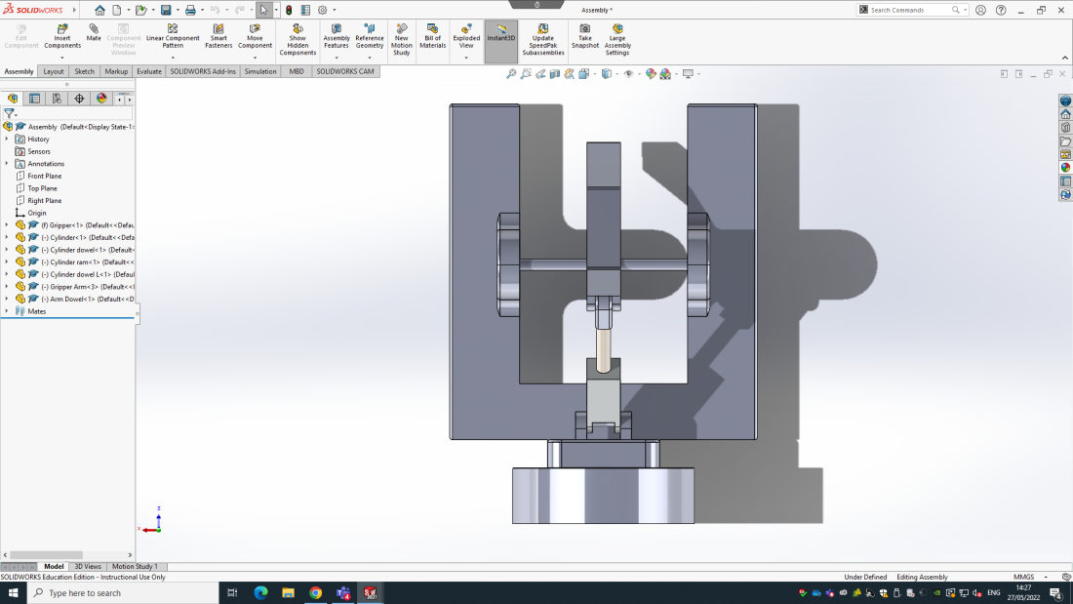
Grease nipples
Rubber pads

Greasing/Bushing
Also to ensure the longevity of the tooling it will be a good idea to use some form of grease to the moving parts such as the dowels that rotate inside the housing components like the main body and cylinder ram. This can be applied before assembly and lasts for months, meaning it can be arrange to be reapplied quarterly throughout the year during maintenance checks. This can be applied through dismantling the tooling or through using grease nipple incorporated into the design. This hasn’t been included in this CAD design but can easily been included through drilled and tapped holes in the locations seen above.

Another form of maintenance/the use of consumables can be using brass bushes instead of grease. This has the advantage of few maintenance checks needed as the bushes will be design to be changed on a yearly bases or when worn. This will be indicated by the amount of play in the dowels. As previously mentioned the steel dowels could wear through the aluminium of the body which will be expensive to replace and cause longer term down time for the production line. The use of brass bushes can reduce this as they will be far easier to and quicker to replace and prevent wear to the aluminium and long term wear to the dowels. The bushes can either be inserted into the holes of the body, or a top-hat design and pushed into place, either will perform well and as expected in this system.

Planning
For all the above considerations towards maintenance and the use of features such as regulators, sensors and programming the Cobot it is important these are considered before the design of the system is manufactured to save costs and time through redesigns and remanufacturing. There are tools that can be used in order to help prevent setback by highlighting areas to consider and adapt or improve. Planning a project such as this can be difficult which is why it is useful to gain an understanding on certain techniques that can be used, such as in the 2016 book Evaluation in the Planning Process: The Urban and Regional by N Lichfield, P Kettle, M Whitbread.

FMEA
Process Step | Potential Failure | Potential effects | Severity | Potential cause | Likelihood | Controls | Detection | RPN
Ordering components and materials | Ordering the incorrect components or sized materials | More money and time has be spent placing another order for correct components | 4 | Lack of research or poor knowledge of the components/materials | 3 | Research components and check specifications relevant to project design and function | 3 | 36
Collecting components and materials | Incorrect components delivered | Time will be wasted on spending component back and having them re send correct components | 5 | Supplier making a mistake | 1 | Research delivery company and check timings of delivery | 2 | 10
Connecting airlines | Air lines connecting in incorrect order | Cylinder may operate in completely the wrong order and cause a smash up or damage tooling/product. | 7 | Accidental mistake or misinterpreting air lines | 1 | Check air lines to make sure they’re connected properly and test tooling operations before the Cobot is in location. | 3 | 105
Loading or unloading product | Miss location of tooling from Cobot | Smash up for tool and damaged product | 9 | Locations not accurately defined in Cobot programming | 2 | Make sure time is taken to carefully create the programme and route to destinations are set accurately | 3 | 54

One planning tool that has been used to design and subsequently manufacture the gripper system is a failure mode affect analysis or FMEA. This tool will highlight areas where a failure could happen, why it can occur, what will be the consequences of the failure, what can be done to prevent such a failure, and score the different failures to determine which should be a priority for the design to focus their attention to.
As you can see the main area to focus on is making sure the air lines are connected properly and into the accurate ports. Otherwise the gripper will operate in the opposite way as intended and will cause a smash up of the tooling and or damage to the phone cases. As the gripper moves to pick up the product the gripper arm will be closed and will catch on the phone case damaging it and possible even damaging the arm itself which will be expensive to repair and will result in down time towards the product line as previously mentioned.
The other factors should still be taken into consideration like making sure the correct materials and components are ordered to prevent loss of time. And taking the time to ensure the programme for the Cobot is accurate to avoid a smash up or damaged product.
It is a very useful tool to use to maximise efficiency and prevent unforeseen costs or missing deadlines. A book written by D. H. Stamatis perfectly explains the conception, use and advantages of this management tool.

References
2006 Survey of research in the design and control of automated guided vehicle systems by Iris F.A https://www.sciencedirect.com/science/article/abs/pii/S0377221704006459

1988 book entailed Journal of Mechanical Working Technologies by D.V Wilson https://www.sciencedirect.com/science/article/abs/pii/0378380488900551

‘An approach to maintenance optimization where safety issues are important’ by Jørn Vatn in 2008. https://www.sciencedirect.com/science/article/abs/pii/S095183200900132X

2016 book Evaluation in the Planning Process: The Urban and Regional by N Lichfield, P Kettle, M Whitbread. https://books.google.co.uk/books?hl=en&lr=&id=rAFPDAAAQBAJ&oi=fnd&pg=PP1&dq=planning+process&ots=KXAE1DWVC9&sig=87rlcX8K-lK4sNF95H3Mc1ZMjcQ&redir_esc=y#v=onepage&q=planning%20process&f=false

D. H. Stamatis book Failure Mode and Effect Analysis 2003: FMEA from Theory to Execution https://books.google.co.uk/books?hl=en&lr=&id=TTxI8jbTkVwC&oi=fnd&pg=PT11&dq=failure+mode+and+effect+analysis&ots=OwtPVwH2fa&sig=qAktuHOXGEh_czTX54vYwGCz_to&redir_esc=y#v=onepage&q=failure%20mode%20and%20effect%20analysis&f=false

