Phils Muobike (1706873)

Research proposal 2019-2020
Investigation on food waste in the UK and the importance of food banks in Swansea

Table of Contents
1. Introduction 2
1.1 The food industry in the UK 2
1.2 Rationale 2
1.3 Literature review 2
1.4 Aims and objectives 3
2.Methodology 3
2.1 Philosophy 4
2.2 Sample 5
2.3 Approaches 5
2.4 Strategies 5
2.5 Ethical risks 6
2.6 Reliable and valid data 6
3.Resources and planning 6
3.1 Gantt chart 7
4.References 8

Table of Figures
Figure 1 the research Onion. Source: Saunders et, 2007) 4
Figure 2 Gantt chart 7

Introduction
This dissertation seeks to examine food waste and the importance of food banks in the UK. Food poverty will be also be mentioned in order to investigate and understand the importance of food banks and the reason behind food waste. Previous researches have been made to analyse if social media could be utilised to reduce food waste in the UK (Young, Russell, Robinson and Barkemeyer, 2017) and why people should choose between heating and eating (O’Connell and Hamilton, 2017).

The food industry in the UK
The food industry is a complicated sector where various businesses collectively supply the food consumed by the global population; farmers and hunters are exempted from this strategy utilised in the modern food industry (Traill and Grunert, 1997).

1.2 Rationale
There are various studies on food waste and the consequences that could have on the environment and the rise of food banks and how is helping the households in the UK to survive (Porpino, 2016). Although, there are few academic types of literature that analyse the factors which are affecting consumers to waste food and the main disadvantage of food banks which is food poverty (Caplan, 2016). This research proposal will investigate how citizens and companies in Swansea are trying to reduce food waste and how the use of food banks is vital for some people.

1.3 Literature review
Tonnes of food is wasted by the British food industry annually. In the meantime, millions of citizens in the UK are striving to afford food. Despite the introduction of “Love Food, Hate Waste” by the Government which is a programme where food waste reduction is targeted; the aim is to encourage consumers to reconsider the way they shop and cook their food (Www.Parliament.UK, 2019). The main reasons behind consumers’ food waste are because people do not write their shopping list, lack of planned meals and not checking what they really need before going to the supermarket (Graham-Rowe, Jessop and Sparks, 2014).
There is also a non-profit organisation known as food banks, they collect food and donate them to charities that fight hunger and food waste. Food banks could be patronising and make some people feel uncomfortable and humiliating to get products from food banks. Food banks could be seen as the only solution to food waste but when food banks are utilised as tools to provide emergency food and this cannot tackle food poverty (Downing, Kennedy and Fell, 2014).
Based on the two issues mentioned above, it is possible to notice that this serious phenomenon should be seriously considered. According to O’Connell and Hamilton (2017), The UK is one of the richest countries in the world but food poverty and food waste are alarming (Caplan, 2017). This dissertation will study how to reduce food waste and the importance of food banks within the Swansea area.

1.4 Aims and objectives
The aim of this research is to critically analyse what initiative in place in Swansea to tackle food waste and the use of foodbanks. To achieve the aims which are simplified through broad researches surrounding the topic, this dissertation will focus on the following three objectives:
- Critical analysis of previous researches on general food waste issues in the UK and issues regarding food banks.
- Primary research will be conducted in the form of online surveys (Google Forms) and interviews to understand what residents and businesses in Swansea are doing to tackle the two issues.
- Summarising academic literature and the primary research will be made in order to make recommendations for British companies and residents to obtain a better understanding regarding food waste consequences and the importance of food banks.

2.Methodology
Ghauri and Grønhaug (2005) believe that research depends on logical relationships rather than beliefs and it includes describing, explaining, understanding, criticising or analysing. Researches are conducted to solve a problem and is done by collecting data and facts which produce evidence to help the researches to solve the problem (Ariola, 2006). According to Saunders et al (2012) describe research as ’something that people undertake in order to find out things in a systematic way, thereby increasing their knowledge’. Saunders developed The Research Onion, which is a prevalent approach recognised as an effective research strategy (Saunders et al, 2007).

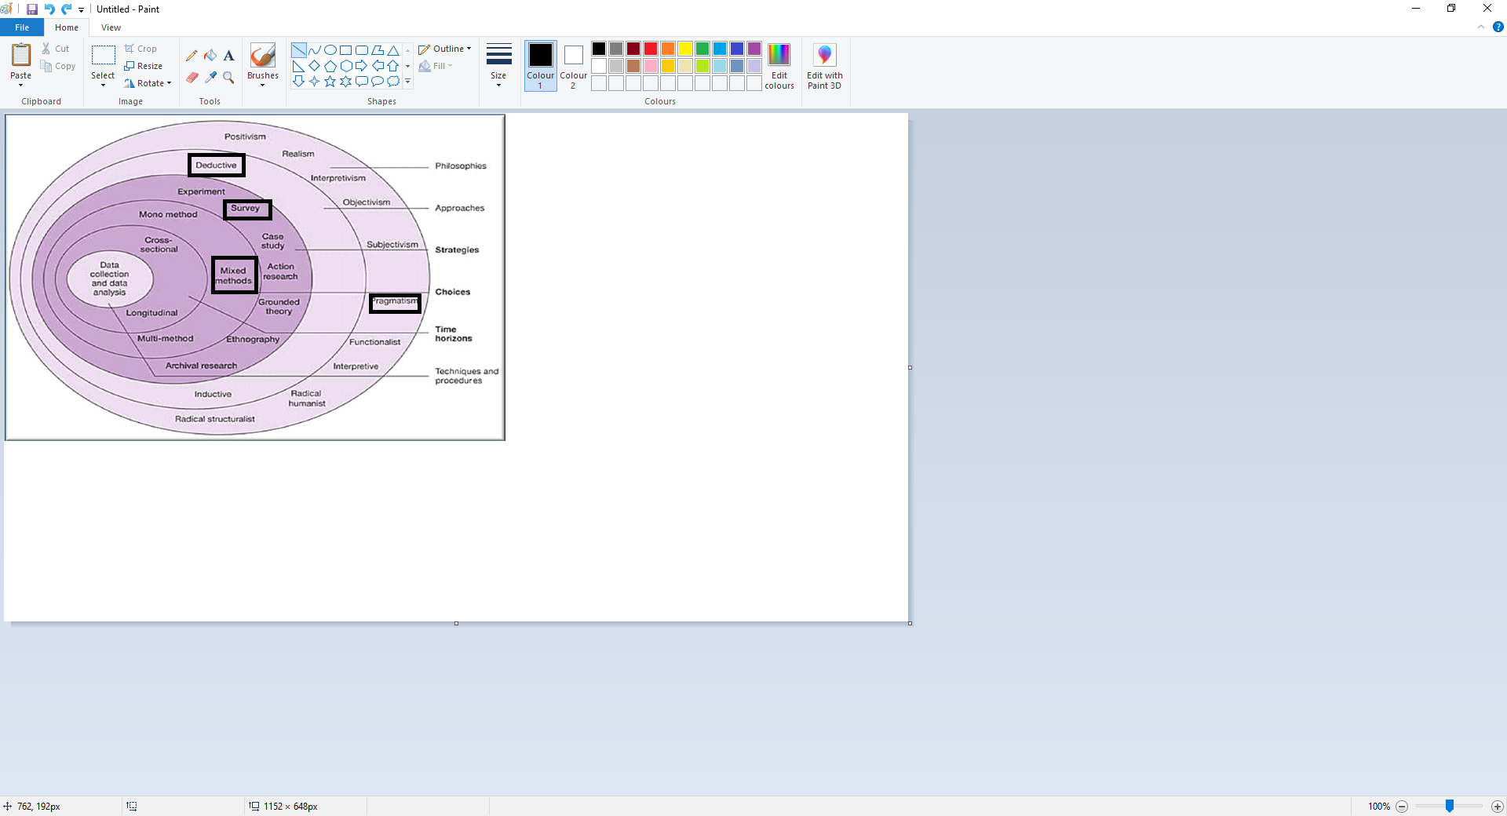
Figure 1 the research Onion. Source: Saunders et, 2007)
As demonstrated in Figure 1, The Research Onion consists of various layers which are related to some stages of the research. Analysing these layers from the centre region of The Research Onion, Saunders et al (2012) believe that a straightforward approach for developing an efficient approach could be accomplished. Basically, this strategy could provide a perfect method for the research which will provide the researchers with the most satisfying data and provide the best answer for the research question. In this research proposal, an organised pathway will be selected utilising the layers illustrated in figure 1 will help to improve the methodology and the design of the research that will enable the researcher to achieve the objectives the research proposal.

2.1 Philosophy
Johnson and Clark (2006) indicate the usefulness of the philosophical commitments and they believe that has a significant impact fulfilment and the understanding of the research. Saunders et al (2007) argue that there only two fundamental philosophies and there are the Interpretivism and the positivism. Positivism refers to the notion that research should be only be conducted with quantitative research approach (Johnson and Clark, 2006). Interpretivism refers to the theory that research cannot be undertaken only with experimental means but it should include qualitative research (Saunders et al, 2012). This proposal will adopt the positivism philosophy in order to achieve the objectives set out in the research question. Although, there will be some elements of the Interpretivism philosophy and there be qualitative and quantitative data will be utilised for the study. As mentioned above, there will be mostly elements of the positivism philosophy and some elements of interpretivism so it might be more suitable to classify as pragmatism philosophy.

2.2 Sample
In this proposal, the researcher will select the candidates that are involved with food banks and people that are fighting food waste and students; this will enable the researcher to answer the research question and meet the objectives of the study. The sample will consist of a large volume of people especially students and Swansea community fridge, Matts café and other projects in Swansea. The survey will be completed at least by 80 people and there will be at least five interviews to understand to importance of food banks and how businesses are trying to deal with food waste. The sample will be only for adults (18 years above).

2.3 Approaches
In this dissertation, the researcher will be utilising the deductive approach. According to Loseke (2017), a deductive approach includes using facts that are already known to discover what type of data to obtain. There is a significant amount of literature, and theories based on food waste and the lack of food in some households and food banks. For this dissertation, exploratory research purpose will be used to investigate the research question and provide a basis for further researches or study on this subject (Cicatiello et al, 2016, instead of providing a valid solution to the research question (Dudovskiy, 2016).

2.4 Strategies
The researcher will utilise a mixed methodology which consists of undertaking the research project utilising various methods and confront the findings, which are known as qualitative and quantitative approaches. The two approaches are usually used to have two different perspectives when analysing the research question and have a conjoined conclusion (Creswell and Creswell, 2017). Quantitative research involves using data that could be measured such statistics and surveys to explain problems or facts (Osanloo and Grant, 2016). Qualitative research involves words and pictures such as interviews or secondary data, and explores the problems in-depth and try to understand the reason behind the problem (Osanloo and Grant, 2016). In other words, qualitative research is descriptive and studies things that can be examined but they are unable to measure (Coffey and Atkinson, 1996). Additionally, utilising quantitative data and qualitative data enables to combine reliable unbiased opinions to the numerical data and allow the readers to understand the data easily (Bryman, 2017). The researcher will focus more on the food waste of food and food banks in Swansea which are helping the less privileged families and homeless people. In this proposal. there will also an investigation on food poverty and how food banks are essential for some people within the UK, especially in Swansea. In the research the quantitative data will come from online surveys and the Government official; the qualitative will formed through interviews and secondary research to have a depth understanding on why customers still buy products even though the fraud activities in the business sector is widespread. The surveys and the interviews will produce more depth to the study and will enable the researcher to analyse all the data and combine them and have a unified conclusion to the study.

2.5 Ethical risks
The online surveys and the interviews will be conducted with people who are at least 18 years old and people/volunteers who work in food banks. Some problems may arise for the researcher and they could be that people taking the survey might feel uncomfortable to answer the questions but they will be anonymous and they could decide when they would like to end the online questionnaire if they do not want to give other details on food waste and the importance of food banks in their lives (Fink, 2015). The interviews will follow the ethical policy and every candidate will have the option to be anonymous or be addressed by their job title and have the right to end the interviews if they feel embarrassed (Oltman, 2016). Data security and confidentiality are important because it allows people companies to protect people’s data safe, lawful and ethical (Wang and Petrison, 1993).

2.6 Reliable and valid data
As described by Kirk and Miller (1986) credible data are vital, when the researcher of the data utilises unreliable and invalid data then the final conclusion to the argument shall be considered false. The researcher of this proposal will utilise reliable and valid data, and will not include his personal point of view and will be unbiased as possible in order to provide a trustworthy investigation.

3.Resources and planning
Most of the researches will be utilised to achieve a clear understanding of the argument and accomplish the aims and objectives of this research. Planning is a fundamental element in research because it makes sure that it is finalised. Primary data will be online questionnaire and interviews. The researcher will ask the candidate if he can record the interview and then write them for the analysis. As mentioned in the previous sections, the candidates will be the people working in food banks, less privileged and people with no difficulties utilising food banks and understand their food waste habits. The secondary research such as books, journal articles and other reliable resources will be used to provide academical context to the researcher’s primary data.

3.1 Gantt chart
The researcher will use the Gantt Chart to control the limitations of time management. A Gantt chart is utilised to keep track of their research project and provide help by enabling them to able to organise and plan the timetable (Saunders et al, 2012). In the following section, there will be illustrated a Gantt chart where a visual representation of each task will be shown to enable the researcher to provide a timeframe in order to meet every deadline and complete the final project.
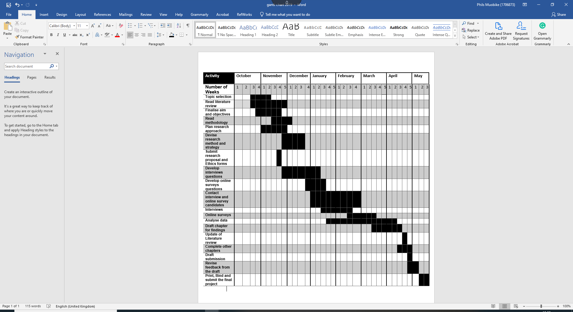
Figure 2 Gantt chart

4.References
Ariola, M.M., (2006). Principles and methods of research. Rex Book Store.
Bryman, A., (2017). Quantitative and qualitative research: further reflections on their integration. In Mixing methods: Qualitative and quantitative research (pp. 57-78). Routledge.
Caplan, P., (2016). Big society or broken society?: Food banks in the UK. Anthropology Today, 32(1), pp.5-9.
Caplan, P., (2017). Win‐win?: Food poverty, food aid and food surplus in the UK today. Anthropology Today, 33(3), pp.17-22.
Cicatiello, C., Franco, S., Pancino, B. and Blasi, E., (2016). The value of food waste: An exploratory study on retailing. Journal of Retailing and Consumer Services, 30, pp.96-104.
Coffey, A. and Atkinson, P., (1996). Making sense of qualitative data: complementary research strategies. Sage Publications, Inc.
Creswell, J.W. and Creswell, J.D., (2017). Research design: Qualitative, quantitative, and mixed methods approaches. Sage publications.
Dudovskiy, J., (2016). The ultimate guide to writing a dissertation in business studies: A step-by-step assistance. Pittsburgh, USA.
Fink, A., (2015). How to conduct surveys: A step-by-step guide. Sage Publications.
Ghauri, P.N. and Grønhaug, K., (2005). Research methods in business studies: A practical guide. Pearson Education.
Graham-Rowe, E., Jessop, D.C. and Sparks, P., (2014). Identifying motivations and barriers to minimising household food waste. Resources, conservation and recycling, 84, pp.15-23.
Johnson, P., Clark, M., (2006). Business and Management Research Methodologies. Sage Publications.
Kirk, J. and Miller, M.L., (1986). Reliability and validity in qualitative research.
Loseke, D., R. (2017). Methodological Thinking, Basic Principles of Social Research Design. Florida: Sage Publications/University of South Florida.
O'Connell, R.E. and Hamilton, L., (2017). Hunger and food poverty. Pluto Press.
Oltmann, S., (2016), May. Qualitative interviews: A methodological discussion of the interviewer and respondent contexts. In Forum Qualitative Sozialforschung/Forum: Qualitative Social Research (Vol. 17, No. 2).
Osanloo, A. and Grant, C., (2016). Understanding, selecting, and integrating a theoretical framework in dissertation research: Creating the blueprint for your “house”. Administrative issues journal: connecting education, practice, and research, 4(2), p.7.
Porpino, G., (2016). Household food waste behavior: avenues for future research. Journal of the Association for Consumer Research, 1(1), pp.41-51.
Saunders, M., Lewis, P. and Thornhill, A., (2007). Research methods for business students. Essex. Financial Times/Prentice Hall.
Saunders, M., Lewis, P. and Thornhill, A., (2012). Research methods for business students. Essex. Financial Times/Prentice Hall.
Traill, B. and Grunert, K.G. eds., (1997). Products and process innovation in the food industry. Springer Science & Business Media.
Wang, P. and Petrison, L.A., (1993). Direct marketing activities and personal privacy: A consumer survey. Journal of Direct Marketing, 7(1), pp.7-19.
Www.Parliament.UK (2019). Government and supermarkets must do more to prevent food waste scandal - News from Parliament. [online] Available at: https://www.parliament.uk/business/committees/committees-a-z/commons-select/environment-food-and-rural-affairs-committee/news-parliament-2015/food-waste-report-published-16-17/. [Accessed 12 Nov. 2019].
Young, W., Russell, S.V., Robinson, C.A. and Barkemeyer, R., (2017). Can social media be a tool for reducing consumers’ food waste? A behaviour change experiment by a UK retailer. Resources, Conservation and Recycling, 117, pp.195-203.

