

SBUS4100 – ACCOUNTING FUNDAMENTALS
ASSIGNMENT 1
MODULE TUTOR: REXON NTING

STUDENT NAME: ERIKA MAE M. PAGADUAN
STUDENT NUMBER: 1604894

Task 1

Journal Entries

DATE | PARTICULARS | DEBIT | CREDIT
5 APRIL | CASH | £300.00
 | CAPITAL |  | £300.00
 | introduce cash into the business
7 APRIL | PURCHASES | £200.00
 | CASH |  | £200.00
 | purchase of goods
8 APRIL | CASH | £250.00
 | ACCOUNTS PAYABLE - TATIANA |  | £250.00
 | receipt of loan from Tatiana
15 APRIL | MOTOR VAN | £150.00
 | CASH |  | £150.00
 | purchase of motor van
20 APRIL | CASH | £350.00
 | SALES |  | £350.00
 | sale of goods
28 APRIL | RENT EXPENSE | £50.00
 | CASH |  | £50.00
 | payment of rent
29 APRIL | ACCOUNTS PAYABLE - TATIANA | £200.00
 | CASH |  | £200.00
 | partial payment of loan
30 APRIL | CAPITAL | £60.00
 | CASH |  | £60.00
 | withdrawal of cash from business

Ledger/T-accounts
 | CASH
5 APRIL | £300.00 | £200.00 | 7 APRIL
8 APRIL | £250.00 | £150.00 | 15 APRIL
20 APRIL | £350.00 | £50.00 | 28 APRIL
 |  | £200.00 | 29 APRIL
 |  | £60.00 | 30 APRIL
 | £900.00 | £660.00
BALANCE | £240.00
 | CAPITAL
30 APRIL | £60.00 | £300.00 | 5 APRIL
 |  | £240.00 | BALANCE
 | PURCHASES
7 APRIL | £200.00
BALANCE | £200.00
 | ACCOUNTS PAYABLE - TATIANA
29 APRIL | £200.00 | £250.00 | 8 APRIL
 |  | £50.00 | BALANCE
 | MOTOR VAN
15 APRIL | £150.00
BALANCE | £150.00
 | SALES
 |  | £350.00 | 20 APRIL
 |  | £350.00 | BALANCE
 | RENT EXPENSE
28 APRIL | £50.00
BALANCE | £50.00

MAXIM’S BAKERY
TRIAL BALANCE
30 APRIL

ACCOUNT TITLE | DEBIT | CREDIT
CASH | £240.00
MOTOR VAN | £150.00
ACCOUNTS PAYABLE - TATIANA |  | £50.00
CAPITAL |  | £240.00
SALES |  | £350.00
PURCHASES | £200.00
RENT EXPENSE | £50.00
BALANCES | £640.00 | £640.00
MAXIM’S BAKERY
STATEMENT OF PROFIT OR LOSS
FOR THE MONTH ENDED 30 APRIL

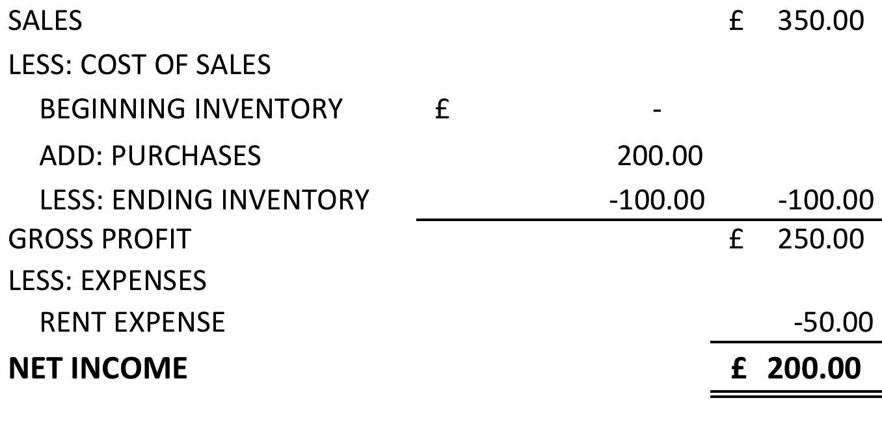

MAXIM’S BAKERY
STATEMENT OF FINANCIAL POSITION
30 APRIL

ASSETS
CASH |  | £240.00
INVENTORY |  | £100.00
MOTOR VAN |  | 150.00
TOTAL ASSETS |  | £490.00
LIABILITIES AND OWNER'S EQUITY
LIABILITIES
ACCOUNTS PAYABLE - TATIANA |  | £50.00
OWNER'S EQUITY
CAPITAL | £240.00
RETAINED EARNINGS | 200.00 | 440.00
TOTAL LIABILITIES AND OWNER'S EQUITY |  | £490.00

Task 2

Journal Entries
DATE | PARTICULARS |  | DEBIT | CREDIT
01 January | Cash |  | £5,000.00
 |  | Capital |  | £5,000.00
 | start-up capital
02 January | Motor Van |  | £600.00
 |  | Cash |  | £600.00
 | purchase of motor van
03 January | Purchases |  | £1,300.00
 |  | Cash |  | £1,300.00
 | purchase of goods
04 January | Cash |  | £1,000.00
 |  | Accounts Payable - Sergei |  | £1,000.00
 | loan from Sergei
10 January | Motor Van Expenses |  | £200.00
 |  | Cash |  | £200.00
 | expenses for motor van
13 January | Cash |  | £300.00
 |  | Sales |  | £300.00
 | sale of goods
20 January | Cash |  | £500.00
 |  | Sales |  | £500.00
 | sale of goods
24 January | Storage Expense |  | £150.00
 |  | Cash |  | £150.00
 | storage expenses incurred
27 January | Accounts Payable - Sergei |  | £350.00
 |  | Cash |  | £350.00
 | partial payment of loan from Sergei
30 January | Capital |  | £175.00
 |  | Cash |  | £175.00
 | withdrawal of cash from Sergei
31 January | Cost of Sales |  | £500.00
 | Inventory |  | £800.00
 |  | Purchases |  | £1,300.00
 | to record cost of sales

Computation of Cost of Sales

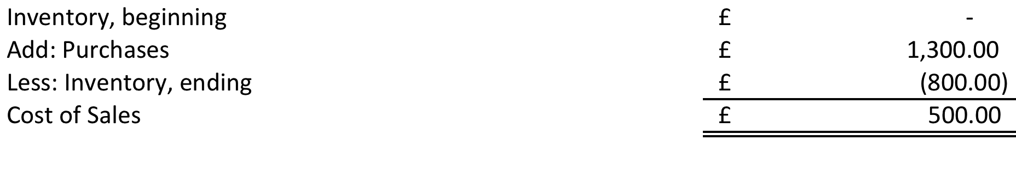
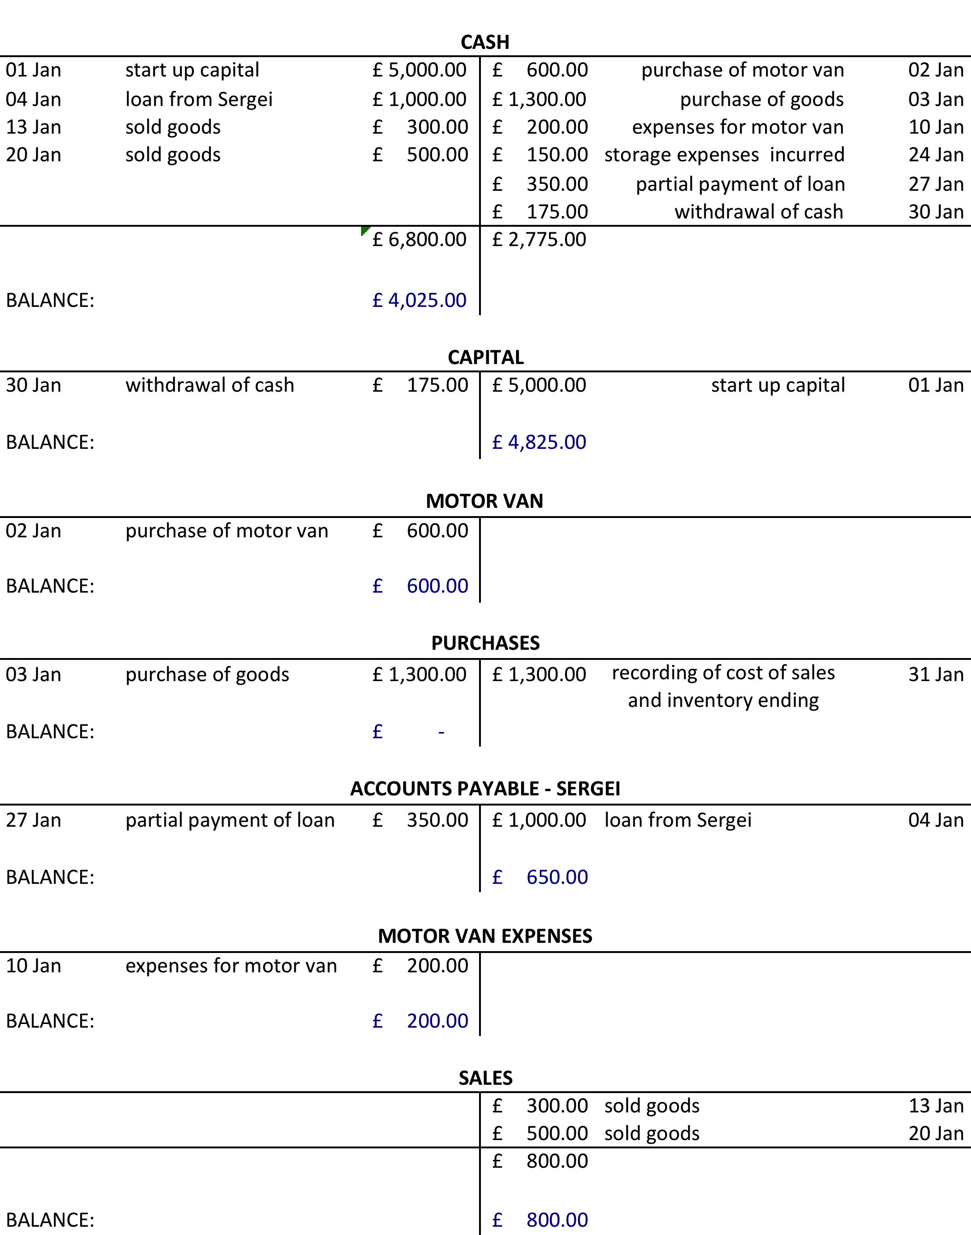
Ledger/T-accounts
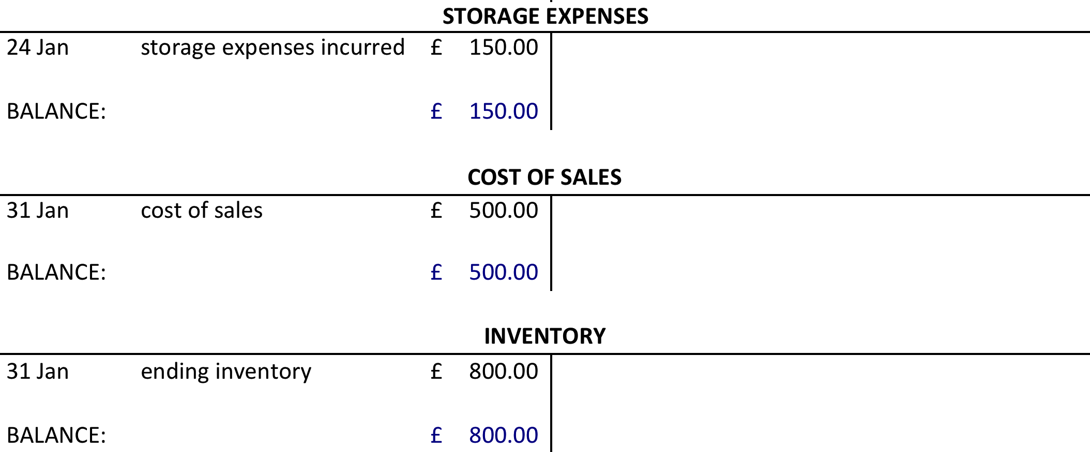

PENDO’S FURNITURES
TRIAL BALANCE
31 JANUARY

ACCOUNT TITLE | DEBIT | CREDIT
CASH | £4,025.00
INVENTORY | £800.00
MOTOR VAN | £600.00
ACCOUNTS PAYABLE - SERGEI |  | £650.00
CAPITAL |  | £4,825.00
SALES |  | £800.00
COST OF SALES | £500.00
MOTOR VAN EXPENSES | £200.00
STORAGE EXPENSES | £150.00
BALANCES | £6,275.00 | £6,275.00

PENDO’S FURNITURES
STATEMENT OF PROFIT OR LOSS
FOR THE MONTH ENDED 31 JANUARY

SALES |  | £800.00
LESS: COST OF SALES |  | -500.00
GROSS PROFIT |  | £300.00
LESS: EXPENSES
MOTOR VAN EXPENSE | £200.00
STORAGE EXPENSE | 150.00 | -350.00
NET LOSS |  | £(50.00)

PENDO’S FURNITURES
STATEMENT OF FINANCIAL POSITION
31 JANUARY

ASSETS
CASH |  |  |  | £4,025.00
INVENTORY |  |  |  | £800.00
MOTOR VAN |  |  |  | £600.00
TOTAL ASSETS |  |  |  | £5,425.00
LIABILITIES AND OWNER'S EQUITY
LIABILITY
ACCOUNTS PAYABLE - SERGEI |  |  |  | £650.00
OWNER'S EQUITY
BEGINNING |  |  | £5,000.00
LESS: DRAWINGS |  |  | -175.00
ADD: NET LOSS |  |  | -50.00 | 4,775.00
TOTAL LIABILITIES AND OWNER'S EQUITY |  |  |  | £5,425.00

Task 3

Computation of Capital, beginning balance (Capital = Asset – Liabilities)

MAFUTA RETAIL
STATEMENT OF FINANCIAL POSITION
01 JANUARY
ASSETS
CASH IN HAND |  | £343.00
INVENTORY |  | 458.00
FURNITURES AND FITTINGS |  | 198.00
RECEIVABLES
SMITH | 18.00
HARVEY | 39.00
MOON | 26.00 | 83.00
TOTAL ASSETS |  | £1,082.00
LIABILITIES AND OWNER'S EQUITY
LIABILITIES
ACCOUNTS PAYABLE
RICH | £12.00
MAX | £21.00 | 33.00
CAPITAL |  | £1,049.00
TOTAL LIABILITIES AND OWNER'S EQUITY |  | £1,082.00
Journal Entries
DATE | PARTICULARS |  | DEBIT | CREDIT
02 January | Receivables - Harvey |  | £124.00
 |  | Sales |  | £124.00
05 January | Wages |  | £12.00
 |  | Cash in hand |  | £12.00
 | Purchases |  | £150.00
 |  | Payables - Rich |  | £150.00
07 January | Cash in hand |  | £18.00
 |  | Receivables - Smith |  | £18.00
09 January | Payables - Max |  | £21.00
 |  | Cash in hand |  | £21.00
11 January | Cash in hand |  | £64.00
 |  | Sales |  | £64.00
14 January | Wages |  | £14.00
 |  | Cash in hand |  | £14.00
 | Purchases |  | £75.00
 |  | Cash in hand |  | £75.00
15 January | Payables - Rich |  | £162.00
 |  | Cash in hand |  | £162.00
20 January | Office Desk |  | £32.00
 |  | Cash in hand |  | £32.00
21 January | Wages |  | £17.00
 |  | Cash in hand |  | £17.00
 | Cash in hand |  | £110.00
 |  | Sales |  | £110.00
23 January | Office Expenses |  | £3.00
 |  | Cash in hand |  | £3.00
 | Cash in hand |  | £25.00
 |  | Receivables - Harvey |  | £25.00
28 January | Cash in hand |  | £84.00
 |  | Sales |  | £84.00
 | Wages |  | £15.00
 |  | Cash in hand |  | £15.00
31 January | Cash in hand |  | £30.00
 |  | Sales |  | £30.00
 | Cost of Sales |  | £309.00
 |  | Inventory |  | £84.00
 |  | Purchases |  | £225.00

Computation of Cost of Sales
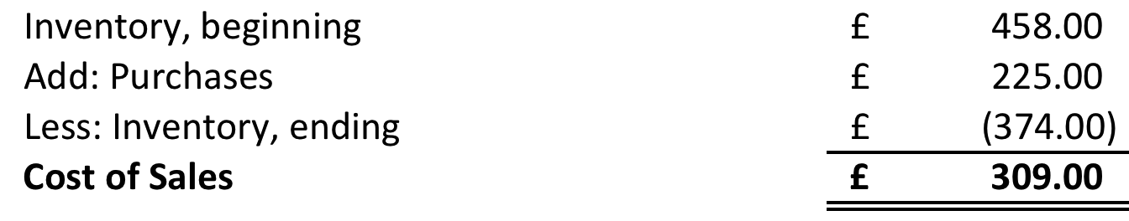

Ledger/T-accounts

CASH IN HAND
01 Jan | beginning balance | £343.00 | £12.00 | paid wages | 05 Jan
07 Jan | Smith settled account | £18.00 | £21.00 | payment to Max | 09 Jan
11 Jan | cash sales | £64.00 | £14.00 | paid wages | 14 Jan
21 Jan | cash sales | £110.00 | £75.00 | bought goods | 14 Jan
23 Jan | Harvey's partial payment | £25.00 | £162.00 | payment to Rich | 15 Jan
28 Jan | cash sales | £84.00 | £32.00 | office desk | 20 Jan
31 Jan | cash sales | £30.00 | £17.00 | paid wages | 21 Jan
 |  |  | £3.00 | office expenses | 23 Jan
 |  |  | £15.00 | paid wages | 28 Jan
 |  | £674.00 | £351.00
BALANCE |  | £323.00
INVENTORY
01 Jan | beginning balance | £458.00 | £309.00 | cost of sales | 31 Jan
 | total purchases for the month | £225.00
 |  | £683.00 | £309.00
BALANCE |  | £374.00
FURNITURE AND FITTINGS
01 Jan | beginning balance | £198.00
BALANCE |  | £198.00
RECEIVABLES - SMITH
01 Jan | beginning balance | £18.00 | £18.00 | settlement | 07 Jan
BALANCE |  | -
RECEIVABLES - HARVEY
01 Jan | beginning balance | £39.00 | £25.00 | partial payment | 23 Jan
02 Jan | goods sold on credit | £124.00
 |  | £163.00 | £25.00
BALANCE |  | £138.00
RECEIVABLES - MOON
01 Jan | beginning balance | £26.00
BALANCE |  | £26.00
PAYABLES - RICH
15 Jan | payment | £162.00 | £12.00 | beginning balance | 01 Jan
 |  |  | £150.00 | goods bought on credit | 05 Jan
 |  | £162.00 | £162.00
BALANCE |  | -
PAYABLES - MAX
09 Jan | payment | £21.00 | £21.00 | beginning balance | 01 Jan
BALANCE |  | -
CAPITAL
 |  |  | £1,049.00 | beginning balance | 01 Jan
BALANCE |  |  | £1,049.00
SALES
 |  |  | £124.00 | sold to Harvey on credit | 02 Jan
 |  |  | £64.00 | cash sales | 11 Jan
 |  |  | £110.00 | cash sales | 21 Jan
 |  |  | £84.00 | cash sales | 28 Jan
 |  |  | £30.00 | cash sales | 31 Jan
 |  |  | £412.00
BALANCE |  |  | £412.00
WAGES
05 Jan | paid wages | £12.00
14 Jan | paid wages | £14.00
21 Jan | paid wages | £17.00
28 Jan | paid wages | £15.00
 |  | £58.00
BALANCE |  | £58.00
PURCHASES
05 Jan | goods bought from Rich on credit | £150.00 | £225.00 | closed to inventory | 31 Jan
14 Jan | goods bought for cash | £75.00
 |  | £225.00 | £225.00
BALANCE |  | -
OFFICE DESK
20 Jan | bought office desk for cash | £32.00
BALANCE |  | £32.00
OFFICE EXPENSES
23 Jan | office expenses | £3.00
BALANCE |  | £3.00
COST OF SALES
 |  |  | £309.00 | cost of sales | 31 Jan
BALANCE |  |  | £309.00

MAFUTA RETAIL
TRIAL BALANCE
31 JANUARY

ACCOUNT TITLE | DEBIT | CREDIT
CASH IN HAND | £323.00
RECEIVABLE - HARVEY | 138.00
RECEIVABLE - MOON | 26.00
INVENTORY | 374.00
FURNITURE AND FITTINGS | 198.00
OFFICE DESK | 32.00
CAPITAL |  | £1,049.00
SALES |  | 412.00
COST OF SALES | 309.00
WAGES | 58.00
OFFICE EXPENSES | 3.00
BALANCES | £1,461.00 | £1,461.00
MAFUTA RETAIL
STATEMENT OF PROFIT OR LOSS
FOR THE MONTH ENDED 31 JANUARY

SALES |  | £412.00
LESS: COST OF SALES |  | -309.00
GROSS PROFIT |  | £103.00
LESS: EXPENSES
WAGES | £58.00
OFFICE EXPENSES | 3.00 | -61.00
NET PROFIT |  | £42.00

MAFUTA RETAIL
STATEMENT OF FINANCIAL POSITION
31 JANUARY

ASSETS
CASH IN HAND |  | £323.00
RECEIVABLES
HARVEY | £138.00
MOON | 26.00 | 164.00
INVENTORY |  | 374.00
FURNITURE AND FITTINGS |  | 198.00
OFFICE DESK |  | 32.00
TOTAL ASSETS |  | £1,091.00
LIABILITIES AND OWNER'S EQUITY
LIABILITIES |  | £0.00
CAPITAL
BEGINNING BALANCE | £1,049.00
NET PROFIT | 42.00 | 1,091.00
TOTAL LIABILITIES AND OWNER'S EQUITY |  | £1,091.00

Task 4

Journal Entries
02 Jun | Accounts Receivable - Claire |  | £8,500.00
 |  | Sales |  | £8,500.00
13 Jun | Purchases |  | £12,000.00
 |  | Accounts Payable - Georgina |  | £12,000.00
14 Jun | Accounts Receivable - Hywel |  | £9,000.00
 | Sales Discount |  | £473.68
 |  | Sales |  | £9,473.68
20 Jun | Cash |  | £6,000.00
 |  | Sales |  | £6,000.00
21 Jun | Purchases |  | £4,500.00
 |  | Accounts Payable - Andrew |  | £4,500.00
22 Jun | Sales Return |  | £1,000.00
 |  | Accounts Receivable - Claire |  | £1,000.00
24 Jun | Accounts Receivable - Mandy |  | £5,000.00
 |  | Sales |  | £5,000.00
 | Cash |  | £7,125.00
 | Sales Discount |  | £375.00
 |  | Accounts Receivable - Claire |  | £7,500.00
25 Jun | Cash |  | £9,000.00
 |  | Accounts Receivable - Hywel |  | £9,000.00
 | Accounts Payable - Georgina |  | £12,000.00
 |  | Purchase Discount |  | £840.00
 |  | Cash |  | £11,160.00
27 Jun | Accounts Payable - Andrew |  | £4,500.00
 |  | Purchase Discount |  | £90.00
 |  | Cash |  | £4,410.00

Ledger/T-accounts

ACCOUNTS RECEIVABLE - CLAIRE
02 Jun | sales on credit | £8,500.00 | £1,000.00 | sales return | 22 Jun
 |  |  | £7,500.00 | payment from Claire | 24 Jun
 |  | £8,500.00 | £8,500.00
BALANCE |  |  | -
SALES
 |  |  | £8,500.00 | sold to Claire on credit | 02 Jun
 |  |  | £9,473.68 | sold to Hywel on credit | 14 Jun
 |  |  | £6,000.00 | cash sales | 20 Jun
 |  |  | £5,000.00 | sold to Mandy on credit | 24 Jun
BALANCE |  |  | 28,973.68
PURCHASES
13 Jun | from Georgina, on credit | £12,000.00
21 Jun | from Andrew, on credit | £4,500.00
BALANCE |  | £16,500.00
ACCOUNTS PAYABLE - GEORGINA
25 Jun | payment to Georgina | £12,000.00 | £12,000.00 | purchased goods on credit | 02 Jun
BALANCE |  |  | -
ACCOUNTS RECEIVABLE - HYWEL
14 Jun | sales on credit | £9,000.00 | £9,000.00 | payment from Hywel | 25 Jun
BALANCE |  |  | -
SALES DISCOUNT
14 Jun | trade discount for Hywel | £473.68
24 Jun | discount for Claire | £375.00
BALANCE |  | £848.68
CASH
20 Jun | cash sales | £6,000.00 | £11,160.00 | payment to Georgina | 25 Jun
24 Jun | payment from Claire | £7,125.00 | £4,410.00 | payment to Andrew | 27 Jun
25 Jun | payment from Hywel | £9,000.00
 |  | £22,125.00 | £15,570.00
BALANCE |  | £6,555.00
ACCOUNTS PAYABLE - ANDREW
27 Jun | payment to Andrew | £4,500.00 | £4,500.00 | purchased goods on credit | 21 Jun
BALANCE |  |  | -
SALES RETURN
22 Jun | sales return from Claire | £1,000.00
BALANCE |  | £1,000.00
ACCOUNTS RECEIVABLE - MANDY
24 Jun | sales on credit | £5,000.00
BALANCE |  | £5,000.00
PURCHASE DISCOUNT
 |  |  | £840.00 | discount from Georgina | 25 Jun
 |  |  | £90.00 | discount from Andrew | 27 Jun
BALANCE |  |  | 930.00
RICARDO TRADING
TRIAL BALANCE
27 JUNE

ACCOUNT TITLE | DEBIT | CREDIT
CASH | £6,555.00
ACCOUNTS RECEIVABLE - MANDY | 5,000.00
SALES |  | £28,973.68
SALES DISCOUNT | 848.68
SALES RETURN | 1,000.00
PURCHASES | 16,500.00
PURCHASE DISCOUNT |  | 930.00
BALANCES | £29,903.68 | £29,903.68

Task 5

Proper recognition of expenditures is essential in the preparation of financial statements, which are vital in decision-making. These expenditures can be divided into two categories: capital expenditure or revenue expenditure.

Capital expenditures are for the property, plant, equipment or fixed assets meeting the standards of IAS 16. These non-current assets’ costs are capitalized as they are expected to be used in the generation of income for a long period of time. The costs then will be depreciated accordingly, except for land which is not depreciated. On the other hand, revenue expenditures are for the costs related to a particular operating or revenue transactions as explained in IAS 18.

Capital expenditures are costs which benefit the business for a longer period of time thus its recognition is gradual, through depreciation while revenue expenditures are costs benefiting only the current fiscal year’s income thus they are recognised right away. Capital expenditures are recorded in the balance sheet as a non-current asset while revenue expenditures are recorded in the income statement.

