
Management Report
Academic and Employability Skills BMSK4001
azmal hussain 1806291 | 4/5/19 | Skills for the workplace

Executive Summary
Employers recruitment process is quite tough and lengthy to search for those talented people with skills who are graduated and are fit for the industry. A person that can make their own unique selling point by finding out their skills by using SWOT, VARK and SMART to prove their ability to work on their own and in a team. Employers will test their ability by applying Belbin teamworking, Tuckman theory along with Meyers Briggs test to find out how good is the employees team working skills.
But it doesn’t end there, there are further search involved.
The report will be looking at time management, networking, negotiation and interpersonal communication. And
Contents
Executive Summary 1
Introduction 1
Findings 1
Time Management: 1
Networking: 3
Negotiation 3
Interpersonal Communication 4
Conclusions 6
Recommendations 6
Action plan 6
Reference list 6

Introduction
benefit of employability skills to both employees and employers what to look for in graduates and check for skills, who are able to perform well in a team and able to work in own initiative

Findings

Time Management:
Being productive with time is all about making constant improvements on performance at work. If in a team, it is then identified by employee which member is letting the team down and report it so the employer may intervene and make the necessary changes to improve productivity. Employee should feel the need to make changes to adapt to others so the team can reach they’re goal in an effective manner. Each decision is based upon achieving clear goal, so it becomes easier to focus on task and block out anything less important.

Do the difficult things first prioritise and block out less important things that way time will be managed well, and mind will be clear.
Cut the clutter read write speak what’s required don’t do unnecessary things where it will slow down productivity which affects the time to the goal.
Do one task at a time then move on to the next, this way stress is minimised, and concentration is maximised to complete goals
Concentrate on a limited number of tasks where manageable
Limit your task if needed for better concentration
Time management is crucial and should be
Be conscious of time and give a lot of time to prepare.
Here is the empty box and here is where the priority urgencies and the non important factors belong to make workload easy and manageable.

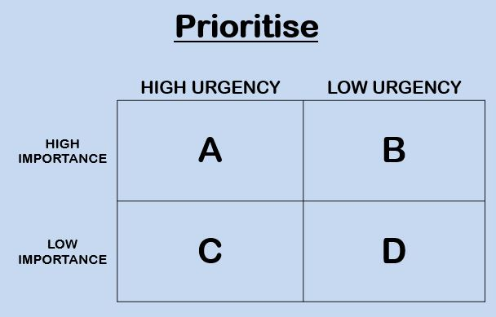

Once the priority box is filled with high important and non-important work into place there will be a clear picture on what needs to be done first as it is the most urgent task.
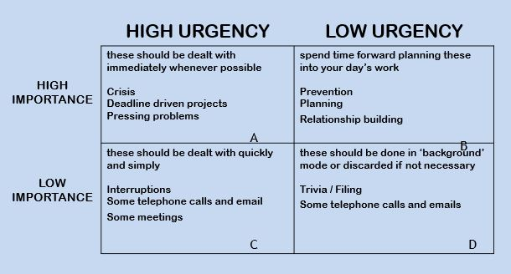
Urgent – requires immediate attention. Tasks are usually visible and insist on action.
Important – has to do with results and contributes to your role. Tasks require initiative and pro-activity.
“Set your goals high and don’t stop till you get there”
Bo Jackson
Bo Jackson Quotes. (n.d.). BrainyQuote.com. Retrieved April 4, 2019, from BrainyQuote.com Web site: https://www.brainyquote.com/quotes/bo_jackson_129219

Networking:
Employers who are engaged with others are more valuable as they can be more productive and valued by the employer and can rely on that person as a valuable member of the team
“Networking is not about just connecting people. It’s about connecting people with people, people with ideas, and people with opportunities.”
Michele Jennae

As employer keeping employees in positions where they can build long-term relationships; or offer greater training and career development opportunities it is better to encourage them to stay with the company for longer making a great asset to the company.
Making sure employees networking efforts are aligned with your customers' buying cycles. In some cases (for example, if you are bidding for government contracts), it may be that employer have to develop relationships over several years. But sometimes it's a matter of just having the right person in the right place at the right time.
By actively recognising the value of networking, encouraging and rewarding it, you can create a positive networking culture.
Individuals find networking unnatural or need to hone their networking skills. Most people find networking difficult or unnatural. This is mainly because:
The fear rejection and being uncomfortable with strangers and don't have the right emotional intelligence skills
lack confidence or fearing the outcome or the result is what is not expected.
time is tight and the feeling of wasting time and have better things to do
they need proof it works.

One cannot convert unnatural networkers to natural networkers overnight. But can help them improve their skills and confidence in stages. Employee can:
Explain the benefits of networking to them (personally and professionally) so employee understand why employer need them to network.
Encourage them to develop an approach to networking they feel comfortable with. Someone who is uncomfortable approaching contacts, for example, might prefer to be introduced by someone else or to meet people at sociable events.
Employer must Ensure their networking activities are aligned with the buying cycles of your clients, so they can see a clear purpose to the networking.
Encourage them to form business relationships they are happy with: some people prefer quite sociable relationships whilst others prefer a more business-like relationship. Both are acceptable - don't force employees to behave in a way that makes them feel uncomfortable.
Give them patient, persistent support.
A minority of people are natural networkers - these people are willing, build relationships easily and are perfectly comfortable approaching strangers. But even natural networkers may need to refine their approach to networking in order to be of greatest benefit to your business. You may need to encourage them to:
- build a wider circle of influential contacts
- refine their 'soft' skills
- make better use of their network - many people build up good networks, but are reluctant to ask anything of their contacts
- work on what they should say about your business to new and existing contacts
Of course, there are some people you should never send out to represent your company! So please don't be tempted to get everyone out there. After all they are the voice and image of your company.
problems will be the level of importance that you place on successful networking. You have to ask yourself whether you are willing to reward your employees for networking?

Negotiation
Conflict and disagreement will always arise time to time as the needs, wants and goal or task changes.
Without negotiation, such conflicts may lead to argument and resentment resulting in one or all of the parties feeling dissatisfied and team being broken, negotiation is to try to reach agreements without causing future barriers to communications so being a good communicator means the employee is a good negotiator and be able to communicate well within the team. And listening is also part of communication which can help with finding out the needs of others and problem solving.
It is all about listening.
Eric Berne. (1950) developed the concept of TA.
Transactions – interactions of a person with other people.
This is a for of agreement
I'm OK and you are OK
I'm OK and you are not OK
I'm not OK and you are OK
I'm not OK and you are not OK
assertivvness
You should aim to be neither passive nor aggressive.
Being assertive is about expressing your feelings and beliefs in a way that others can understand and respect.
And is fundamental to successful negotiation
- Preparation
- Discussion
- Clarification of goals
- Negotiate towards a Win-Win outcome
- Agreement
- Implementation of a course of action
Saving face! And not being shamed.

Interpersonal Communication
It consists of Verbal , non-verbal with feeling , information and meaning. This then include other barriers like religious, cultural, status and physical which also play a big part.

- We all see things in different ways
- We all have our own version of how we see the real world
- Information received via our senses – we analyse it and judge it
- Perceived reality, not actual reality, is the key to understanding behaviour
- How we perceive others and ourselves is the root of our actions and intentions
- We need to understand the process in order to develop effective relationships with others
- Lack of understanding can lead to misunderstandings and conflict

Albert Mehrabian (1981) claims that the message that someone receives is broken up as it shows here


L. James(2019) uwtsd class

Listening is not the same as hearing; learn to listen not only to the words being spoken but how they are being spoken and the non-verbal messages sent with them.
Use the techniques of clarification and reflection to confirm what the other person has said and avoid any confusion.
Try not to think about what to say next whilst listening; clear your mind and focus on the message being received instead.
Your friends, colleagues and other acquaintances will appreciate good listening skills
- Do not say the first thing that comes into your mind but instead take a moment and pay close attention to what you say and how you say it.
- Focus on the meaning of what you want to communicate.
- Aim to increase understanding by considering how your message might be received by the other person.
- Present information in a way that its meaning can be clearly understood.
- Avoid jargon and over-complicated language.
- Laughing releases endorphins that can help relieve stress and anxiety; most people like to laugh and will feel drawn to somebody who can make them laugh.
- Do ensure your humour is appropriate to the situation!!
- Use your sense of humour to break the ice, to lower barriers and gain the affection of others.
- By using appropriate humour you will be perceived as more charismatic.

Conclusions
When all this skill is mastered by the employee it can be applied in an effective manner for better productivity. The employer will see the employee as a better candidate for joining the company and be able to manage or be a good team player.

Recommendations
Employee needs good time management skills if the employer is to employ this individual so company will benefit by having someone who can adhere to time for better productivity and for higher profitability.
Networking is the key to boost your skills bring in information and sell your products so coming out the shell and greeting other people listening and communicating will have a great effect on the company the employer and team.
Negotiation by listening and understanding and offer your knowledge or product dependant on situations and to offer support and gain trust to make better sales or reach goals faster.
Interpersonal communication to keep feelings clear and to promote yourself to be a good listener and be empathetic to be able to give good feedback and work better in a team by helping and developing trust.

Action plan

Reference list

https://www.coachingpositiveperformance.com/17-essential-time-management-skills/

