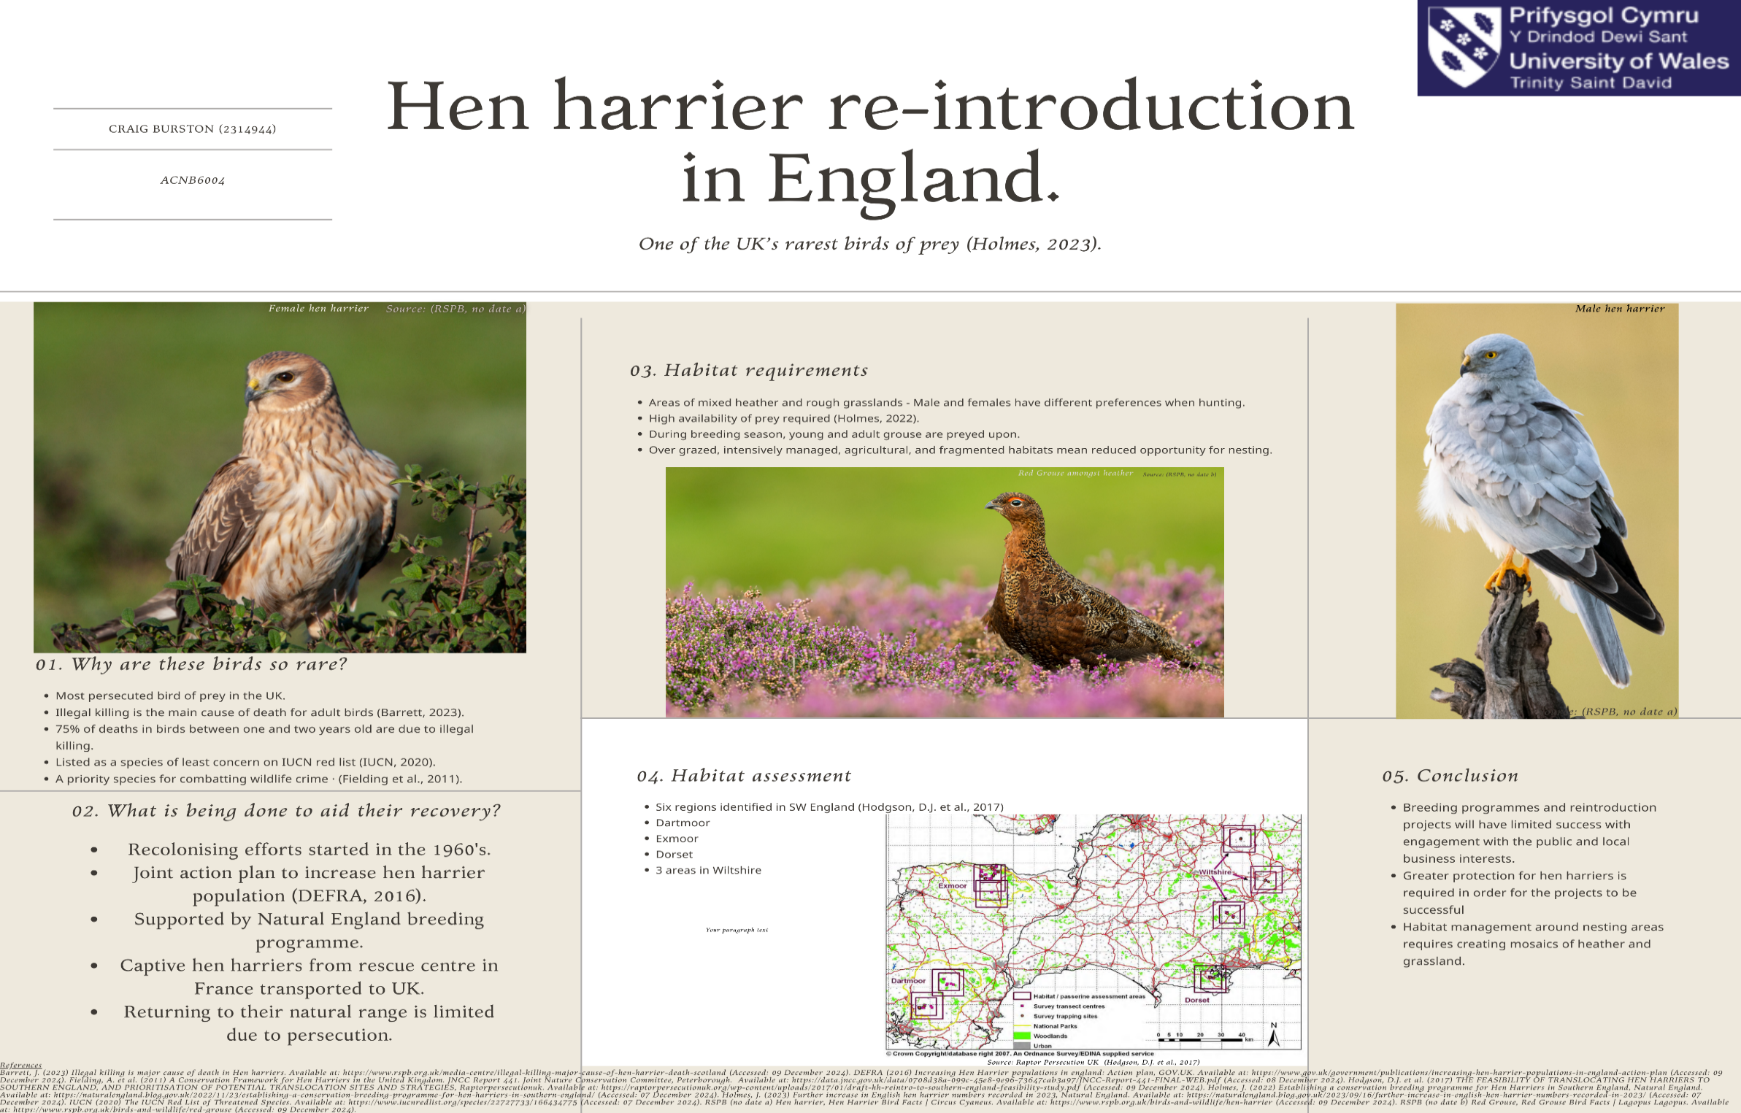

Note: Due to an error received via Turnitin when attempting to submit my poster for the assignment, this image has been added to a word document and this note added to meet the minimum 20 word requirement. Turnitin does not accept .PNG or .JPG images as submissions.

