Synthesize a solution to a potential real life scenario
Author: Cameron Brown (2004688)
ACCA4024
School of Applied Computing
Wales Institute of Science and Art

Introduction
I have been asked to design and recommend a framework that demonstrates existing flaws in Che-Si’s policies and infrastructure, guidelines for their staff members, vendors and clients to responsibly use their devices. I will do this by designing a possible attack that can be made if their devices are not used responsibly, and how these attacks can be mitigated while documenting the process.

After this I will explain how Che-Si can improve their security by explaining the concept of encryption and its benefits, then I will suggest improvements and additions to their policy to make sure that the staff understands how to keep their data safe in order to protect the integrity of the company.

Flaws
Employees accessing Che-Si’s systems from different locations can be very unsafe for the company. This is due to the vulnerability of the company's data if it is stored on an employees personal device or if they use the device to access company resources.\ This is especially true if it is accessed on a public network; for example, if the systems are accessed from an internet cafe then it could be possible for them to be exposed to a sniffer attack. “The sniffing attack or sniffer attack, in the context of network security, corresponds to data theft or interception by capturing network traffic using a sniffer”. [1] There are 2 different sniffing attacks, active and passive sniffing. “The former one can be detected where the attacker can sniff the traffic in the network, whereas the later one is difficult to detect but can be prevented” [2] The active sniffing will be the attack that I will be designing and recommending mitigations for further on in this report.

Design overview
For the design I have gone with an attack that may be used if an employee used company resources on a public network in a public place such as an internet cafe. Internet cafes tend to contain a lot of computers which makes it possible for at least one of them to be hooked up to a sniffing device or potentially infected with a sniffing application. I have designed a sniffing attack to demonstrate a potential active sniffing attack;
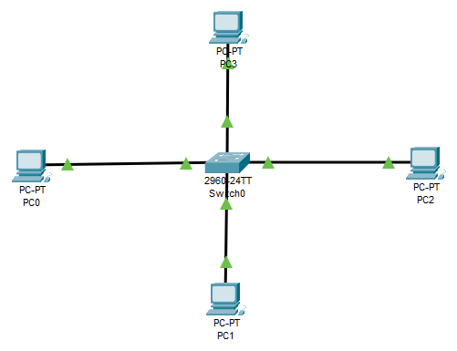
This is a rough example of how the network of an internet cafe could be set up but I have only used 4 PCs to make it less cluttered. Normally the PCs would be directly connected to the switch as shown above but if the computer is the victim of a sniffer attack then it may not connect directly to the switch.
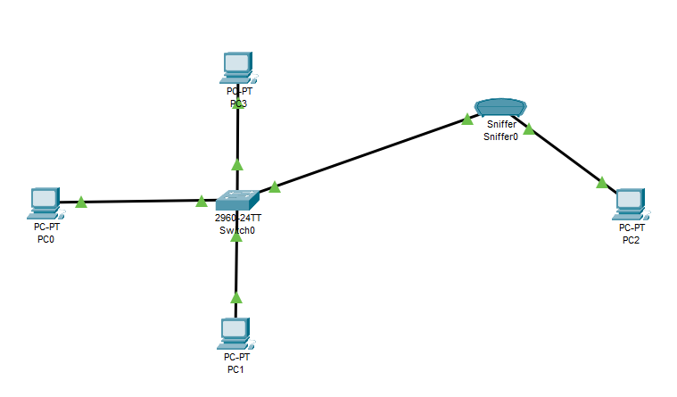
A PC that's hooked up to a sniffer tool would be represented as this, instead of a direct connection to the switch, it’s instead routed through a sniffer that reads any information sent between the PC and the switch. If the sniffed information was not encrypted and important data transferred via the companies cloud storage, then the company could be vulnerable to further attacks that could deal more damage to the company depending on the contents of the data being sniffed.

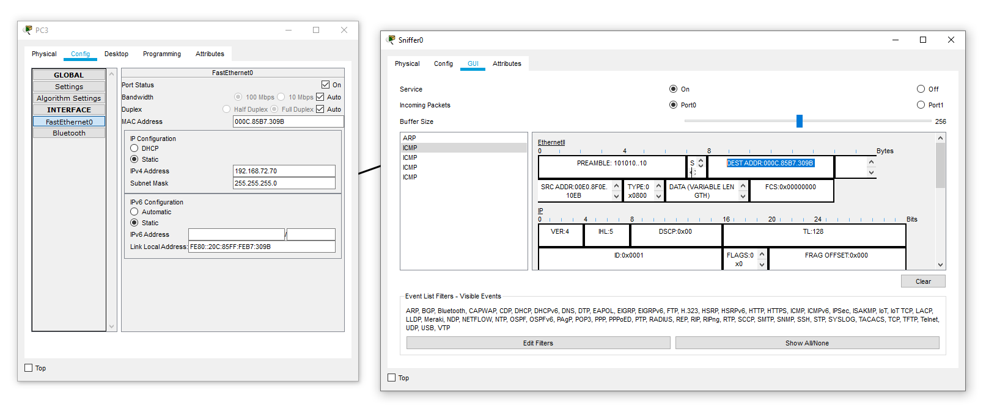
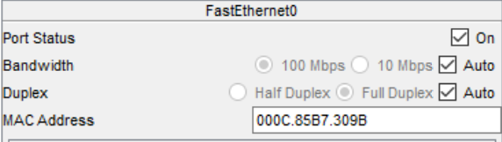
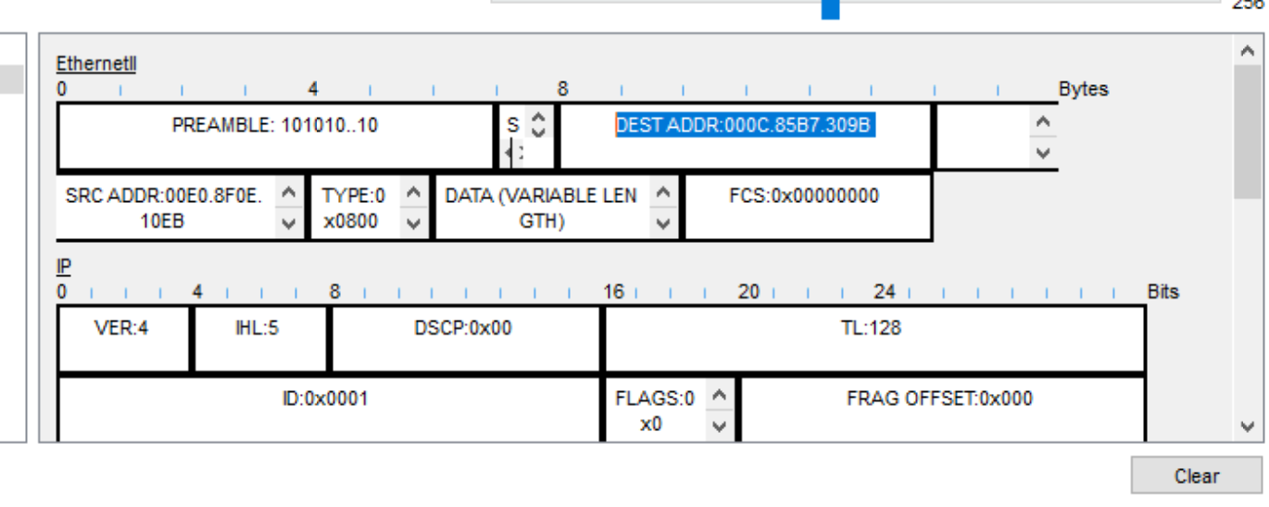
As we can see from the screenshots, the sniffer picks up the mac address of the PC when it sends information to the switch, in this case it was a simple ping command but in more extreme cases it can pick up confidential data if it is not protected enough.
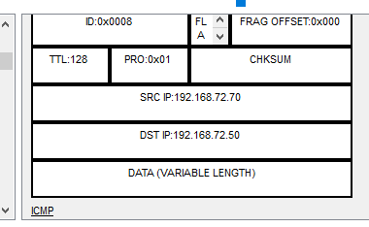
As we can see in the screenshot, the source IP is the IP of the PC hooked to the sniffer tool while the destination IP is the IP the ping command was directed towards.

Sniffing attacks are very harmful as if an employee is accessing a public network that's hooked up to a sniffing tool, then the attacker has access to any information that the employee may send over the public network, such as confidential files over email, login information on a banking website or company website, etc. A way to make sure that the information is safe is to encrypt the information before it is sent over a public network so that attackers aren’t able to access the information being sent.

If a sniffing attack was performed on the company network itself then ways of mitigating/preventing the attack would fall on the network admin, this can be done by monitoring the network for any intrusive devices, “Networks must be scanned for any kind of intrusion attempt or rogue devices that may be setup in span mode to capture traffic” [3] This will allow the network admin to detect the sniffing attack and take measures against it which allows data within the company to be protected.

Implementation
The design was done via Cisco Packet Tracer as it is a very good and mainstream network designing application used by many professionals worldwide. I had used 4 computers and a switch to simulate a small network then added a sniffer tool connected between one of the computers and switch to read the data sent between the 2. With a sniffing tool potentially being used on a network, it is very important to make sure all the data being transported is as secure as possible to avoid any 3rd parties from looking into the data. This will be enforced via the policies found later on in this report with other improvements on the existing policies.

Encryption
Encryption is used to protect data in a way that only people with a key can have access to it, this makes sure that the data being sent has not been altered while being sent or is visible to anyone spying on the network. Due to cloud storage being a vital part of the company, encryption is vital for a productive and secure workflow. In late 2010 Microsoft encountered a massive security breach where non-authorized users could gain access to the cloud storage of the employees data and contact info. While this breach was reportedly solved within 2 hours, it showcases how even the biggest companies can be vulnerable to cloud storage security breaches. This furthers the reasoning for increasing the security of transporting data via the cloud by encrypting them.

“E-mail can be encrypted by the sender and then decrypted by the intended recipient using Secure/Multipurpose Internet Mail Extensions (S/MIME). E-mail can be read only by the sender and the intended recipient.” [4] This means that we can double encrypt if we send data via email, the email itself will be encrypted and the contents will be encrypted which dramatically reduces any possible way an attacker could see the contents. If we assume employees will be sending important data on a public network, encrypting the information and sending it via an encrypted email allows it to stay protected.

“The two main areas for which encryption should be considered are the protection of sensitive infor­mation on notebook computers and the protection of information being sent across public networks.” [5] This helps us to understand that encryption is vital when transferring data across a public network. This is due to the fact that public networks can be very unsafe and data could be seen by anyone monitoring the network. Encrypting the data prevents attacks from doing this.

Conclusion
With many bigger companies being exposed to security breaches and attacks on the cloud in the past, making sure the cloud storage is as secure as possible and ensuring that the employees know how to keep their data safe will go a long way in keeping the data of the company secure. Keeping this data secure also helps prevent any other attacks happening as it lessens the chance of attackers gaining the information needed to plan a different attack.

Sniffing attacks can be scary and very harmful for the company if they are not discovered and need to be dealt with immediately upon discovery. This job falls on the network admin to detect and deal with it. Just in case the sniffer cannot be detected all that easily, important data being sent should be encrypted to make sure that any data read by the sniffer becomes meaningless as they would not have the key to read it.

While it would be preferable to not work in public areas on a public network, the accessibility can improve productivity. To make up for the lack of security on public networks, encryption is even more important and is vital when sending data over the public network. Changing passwords every now and then, about every 60 days or less, will also increase the security of employees accounts and prevent any long-term third party access.

Updating existing policy
Due to all of the potential threats to the company's data, Che-Si’s policy will need to be updated otherwise the data will remain highly vulnerable. Some new policies will be added to make up the changes, these include;

- All data sent over across a network outside of the company network must be encrypted and sent via an encrypted email. Data sent over the company network does not have to be encrypted but would be preferable if it was.

- Passwords for company resources will have to be reset every 60 days and not shared with any individual in order to protect company integrity.

- Any access of company resources on a public network must be done on a trusted device and not on a public device to avoid any potential tampering.

- All company data stored on employee personal devices must be backed up to prevent any data loss.

- Notify Che-Si upon the loss or theft of the personal device that contains company data.

These policies will improve how the employees treat company data, this is because they will be more careful when handling the data on their own personal devices and they will also encrypt the information meaning that attackers won't be able to read the information even if they get ahold of it.

References
[1] D. Glăvan et al, "Sniffing attacks on computer networks," Scientific Bulletin "Mircea Cel Batran" Naval Academy, vol. 23, (1), pp. 202-207,202A, 2020. Available: https://www-proquest-com.ezproxy.uwtsd.ac.uk/scholarly-journals/sniffing-attacks-on-computer-networks/docview/2429826362/se-2?accountid=130472. DOI: http://dx.doi.org.ezproxy.uwtsd.ac.uk/10.21279/1454-864X-20-I1-027.
[2] B, Prabadevi & Nagamalai, Jeyanthi. “A Review on Various Sniffing Attacks and its Mitigation Techniques” Indonesian Journal of Electrical Engineering and Computer Science, 2018 https://www.researchgate.net/publication/329467167_A_Review_on_Various_Sniffing_Attacks_and_its_Mitigation_Techniques
[3] H Passi, “What is a Sniffing attack and How can you defend it?” 2018 [Online] Available: https://www.greycampus.com/blog/information-security/what-is-a-sniffing-attack-and-how-can-you-defend-it
[4] K. Stine and Q. Dang, "Encryption Basics," Journal of AHIMA, vol. 82, (5), pp. 44-6; quiz 47, 2011. Available: https://search-proquest-com.ezproxy.uwtsd.ac.uk/trade-journals/encryption-basics/docview/869079323/se-2?accountid=130472.
[5] A. Caldur, S Watkins and I Hallsworth, IT Governance: An International Guide to Data Security and ISO27001/ISO27002, 2012. Available: https://ebookcentral.proquest.com/lib/trinity/reader.action?docID=838114

