Levente Sebi

academic & employability skills

Part 1

HI, my name is Levente Sebi, I`m from Romania ,and I came in UK in 2015.I`m a student in the first year at University of Wales Trinity Saint David where I`m studying Cloud Computing.
When I came in UK ,I lived in Northampton ,where I worked for 3 companies,99P,Panther Logistics and Amazon. After 15 months at Amazon working as a picker I was promoted as a team leader in UK biggest Amazon FC in Tilbury. In 2017 I moved to Basildon, Essex.

Academically, I’m interested in computer programming, as one of my biggest passion are the video games. For me video games are fun and interactive, and I believe that video games can relax and train your brain for bigger challenges. In order to achieve my goals faster I started an online programming course that will help me to get all the knowledge easier and faster

My strongpoints -Hard worker
-Quick learner
-Sports fan
-Love to travel
-Video games
-Pizza lover
-Ambitious

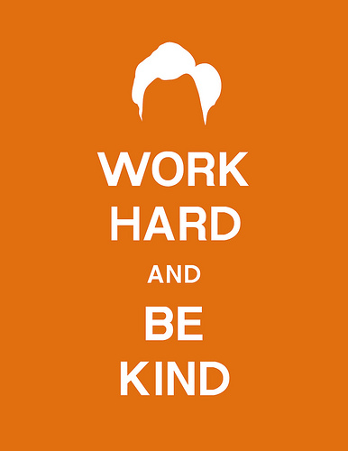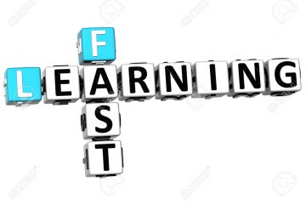





Key points that I learned when I was presenting my PDP
-Be prepared
-Be confident
-Speak loud and clear
-Always have eye contact with the crowd
-Smile
-Be funny when it`s possible

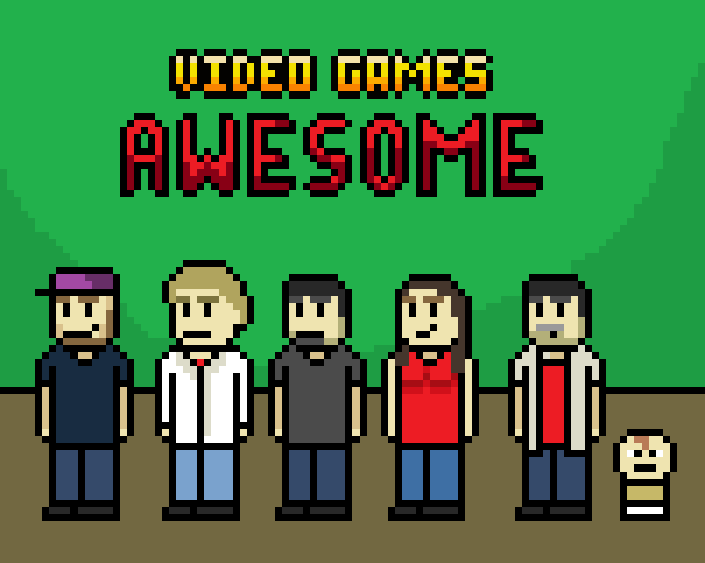
Part 2
This Photo by Unknown Author is licensed under CC BY-SA

Employability or ‘soft skills’ are the building blocks of your career. The media frequently run stories on how these skills are lacking in school-leavers, graduates and/or those already in employment. Organisations spend a lot of time and money training staff, not in job specific areas but in general and basic skills.
In times of high unemployment, employers have more choice of applicants and will favour those with well-rounded employability skills.
Most of us start to develop these skills early on in life, but we may not be aware that we are doing so.
Remember, though, that mastering these skills is a long-term process: there are few people who could—or would—ever claim that their soft skills could not be improved.
Creating a strong CV or résumé, writing a good covering letter, and interviewing well, are how you will show off your employability skills to potential employers. They are, however, not generally regarded as ‘soft skills’.

Higher education (also called post-secondary education, third-level or tertiary education) is an optional final stage of formal learning that occurs after completion of secondary education. Often delivered at universities, academies, colleges, seminaries, conservatories, and institutes of technology, higher education is also available through certain college-level institutions, including vocational schools, trade schools, and other career colleges that award academic degrees or professional certifications. Tertiary education at non-degree level is sometimes referred to as further education or continuing education as distinct from higher education.

Skills that I onw for my dream job (Programmer)
-quick learner
-ambitious
-hard worker
-basic knowledge
-team work

Skills that I need for my dream job
-Individual learning
-learn to work in PYTHON
-learn to work in C++
-learn to work in Java
-home projects

Short-term goals
-learn how to be a successful programmer
-finish the 1st year with good grades at Univesity
-move to a new house with my girlfriend
-take the driving test

Long-term goals
-have my own company with my friends
-create a successful video game
-buy a dog
-travel

Time management means working efficiently, and employers in every industry look for staff who can make optimal use of the time available to them on the job. Saving time saves the organization money and increases revenue.
Employees who manage their time well are more productive, more efficient, and more likely to meet deadlines. They focus on the most important and time-sensitive tasks and limit the amount of time wasted on non-essential duties.

Top Skills
Top skills

Prioritizing
It is usually impossible to do every single that you need and want to do all at once, but if you prioritize well, you should be able to complete the most important tasks in an order that makes sense. When assigning priority, consider such factors as when each task needs to be done, how long it might take, how important it might be to others in the organization, what could happen if a task is not done, and whether any task might be interrupted by the need to wait for someone else.
Planning
Planning is important, and not only because some tasks have to be done at specific times. Scheduling affects your day, your week, your month, as well as other people, their projects, and their short and long-term plans for projects and tasks. Most people also have specific times of the day when they are more and less energetic and become more productive when they schedule themselves accordingly. Schedules can be a good way to avoid procrastination, too.
Keeping a To-Do List
To-do lists (properly prioritized and integrated with your schedule) are a great way to avoid forgetting something important. They are also a great way to avoid spending all day thinking about everything you have to do. Remembering tasks takes energy, and thinking about everything you have to do all week can be exhausting and overwhelming. Split all the necessary tasks up into a list for each day, and you won’t have to worry about any of it anymore. Just look at today’s list.
Resting
Resting, even though it may seem contradictory, is an important time-management skill. Although working long hours or skipping breaks can sometimes improve productivity in the short-term, your exhaustion later will ensure that your average productivity actually drops. Except for rare emergencies, it is important to resist the temptation to over-work. Include necessary breaks, and a sensible quitting time, in your schedule.
Delegation
Depending on what type of work you do, you may be able to delegate some tasks. Knowing what to delegate and when is a skill. Some people resist delegating, either because they want to maintain control or because they want to save money by not hiring assistants. Both approaches ultimately hurt productivity and raise costs.

Examples in the Workplace
- Adapting plans to changing circumstances
- Allocating time for specific tasks
- Analyzing processes and selecting the simplest way to accomplish a task
- Asking for help when overwhelmed with demands
- Assertiveness to say no to inappropriate demands that distract from central duties
- Attacking more complex tasks when you have the highest energy and sharpest concentrations
- Auditing how time is spent
- Avoiding excessive small talk with co-workers
- Avoiding procrastination; acting instead of worrying
- Breaking broader goals into smaller parts and focusing on one step at a time
- Breaking up projects into manageable parts
- Creating daily, weekly and monthly “to do” lists
- Creating schedules
- Delegating more routine tasks to lower level staff
- Eating well to maintain energy
- Eliminating time wasters
- Exercising and participating in other stress-reducing activities during leisure time to maximize energy when at work
- Facilitating efficient meetings; sticking with time frames for meetings
- Grouping similar tasks together to limit transition time
- Maintaining an organized work area
- Multitasking; shifting smoothly from one task to another
- Openness to more efficient ways of doing things
- Organizing digital files for easy retrieval
- Planning your day the night before or first thing in the morning
- Prioritizing requests and demands
- Prioritizing a list of projects and focusing on higher value tasks with more immediate deadlines
- Punctuality
- Putting cell phones aside to eliminate the distraction of personal messages unless required for work
- Reviewing performance and eliminating deviations from priorities
- Setting daily, weekly and monthly goals
- Setting realistic standards for quality and avoiding perfectionism
- Setting specific times for responding to email
- Taking short breaks to restore energy
- Touching each piece of paper or reading each email just once, whenever feasible

What I `ve done to have a good time management work and social time.

At work:
-always planning, and trying to find the easiest way to solve an issue or to get the best result of my actions
-punctuality-for me is a very important thing ,it`s a form of respect for your work and your colleagues
-no mobile phones-a distraction from you work than might affect your work or you can put your associates health in danger
-Multi-tasking-is one of the key qualities that I have in order to have a successful and productive day at work
-always have an action plan-be proactive, control the situation
Social life

-to do list: prioritizing daily tasks from the most important to the less important
-resting: in my opinion with a rested mind and body you can face every challenge and you can hope for a positive outcome
-planning: planning your next day or your next step in your life is very important for me and I m trying to plan everything that happens in my life, in this way I can control my self confidence and aim for more

References
- Bakvis, Herman and David M. Cameron (2000), "Post-secondary education and the SUFA". IRPP.
- Commission Reports: A National Dialogue: The Secretary of Education's Commission on the Future of Higher Education, United States Department of Education, 2006. [2]
- Davies, Antony and Thomas W. Cline (2005). The ROI on the MBA, BizEd.
- Douglass, John A. and Todd Greenspan, eds. "The History of the California Master Plan for Higher Education."
- El-Khawas, E. (1996). Campus trends. Washington, DC.: American Council on Education.
- Ewell, P.T. (1999). Assessment of higher education and quality: Promise and politics. In S.J. Messick (Ed.),
- or university for study. ISBN 0-87784-172-1

Bibliography:
https://www.skillsyouneed.com/general/employability-skills.html
https://www.skillsyouneed.com/general/employability-skills.html
https://www.thebalancecareers.com/time-management-skills-2063776
https://www.mindtools.com/pages/article/get-started.htm
Journals
By Alison Doyle
Updated November 06, 2018

