A critical evaluation and the identification of next teaching and learning steps focusing on a case study of an individual learner or a group of learners, based on an observed critical incident

The purpose of this work is to evaluate a critical incident taking place in a school setting. In the context of this written work, a critical incident is any incident that analysis is applied to. An ‘incident’ does not have to be a major development in a child’s learning, nor an intense behavioural outburst. An ‘incident’ in the context of this work is an everyday occurrence that is mundane to the average observer, however it is the analysis and critical response to the mundane, everyday occurrence that makes the incident critical (Tripp, 2012: 25).
This will be achieved through an observation of lessons. Firstly, it is crucial to identify which observation method the researcher would utilise before continuing (Dawson, 2007: 4). With this in mind, it was then determined that the researcher would operate in a non-participatory role, and during the observations the researcher will be watching for incidents that can be unpicked and analysed in greater detail. It is the aim of the researcher to observe lessons with a professional approach; it is important that the researcher does not impede learning or compromise the validity of the observation through interaction with the children, teacher or learning environment. After discussing the observation and outlining why certain methods were used over others, the observer will then explore how the critical incident links to Donaldson’s four purposes of education. After, the incident will be explored using literacy and theories published in the relevant specialist areas to compare different approaches, with a focus on ALN and behaviour management within the classroom. Finally, the researcher will evaluate the critical incident and use the literature reviewed to form a personal opinion on the incident and maybe suggest alternative strategies if appropriate.

It is important to factor in how the observation could affect the observed party (Cohen, Manion and Morrison, 1994: 359). The observation will be from a non-participant view and - in line with BERA guidelines (BERA 2018) - anonymity will be essential to protect the identity of both the child and school, and ensure a respectful conduct is accomplished. It is important that the researcher maintains an indifferent in tone, and it is imperative that the research does not negatively reflect upon the child, the teacher, or the school (Tripp, 2012: 1). The child in the incident will be referred to not by name and instead as Child X. Furthermore, the school in which the incident was observed shall be referred to as School Y (BERA 2018: 21).
School Y is comprised of over 1,002 pupils, 10% of which are part of the school’s sixth form. School Y has nearly double the national average (Gov.wales, 2019) statemented pupils (2.8%), with School Y having (4%), and 23% have an additional learning need (ALN). The national average for free school meal provision is 18.3%; at School Y the free school meal provision is 26%. Nearly 40% of pupils are from the top 20% most economically deprived areas in the whole of Wales.
The class that was observed was an intermediate-ability Year 10 class during a Religious Studies (RS) lesson, just before lunch (see appendix lesson 1 notes). Child X was disrupting the lesson after being told to stop. Child X continued to disrupt whilst the teacher ignored him. The focus of this observation will be about what could have caused Child X to disrupt or what might have instigated this behaviour. Similarly, the researcher will explore the teacher’s choice to simply ignore Child X after they continued disrupting. A consequence of Child X’s disruption was that several other students became confused about what they were supposed to be doing.

The critical incident - in function at least – is comparable to a focused case study. This simply means that where a case study would traditionally take place over months or years, the critical incident and its applied analysis would take place over a much shorter period (two to three weeks). It was decided that the method of observation to be used would be non-participatory observation. Non-participatory simply means to observe from the boundary and not take an active role in what is occurring. The importance of this compared to participatory (taking an active role) is that the personal relationships developed between the researcher and learner may unintentionally apply a bias to the research (Tripp, 2012: 15). Moreover, research methods such as grounded theory - the employment of focus groups and interviews of the subjects to then create a hypothesis based on the data collected - were discarded as potential methods. Although flexible and open-ended as a research method (Dawson, 2007: 20), it was deemed too open-ended by the researcher given the time constraint to find a suitable research method. Finally, the interview process relies on the interviewer being able to establish a relationship with the interviewee so that they feel comfortable sharing their views and opinions on things (Dawson, 2007: 28); this relationship in itself would be wholly detrimental to the validity of the critical incident and muddy the findings, as the interviewee (in this case a pupil of a school) could fabricate feelings and opinions to try and manipulate the relationship with the interviewer.
A non-participatory role is important, as a negative consequence of case study-style observation is that the observer can allow personal bias to affect the process of observation, for example, helping children or spending time working alongside them creates the possibility of a bond that may bleed into the findings or the way events are recorded (Cohen, Manion and Morrison, 1994: 111). This is somewhat rectified in a non-participant role within observation, as those interpersonal bonds don’t have a chance to develop.
Contrasting this, participatory observation has advantages in the way that it allows the observer to elicit a greater understanding of what the thought process of an observed party may be - and in cases where the observer has taken a participant role within the class - they may be privy to ideas and thoughts that the observed party wouldn’t share with the teacher, and so a non-participatory observer would also be unable to access this private aspect of the observed.
To conclude, a sociogram was used (see appendix sociogram) as it demonstrates just how the disruption affected the class due to Child X’s centralised proximity and how the geography of the classroom affected the incident, and also how the seating arrangements of other classes may be more appropriate for the learner. However, it is crucial when considering what has happened in the critical incident and why it has happened, to also consider what has not happened, as it may shed some light as to why the critical incident has occurred in the first place (Tripp, 2012: 45). Finally, the Hawthorne Effect (McCarney et al., 2007) must be considered when contemplating how to observe. The ‘Hawthorne Effect’ is a theory that the observed being aware that they are being observed leads them to act in ways that are not the norm in that circumstance. It is imperative that the researcher stays out of the line of sight of the observed and tries to ensure the minimum amount of awareness from the learners that they are being observed.

Whilst describing the incident, it is going to be beneficial to identify and explore areas of Donaldson’s Four Purposes mentioned in that are either present or absent during the incident. These four can be summarised as; ‘ambitious capable learners, enterprising and creative contributors, ethical, informed citizens, and healthy, confident individuals’ (Donaldson 2015: 29). During a Year 10 Religious Studies (RS) lesson, Child X repeatedly shouted out. After a warning from the class teacher, Child X was moved to a seat at the centre-front of the class. Whilst at the front, Child X continued to shout out and disrupt by talking over other pupils, however when the teacher ignored this disruption and crouched by Child X and talked through some of the work that had been set, it was apparent that Child X was struggling to complete the task. Whilst the teacher worked one-to-one with Child X, he was quiet, polite, and engaged with the task. When the teacher began to move around the class and away from Child X, they started shouting out. After the class had left, the teacher said that the child had an ALN as well as awaiting diagnosis for another learning need.
In line with healthy and confident, Child X clearly demonstrated confidence and wasn’t afraid to speak in front of a large group (29 people). Also, Child X had clearly garnered the respect of several of his peers and so it could further be inferred that Child X has begun to ‘...form positive relationships based upon mutual trust and respect,’. (Donaldson, 2015: 30). However, the respect was not unanimous and - whilst assured - Child X was speaking about inappropriate topics. It may be prudent to help steer Child X towards speaking in front of groups in a way that is fruitful to their - and their peers’ - education and demonstrates respect towards all in the class, not just a select few.
Conforming to Donaldson’s purpose of all children becoming ethically informed citizens, Child X was, when impressed upon by the teacher who crouched next to them, able to ‘...engage with contemporary issues based upon their knowledge and values,’. During the course of the RS lesson, the teacher asked the pupils what they knew about looking after the planet in the context of man-made destruction (nuclear war) and pollution (e.g. birds covered in oil unable to fly). Child X was able to articulate an awareness of how much food waste as a country is thrown away each year. This demonstrates that Child X is already ethically informed about pollution and stewardship of the planet, however as discussed previously, Child X’s disrespect towards his peers by disrupting displayed a lack of knowledge in respect to the rights of the child (UN, 2019) and is a direct contradiction of Article 28, Every Child Has A Right To An Education (UN, 2019). By interrupting their learning and violating their right to learn, Child X has clearly shown an area in need of improvement regarding the Four Purposes.

The ALN of the child was ADHD with suspected autism, as of yet undiagnosed, could be of great importance when dissecting the critical incident. Special educational needs (SEN) are defined by the culture in which they are contextually based (Galloway, 1994: 13), and with that in mind we shall be examining SEN as it is outlined in the British SEN code of practice. ‘The SEND Code Of Practice 2015’ states that ‘a child or young person has SEN if they have a learning difficulty or disability which calls for special educational provision to be made for him or her’ (Department of Health, Department of Education, 2019: 15). The significance of this is that it is possible for children to have an ALN (dyslexia, dyspraxia, ADHD, etc) and still not be considered SEN by their school (Farrell, 2003: 12). However, the SEND Code Of Practice also declares that a child requires SEN if they consistently have a greater difficulty engaging with the subject comparative to their peers (Department of Health, Department of Education, 2019: 16). This is recognised by Farrell who writes about children with ALN but who are not considered SEN, and how they demand ‘flexible teaching’ (Farrell, 2003: 13). So, in relation to Child X, a task that was slightly altered from the rest of the class’ task may have been more appropriate, and allowed Child X to engage with the learning task without the teacher providing one-to-one support. Hattie and Yates write that the inability to understand a certain word in a sentence can massively undermine the comprehension of the text as a whole (Hattie and Yates, 2014: 52) and this may explain why Child X could only seem to access the work when the teacher was supporting.
As previously stated, Child X had suspected Autism Spectrum Disorder (ASD) but was as of yet undiagnosed. If Child X did have ASD then it could reveal why they had difficulty accessing the task; learners with ASD may require additional resources or resources of a differentiating level (Frith, 1989: 90). This is compounded by Farrell who affirms that not only do children with ALN need differentiation when it comes to lesson planning, and thus resources, but it is also essential that the child has a clear understanding of what is being asked of them, and learning objectives need to be available and concise (Farrell, 2003: 90). In spite of this, Farrell also writes that while integrating SEN pupils into classrooms can benefit them by providing a ‘normalised’ education, a standard secondary school teacher will have vastly different training when compared to a teacher who works in a SEN school or unit, and has constant training on the various aspects of SEN in education (Farrell, 2003: 107). Returning to Child X, it could be suggested that they need a more personal provision tailored to their individual needs and perhaps even a dedicated one-to-one support from an LSA for certain aspects of their learning experience or a few lessons a week in the school’s SEN unit where appropriate support is available. Importantly, Youell writes that a child with an ALN gives themselves a further ALN by accepting the low standards that they believe others have of them (Youell, 2006: 97).

When analysing literature that may aid our investigation of the critical incident, the field of behaviourism could inform our findings greatly. Child X’s disruption could be interpreted as a way of unknowingly displaying ASD tendencies and the need for additional support, however it could also be the case that they do not have ASD and could in fact be ambivalent of behavioural standards, or even being indifferent towards behaviour policy. The act of disrupting itself, of shouting out irrelevant information to evoke a comedic or respectful response from peers, could either be an operant behaviour or a reflexive one. The main difference between the two is that operant behaviour is controllable, and reflexive is not (Skinner, 2006: 44). This is important as if Child X’s behaviour is operant, it has wholly different connotations compared to if it is reflexive behaviour. If the disruption is operant then a closer look at the relationship between teacher and learner is required, and if it is reflexive it could infer that Child X’s anxieties are manifesting as disruption and a farcical bravado. The teacher choosing to ignore the disruption does not demonstrate a lack of control within the classroom, rather, the teacher has an intimate knowledge of their learners and can anticipate reactions to certain disciplinary sanctions. Being overly rigid and authoritarian with the pupils may have negative results, such as developing a barrier to pupils' learning in the form of a resentful relationship with the teacher (Canter and Canter, 2009: 18). Moreover, a pupil who is finding tasks difficult will often unknowingly signal for help (Hattie and Yates, 2014: 30), and, as a teacher, being able to notice and identify these subconscious pleas for assistance is absolutely crucial in the classroom (REF))). The pupil will - over time - come to associate disrupting class with one-to-one support (Skinner, 2006: 143).
Contrasting operant behaviour, reflexive behaviour can be an individual’s way of emotionally protecting themselves. To admit weakness in a subject area is an exposing event and can make learners feel vulnerable. Much like an animal of prey may associate seeing a predator with instantly flying/swimming/running away from the negative stimuli (Skinner, 2006: 47), learners who find a subject difficult will gradually begin to associate the inability to complete tasks to the required level to feelings of low self-esteem and inadequacy. What this means in terms of a reflexive behaviour is that the pupil will disrupt during the lesson automatically to avoid doing the provided task and thus protect themselves from criticism. Finally, when it comes to a reward system or sanctions, rewards are the preferred method of discipline, as sanctions simply put an end to the undesired behaviour, where in fact praise for good behaviours gently guide learners toward the desired behaviour (Mcphillimy, 1997: 55). (462)
Relationships in the classroom are an integral part of the learning experience and the most important relationship is the one between the learner and the teacher. If a teacher is ignoring - or appearing to ignore - a pupil who is not engaging or misbehaving, then the student could feel like the teacher is uninvolved in their well-being; this can lead to low self-esteem for the pupil and a reluctance to complete tasks in the classroom (Hattie and Yates, 2014: 17). When examining the poor performance of pupils (either in regard to working targets or classroom behaviour) it is important to also consider not only behavioural interventions, but what ways the teacher can have an impact upon the pupil and affect them positively (Cooper, Smith and Upton, 1994: 51). Further, the relationship between the teacher and child can boost the child’s social-emotional functioning (Rucinski, Brown and Downer, 2018: 993). Children will impress their own familial relationships upon teachers subconsciously, expecting a paternal or maternal role (Youell, 2006: 136) and this is especially significant in regard to pupils who come from homes where their well-being and emotional state are not prioritised in the home environment. Also, it is important to look at the role of the pupil and the learner, and recognise that there are multiple roles expected of the learner. There is the ‘traditional’ role of the learner, where they are expected to sit silently and receive verbal information and commands. There is the role of participating in small groups, maybe even pairs, where they must constantly switch roles and transform from speaker to listener. There is the role of presenting information to the class, reading completed work or prepared texts. It can be difficult for learners to deviate from one role to the next, and even more so in learners where they have a poor social model at home (Andersen, 2009: 113), where the parents may have a slighter comprehension of social constructs such as turn-taking in conversation and listening and responding respectfully. Where there typically might not be the chance for one to blossom in a class of 30 pupils and only one teacher, and so the teacher must instead use the limited interaction with each pupil tactically to create a positive relationship. Engaging a late pupil in discourse about their tardiness immediately puts them on the defensive and can damage the pupil-teacher relationship, whereas a polite greeting and a quiet word about their lateness at a less exposing time can reassure pupils that they are in a friendly environment but also cared for (Alison and Halliwell, 2002: 8) and this nurturing effect can positively affect the majority of aspects related to school life.
Linking back to Child X and the critical incident, Hattie and Yates write ‘Close and supportive relationships with teachers have the potential to mitigate the risk of negative outcomes for children who may otherwise have difficulty adjusting and succeeding in school’ (Hattie and Yates, 2014: 18). Therefore, the pupil assuming a strong relationship with the class teacher can act as a buffer for negative behaviours such as refusal to do work or poor behaviour.

Here I - the researcher - will evaluate the three chosen areas of investigation in regard to the critical incident and consider next steps. It is important to remember that the critical incident is only a snapshot of Child X and the teacher, and may not be representative of their regular behaviour. That is to say, the behaviour exhibited by Child X may not be the norm, or there may be extenuating circumstances that I could not have known about, that the teacher is in fact aware of and unable to disclose. The beginning of the literature review focused on possible ALNs such as suspected ASD and diagnosed ADHD. These (suspected) ALNs appear to be having a big impact on Child X and their ability to focus and carry out work tasks successfully. If I were in a position to impress change for Child X, I would begin by ensuring the assessment of the child regarding ASD is completed as soon as possible. Once the assessment has been completed, a statement will likely be obtained declaring the additional help the child will need. A good line of communication with Child X’s family would ensure he is taking his ADHD medication punctually which would hopefully lead to a drop in behaviour spikes. Furthermore, it may be beneficial to communicate with guardians and see if it would be possible to keep a reserve of the medication at school in case Child X forgets to take it in the mornings, complicating their school day. The completion of the assessment will hopefully mean that Child X is assigned a Learning Support Assistant (LSA) who can aid Child X in lessons where they usually have difficulty, in addition to being a consistent friendly adult that Child X will be able to build a positive relationship with. Moreover, Child X will most likely feel safest talking to the LSA about problems should they arise, and the LSA will be able to pick up changes in Child X’s behaviour if it changes throughout the day compared to teachers who only witness Child X for an hour a day. This intuition would be immensely helpful in not only helping to anticipate changes in mood for Child X but also what are Child X’s triggers, and how can these triggers be navigated in a way that doesn’t impact their learning. For example, something as simple as Child X becoming agitated and socially hostile during a lesson because the class has been asked to colour in a map of Europe with different colours for each country could be rectified by having a similar task prepared that calls upon the same knowledge but without the trigger (colouring). In this example, Child X could instead simply write the names of the different countries or use an atlas to look up the names of each country. This method is helpful as it still progresses their learning in a way that will not socially alienate them among their peers (the same way being sent out of the room each time there was a colouring activity might) and will minimise the chance of them becoming frustrated and upset.
Be that as it may, if the ASD assessment came back negative, then there would need to be behaviour interventions put in place to deal with the behavioural aspect present in the critical incident. Emulating the techniques of the RS teacher, I would ignore the disruption and speak to Child X at the end of class. The thought process behind this is that Child X is using the disruption to gain attention, negative though it may be. When their peers had left and they no longer had an ‘audience’ to impress, a restorative-style talk between teacher and pupil could take place where they discuss what went wrong in the lesson and how it can be avoided in future lessons. Furthermore, a conversation with the pastoral team would take place regularly should the child’s behaviour continue to be less than desirable. Whether the main stimuli in the critical incident was ASD, poor behaviour or a lacking relationship, communication with home and the pastoral team is paramount in ensuring the safety of the child in the long run.

Concluding, my main objective in relation to the critical incident was to observe several lessons in School Y and decide which observation to apply deeper analysis to, using my findings to potentially inform my teaching. This drew me towards barriers to learning and ALN. The analysis would be guided by relevant academia in the fields of ALN, behaviourism and relationships, and how the Four Purposes (Successful Futures) were either impressing the critical incident or were absent from it. It appears to me that Child X could have the additional learning need of autistic spectrum disorder (ASD) or has chosen to display poor behaviour through operant or reflexive behaviour. Following this, Child X might require some additional support, either through learning support assistants aiding in the lesson. My findings have demonstrated the importance of being able to adapt lessons to ensure their accessibility at all levels within the classroom. Moreover, the importance of being able to quickly identify students that need extra provisions - whether that is in the form of LSA deployment through one-to-one methods, by teachers of Child X creating additional resources that are pitched more closely to a level that Child X can work comfortably at, behavioural interventions, or the learner developing long-lasting relationships with the appropriate safe adult – will have an impact on how I manage difficulties within lessons that I lead. Also, if the behaviour is reflexive then it could be indicative of low self-esteem for Child X, and so more discourse is required between Child X and the teacher about why that may be.

References:
Alison, J. and Halliwell, S. (2002) Challenging classes. London: CILT, pp. 8.
Andersen, N. (2009). Power at play. London: Palgrave Macmillan, pp. 113.
British Educational Research Association [BERA] (2018) Ethical Guidelines for Educational Research, fourth edition. Available at: https://www.bera.ac.uk/researchers-resources/publications/ethical-guidelines-for-educational-research-2018 (Accessed: 20th October 2019)
Canter, L. and Canter, M. (n.d.) Assertive discipline. Santa Monica, CA: Canter and Associates, pp. 18.
Cohen, L., Manion, L. and Morrison, K. (1994) Research methods in education. 4th ed. London: Routledge, pp.111, 359.
Cooper, P., Smith, C. and Upton, G. (1994) Emotional and Behavioural Difficulties. London: Routledge, pp. 51.
Dawson, C. (2007) A practical guide to research methods. 4th ed. Oxford: How To Books, pp. 4, 20, 28.

Department of Health and Department of Education (2019) Special Educational Needs and Disability Code of Practice: 0 to 25. Available at: https://www.gov.uk/government/publications/send-code-of-practice-0-to-25 (Accessed: 15th October 2019)

Donaldson, G. (2015) Successful Futures: Independent Review of Curriculum and Assessment Arrangements in Wales. Available at: https://gov.wales/sites/default/files/publications/2018-03/successful-futures.pdf (Accessed: 15th October 2019)
Estyn (2015) A Report on School X. Available at: https://www.estyn.gov.wales/sites/www.estyn.gov.wales/files/documents/Bishop%20Gore%20School.pdf

Farrell, M. (2003) The Special Education Handbook. 2nd ed. Hoboken: Taylor and Francis, pp. 91.
Frith, U. (1989) Autism. Blackwell, pp. 90

Galloway, D. (1994) Assessment of special educational needs: Whose Problem? London: Routledge, pp. 13.
Hattie, J. and Yates, G. (2014). Visible learning and the science of how we learn. London: Routledge, pp. 17, 18, 30, 52.
McCarney, R. et al. (2007) ‘The Hawthorne Effect: a randomised, controlled trial’, BMC Medical Research Methodology, 7(1). Available at: https://bmcmedresmethodol.biomedcentral.com/articles/10.1186/1471-2288-7-30 (Accessed: 10th October 2019)
Mcphillimy, B. (1997) Controlling your class. Chichester [u.a.]: Wiley, pp. 55.
Rucinski, C., Brown, J. and Downer, J. (2018) ‘Teacher–child relationships, classroom climate, and children’s social-emotional and academic development’, Journal of Educational Psychology, 110(7), pp. 993.
Skinner, B. (2006) About behaviourism. Pimlico, pp. 44, 47, 143.
Tripp, D., 2012. Critical incidents in teaching: Developing professional judgement. Classic ed. London: Routledge. pp. 1, 15, 25, 45.
UN General Assembly (1989) ‘Convention on the Rights of the Child’, United Nations, Treaty Series. 1577, pp. 3. Available at: https://www.refworld.org/docid/3ae6b38f0.html (accessed 15 October 2019)
Welsh Government (2019) Statistical First Release. Available at: https://gov.wales/sites/default/files/statistics-and-research/2019-07/school-census-results-2019-764.pdf (Accessed: 10th October 2019)
Youell, B. (2006) The Learning Relationship. London: Karnac Books, pp. 97, 136.

Appendix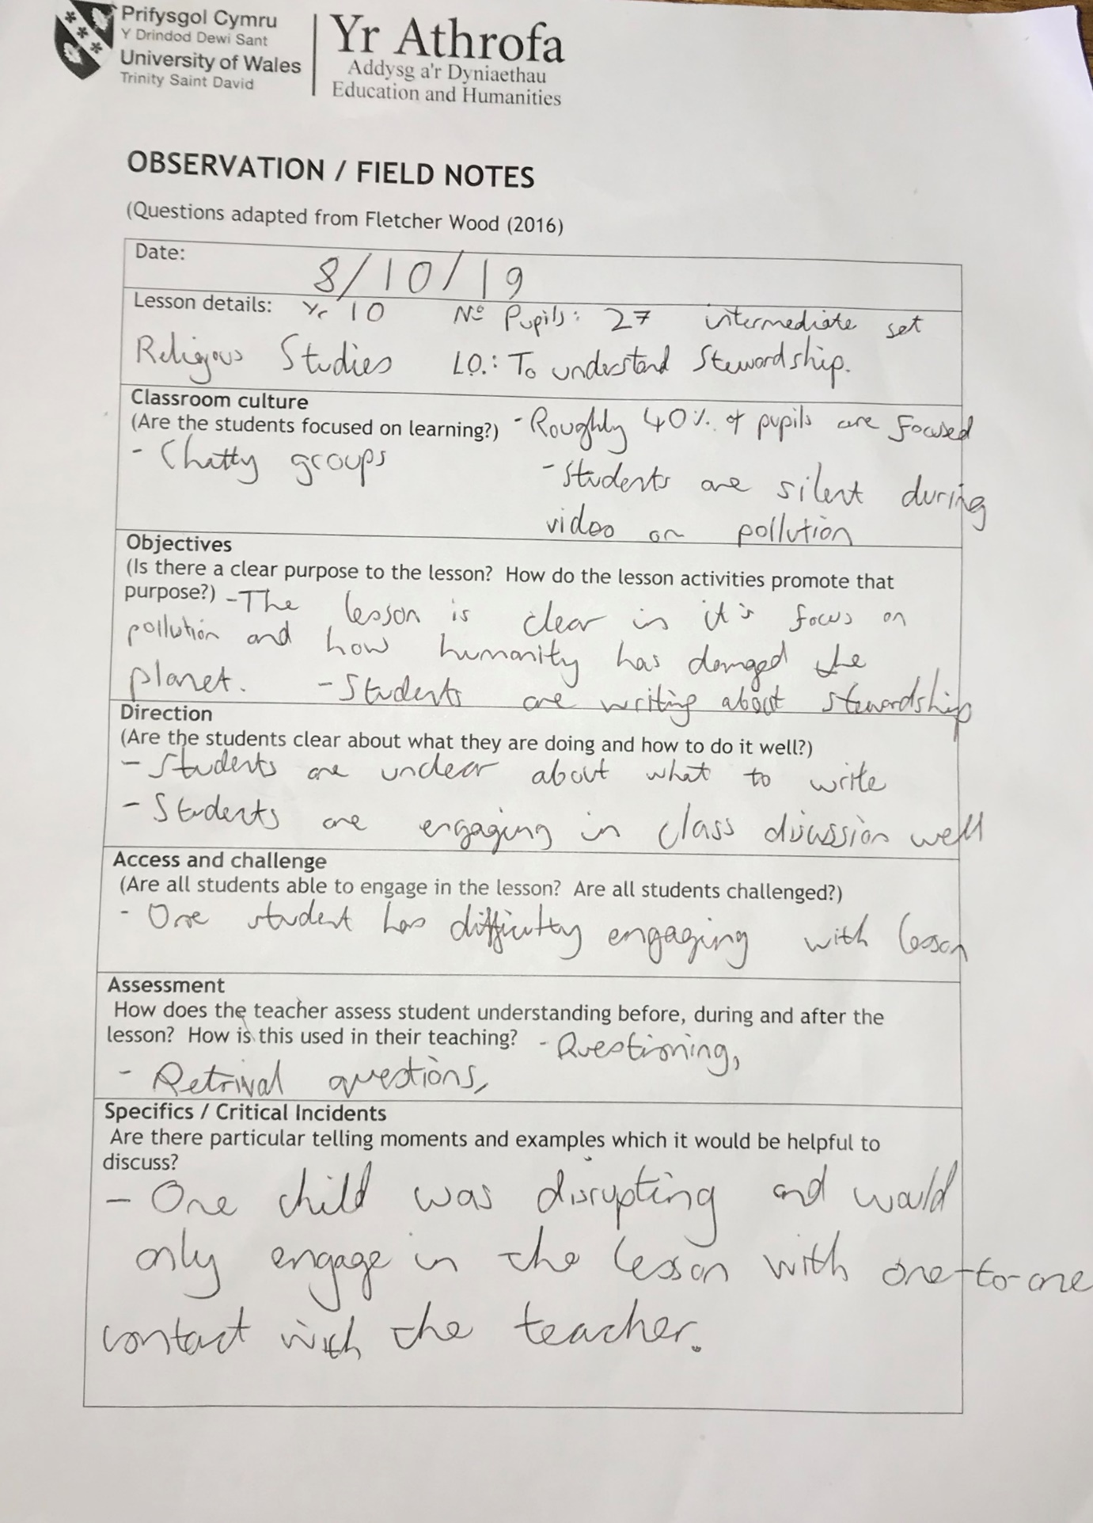
Lesson 1: Religious Studies

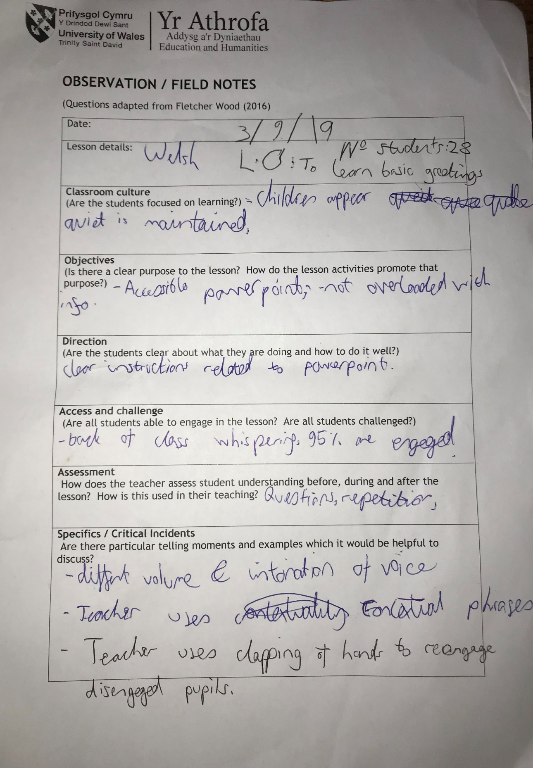
Lesson 2: Welsh
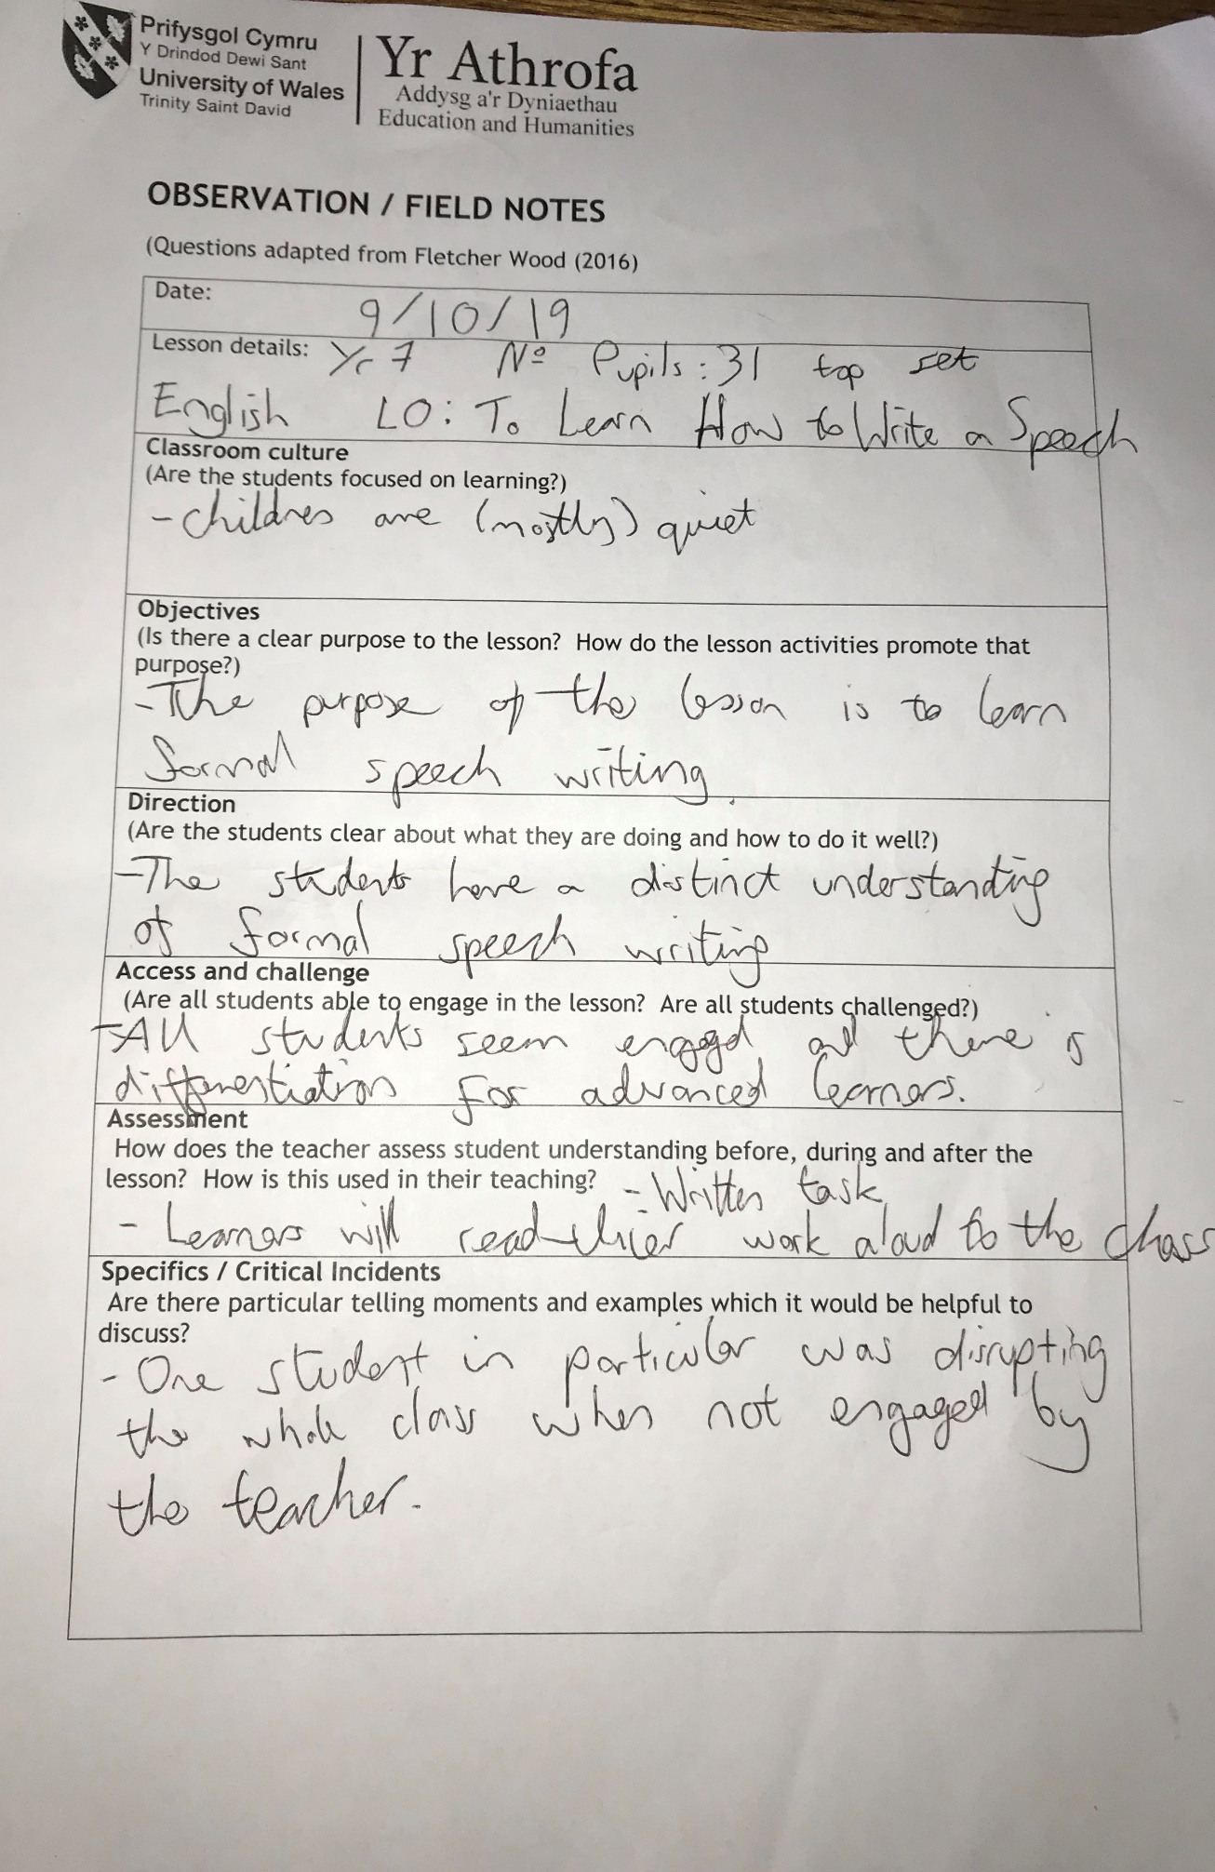
Lesson 3: English
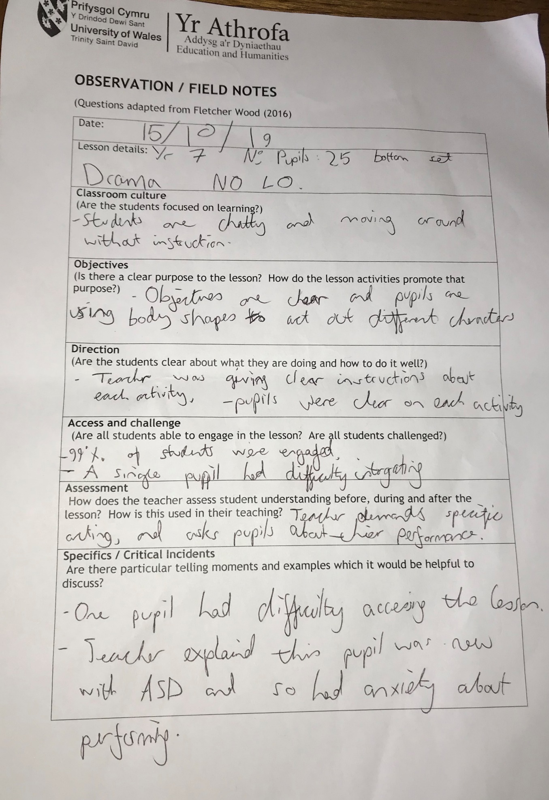
Lesson 4: Drama
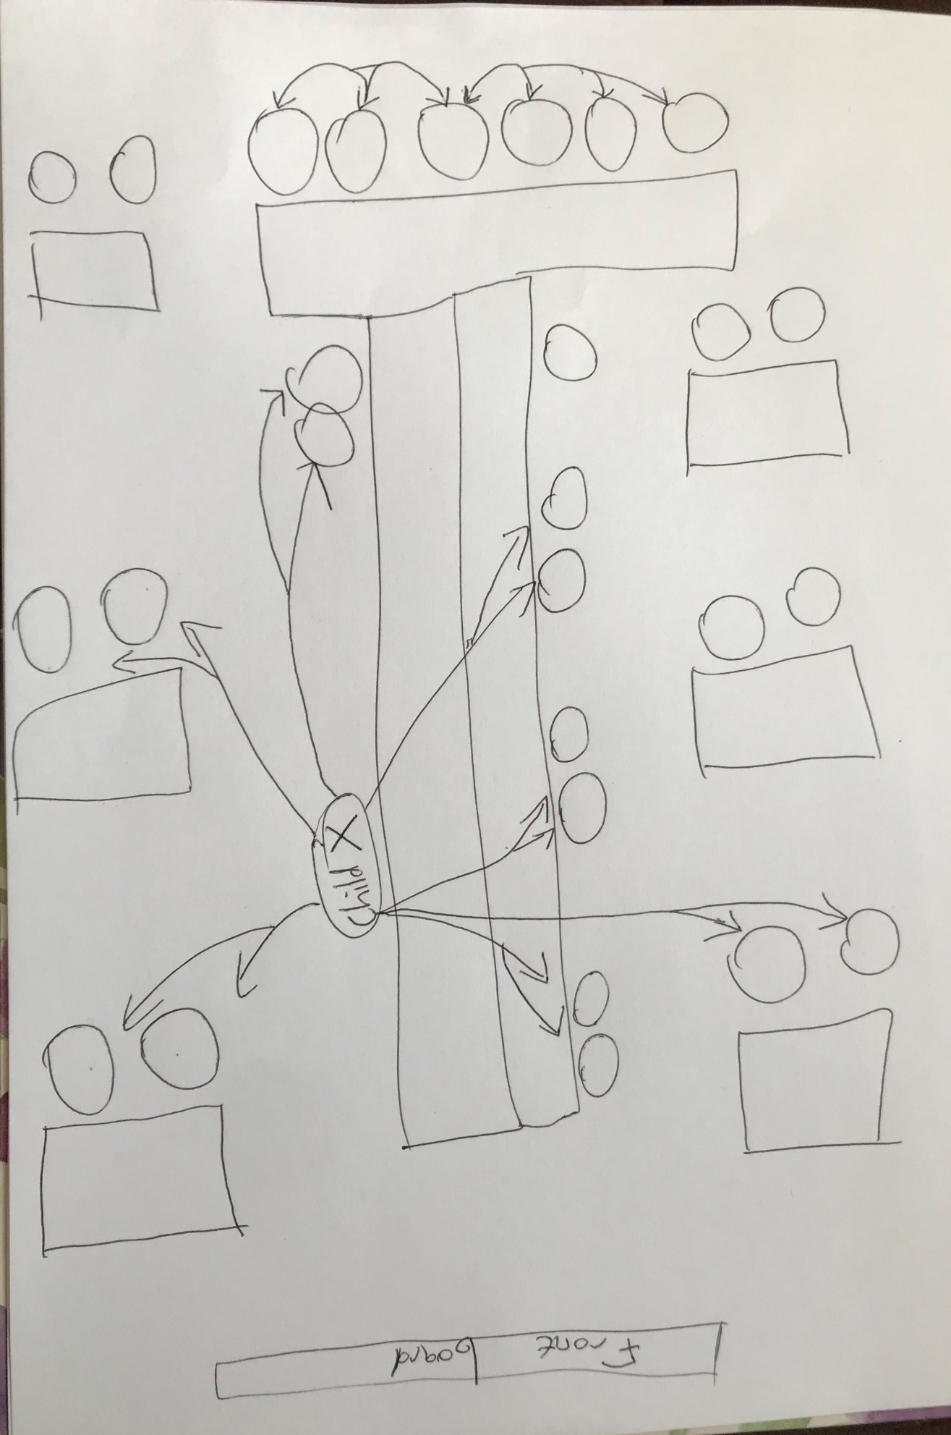
Sociogram – Religious Studies

