
Module Title & Code: Food and Beverage Operations BMIH4002

Assessment 2 Food Beverage

Student Name: Shabana Begum
Student ID: 2223853
Contents
Introduction 3
Restaurant Concept 4
Target Audience 4
Reasoning Behind Menu Choices 4
Menu Design 6
Conclusion 8
Bibliography 9

Introduction
In food and beverage industry there are multiple things that play critical role on the prospect of how the customer can be attracted. From designing a menu to check the authenticity of a cuisine all favors the necessary process that requires the proper framework that will make the restaurant successful (Yang et al, 2017). The pricing strategy also plays a critical role as customers are price sensitive and there are lots of reasons one restaurant may become successful while other not. This report will focus on the prospect of how a restaurant menu is design under Trinity Hotel and how the target customers are acquired and how the overall prospect of the business will be used for making the restaurant successful.

Restaurant Concept
The main purpose of a restaurant is to bring the overall Mexican cuisine under the name of Trinity Hotel (Powell et al, 2013). For this reason, “El Nino” will be our flagship restaurant that will be focused on the prospect of new products that will satiate the customers. The main target of this restaurant is to bring Mexican food in UK. The main prospect is that Mexican food is full of flavor. And the menu we are going to make is mostly the menu that will be liked by others as they are the snacks category food. For this reason, we will choose open place for London where lots and lots of students are willing to go. The main target here is that the students are eager to eat this spicy product and market research suggest there are a huge demand in the market. For this reason, the restaurant has fantastic market prospect in term of new audience in the market.

Target Audience
The target audience is one of the most critical factors in the business. As the segmentation, target and positioning plays critical role on the prospect of how an audience will be focused, a restaurant on food and beverage business needs to upgrade them for the future improvement (Ojugo, 2009). The main prospect of gaining the proper ways of knowledge is to find out how restaurant can thrive in current market scenario.
The overall understanding of the market for “El Nino” is highly important due to fact that the proper ways of brining new cuisine in the market is to bring proper market analysis which will aid for further understanding of the business.

Reason Behind Menu Choices
The menu is one of the most critical factors. As the main selling point of business is to sell its products, the menu has all the necessary products of the company in the market. The main target here is to check how one might look for and customize the order that needed to be met (Lillicrap and Cousins, 2010). For this purpose, we need to make the menu. The main reason why we have chosen the proper ways of making new menu is that it aids use to understand the common perception about the food in the market and how they are focused on making new things in the market. For this reason, the overall menu choice will handle how much customer acquisition we are going to get from the market. For this reason, we have chosen such Mexican menu is that.
The Mexican menu is one of the most prominent food choices one can have. As our targeted customers are mostly young persons, the spicy food of Mexico will attract them more. Not only the menu will have multiple foods in spicy category but also they will provide food in all aspects of the product that can be consumed on the go.

Menu Design
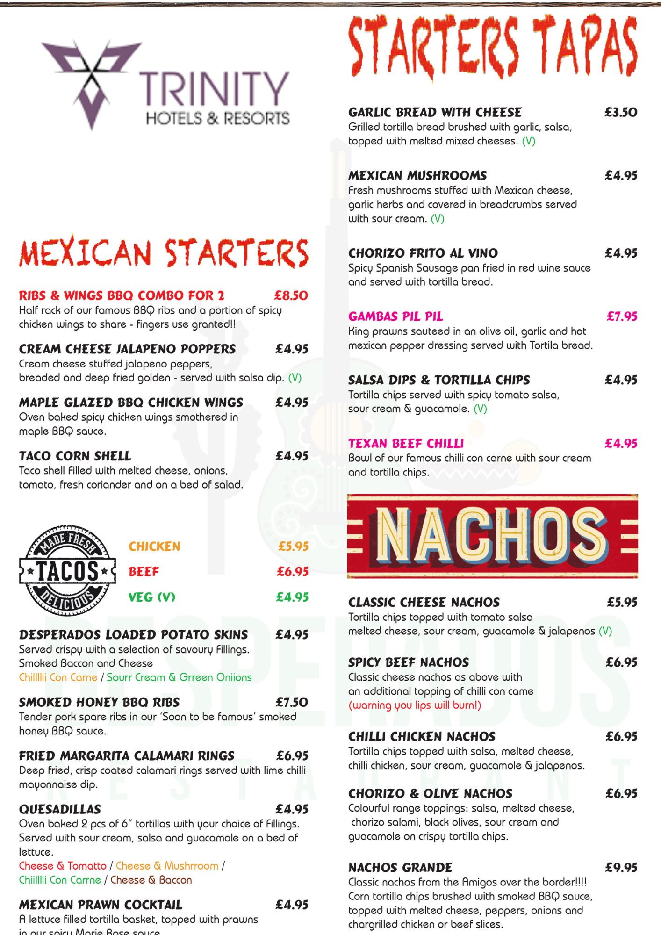
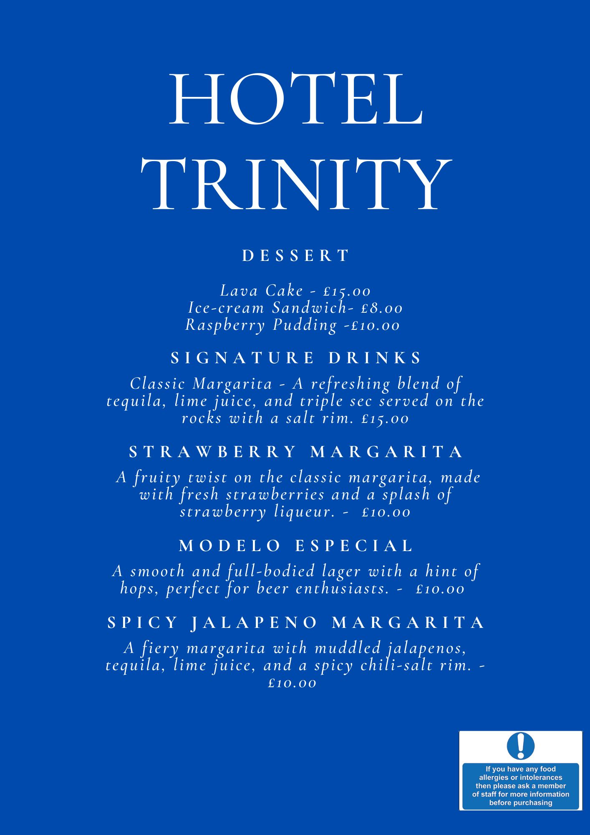

Conclusion
There are a number of different aspects to consider in the food and beverage industry, each of which plays a vital role in determining the chances of effectively attracting new consumers to a business. Every stage of the process, from conceiving of a menu to assessing whether or not a certain cuisine is authentic, adds to the accomplishment of a restaurant's goal of being successful, and that achievement is contingent on having the necessary framework in place. Customers are price aware, which means that the pricing strategy plays an important role in the equation as well. The level of success that a particular restaurant achieves in comparison to others might be the result of a number of different reasons. This research has focused on the potential of how a restaurant menu can be established under the Trinity Hotel, how target consumers can be reached, and how the complete potential of the firm can be used for the aim of making the restaurant successful.

Bibliography
Araci, U.E., Bulut, Z.A. and Kocak, N., 2017. The relation among experiential marketing, customer satisfaction, and behavioral intention: A study on food and beverage businesses. Economic and Social Development: Book of Proceedings, pp.361-371.
Cousins, J., Foskett, D., Graham, D. and Hollier, A., 2019. Food and beverage management: for the hospitality, tourism and event industries. Goodfellow Publishers Ltd.
DiPietro, R.B. and Levitt, J., 2019. Restaurant authenticity: Factors that influence perception, satisfaction and return intentions at regional American-style restaurants. International Journal of Hospitality & Tourism Administration, 20(1), pp.101-127.
Fleming-Milici, F. and Harris, J.L., 2020. Adolescents’ engagement with unhealthy food and beverage brands on social media. Appetite, 146, p.104501.
Jack E, M., David K, H. and Lea R, D., 2008. Food and beverage cost control. Joh Wiley And Sons.
Kent, M.P., Dubois, L., Kent, E.A. and Wanless, A.J., 2013. Internet marketing directed at children on food and restaurant websites in two policy environments. Obesity, 21(4), pp.800-807.
Kurnia, Y., Isharianto, Y., Giap, Y.C. and Hermawan, A., 2019, March. Study of application of data mining market basket analysis for knowing sales pattern (association of items) at the O! Fish restaurant using apriori algorithm. In Journal of Physics: Conference Series (Vol. 1175, No. 1, p. 012047). IOP Publishing.
Lillicrap, D. and Cousins, J., 2010. Food and beverage service. Hodder education.
Ojugo, C., 2009. Practical food and beverage cost control. Cengage Learning.
Powell, L.M. and Nguyen, B.T., 2013. Fast-food and full-service restaurant consumption among children and adolescents: effect on energy, beverage, and nutrient intake. JAMA pediatrics, 167(1), pp.14-20.
Yang, S.B., Hlee, S., Lee, J. and Koo, C., 2017. An empirical examination of online restaurant reviews on Yelp. com: A dual coding theory perspective. International Journal of Contemporary Hospitality Management, 29(2), pp.817-839.

