C Lewis Student
Module 5
Reflective report on the many and varied challenges of operational leadership in policing


General introduction
Challenges to operational leadership in policing in England and Wales are multiple and correspond to the complexity of the rapidly changing socio-economic, political and environmental climates. The College of Policing (2020) presents a range of key trends that are currently mounting challenges to policing, and which will continue to do so over the next twenty years, such as rising inequality and social fragmentation; an expanding and unregulated information space; a changing trust landscape; technological change and convergence (Batts et al. 2012) and harnessing artificial intelligence and work force automation. Add to this a framework of policing constraints that are often present within policing culture (Cockcroft, 2019), complex multiagency environments (Ransley and Mazerolle 2009), the burgeoning requirement of accountability (Rowe, 2020), demands of vulnerability and threats from serious and organised crime (Her Majesty’s Chief Inspector of Constabulary, 2022), whilst policing diverse communities and being under the often unfavourable glare of the press and media (Walsh and O’Conor, 2019). It is not surprising therefore that police leaders are like all police officers, experiencing increasing impact on their mental health and wellbeing (Demou et al. 2020). This too is a challenge for operational leaders (OL) who must maintain the morale and wellbeing of their staff and themselves, whilst engaging with so many demands.
Challenges to focus on
It is logical therefore that with so many competing demands clamouring for the attention of OL that it is increasingly important that policing in a multiagency environment, looks to effective prevention work to drive down demand. The challenge of effective police prevention work will therefore feature significantly in this report. OL must also be cognisant of the need for policing to be on a trajectory of increased effort around procedural justice, to address the waning trust and confidence that exists within society towards policing. Therefore, this challenge will be additionally highlighted. A significant decrease in trust and confidence in the police was recorded between 2017 and 2020, with trust down from 62% to 55% of people surveyed (Brown, 2021). Trust in policing has been seriously undermined by high profile cases such as the abduction, rape and murder of Sarah Everad in 2021, by a serving police officer, Wayne Couzens. 50% of women and girls who were recently surveyed about their feelings of personal safety reported feeling unsafe when out and about in busy places and three out of five women aged 16 to 34 years of age experienced at least one form of harassment in the previous 12 months (Office for National Statistics, 2022). In fact, violence against Women and Girls and Domestic Abuse (VAWGDA) is at epidemic proportions (Office for National statistics, 2022). Amongst the challenges to operational leadership from the demand in policing vulnerability, is how we change outcomes for women and girls. To effect such a change means addressing cultural normalisation of sexual harassment and violence (Estyn, 2021). Changing cultural behaviours needs addressing at an educational level (Finch, 2012; Dukes et al., 2022). Within this report, I will be exploring the importance of OL getting down stream of the complex issues of vulnerability, affecting children and young people (C&YP), such as VAWGDA, by engaging C&YP in crime prevention educational interventions, which have the additional benefit of also creating trust and confidence in in the police through procedural justice, which is shown to increase legitimacy and compliance with the law (Sindall, 2017; Braford and Yesburg, 2020).
Prevention and education
Prevention is central to all public service’s work that attempts to address health, wellbeing, safety and harm reduction in our communities. However, Muir (2021) notes that little is spent on such an important aspect of work. For example, from the £160 billion NHS budget only 3% or £5 billion was allocated to preventative work. Policing too requires a prevention approach to reduce demand, which is outstripping the resources available to meet it. Muir goes on to note that there is clear evidence for the effectiveness of a prevention approach to crime. The Office for National Statistics show that between 1995 and 2019, burglaries in England and Wales fell by 74%. There is therefore strong evidence for the effectiveness of a preventative approach to crime (Marlow 2011). Better security through door and window locks and security systems were at the heart of this downward trend. This decrease was also prevalent in car theft, which fell by almost 80% in the same time frame. It was not tougher sentencing or new police tactics that assisted in reducing crime, but improved security measures.
The Barber report (2022) noted a shift in the threat of crime from conventional sources to amongst other crimes, computer misuse and fraud offences, which in 2021 accounted for 53% of all crime. Muir suggests that catching such offenders, who may even exist outside of the UK is extremely difficult. Clearly more police officers on our streets will not address this threat and he proposes that an approach that designs out these forms of crime at source, as achieved with car crime and burglary, is the way to proceed. He exposes the key weakness within crime prevention work, as primarily no one owning the task of prevention. In the absence of a systematic approach to crime and harm prevention, unlike the policing and Criminal Justice System, which benefits from defined lines of accountability, distinct roles and duties, funds, priorities, and designated support from other organisations, conversely, prevention exists without these systemic approaches to collaboration across multi agencies.
To design out online crime, however, which is a significant risk to C&YP (Internet Watch Foundation, 2021) and a challenge to OL, it is important to acknowledge the wide spectrum of offences that exist, from online fraud to a range of sexual offences, harassment, stalking, malicious communication, hate crime and so on. It is not easy to design out crime in this domain. A long-awaited Online Safety Bill to protect children online should become law soon. This bill will put a burden of responsibility on online companies to put safeguarding measures in place to prevent certain harms from happening to children. However, this bill will be ineffective in protecting children from ‘regulated content’ in relation to ‘user-to-user’ services, meaning user-generated content such as sexting, abusive communications and scams, will not be in the framework of the bill (Landmark Chambers, 2021). Therefore, prevention approaches to reducing this kind of offending, requires another approach, a prevention education one.
Education as a tool to preventing crime as endorsed by the United Nation’s Doha Declaration 2017, essentially acknowledges, and promotes education as a tool to foster peace, justice and equality for sustainable development. It has a significant part to play in determining the values of future generations, forging a united consciousness, redesigning societal predilections, and accompanying this with the required skills to perform these values (United Nations Office on Drugs and Crime, 2017). In Wales multi-agencies are required to collaborate in preventing C&YP from entering the Youth Justice System, to avoid poor outcomes that may result (The Social Services and Well-being (Wales) Act, 2014 and the Well-being of Future Generations (Wales) Act, 2015).
In this report I plan to reflect on the challenges to OL of working within a youth crime prevention-oriented policing domain, against a backdrop of a senior policing leadership culture, where working in a youth crime prevention capacity, had traditionally been viewed as a poor cousin to other forms of operational policing. I will explore the significance of these operational leadership challenges to crime prevention amongst the young, upon reflection of a significant event during a period of review of my force’s prevention police services, in schools. I will reflect upon the learning and experience gained from one event and its repercussions, identifying my own leadership approaches and how effective leadership supports the wellbeing of staff when managing change.
Reflective models
A range of reflective models exist to assist in the analysis of experiences within a policing context. Some simple models like Kolbs Reflective Cycle (1984) (Appendix 1), guide us to describe the experience, reflect on it and implement what is learnt from it. Rolfe et al. (2001) (Appendix 2) in similar manner asks us to consider, ‘What happened? So what? Then, now what, or what’s next?’ Gibbs Reflective Model (1998) (Appendix 3) adds further guidance in his approach, starting with a description of what happened, a reflection on the thoughts and feelings produced by the experience, what might have been good or bad about the experience; what did you make of the experience, what else you might have done at the time and the impact on what you might do in the future. John’s Model (2002) (Appendix 4) shares similarities with Driscoll’s Model (2007) (Appendix 5). John’s model sets the tone by asking, ‘What information do I need to access to learn from the experience?’ He suggests describing the experience, reflecting upon it through analysis of the event and any influencing factors, before deciding how you could have dealt with the experience better and formulating the learning that has come from it. Driscoll adds a further step of actioning the learning as it pertains to clinical practice.
In this assignment I will be using the Gibbs’ Reflective Model to unpack the challenges around operational leadership and provide a useful framework for the learning I want to explore. Given the aspect of stress that can be created for OL from challenges being faced within a role, this framework reminds me to explore the aspect of the impact of an experience on me as an individual leader and on others, who must navigate daily pressures created by the job, which can have an impact on health and wellbeing if not effectively managed.
Reflection - What happened?
It will help to contextualise the event I will be reflecting on. In 2015, a national review of the Wales Police Schools Programme (WPSP) was initiated by the National Programme Police Lead and Police and Crime Commissioner in South Wales. This was at a time when Welsh Government (WG) was considering withdrawing the annual 50% funding it provided from its Health and Social Care budget. WG and the four Welsh Police Forces jointly fund the WPSP, which operates in partnership with all schools in Wales, including alternative and special educational settings.
School Police Officers (SPOs) work closely with schools to deliver crime prevention education on substance misuse and wider community and personal safety issues, amongst a range of other lessons in line with the new Health and Well-being Curriculum for Wales. It also provides supportive policing services to schools, dealing with incidents, using the School Crime Beat Protocol (See appendix 6) to keep young people out of the Criminal Justice System. During this period only Divisional Commanders were surveyed for their opinion on the potential impact of the loss of the programme or its future development. Schools were not consulted, and decisions being made, were not undergirded by evidence-based practice (Sherman, 1998) or adequate stakeholder consultation. Even misinformation was being fashioned to undermine the accomplishments of the programme, by my own organisation.
The specific incident I want to present happened when a now departed Assistant Chief Constable (ACC), asked to address the whole WPSP team of thirty SPOs, during a designated training day, to speak with them about their work. The ACC addressed the audience with an accusatory tirade on how poorly the team were performing, based on what he stated was evidence he apparently contained in documents he had to hand. His facts were wildly inaccurate, and his comments spilled over into personally calling out a few SPOs who had attempted to politely question the source of his information or respond to accusations about their work. I attempted to challenge the inaccuracies that were being portrayed, contradicting them with facts and figures that I could recall. Many references were made to the aspect of real policing work, which at the time I found quite triggering, as it implied that if you were not arresting young people then you were not engaged in real policing. When I asked if there was an impact report in the pipeline, to ascertain from all the stakeholders, such as C&YP and school staff, what their perspective was regarding any changes to the programme, or the impact on them of losing it, I was told flatly that ‘they’ already knew what schools would say and so this was unnecessary. I hasten to clarify here that this was not because of any consultation having already been undertaken, but it was a supposition on behalf of this ACC that schools would naturally not want any changes to the service. However, there were already plans to diminish the time spent working in schools and the size of the team.
Reflection – Thoughts and feelings
My initial reflection upon the event is to acknowledge the damage that was done to the team by the hostility prevalent in the communication on this day. Management of police personnel is by far one of the most challenging and important aspects of operational leadership (White and Robinson, 2014). The research highlights the importance of managing the ‘psychological contract’ when navigating change. Isaksson (2020) notes that the psychological contract is a useful theory for understanding the relationship between employers and employees, and represents how agreement or disagreement, often based on unwritten, tacit perceptions and beliefs, affect attitudes and behaviour at work. There is a clear correlation between positive psychological contract and the performance of an organisation (White and Robinson, 2014). The negative impact the meeting with the ACC had upon the team of SPOs was evident in the damage to their psychological state at the time and their consequent relationship with this leader. Studies indicate that police officers most frequently identified effective leaders as being integrous, having a strong work ethic, good communication, and essentially care for personnel; ineffective leaders were characterized as failing to express these traits (Schafer 2010).
Hearing such a damning representation of the role of an SPO, caused many on this day to be angry and visibly upset, a feature of their communication with me after he left. They were frustrated at the lack of recourse and dejected that they were treated in such a dismissive and disparaging way. On this day I too experienced a wide range of feelings from confusion as to where the information had been sourced, indignation that we should be spoken to in such an unacceptable manner, exasperation that there was nothing positive related to us throughout the discourse, humiliation at the tone of the monologue and disgust that such a hard working team were being verbally, unjustifiably berated by such a senior figure and made to feel like rubbish.
The leadership culture being demonstrated at this time through the ACC was not one that modelled fairness, treating all people with respect and dignity, giving people a chance to express their views, listening to them, and making impartial decisions that can be explained in an open and honest way (College of Policing, 2021). As OL it is imperative that we model the right policing culture in our interactions with our staff, so that they behave similarly when engaging with our communities.
It was, therefore, incumbent upon me to find the personal resources to meet this leadership challenge. Despite having been emotionally impacted by the event, I needed to control my emotional state. Had I expressed how I was personally feeling at the time it could have acted as emotional contagion. This is one of three ways described by Decuypere and Schaufeli (2020) in which leaders directly influence employee engagement. It was imperative that I also try to contain the emotional contagion that was being freely expressed by the team, after the ACC left. So I shortened the break to focus on a guided conversation about the ACCs communication. Not being emotionally dismissive was an important facet of how I dealt with the immediate aftermath, however, essentially, I had to establish some ground rules for the team’s conversation that ensured we kept to the key concerns. This was achieved by capturing the conversation in bullet points on flip chart paper. Seeing the comments in black and white, helped the team appreciate that their concerns were being taken seriously and moderated the discussion to stay factual and less opinions oriented.
Reflections Good and bad
It was very intimidating to face off with an ACC in such a setting. Davis (2020) noted police hierarchy that underpins leadership structure is relied on more heavily by senior leaders in ‘high-audience’ and ‘high-risk situations’, compared with ‘low-audience’ and ‘low-risk situations. This high audience event therefore predisposed the ACC most likely to rely on his rank to command the audience. Cockcroft (2019) also notes that much of policing relies on a transactional style of command and coercive power. However, research “findings reveal that coercive power increases an antagonistic climate and enforced compliance, whereas legitimate power increases reason-based trust, a service climate, and voluntary cooperation, (Hoffman et al. 2017, p.1).
Although my own leadership had been undermined throughout the event; as it became plain to all that I had not been consulted prior to the event about the content of the ACCs address, I was able to draw upon the trust I had built with this team to manage the initial fall out. Englebrecht et al. (2017) referencing the work of Wong et al. (2010) noted that employees trust leaders who display ethical leadership. Van Wart (2014) recognised ethical leadership as not simply a style but a process (see appendix 7) and which comprises several styles to include virtuous leadership; authentic and positive leadership; moral management; professionally grounded leadership; social responsibility leadership; and transformational leadership. However, although I displayed a compassionate response to the team, which at the time was a positive element of the event, it appeared to have a limited impact in addressing the harms experienced by the team. This may have been due to the theoretical phenomenon of negative bias. Baumeister et al. (2001) presented that ‘bad is stronger than good’. They state, “When equal measures of good and bad are present… the psychological effects of bad ones [events] outweigh those of the good ones [events]” (p323). Corns (2018) citing Schroeder (2004) further qualifies this phenomenon by suggesting that unexpected, negative occurrences have bigger hedonic clout. This concurs with Rozin and Royman (2001) who add that the momentous significance of an event also explains how pleasant or unpleasant it feels. Upon reflection on this event, the usual positive climate anticipated from utilising a more transformational leadership approach, was diminished due to the unprecedented and highly unpleasant nature of the event.
In response to the identified issues that had been raised from the ACC’s input and in conversation with the team, I set about to create an action plan to respond to all criticism made and to instigate consultation with our stakeholders. It was important to establish with the team that there would be a series of actions moving forwards, to address their concerns at a senior level and that I would be executing a rebuttal to misinformation supplied.
On a personal level the experience was the incubator of my desire to be a better leader and to ensuring that I had all the tools to hand to bring evidence-based challenges in the future to how we should be engaging as an organisation with C&YP and with our partners, whilst managing staff. It was a catalyst for me looking to develop as a leader, as at the time I felt the weight and powerlessness of being a civilian manager in a very hierarchical police system. With the absence of literature around the integration of police and civilian leaders, a comparison with military and civilian integration is worth considering. Goldenberg et al. (2019) notes that military organisations are cognisant of the needs for integrating military and civilian personnel, to create a ‘cohesive whole’ and are adopting terms to describe the workforce that implies this, such as in Canada, ‘the Defence Team’, ‘One Defence Team’ in Sweden and the ‘Whole Force Concept’ in the United Kingdom.
I would suggest that often when people think of operational leadership in policing, the pictured formed is one of uniformed officers with rank and not civilian leaders minus rank. It can often feel as though you are not a real OL unless you have a position of rank. Goldenberg et al. (2019) identified that there were a range of challenges that were experienced by civilian personnel that spanned, cultural differences, equity in career development, understanding of roles and more. Research should be carried out into how well civilian police leadership is integrated into an arena with police ranked leadership, to ensure that civilian police leaders like me are better integrated into leadership structures.
Analysis - Making sense of the event
To make sense of the thinking and beliefs prevalent during this period, it is important to understand the changes that were happening nationally and what was being resisted by some leaders with regards to changes in policing approaches and policy. For example, changes were being instigated in how policing was being directed to engage with C&YP, through the National Police Chief’s Council (NPCC) strategy for Child Centred Policing (CCP) policies and approaches, with the promise of better supporting procedural justice amongst the young. There was also a better understanding emerging around vulnerability and the role it plays in offending and victimisation and the essential role of partnership-working in making and sustaining positive outcomes for C&YP.
The literature supports that young people’s trust and confidence in the police, is more precarious than it appears in adults (Flexon et al., 2009; Hinds 2007) because they encounter police more frequently, creating more opportunity for conflict (Loader, 1996; McAra and Mcvie, 2010). During this period there appeared to be a resistance from some quarters to recognising the WPSP as the organisation’s leading CCP approach to C&YP engagement. Deputy Chief Constable Olivia Pinkney, the former National Lead for CCP states, its core purpose in all police and C&YP encounters is to recognise children as ‘children first’ in every interaction. She noted that “Crucially, children tell us that the biggest difference we can make is to listen in order to make sure that their voice is heard” (NPCC,2016).
I therefore felt an additional weight of responsibility to represent the voice of the child in leading a way forwards, as their voices were being deliberately silenced. The lack of desire to consult with C&YP about any changes that might be implemented in the programme and the impact to them, if it should cease to exist, is in complete opposition to the literature around Stakeholder Theory, which promotes consultation with stakeholders who are identified as anyone who is impacted upon by an organisation successfully meeting its goals (Rogers et al 2019 and Freeman 1984). This has everything to do with leadership accountability and transparency. There was a significant risk of failing to protect the integrity of procedural justice in policing amongst the young, recognised as so imperative in the literature (Tyler et al. 2015; Murray et al. 2021; Pósch 2021; Gold 2022). A growing body of procedural justice theory research that concentrates on C&YP, evidence that similar results are true for children and adults alike. Both,
“prioritise procedural fairness and mutual respect in their encounters with police. Like adults, the experience of procedural justice (or injustice) is linked to trust and legitimacy; when young people feel that an officer’s behaviour is not fair or respectful, trust and confidence in the police is damaged.” (Bradford and Yesberg, 2021, p.3).
Evidence-based research by Pósch and Jackson (2021) demonstrated that ‘engineered positive contact’ between the police and young people in school-based settings, not only showed attitudes towards the police improved over the short and long term, but the engagement helped learners also acquire new concepts.
Since 2004, when the WG adopted the United Nations Rights of the Child to underpin all policy making relating to C&YP in Wales, the voice of the child has become central to all work across all agencies including policing. I recognised that I had a responsibility as a leader in my organisation to ensure that the profile of the work undertaken by the WPSP was better understood by our force as the organisation’s key partnership approach, by which children’s voices are heard by police constables on a near daily basis. The leadership challenge in this context was about promoting change in how my organisation perceived crime prevention work amongst the young and the ways in which it should be working in future partnership, with schools to listen to and safeguard C&YP. As a leader I became aware that I needed to offer advice more often to more senior leaders, creating more effective channels and opportunities for communication, building their confidence in my skills to lead, through my commitment to leadership development.
Analysis - Leadership and partnerships
Around the time of this event in 2015, a Public Health Wales study into ‘The prevalence of ACEs and their impact on health-harming behaviours in the Welsh adult population, was published. Understanding that criminality can be linked with trauma, (Bellis et al.,2015) informed policing, which had to extensively undergo a transformation in its approach to addressing vulnerability. The period in which this event with the ACC occurred was at the threshold of this transformation and the operational leadership challenge was in managing this change.
The literature clearly indicates that policing cannot resolve the broad spectrum of challenges being experienced in society, vulnerability being a key issue. (The College of Policing, 2020). Policing in Wales has developed and strengthened its partnerships since the Police Reform and Social Responsibility Act 2011, with the resulting introduction in 2012 of Police and Crime Commissioners. Championed by international research, best practice policing approaches, often described as evidence-based policing (EBP) (Sherman 2013) and epidemiological models, for example, models of violence prevention, require the introduction of a multi-agency public health approach (Williams and Squires, 2021). According to the literature EBP can;
“strengthen police accountability to the public and those agencies charged with governance responsibility for the service. This will lead to greater transparency, legitimacy, and accountability in professional practice, ultimately strengthening police–public relationships and enhancing the democratic policing model” (Pepper et al., 2020, p95).
With so many converging changes happening in this time frame, I recognised the significant importance that OL had in managing this change. Ensuring that the workforce had the skills and expertise and resources to meet the demands. Noordegraaf, in his research emphasised the importance of police officers being taught how to collaborate with other professionals, other organisations, and partners “to acquire connective capacities, which they use to tackle cases, build careers, and secure authority” (2016, p 82). The WPSP being a partnership needed to ensure that through this tumultuous period it remained focused, and effective, remaining central to police crime prevention work, and not retreating to the edges of partnership work or being reduced to simply facilitating a coordinating role (Ransley and Mazzerolle 2009). I understood my role as an expert in this arena of collaborative working was to forge stronger connections within my organisation with a range of leaders and departments, whilst amplifying the efficacy of my leadership presence amongst my network of partnerships.
Conclusion – What else could I have done?
Context is everything with regards to the choice of leadership styles available to OL and I favour a blended approach commensurate with any given situation (Goleman, 2000). During the period outlined here I believe I had correctly demonstrated a more transformational approach, relying on referent power which is cognisant of the dynamic and changing environment in which policing operates, understanding effectiveness in delivering services is not dependent on rewards and sanctions, but on whether the leader stands for something that followers aspire to; is able to create a sense of collective identity through their vision; challenges their followers to enhance productivity, whilst demonstrating care and concern for the individual (Murphy and Drodge 2004; Walsh and Vito, 2018). I was concerned for staff; whilst being cognisant of my organisation’s fiscal needs. I was focused on fairness and the rights of followers to be treated respectfully and I believe showing self-awareness, characteristics often attributed to a servant leader style (Hunter, 1998; Linden et al., 2014).
I understood the need to reinvigorate and unify this shattered team however, I believe I failed to recognise that it not only mattered how they would go on to relate to leadership, but to one another too. Daniel Goleman (2000) promotes emotional intelligence in leadership as the essential element of noticing, identifying, understanding and managing our own feelings and the emotions of others. I believe we ignore people’s emotional wellbeing at our peril as a leader and what I had not recognised due to this event, is that team members would look to one another to apportion blame for the ACCs perspective. I recognise on that day, I should have quickly arranged a future check in with divisional teams, to gauge after further reflection, what they were feeling. I had not created an opportunity for them to further discuss everything that transpired on that day, which created a vacuum in my management of the team, in which certain SPOs began to look for justice by targeting another, who they believed to be responsible for the negative perspective displayed. This might have been avoided if I had had a better grip on the situation.
Action plan
Since this event occurred, I have invested a lot of time into personal development as a leader and to developing a strong team identity, achieved through fortnightly team meetings replacing ones only occurring twice an academic term. The emphasis on wellbeing is a feature of all training days and meetings and in team communications. Additionally, I have committed to investing in the development of individual officers where they show interests in key areas of business, creating specialisms in the team, which is of benefit to all team members.
Gobble (2019) referencing Maxwell (2000) attributed him with coining the phrase ‘tipping point’ in leadership innovation, where a slow change in a system suddenly becomes irreversible, triggering dramatic, and sometimes unexpected, consequences. This term is ascribed to positive change that gains momentum and suddenly renders a change in direction, most usually in a positive direction. The series of actions that were undertaken post this event, although slow in gaining the positive results desired, have now reached a tipping point in creating a team that is not only efficacious in the delivery of the WPSP but is largely a happy one. I have demonstrated that a commitment to investing in the wellbeing of staff is a commitment to optimising performance (Phythian et al., 2022).
Concluding thoughts
I am aware that my leadership parameters extend beyond the team I am managing and are in fact collaborative in practice, within a networking environment of policing and other partners. Policing does not exist in a vacuum and its leadership does not either. With the advent of partnership work in the domain of prevention work, OL must increasingly work with systemic approaches to problem solving in policing. Recognising that decisions made in one organisation have a ripple effect on others for good and bad, is a prerequisite for understanding successful collaborative work. Given the permanent presence of change in society, it is important that police OL aspire to be prepared to meet these demands and embrace challenges as opportunities to grow personally and grow the people in their organisations. Smith proposed that often “existing leadership capabilities, in the context of change, are frequently not of the standard required. There is no formal selection process to identify change leaders. (2019, p164). Therefore, future solutions for OL in managing change should incorporate training that focuses on the skillsets that are a pre-requisite for effective change management.
When managing change, OL have the power to ensure smooth effective transitions that guarantee that teams are well supported and for example, difficult conversations are carried out respectfully, assessing the risks to the wellbeing of employees that may result from decisions necessitated in response to organisational challenges. The legacy of this event in 2015 is one where I have resultingly improved my own leadership practice, with insight gained from participating in the College of Policing’s, Policing Futures Programme, the Academi Wales, Leadership Summer School, and current studies around an MSc in Policing Leadership. My mantra is always ‘relationship is king’ and I have discovered that forging positive relationships with subordinates, superiors, peers and partners is the secret to managing challenges in operational leadership. Moving forwards in possession of a range of leadership skills that place relationships at the forefront of discharging responsibilities, OL are best placed to work effectively in partnerships around crime prevention and safeguarding of C&YP. Building C&YP’s trust and confidence through procedural justice. It is hoped in turn this will transition into better outcomes for all our futures.

Word count: 5484

Bibliography

Ace Hub Wales. (n.d.). About ACEs and trauma informed approach. Retrieved April 10, 2023, from ACE Hub Wales: https://acehubwales.com/what-are-aces/
Barber, M. (2022). The final report of the strategic review of policing in England and Wales: A new mode of protection: Redesigning policing and public safety for the 21st century. The Police Foundation. London. Retrieved on 11 April, 2023 from srpew_final_report.pdf (policingreview.org.uk)
Barrow Cadbury Trust. (2005). Lost in transition: A Report of the Barrow Cadbury Commision on young adults and the Criminal Justice System. London: Barrow Cadbury Trust. Retrieved April 9, 2023, from https://barrowcadbury.org.uk/wp-content/uploads/2011/09/Lost-in-Transition.pdf
Batts A., Smoot S. & Scrivner E. (2012). Police Leadership Challenges in a Changing World’ New Perspectives in Policing. National Institute of Justice, 1-20. Retrieved April 11, 2023, from https://www.ojp.gov/pdffiles1/nij/238338.pdf
Baumeister, R., Bratslavsky, E., Finkenauer, C. & Vohs, K. . (2001). Bad is stronger than good. Review of General Psychology, 5(4), 323-370. doi:10.1037/1089-2680.5.4.323
Bradford, B. & Yesberg, J. (2020). Police in schools: An evidence review. London: UCL Jill Dando Institute for Security and Crime Science. Retrieved April 12, 2023, from https://fs.hubspotusercontent00.net/hubfs/20248256/Evidence%20and%20research/Police%20in%20schools%20Evidence%20Review.pdf
Brown, J. (2021). Policing in the UK. London: House of Commons. Retrieved April 18, 2024, from https://researchbriefings.files.parliament.uk/documents/CBP-8582/CBP-8582.pdf
Cockcroft, T. (2019). Police Culture and Police Leadership. In:. In L. B. Repository, Police Leadership: Changing Landscapes. London: Palgrave Macmillan. doi:10.1007/978-3-030-21469-2_2
Constabulary, H. M. (2022). State of Policing – The Annual Assessment of Policing in England and Wales 2021. London: Her Majesty's Inspectorate of Constabulary and Fire and Rescue Services. Retrieved April 12, 2023, from https://www.justiceinspectorates.gov.uk/hmicfrs/wp-content/uploads/State-of-policing-2021-1-double-page.pdf
Corns, J. (2018). Rethinking the Negativity Bias. Rev.Phil.Psych, 9, 607–625. doi:10.1007/s13164-018-0382-7
Davis, C. (2020). Rank Matters: police leadership and the authority of rank. Policing & Society, 30(4), 446-461. doi:10.1080/10439463.2018.1555250

Decuypere, A., & Schaufeli, W. (2020). Leadership and work engagement: Exploring explanatory mechanisms. German Journal of Human Resource Management, 34(1), 69-95. doi:10.1177/2397002219892197
Demou, E., Hale, H. & Hunt, K. (2020). Understanding the mental health and wellbeing needs of police officers and staff in Scotland. Police Pract Res, 21(6), 702-716. doi:doi: 10.1080/15614263.2020.1772782
Dukes, Daniel, Andrea C. Samson, and Eric A. Walle (eds), The Oxford Handbook of Emotional Development (2022; online edn, Oxford Academic, 13 Jan. 2022). Retrieved on April 18,2023 from https://doi.org/10.1093/oxfordhb/9780198855903.001.0001.
Bellis, M., Ashton, K., Hughes, K., Ford, K. Bishop, J., & Paranjothy, S. (2015) Adverse Childhood Experiences (ACEs) in Wales and their Impact on Health in the Adult Population: Mariana Dyakova, European Journal of Public Health, 26(suppl_1). https://doi.org/10.1093/eurpub/ckw167.009
Engelbrecht, A., Heine, G. & Mahembe, B. (2017). Integrity, ethical leadership, trust and work engagement. Leadership & Organization Development Journal, 38, 368-379. Retrieved April 21, 2023, from https://www.researchgate.net/deref/http%3A%2F%2Fdx.doi.org%2F10.1108%2FLODJ-11-2015-0237
Estyn (2021) “We don’t tell our teachers” Experiences of peer-on-peer sexual harassment among secondary school pupils in Wales December 2021. Estyn.gov.wales. Retrieved on 16 February 2023 from experiences of peer-on-peer sexual harassment among secondary school pupils in Wales (gov.wales)
Finch, A. (2012). Attitude Change Through Learning. In N. M. Steel, Encyclopedia of the Sciences of Learning (pp. 369–371). Boston, MA: Springer. doi:10.1007/978-1-4419-1428-6_1631
Flexon, J. L. (2009). Exploring the dimensions of trust in the police among Chicago juveniles. Journal of Criminal Justice, 37(2), 180–189. Retrieved April 6, 2023, from https://pdf.sciencedirectassets.com/271758/1-s2.0-S0047235209X00036/1-s2.0-S0047235209000208/main.pdf?X-Amz-Security-Token=IQoJb3JpZ2luX2VjEF0aCXVzLWVhc3QtMSJIMEYCIQCVxOBjbTBm10jxUzP98Wy8NrLfsUjHL6cGjnN9xtlG6gIhAPXizKDkYpccGIm60TTbRxHN5VZtp0KKjLNOuQ6nqfk%
Freeman, R. (1984). Strategic Management: A Stakeholder Approach. Boston: Pitman.
Gobble, M. (2019). Defining the Tipping Point, Research-Technology Management. (62), 53-56. doi:10.1080/08956308.2019.1661082
Gold. (2022). Improving community relations in the police through procedural justice - An action learning intiiative. Action Learning: Research and Practice, 19(3), 230–247. doi:10.1080/14767333.2022.2129586
Goldenberg, I., Andres, M., Österberg, J., James-Yates, S., Johansson, E. & Pearce, S. (2019). Integrated defence workforces: Challenges and enablers of military–civilian personnel collaboration. Journal of Military Studies, 8(Special Issue), 28-45. doi:10.2478/jms-2019-0004
Goleman, D. (n.d.). Retrieved from https://med.stanford.edu/content/dam/sm/CME/documents/Goleman-20--20Leadership-20That-20Gets-20Results-20093019-20-1-.pdf
Goleman, D. (2000). Leadership that gets results. Harvard Business Review, 78(2), 4-17. Retrieved April 19, 2023, from https://med.stanford.edu/content/dam/sm/CME/documents/Goleman-20--20Leadership-20That-20Gets-20Results-20093019-20-1-.pdf
Held, V. (1993). Feminist Morality: Transforming Culture, Society and Politics. Chicago. IL: University of Chicago Press.
Her Majesty's Chief Inspector of Constabulary. (2019). State of Policing: The annual assessment of policing in England and Wales. London: HMICFRS. Retrieved April 18, 2023, from https://www.justiceinspectorates.gov.uk/hmicfrs/wp-content/uploads/state-of-policing-2019.pdf
Hinds, L. (2007). Building police–youth relationships: The importance of procedural justice. Yoouth Justice, 7(3), 195-209. Retrieved April 7, 2023, from https://journals-sagepub-com.ezproxy.uwtsd.ac.uk/doi/epdf/10.1177/1473225407082510
Hofmann, E., Hartl, B., Gangl, K., Hartner-Tiefenthaler, M. & Kirchler, E. (2017). Authorities' Coercive and Legitimate Power: The Impact on Cognitions Underlying Cooperation. Frontiers in Psychology, 8(5), 1-15. doi:10.3389/fpsyg.2017.00005
Hunter, E., Neubert, S. Perry, S., Witt L., Penney, L. & Weinberger, E. (2013). Servant Leaders inspires servant followers: Antecedents and outcomes for employees and the organization. The Leadership Quarterly, 24, 316-331.Retrieved March 6, 2023 from Servant leaders inspire servant followers: Antecedents and outcomes for employees and the organization - ScienceDirect
Internet Watch Foundation. (2021). The Annual Report 2021. Internet Watch Foundation. Retrieved April 12, 2023, from https://annualreport2021.iwf.org.uk/
Isaksson, J. (2020). Psychological Contracts and the Employment Relationship. In K. Isaksson, Oxford Research Encyclopedias: Psychology. London: Oxford University Press. doi:10.1093/acrefore/9780190236557.013.556
Landmark Chambers. (2021, December 15). Online Safety Bill: Aims and Limitations. Retrieved April 6, 2023, from Landmark Chambers: https://www.landmarkchambers.co.uk/resource-post/online-safety-bill-aims-and-limitations/
Liden, R., Wayne, S., Liao, C. & Meuser, J. (2014). Servant leadership and serving culture: influence on individual and unit performance. Academy of Management Journal, 57(5), 1434–1452. doi:10.5465/amj.2013.0034
Loader, I. (1996). Youth, Policing, and Democracy. Basingstoke: Macmillan.
Maguire, E. (2018). New frontiers in research on procedural justice and legitimacy in policing. Police Practice and Research, 19(2), 107-110. doi:10.1080/15614263.2018.1418171
Marlow. (2011). Linking crime prevention with science education: an assessment of a DNA property-marking crime prevention scheme in secondary school education. . Safer Communities, 10(2), 5-10. doi: https://doi.org/10.5042/sc.2011.0180
Martin, D. (2022). Understanding the reconstruction of police professionalism in the UK. Policing and Society, 32(7), 931-946. doi:10.1080/10439463.2021.1999447
Martin, D. (2022). Understanding the reconstruction of police professionalism in theUK. Policing and Society, 32(7), 931–946. Retrieved March 21, 2023, from https://www.tandfonline.com/doi/epdf/10.1080/10439463.2021.1999447?needAccess=true&role=button
McAra, L. & McVie, S. (2010). Youth crime and justice: Key messages from the Edinburgh Study of Youth Transitions and Crime. Criminology and Criminal Justice, 10(2), 179–209. Retrieved April 7, 2023, from https://journals-sagepub-com.ezproxy.uwtsd.ac.uk/doi/epdf/10.1177/1748895809360971
McCarthy, & O’Neill, M. (2014). The Police and Partnership Working: Reflections on Recent Research. Policing : a Journal of Policy and Practice, 8, 243–253. doi:https://doi.org/10.1093/police/pau022
McCauley, C. and Palus, C. (2021). Developing the theory and practice of leadership development: A relational view. The Leadership Quarterly, 32(5). doi:10.1016/j.leaqua.2020.101456
Muir, R. (2021, May 5th). News and Blog. Retrieved February 22, 2023, from Policing Review: https://www.policingreview.org.uk/its-time-to-take-crime-prevention-seriously/
Murphy, S. A., & Drodge, E. N. (2004). The Four I’s of Police Leadership: A Case Study Heuristic. International Journal of Police Science & Management, 6(1), 1–15. doi:10.1350/ijps.6.1.1.34461
Murray, K., McVie, S., Farren,D., Herlitz,L., Hough, M., & Norris, P. (2021). Procedural justice, compliance with the law and police stop-and-search: a study of young people in England and Scotland. Policing and Society, 31(3), 263-282. doi:10.1080/10439463.2020.1711756
National Assembly for Wales. (2014). Social Services and Well-being (Wales) Act 2014. Retrieved April 8, 2023, from Legislation.gov.uk: https://www.legislation.gov.uk/anaw/2014/4/contents
National Assembly for Wales. (2015). The Wellbeing of Future Generations (Wales) Act 2015. Retrived April 8, 2023 from Well-being of Future Generations (Wales) Act 2015 (legislation.gov.uk)
National Police Chief Council. (n.d.). Child Centred Policing National Action Plan 2018- 2021. London, United Kingdom. Retrieved April 9, 2023, from https://www.safe4me.co.uk/wp-content/uploads/2018/10/CYP-Chart-2018-v5.pdf
National Police Chief's Council (NPCC). (2016). Child Centred Policing: National Strategy for the Policing of Children & Young People. NPCC. London. retrieved March 18, 2023 from CYP strategy 2016 (icva.org.uk)
Pinkney, O. (2015, March 6). Early Intervention and Police - Interview with Olivia Pinkney. (E.I. Foundation, Interviewer). Retrieved March 11, 2023 from Early Intervention and Police - Interview with DCC Olivia Pinkney - Bing video
Noordegraaf, M. (2016). Reconfiguring professional work: changing forms of professionalism in public services. Administration & Society, 48 (7), 783–810. doi: 10.1177/0095399713509242
Office for National Statistics (ONS) November (2022). (2022, November 25). Violence against women and girls research update. Retrieved April 19, 2023, from Office for National Statistics: https://www.ons.gov.uk/peoplepopulationandcommunity/crimeandjustice/articles/violenceagainstwomenandgirls/researchupdatenovember2022
Office for National Statistics. (2017, July 20). Overview of burglary and other household theft: England and Wales. Retrieved February 22, 2023, from Office for National Statistics: https://www.ons.gov.uk/peoplepopulationandcommunity/crimeandjustice/articles/overviewofburglaryandotherhouseholdtheft/englandandwales
Office for National Statistics. (n.d.). Perceptions of personal safety and experiences of harassment, Great Britain: 2 to 27 June 2021. London: Office for National Statistics. Retrieved April 2023, 2023, from file:///C:/Users/swp54722/Downloads/Perceptions%20of%20personal%20safety%20and%20experiences%20of%20harassment,%20Great%20Britain%202%20to%2027%20June%202021.pdf
Pepper, I., Rogers, C., & Martin, H. (2020). Evidence based policing: a view on its development in the police service. Journal of Work-Applied Management, 12(1), 91-96. doi:10.1108/JWAM-01-2020-0001
Phythian, R. B. (2022). Developments in UK police wellbeing: A review of blue light wellbeing frameworks. The Police Journal, 95(1), 24-49. doi:https://doi.org/10.1177/0032258X211073003
Posch. (2021). Prying Open the Black Box of Causality: A Causal Mediation Analysis Test of Procedural Justice Policing. Journal of Quantitative Criminology, 37(1), 217–245. doi:10.1007/s10940-020-09449-
Pósch, K. & Jackson, J. (2021). Police in the classroom: Evaluation of a three-wave cluster-randomised controlled trial. London: London School of Economics and Polictical Science. Retrieved April 7, 2023, from https://www.lse.ac.uk/business/consulting/assets/documents/Police-in-the-classroom.pdf
Prilla, M. (2015). Supporting Collaborative Reflection at Work: A Socio-Technical Analysis. AIS Transactions on Human-Computer Interaction, 7(1), 1-17. Retrieved January 28, 2023, from https://aisel.aisnet.org/cgi/viewcontent.cgi?article=1065&context=thci
Prilla, M., Blunk, O. & Chounta, I. (2020). How Does Collaborative Reflection Unfold in Online Communities? An Analysis of Two Data Sets. Computer Supported Cooperative Work (CSCW), 29, 1-45. doi:10.1007/s10606-020-09382-0.
Ransley, J. & Mazzerolle, L. (2009). Policing in an era of uncertainty. Police Practice and Research, 10(4), 365-381. Retrieved April 11, 2023, from https://www-tandfonline-com.ezproxy.uwtsd.ac.uk/doi/pdf/10.1080/15614260802586335?needAccess=true
Ransley, J. & Mazzerolle, L. (2009). Policing in an Era of Uncertainty. Police Practice and Research, 10(4), 365-381. http://doi.org/10.1080/15614260802586335
Reflection toolkit: Gibb's Reflective Cycle. (n.d.). Retrieved January 28, 2023, from The University of Edinburgh: https://www.ed.ac.uk/reflection/reflectors-toolkit/reflecting-on-experience/gibbs-reflective-cycle
Rogers Z., Mcintyre, M. L. & Caputo T. (2019). Gold Standard Strategic plans: how well do Canadian Police services do? Police Practice and Research, 21(3), 210 -226. doi:10.1080/15614263.2019.1570848
Rowe. (2020). Policing the police: challenges of democracy and accountability. Policy Press. Retrieved April 12, 2021, from https://r1.vlereader.com/Reader?ean=9781447347088
Royal Society for Public Health. (n.d.). Early Action Together ACEs Learning Network. Retrieved April 9, 2023, from Royal Society for Public Health: https://www.rsph.org.uk/our-work/resources/early-action-together-learning-network.html
Rozin, P. & Royzman, E.B. (2001). Negativity bias, negativity dominance, and contagion. Personality and Social Psychology Review, 5(4), 296–320. doi:10.1207/S15327957PSPR0504_2
Schafer, J. (2010). Effective leaders and leadership in policing: traits, assessment, development, and expansion. Policing : an International Journal of Police Strategies & Management, 33(4), 644–663. doi:10.1108/13639511011085060
Sherman, L. (1998). Evidence Based Policing: Ideas in American Policing. Police Foundation, 1-16. Retrieved April 11, 2023, from https://www.scribd.com/document/111422153/Sherman-1998-Evidence-Based-Policing#
Sherman, L. (2013). The rise of evidence-based policing: targeting, testing, and tracking. Crime and Justice (Chicago, Ill), 42 (1), 377–451. doi:https://doi.org/10.1086/670819
Sindall, K. M.-S. (2017). Young people and the formation of attitudes towards the police. European Journal of Criminology, 14(3), 344-364. doi:10.1177/1477370816661739
Smith, R. (2019). The ‘Police Change Manager’: Exploring a new leadership paradigm for policing. International Journal of Police Science & Management, , 21(3), 156-167. doi:10.1177/1461355719854104
The College of Policing. (2021, Janaury 11). Promoting the right culture. Retrieved April 7, 2023, from The College of Policing: file:///C:/Users/swp54722/Downloads/promoting-the-right-culture--1680860873.pdf
The College of Policing. (2020). Policing in England and Wales: Future operating environment 2040. Coventry: College of Policing. Retrieved March 22, 2023, from https://paas-s3-broker-prod-lon-6453d964-1d1a-432a-9260-5e0ba7d2fc51.s3.eu-west-2.amazonaws.com/s3fs-public/2020-08/Future-Operating-Environment-2040_0.pdf
College of Policing. (n.d.). Resources for Reflective Practice Version 1.0. Retrieved January 28, 2023, from https://assets.college.police.uk/s3fs-public/2020-11/Resources_for_reflective_practice_v1_0.pdf

Tyler, T., Goff, P., & MacCoun, R. (2015). The impact of psychological science on policing in the United States: Procedural justice, legitimacy, and effective law enforcement. Psychological Science in the Public Interest, 16(3), 75-109. doi:10.1177/1529100615617791
United Nations Office on Drugs and Crimes. (2017, February 13). Education as a tool to preventing crime and promoting a culture of lawfulness. Retrieved April 8, 2023, from United Nations Office on Drugs and Crimes: https://www.unodc.org/dohadeclaration/en/news/2017/02/education-as-a-tool-to-preventing-crime-and-promoting-a-culture-of-lawfulness.html
UK Parliament. (2011) Police Reform and Social Responsibility Act 2011. Retrieved April 8, 2023 from Police Reform and Social Responsibility Act 2011 (legislation.gov.uk)
Van Wart, M. (2014). Contemporary varieties of ethical leadership in organizations. International Journal of Business Administration, 5(5), 27-45. doi:10.5430/ijba.v5n5p27
Walsh, J. & O’Connor, C. (2019). Social media and policing: A review of recent research. Sociology Compass, 13(1), 1-14. Retrieved April 12, 2023, from https://compass-onlinelibrary-wiley-com.ezproxy.uwtsd.ac.uk/doi/pdfdirect/10.1111/soc4.12648
Walsh, W. & Vito, G. (2018). Police Leadership and Administration. New York: Routledge. doi.org/10.4324/9781351244435
Welsh Government. (2015, June 23). Well-being of Future Generations (Wales) Act 2015. Retrieved April 9, 2023, from Welsh Government: https://www.gov.wales/sites/default/files/pdf-versions/2023/2/2/1676979458/well-being-future-generations-act-essentials.pdf
Welsh Government. (2021). Review of Adverse Childhood Experiences (ACE) Policy: Report. Cardiff: Welsh Government. Retrieved April 9, 2023, from https://www.gov.wales/sites/default/files/pdf-versions/2021/3/3/1615991408/review-adverse-childhood-experiences-ace-policy-report.pdf
Welsh Government. (n.d.). Youth Justice Blueprint for Wales. Retrieved April 8, 2023, from Welsh Government: https://www.gov.wales/sites/default/files/publications/2019-05/youth-justice-blueprint_0.pdf
White, V. & Robinson, S. (2014). Leading Change in Policing: Police Culture and the Psychological Contract. Police Journal, 258–269. doi:10.1350/pojo.2014.87.4.675
Williams, E. & Squires, P. (2021). Rethinking Knife Crime: Policing Violence and Moral Panic. London: Palgrave Macmillan, Cham. https://doi.org/10.1007/978-3-030-83742-6_8

Appendices
Contents page

Appendix 1 Kolb’s Reflective Cycle/ model of learning (1984)
Appendix 2 Rolfe et al. Framework on Reflective Practice (2001)
Appendix 3 Gibb’s Reflective Cycle (1998)
Appendix 4 John’s Model (2002)
Appendix 5 Driscoll’s Model (1994)
Appendix 6 School Beat Protocol
Appendix 7 Van Wart (2014) Steps to Ethical Leadership

Appendix 1 - Kolb’s Reflective Cycle or Model of learning (1984)
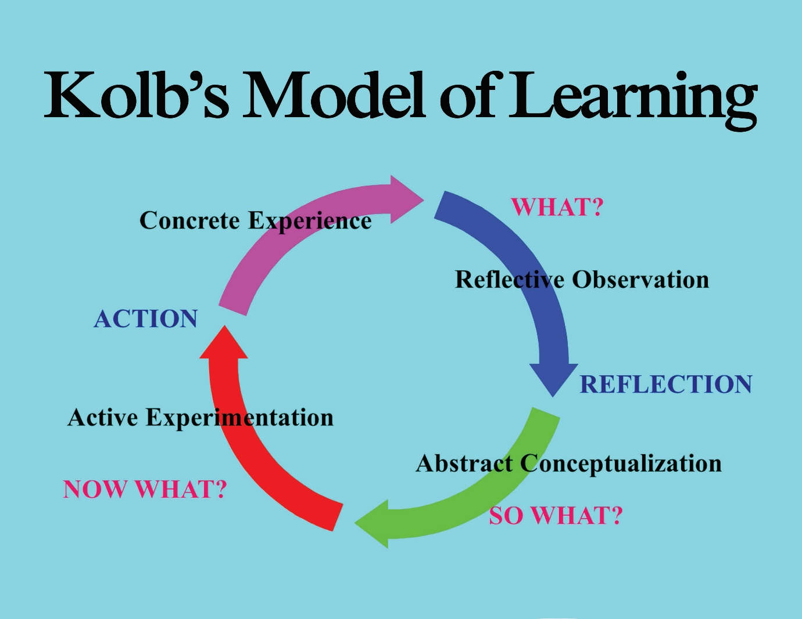
Appendix 2 - Rolfe et al. Framework on Reflective Practice (2001)
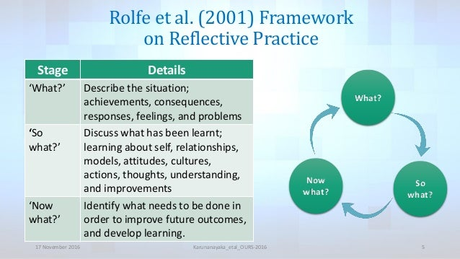

Appendix 3 - Gibbs Reflective Cycle (1998)
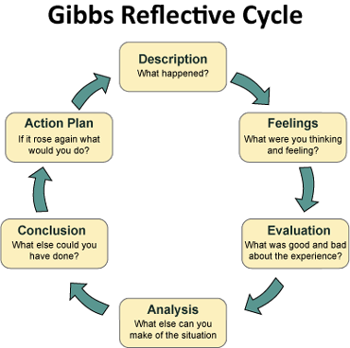

Appendix 4 - John’s reflective Model (2002)
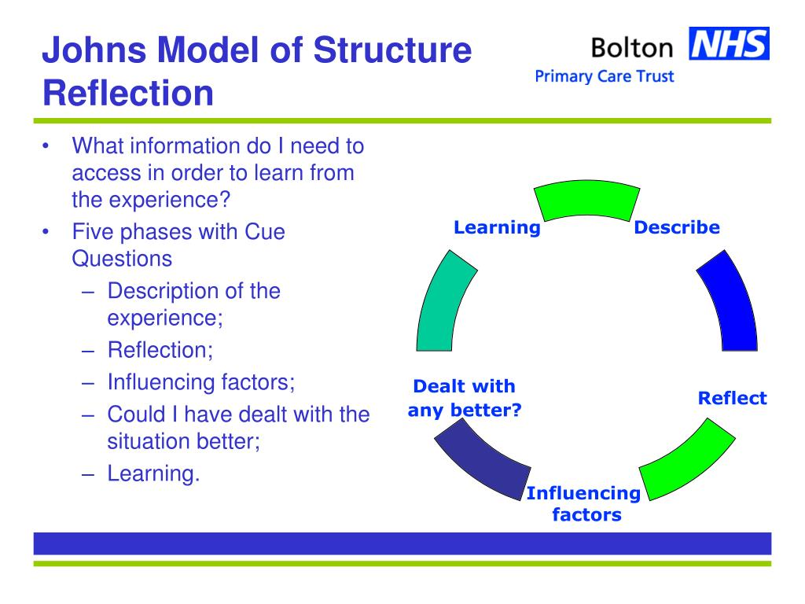
Appendix 5 – Driscoll’s Reflective Model (1994)
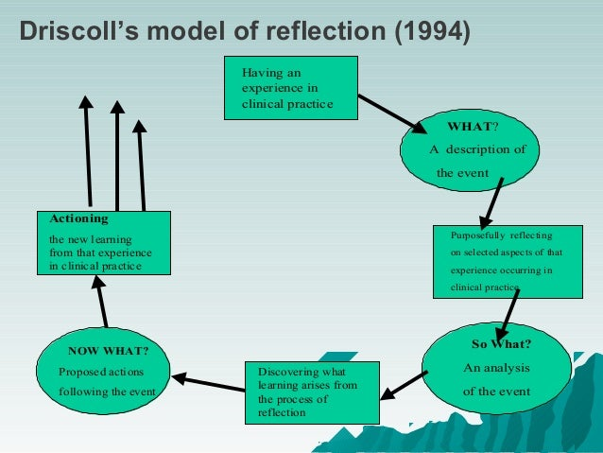

Appendix 6 – School Crime Beat Protocol

Appendix 7 – Van Wart 2014 Steps to Ethical Leadership Process


