Policing the Public – Lecture Topics

Week 3 Questions
- DA - It is imperative that police officers STOP (if possible) LOOK (assess) and LISTEN (effectively) to those they want or need to communicate with.
- Willis and Mastrofski (2018) supports Bayley and Bittner (1984) in describing how domestic incidents can be amongst the most challenging incidents for officers to utilise their discretion and make decisions as to how to proceed.

Why do you think this is?
Problem Solving
First of all when dealing with an incident, Thurman and Jamieson (2014) suggest that in order to understand the problem properly an officer should gather of information including;
- Who is complaining and about what in particular?
- Where has it happened and when?
- Are the complaints well founded?
- Is their evidence to support the complaint?
- Will the person raising the complaint provide a statement?
- What are the different perspectives of those involved?
- What would the complainant like to happen?
- Has the person complaining attempted to resolve the issue in any way?

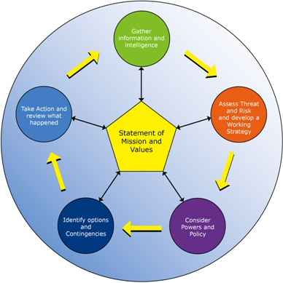

Whichever model is adopted, there are many and numerous factors which should be taken into consideration by the officer
- Presence of others or crowds
- Weapons present
- other dangers present such as vehicles or rivers
- The person’s believed use of alcohol and/or drugs
- The physical ability and mental capacity of the individual etc
- All these factors should be considered by the police officer before acting to ensure both the officers and public’s safety
The Old Lady
- During a hot summer’s night two police officers in a single patrol car were asked to attend to the report of a disturbance at sheltered accommodation bungalows occupied by elderly pensioners.
- As the police officers arrived they heard music blaring from the bungalows and there were many angry residents out and about pointing at a particular address.

- Using effective communication over the next two hours the police officers gathered information and established that the elderly lady suffered with dementia.
- The particular day was the first anniversary of the death of her husband.
- What the elderly lady actually wanted was some company!
- Whilst gathering information and assessing the risk, the officers clearly heard where the music was coming from.
- This went on for 2 hours – back & forth
- In an attempt to resolve the problem that night, the police officers decided that they were not best equipped to deal with the elderly lady and instead requested that the on call emergency duty team from Social Services.
- Once they had arrived the police officers could be released from dealing with the incident and at least the immediate problem was solved for that night
- And in the longer term the elderly ladies particular set of circumstances were to be handled by a more appropriate set of supporting agencies.
- Never ASSUME

Week 4

Hillsborough
https://youtu.be/MNS26Oj9B4o
--------------------------------------------------------------------------------------------------------------------------------------
- Poor decisions can lead to dire consequences.
- In 1989 fans surging into the Hillsborough football stadium for an FA semi-final match led to people being crushed against retaining fences, this resulted in the unfortunate deaths of 96 people and injuring of over 700.
- A former senior police officer, Mark (1978), suggested that the police service was the place where problems not wanted by others could be placed, he continued suggesting that a Police Chief serves five masters, which still persist today:
- Criminal law
- Police Authorities (now police and crime commissioners)
- Police (and now also police staff) under their command
- Public citizens
- The officer’s conscience.

NDM
CIAPOR stands for;
- Code of Ethics – Principles and standards of professional behaviour
- Information – Gather information and intelligence
- Assessment – Assess threat and risk and develop a working strategy
- Powers and policy – Consider powers and policy
- Options – Identify options and contingencies
- Action and review – Take action and review what happened

- Are actions consistent with the Code of Ethics?
- What would a victim or community affected expect of me?
- What does police service expect of me?
- Is this action or decision likely to reflect positively on my professionalism and the wider policing profession?
- Can I explain my action or decision in a public forum?
Options

- Immediacy of the threat
- Limitations of the current information
- Time available
- Resources and support available
- Individual’s own knowledge, experience and skills
- Impact of an action on the situation and the public
- What action can be taken if things do not happen as anticipated?

Yorkshire Ripper

- During the late 1970’s and early 1980’s the Yorkshire Ripper, a case involving a serial killer, demonstrated how the direction given by the SIO can influence the rest of the enquiry.
- For example, Peter Sutcliffe, who was later convicted of 13 murders as the Yorkshire Ripper, was interviewed nine times by the Police between 1975 and his arrest in January 1981.
- Interviewing officers were influenced by the credence given to the letters and the tape sent by a hoaxer.
We are back to the danger of assumption

SIO Traits

