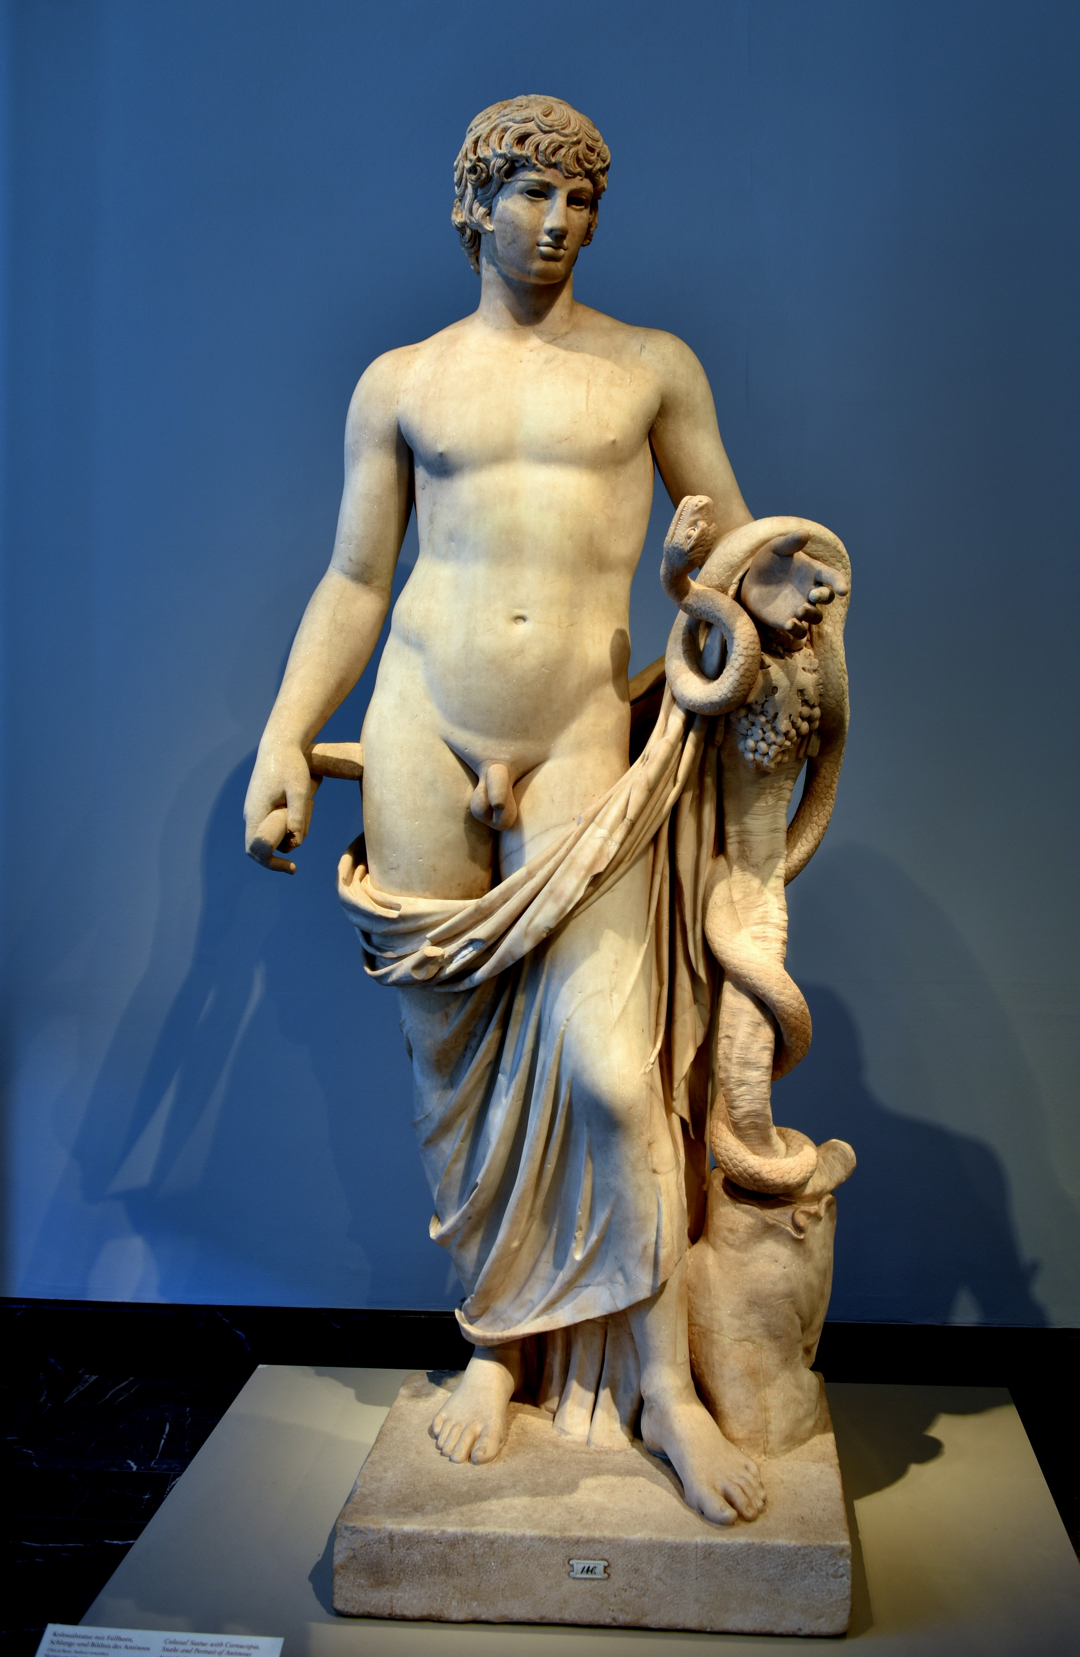  The Cult of antinous:  The Boy Who Became A God |   An Essay for HPAH7020: Aspects of greek and roman RELIGION AND CULT  Kaspian Oaken  MA Ancient History – University of Wales: Trinity St David

Contents
Introduction 2
Antinous and Hadrian: A Brief History 4
The Death on the Nile 5
The Cult of Antinous 6
Identifying the Cult 10
Conclusion 12
References 13

Introduction

The Ancient World is known for many things but one that survives through history and captures the hearts and imaginations of all, academic and otherwise, is the celebration and worship of a polytheistic pantheon of gods. Whether it be the Egyptian gods with the heads of animals and their golden headdresses, the Greek gods on Mount Olympus in the clouds looking down over Athens or the Roman pantheon of gods who gave their names to the planets and the stars above us. But what IS a god? How does one become one, or are they always gods? This essay explores the story of a boy, a human boy from humble beginnings who through chance, love, passion and perhaps intrigue was raised to the highest of stations, to become immortalised as a god.
The boy in question, was named Antinous. He was a Greek boy from Bithynia, famed for his unnatural beauty and elegance, who met and quickly became the lover of the famed Roman Emperor Hadrian. When he died tragically, he was raised to the status of a god and joined the Roman pantheon. History shows us through the classical writers, archaeology and iconography however that though the boy became a Roman god, decreed by a Roman Emperor, the worship of him and the cult that formed around this worship, was mostly from the East.
Considering historical claims were that the boy was worshipped out of fear of their Emperor’s wrath, why is it therefore that most of the cult’s worshippers were in fact outside of Italy altogether? Why did people worship and follow the Cult of Antinous, if not out of fear? What was the mindset of these westerners who continued to celebrate the new god, years after the Emperor’s passing? Was this cult worship about culture, identity or representation or something else entirely?
This essay aims to answer these questions and others and will use examples from ancient primary sources such as the writings of Cassius Dio, Pausanias and the unattributed works known as the Historia Augusta as well as Archaeological findings and scholarly opinion. To create adequate critique of these sources, this essay will also use evidence from Christian writers who were against the worship of a Pagan god such as Antinous, such as the writings of Jerome and Justin Martyr as well as others.

Antinous and Hadrian: A Brief History

Not many modern scholars have broached the subject of Antinous and his history so the precise details of his birth and background are relatively scarce. The ancient sources we do have, such as Dio’s Roman History (Cocceianus, 1914) and the Historia Augusta give us the most but these were written after both Hadrian and Antinous were long gone so they may be based more on story and rumour than fact (Lambert, 1984). The only ancient source that exists from the time Antinous would have been alive is that of Pausanias who writes that even he never physically met or saw the boy. We know from Cassius Dio and Pausanias, both from the same region of Greece as Antinous, that he indeed was born in Bithynia.
Lambert tells us that Antinous would have been born around 110-112 CE and arrives at this conclusion from societal evidence of the relationship he had with Hadrian. In sexual male relationships, the younger partner would have to be under the age of twenty or face scorn and dishonour. With his death being dated as 130 CE, this works out about right. It is suggested that Antinous and Hadrian met in 123 CE during Hadrian’s visit to Asia Minor, now Turkey (Nicklas & Spittler, 2013) which suggests the boy to have been around 13-15. Lambert disputes this and suggests instead that Hadrian may have met the young boy in Rome, where he was schooled as a Page for courtly duties. With Hadrian being dedicated to travelling around his Empire, he took the boy with him.

The Death on the Nile

It is on Hadrian’s visit to Egypt in around 130 CE that tragedy strikes. The young lover, Antinous dies. Most historians and scholars agree that the boy died by accidental drowning in the Nile, but there have been a few suggestions that his death was sacrificial, either at his own hands or those of Hadrian. Dio wrote that Antinous “had died in Egypt, either by falling into the Nile, as Hadrian writes, or, as the truth is, by being offered in sacrifice” which suggests gossip or rumour considering Dio himself later states that when Hadrian honoured his lover after his passing, that this was due to his love for him, or “because the youth had voluntarily undertaken to die”, giving Antinous an air of heroic duty, rather than the mark of a victim.
It was here, at the site of his lover’s death, that Hadrian took the steps to forever immortalise his Antinous. He built the only Roman city ever to be built in Egypt and named it Antinoopolis, the “city of Antinous” and here he invited Greeks to live and to worship Antinous, not as just a fellow Greek, but as a god and new deity in the Roman pantheon.
Creating a god or “deifying” a human being was not unheard of at the time but was generally reserves for Emperors and those in the Imperial family, not a young male lover of ignoble birth and especially not without direct permission from the senate.
Archaeologist Caroline Vout tells us that though contemporary scholars are unable to tell how the boy died for sure, “the only certainty is that the Empire was flooded with commemorative images to the ‘god’ or ‘hero’ Antinous” and this seems to be backed up in the Historia Augusta which states that: “Even the Greeks indeed elevated him to the rank of a deity with Hadrian’s wish, declaring that oracles were given through him… (Vout, 2005)”

The Cult of Antinous

The worship of Antinous had begun and statues, sculptures and portraits of the beautiful youth of Bithynia spread like wildfire across the Empire. Though Hadrian was the Roman Emperor and Antinous joined the Roman pantheon of gods, the Historia Augusta tells us it wasn’t the Romans but in fact the Greeks who actually named Antinous as a god and began to worship him. This is a fascinating point, as we know the city of Antinoopolis was in Egypt and the Empire leading from Rome, yet it was Greek followers to begin this cult to their boy god. Bell tells us that to live in Antinoopolis, one had to complete a citizenship application and that it was only open to Greek people and those who had Greek origins, but also who were happy to adhere to the Athenian codes of living (Bell, 1940). This reinforces the idea that the cult of Antinous was Greek in origin, not Roman.
The city of Antinoopolis was built, according to Dio, almost immediately after the boy was found drowned and writes that sculptures of the boy appeared in the “whole inhabited world” meaning all across the Empire. The cult followers of Antinous began to display images of their new god in Bithynia, Mantineia and across the world, representing him and adorning him as other figures, such as Dionysus, Apollo and Osiris. This can be seen on the Obelisk of Antinous, which explicitly displays the integration of Antinous with Osiris, calling him “Osiris Antinous.” The Egyptian god Thoth is also mentioned on the Obelisk as assistant to the god Antinous and many coins were minted to celebrate Antinous, as a god and a hero (Vout, 2007).
Though the cult was established out of one man’s personal grief for his fallen lover, it seemingly eclipsed the cult followings of other heroes of the time. Jones tell us as such and that this was “both in geographical spread and in degree of elaboration” (Jones, 2019) and there were even many contests and games held in his honour according to the writings of Pausanias: “Going into Tegea, there is on the left of the highway, besides the walls of Mantineans, a race spot for horses and not far from this is a race-course, where they place the contest for Antinous”.
It is believed that followers of Antinous saw him as a deity of healing but also of the passage from life to death, perhaps due to the way he died himself and in Lavinium, a group of worshippers created a group that prayed to Antinous and Diana to ensure safe and proper burial of loved ones.
The cult of Antinous had many critics and many of these were of the Christian faith. Origen, for example, condemns the relationship of Antinous and Hadrian, then states: “If one were to investigate, in a spirit of truth and impartiality, the stories relating to Antinous, he would find that it was due to the magical arts and rites of the Egyptians that there was even the appearance of his performing anything in the city which bears his name” suggesting that the miracles performed in his name were actually from the Egyptians and their demonic forces.
Clement, another Christian writer, writes: “Another new deity was added to the number with great religious pimp in Egypt, and was near being so in Greece by the King of the Romans, who deified Antinous, whom he loved as Zeus loved Ganymede, and whose beauty was of a very rare order: for lust is not easily restrained, destitute as it is of fear; and men now observe the sacred nights of Antinous, the shameful character of which the lover who spent them with him knew well”. These ‘sacred nights’ referred to the Christian propaganda that the cult of Antinous held homosexual orgies in his name. Clement stresses in his works the newness of the cult but also that the members were Greek and that they did so out of fear of Hadrian, arguing they wouldn’t worship Antinous otherwise due to his poor character. This is backed up by Justin Martyr who tells us that “all Greeks were prompt, through fear, to worship Antinous”
Evidence suggests that the cult worship of Antinous lasted many years, with later Christian writers still telling of the cult in years to come. Athanasius, in the 4th Century, equates the worship of Antinous to worshipping Emperors and suggests that Egyptians worship the youth as a god because Hadrian ordered it. A century later, Jerome too mentions the cult and how the Romans bult temples and monuments “such as the one to Antinous, servant to the Emperor Hadrian, in whose honour also games were celebrated, and a city founded bearing his name, and a temple with priests established”
The insistence of these Christian poets and scholars to blame the fear of Hadrian forcing the Greek, Roman and Egyptian people to worship Antinous seems very farfetched considering the Emperor had been dead for hundreds of years when these things were written and suggests just how long lasting and far reaching the cult actually was.
When Antinous was created a god, the cult began performing certain rites, to “purify the souls of initiates for entrance into the next life” and Vout tell us that “epigraphic and literary evidence attests that Antinous was associated with a variety of gods” naming specifically, Bacchus, Hermes and Osiris as well as Ganymede and Narcissus. Epigraphy dedicated to Antinous has been uncovered where he is being asked aid and guard the dead on their journey to the afterlife (Vout, 2005). Another reads: “Doxa’s son, Isocgrysus, whom the god Antinoos himself loved dearly as one enthrones with the immortals, Epitynchanus, his father, constructed in the form of a bronze image and erected a statue of his son by the decree of his fatherland” again echoing that Antinous was seen as a god of death and the afterlife. As he died so young and beautiful and lived on as a god, this is how he is worshipped and remembered.
Though many statues, sculptures and art has been attributed to Antinous, Caroline Vout is less convinced, suggesting that because of the popularity of Antinous and his cult, statues of other gods and handsome boys were attributed to Antinous by Archaeologists who simply wished them to be him due to him being “in vogue”. With so many of the statues to Antinous being argued as misattributed, it again points to the fact that Romans did not worship Antinous the way Greeks did.
At least 50% of the statues of Antinous that were discovered on Italian soil were found at Hadrian’s own home, which of course makes sense, considering he was his lover. The other area in Italy rich with sculptures to Antinous is Naples, which, though Lambert suggests had a huge religious following to Antinous, was also largely a Greek speaking city and the name “Antinous” was a popular name for young boys after the deification and the epic of the Odyssey where Antinous was the name of a prominent character, as well as Polybius and Livy mentioning someone with the name in their own works.
The fact that no games or contests to Antinous seem to have occurred in Italy also suggests the worshipping of him to be more prevalent in Greece and Egypt. The priest of Antinous has a special seat at the theatre of Dionysius in Athens as well as the fact that all major cities in Greece and Turkey minted coins with the face of Antinous, it seems indeed that the cult was stronger and more prevalent in the East.

Identifying the Cult

Even centuries after the death of Hadrian, Christian writers attributed the sudden praise of Antinous to some kind of fear or pressure from the Emperor, Hadrian, but now that evidence suggests the cult to be more prevalent in the East outside of Rome, it’s very unlikely that those people would fear the Emperors as none of the Emperors who followed Hadrian did anything to respect or cultivate the cult. This can be evidenced in the moving of the Obelisk of Antinous, which is rumoured to have been originally based in Antinopoolis. It was moved in 220 CE by Elagabalus for his own amusement (Boatwright, 1987). There is no way this can be motivated by “fear” of Hadrian.
There was a clear connection to the Greek parts of the Empire that simply didn’t exist in the Latin West. In the East, Emperors were known to be heavily involved in the creation of their own cults and we do know from scholarship that Hadrian encouraged Greeks to move to Antinoopolis with the promise of land and gifts (Bell, 1940). This could be seen as bribery maybe, but not fear.
There was a clear bias towards the Eastern parts of the Empire by this time in history, with the Greeks often being mocked as inferior and less Roman. Juvenal wrote many poems about the hierarchy of culture between Rome and Egypt and these moral views spread through art and poems throughout the Imperial period of the Roman Empire. Plutarch assimilates Greekness and Egyptian-ness into one culture, setting it as inferior to the true Roman way (Alston, 1996). Juvenal goes on to lament the influence Greece has had on Roman culture and hating the “language, customs, flutes, string instruments, foreign tambourines and the prostitutes” He writes about how he fears Greek, Egyptian and Syrian cultures destroying proper Roman ideals.
Thus, it seems that it was this group of downtrodden Greeks and Egyptians who adopted a new god in Antinous. A Roman god who was born a strong, beautiful Greek boy, one of their own and they had been told to worship him by the Emperor. With the way the Greeks were talked about and treated by the classical writers, it seems that worshipping Antinous as their Roman god of choice was tied to their heritage and identity of being Greeks under Roman rule. The cult and their god were created by the ruling elite and in worshipping Antinous, these Greeks were celebrating their identity but also showing a devotion to the Rome that ruled them, ran their legal system and taxed them.
It is for this reason, that some writers, including Dio, suggest the possibility of Antinous dying by sacrifice. That the youth died so that he could become a symbol of hope for his people. Another view is that the tragic drowning was indeed the case, and Hadrian used the tragedy to his advantage by creating this idol for the Greeks to worship. It is well documented that Hadrian was a Hellenophile and pleasured greatly in the Greek culture. This can be seen in how he funded certain sites and leagues, always focusing on the Greek origins of those involved and promoting the value of Greek civilisations.

Conclusion

In conclusion, the evidence presented in this essay so far tells us some simple things. We know that Hadrian had a lover, that he was beautiful and young as well as Greek. We know Antinous died in Egypt and his body was found in the Nile. We know a city was founded in his honour and that Hadrian deified him. The evidence presented supports my claim that the cult was more prevalent in the East of the Empire and I will be clear that I believe wholeheartedly that the original worship of Antinous was by decree of the Emperor but the continued worship cannot possibly be so.
Hadrian, a well-known lover of Greek Culture and powerful Roman Emperor created a God from his lover. Whether this be out of grief or for political gain we will never know but when we look back at Antinous the man rather than the god, we see a man who has no clear skills or accomplishments besides the overwhelming record of his beauty. His only other attribute was his Greek heritage. The evidence provided today suggests that the Greeks worshipped Antinous as someone they could identify with ethnically and culturally, someone honoured by the Roman elite, yet loyal to the Greeks. This was cultural representation and inclusivity in the Ancient World.

References

Alston, R., 1996. Conquest by text: Juvenal and Plutarch on Egypt. In: Roman imperialism: post-colonial perspectives. s.l.:s.n., pp. 99-109.
Beard, M., North, J. & Price, S. R. F., 1998. Religions of Rome. New York: Cambridge University Press.
Bell, I. H., 1940. Antinoopolis: A Hadrianic Foundation in Egypt. The Journal of Roman Studies.
Birley, A. R., 2000. Hadrian to the Antonines. In: The Cambridge Ancient History: The High Empire, A.D. 70-192. Cambridge: Cambridge University Press.
Boatwright, M. T., 1987. Hadrian and the City of Rome. Princeton: Princeton University Press.
Cocceianus, C. D., 1914. Dio's Roman History. London: W. Heinemann.
Jones, C. P., 2019. New Heroes in Antiquity: From Achilles to Antinoos. Cambridge: Harvard University Press.
Lambert, R., 1984. Beloved and God: The Story of Hadrian and Antinous. s.l.:George Weidenfeld & Nicolson.
Nicklas, T. & Spittler, J. E., 2013. Credible, Incredible: The Miraculous in the Ancient Mediterranean. Tubingen: Mohr Siebeck.
Opper, T., 1996. Hadrian: Empire and Conflict. s.l.:Harvard University Press.
Skinner, M., 2013. Sexuality in Greek and Roman Culture. Ancient Cultures. 2nd ed. s.l.:Wiley-Blackwell.
Vermeule, C. C., 1979. Roman Art: Early Republic to Late Empire. s.l.:Boston Museum of Fine Arts.
Vout, C., 2005. Antinous, Archaeology, History. The Journal of Roman Studies, Volume 95, pp. 80-96.
Vout, C., 2007. Power and Eroticism in Imperial Rome. Cambridge: Cambridge University Press.
Waters, S., 1995. "The Most Famous Fairy in History": Antinous and Homosexual Fantasy. Journal of the History of Sexuality, 6(2), pp. 194-230.
Wildon, R. J. A., 1998. Roman art and architecture. In: The Oxford History of the Roman World. Oxford: Oxford University Press.

Hist.Aug
Paus.
Cass.Dio.
Origen
Clement of Alexandria
Justin Martyr
Athanasius
Jerome.
Hom.Od
Liv.
Plb.
Juv. 1.3 63-65

