Essential Skills for Study and employment

There are many skills needed alike for Study and employment. Generally studying and working harder will make you a more knowledgeable person, this will lead to you being more likely to be employed. They work hand in hand.

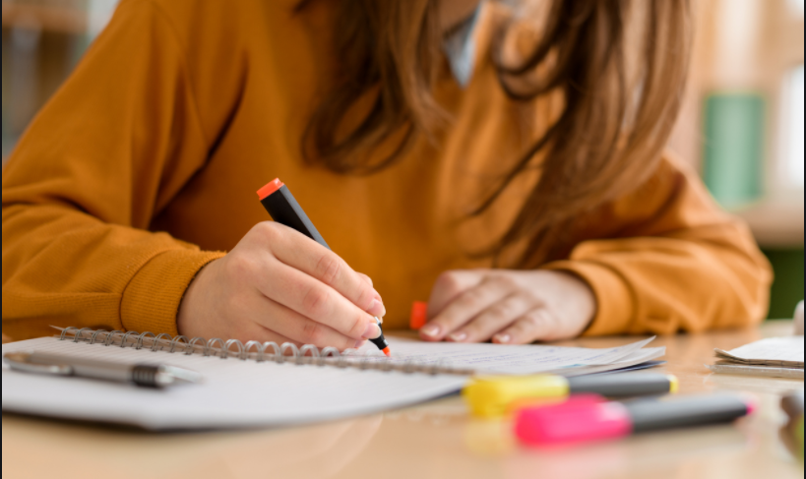

I have taken some extracts below one from a textbook and one from an article , one discusses self-management as a key skill , the other (article) discusses a study completed to identify what employers ranked as the most valued skills for people to have who are entering employment.

A big part of being able to study and getting ready for employment is self-management. Good self-management skills provide a solid foundation upon which to build other skills, whether academic or professional or for managing life in general. [1]

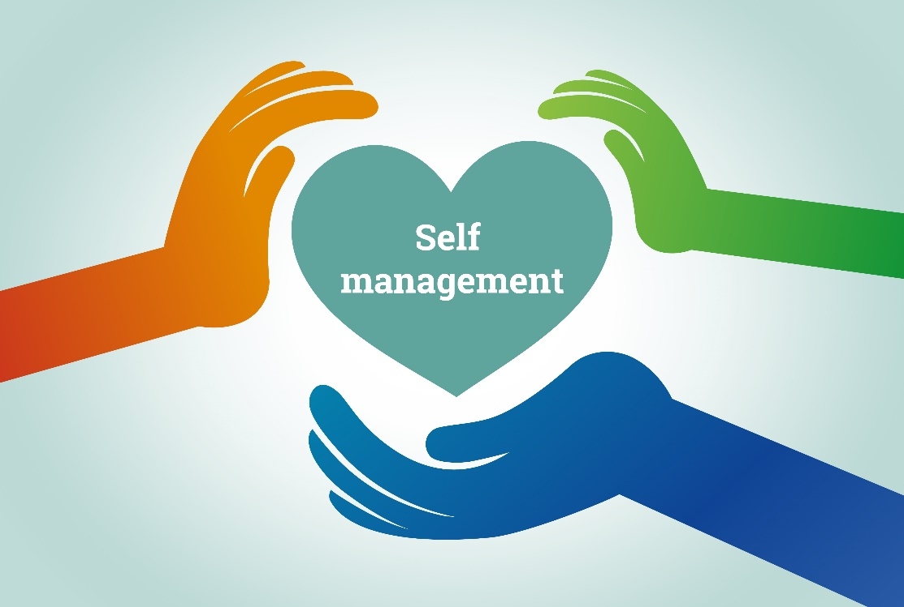

The purpose of this study was to identify employability skills that employers value as important for entry-level employees with disabilities and employees without disabilities. One finding indicates that the same four skills were viewed as most important for both groups, including “demonstrating personal integrity/honesty in work,” “ability to follow instructions,” “ability to show respect for others,” and “ability to be on time.” Apparently, employers consider some employability skills as essential for all entry-level employees regardless of whether an employee has a disability or not.
[2]
Looking at research on the internet at key skills for employment and study – there is a good website here which summarises the majority of things needed for the both.


- Communication
- Teamwork
- Problem Solving
- Self-management
- Planning
- Technology
- Learning
- Initiative

[3]

I think one of the greatest skills to have for both study and employment is being able to effectively communicate with others.
If you communicate with others – this may help you study and learn new ideas. This helps me with the day to day work I do within my workplace.
This is also widely looked for in employment, if you can effectively communicate with others, this will help you progress within a work environment.

Being able to communicate effectively is perhaps the most important of all life skills. It is what enables us to pass information to other people, and to understand what is said to us.
[4]
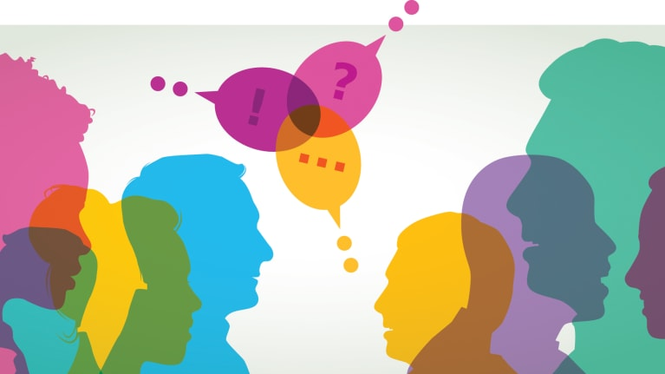

Works Cited

[1] | S. Cottrell, Skills for Success, Macmillan Education UK, 2015.
[2] | J. Song, "Employability Skills valued by employers as important for entry level employees," p. 35, 2012.
[3] | "8 essential employability skills," (Adapted from Department of Education, Science & Technology, 2002, Employability Skills for the Future), 16 August 2013 . [Online]. Available: https://career-ready.blogs.latrobe.edu.au/2013/08/16/8-essential-employability-skills/. [Accessed 10 10 2020].
[4] | "Skills you need," Skills you need, 2012. [Online]. Available: https://www.skillsyouneed.com/ips/communication-skills.html#:~:text=Being%20able%20to%20communicate%20effectively,what%20is%20said%20to%20us.&text=Communication%2C%20at%20its%20simplest%2C%20is,from%20one%20place%20to%20another. [Accessed 10 10 2020].

Reflection

My Similarity score = 46%

I scored this as my similarity score. I could improve this next time by writing things in my own words that I have read from the Swansea uni library.
I could also look at more sources and collaborate with others to get more information on the topic.

I did think I wrote a good summary though and hit the points that were needed / mentioned in section A. There are plenty of sources of information there, which help discuss the topic. Including supporting images and sections that I wrote myself.

I Think I would give it 85% when looking at what information question A was looking for.

