Network Operating Systems and Services ACCA5023
Research, build, and deploy a Virtualised Enterprise network
‘’NOSSLONDON2026 – Network Virtualisation Coursework Report’’

Name of Studen:-
Robel Gebregziabher
ID Number 2427640

Submitted to:-
MD. Sadeque Imam Shaikh
University of Wales Trinity saint David
March26, 2026

Contents

0
Task 1: Research Report 2
1.1 Hypervisor 2
1.2 IP Addressing 2
1.3 Routing 3
1.4 Network Services 3
2 HypervisOracle VirtualBox 3
2.1 Installation and Setup 3
Technical Reflection 51
Personal Reflection 51
References (Harvard Style) 52

NOSSLONDON2026 – Network Virtualisation Coursework Report

Task 1: Research Report

1.1 Hypervisor
Hypervisors are essential to virtualisation, enabling multiple operating systems to share a single physical machine. There are two main types: Type 1 (bare-metal) and Type 2 (hosted). Type 1 hypervisors, such as Microsoft Hyper-V and VMware ESXi, run directly on hardware, offering improved performance, scalability, and security due to reduced abstraction layers. Type 2 hypervisors, including Oracle VirtualBox, operate on top of an existing operating system, providing greater flexibility and ease of use, though with slightly lower performance (Pfoh et al., 2009).
For NOSSLONDON2026, a Type 2 hypervisor is preferable, as academic environments often have limited hardware resources. The network must support both Windows Server 2022 and Debian, which VirtualBox handles effectively. Although Type 1 hypervisors provide advanced features, their higher hardware requirements and complexity make them less suitable for this scenario.
VirtualBox offers key features such as snapshot management, multiple networking modes, and cross-platform compatibility. These capabilities make it well-suited for testing domain-based configurations like BIRMINGHAM.ACCA. Its lightweight design also ensures reliable performance on systems with limited resources.
In summary, considering performance, resource constraints, and compatibility, a Type 2 hypervisor is the most suitable choice for this network configuration.

1.2 IP Addressing
IP addressing is fundamental to network communication, as it uniquely identifies each device and enables data transfer between systems. Data transmitted over the Internet is divided into packets, each containing source and destination IP addresses. Routers use these addresses to determine optimal delivery paths (Kurose and Ross, 2021).
IPv4, which uses 32-bit addresses, remains widely used despite its limited address space. IPv6, with 128-bit addresses, offers a significantly larger address pool and addresses scalability concerns. While IPv4 currently meets the needs of the NOSSLONDON2026 network, adopting IPv6 will support future expansion.
Subnetting increases network efficiency by dividing large networks into smaller segments, reducing broadcast domains and enhancing performance. Variable Length Subnet Masking (VLSM) optimises address allocation by assigning appropriate subnet sizes (Odom, 2020). In this context, small subnets such as /29 and /30 are used to avoid wasting addresses.
Switches operate at the data link layer, forwarding frames within local networks. Routers function at the network layer, directing packets between different networks. In this setup, routing enables communication between the Birmingham and London networks.
In summary, IP addressing is essential for structured communication, efficient resource utilisation, and network scalability.

1.3 Routing
Routing determines the optimal paths for data transmission between networks, using routing tables that store destination and path information. Routing can be static or dynamic. Static routing requires manual route configuration, offering simplicity and predictability but limited scalability. Dynamic routing protocols, such as OSPF and RIP, automatically adjust to network changes, enhancing resilience but adding complexity (Tanenbaum and Wetherall, 2011).
For NOSSLONDON2026, static routing is recommended due to the small number of networks and predictable structure. The point-to-point WAN link (10.0.0.0/30) between Birmingham and London can be efficiently managed with manual routes, simplifying configuration and troubleshooting.
The Debian server functions as a DHCP relay, forwarding requests to the Windows Server. This arrangement requires consistent routing between subnets to maintain reliable service delivery. Static routing provides sufficient control and performance for these requirements.
Dynamic routing is beneficial in larger or evolving networks, but currently, static routing is simpler and meets the present needs. If the network expands, transitioning to dynamic routing may become necessary.
1.4 Network Services
Modern enterprise networks require several services to operate securely and efficiently. In this configuration, essential services include DHCP, Active Directory Domain Services (AD DS), Virtual Private Networks (VPNs), and Certificate Authorities (CA).
DHCP automaticalDHCP automates IP address assignment, reducing administrative workload and errors. Implementing a DHCP relay enables centralised address management by the Windows Server. AD DS offers centralised authentication and authorisation, supporting management of the BIRMINGHAM.ACCA domain (Microsoft, 2022). Authorities are important for network security because they issue digital certificates for encryption and authentication. These certificates make secure communication possible with protocols like SSL/TLS. VPNs let users connect safely to internal resources from outside the network.
Best practices include implementing strong authentication policies, securing DHCP scopes, and maintaining up-to-date certificates. Collectively, these services establish a secure, scalable, and efficient enterprise network.
2 HypervisOracle VirtualBox
was selected for its compatibility, flexibility, and low hardware requirements. It supports both Windows Server 2022 and Debian, and provides the necessary networking options to simulate real-world environments.orld networks.

2.1 Installation and Setup
Software was downloaded from official sources:
Observing the virtual machine console confirms correct configuration of memory, storage, and CPU. Successfully initiating the installation process also verifies proper hypervisor setup and compatibility between host and guest systems.
This step is essential for establishing the virtual network, as it ensures the Windows Server, designated as the domain controller for BIRMINGHAM.ACCA, is installed correctly before proceeding to IP addressing, Active Directory configuration, and network services.
Oracle VirtualBox
Windows Server 2022 ISO
Debian ISO
Download pages (timestamp required
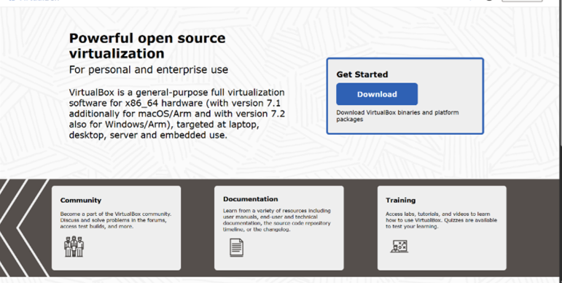

The presence of the virtual machine console confirms that system resources such as memory, storage, and CPU allocation have been appropriately assigned. Furthermore, the successful initiation of the installation process demonstrates the correct configuration of the hypervisor and validates compatibility between the host system and the guest operating system.

This stage is critical in the virtual network deployment process, as it ensures that the Windows Server environment—intended to function as a domain controller within the BIRMINGHAM.ACCA network—is correctly installed prior to further configuration tasks such as IP addressing, Active Directory setup, and network services deployment.

The presence of the virtual machine console confirms that system resources such as memory, storage, and CPU allocation have been appropriately assigned. Furthermore, the successful initiation of the installation process demonstrates the correct configuration of the hypervisor and validates compatibility between the host system and the guest operating system.

This stage is critical in the virtual network deployment process, as it ensures that the Windows Server environment—intended to function as a domain controller within the BIRMINGHAM.ACCA network—is correctly installed prior to further configuration tasks such as IP addressing, Active Directory setup, and network services deployment.

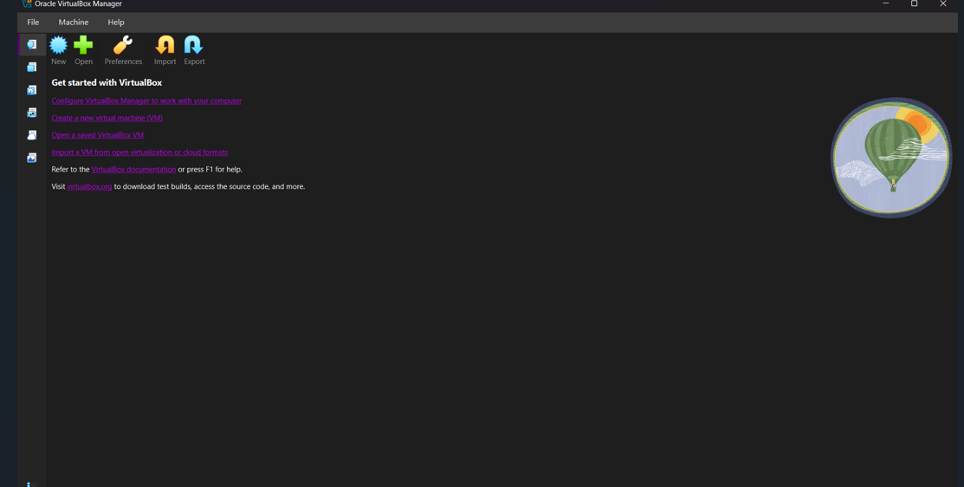

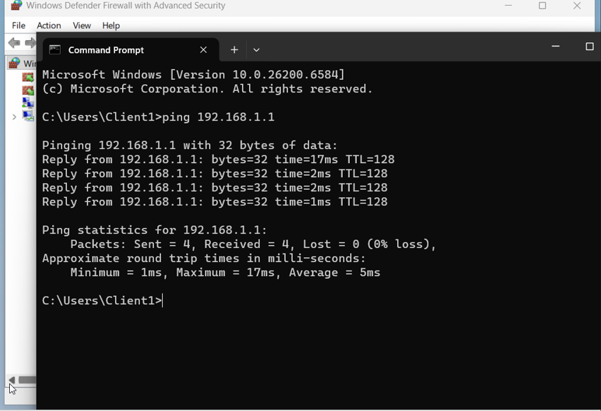

FIGURE 1 Active Directory configration
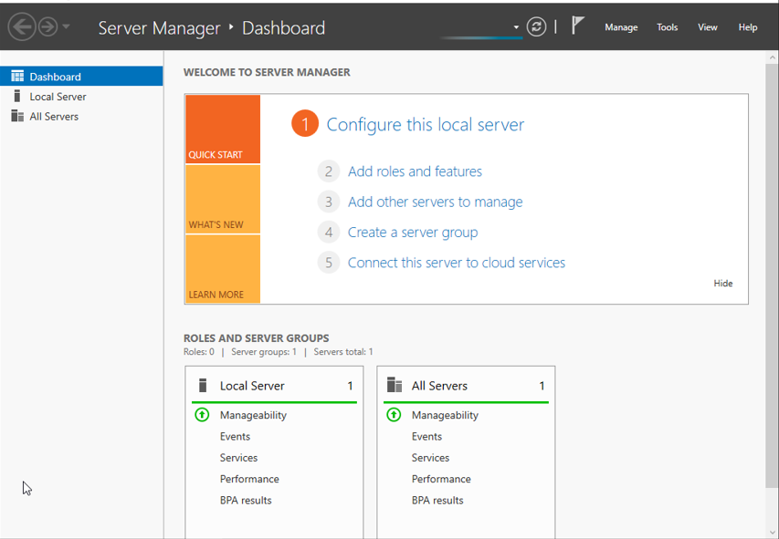

Oracle VirtualBox
Windows Server 2022 ISO
Debian ISO Debian Net
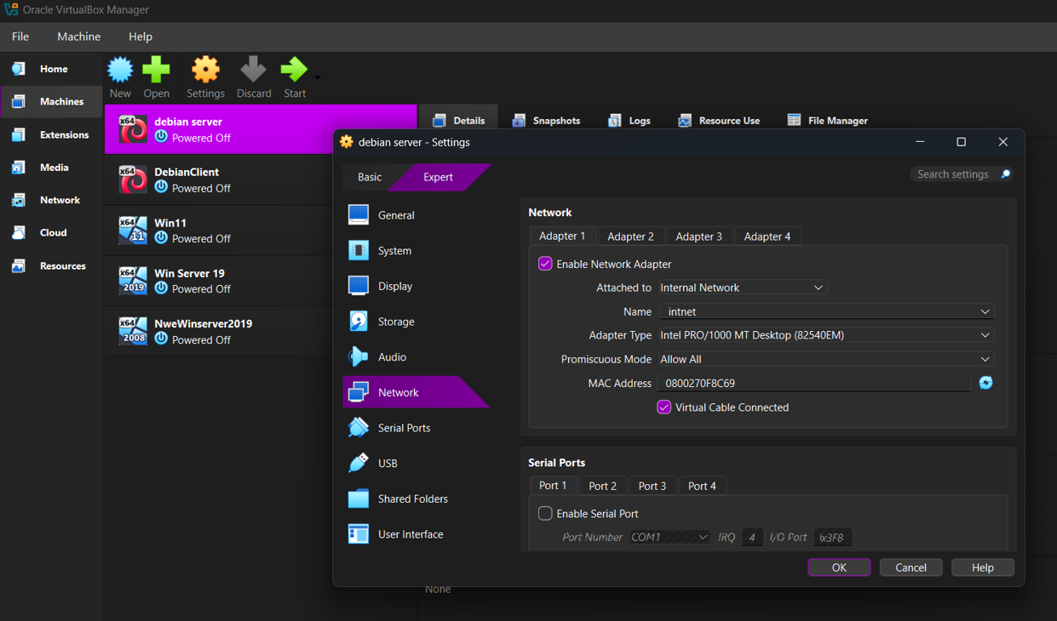Debian Server and Client
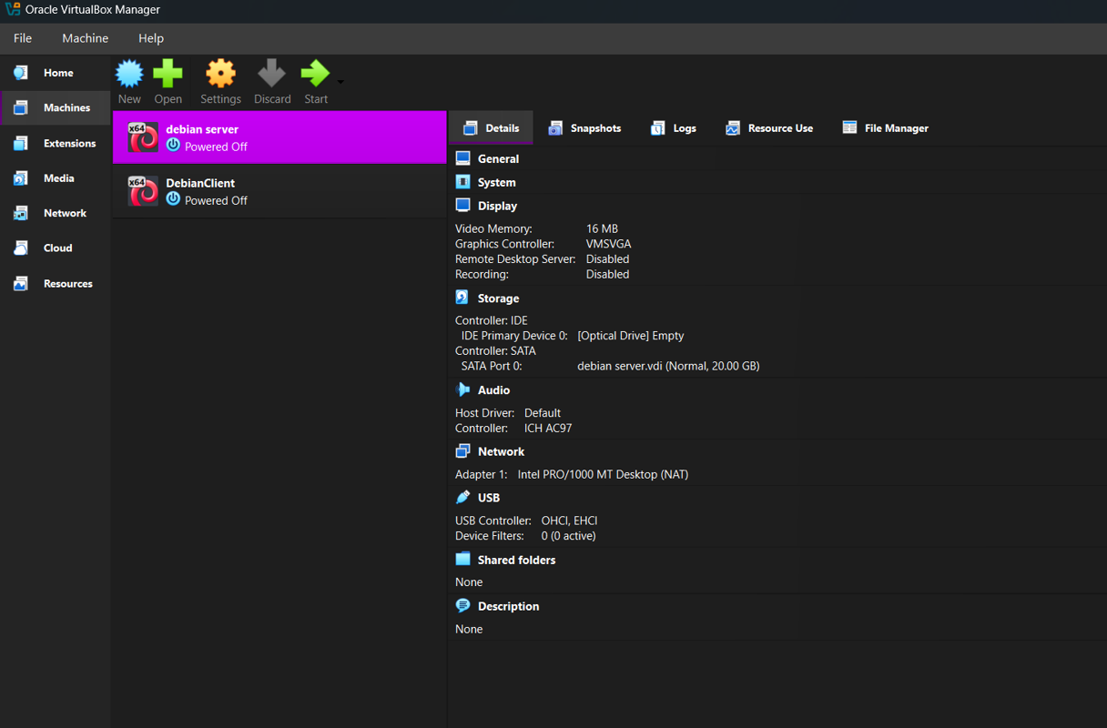

DebianNetClient

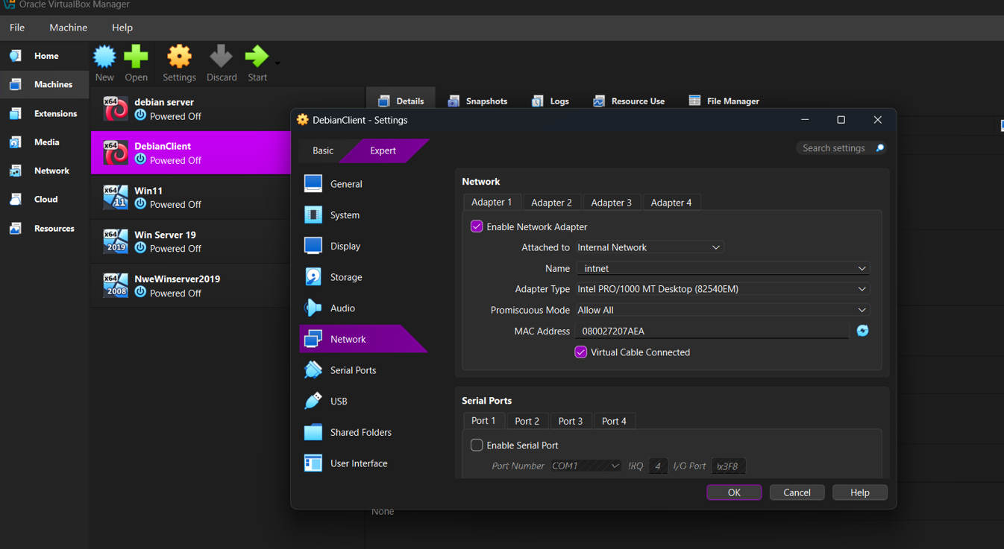

Debianserver

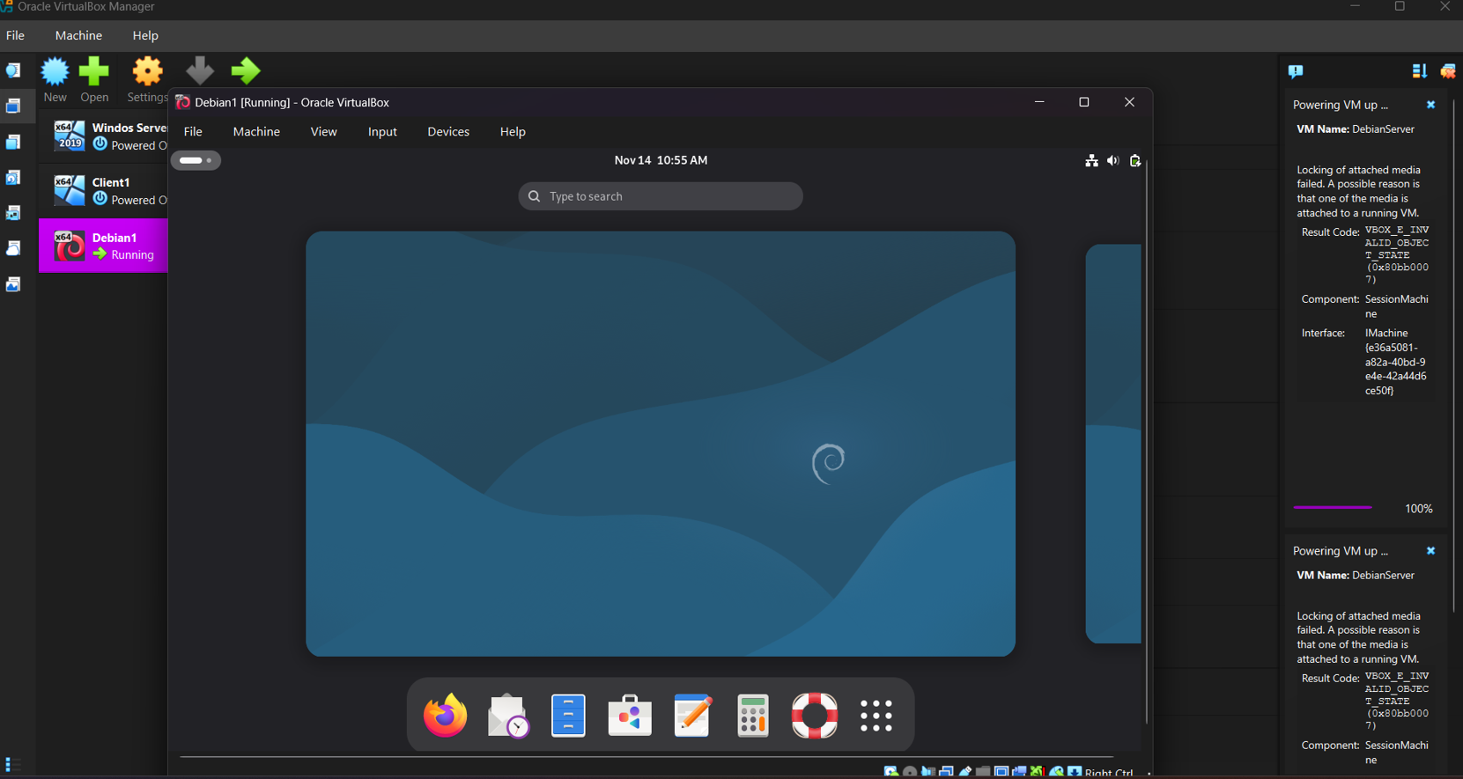

DebianServerNet
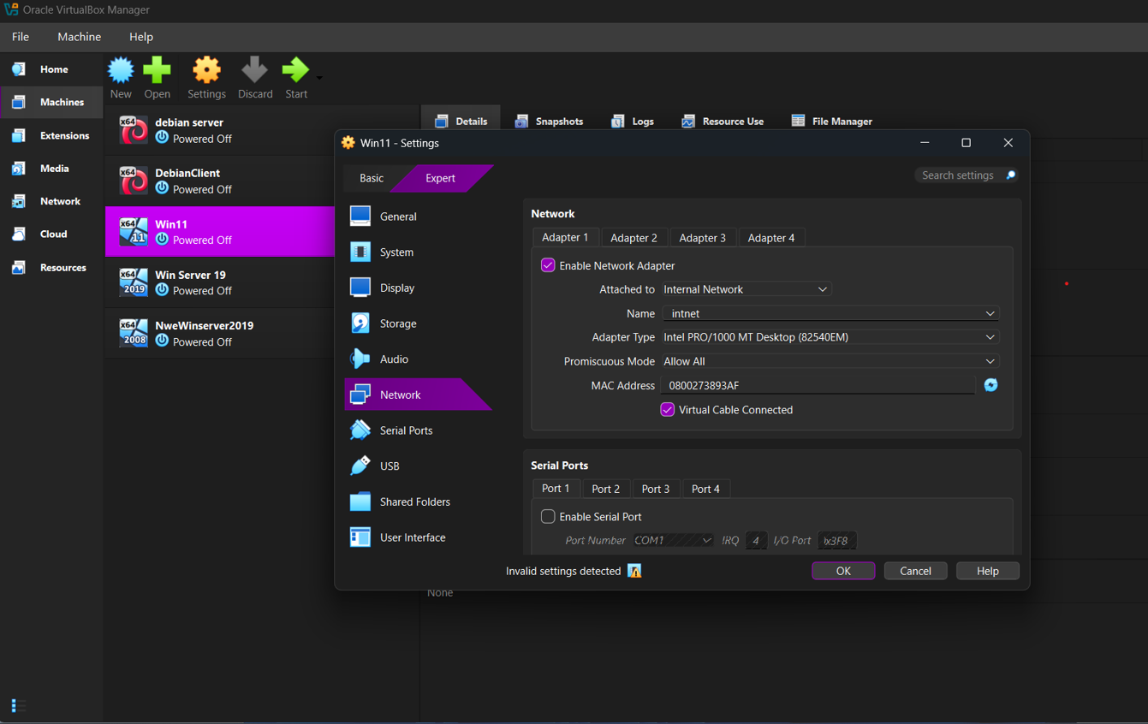

ClienRule

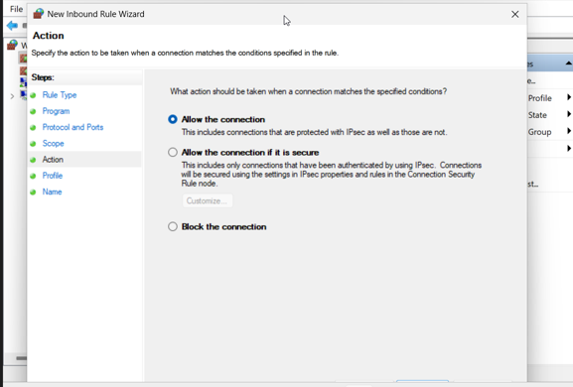
Clien Rang IP Adress
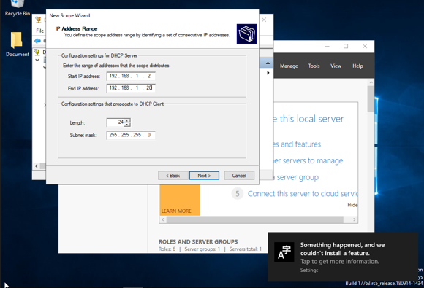

Virtual machines created: client rule

B-DC (Windows Server)
L-CD (Debian Server)

Client1 (Windows 10)

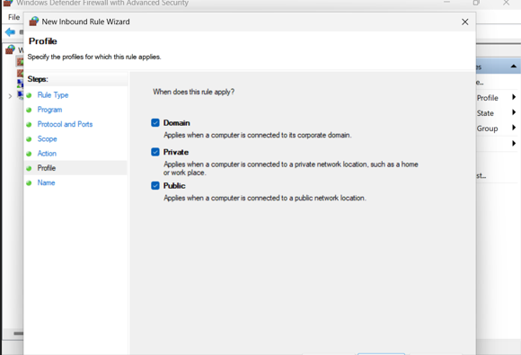
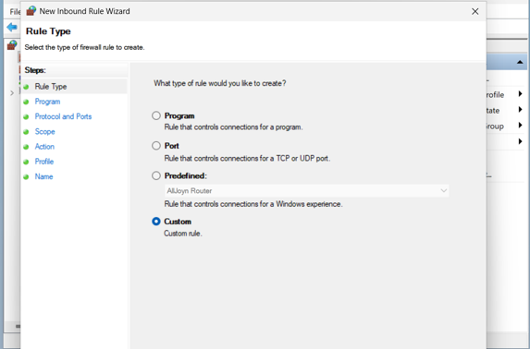
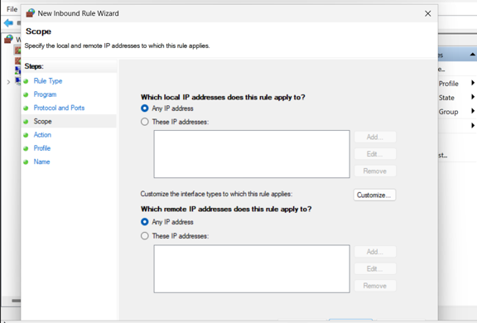
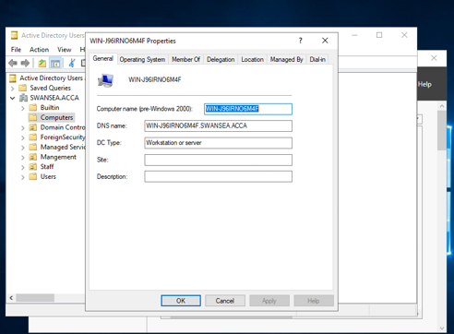
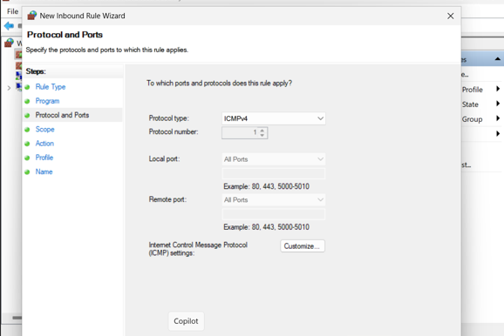

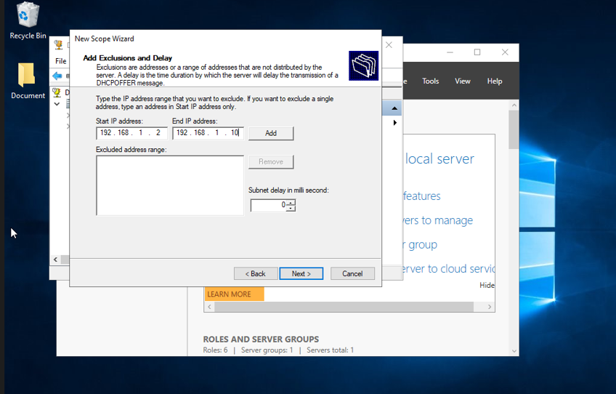
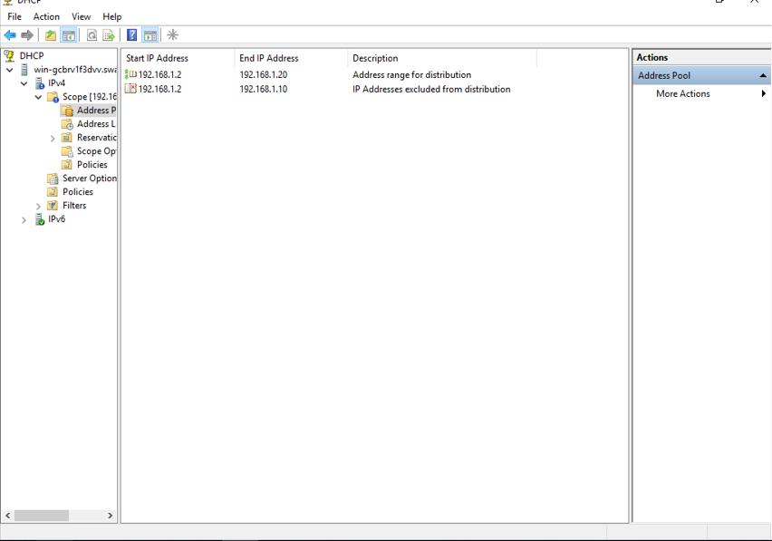
📸 I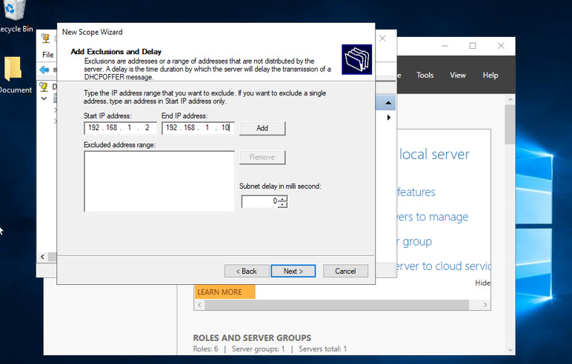

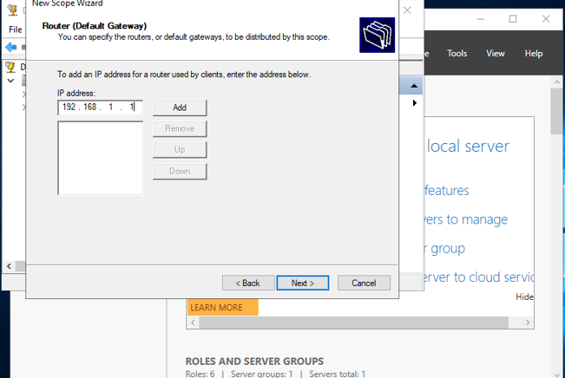

VM setup and network configuration
2.3 VLSM IP Addressing Scheme
Network Subnet Purpose
172.16.1.0/29 Birmingham LAN 3 hosts
172.16.2.0/29 London LAN 3 hosts
10.0.0.0/30 WAN Link 2 hosts
Device IP Address
B-DC 172.16.1.1
Client1 172.16.1.2
L-CD 172.16.2.1
ClientL1 172.16.2.2
WAN Win 10.0.0.1
WAN Deb 10.0.0.2
📸 Insert:
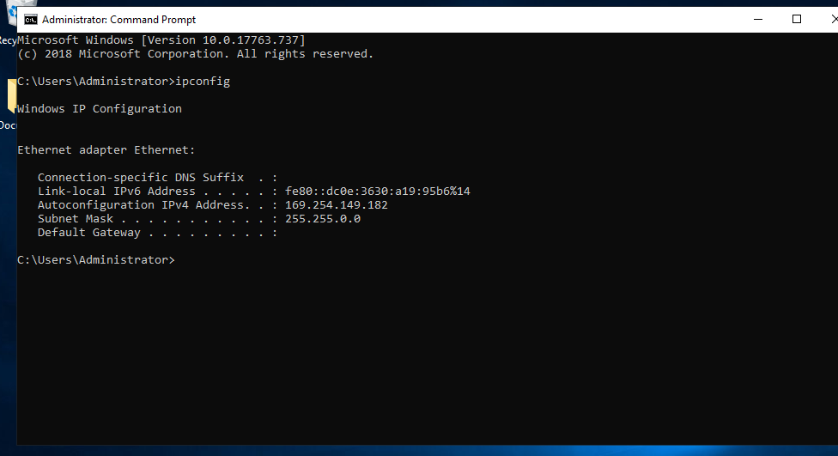
IP configuration (Windows + Debian)
2.4 Testing and Troubleshooting
Successful:
Ping within same network
Failed:
Ping across networks (before routing)
Successful ping
Failed ping(Ping from client windows failers)
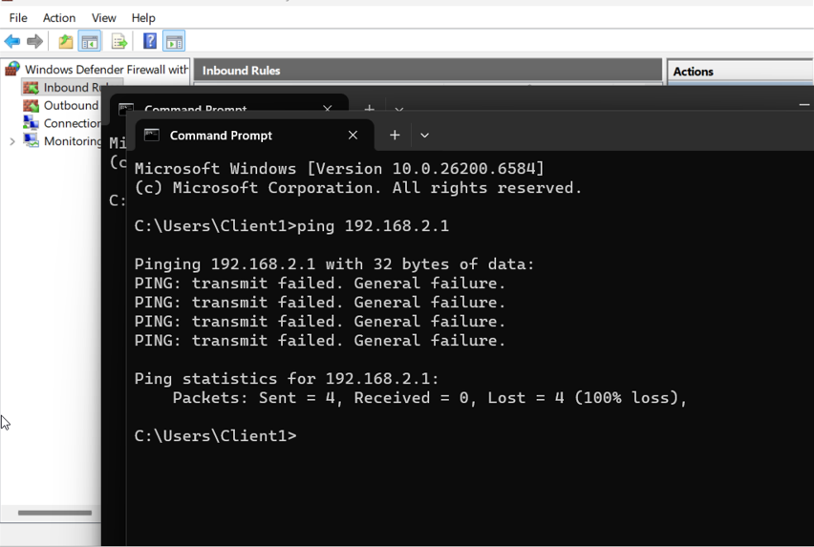
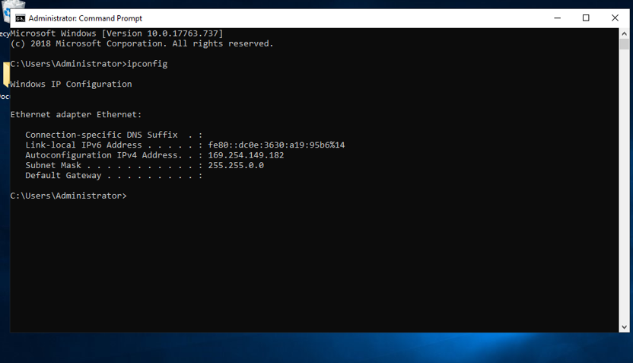
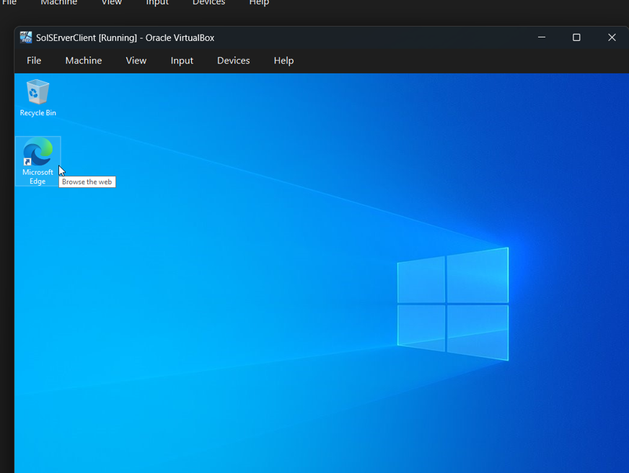
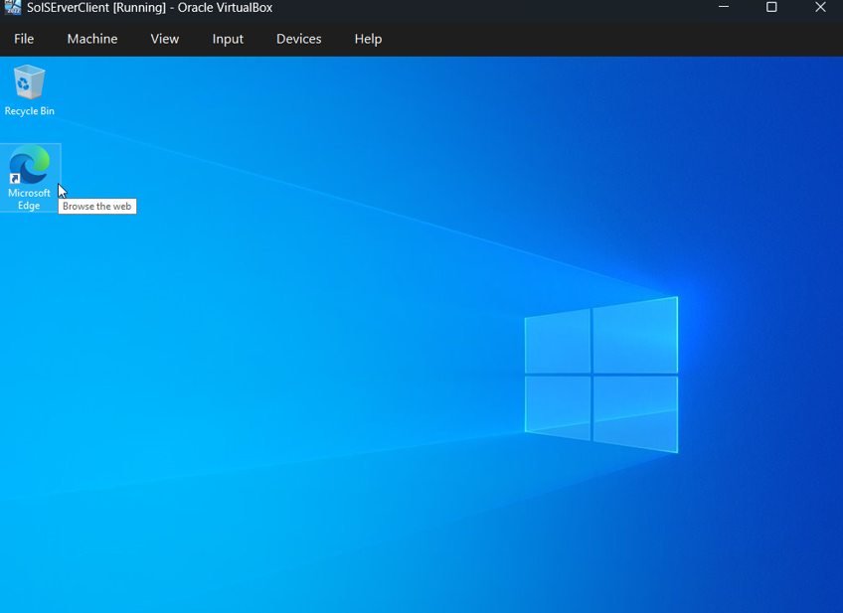
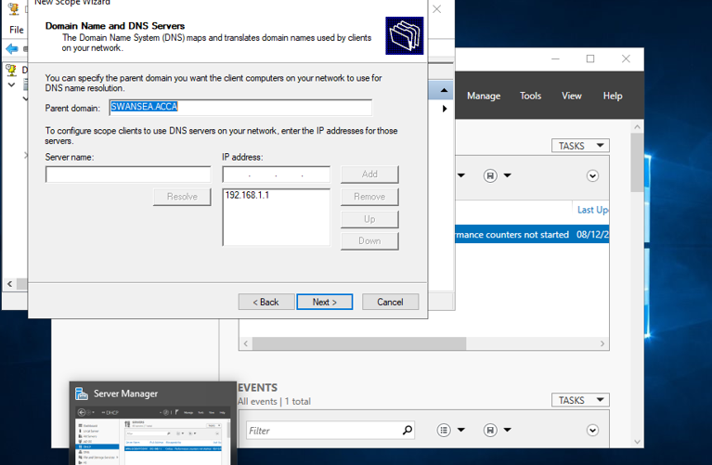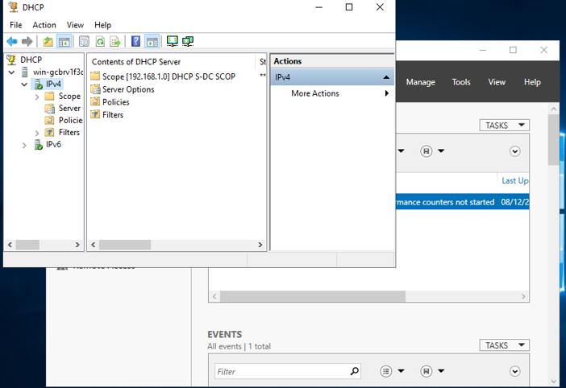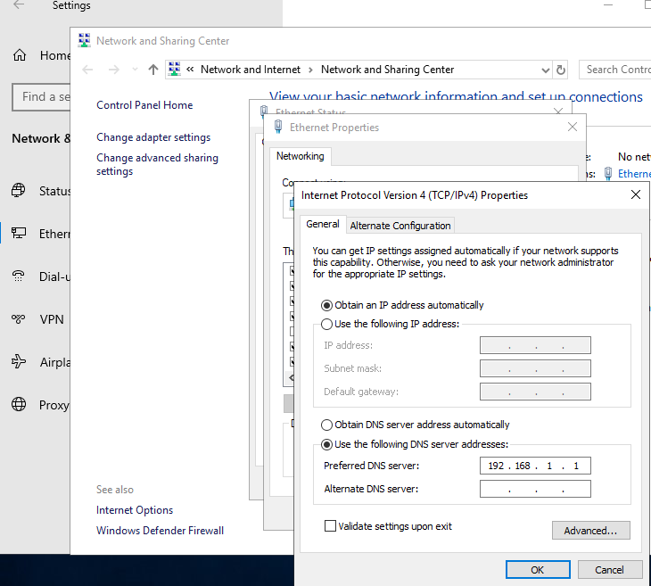

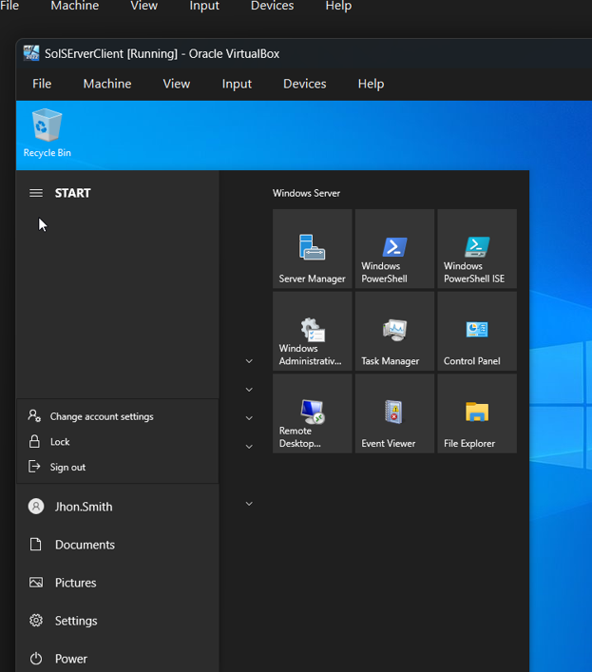
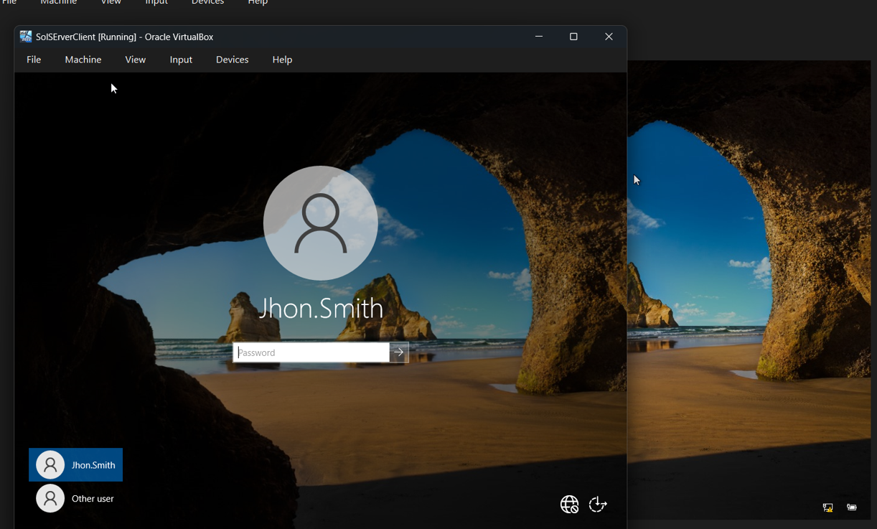
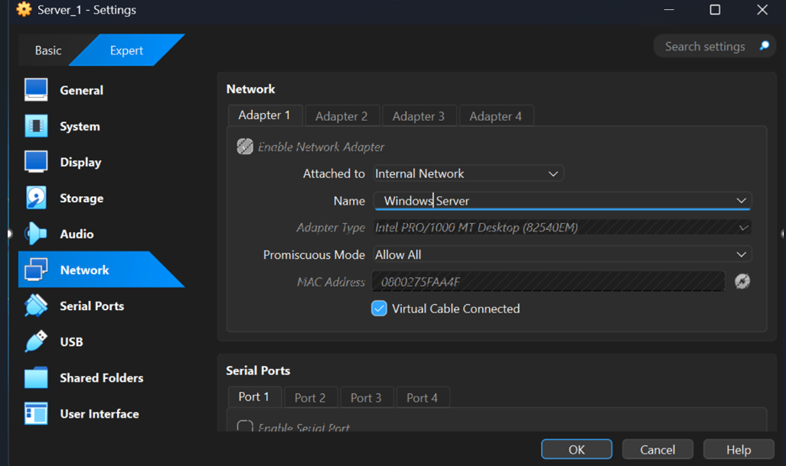
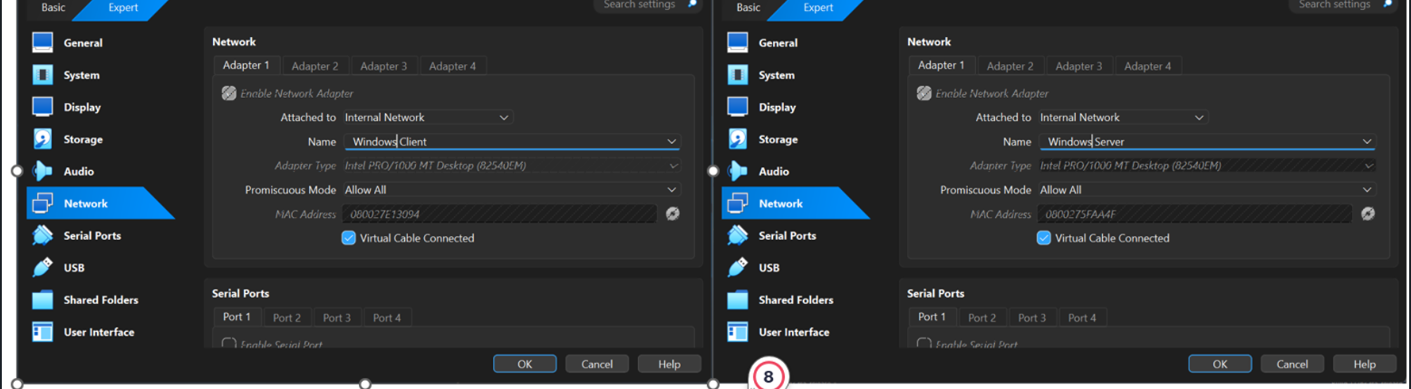
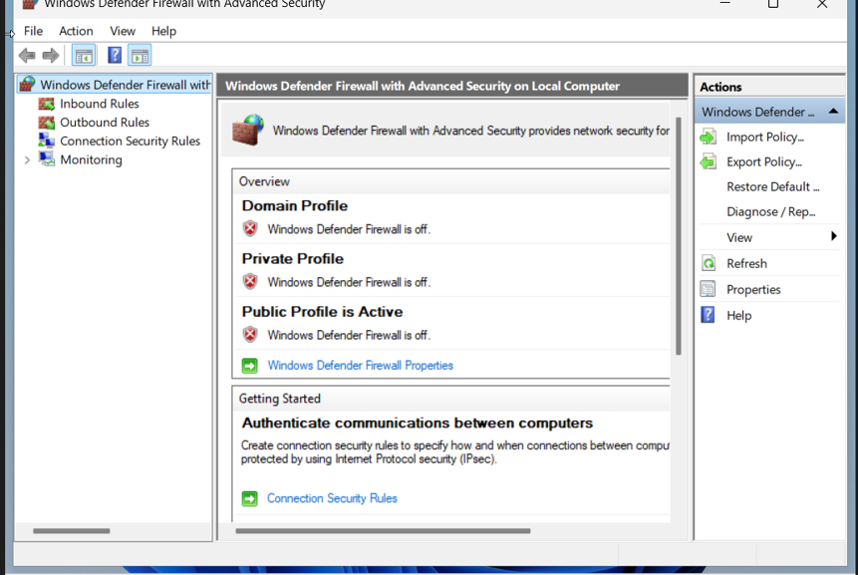

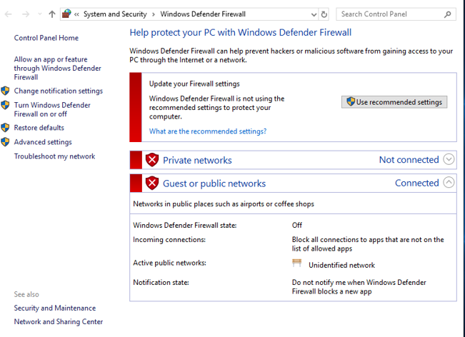

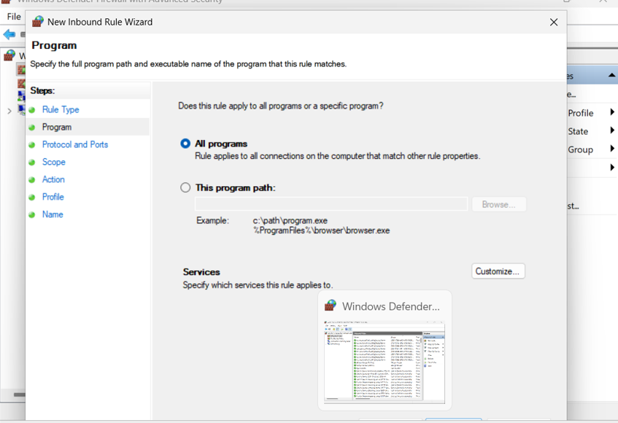

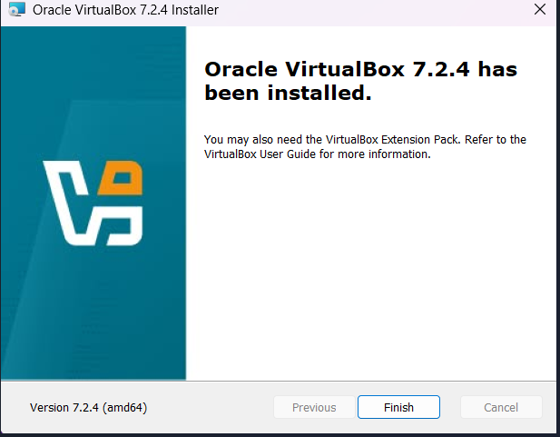
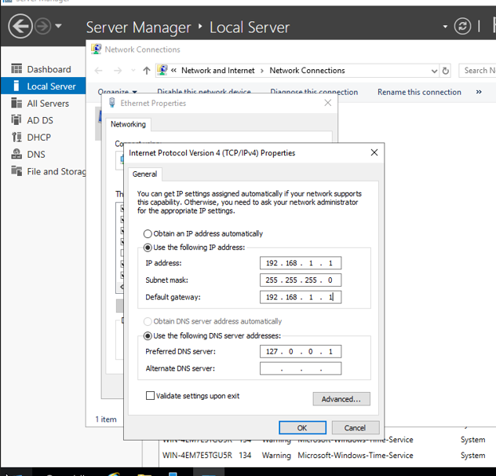

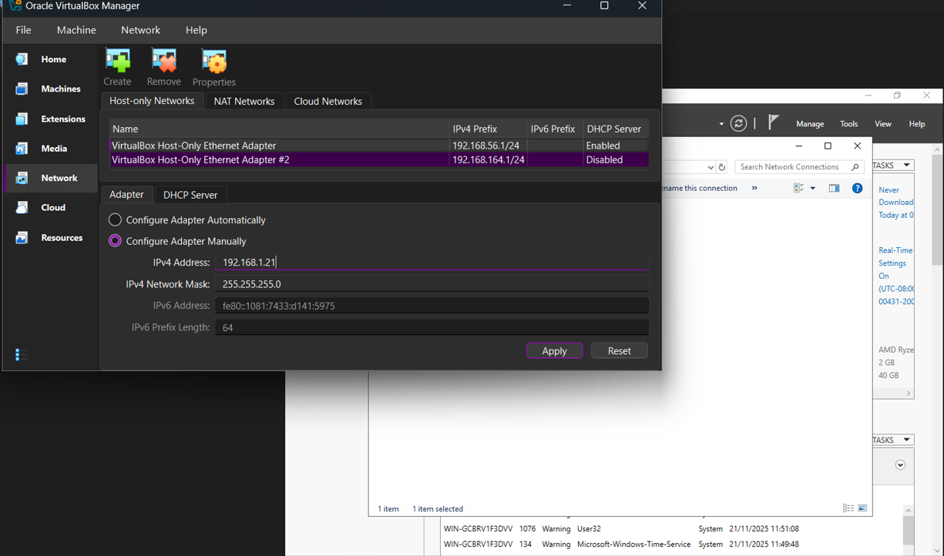
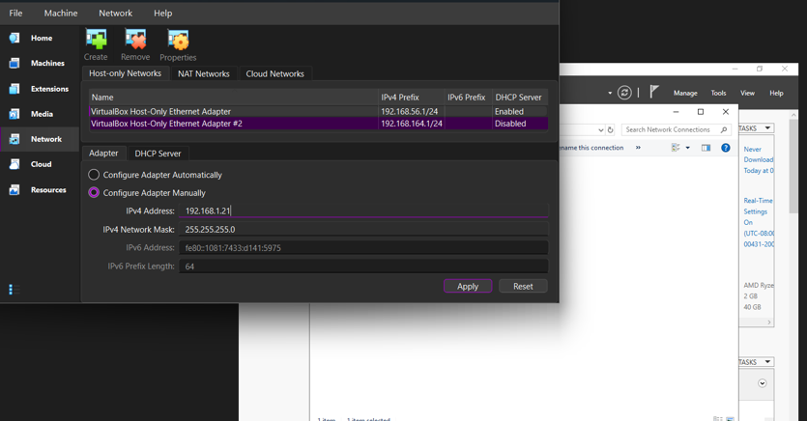

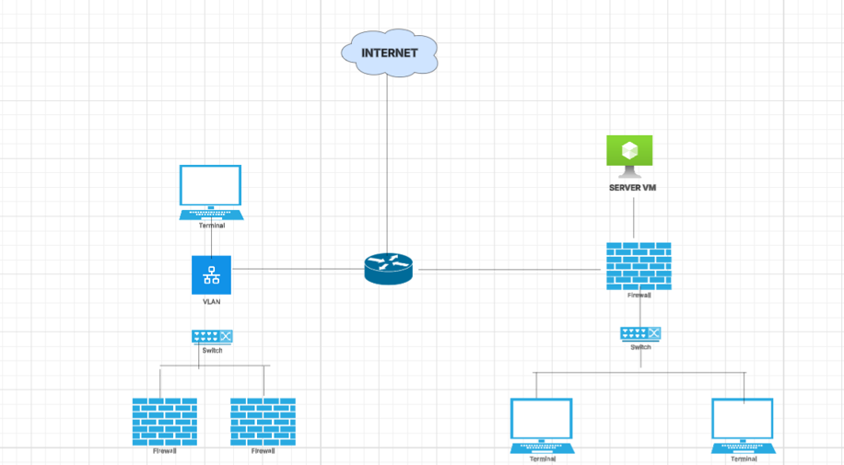

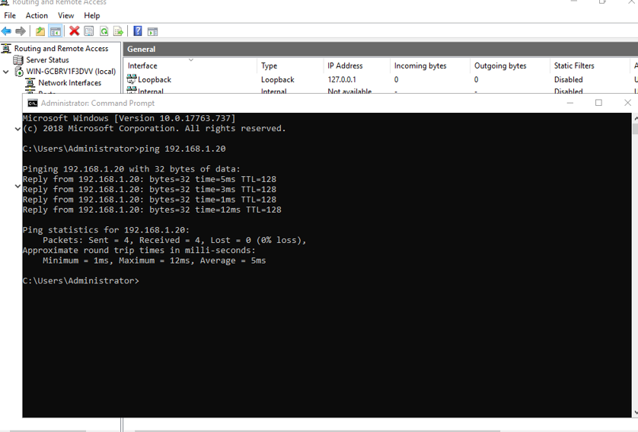
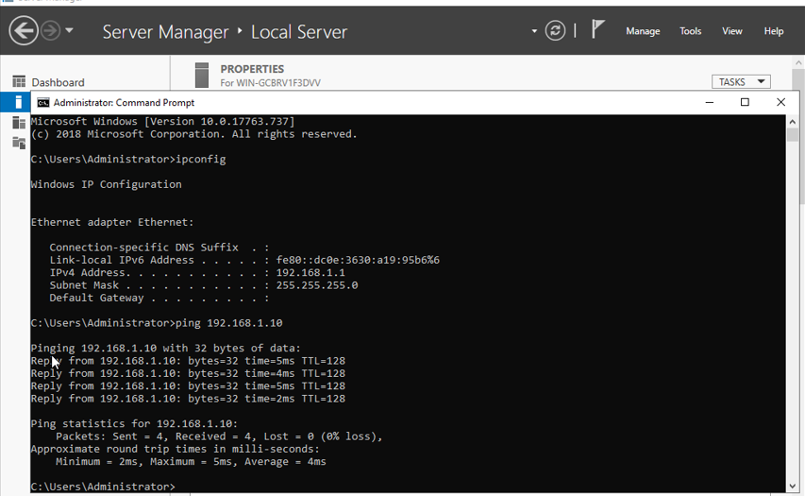

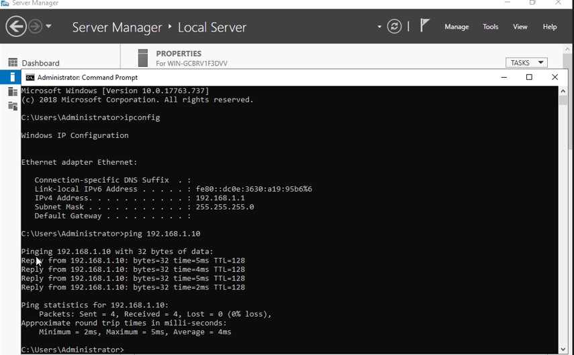

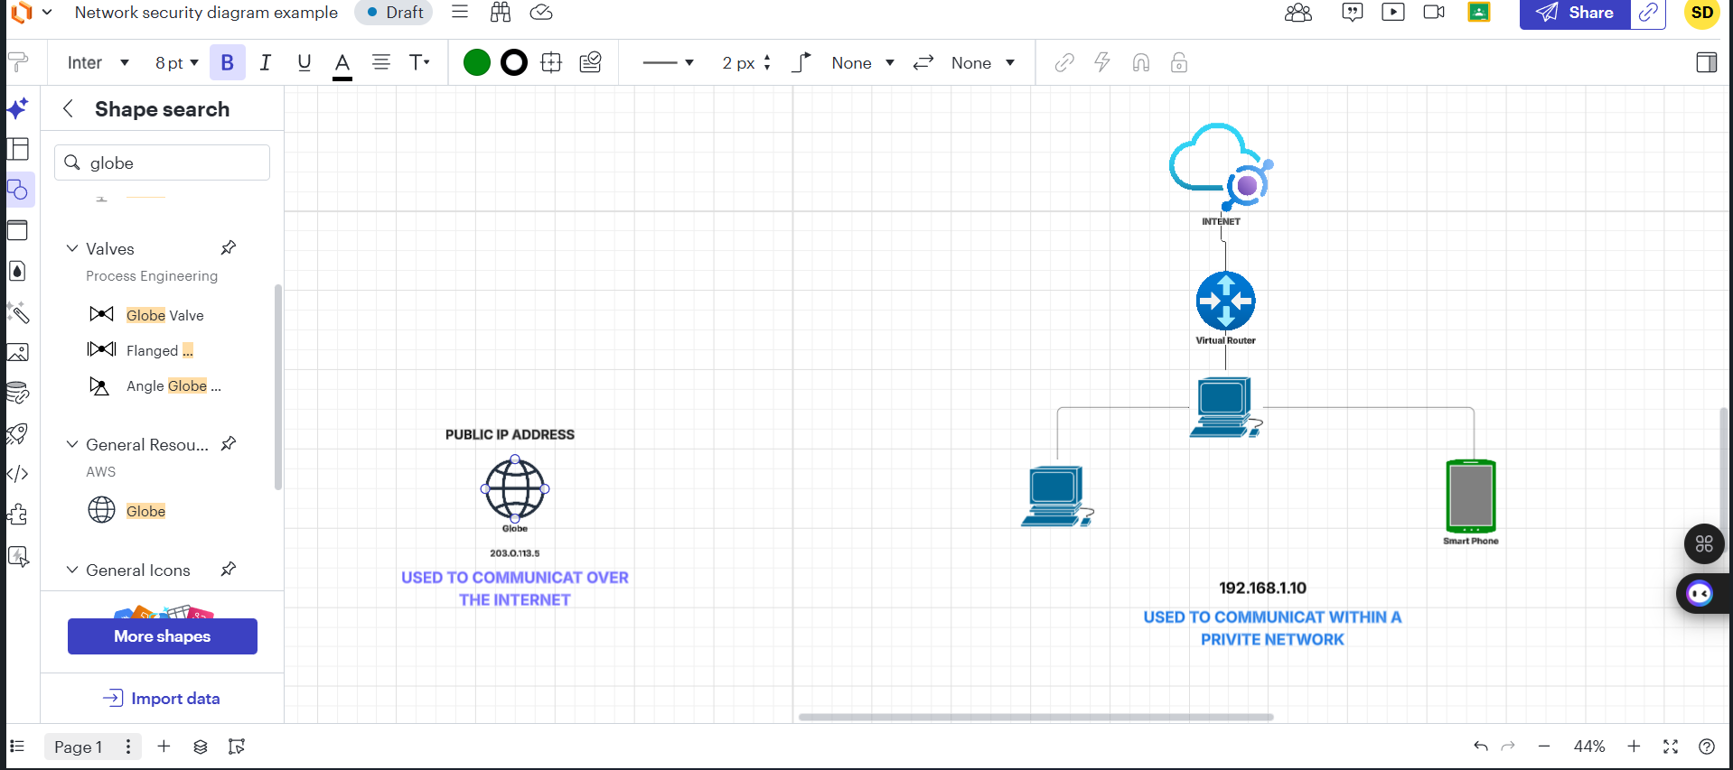
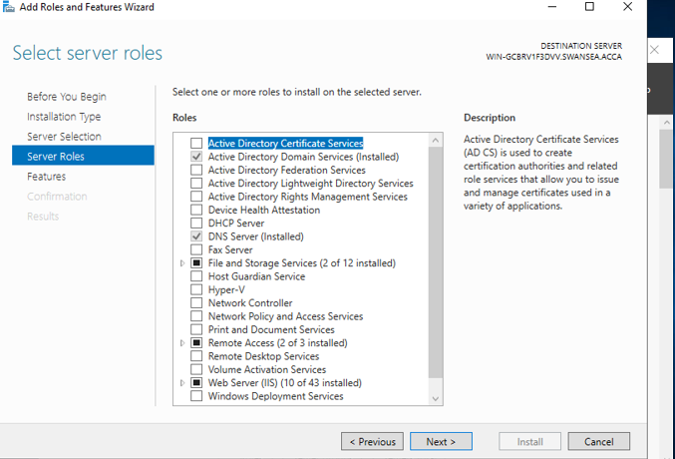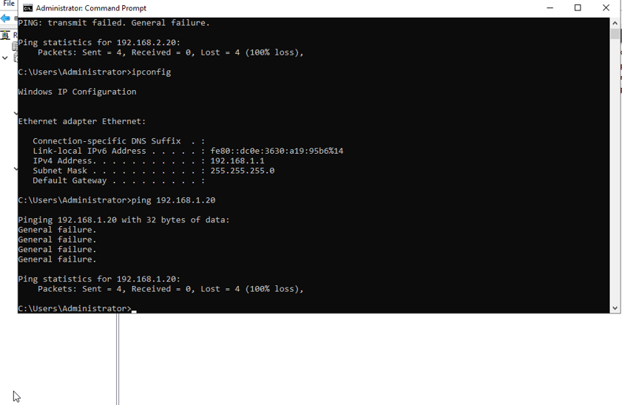

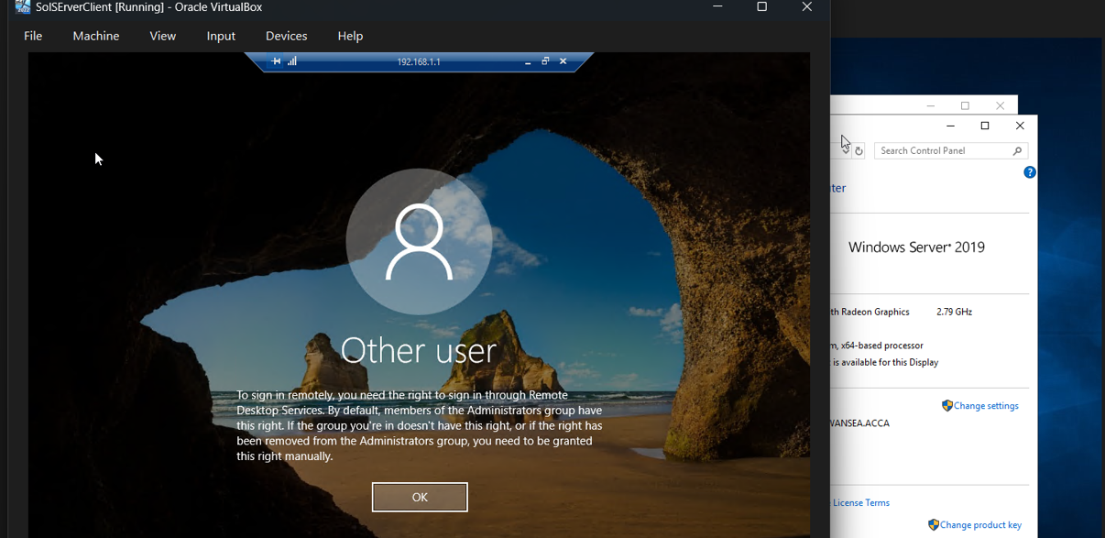

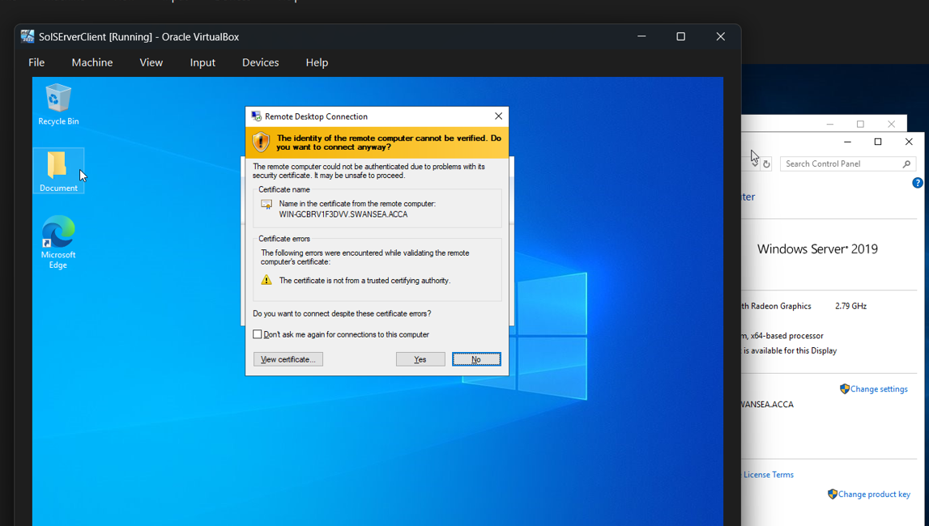

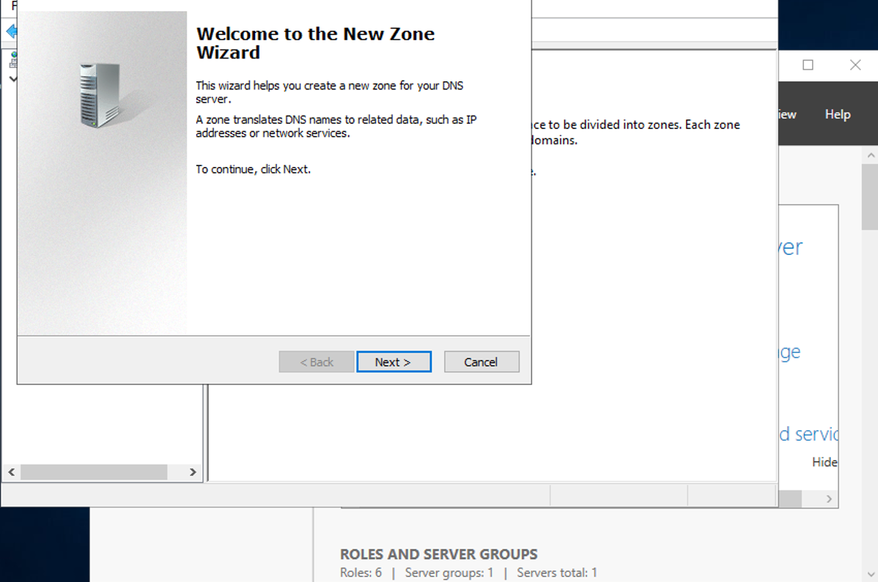

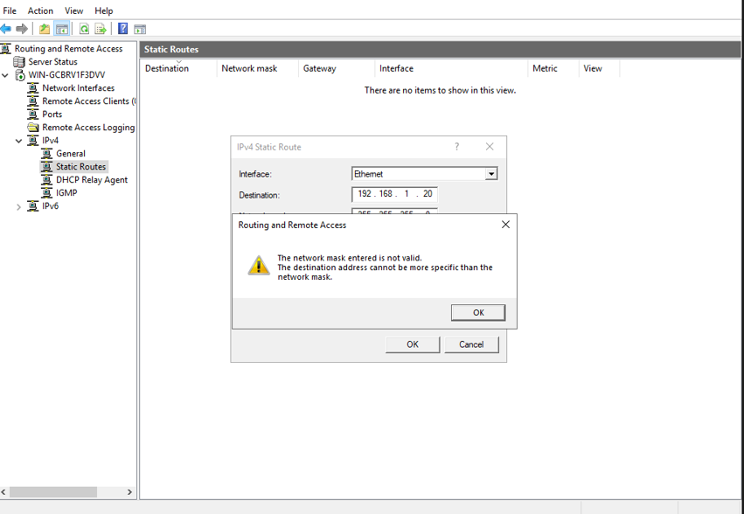

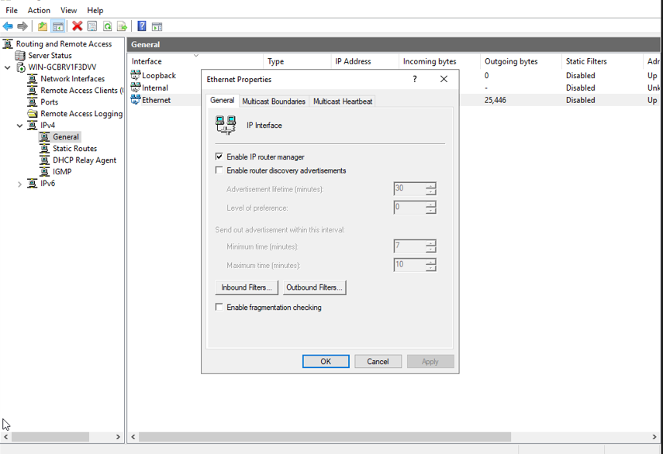


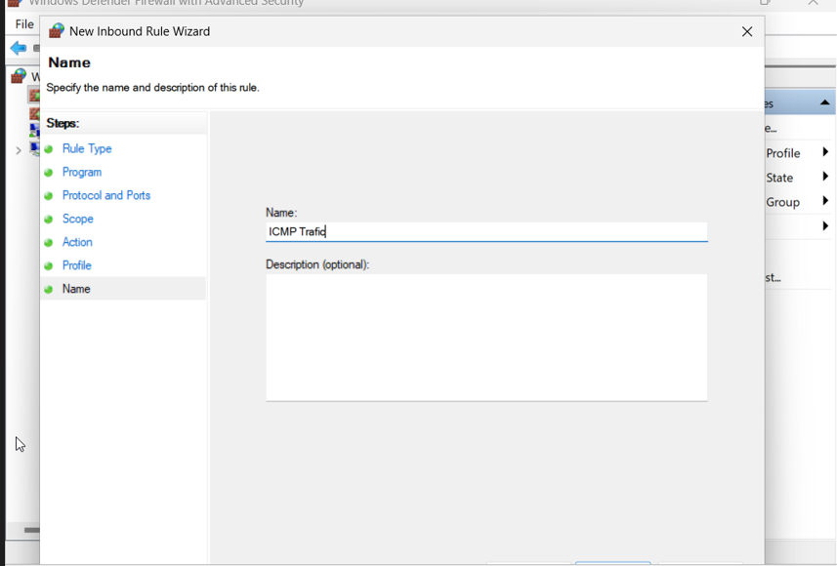

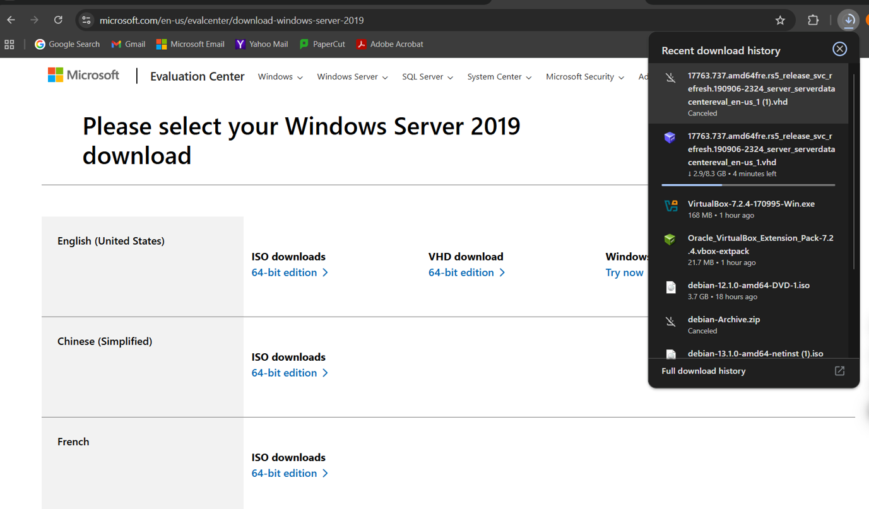

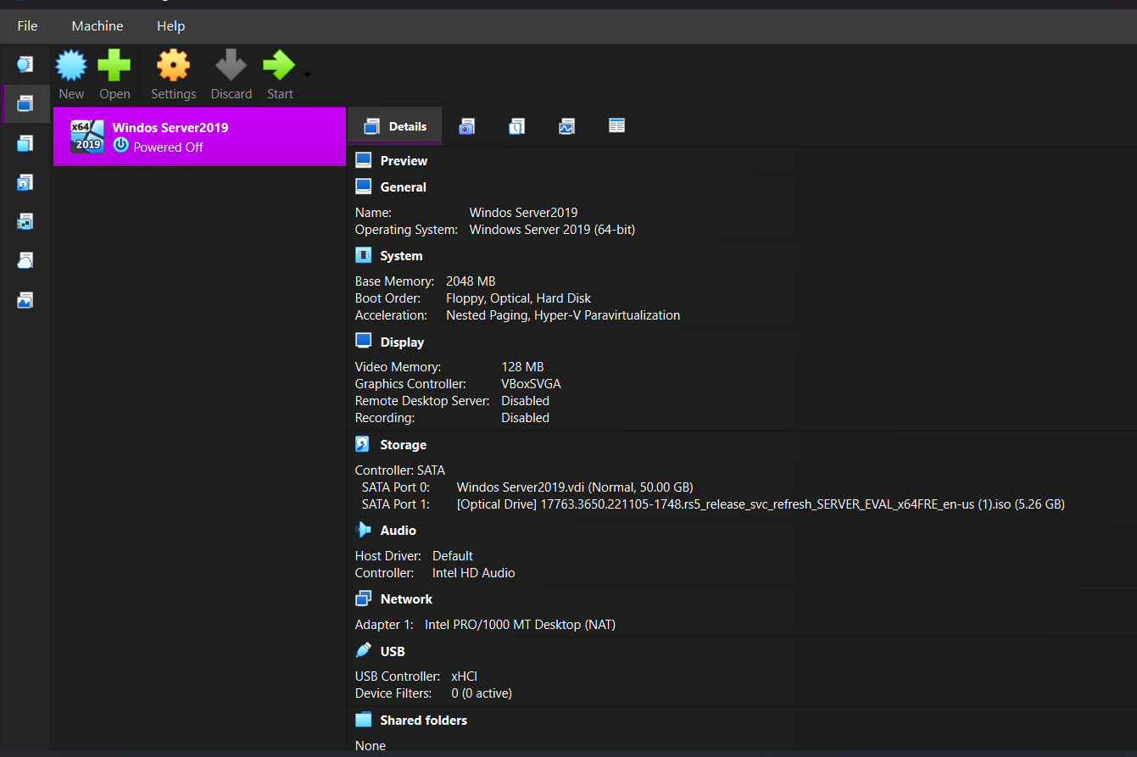
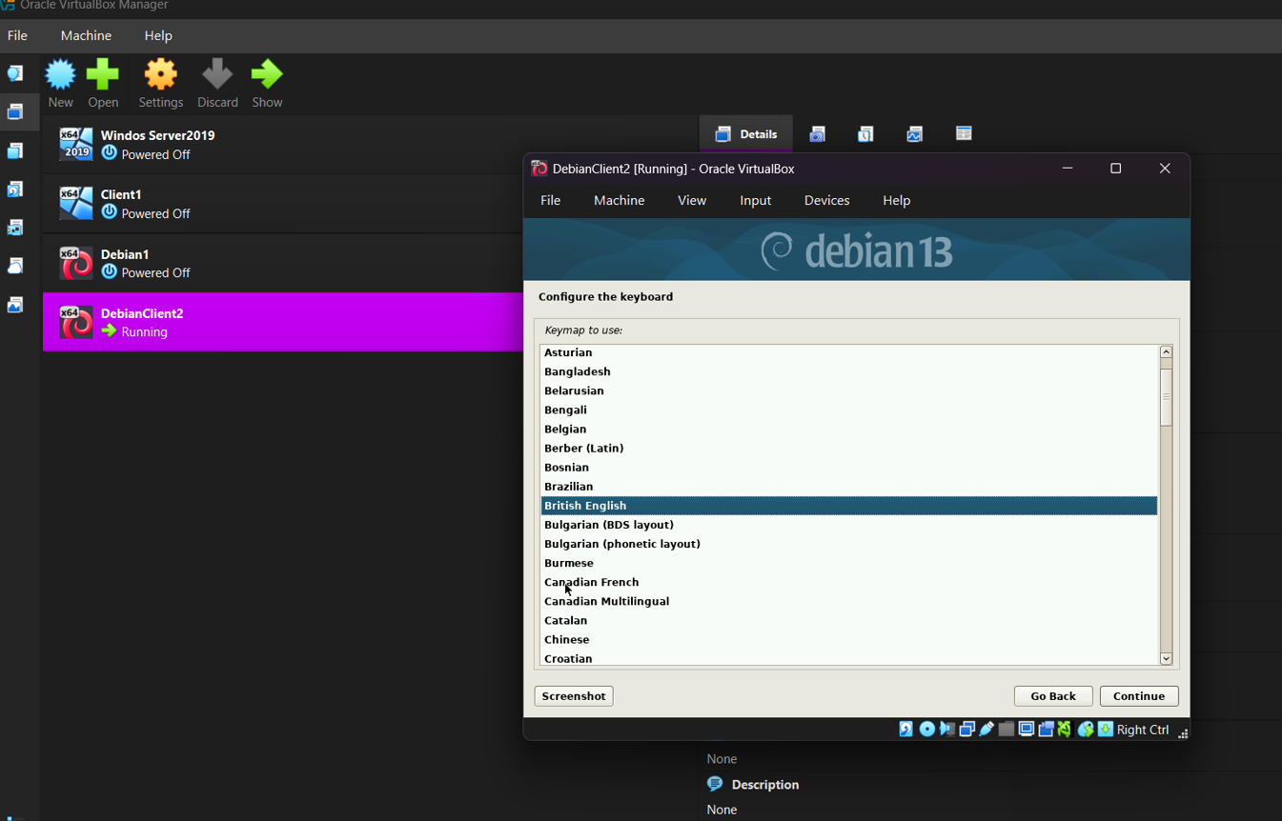
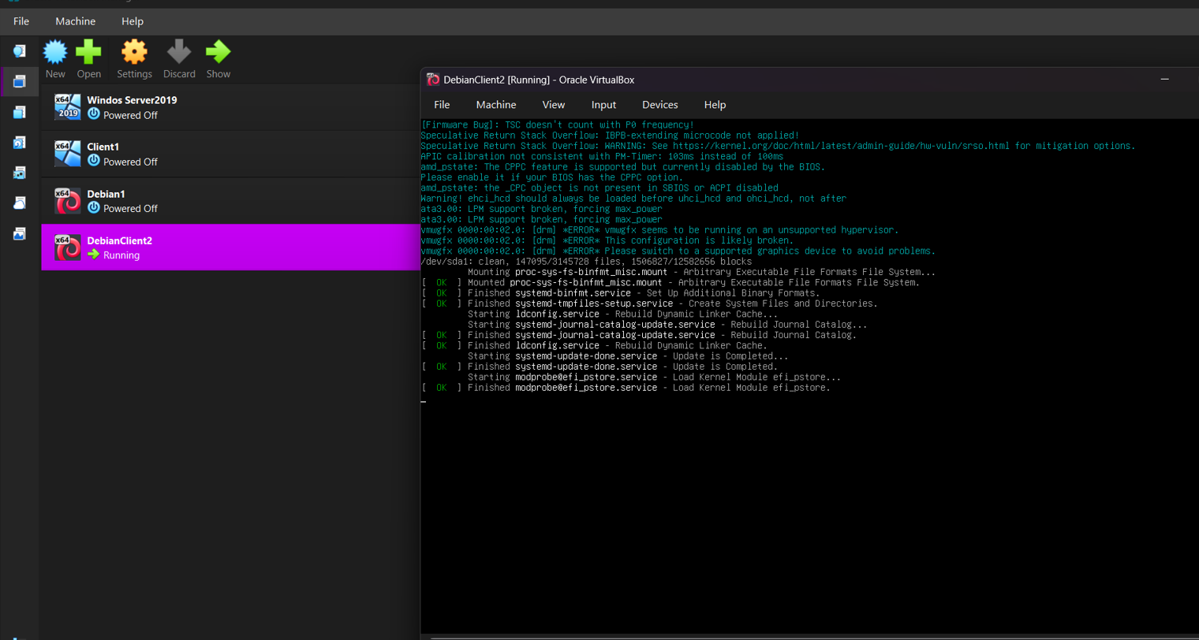
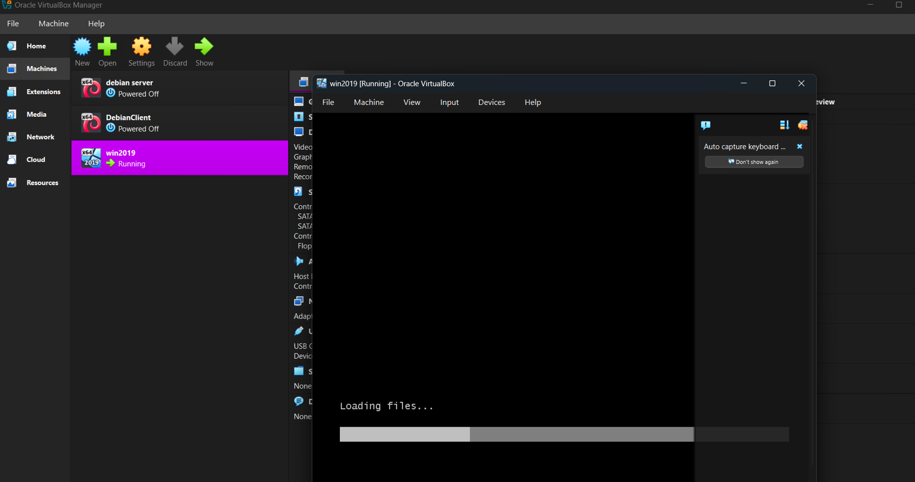
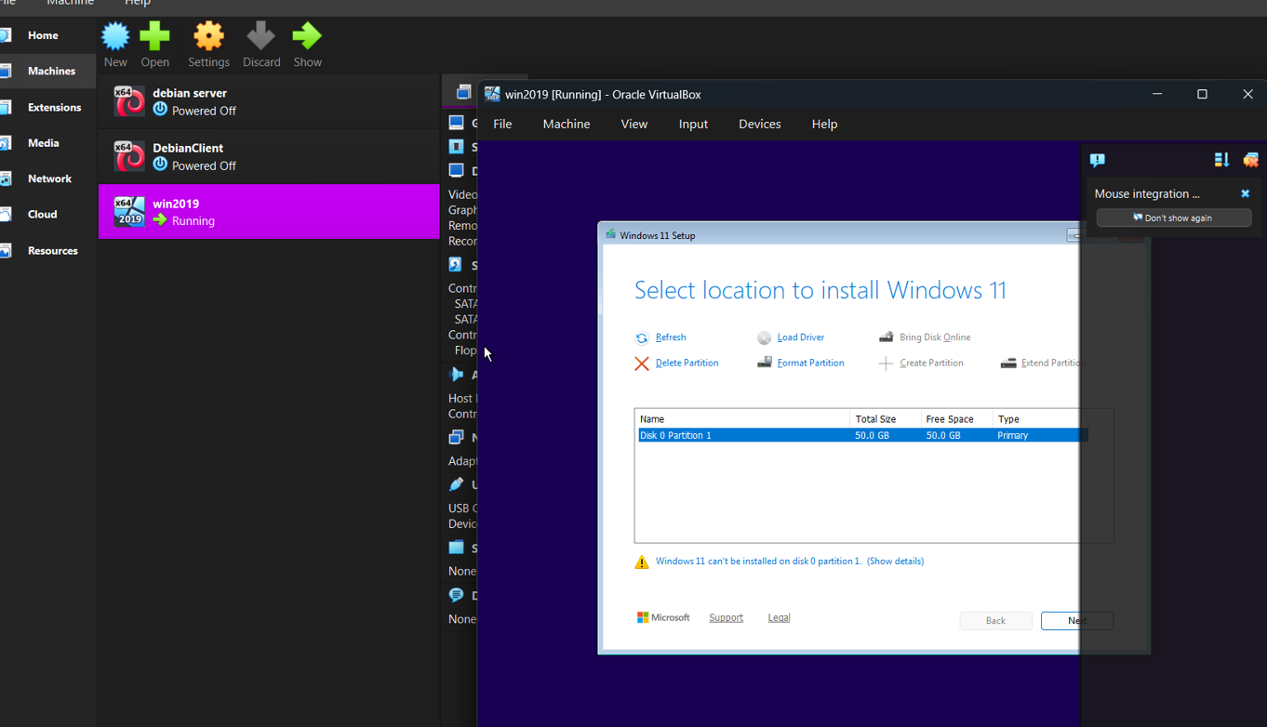
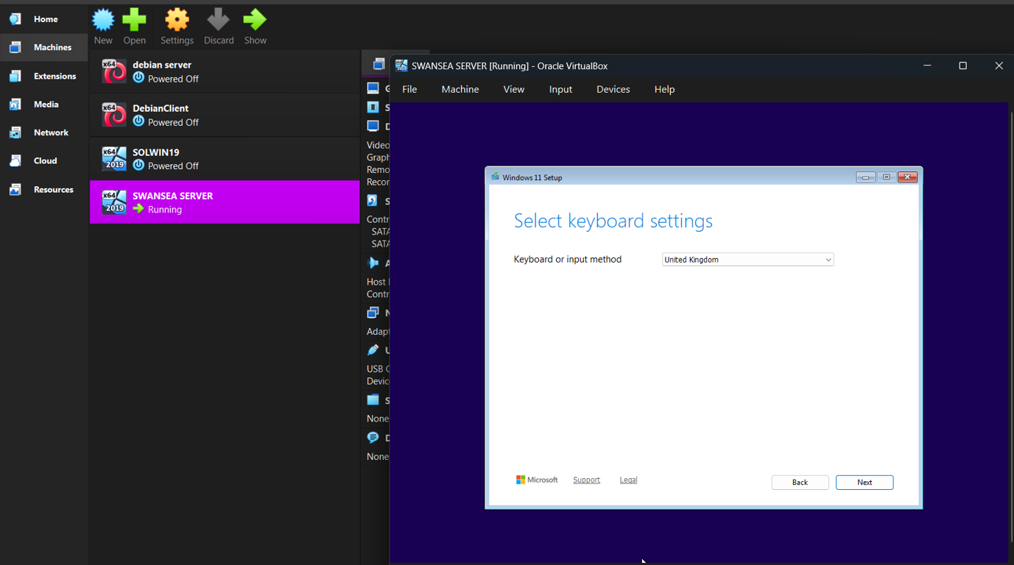

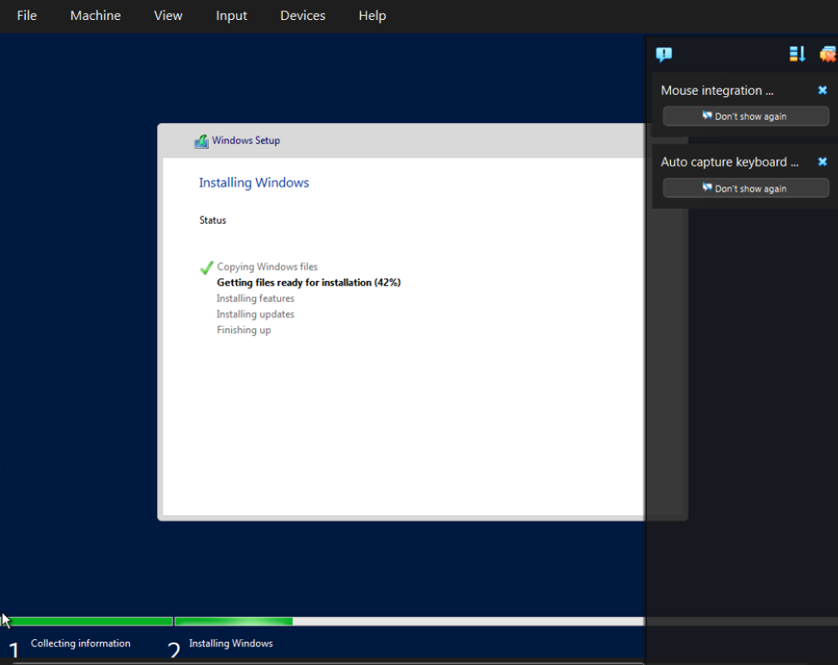

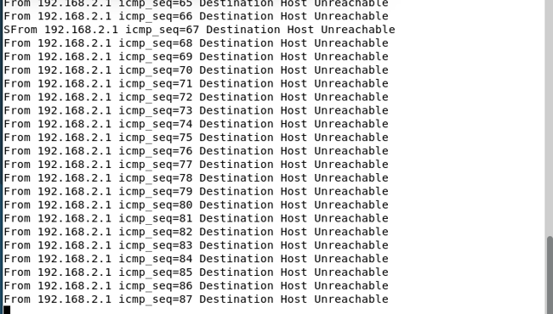
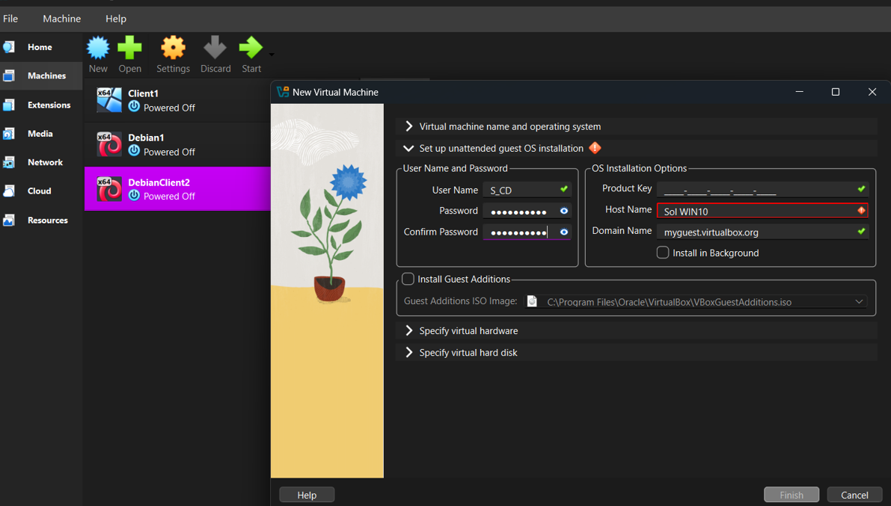

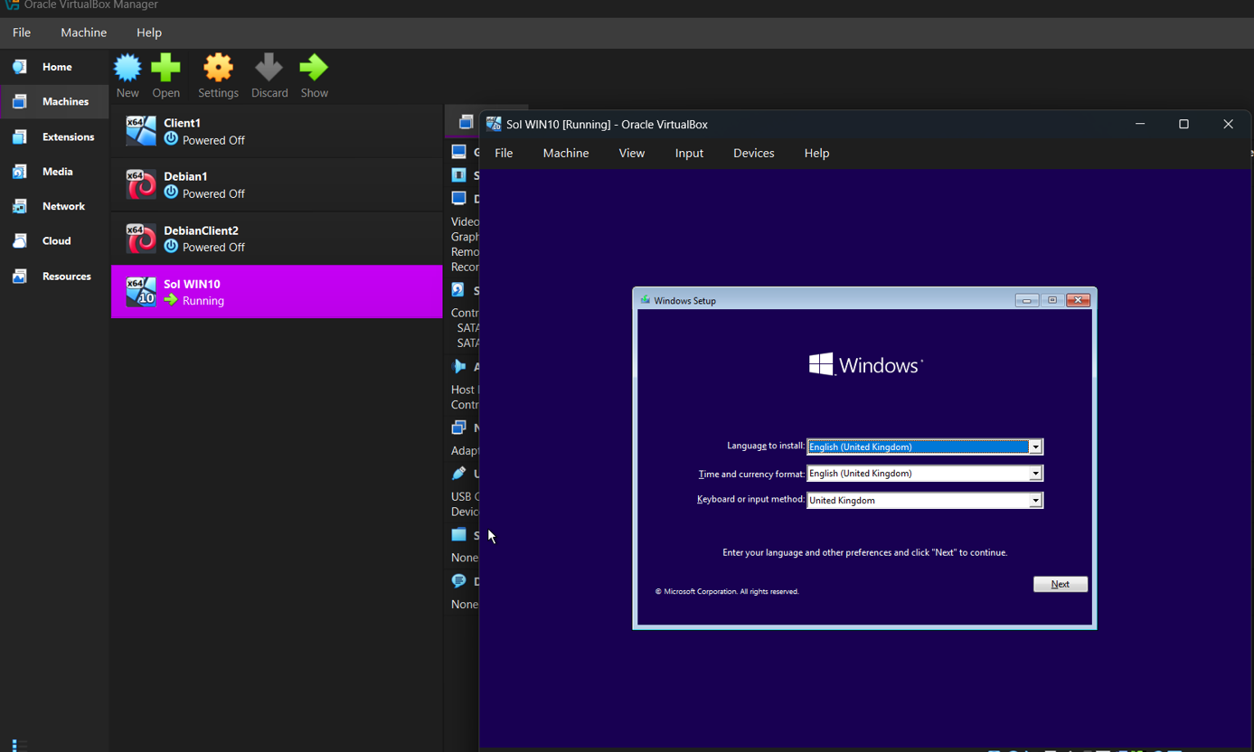
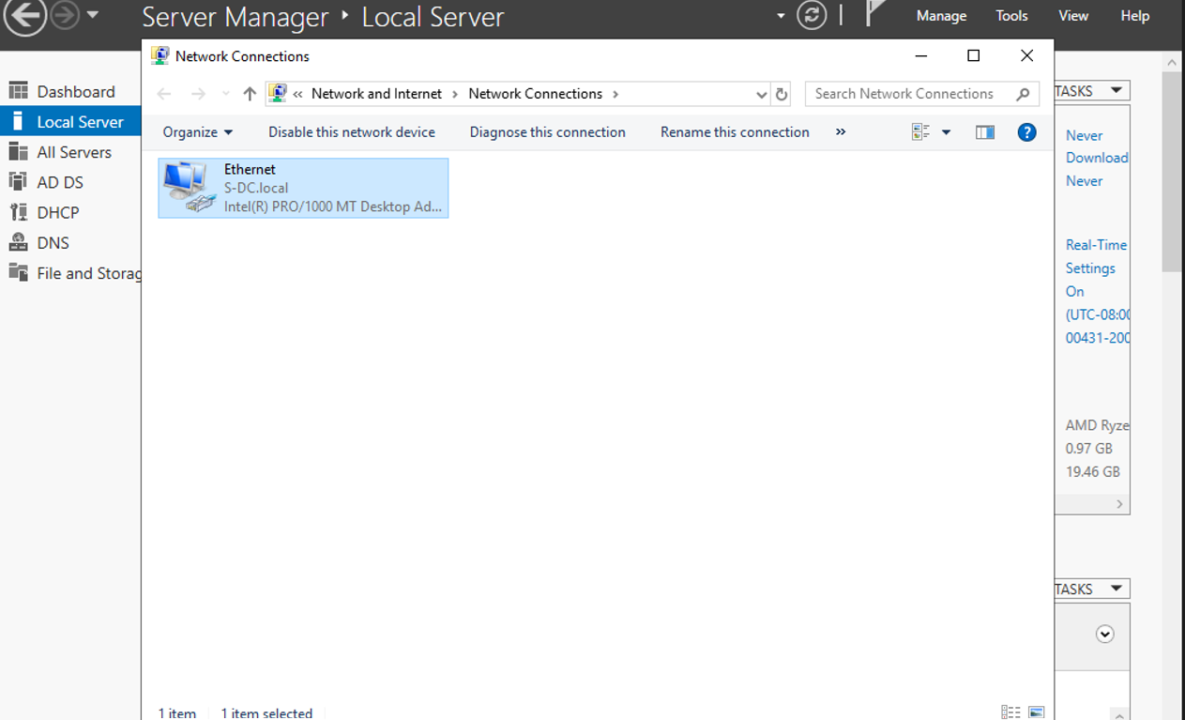

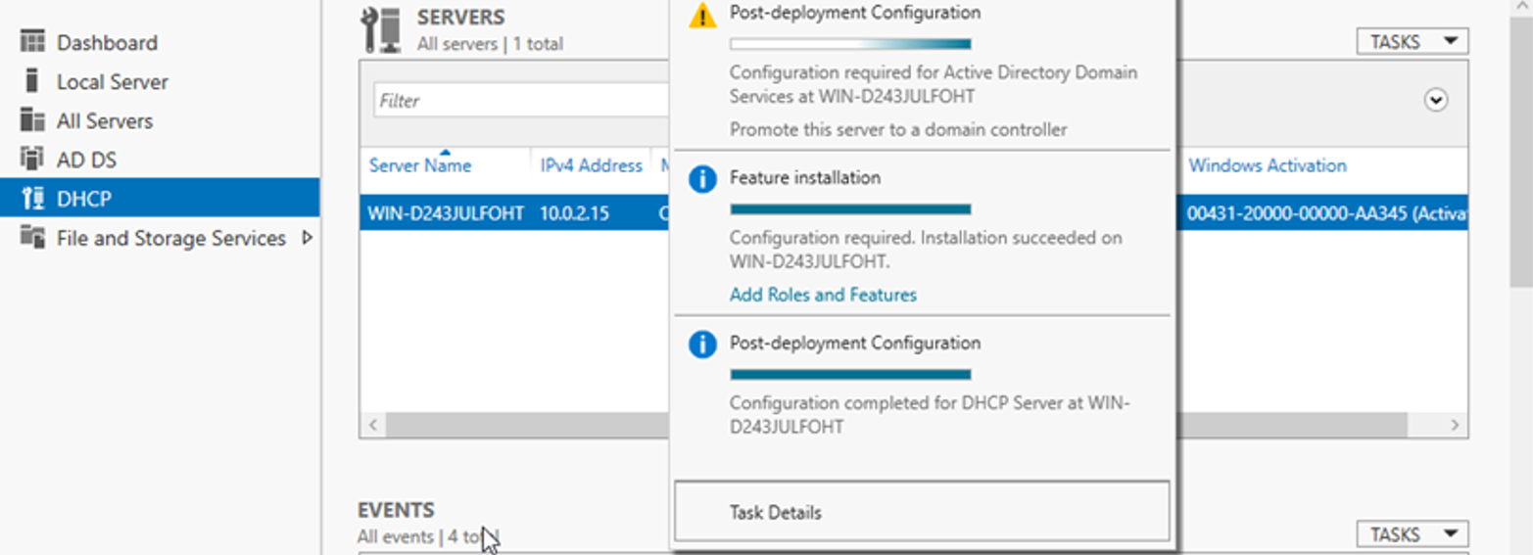

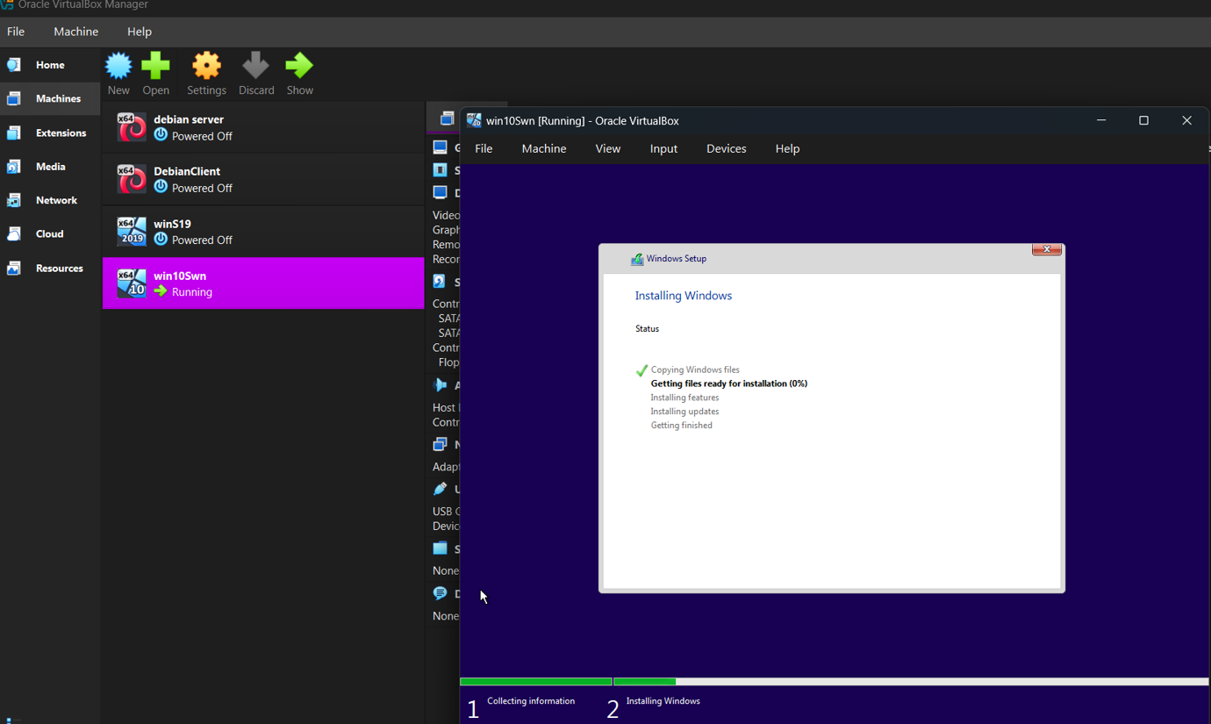
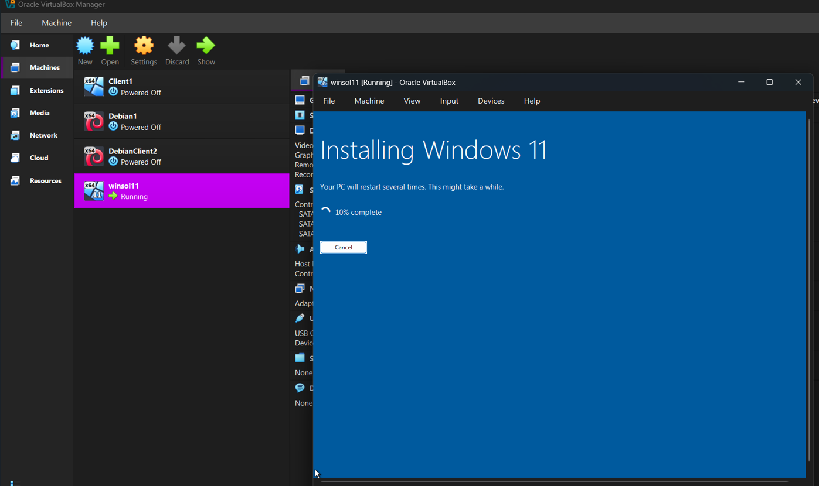

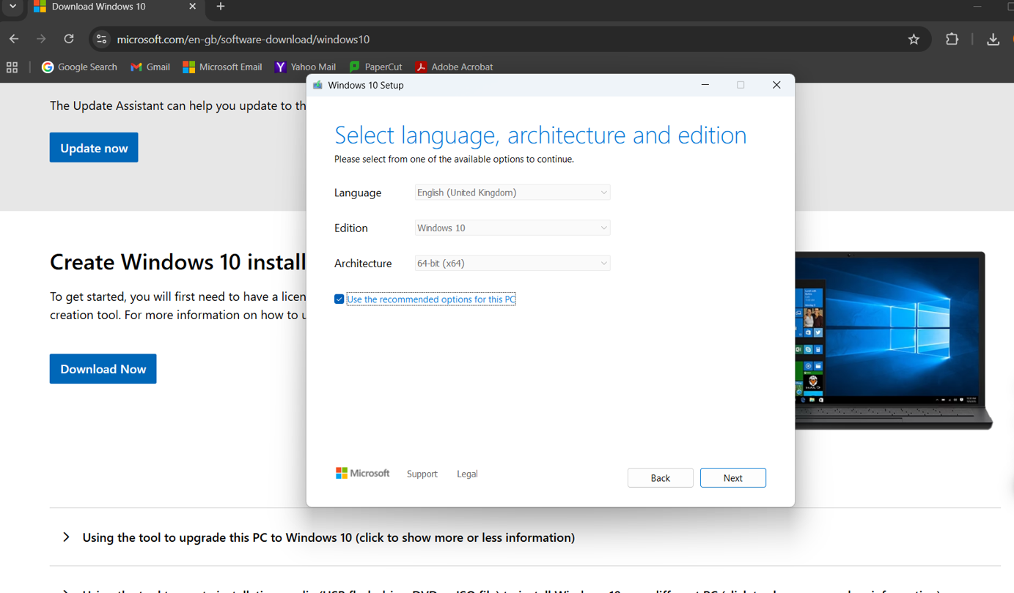
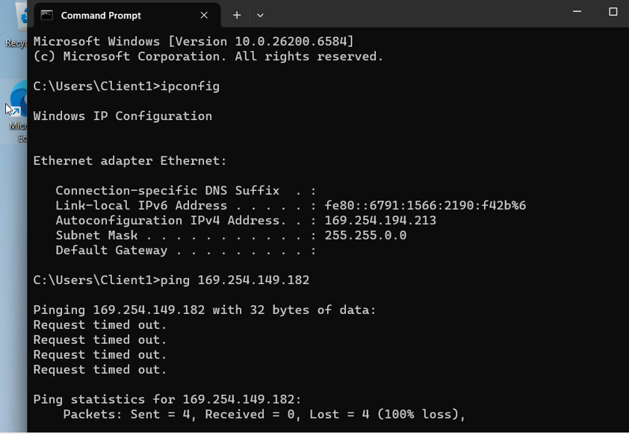
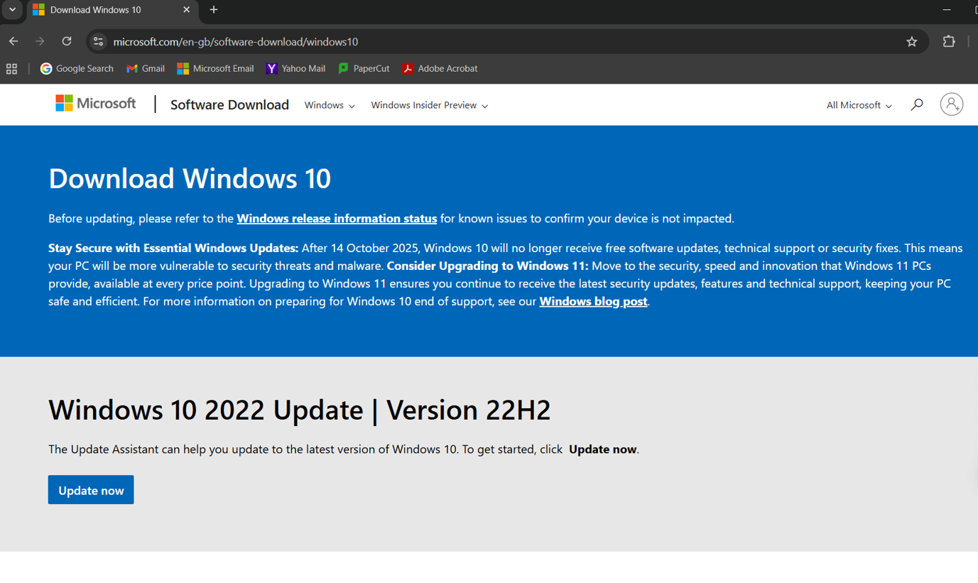

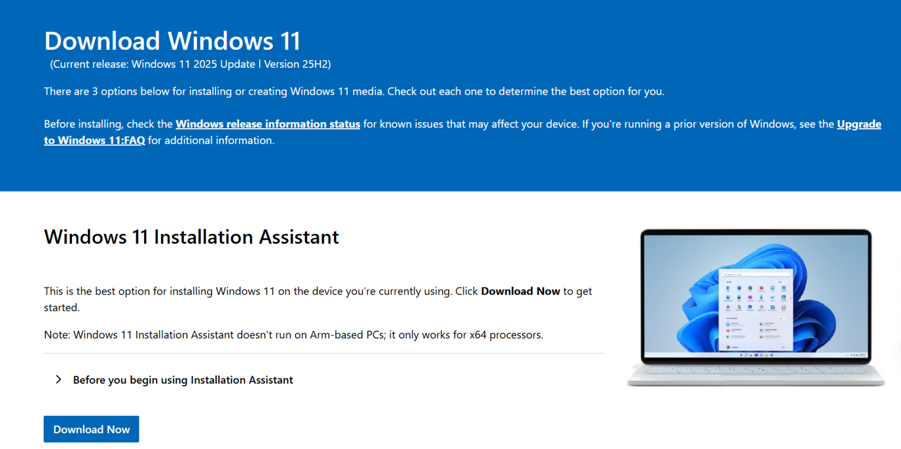
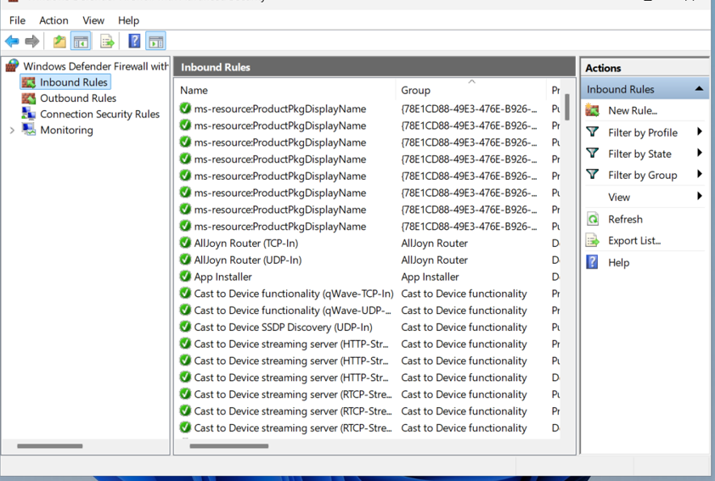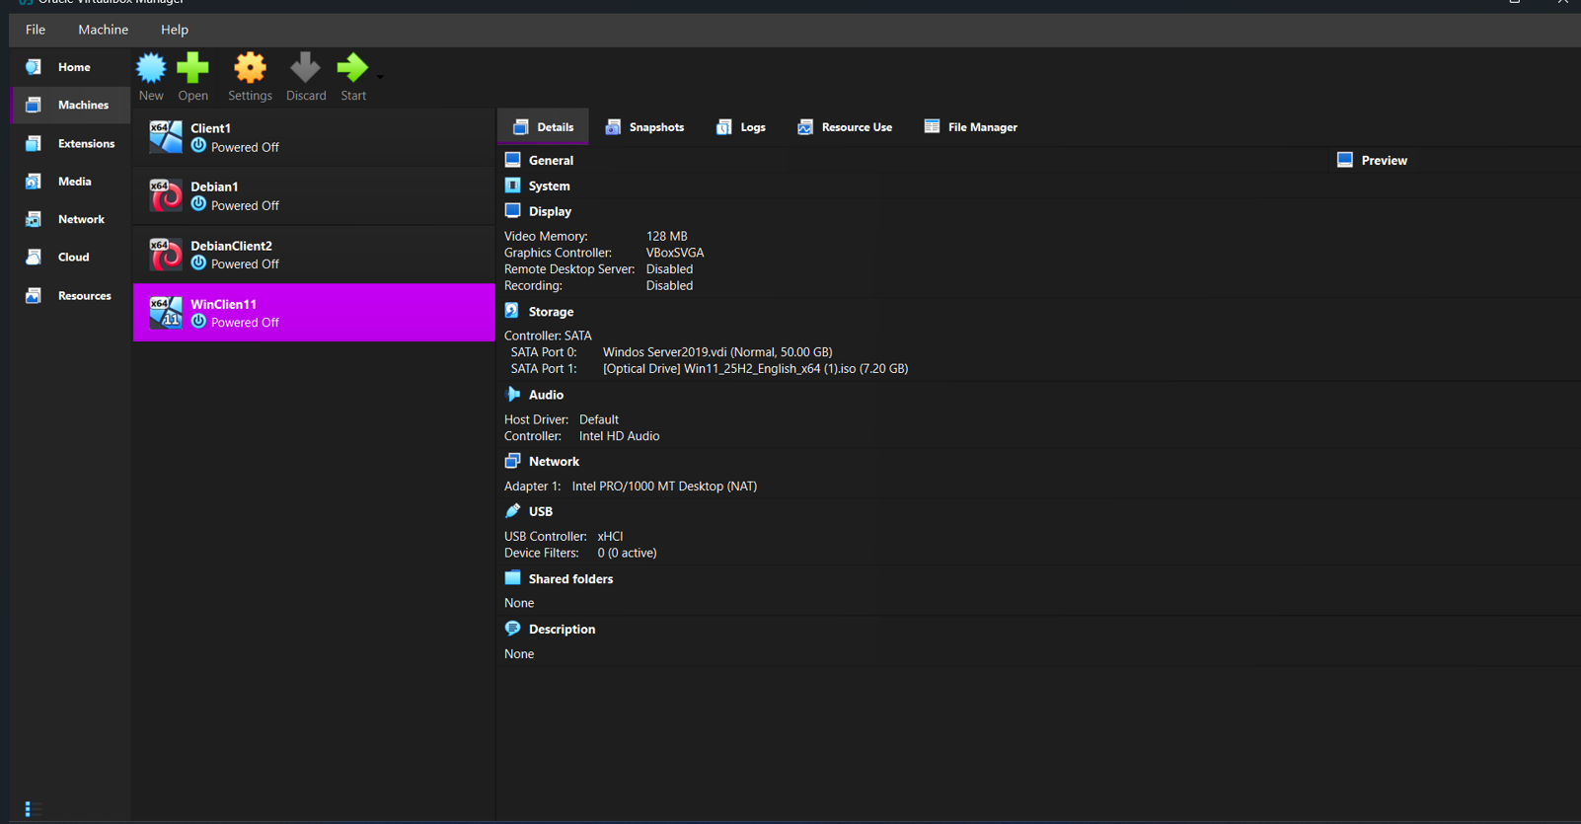
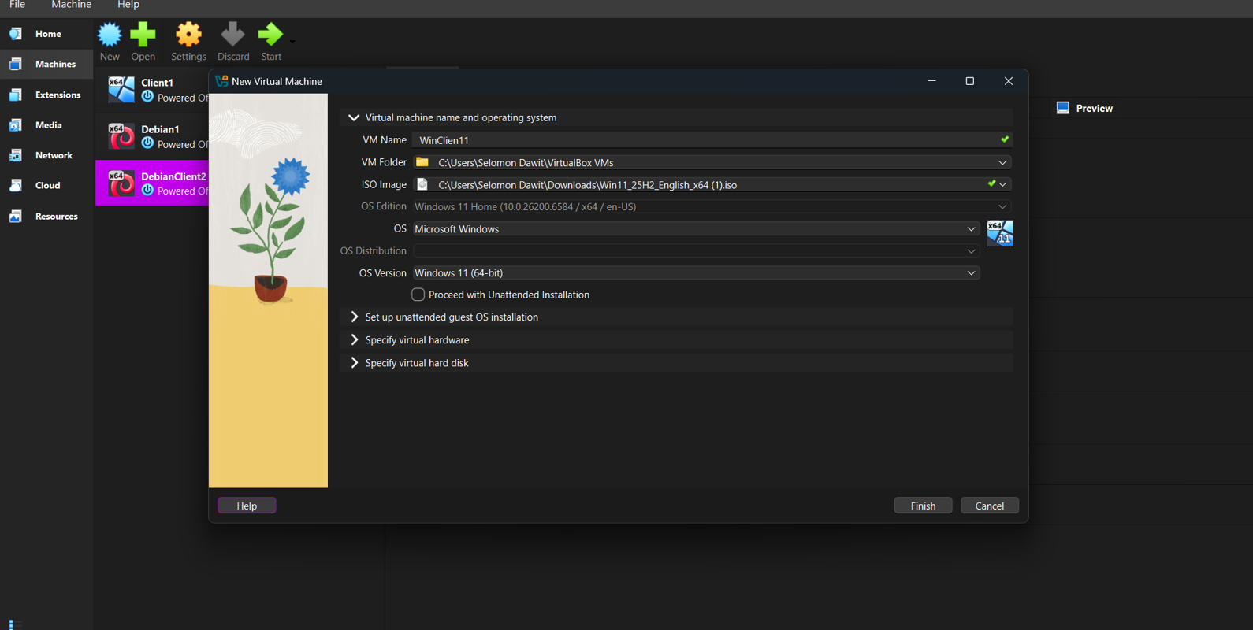

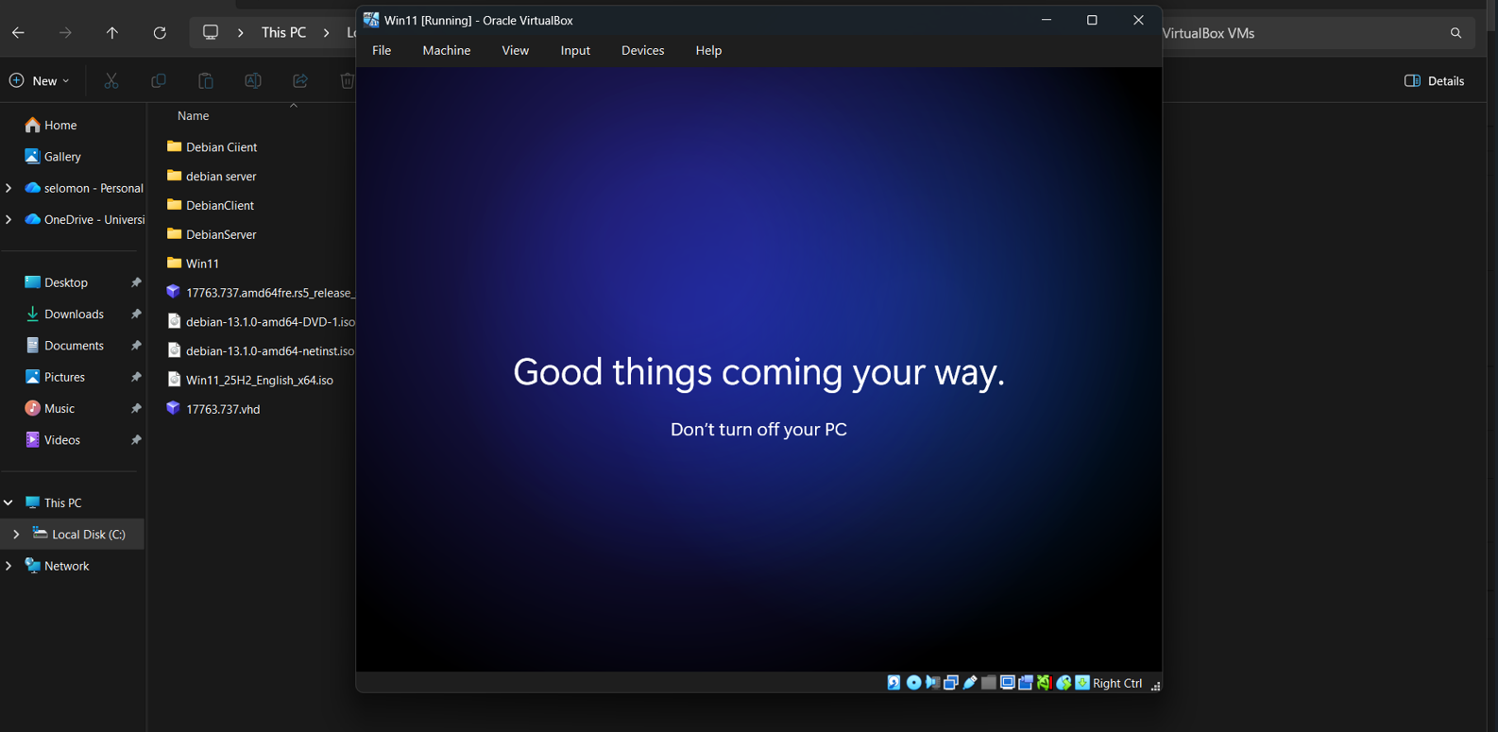
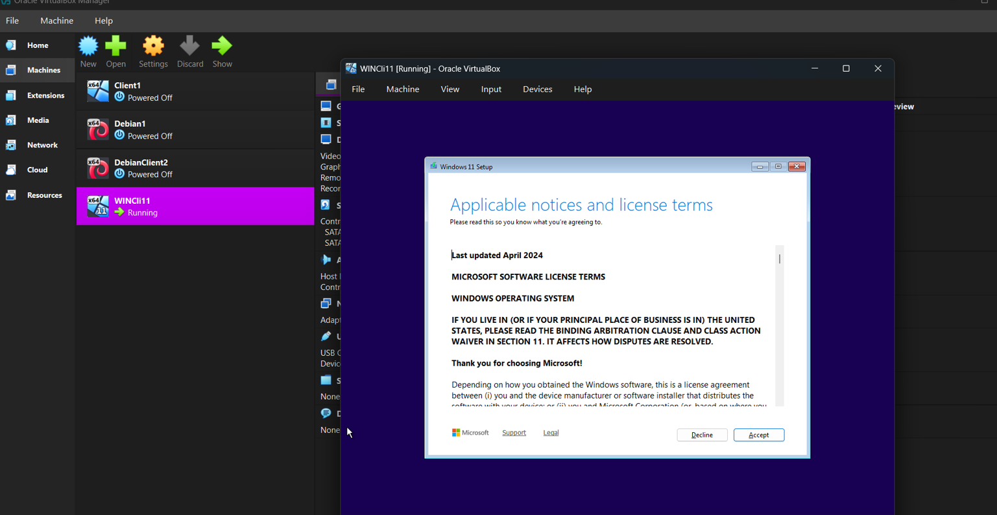
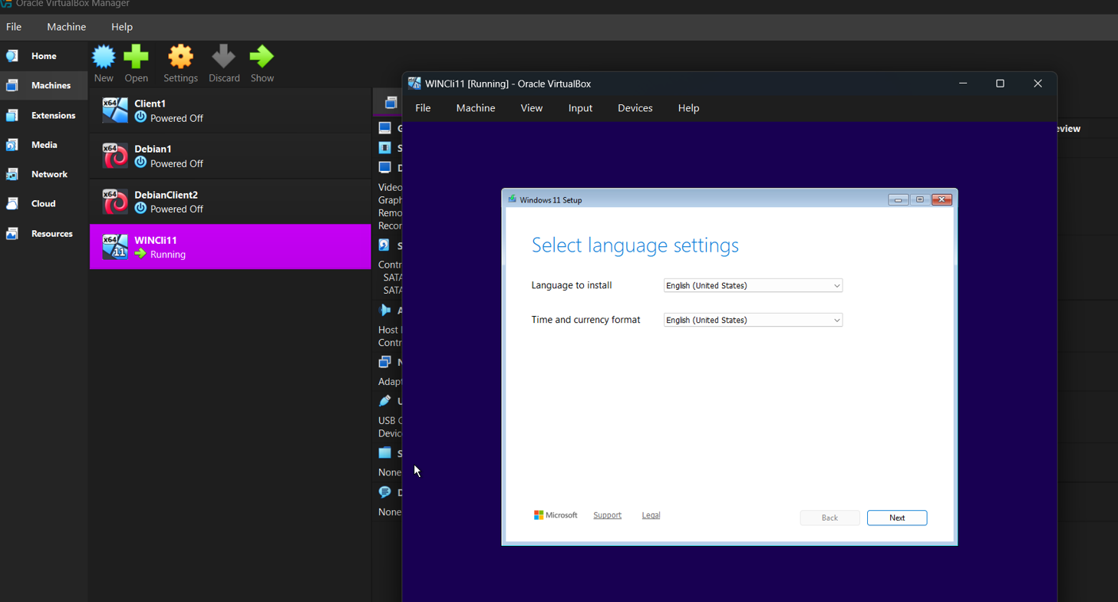

Windos Installation Problam
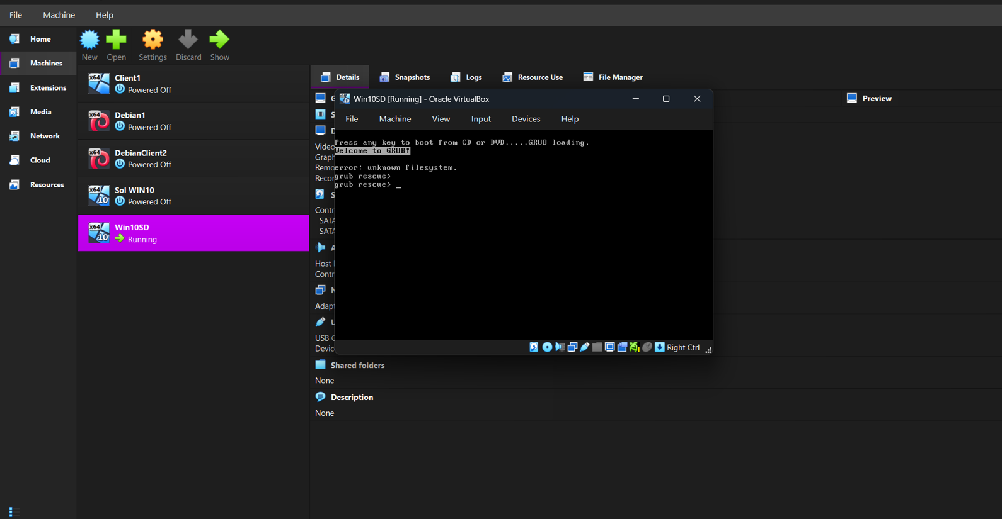

Window defender firewall
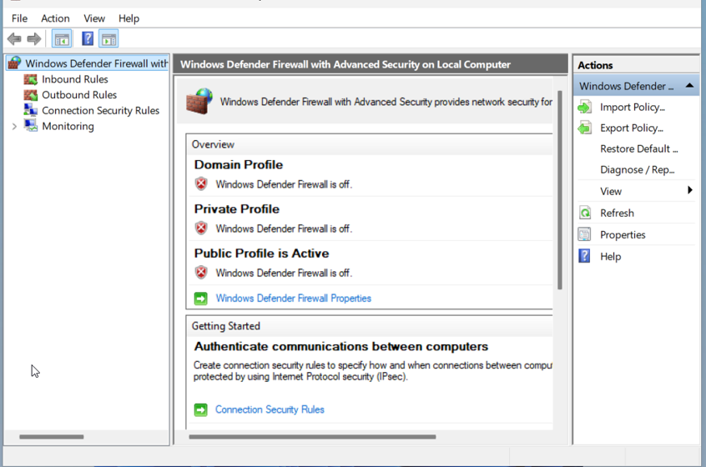

🪞 Task 3: Reflection

Technical Reflection

During deployment, several issues were encountered, particularly with IP addressing and network configuration. Incorrect subnet masks initially prevented communication between devices. This issue was identified through failed ping tests and resolved by correcting the subnet configuration according to the VLSM design. Additionally, VirtualBox network adapter misconfigurations caused connectivity issues, which were resolved by assigning the correct internal networks.

Personal Reflection

This coursework enhanced my practical understanding of networking concepts and virtualisation technologies. I developed skills in configuring servers, managing IP addressing, and troubleshooting network issues. Time management played a crucial role, as completing tasks incrementally ensured accuracy and proper documentation. Overall, the project improved both my technical expertise and problem-solving abilities.

References (Harvard Style)
Kurose, J.F. and Ross, K.W. (2021) Computer Networking: A Top-Down Approach. 8th ed. Pearson.
Microsoft (2022) Active Directory Domain Services Overview. Available at: https://learn.microsoft.com
Odom, W. (2020) CCNA 200-301 Official Cert Guide. Cisco Press.
Pfoh, J., Schneider, C. and Eckert, C. (2009) ‘A performance analysis of hypervisors’, IEEE.
Tanenbaum, A.S. and Wetherall, D.J. (2011) Computer Networks. 5th ed. Pearson

