Sustainable Business Revenue Generation Plan

Student Name:
Hani Rosteenmehr
Student ID Number:
2118863
Financial Management for the Hotel Industry
(5002-5007)

Lecturer:
Chris Wilkin

The Case against Outsourcing the Housekeeping Department within Marriott International
Introduction
Marriott International is a top provider of lodging services with a vast network of hotels, resorts, and other lodging options. Marriott has a long history spanning more than nine decades and maintains its main office in Bethesda, Maryland, in the United States (Wood, 2017). J. Willard Marriott founded the business in 1927, and since then it has become a household name in the hospitality sector, known for its top-notch service, opulent lodgings, and extraordinary guest experiences (Bardi, 2021). The success of Marriott is based on its commitment to innovation, adoption of technology, and adaptation to shifting client demands and tastes. In order to improve the visitor experience and go above and beyond expectations, the business aims to offer cutting-edge amenities, modern facilities, and personalised services (Wood, 2017).
In the current economic environment, outsourcing is a widespread practise that many businesses are now contemplating as a way to cut expenses and concentrate on their core strengths. Outsourcing might not be the ideal choice for Marriott International's housekeeping division, though (Bardi, 2021). This study compares and contrasts internal housekeeping teams with external alternatives in order to make the case against outsourcing the housekeeping division of Marriott International. The debate will take into account a number of variables, including the employed people's skills, the cost implications, the outcomes, sustainability, consistency, and the guest experience (Wood, 2017).

Comparison of Insourced Housekeeping Team vs. Outsourcing Housekeeping
Abilities of Employed

Regarding the skills of employees employed, outsourcing the housekeeping division inside Marriott International has a number of benefits. Marriott can build a committed team with specialised expertise and abilities that are tailored to meet the unique demands and standards of its properties by personally hiring, training, and managing its workers (Legrand et al., 2023).
Marriott is able to completely oversee the hiring of housekeeping personnel because to insourcing. The corporation has the authority to specify the credentials, background, and standards that correspond to its brand and service expectations. This guarantees that workers have the abilities, work ethics, and cultural fit needed to provide high-quality housekeeping services. Outsourcing, in contrast, might make it more difficult to hand-pick employees and might lead to a less tailored approach to staffing (Mutyaba, 2023).
With the use of outsourcing, Marriott is able to put in place extensive training programmes that adhere to its standards and service ethos (López-Andreu et al., 2019). In order to ensure that staff members are knowledgeable about Marriott's operating processes, cleanliness standards, and guest service regulations, the company can build training courses that are especially targeted to the particular needs of its properties (Legrand et al., 2023). This specialised training helps give outstanding housekeeping services with greater consistency and skill. On the other hand, outsourcing might not offer the same level of control over training programmes, which could result in inconsistent service quality (Mutyaba, 2023).
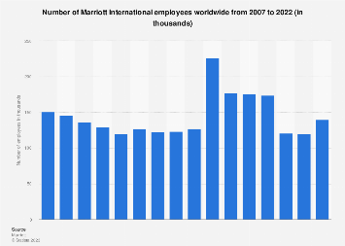
Marriott is able to set and enforce identical quality standards across all of its properties because it directly manages its housekeeping workforce (López-Andreu et al., 2019). To guarantee that service levels match or exceed expectations, the organisation can put in place strong quality control procedures, carry out routine inspections, and offer prompt feedback and coaching (Legrand et al., 2023). The reputation of the brand and the level of customer satisfaction that Marriott seeks to achieve must be maintained at this level of control. In contrast, outsourcing could lead to a loss of control over quality standards since the outside provider might employ alternative strategies, set different objectives, and employ various degrees of supervision (Mutyaba, 2023).
Marriott is able to develop a solid organisational culture among its housekeeping workers thanks to insourcing. Employees can fully immerse themselves in the company's values, mission, and service-oriented culture by joining the Marriott team (Chatterjee, 2022). This alignment can improve staff loyalty, engagement, and motivation, all of which have a favourable effect on the customer experience. Outsourced teams, on the other hand, can have a different organisational culture, making it difficult to fully align them with Marriott's values and service standards (Cobanoglu, 2022).
Cost Implications

Thanks to insourcing, Marriott is able to create a strong organisational culture among its housekeeping staff (López-Andreu et al., 2019). By joining the Marriott team, employees may fully ingratiate themselves into the organization's values, mission, and service-oriented culture (Cobanoglu, 2022). This alignment can increase employee engagement, motivation, and loyalty, all of which are good for the customer experience (Chatterjee, 2022). The organisational cultures of outsourced teams, on the other hand, can differ, making it challenging to fully align them with Marriott's values and service standards (Cobanoglu, 2022).
Price hikes implemented by outsourced service providers over time may affect how cost-effective outsourcing is. The outsourcing provider may raise pricing over the course of the contract owing to things like inflation, rising labour expenses, or shifting market conditions. The early cost savings that outsourcing promised can be reduced by these price increases, potentially making it less financially viable over time (SÖNMEZ et al., 2022).
Although outsourcing could appear to be a solution to unload management and supervision duties, in practise, it frequently necessitates more time and effort (López-Andreu et al., 2019). To manage the outsourcing arrangement, track performance, and guarantee that service level agreements are followed, Marriott would need to allocate staff. This increased administration and supervision may come at a cost in terms of employee time, administrative work, and training (Chatterjee, 2022).
The housekeeping department may lose control over operations and flexibility in responding to changing needs if it is outsourced. Staffing, scheduling, and service delivery would all be handled by the outsourced vendor, on whom Marriott would have to rely. This lack of control may affect the effectiveness of operations and the capacity to rapidly respond to changes in demand or the needs of particular properties (SÖNMEZ et al., 2022).
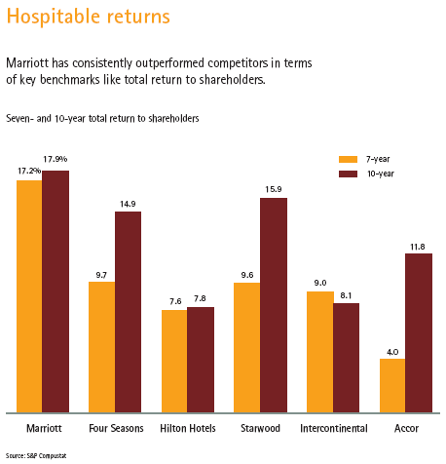

Results
Sustainability

Marriott International's decision to outsource its cleaning division is consistent with the organization's dedication to sustainability in a number of areas. Marriott can more effectively develop and enforce ecologically friendly practises across all of its properties if it directly employs housekeeping workers. This degree of control is necessary for efficiently managing waste, water use, energy efficiency, and putting into practise sustainable projects (Widyatmaja, 2022).
Marriott can directly monitor and regulate waste management procedures thanks to insourcing. The business can put in place extensive waste reduction and recycling programmes, making sure that the right sorting and disposal techniques are used (Datta, 2022). To reduce waste production and boost recycling rates, Marriott can set precise goals and track success. This degree of oversight is necessary to guarantee the uniform application of sustainable waste management techniques across all properties (Widyatmaja, 2022).
Water usage in hotels is significantly influenced by housekeeping. Marriott can continuously adopt water-saving practises thanks to insourcing, including employing effective cleaning techniques, setting up water-saving fixtures, and educating staff members about these techniques (Datta, 2022). Marriott can oversee and enforce these procedures since it has direct control over the housekeeping staff, ensuring that water is used effectively throughout all of its hotels. When outsourcing, this level of control could be jeopardised because external providers might employ alternative strategies or not place the same priority on water saving (Widyatmaja, 2022).
Hotel energy use can be significantly impacted by housekeeping tasks including laundry, cleaning, and maintenance. Marriott can apply energy-efficient practises consistently across all properties by outsourcing the housekeeping division (Datta, 2022). This can involve utilising energy-efficient equipment, designing cleaning schedules to utilise the least amount of energy possible, and educating staff members on energy-saving techniques (Oskam & Zandberg, 2019). With direct control, Marriott is able to keep an eye on and enforce these procedures, resulting in increased energy efficiency across the board. The implementation of energy-saving measures may become less controlled and consistent as a result of outsourcing (Widyatmaja, 2022).
Marriott can create and implement sustainable programmes that are specific to its properties thanks to insourcing. This can involve initiatives like employing eco-friendly cleaning supplies, encouraging ethical sourcing for towels and other amenities, and putting in place green certifications or sustainability requirements (Flores, 2022). Marriott is able to make sure that these initiatives are successfully communicated, put into practise, and maintained across all of its properties since it has direct control over the housekeeping personnel (Nam et al., 2021). Due to the possibility that the outside provider will have different priorities or not share Marriott's sustainability objectives, outsourcing may make it difficult to ensure consistent implementation of sustainable measures (Flores, 2022).
Consistency
For a company like Marriott International, which prides itself on providing extraordinary experiences to its customers, consistency in service quality is of the utmost importance. The housekeeping department's insourcing is essential for preserving uniformity across the entire business (Nam et al., 2021).
Marriott can create and implement standardised training programmes for its housekeeping employees thanks to insourcing. These programmes can include a range of topics, such as operational procedures, guest service guidelines, and cleaning requirements (Alrawadieh et al., 2020). Marriott can ensure that every employee receives consistent, thorough training, enabling them to achieve the brand's high service requirements, by having control over the training process (Oskam & Zandberg, 2019). This consistency in training strengthens the capacity to provide a consistent guest experience by fostering a common knowledge of Marriott's service philosophy (Nam et al., 2021).
Marriott can create standardised performance indicators and evaluation procedures for its housekeeping workers thanks to insourcing. The business might lay out specific requirements, KPIs, and quality assurance procedures (Alrawadieh et al., 2020). Employee performance can be assessed on a regular basis, and feedback and opportunities for development can be given. This methodical approach to performance management encourages ongoing development while maintaining uniform service quality across all sites (Nam et al., 2021).
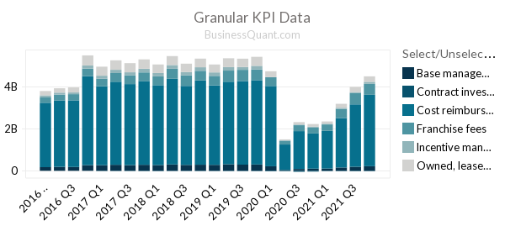
Marriott can put in place effective quality control procedures with in-house housekeeping teams to guarantee dependable service (Oskam & Zandberg, 2019). To evaluate adherence to cleaning standards, service protocols, and general guest satisfaction, the corporation can perform routine inspections, audits, and mystery shopping programmes (Alrawadieh et al., 2020). Any deviations or problems can be quickly found and fixed, ensuring that the organization's service quality is maintained consistently. It may be more difficult to implement consistent quality control methods when working with outsourced teams because they may have varied standards and operating processes (Tavitiyaman et al., 2022).
Marriott's dedication to excellence and reliable service delivery is the foundation of its brand reputation. Because they are confident in the excellent standards of the brand, visitors favour Marriott resorts. When housekeeping is outsourced, there is a chance for inconsistent service quality, which could damage the brand's reputation. If different hotels offer varied standards of cleanliness or customer service, guests could get dissatisfied and look for other places to stay (WIRIYA, 2021). Marriott can better manage and guarantee a constant level of service quality by outsourcing the housekeeping division, enhancing the reputation of its brand and fostering customer adherence (Tavitiyaman et al., 2022).
Guest Experience
Marriott International places a high focus on the guest experience, and the housekeeping division is a key player in determining that experience. With the housekeeping division outsourced, Marriott is able to personally educate and fit housekeeping workers with the business's service ethos, which has various advantages for guest satisfaction (WIRIYA, 2021). Here is further information:
By outsourcing housekeeping, Marriott is able to actively educate staff members and ensure that they adhere to the business's service ethos (Oskam & Zandberg, 2019). This guarantees that housekeeping personnel are aware of and uphold the brand's fundamental values, standards of service, and customer-centric philosophy. Marriott can consistently provide the level of service that visitors expect, boosting their whole experience, by establishing a strong service culture (Parker & Chung, 2018).
Housekeeping teams who are outsourced have a better awareness of Marriott's brand and service standards. In order to guarantee that visitors receive the same degree of care and attention regardless of the property they stay at, they are taught to deliver consistent service across properties. The reliability and comfort that come from knowing customers can anticipate a specific degree of service quality during their stay is made possible by this constancy (WIRIYA, 2021).
Marriott may strengthen ties between cleaning employees and visitors via insourcing. Employees that are insourced have the chance to gain a deeper comprehension of customer preferences, wants, and expectations, enabling them to offer a more specialised and individualised level of service. This special attention encourages the warmth and hospitality that are emblematic of Marriott's brand and enhances the visitor experience (Parker & Chung, 2018).
Marriott is able to provide timely and attentive service by outsourcing its housekeeping personnel. Marriott is able to create effective channels of communication and protocols by directly employing the cleaning staff, which enables swift responses to guest requests or problems. It improves the entire experience and happiness of the guests by being able to respond to their demands quickly (WIRIYA, 2021).
It is possible to train insourced cleaning employees to pay close attention to detail, ensuring that guest rooms and common areas are constantly clean, well-maintained, and represent the high standards anticipated from Marriott. Because of the comfort, cleanliness, and general contentment this attention to detail fosters, it helps guests have a good experience (Stringam & Gerdes, 2021).
Marriott can effectively manage and respond to customer input about cleanliness, room conditions, and other relevant issues by outsourcing housekeeping. Due to its direct oversight of the housekeeping division, Marriott is able to quickly resolve customer complaints, implement required changes, and make sure that customer feedback is taken seriously (Oskam & Zandberg, 2019). Marriott's dedication to guest satisfaction is demonstrated by its proactive approach to handling complaints, which enhances the overall visitor experience (Stringam & Gerdes, 2021).
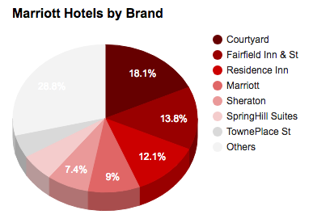
Conclusion
It is clear that outsourcing the housekeeping department inside Marriott International may not be the best option when taking into account the skills of individuals hired, financial implications, results, sustainability, consistency, and guest experience. More control over employees, improved sustainability goals alignment, dependable service quality, and improved guest experiences are all benefits of insourcing. These elements contribute to Marriott's brand recognition and client loyalty, supporting the internal operation of the housekeeping department. Marriott can employ its insourced housekeeping workforce to uphold high standards and guarantee ongoing performance by investing in training and implementing effective management practices

References
Alrawadieh, Z., Alrawadieh, Z. and Cetin, G., 2021. Digital transformation and revenue management: Evidence from the hotel industry. Tourism Economics, 27(2), pp.328-345.
Bardi, J.A., 2021. Hotel-Front-Office-Management.
Chatterjee, P., 2021. Role of Housekeeping Cleaning Equipment and Agent in the world of Hospitality Industry.
Datta, P.M., 2022. Managing in the 4IR World. In Global Technology Management 4.0: Concepts and Cases for Managing in the 4th Industrial Revolution (pp. 19-34). Cham: Springer International Publishing.
Flores, L.M., 2022. Technology in hospitality: how generation Y perceives this trend (Doctoral dissertation).
Legrand, W., Kuokkanen, H. and Day, J. eds., 2023. Critical Questions in Sustainability and Hospitality. Taylor & Francis.
López-Andreu, M., Papadopolous, O. and Jamalian, M., 2019. How has the UK hotels sector been affected by the fissuring of the worker–employer relationship in the last 10 years?
Moret, N.J., 2020. The sustainable business model of a hotel–the case of the W Barcelona.
Mutyaba, J.L., 2023. Factors that Influence PCI DSS Noncompliance by Small and Medium-Size Merchants in the Hospitality Industry (Doctoral dissertation, Capella University).
Nam, K., Dutt, C.S., Chathoth, P., Daghfous, A. and Khan, M.S., 2021. The adoption of artificial intelligence and robotics in the hotel industry: Prospects and challenges. Electronic Markets, 31, pp.553-574.
Oskam, J. and Zandberg, T., 2019. The hospitality industry. In Hospitality Experience (pp. 66-96). Routledge.
Parker, L.D. and Chung, L.H., 2018. Structuring social and environmental management control and accountability: Behind the hotel doors. Accounting, Auditing & Accountability Journal, 31(3), pp.993-1023.
Rutherford, D.G., 2021. Hotel management and operations.
SÖNMEZ, N.K., AYDEĞER, İ.A., SAYILIR, E., DÜLGAROĞLU, O., KARADENİZ, Y., OFLAZ, M., SAÇILIK, M.Y., ADAMIŞ, E., ÖZKAN, Ç, TÜRKMEN, E. and KÖSE, B.Ç., 2022. Analysis of New Applications in Hotel Enterprises Main Departments. Livre de Lyon.
Şener, G. and Cobanoglu, C., 2022. Analysis of International Hotels’ Social Media Strategies. Journal of Mediterranean Tourism Research, 1(2), pp.123-139.
Stringam, B.B. and Gerdes, J.H., 2021. Hotel and guest room technology. University of South Florida M3 Center Publishing, 17(9781732127593), p.6.
Tavitiyaman, P., So, C.Y.A., Chan, O.L.K. and Wong, C.K.C., 2022. How Task Technology Fits with Employee Engagement, Organizational Support, and Business Outcomes: Hotel Executives’ Perspective. Journal of China Tourism Research, 18(6), pp.1212-1238.
Widyatmaja, G.N., 2022. STUDY OF ATTITUDES OF HUMAN RESOURCES DEPARTMENT (HRD) MANAGERS ON WORKERS WITH DISABILITIES IN STAR HOTELS IN THE NUSA DUA, BALI. PalArch's Journal of Archaeology of Egypt/Egyptology, 19(3), pp.590-602.
Wiriya, K. and Soontornthum, T., 2021. Sustainability practices in hotel business: a case study of 5-star hotel in Phuket, Thailand (No. 303711). Thammasat University.
Wood, R.C., 2017. Housekeeping and related accommodation services. In Hotel Accommodation Management (pp. 70-82). Routledge.

