Idea and Concept Development
This project idea was generated while researching some iconic and memberable characters from classic video games. These games included characters such as Sonic the Hedgehog (Sega 1991+ series) and Ratchet & Clank (First release: Ratchet & Clank, 2002 by Insomniac Games). The games feature anthropomorphic characters as the main protagonist. The first story concept began as a having two lead characters, one anthropomorphic thief character with a feathered cat sized dragon companion. The concept was to introduce these two characters meeting for the first time and becoming the duo to be featured in the animation, even though the idea was to focus on developing the introduction cutscene of the characters, the overall idea was having this be an intro to a game franchise (or game series).
The game would feature two playable characters and be focused on platforming as its core. Both characters would rely on each other. The thief would be the overall main playable character of the two. This character would be the one to engage in combat, solve puzzles/problems within the game world. The companion would have abilities such as transforming into an ashy burning cloud, able to pass though vents or over places the thief cannot access alone. This would implement a teamwork component and enrich a bond between the two characters. At this stage the concept was aimed towards the same audience as the other classic games, this created competition from already known IPs with years of reputation.
The concept of aiming the game to an older audience was then explored as this would exterminate the inspired resources in the other games, which were the main competition. This would enable gore or a darker concept within the game if wanted. The Thief was then redesigned to become more anatomically correct and planned to wear dark leather clothing (light and agile yet protected against attacks). The companion was removed, and the powers moved into the thief for the game. The gameplay would then become focused on combat. The player having to rely on the agility of the character over the power and force. The character redesign focused on a cheetah; an animal known for its character trait of speed, however, having the lack of natural killing tools recognised in animals such as a lion or bear. The character's backstory would feed off the original, they would be a thief, tasked with the heist of Pandora’s Box, only the heist goes wrong as he stumbles upon a ritual taking place. This leaves Sarff (the protagonist) tainted with the mysteries of Pandora's Box. He must learn to tame these new abilities as he uses them to return the enemies that had escaped the box. The game would follow Greek mythology, to stay true to Pandora's Box.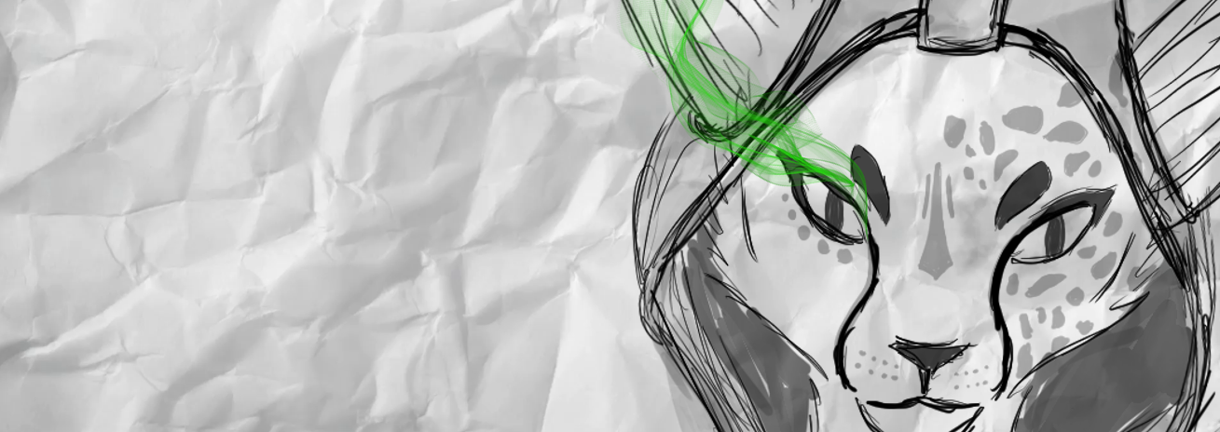
(Fig.1)
With the new story and concept in place, concerns were raised about my venture into the unknown territory of game development. However, my plan was to create the opening cutscene or teaser for the game and not to develop the game itself. This feedback set me back a while as I explored the possibility of creating a series, rather than a game. The same argument would apply though, to creating the teaser not the full series, this meant I was technically "in the same boat" and decided to focus on my original concept despite the concerns of myself not being a games student. This teaser could then also be used in the future to generate interest in the concept and potentially crowdfunding to hire a team to make the game a reality.

Character and Environment Design
The idea of the character being anatomically correct, I set my mind to early on, this was to separate it from other popular anthropomorphic based games to avoid some competition. This would also mean the game could feed off the nostalgia of fans of classic games with the option of an anthropomorphic game being focused towards an older audience. During the research, I investigated many games that feature these characters as well as games that were similar in the gameplay style, both of which embodied the concept.
Sarff (the main character) would have a powerful lower body with a light upper body, this would follow the plan of having him based primarily off the design of a cheetah, but if he were to have walked on two legs, not four like his animal counterpart. He was given large ears to create a better character silhouette, this was inspired by Ratchet from the Ratchet and Clank game series (2002). Sarff would be covered in spots as expected of a cheetah at the start of the game, but after the accident (failed Pandora’s heist), one side of his face would become clear, this side would also feature his smoke emitting eye (infected by Pandora). He would be incapable of controlling this new power at the start of the game. The eye would cause great pain to him when smoking as he is yet to tame this new found ability.
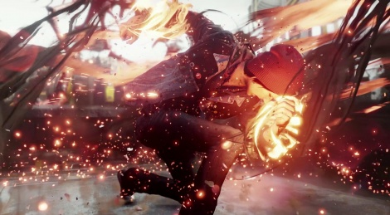
The smoke from his eye would become his signature character trait and theme of all his abilities, he will be able to temporally transform into this green ashy smoke cloud to avoid contact, jump higher or move faster while in this form or partly in this form. These powers would be close to Delsin from Infamous Second Son.

(Fig.2)

The power would be used in very similar ways, to temporally give attacks extra damage, increase speed or movement or even to coat himself in smoke for a final blow to the opponent. These abilities cause pain to the character, using them too much can put the player in a runnable situation.
Due to Sarff's body type, his legs would be the main source of strength and the use of legs in combat will be a heavy focus. Combat such as in Mirror's Edge Catalyst (7 June 2016 by EA Dice) would be used as a reference as the character is light and nimble so she must focus on using her momentum to take down foes as well as her full body weight when required. Clothing and environment would become inspired by Thief (Eidos Montréal 2014), streets would be dark, wet and gritty, with housing and buildings inspired by the style of Victorian London in the 1800s.
Limitations in drawing would be a factor when creating the concept character and environment. To start getting the shape of the character accurate to what I envisioned, I focused on the creation of the character silhouette, this was a long process for me, as I wanted the character to be true to the animal I had chosen and also memorable and recognisable based on just the silhouette. My aim was for the character to be anatomically correct. Multiple sketches were done over time, then mixed to create one unified character.
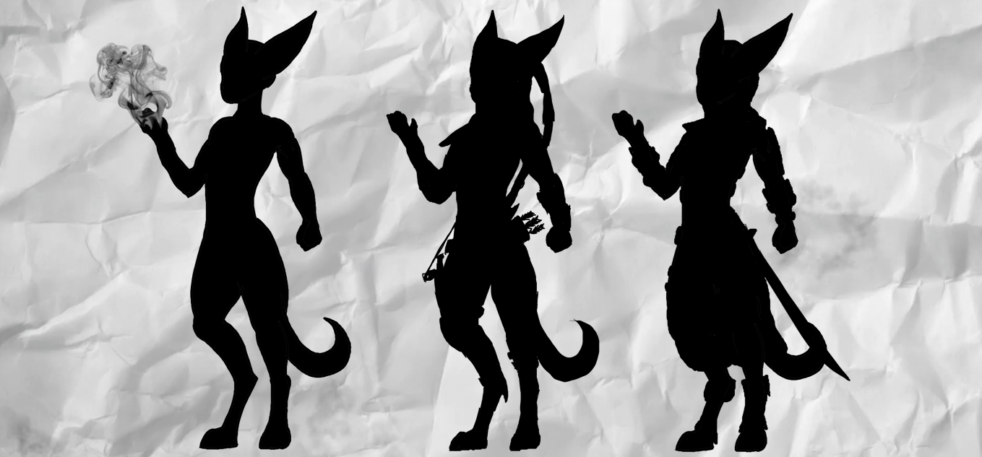
(Fig.3)
Creating a silhouette over a full concept at this stage allowed me to focus on shape over accuracy and detail for Sarff. Inspiration was taken from The Art of Aaron Blaise, a YouTube channel focused on art and animation with how he approaches drawing from life. The middle of these three (Fig.3) depicts the design of his suit and gear (armed with daggers and short sword as well as bow and arrow). The character's appearance focused on agility, speed and stealth assets. This was the reason the animal choice was selected as a cheetah. Although changes were made such as a thicker tail as he is now standing upright and this would aid with balance.
During design, multiple documentaries were looked at including the skeleton of the cheetah to correctly implement the design. Powerful back legs, momentum by using the spine as a spring when running, as well as the lack of killer teeth and warn claws due to running, make the character rely on his tools and speed.
Modelling would begin in ZBrush by creating a front and back reference to use as a guide. The basic body shape and type was created then put on hold as I met a person online (Ardent) who was making a game. This game would feature characters as bosses but represent streamers and friends. I was offered a slot in the game, a character representing myself as a game boss. This would mean the character could be featured in a game (not just a concept). However, the character had to somehow portray myself but without changing the fundamentals of my character so late in production.
The game would feature the player locating portals to different realms. Each realm would include a new unique boss battle. The character would be used as one of the bosses within the game. While streaming my image had become a rabbit character, which was created in the games I streamed. This had become well recognised by the viewers, so that I could implement the redesign of my logo. A rabbit character would work without changing the concept of the game. Both animals rely on speed and have powerful back legs, both relying on agility. This allowed me to keep the body design from the original character for the new character. A redesign at this stage was still a problem however due to the lack of time and resources (and the limitations of a one-person team). The character redesign was not without its challenges. Leg size was increased to better represent a rabbit as well as the paws being larger. The build of the head and tail would also change to represent rabbit traits more effectively. Sarff's ears would now be primarily down (almost like a cape).
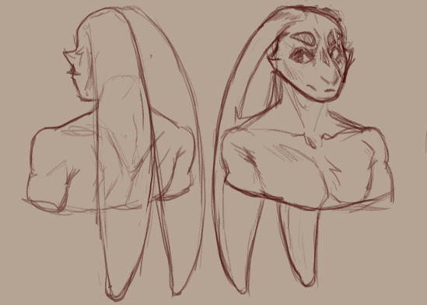
The head was modelled based on this sketch, however, with a less sharp jawline and longer ears. After modelling, the UVs were unwrapped making the character ready for textures in Maya, focusing the seams down the spine of the character and on unseen areas to be covered by clothing and the character’s hood.
(Fig.4)

The character was re-topped down to a poly count of 40K before entering UV stage, the goal of the character being a max of 70K polys with completed clothing. The use of normal maps would help this goal as well as removing the mesh of the character located under the clothing (therefore removing the unseen/unused polys).
Creating the textures for the character were put on hold due to time limitations. With the UVs created it would mean I could add the textures later if time was available. Focus now had to turn to the rig of Sarff for the animation. This process became more complicated than I had hoped as I wanted the character rigged for use within the game as well as animation ease of use. My first rig lacked finger, toe and ear control, this was due to my lack of knowledge with creating character rigs as I was unable to add the joints in Maya. In response the rig was moved to Blender as I have more experience in using this software, however, Blender was unable to make sense of the rig from Maya even when using global file types such as the FBX format. This led to a second more controllable rig being created featuring fingers, toes and ear bones, this rig would also be closer to the one needed within the game itself. For animation, I decided to use the first rig for the opening shots. Scenes closer to the character or demanding more movement would then use the second rig created for use in the game (an Unreal Engine ready rig was also created but discarded due to time and weight painting problems).
Animation
During the animation, I wanted to explore alternate possibilities and methods to create the movements. I also aimed to use this time to learn, not just create. During this period, I had become familiar with VR technologies and uses. I streamed games where I was able to create and use my own characters. My choice of hardware was the Oculus Rift CV1 VR headset and controllers, during my time with the device I learnt of it’s capabilities to implement tracking of both feet and hips within the game world using the Xbox Kinect, however, this was not to the standard I desired. At this point, a limiting factor was funding as the HTC Vive gear allowed for full body tracking (Head, hands, feet and hips) but this ran through the Vive software, not the Oculus gear that was available.
Research was conducted in editing and modding. I found that Oculus could be made to work with Vive by editing the Steam VR code to run multiple drivers and then through editing the play space of both VR systems to match. This covered the problems in the gap in hardware, but funding was still an issue. This was where streaming was introduced, as the hardware could be used for streaming also, I published a stream donation goal of £570 (2x £120 Base stations needed, 3 x £100 Vive Leg Trackers Needed and £30 for straps to hold the trackers) and put £100 of my own saving towards this goal. After funding from generous viewers was met, I ordered the trackers.
With the trackers and the modification of the Steam VRs code, this allowed for cross use in hardware, my full body could then be accurately tracked onto my in-game character. Now with the technology needed for full body VR gaming, I wanted to use this for motion capture in animation. With motion capture already existing and used heavily in animation I knew there must be a way to somehow convert my VR movements into a motion capture for animation. This was then done using multiple software all working in harmony (Advanced Steam VR Settings Mod, OpenVR Space calibrator, OpenVR recorder, Steam VR, Maya, Oculus and Vive Drivers). This allowed me to use my VR in the game while capturing it to an FBX format. After capturing the animation and exporting to FBX this would then be imported into Maya. The file would contain 6 animated reference points (captured in 24fps to match Maya). The references would then be parented to the characters rig, hips, feet, hands (head was ignored due to rig problems). The animation would then be baked to the skeleton before being cleaned up, with the other unparented parts being animated by hand.
You are free to use as many trackers as you like to create the references. This would mean, that with the required funding it would be possible to capture all key points of the body for animation. Using VR technology to motion capture is a new concept, so it does take trial and error, problem solving and multiple programs to function, however, it opens up so many possibilities with home ready motion capture.
This VR motion capture method was used to create a "warm-up/stretching" animation for the character after landing from the high jump as well as other tests that were unused in the final animation, such as idle stances and movement tests. Of course, there are massive limitations with this method of animation. Rooms size was a problem, with not enough room or resources to carry out all the needed movements. Also movements such as jumping from roof to roof are not possible using this method, as any movements required multiple turns (as bound by VR wires). You are also limited to the maximum tracking space of the hardware used. So, most of the animation for my project was done by hand in Maya. The character had to be animated running and jumping over rooftops to get to his needed location before the heist goes wrong. Reference from YouTube free runners and instructors as well as games such as Mirror's Edge Catalyst (7 June 2016 EA Dice) was used to influence how the character moved between shots as well as landed after jumps.
With the character now being a rabbit-based design, I wanted to implement the use and power of his legs more within the animation. This was a subtle change to the original intention of a roll after a jump, as the character was changed to spring out of the roll (to his feet) instead whilst completing the action.
With little time remaining play blasts were used along with unanimated scenes to complete the animatic for submission, play blasts were left containing the rig to show the rig limitations. Animation for this project will continue after this submission date for use as a teaser for Sarff and his abilities, as well as new animation for the boss fight position open to my character. This will allow the character to be experienced by players and potentially even gain some following before a stand-alone game is to be developed and published.
Future Trajectories
The current state of the project is far from complete as it is planned to be continued and worked on over the coming weeks and months. The first steps would be revisiting the character to texture, and also add clothes and gear to him ready for use in both the animation and game. His rig also needs to be improved adding the needed ear, finger, toe, tail and ear bones for full control over the character itself. Also, the rig will have to be made to be used within the game, this would involve the compatibility with Unity dynamic bones for automated movement and flow of the ears etc. Working in connection with Ardent and the others working on the game I will need to agree on a polycount and rig with them as well as making sure the character is unique in comparison to all other bosses within the game. The design of the environment also needs to be discussed and agreed to as I would like it to reference the source of the character (Greek mythology and Pandora's box).
This game creation on the side of the main teaser will allow me to explore the gaming development fundamentals as well as investigate methods of optimising my creations as this must be done for the game itself. I also hope to learn new methods of modelling, this will be done by offering my time to help with the creation of other characters as well as working with the other developers.
I hope to focus my time on practising to draw both from life and my mind. I have made plans with two artists linked to the game to have some crash course lessons with them as well as bought all of Aaron Blaise's online lessons and guides so that I can follow and improve my abilities. This will give me more confidence in my 2D art and also hopefully reduce the time I take to complete my concepts. Concepting is a key skill within the industry to allow me to show and develop my visions into reality.
The character will be the primary focus of completion following this deadline, this will allow it to be featured in the coming game. The environment will then be the next focus, to create the teaser and back story for Sarff. After finalising the environment, the animation can then be completed and used to generate a crowdfunded standalone game for the character.

Bibliography

Images:

Fig.1
Richard Kane Morris
R.K.M
2019
Sketch of Sarff
[Digital Art]
(Not available publicly/online or as part of a collection)

Fig.2
Infamous Second Son
2014
Sucker Punch Productions
[Game Screenshot]

Fig.3
Richard Kane Morris
R.K.M
2019
Silhouette of Sarff
[Digital Art]
(Not available publicly/online or as part of a collection)

Fig.4
Roberto Rodriguez-Perez
R.R
2019
Kane’s character Sketch
[Digital Art]
(Not available publicly/online or as part of a collection)

Referenced Games:

Infamous Second Son
2014
Sucker Punch Productions
[Game]

Mirror's Edge Catalyst
2016
EA Dice
[Game]

Ratchet & Clank
2002
Insomniac Games
[Game]

Sonic the hedgehog
1991
SEGA
[Game]

Thief
2014
Eidos Montréal
[Game]

YouTube Sources:

Aaron Blaise (2013) The Art of Aaron Blaise [YouTube Channel]
Available at: https://www.youtube.com/channel/UC0lLeNdvLrFozQRsQ1TQiAw
(Accessed: 01/04/2019).

