Materiality of Late Cypriot Burials

Today we will consider why Late Cypriot communities placed such a diversity of objects in the tombs with the deceased.
- Traditionally archaeologists have argued that “burial goods must be surer signs of afterworld belief?” (Ucko 1969: 265).
  - Should we then consider these as provisions for the dead?
  - Are they included because they are intrinsically associated with the deceased (biographical object or souls trapped in the object)?
  - Favourite/personal possessions of the deceased?
  - Very visible statement of the individual’s identity?
- Are grave goods intrinsically associated with aspects of funerary ritual?
  - What sort of items might we identify that were associated with the performance of funerary ritual?
- Ucko also questions whether the wealth and number of grave offerings necessarily correlates to wealth and status amongst the burial community.
  - How might we define wealth / status in funerary objects?
  - How might we interpret some of the apparently more luxurious objects placed in tombs?
  - Does paucity of grave goods imply a low level of material wealth?

Objects from tombs in the British Museum
Pottery:
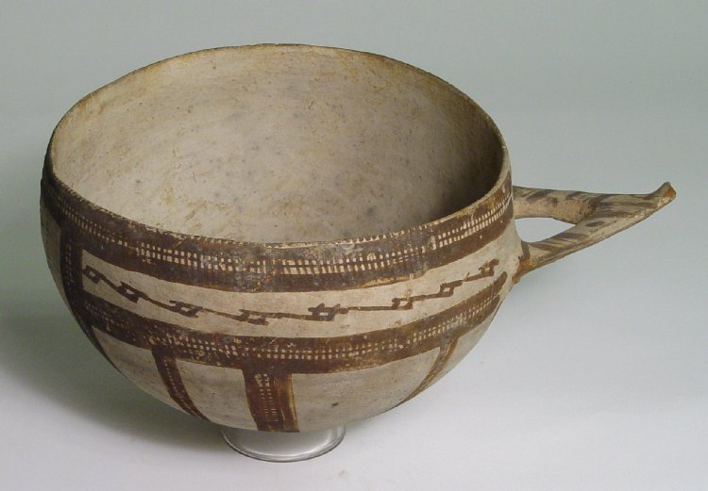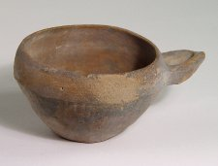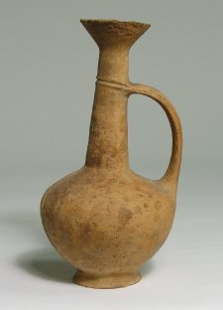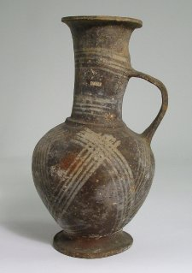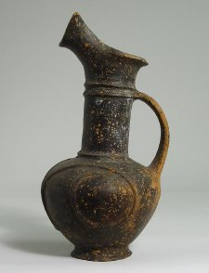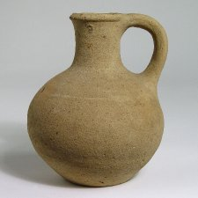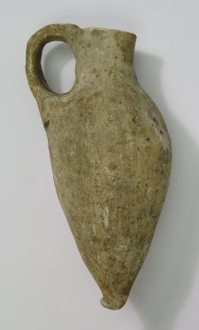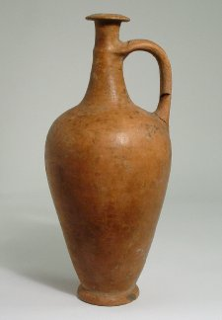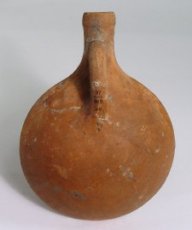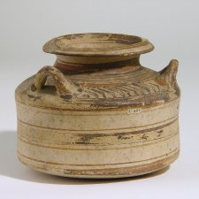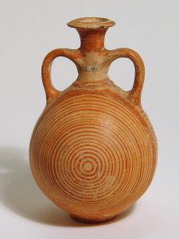

Vitreous materials:
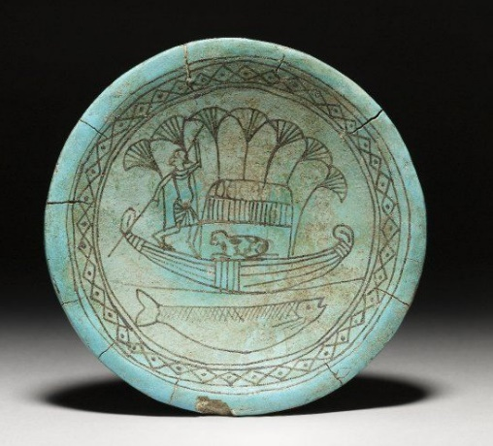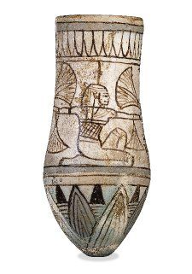
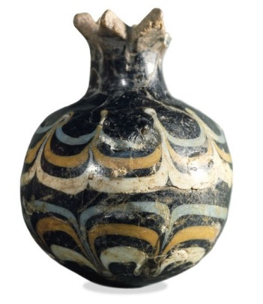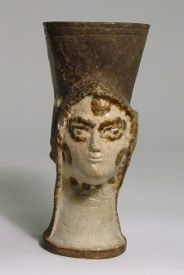
Personal Adornment:


