Student name: | Sofiya Radkova Williams | Student ID number: | 2407274
Programme: | BA (Hons) Leadership and Management Skills in the Workplace
Module: | Project Management
Module code: | LCLM5003
Module Leaders: | Rexon Nting  Doreen Nyaa Amundam  Samson Oladejo
Assignment Title: | A Project portfolio. | Word count or equivalent.

Table of Contents
Part A – Poster 2
Part B - Reflections from the feedback received from tutor and peers 3
Introduction 3
What? 3
So what? 3
Now what? 4
Conclusion 4
Part C – Report 5
1. Introduction 6
2. Project Description 6
3. Scope 8
4. Work Breakdown Structure (WBS) 8
5. Quad Chart 10
6. Gantt Chart 11
7. Stakeholders' Involvement 12
8. Allocation of Resources 13
9. Risk Analysis 15
10. Conclusion 16
References 18
Appendix: Part A File 20

Part A – Poster
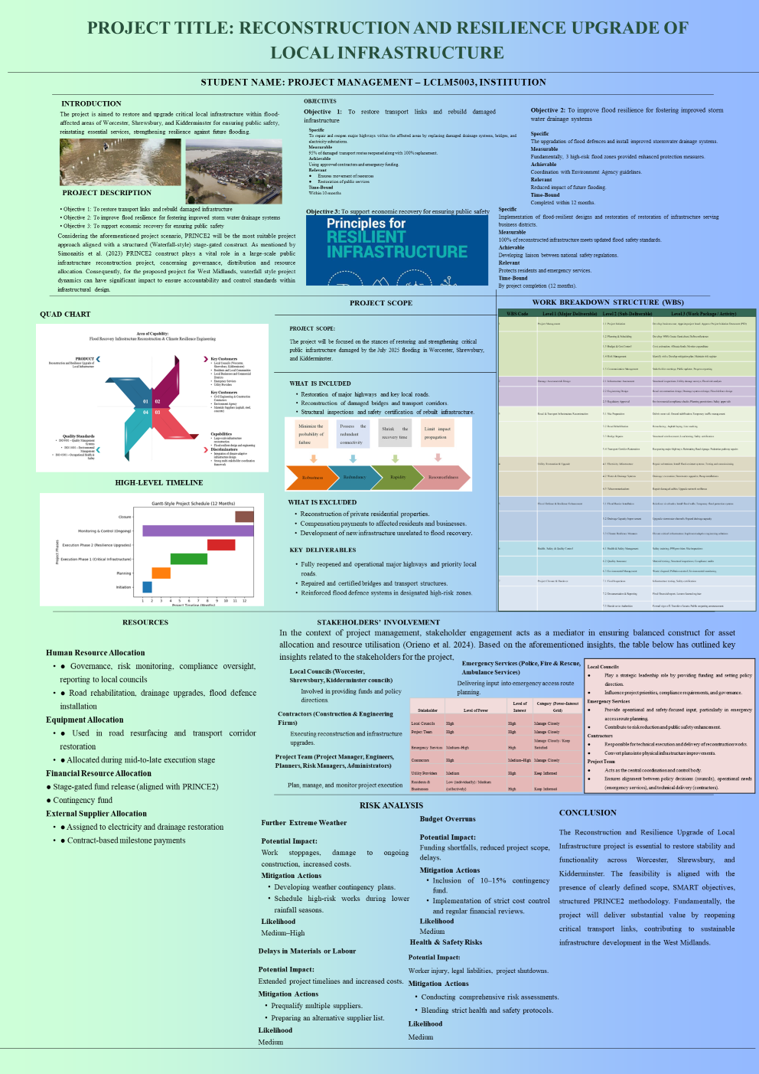

Part B - Reflections from the feedback received from tutor and peers

Introduction
Information in the feedback given by the tutor and other students has been useful to the project proposal of the Reconstruction and Resilience Upgrade of Local Infrastructure project. Specifically, it paid attention to the design of the poster and the necessity to enhance the listing of references and word count.

What?
The main feedback was based on the poster where it was recommended that the wording should be increased to 500 words since the one being dealt with was short. The change will also assist in ensuring that the poster is detailed to address the constituents required like the scope, objectives and deliverables (Peeters et al. 2025). Primary feedback was focused on the poster, as I was recommended to increase the length of the words up to 500 words. The existing version was not detailed enough and such modification would enable me to address the critical aspects of the scope, objectives, and important deliverables in a more detailed manner. Besides, I was reminded of adding in-text and a list of references. The addition of in-text citations will contribute to the project by providing credibility to my assertions by giving them support of credible sources. Other peers also indicated that the overall project idea was well understood yet, the poster could have been expanded more to give an idea of the scope of work and deliverables. I was also advised to enhance the visual sense and clarity of the information, ensuring the information is presented logically and concisely.

So what?
The feedback that I have gotten has been quite beneficial in making me work on my project proposal. Increasing the size of the project to 500-word size will enable me to describe the project scope, goal, and deliverables in a better way. It will add credibility to my work and prove that I have a strong basis of the research, which is important to achieve academic standards. Also, rearrangement of the layout so that it can be easier to look through will enhance readability and make the most important information easily accessible (Mêda et al. 2024). The revisions will contribute greatly to the overall quality of my submission whereby I will be able to communicate on the goals and plans of the project better.

Now what?
Goals | Actions | Timeline | Outcomes or Measures
Revise the poster to meet word count | Increase the word count up to 500 words with the description of scopes, objectives, deliverables, and milestones. | 1 week | The poster is already 500 words long, which provides it with a detailed explanation of important aspects of the project.
Ensure logical structure and clarity | Arrange the material in rational, properly structured format and provide certain details where it is needed. | 1 week | Enhanced structure order and clarity of the contents, which is easier to read.
Include in-text citations | Include the in-text citations of the arguments that include references to credentials. | 1 week | Enhanced academic rigour and citations as well as credibility of the information.
Add reference list | Prepare a reference list at the bottom of the poster in the necessary referencing style. | 1 week | Finish the reference list, make sure that it is properly formatted and oriented to the citation style.

Table 1: Action plan in response to “Now what”?
(Source: Self-assessed)

Conclusion
The response that I have gotten has played a critical role in identifying areas of weaknesses. Through the elevated word count, incorporation of in-text citation and the layout of the poster, I believe that the final project proposal shall be substantially stronger. Such amendments will be able to assure that the submission is of academic and presentation standard.

Part C – Report
Executive Summary
The Reconstruction and Resilience Upgrade of Local Infrastructure project aims at rebuilding key infrastructure in flood prone regions of Worcester, Shrewsbury and Kidderminster. The project will not only repair and upgrade significant highways, bridges, and drainage systems that were largely impacted during the 2025 floods; it will also enhance flood resilience to be used in the future. The most notable goals are to reconnect transport, enhance the flood defences, and help the economies of the regions that were affected by the event. This project management plan shows how the project should be undertaken, the schedule, the development of the resources, and a risk management strategy, which will help the successful project completion. It entails a work breakdown structure (WBS) that is detailed, Gantt chart, stakeholder involvement, and risk analysis. The plan will make sure that the project is done and completed within the stipulated time and budget, as well as it measures up to safety and quality standards. With well-organised approaches to project management, the project will settle its objectives, which will result in long-term sustainability and durability of the local infrastructure.

1. Introduction
Purpose
The key task of the program of “Reconstruction and Resilience Upgrade of Local Infrastructure” is to recover and upgrade both critical infrastructure in the flood-caught neighbourhoods of Worcester, Shrewsbury, and Kidderminster. 12 flood warnings and 7 flood alerts were issued for the whole county of Worcestershire (BBC, 2026). The purpose of the report is to secure the future resilience of flooding as well as the preservation of the well-being of people.
Scope
The project focuses on the rebuilding of major highways, transport lines, bridges, and drainage systems that were greatly affected by the 2025 floods. Building new facilities that are not part of the recovery effort, and also the restructuring of residential property owned by individuals are excluded from the scope.
Overview of the Plan
In this project management plan, the specific goals, anticipated deliverables, an elaborate timeline, and the strong risk-reduction strategies are outlined to guide the restoration processes. The overall purpose is to enhance flood defences and implement speedy economic recovery solutions.

2. Project Description
Background
Exceptional flooding of the West Midlands took place in July 2025, which included such areas as Worcester, Shrewsbury, and Kidderminster due to a severe Atlantic weather system that led to the River Severn breaking its flood control defences (BBC, 2025). The subsequent flooding drowned roads, houses and businesses at the same time interfering with the power supply. There was overburdening of local authorities, emergency responders and community organizations visiting the area and the Environment Agency even issued severe flood warnings (MSN, 2026). Destruction of vital infrastructure like roads, bridges and drainage facilities also worsened transportation and other vital services severely affecting the crisis. Repairs on flood damaged facilities. Infrastructure that cannot be replaced and enhanced flood resilience is necessary in ensuring that the safety of people is not put at risk (Wang et al., 2022). Local economies are rejuvenated and the ability to face floods affecting the region is intensified.
Project Goals and Objectives
Project Goals
The overall objective of the project on Reconstruction and Resilience Upgrade of Local Infrastructure is to restore critical infrastructure in the flood-damaged areas of Worcester, Shrewsbury as well as Kidderminster and increase flood resolutions and economic regeneration of the area in the long run.
Objectives
- Reconstruct necessary transport routes and infrastructures damaged by floods.
- Enhances resilience to floods by laying new stormwater drainage systems and reinforced flood defences systems.
- Assist economic recovery by rebuilding important infrastructure facilities and securing people.
Deliverables
The project provides some of the key deliverables geared towards revamping and strengthening infrastructure in the geographical locations that are affected. First, the principal transport systems, including roads and bridges, will be rebuilt to provide a smooth flow of products and human beings. Second, there is a significant improvement of flood resilience due to the implementation of advanced storm drainage facilities and flood defence fortification of susceptible areas hence reducing the chances of future floods. Third, to ensure structural integrity and safety of the people, safety certifications will be performed on all the rebuilt infrastructure. Moreover, the project rebuild and refurbish the crucial facilities taking care of business areas hence helping in the economic recovery of the affected areas. Project stakeholders are provided with an overall project report that comprises end-of-construction safety validations, risk-control models, and project development reports. At its end, the infrastructure should be well operational and able to accommodate future floods leading to the resilience and sustainability of the region.

3. Scope
Inclusions
The area of this project focuses on recovery and rebuilding the major infrastructure in the areas affected by floods in Worcester, Shrewsbury and Kidderminster. It involves the reconstruction of key roads, bridges that were damaged as a result of the floods and also the recovery of key transport corridors. In addition, the project improves stormwater drainage work, as well as reinforce flood defence, to enhance the resilience of flooding and reduce the chances of further flooding of vulnerable regions in future. The restructuring of the infrastructure also includes safety checkups and certification to verify that all the necessary safety standards are met.
Exclusions
It is beyond the scope of reconstruction of individual property of a domestic nature or the building of other new infrastructure that is not directly connected with flood recovery. The developments or infrastructures outside the designated flood recovery areas are equally out of the project scope. Any future infrastructure upgrading beyond simply recovering the damage caused due to floods are not included under the umbrella of this project.
Objectives Alignment
This scope ensures that the project is not deviated from its main goals, which are the restoration of transport connections, improvement of flood resilience, and enhancement of human safety.

4. Work Breakdown Structure (WBS)
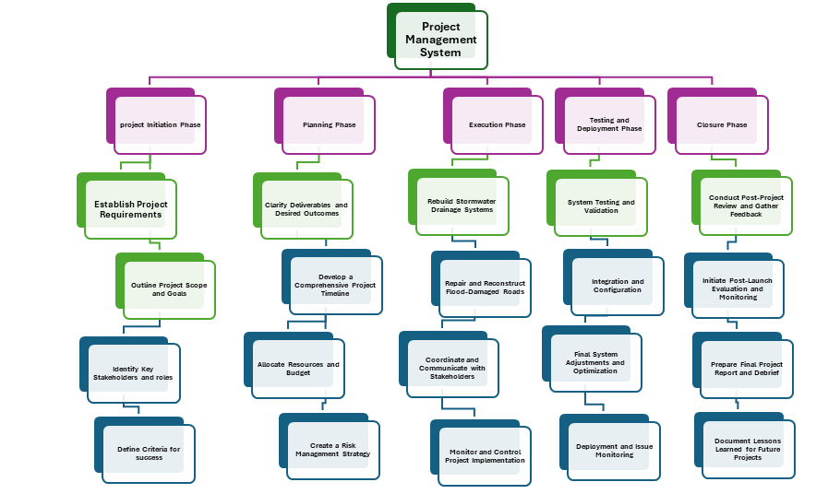
Figure 1: WBS of Project Management System
(Source: Self Developed)
Analysis
The Work Breakdown Structure (WBS) outlines a defined methodology used in the management of a complicated venture during separate phases. The Project Initiation Phase then provides the groundwork by outlining project requirements, scope, and objectives, key stakeholders of the project and success criteria; it is an essential step to clarifying what is really expected and what the success criteria should be. During the Planning Phase, the project team helps in clarifying deliverables, developing a comprehensive schedule, assigning necessary resources, and budgets (Kussumardianadewi et al., 2024). This phase provides the input of operations in that everything is allocated wisely whereby all the risks are mitigated. The next step is the Execution Phase that focuses on the practical recreation of stormwater drainage systems and restoration of damaged infrastructure (Odedairo, 2024). On-going communication between the stakeholders and constant monitoring help in smooth movement of the project and necessary changes in time. Testing and Deployment Phase cannot be done without because testing of the infrastructure by technical inspection and system integration is carried out to ensure everything works properly before the full deployment is implemented. The last phase, which will include the feedback collection process, the final project report preparation, and the implementation of a post-launch evaluation, is the Closure Phase, that also involves the recording of lessons learned, and this is necessary when developing an improved initiative in the future. In short, this WBS is the summary of a meticulous, systematic procedure that helps to make every step of the project implementation efficient, which allows risk reduction, and general success maximization.

5. Quad Chart
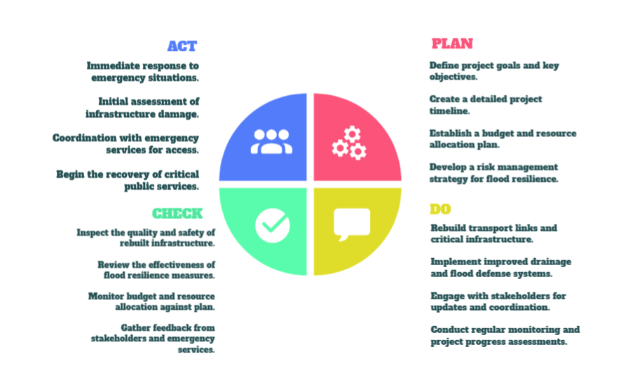
Figure 2: Quad Chart
(Source: Self Developed)
Analysis
The Quad Chart provides an organized overview of the Reconstruction and Resilience Upgrade of Local Infrastructure project in accordance with the flood recovery activities in the West Midlands. The ACT phase focuses on the rapid response to the crisis of floods. Quick re-establishment of the essential facilities ensures that local areas are not left without vital facilities whilst other more thorough re-building work is well coordinated. It implies liaison with emergency services to evaluate the destruction of infrastructures and give priority in the restoration of the vital sectoral services.
At the PLAN phase, the team organises the project identifies specific goals, creates a detailed timeline, plans the required amount of financial and human resources, and creates a risk-management strategy aimed at ensuring the resiliency of flood infrastructure and eliminating the effects of potential risks. This baseline stage defines the parameters of the successful execution of projects.
During the DO stage, the project is given attention on the reconstruction of transport links, roads and bridges as well as installation of flood-defensive systems like drainage systems, etc. Communication with the stakeholders is also very critical to ensure transparency and alignment during this time (Eyinade et al., 2022). This is done through constant observation and periodic progress reviews to make sure that the set goals and time frame are followed.
The CHECK phase examines the effectiveness of work done. The team inspect the quality and safety standards of restored infrastructure, control budget adherence and receive feedback. The given iterative feedback loop contributes to the achievement of goals associated with the improvement of infrastructure resilience and safety of the impacted communities.

6. Gantt Chart
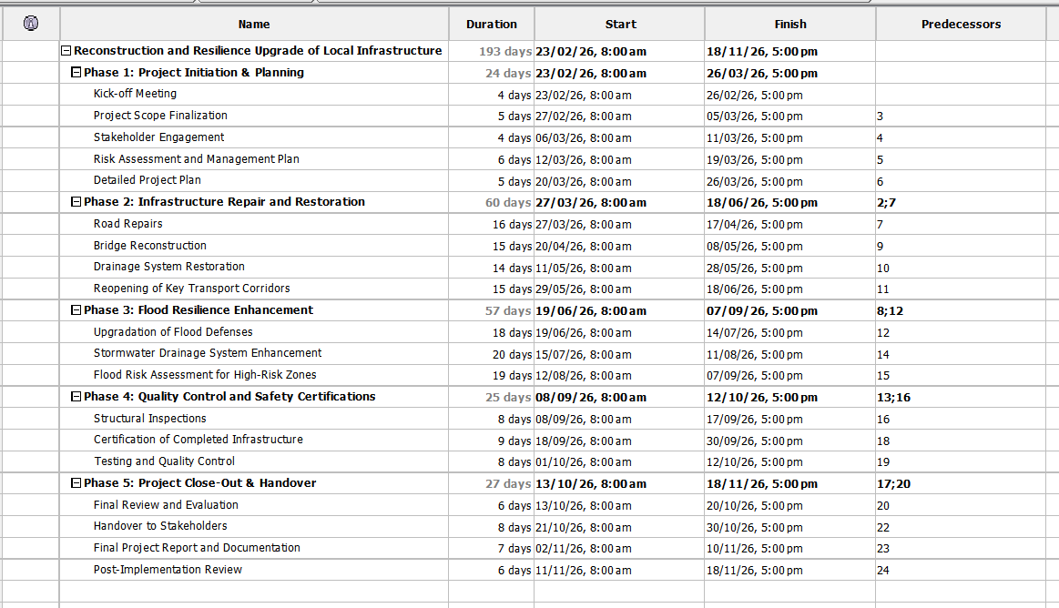
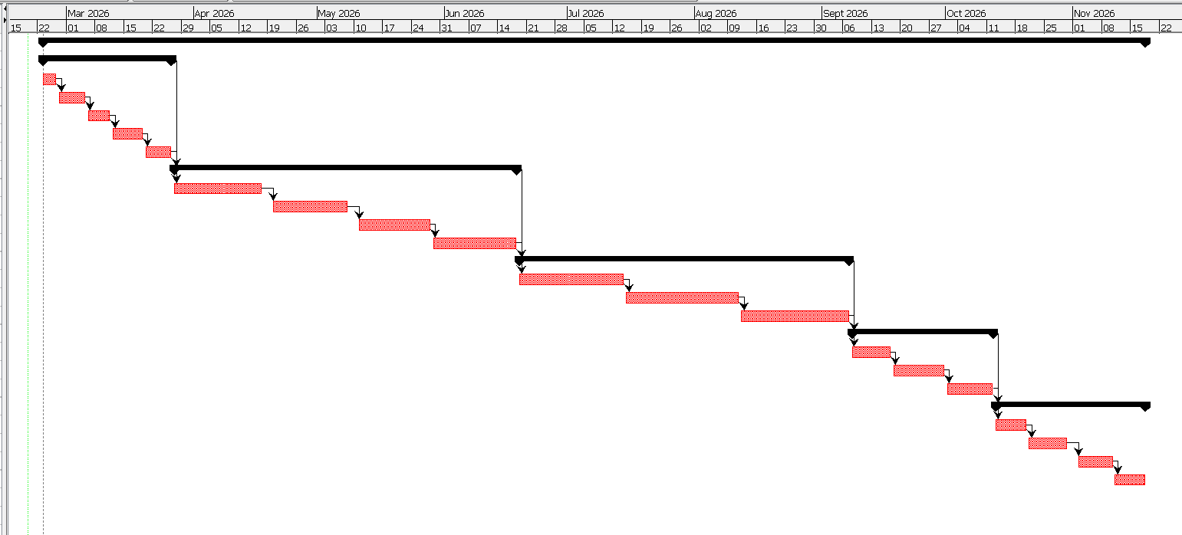

Figure 3: Gantt Chart
(Source: Self-Developed)
The given timeline includes the general span of the project (193 days), the beginning of which is determined on 23rd February 2026 and the end is on 18th November 2026 and consists of five phases. This phase has set start and finish dates of each subtask and task dependencies. Those phases are represented by a Gantt chart and are illustrated by the task duration, overlapping activities, and milestones. The completion of certain subtasks during the project timeline is represented by the red-highlighted bars and is used to track the progress. It also shows the chronology of activities in the chart, properly maintaining smoothness in the workflow.

7. Stakeholders' Involvement
Internal Stakeholders' Involvement
Project administrators, engineers and the project managers are considered to be the internal stakeholders of the project under scrutiny-Reconstruction and Resilience Upgrade of Local Infrastructure. The project managers will be in charge of the entire project, where milestones would be achieved in the stipulated time. The planners and engineers will do the design and implementation of the infrastructure repairs and upgrades (Aljumaily and Abd, 2025). Project administrators are in charge of communication and documentation that make sure there is a good flow of stakeholders. They need to cooperate to ensure that the whole project is continued and any arising issues are addressed. The definite separation of the duties of the internal team makes the project successful and ensures the compliance with the timelines.
Internal Stakeholders | Project Managers  Project Team (Engineers, Planners, Risk Managers)  Project Administrators
External Stakeholders | Local Councils  Funding Agencies (Government, Emergency Relief Funds)  Construction Contractors (Road and Bridge Builders)  Utility Providers (Water, Electricity, Telecommunications)  Businesses (Local SMEs Affected by Flooding)  Environmental Agencies (Environment Agency)  Local Residents (Directly Affected by Flooding)

Table 1: Internal and External stakeholders
(Source: Self-developed)
External Stakeholders' Involvement
The external stakeholders are the local councils, funding agencies, contractors, utility providers, environmental, and businesses and the residents. The local councils are also responsible in making policies and offering funding where the project requires. Financial support on the repairs of the infrastructure is facilitated by the funding agencies, including governmental bodies (Wang et al. 2024). The actual process of repairing the physical infrastructure is done by the contractors who are the ones responsible in the process of construction. Utility providers aid in re-establishing the necessary essential services such as electricity, water and telecommunication in the affected areas. The project affects businesses and the people living in the area, who will be able to supply key feedback regarding the progress.

8. Allocation of Resources
Resource Type | Description | Details
Human Resources | Team members that were key to good governance, systematic risk management, implementation of construction processes, and strict quality management. | - Engineers manage the design and the construction and construction workers making physical modifications.  - Risk managers make sure that the risk-reduction strategies are observed, and quality control specialists make sure that safety standards are met (Björnsdóttir et al., 2022).
Material Resources | Materials needed are critical in restoration and upgrading of the infrastructure. | - Road resurfacing asphalt, bridge reconstruction concrete and steel, storm-water drains, flood-diverting defences.
Financial Resources | Provision of budget allocation to make sure that the project has sufficient funding at every stage. | - A comprehensive project budget that accommodates all the outlays and a contingency budget of 10-15% that accommodates unexpected expenditures.
External Suppliers | vendors and contractors that are on external employment. | - Drainage system suppliers, electrical supply, machinery hiring, and other subcontracted services like bridge repairs and specialised flood-defence system installation are used.
Table 2: Allocation of Resources
(Source: Self-Developed)

Analysis
The table demonstrates major project resources that are necessary to carry out the project of Reconstruction and Resilience Upgrade of Local Infrastructure. Project management, construction and quality control functions are identified and human resources are identified to carry on with the project. Material resources list critical inputs of the construction: asphalt, concrete, and drainage systems components that will be required to fix the infrastructure and contribute to resiliency of floods (Bayeroju et al., 2023). The financial aspect outlines the project budget including contingency reserves of unpredictable expenses and outlines a gradual release plan in accordance to project points.

9. Risk Analysis

Risks | Solvency | Probability | Impact | Mitigation Strategy
Extreme Weather Delays | High | High | High | Prepare a contingency plan, scheduled work in dry rainy seasons, and alternative scheduling in regard to weather.
Budget Overruns | High | Medium | High | Reserve a 10-15% contingency budget, have a stringent cost cheque, and have a periodic cheque of the financial accounts.
Delays in Material or Labor | Medium | Medium | Medium | Pre-qualify several suppliers and maintain a backup list in the event that materials and labour resources are delivered on time.
Health & Safety Incidents | High | Medium | High | Accomplish good health and safety tests, follow up procedures and train workers on safety measures.
Stakeholder Delays | Medium | Low | Medium | Setting up open communication lines, frequent meetings with stakeholders, and expectations management by giving feedback on time.

Table 3: Risk Matrix
(Source: Self-developed)
The Risk Matrix of the project of reconstruction and resilience upgrade of local infrastructure reveals a number of important risks that may affect the success of the project. The risks have been assessed as per their solvency, probability, impact, and mitigation plan in order to have proactive risk management (Rehman, 2024). Combining this analysis with the Stakeholder Theory, it is possible to understand that the mitigation of these risks is the key to the balanced interests of all the communities, similar to internal project staff, external contractors, the local councils, and impacted citizens.
The delays associated with extreme weather are quite likely and significant because they can interrupt the activities, and this will influence the contractors and the timeline of the whole project. Contingency planning enables the project to meet the expectations of the stakeholders regarding timely delivery of the project (Jariwala, 2024). This can be used away through appropriate cost management, and that way, their interests are enhanced.
Also, other risks including delays of materials or labour and health and safety accidents are related to the contractors, labour force, and the local community. These risks are dealt with through effective mitigation measures, which guarantee the success of the project in the long run and also the satisfaction of the stakeholders. Adequate consultation with the stakeholders during this process is also vital towards ensuring trust and transparency.

10. Conclusion
In conclusion, the project, Reconstruction and Resilience Upgrade of Local Infrastructure, is a vital project to rebuild and reinforce the damaged infrastructure in Worcester, Shrewsbury, and Kidderminster. The project seeks to attain significant goals, which will be to reinstate the transport connections, increase resilience to flooding, and contribute to the recovery of the economic activity in the region. The project employs a systematic process that uses project management tools to achieve successful project implementation, risk management, as well as stakeholder involvement.
The project plan, which includes the work breakdown structure (WBS), the Gantt chart and risk analysis, shows an overall approach of attaining these objectives. The internal and external stakeholders are critical to the success of this project. The effectiveness of managing any potential difficulties (e.g. extreme weather delays, budget overruns, and shortages in labour/materials, etc.) is to be achieved through appropriate resource allocation, effective communication, and the continuous risk mitigation. These risks and the systematic approach of working on the project will allow the team to make sure that the restoration work will be delivered on time and on the budget, and that the needs of the community will be met. Such a project will eventually improve the resiliency of the infrastructure, which is a long-term kind of safety and sustainability of the area.

References
Aljumaily, M. and Abd, H., (2025). ‘Interdisciplinary Approaches to Smart City Development: Integrating Engineering, Urban Planning, and Social Sciences with AI and Cybersecurity Governance’. International Journal of Mechatronics, Robotics, and Artificial Intelligence, 1(1), pp.11-19. https://doi.org/10.33971/ijmrai.1.1.3
Bayeroju, O.F., Sanusi, A.N. and Nwokediegwu, Z.Q.S., (2023). Framework for Resilient Construction Materials to Support Climate-Adapted Infrastructure Development. Shodhshauryam, International Scientific Refereed Research Journal, 6(5), pp.403-428. https://doi.org/10.32628/SHISRRJ
BBC. (2025). Flood warnings on Severn following heavy rain. https://www.bbc.com/news/articles/cr7lm4v9l33o
BBC. (2026). Roads closed and flood warnings after heavy rain, https://www.bbc.com/news/articles/c5yv8299llxo
Björnsdóttir, S.H., Jensson, P., de Boer, R.J. and Thorsteinsson, S.E., (2022). The importance of risk management: What is missing in ISO standards?. Risk Analysis, 42(4), pp.659-691. https://onlinelibrary.wiley.com/doi/abs/10.1111/risa.13803
Eyinade, W., Ezeilo, O.J. and Ogundeji, I.A., (2022). A Stakeholder Engagement Model for Strengthening Transparency in Corporate Financial Performance Reporting. Shodhshauryam, International Scientific Refereed Research Journal, 5(6), pp.236-251. https://www.researchgate.net/profile/Onyinye-Ezeilo/publication/393146077_A_Stakeholder_Engagement_Model_for_Strengthening_Transparency_in_Corporate_Financial_Performance_Reporting/
Kussumardianadewi, B.D., Latief, Y., Trigunarsyah, B., Rarasati, A.D. and Widiani, W., (2024). Development of Work Breakdown Structure (WBS) in high-rise office buildings using green retrofitting based on GBCI and minister of PUPR Regulation No. 21 of 2021 to improve the quality of resource planning. Civil Engineering and Architecture, 12(2), pp.740-753. https://www.researchgate.net/profile/Bernadette-Kussumardianadewi/publication/377931010_Development_of_Work_Breakdown_Structure_WBS_in_High-Rise_Office_Buildings_using
Mêda, P., Calvetti, D., Sousa, H. and Moreira, J., (2024). ‘Data discovery for digital building logbook (DBL): Directly implementing and enabling a smarter urban built environment’. Urban Science, 8(4), p.160. https://doi.org/10.3390/urbansci8040160
MSN. (2026). Britain underwater: Cricket ground in Worcestershire is completely submerged after 40 days of rain. Available at: https://www.msn.com/en-in/news/india/britain-on-flood-alert-300-areas-at-risk-of-rising-water-levels-as-relentless-downpours-continue/ar-AA1VXVcC
Odedairo, B.O., (2024). Assessing the influence of various work breakdown structures on project completion time. Engineering, Technology & Applied Science Research, 14(2), pp.13773-13779. https://doi.org/10.48084/etasr.7023
Peeters, M., Lee-Smith, W., Allen, D. and Giuliano, C., (2025). ‘Academic conference posters: A systematic review’. INNOVATIONS in pharmacy, 16(3). https://doi.org/10.24926/iip.v16i3.6629
Rehman, S., (2024). Risk Management in Business: Strategies for Mitigation. Journal of Management Science Research Review, 2(1), pp.1-13. https://jmsrr.com/index.php/Journal/article/view/20
Wang, D., Xu, P.Y., An, B.W. and Guo, Q.P., (2024). “Urban green infrastructure: Bridging biodiversity conservation and sustainable urban development through adaptive management approach’. Frontiers in Ecology and Evolution, 12, p.1440477. https://doi.org/10.3389/fevo.2024.1440477
Wang, L., Cui, S., Li, Y., Huang, H., Manandhar, B., Nitivattananon, V., Fang, X. and Huang, W., (2022). A review of the flood management: from flood control to flood resilience. Heliyon, 8(11). https://doi.org/10.1016/j.heliyon.2022.e11763

